Service Model

Author: IBM
Owner: IBM

Document History
Document Location
This is a snapshot of an on-line document. Paper copies are valid only on the day they are printed. Refer to the author if you are in any doubt about the currency of this document.
The source of the document will be found in /tmp/lo/0000.doc
Revision History
Date of this revision: 10-15-2008 | Date of next revision (date)

Revision Number | Revision Date | Summary of Changes | Changes marked
3.2 | 10-15-08 | Template extracted out from WPD (Arun Thakore). Service Model is broken into one parent and three sub-artifacts, namely, Service Portfolio, Service Dependencies, Service Specification. | (N)
3.1 | August 2007 | Updated to include SOMA 3.1 concepts and additional details for the Service Model (Shuvanker Ghosh).
2.1 | June 2005 | Version numbered to synchronize with TP
0.5 | May 2005
0.4 | April 2005
0.3 | April 2005
0.2 | April 2005 | Revised after internal review
0.1 | March 2005 | Revised for SOMA 2 (David Janson)
New draft baseline | Sep 2004 | Added contents (Abdul Allam)
Approvals
This document requires following approvals. Signed approval forms are filed in the Quality section of the PCB.
Name | Title
(name) | (title)
Distribution
This document has been distributed to
Name | Title
(name) | (title)
Contents
1. Introduction 4
1.1 Identification 7
2. System Model 8
2.1 Service Model Control Information 8
2.2 Service Portfolio 8
2.3 Service Dependencies 8
2.4 Service Specification 8

Introduction
Please note that:
- Text in the “Editor’s comments” style (such as this) provides guidance to the editor, in conjunction with the corresponding work product description, and should be removed from the published version of the document.
- The “Reader’s comments” style (in purple) provides guidance for the (client) reader and should be modified as appropriate by the editor to reflect any customization of the template.
- The “Normal” style (in black) should be used by the editor when adding the text describing the (sub) system appropriate for this work product.
When using this template, refer to the Unified Method Framework work product description “Service Model”.
The Service Model augments other GS Method Work Products by capturing information related to services that is not captured in other work products. Information documented in the Service Model is the result of work that spans the identification and specification of services as well the decision-making that is needed to support service realization.
The Service Model is composed of several sections (Figure 1 Service Model), each of which is summarized below in Table 1: Service Model Detail. The Service Model artifact consists of three sub-artifacts, namely the Service Portfolio artifact, Service Dependencies artifact and the Service Specification artifact.

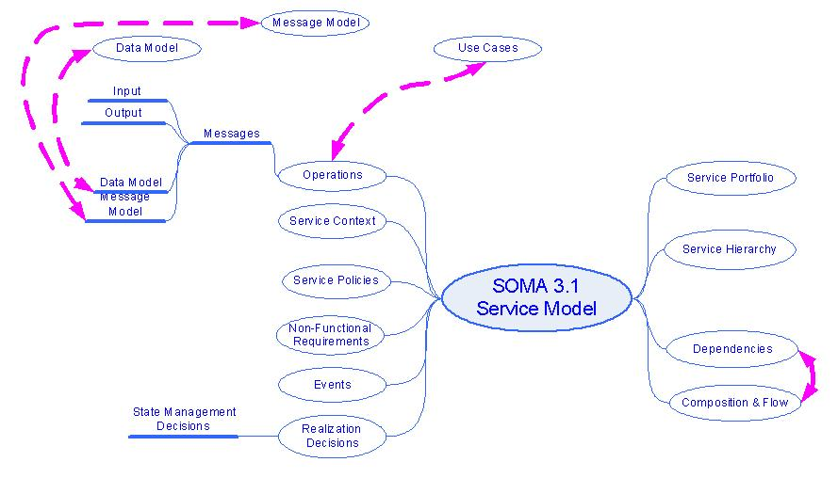
Figure 1 Service Model

Section | Description | SOMA step where created
Service Portfolio | List of candidate services discovered during SOMA service identification activities. | SOMA Identification:  - Domain Decomposition  - Goal-Service Modeling  - Existing Asset Analysis
Service Hierarchy | Candidate services organized using a business significant categorization scheme, making evaluation of candidate service more manageable. Domain Decomposition Functional Area Analysis typically provides the classification scheme. | SOMA Identification:  - Domain Decomposition: Functional Area Analysis
Service Exposure | Documents the rationale behind why we chose to expose a given candidate service or group of services in the service hierarchy or composition. The Service Litmus Test is applied to candidate services to make exposure decisions. | Service Specification:  - Exposure Decisions using the Service Litmus Test as part of Service Re-factoring and Rationalization
Service Dependencies | Documents dependencies between services in the model. | Service Specification:  - Model Service Dependencies
Service Composition and Flow | Identifies which services are choreographed together to form a composite service. | Service Specification:  - Identify Service Composition and Flow
Service Context Aware Attributes | Specifies context aware attributes for dynamic assembling and routing. | Service Specification  - Specify Context-Aware Service Specification
Service Operation | Identifies service operations. | Service Specification  - Identify Service Operation
Events | Identify events that trigger services and service operations. | Service Specification:  - Identify Events
Rules and Policies | Specify/associate rules executed by service and service operation and policies it follows. | Service Specification  - Associate Business Rules and Policies
Service Context Diagram | Illustrates the service consumers and service providers. | Service Specification  - Specify Context-Aware Service Specification
Service Messages | Documents messages that are exchanged between service consumer and service provider. | Service Specification:  - Specify Input, Output, Error Messages
Service Non-Functional Requirements | Documents the non-functional requirements that dictate those characteristics. | Service Specification:  - Gather and Categorize Non-functional Requirements
State Management Decisions | State can be an important consideration for composite services and the related decisions are documented here. | Service Specification:  - Document State Management Decisions
Service Allocation To Components | Map to Service Component realizing the service and Functional and Technical Components | Component Specification:  - Allocate Services to Component
Realization Decisions | Documents architectural decisions that deal with how the services will be realized, such as buy, build, subscribe, etc. Nonfunctional requirements are prominent criteria in many of these decisions. Realization Decisions are documented in the Architectural Decisions work product. | Realization:  - Establish Realization Decisions
Table 1: Service Model Detail

Identification
This document captures the Service Model information for .

Service Model

Service Model Control Information
Define the scope, owner and version for the service model in this section.

Service Categories
Document the service categories and their descriptions.
Service Category | Description

Service Portfolio
Define the ownership and completion information of the Service Portfolio sub-artifact

Service Dependencies

For each set of service dependencies define the ownership. Each set of service dependencies will be captured in a sub-artifact.

Service Specification

For each set of service specifications define the ownership. Each set of service specificaitons will be captured in a sub-artifact.

