Service Portfolio

Author: IBM
Owner: IBM

Document History
Document Location
This is a snapshot of an on-line document. Paper copies are valid only on the day they are printed. Refer to the author if you are in any doubt about the currency of this document.
The source of the document will be found in /tmp/lo/0000.doc
Revision History
Date of this revision: 10-15-2008 | Date of next revision (date)

Revision Number | Revision Date | Summary of Changes | Changes marked
3.2 | 10-15-08 | Template extracted out from WPD (Arun Thakore). Service Model is broken into one parent and three sub-artifacts, namely, Service Portfolio, Service Dependencies, Service Specification. | (N)
3.1 | August 2007 | Updated to include SOMA 3.1 concepts and additional details for the Service Model (Shuvanker Ghosh).
2.1 | June 2005 | Version numbered to synchronize with TP
0.5 | May 2005
0.4 | April 2005
0.3 | April 2005
0.2 | April 2005 | Revised after internal review
0.1 | March 2005 | Revised for SOMA 2 (David Janson)
New draft baseline | Sep 2004 | Added contents (Abdul Allam)
Approvals
This document requires following approvals. Signed approval forms are filed in the Quality section of the PCB.
Name | Title
(name) | (title)
Distribution
This document has been distributed to
Name | Title
(name) | (title)
Contents
1. Introduction 4
1.1 Identification 4
2. Service Portfolio 5
2.1 Service Portfolio Detail 6
2.2 Service Re-factoring and Rationalization 9

Introduction
Please note that:
- Text in the “Editor’s comments” style (such as this) provides guidance to the editor, in conjunction with the corresponding work product description, and should be removed from the published version of the document.
- The “Reader’s comments” style (in purple) provides guidance for the (client) reader and should be modified as appropriate by the editor to reflect any customization of the template.
- The “Normal” style (in black) should be used by the editor when adding the text describing the (sub)system appropriate for this work product.
When using this template, refer to the Unified Method Framework “Service Portfolio”.
This chapter captures the Service Portfolio. The Service Portfolio is a part of the Service Model and consists of a list of candidate services discovered during SOMA service identification activities. This artifact is a sub-artifact of the Service Model artifact. In addition to the Service Portfolio, the Service Model consists of the Service Dependencies artifact and the Service Specification artifact. Table 1 shows the elements of the Service Model that are created during the identification phase and captured in this template.

Section | Description | SOMA step where created
Service Portfolio | List of candidate services discovered during SOMA service identification activities. | SOMA Identification:  - Domain Decomposition  - Goal-Service Modeling  - Existing Asset Analysis
Service Hierarchy | Candidate services organized using a business significant categorization scheme, making evaluation of candidate service more manageable. Domain Decomposition Functional Area Analysis typically provides the classification scheme. | SOMA Identification:  - Domain Decomposition: Functional Area Analysis
Service Exposure | Documents the rationale behind why we chose to expose a given candidate service or group of services in the service hierarchy or composition. The Service Litmus Test is applied to candidate services to make exposure decisions. | Service Specification:  - Exposure Decisions using the Service Litmus Test as part of Service Re-factoring and Rationalization
Table 1: Service Portfolio Detail

Identification
This document describes the Service Porfolio for .

Service Portfolio

For simplicity the Service Portfolio can initially be represented as a list of candidate services as shown in Figure 1.
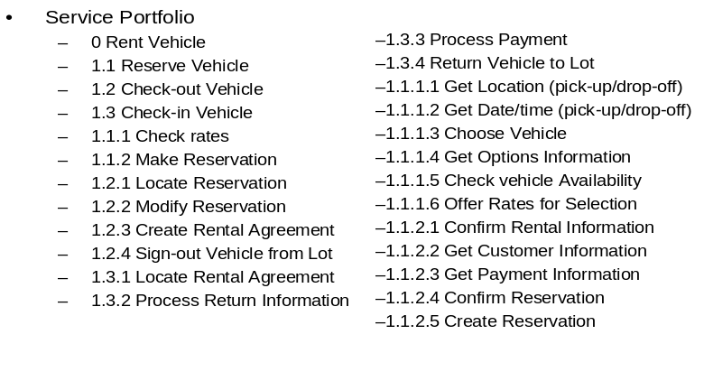
Figure 1: Service Portfolio - initial service list
As the number of candidate services increases, an unstructured list can quickly become unmanageable. Therefore, as soon as possible a service classification scheme should be identified so that candidate services can be organized into groups within the classification hierarchy.
The Service Hierarchy organizes services in the service portfolio using a uniform classification scheme. The classification scheme is often based on the functional areas identified by SOMA Domain Decomposition Functional Area Analysis, and Documented in the Functional Area Descriptions work product. Notation for the Service Hierarchy is an outline format as shown in the example in Figure 2.

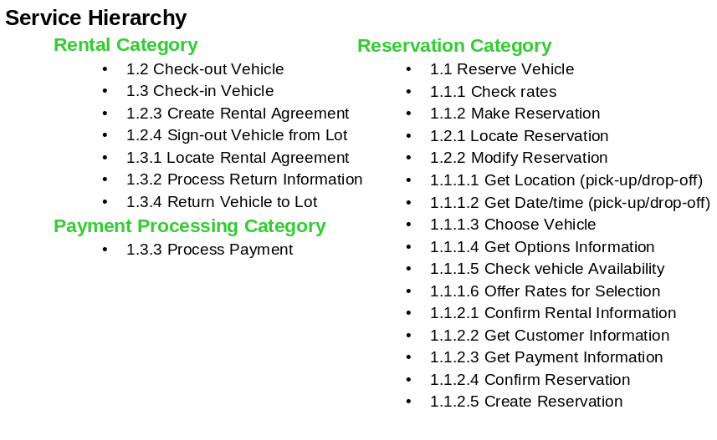
Figure 2: Service Portfolio organized using a classification hierarchy
While a simple list of service names can be a quick starting point, it will eventually be important to capture additional information about each service.

Service Portfolio Detail
Service identification is focused on building a portfolio of services that can be associated with business functions, business goals, assets such as existing systems, and an indication of whether the service is considered a candidate service, or has been chosen for exposure. The table shown in Table 1: Service Portfolio template is a template that can be used to document services at the level of detail needed in the service portfolio. Service specification information is discussed in the Service Specification artifact..

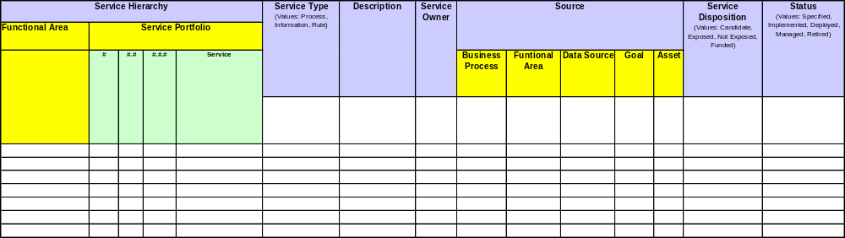

Table 2 Service Portfolio Template

Service: name of service
Service Operation: name of service operation
Description: short description of service or service operation
Service Owner: owner of the service e.g. could be Business or IT owner
Associations:
Business Process: name of (or reference to) business process that the service is associated with (this typically aligns Process Definition). Depending on the level of detail reached in analysis activities this could be a business process, or a process step from some level of process decomposition. More specificity in the reference is generally better.
Business Component/Business Function: name of business component/business function that the service is associated with (this typically aligns with Functional Areas). Depending on the level of detail reached in analysis activities, this could be a business domain, a functional area, a specific function. More specificity in the reference is generally better.
Goal: name of a goal or sub-goal that the service is associated with (this typically matches a goal or sub-goal listed in the Goal-Service Model).
Asset: an asset that is associated with the realization of the service (this typically matches a system listed in the Business Function / System Matrix)
Service Disposition: “C” for candidate service, “E” for a service chosen for exposure, “NE” for a service not chosen for exposure, “F” for a service chosen for exposure and funded
Status: Specified for services that have been specified but not implemented, Implemented for services that have been specified but not deployed, Deployed for services that have been deployed but not approved by SOA Governance, Managed for the services that are governed, Retired for service that have been deprecated

Service Re-factoring and Rationalization
Not all candidate services meet the criteria needed to be chosen for exposure. Service Exposure decisions can be made by applying the Service Litmus Test described in the Service-Oriented Modeling and Architecture (SOMA) technique paper. The template shown below can be used to capture service exposure decisions and the rationale for making the decision. Please use the service model worksheet provided.

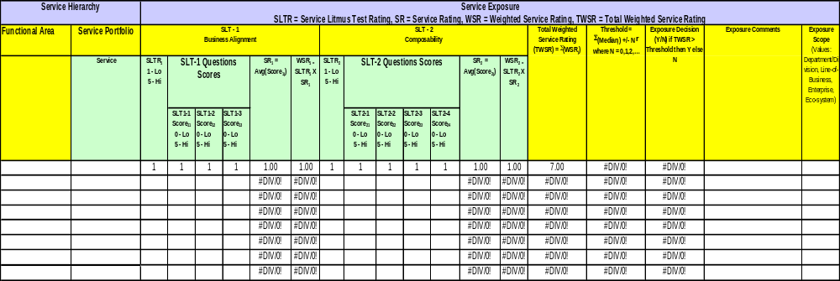
Table 3 Service Exposure Decision Template

Service: name of service
Service Operation: name of service operation
Business Alignment: does the service meet business alignment SLT criteria
Composability: does the service meet composeability SLT criteria
Redundancy Elimination: does the service meet redundancy elimination SLT criteria
Client Defined: litmus tests to satisfy specific business needs for client
Exposure Decision: Y for expose, N for don’t expose
Exposure Comments: cases may arise were a decision is made by the business to expose a service even if it does not pass all SLT tests. Document the reason for overriding the SLT test results.
Exposure Scope: whether the service is exposed to Project, Domain, Line of Business, Enterprise, Eco-system

