PEMM Whitepaper

Performance Engineering support for solution development using Team SD method

Author: David Jelley
Owner: David Jelley
Customer: Martin Jowett - WW Performance & Capacity CoP Leader

Document History
Document Location
This is a snapshot of an on-line document. Paper copies are valid only on the day they are printed. Refer to the author if you are in any doubt about the currency of this document.
The source of the document will be found in /tmp/lo/0000.doc
Revision History
Date of this revision: 13.11.2008 | Date of next revision (date)

Revision Number | Revision Date | Summary of Changes | Changes marked
(#) | (-) | New version created to align with Team Solution Design.  Previous version of this paper was aligned to TeAMethod. | (N)
Approvals
This document requires following approvals. Signed approval forms are filed in the Quality section of the PCB.
Name | Title
(name) | (title)
Distribution
This document has been distributed to
Name | Title
(name) | (title)
Contents
1. Introduction 5
2. Touchpoint Summary. 8
3. Overview of Performance Engineering and Management Method (PEMM) 9
4. Detailed Interlock Analysis 12
5. Appendix A – Summary of PEMM Tasks 15

List of tables
Table 1. Summary of Team SD and PEMM touchpoints 8
Table 2 Detailed touchpoint analysis 14

Introduction

Purpose
The purpose of this whitepaper is to:
- show how Team Solution Design (Team SD) method and Performance Engineering and Management Method(PEMM) can be used together to improve focus on solution performance characteristics, early solution sizing, design and risk management.
- leverage existing guidance and techniques within PEMM and position these for use by the Team SD practitioners.

Benefits
The Team SD practitioners will benefit from using the tried and tested guidance and techniques contained within PEMM. These have been collated from the experiences of practicing Performance Architects.
In an engagement environment, where time and resources are constrained, the use of this performance engineering asset will save time, cost and improve the quality of the solution performance

Contents
This paper contains the following sections:
- Touchpoint Summary – summarising where PEMM supports Team SD.
- Overview of the Performance Engineering and Management Method(PEMM)
- Detailed Interlock Analysis - maps the Team SD activities and tasks to the relevant performance tasks of PEMM.
- Summary of PEMM Task descriptions

Intended Audience
The audience for this whitepaper are those IT Architects that use Team SD as the basis of developing client solutions. It is assumed that the reader of this paper is familiar with Team SD. There is no attempt to provide Team SD education in this paper.

Applicability
Although PEMM can be applied in varying degrees in all engagements the focus area for the Team SD Practitioner should be to use this whitepaper in engagements where the client has critical performance requirements or the technology to be used in the solution is new or novel. PEMM should be used to enhance the performance aspects of the Team SD Work Products that are identified in section 4 ‘Detailed Interlock Analysis’.

How to use the whitepaper.
The whitepaper will be used by the Team SD practitioner to locate information within PEMM to develop and assure the performance aspects of their solutions.
Team SD provides a framework of activities and tasks that guides the IT Architects through the development of their solutions. The Team SD tasks contain a description of the task, the inputs, the outputs and references to other documents that can assist in the execution of the task.
Within the reference section of the Team SD tasks there will be a reference to this whitepaper whenever PEMM can provide performance related guidance and techniques for that task.
When the Team SD practitioner uses this whitepaper they will be able to find a linkage between the Team SD task and the summary of PEMM tasks that describe the performance related guidance and techniques. This linkage is found in section 4. Detailed Interlock Analysis on page 12.
The full details of the guidance and techniques can then be located in the PEMM document. A link to this document can be found in section 1.8 References.
The guidance and techniques provided by PEMM should be applied to the work products specified within the Team SD tasks. It is not intended that the Team SD practitioner will create any additional work products. The relevant work products are identified in the Detailed Interlock Analysis.

Additional Performance and Capacity resources
This whitepaper focuses on the interlock of the Team SD and PEMM Methods, however additional performance and capacity IC that will be of use to the Team SD practitioners can be found in the Performance & Capacity IC Database, see reference 003 below.

References
This section contains the links to the Team SDTeamroom and the PEMM material used in developing this whitepaper.
The PEMM method documentation should be used by the Team SD practitioners to find detailed guidance on PEMM activities and techniques
Ref. No. | Reference | Link
001 | Team SD method | Team Solution Design
002 | The PEMM method documentation | IBM ICM AssetWeb - Performance & Capacity - PEMM
003 | Performance and Capacity CoP IC database | Performance & Capacity IC Database

Development approach for this whitepaper
The steps taken to develop the whitepaper are:
- For each Team SD task review:
- The task descriptions and match to relevant PEMM task description
- The output Work Products and mapping these to the PEMM task outputs
- Where the task could be improved through additional consideration of the solution performance requirements and design. Map the identified improvements to PEMM tasks.
- Document a matrix of the Team SD and PEMM task touchpoints.
- For each touchpoint document the rationale for the mapping and a summary of what support PEMM provides for the Team SD practitioner. See Detailed Interlock Analysis.
- Identify where the reference material should be stored so that it is easily accessible by the Team SD practitioner from the Team SD method site.

Acknowledgements
The author would like to express thanks to the following people who have contributed to the development and review of this whitepaper.
Mark Palmer - Team SD Owner
Tom Seevers – Team SD Owner
Martin Jowett - WW Performance & Capacity CoP co-leader.
.

Touchpoint Summary.
This whitepaper shows how Team SD and PEMM can be used together to improve focus on performance and related risks during solution design & development in the Engagement lifecycle.
This section provides a summary of the touchpoints between the two methods. The table below provides the Team SD practitioner with an ‘at a glance’ view of where PEMM can help them in developing their solutions. It lists the Team SD activities and tasks and indicates with ‘Y’ where PEMM can provide guidance and techniques for developing the performance related aspects of the solution.
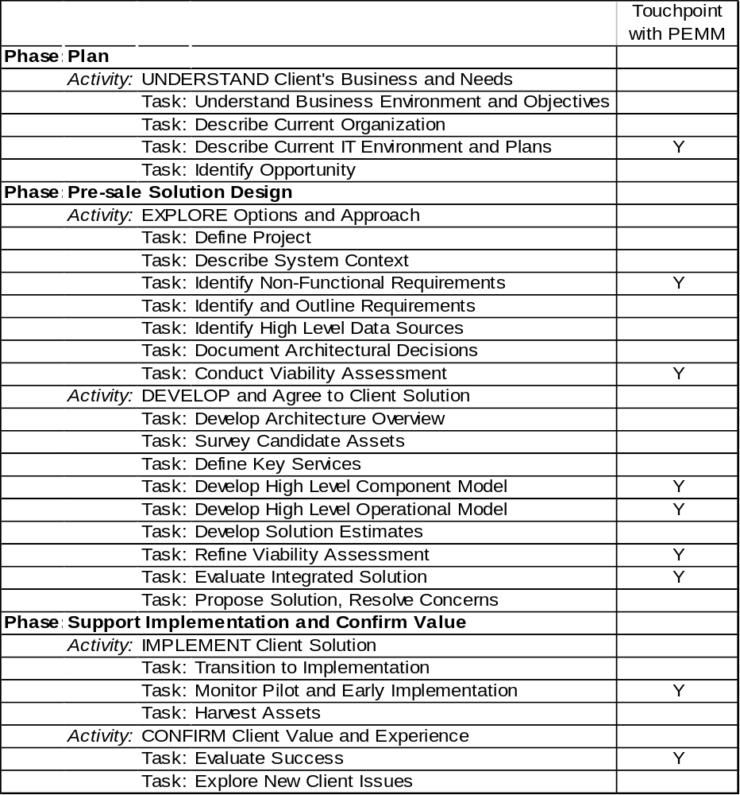
Table 1. Summary of Team SD and PEMM touchpoints
The whitepaper contains a detailed mapping of the PEMM tasks and techniques related to the Team SD tasks in section 4 Detailed Interlock Analysis on page 12 . It provides a description of each touchpoint along with a specific reference within PEMM that provides the guidance and techniques the Team SD practitioners can use.

Overview of Performance Engineering and Management Method (PEMM)
Performance Engineering is a discipline that takes the view that “Performance should never come as a surprise at the end of the project”. While many projects use the approach that “it will be all right on the night”, Performance Engineers believe in, and support “build to specification”.
The Performance Engineering and Management Method is therefore a complete but pragmatic set of tasks and activities required to support a Performance Engineer in
work within a project to deliver to specification
performance consultancy and review
guiding an organisation in setting up Performance Engineering as a discipline.
The tasks cover the complete lifecycle of a system - from concept and inception of a project through roll-out into live running. Activities are identified which are appropriate and necessary at feasibility or bid stage - these can determine the overall success or failure of a project. A set of tasks are provided to support the development and testing process within a project. Many projects are complete when either the code is handed over or roll-out is complete, however, ongoing performance continues to be a requirement of the live system and needs supporting. There are tasks and activities throughout the method which provide for and implement this live support.
The method is divided into eight groups of activities. These are:
Solution Requirements and Early Design | This area is concerned with activities usually at the start of the Performance Engineering lifecycle and sub-project. It establishes the current Performance Engineering environment in which the work is to be done, the environment in which the system will operate and the base user and technical requirements. These requirements contribute to the solution design, in the form of specification for performance. This is the fundamental and vital stepping off point on which the remainder of the Performance Engineering work will be based. This set of tasks could however potentially be considered as a stand-alone group of tasks executed independently to support a bid.
Volumetrics | The quantitative elements of the workload and its data are key in establishing the basis for the performance of the system. Volumetrics are seen from two different but related points of view. Business Volumetrics are concerned with the user perspective of what is required in the system. The Technical Volumetrics break down these Business Volumetrics into IT terms.
Technology Research | A new system often contains new elements (hardware, software, network, ...) for which no performance information is available. This short section is concerned with identifying those elements, carrying out initial research and if necessary making measurements on them to feed the performance and capacity models. More detailed analysis may be suggested by a sensitivity analysis.
Estimation and Modelling | The central core of the predictive work done in Performance Engineering lies in the models. These can be at various levels of detail / accuracy. This activity is nearly always iterative as either more detailed information becomes available, or sensitivity analysis determines where more detailed work is needed. The purpose is to generate views of the performance and capacity of key elements of the system long before the system is fully developed, and in sufficient time to allow corrective action to be taken. It is also the basis for further capacity plans once the system is live.
Design, Development and Tracking | From the time that high level conceptual designs are being produced, to the time the development team are producing the code, the Performance Engineering team needs to be active in helping the designers and developers, to ensure that the design and implementation of the solution, or their specific components will support the delivery of the performance objectives. This section describes some of the techniques that should be employed to help them accomplish this. The development of tools to monitor the system during its lifecycle from development through live operation is also included in this section.
Test Planning and Execution | Preparation for the testing of a complex system is a significant activity requiring a considerable amount of preparation and planning. This section addresses the planning, execution and analysis of the several types of testing required to validate that the system will meet its performance and capacity objectives.
Risk Management / Performance Management | Performance information is a Critical Success Factor in the successful implementation of most new systems. This section is concerned with setting up and structuring the sub-project to enable the successful assessment and management of the performance risks.
Live Monitoring and Capacity Management | Although projects may finish with the roll-out and acceptance of the new system, the users (with the support of Service Delivery) are faced with managing the system for the rest of its operational life. The tasks in this section are about leaving behind a set of management processes and tools with which evolving business volumetrics can be tracked and projected, the system can be monitored and capacity planned to maintain the required service levels.

The relationship of these groups to each other and to a typical system lifecycle is illustrated in the following diagram.
Figure 1. Overview of the PEMM themes
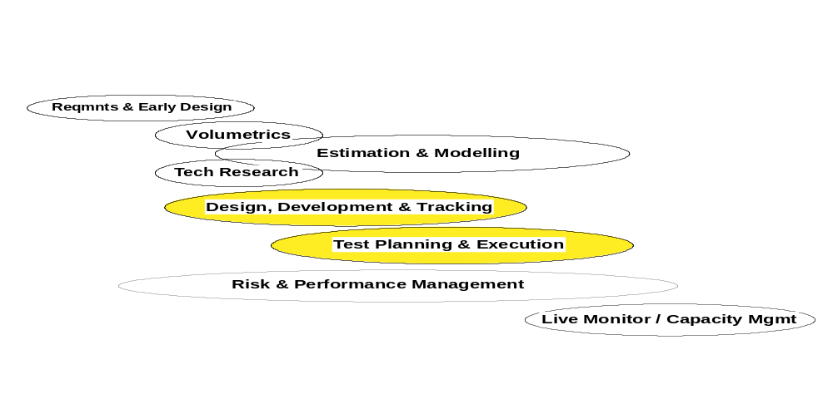

Each group of activities is broken down into one or (more usually) many tasks. The detailed content of each task is found in the method document, but a summary of the tasks within each group is provided in Appendix A – Summary of PEMM Tasks.

Detailed Interlock Analysis
This section of the document lists the Team SD tasks that are supported by specific PEMM tasks. The following table lists those Team SD tasks that have a performance aspect that can be supported by PEMM. The table consists of three columns:
Team SD Task Description – self explanatory
Related Work Products – identifies which of the work products identified in the Team SD task will be supported by the use of PEMM
Linkage to PEMM – this column outlines which PEMM activities support the Team SD task and an explanation for the linkage.
The hyperlinks in the table will take the reader to the PEMM Task summary in Appendix A
Team SD Task Description | Related Work Products | Linkage to PEMM task
Describe Current IT Environment and Plans | Standards  (ARC310) | This task needs to consider those standards that pertain to performance and capacity. These can cover topics such as standard Service Level Agreements, performance design and test standards. The PEMM P1 - Understand current Performance Engineering Strategy will provide guidance on standards you need to consider as they may constrain your solution.
Describe Current IT Environment and Plans | Technical Environment  (ART0506) | In analysing the Technical Environment you should look for an understanding of existing performance procedures, tools and management structure that may constrain your solution. The PEMM P1 - Understand current Performance Engineering Strategy will provide guidance on what needs to be considered in these three areas.
Identify Non-Functional Requirements | Non-Functional Requirements  (ART0507) | Within this task the identification of Non-Functional Requirements is highlighted. The PEMM tasks that provide support are:  P2 Performance Requirements provides specific guidance on the business and IT requirements you should be looking to collect. It deals with performance topics of throughput, response times, batch windows, capacity and system migration performance.  P3 - Acceptance Criteria (Business and IT) provides guidance on which types of criteria you should select and how they should be expressed.
Identify Non-Functional Requirements --continued | Non-Functional Requirements (ART0507) | P6 - Requirements for 'Live Monitoring' Performance Tools When collecting the solution requirements you should consider the need for live monitoring and include that as part of the Non-Functional Requirements and Use Case model. Importantly the monitoring should cover the measurements needed for the SLA. This PEMM task will provide you with guidance on the key areas that you should focus on.  P7 - Requirements for 'Development' Performance Tools  If the solution includes systems development then you should consider the requirements for managing and measuring performance within the development environment. Where possible the tools need to be in line with the tools selection for live monitoring. This PEMM task identifies the characteristics of and the need for performance tools for solution development.  P8 - Business Volumetrics  The business volumetrics are part of the Non-Functional Requirements. They provide a business level requirement of the throughput and capacity requirements. This PEMM task provides extensive guidance on the types of business volumetrics to be collected
Conduct Viability Assessment | Viability Assessment  (ART0530) | The initial viability assessment should consider an initial sizing of the system. The PEMM tasks that provide support are:  P4 - Initial Sizing provides scope and guidance for the initial sizing. It also describes the limitations and risks you will encounter in initial sizing.
Develop Operational Model | Operational Model  (ART0522) | As part of developing the operational model you will need to develop the technical volumetrics the system must support. PEMM P9 - Technical Volumetrics provides guidance and techniques for translating the business volumes into the technical volumes that will drive the load on the system. The technical volumetrics are a key element to development of an appropriate operational model.  PEMM P15 – Overall Design for Performance provides guidance on the focus areas Team SD practitioners need to consider in developing the operational model.
Refine Viability Assessment | Viability Assessment  (ART0530) | Refining the viability assessment needs to consider an estimate or model and verification that the performance requirements can be supported. PEMM P11 - Performance Estimation and Modelling describes how to select the appropriate modelling technique(s) as "fit for purpose" on the basis of cost / effort vs. benefit / accuracy, and use to provide a prediction of the (significant) performance metrics for the system.
Refine Viability Assessment - continued | Viability Assessment  (ART0530) | This Team SD task covers the use of a Performance Test to verify the solution will meet the client’s requirements. The PEMM activities P19-P25 will provide guidance on how to prepare, run and evaluate a Performance Test. Specifically PEMM provides:  P19 - Performance Test Strategy and Plan - Define and document the testing strategy and detailed plans that will be used for performance testing in the project  P20 - Test Case Build - Detailed specification and construction for each planned test case, including test script, detailed data specification, and specification of what measurements should be taken  P21 - Provide Test Environment - Work with appropriate resources (e.g. sub-project and/or customer operations) to build test environment and configure appropriately  P22 - Single Thread Performance Test Execution - Performance testing to verify design (e.g. message length, SQL calls) during unit and integration test (end to end). Further assessment of performance compared to the required targets.  P23 - Volume Test
Monitor Pilot | Viability Assessment  (ART0530) | In monitoring the pilot there should be a focus on the performance capabilities of the pilot. PEMM P32- Implement Live monitoring will describe what needs to be considered in terms of monitoring the systems vs. the Service Level Agreements that the must be achieved. .
Evaluate Success | Viability Assessment  (ART0530) | In evaluating success of the project one consideration is whether the system met the client’s performance expectations. The activities of evaluating this aspect of success are provided in PEMM P35 -Post implementation performance review.

Table 2 Detailed touchpoint analysis

Appendix A – Summary of PEMM Tasks
This section is provided to give the reader an overview of the PEMM Tasks. Full details can be found in Reference 002.

Solution Requirements and Early Design
P1 - Understand Current Performance Engineering Strategy | Document the client’s current performance engineering strategy and the current delivery of performance for other systems
P2 - Performance Requirements | Identify and document the performance requirements (both business and IT) for the system
P3 - Acceptance Criteria (Business and IT) | Specify and agree the detailed performance related criteria by which the customer (i.e. users / business / IT departments) will decide whether to accept the developed and delivered system
P4 - Initial Sizing | Perform an initial estimate of likely capacity and performance of the delivered solution, as a part of contract assurance and / or for budgetary purposes
P5 - Feasibility / Contract Assurance and Risk | Identify significant risks that will impact either the ability to deliver the solution, or the cost of the solution
P6 - Requirements for ‘Live Monitoring’ Performance Tools | Identify, document and agree the customer IT and business requirements for live monitoring of performance. These requirements should support the monitoring of the live system SLAs.
P7 - Requirements for ‘Development’ Performance Tools | Identify and document the requirements for performance and capacity tools that will be required during the project lifetime

Volumetrics
P8 - Business Volumetrics | Investigate, document and analyse appropriate volumetrics expressed in business terms. Should normally identify / include the volumetric for peak situations
P9 - Technical Volumetrics | Transform the business volumetrics into a form that will form the basis for performance and capacity estimation and modelling. For example, transform “process an order” into a set of system level transactions and message pairs required to process it.

Technology Research
P10 - Technology Research | Identification of system components about which there is insufficient performance and capacity information and the gathering of appropriate metrics (e.g. parametric costs, rules of thumb, technical design and performance characteristics) for these components.

Estimation and Modelling
P11 - Performance Estimation and Modelling | Select appropriate modelling technique(s) on the basis of cost / effort / benefit / accuracy, and use to provide a prediction of the key performance and capacity metrics for the system. The performance estimates can be compared against the required targets.
P12 - Capacity Plan | Produce (and revise at regular intervals) a report detailing the capacity requirements of major system components

Design, Development and Tracking
P13 - Select / Design and Build ‘Development’ Performance Tools | Selecting which performance tools will be required for use in performance engineering during the project
P14 - Select / Design and Build ‘Live’ Performance Tools | Designing how customer requirements for live monitoring will be met, either by existing packages that are available to the customer, or through bespoke development
P15 - Overall Design for Performance | Proactive involvement in the solution design process, to ensure that performance requirements are reflected alongside functional requirements during the high level design of both the application and infrastructure. This will start with the development of performance specifications early on in the solution design process, through to detailed design work for performance critical areas.
P16 - Unit Performance Design | Proactively ensuring those performance requirements continue to be designed into application code at the detailed design and coding level and that the detailed design conforms to the decisions taken in the Overall Design.
P17 - Tracking Application Performance Through Development | The ongoing activity of reviewing designs and specifications for the solution that have a significant performance impact (e.g. high volume, business critical or high complexity). This activity is more likely to be reactive rather than proactive.
P18 - Tuning | Optimization of system parameters, to improve performance in the operational environment. If ‘design for performance’ has been done correctly, the impact of this tuning should be minimal to the project

Test Planning and Execution
P19 - Performance Test Strategy and Plan | Define and document the testing strategy and detailed plans that will be used for performance testing in the project
P20 - Test Case Build | Detailed specification and construction for each planned test case, including test script, detailed data specification, and specification of what measurements should be taken
P21 - Provide Test Environment | Work with appropriate resources (e.g. sub-project and/or customer operations) to build test environment and configure appropriately
P22 - Single Thread Performance Test Execution | Performance testing to verify design (e.g. message length, SQL calls) during unit and integration test (end to end). Further assessment of performance compared to the required targets.
P23 - Volume Test Execution | Perform testing to establish that performance of the system is as expected when running at message and data volumes that are representative of the live environment.
P24 - Analyse Test Results | Analysis of monitors and/or traces from single thread and volume testing with the objective of identifying any performance problems.
P25 - Acceptance Criteria Test Execution | Testing to demonstrate that the customer’s acceptance criteria have been met

Risk Management / Performance Management
P26 - Project Start-up | Identify and document the performance strategy (or terms of reference if more appropriate) to be adopted for this engagement
P27 - Initiate / Agree SLR | Based on the overall performance requirements, Slurs should be defined / agreed to cater for two different situations: firstly, a set of Slurs may be needed to define the level of service that the solution will provide to the customer, which should contribute to the overall acceptance criteria of the solution. A second set of SLR may be required to support the projects delivery of the main SLR as a result of ‘things’ upon which it depends, but does not control (e.g. third party network)
P28 - Maintain Project Volumetrics | Devise, agree and implement a process by which the agreed business and technical volumetrics are reviewed, and new volumetrics are gathered throughout the life of this project
P29 - Peer Review | Regular / periodic reviews by colleagues / technical peers at significant milestones within the project to assess quality and completeness
P30 - Ongoing Risk Management | The process by which identified performance risks are assessed for their impact, suitable containment plans are agreed, and the risks tracked until they cease to be risks
P31 - Performance Management | The process of ongoing management of performance activities, for example tracking of problems / defects through change processes, reviewing of changes to the system (e.g. volumes have changed), the raising of changes by us on others, interfacing to the other project managers, the production of progress reports / communications, the monitoring and finalizing of SLAs, the definition of ad-hoc performance testing / investigations, etc.) i.e. this is the project management of the performance sub-project.

Live Systems Monitoring and Capacity Management
P32 - Implement Live Monitoring | Work with ‘service delivery’ to implement the live monitoring systems in the client’s operational environment. We will typically be monitoring against the SLAs defined earlier during development
P33 - Devise / Implement Live Volumetric Maintenance Process | Devise, agree and implement a mechanism by which the key business and technical volumetrics are gathered in the live environment, for purposes of capacity planning throughout the operational life of the delivered system
P34 - Implement Capacity Planning for Live Operation | The activity performed in the live environment, whereby the updated volumetrics (gathered through the live volumetric maintenance process) are used to develop the continuing capacity plans for the system in live operation
P35 - Post Implementation Performance Review | A review of performance in the live system, with the objective of ensuring that the performance and capacity are as expected, and that SLAs are being met

