

Translating Client Imperatives to Transformation Initiatives

Guideline

© Copyright International Business Machines Corporation 2012

All Rights Reserved
Version 1.3 June, 2013
Brief Description
This guideline describes an approach to translating high level transformational client imperatives into specific programs and required changes within various domains of the overall IT environment.
Main Description
When a client expresses some need or intent that is high level, broad in scope and transformational in nature, it is helpful to formally express that need in terms of a client imperative. While achieving this imperative will eventually require design and implementation of specific solutions, the architect’s first concern is to translate this imperative into one or more transformation initiatives. These initiatives can be portrayed in a transformation roadmap that will serve a basis for planning future solution development that will satisfy the need expressed in the client imperative.
In transformational opportunities, the client imperative is likely to be high level and abstract, with no direct mention of the specific changes necessary to satisfy the imperative. How then does the architect identify the necessary transformation initiatives, programs and associated changes? Here are three potential options.
1. Simply recommend that the transformation initiative consists of buying a set of products that you believe might be helpful.
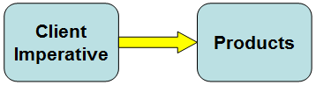

2. Find a subject matter expert who has encountered exactly this client imperative and knows from experience exactly what transformation initiatives should be recommended.

3. Begin with the client imperative and define appropriate transformation initiatives through careful analysis.
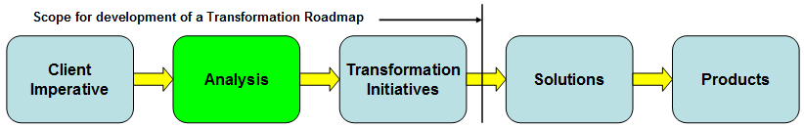
While the first option may be very efficient, it is not likely to be persuasive and certainly will not help your reputation as an architect. Option two would be ideal (like a free gift), but may not be that realistic. Although there are certainly a few pervasive imperatives that many clients share, it is more likely that each client will have a different perspective and most certainly will have other environmental factors that will influence the choice and substance of transformation initiatives.
That leaves option three, which involves analysis and a reasoned progression from the original client imperative to the recommended transformation initiative. Including the advice of the SME (as in option two) may be quite helpful, even if your environment is different and the client imperative is only similar. The remainder of this paper elaborates on option three and outlines an approach to disciplined analysis as a bridge that can help you create traceable recommendations for transformation initiatives that satisfy the client imperative.
The IBM Business Blueprint defines a set of Industry Imperatives that may serve as a starting point for client transformation discussions. Even though the discussion starts with a well defined Industry Imperative, it is likely that the Industry Imperative will have to be specialized to suit a specific client's needs. This specialization is documented using the Client Imperative artifact. In spite of this specialization, general information associated with the Industry Imperative may be helpful in understanding required changes.

Understanding important relationships
Before examining the approach to identifying transformation initiatives, it is helpful to look at the structure of the Client Imperative and its relationship to transformation initiatives more closely. The Client Imperative artifact of course contains a statement of the imperative and accompanying explanation. This is what the client is trying to achieve. It also contains a solution strategy. This is a high level explanation of a course of action, or how it will be achieved. This is normally expressed in business and architectural terms. An initial solution strategy will likely evolve significantly and become more specific in the course of analysis. In addition to an overall component, a solution strategy may have multiple aspects, each of which would be defined as a tactic and realized by a transformation initiative, as illustrated below.
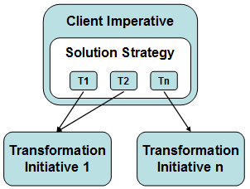

Identifying Transformation Initiatives
The illustration below depicts a summary the steps necessary to develop a transformation initiative which is the basis for a transformation roadmap. Following the illustration are explanations of several key elements of the summary.
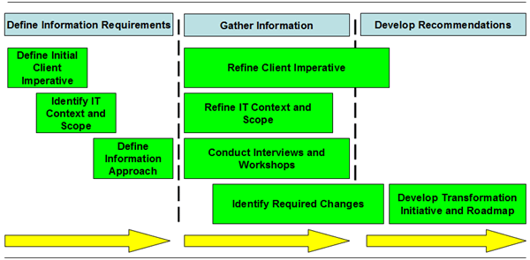

Define Initial Client Imperative
The imperative definition includes an action oriented statement of the client imperative. It should not be so abstract that it is impossible to identify real IT transformation initiatives. It also should not be so specific that it essentially defines a transformation initiative or project. If it does, the opportunity is not likely to be transformational in scope. The following is an example of a well formed imperative statement.
“Enable the Bank’s Multichannel Delivery Strategy with an Optimal Architecture and Technology Platform”
If this opportunity originated with the client's interest in one of the IBM Blueprint's Industry Imperatives, the client imperative represents a specialization of the Industry Imperative, tailored to suit a specific client's needs. In such cases, information associated with the Industry Imperative may be helpful in documenting the client imperative.
The initial client imperative also contains a solution strategy which defines a high level course of action that explains how the client will achieve what is stated in the imperative definition. This strategy will likely evolve during the course of consulting with the client and analyzing the results. The strategy will also contain one or more aspects, referred to as tactics that are clearly stated and describe how the strategy will be realized. These tactics will guide the search for aspects of the overall IT domain that that are likely to require change. The solution strategy should typically not be specific about technology or solution details or you risk straying into option one behavior. The following is an abbreviated example of a solution strategy aspect (tactic).
“Provide an appropriate set of collaboration tools commensurate with the channel operating model and needs of the end user roles.”

In cases where the client imperative is related to an IBM Blueprint Industry Imperative, consult the Industry Imperative documentation for possible stages of transformation and available industry solutions that may inform the solution strategy.

Identify Relevant IT Context and Scope
At this point, it is tempting to leap to a particular approach and just say we need to change this application or replace that application or product. In doing so, other required change may be overlooked. A more disciplined and thorough approach is to first select aspects or domains of the IT environment that should be examined for potential change. A convenient conceptual tool for doing this is the IBM Transformation Framework as illustrated below.
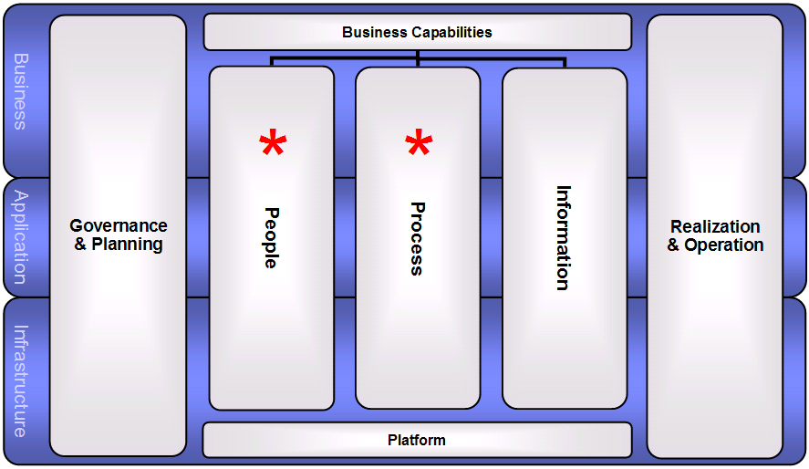
With this tool, you can begin to ask which of the IT domains such as Process or Application are likely to be affected by the particular tactic under consideration. This can yield a very high level context. Using the tactic example above, one might reason that both the People and Process domains will be affected, as indicated by the red asterisks in the illustration above. But the Transformation Framework becomes more interesting by zooming in to look at sub domains such as where the Application and Process domains intersect. The illustration below reveals the sub domains and elements within the sub domains where they exist. In this illustration, one of several sub domains possibly impacted by the tactic from the example is encircled in red.
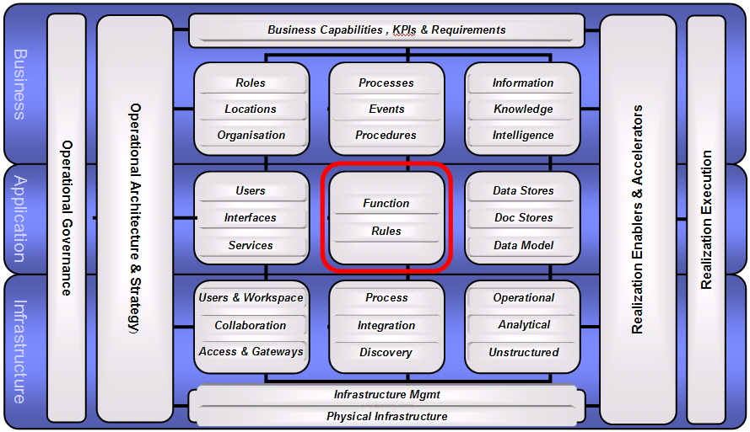
For some sub domains such as the Application / Process example above, the sub domain contains element types that can be formally modeled via UMF artifacts (typically associated with Enterprise Architecture). In the highlighted sub domain above, Function and Rules are examples of such elements. That allows us to zoom in again and improve the precision of our context by selecting specific types of function that will be subject to change. The illustration below depicts the sub domain from the partial example and depicts the strategy aspect (tactic) indicating that Function is impacted. The callout on the right explains the meaning of the function element and cites the UMF artifact used to model function. The previously referenced guideline on the Transformation Framework contains similar information for other sub domains.
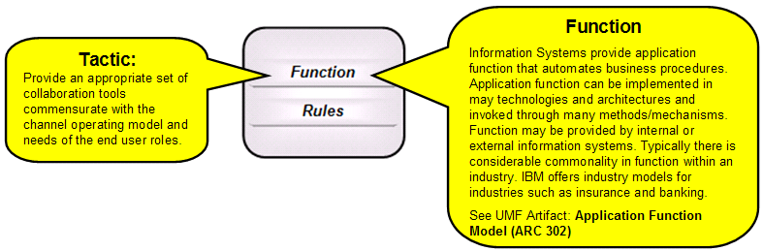
For additional examples in defining context for the Business and infrastructure domains, refer to the appendix.

Identify Required Changes
Continuing the example above, zooming in on Function leads to the Application Function Model (ARC 302). From this model one can select specific functions impacted by change and assert the nature of the change. The illustration below depicts a partial Application Function model and zooms in on the collaboration section to identify the eMeeting as a function that may require change.
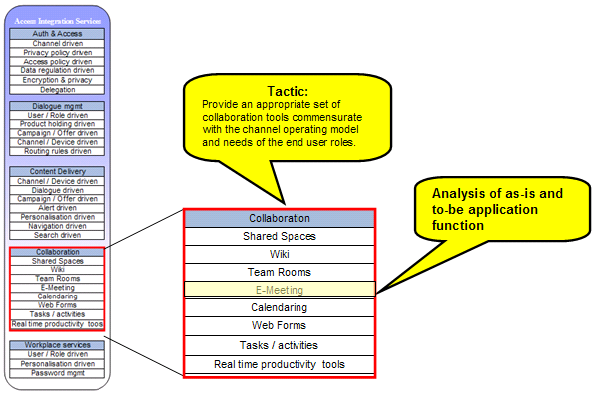

Now that we have zoomed all the way down to isolate a specific application function, the final and most important part of this step is to evaluate the current function by asking questions and forming conclusions about necessary change. Examples of questions include the following.
- Is this function implemented and in production use?
- What application, product or feature is currently used to realize this function?
- Are there multiple and diverse or redundant implementations of the function?
- Is the currently implemented function adequate to support the solution strategy?
- Are the non-functional characteristics of the current implementation adequate to support the solution strategy?
- How will required new or additional function be provided?
- Does the client have the skills necessary to implement and support this function?

This same approach can be used in any of the sub domains with underlying elements. The result of repeating this step for every affected sub domain and relevant underlying element will produce a comprehensive assessment of the technical environment and identify all of the high level changes that will be necessary to implement the tactics and realize the solution strategy.

When defining context and identifying required change, it is important to understand the relationships between domains. For example, if a potential change is identified within the application domain (as in the above example) it is likely that there will be implications in other domains or sub domains. For example, the addition of new collaboration function might impact certain business activities. Understanding this may lead to a discussion of how a business process may need alteration. And of course, new application function may require change to the infrastructure domain. Understanding these relationships will lead to more complete recommendations. The following illustration generally depicts such relationships.
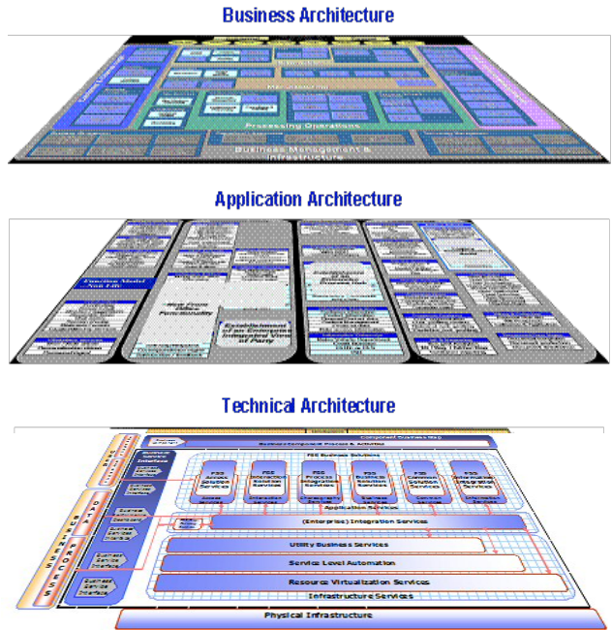.

Develop Transformation Initiative and Roadmap
A transformation initiative consists of programs and defines how one or more tactics will be implemented. Programs implement one or more required changes. The transformation initiative is essentially the sum of all proposed programs and associated change. Granularity and number of initiatives may vary, depending on the scope of the engagement and the client’s preference in structuring programs and projects. In a pre-sale context, a single transformation initiative may be sufficient. A program may consist of multiple projects. This step is intended to package programs and associated changes into one or more transformation initiatives that are acceptable to the client and enable the development of a Transformation Roadmap. It may also be helpful to map the various initiatives or programs onto a high level view of the Transformation Framework to facilitate high level discussion of the proposed initiatives and programs. The following figure illustrates use of the Transformation Framework to map the programs and associated changes for a single transformation initiative. For a complete example of a transformation roadmap, consult TeamSD guidance.

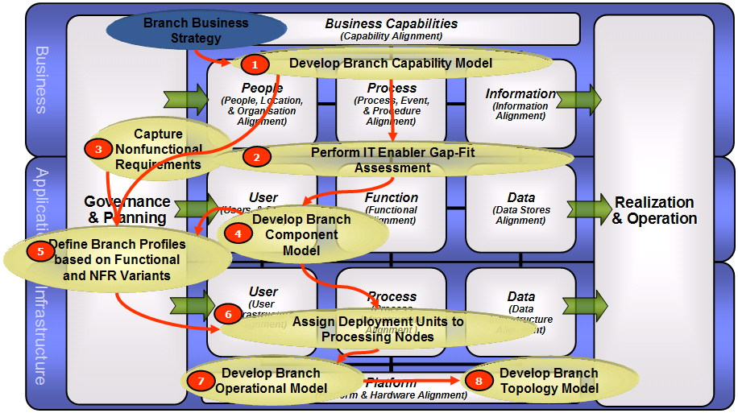

Appendix

Defining Context in the Business Domain
The Component Business Model (CBM) (ART 0587) can be used to refine the context by identifying business components that will likely be affected by an element of solution strategy. This refinement can be used later to identify business processes and services that may require change. The following illustration shows an example of highlighting a business component that will be affected by a solution strategy element (tactic).
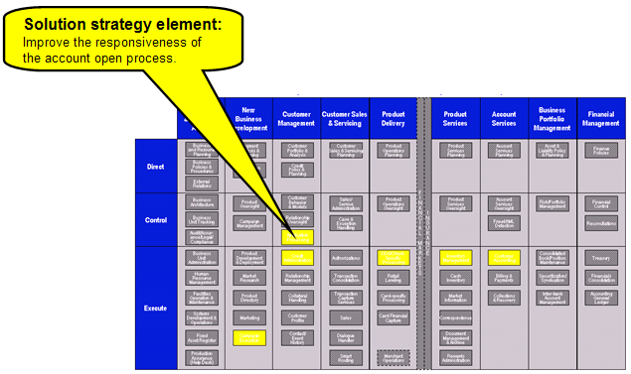

Defining Context in the Infrastructure domain
The Enterprise Technology Framework (ARC 308) can be used to refine the context in terms of general infrastructure (Architecture Building Blocks) that would likely be affected by a proposed solution strategy element (tactic). This refinement can be used later to evaluate existing infrastructure and inform potential buy, build or change considerations. The following illustration, using a partial enterprise technology framework, shows an example of an ABB that will be affected by a solution strategy element (tactic).
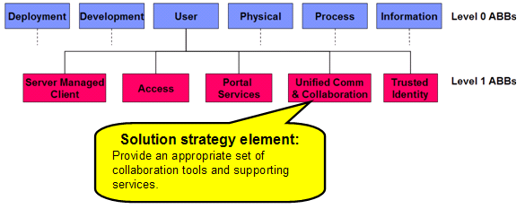

The IBM Component Infrastructure Roadmap (CIR)
An alternative approach to assessing the infrastructure is available via the Component Infrastructure Roadmap (CIR). This approach identifies infrastructure sub domains which can be assessed in terms of general maturity of the as-is and to-be environment. CIR is supported by the Assessment & Roadmap Tool (ART). An example from CIR using ART is illustrated below. For additional information about CIR, refer to: http://w3-03.ibm.com/support/cir/

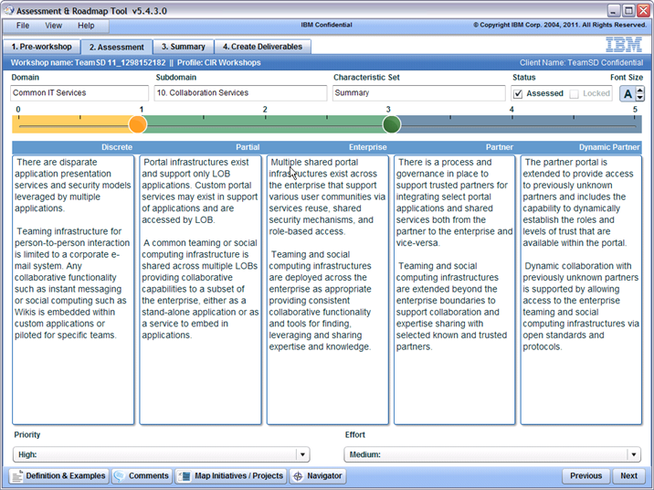

Version Information

Revision Number | Revision Date | Summary of Changes | Author
1.0  1.2  1.3 | 05/31/2011  07/31/2012  06/30/13 | Baseline version  Updated to reflect change from challenge to imperative term to comply with IBM Industry Blueprint terms  Changed activity term to program to conform to EA terminology. | Tom Seevers  Tom Seevers  Tom Seevers

The Client Imperative (ART 0696) is an IBM Unified Method artifact that states in exact terms what the client is trying to achieve. The artifact also includes sections on motivation, solution strategy, business benefits and inhibitors.
A transformation Initiative describes a set of programs and associated changes that define how one or more tactics (as defined in The Client Imperative) will be realized by the client. Tactics in turn describe how the client imperative solution strategy will be realized. Note that terms such as imperative, strategy, tactic and initiative may need to be adapted to the client’s accepted terminology. Refer to Business Direction (BUS 311) for a definition of the terms strategy and tactic.
The IBM Business Blueprint is a strategic initiative to implement a common go to market approach across IBM with a focus on solutions. The IBM Business Blueprint establishes a common set of concepts that enable clarity and cross brand integration in IBM’s capabilities and solution offerings. Several of these concepts have significant implications for pre-sale solution design. Additional information on IBM Blueprint Industry Imperatives may be found in Master Sales Kits at IBM’s Sales Support Information (SSI).
For additional information on the Client Imperative, refer the template and example associated with Client Imperative (ART 0696).
For a description, refer to the Guideline: The IBM Transformation Framework.
The IBM Component Infrastructure Roadmap (CIR) offers a more formal approach to as-is and to-be evaluation of certain infrastructure domains. The appendix contains a brief description of CIR.
Team Solution Design contains a sub activity in the Plan phase entitled Develop Transformation Roadmap. This activity produces a Strategic Roadmap (BUS 326) for transformation, and is commonly referred to as the Transformation Roadmap. The Transformation Roadmap contains information on the Transformation Initiative(s), including a planned timeline for transformation programs.

