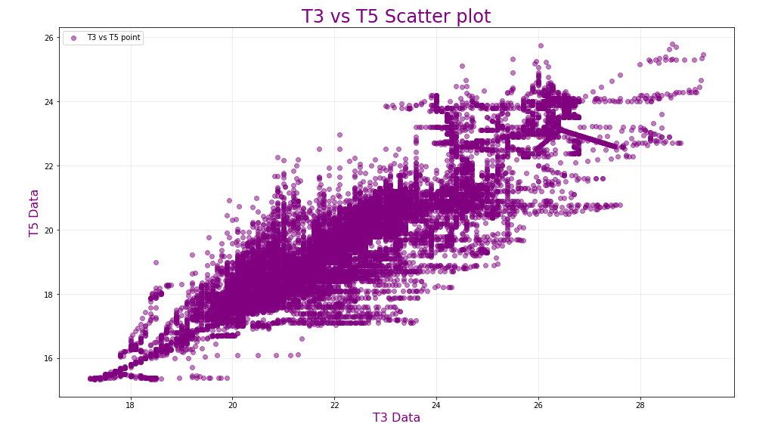
Jason Lubrano
CSCI4502 – Lv – DataMining
Homework 1, Q3 Plot pdf

