How to Make Breakfast at My Apartment

Hello Mom and Armando! Sorry I cannot help you guys make breakfast this morning… or any morning. I, unfortunately, have 8/9 am classes each day of the week. Normally, I don’t eat breakfast, but you’re in luck; I have bought some breakfast ingredients just for you! Armando, I know you are vegan, so I bought some vegan options for you as well. Below, I have prepared a set of 4 recipes (2 vegan). These instructions should be sufficient for you guys to make breakfast this morning. Please text me if you have any questions and I’ll try to get back to you as soon as I can.

# How to Make Pigs in a Blanket (NOT VEGAN)

(See Figure 1)



(Figure 1)

This recipe is fairly simple. It’s just sausage wrapped in a pancake. There are still detailed instructions on how to prepare everything though. Prior to starting, you should know how to use a microwave, and how to clean dishes. Please clean the dishes…

## Ingredients/Instruments

* Pork Sausage
  + Located in the freezer
  + I would recommend 2-4 links (1 per pig in a blanket)
* Buttermilk Pancakes
  + Located in the freezer
  + Same number of pancakes as you have sausages
* Plate
  + Located in the cabinet above the counter, to the left of the sink
  + Only one is needed
* Paper Towels
  + Located on the counter, left of the toaster oven
  + Only two (connected) sheets are needed
* Bacon/Sausage Griddle (See Figure 2)
  + Located in the cabinet above the microwave
* Maple syrup (optional)

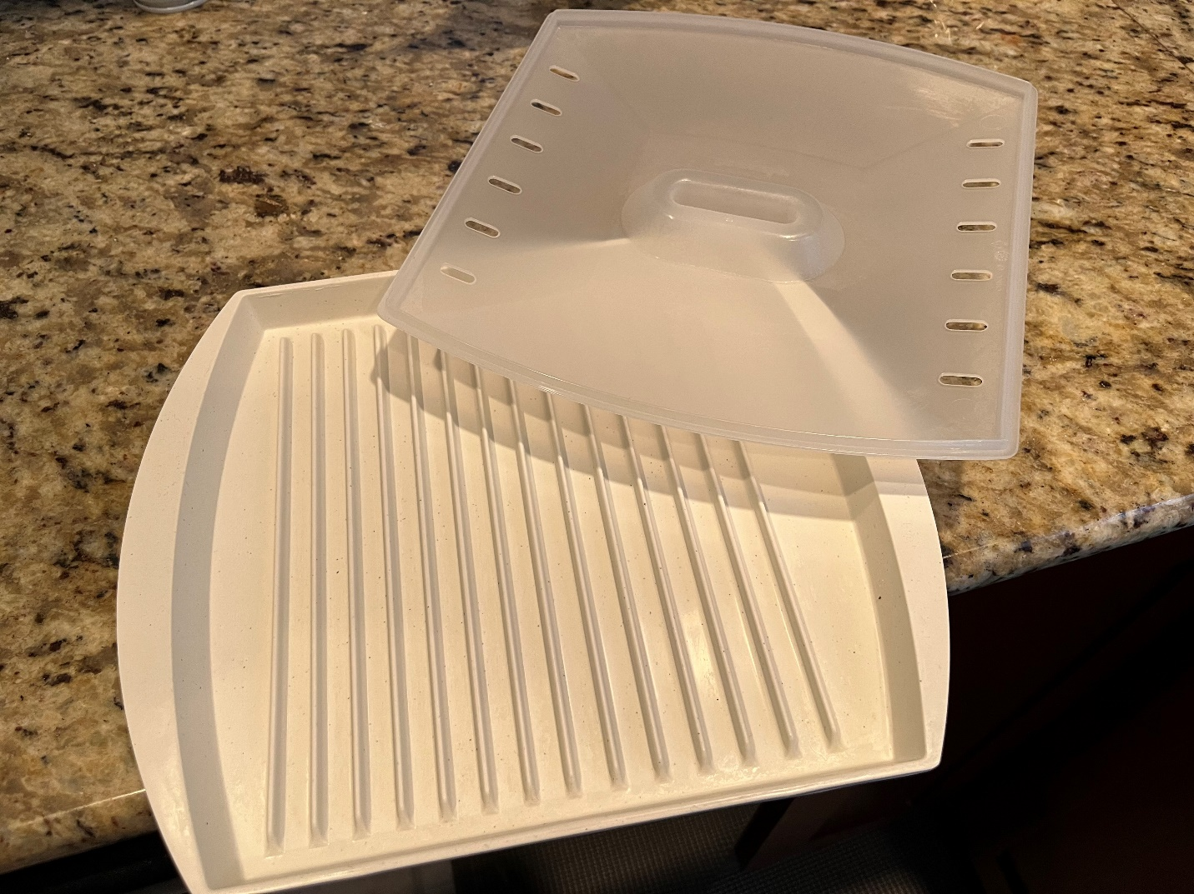

(Figure 2)

## Instructions

1. Gather your ingredients
2. Take the lid off the griddle
3. Put the sausage into the griddle
4. Replace the griddle lid
5. Put griddle into microwave
6. Microwave the sausage
   * 30 seconds for 2 links
   * 45 seconds for 3 links
   * 60 seconds for 4 links
7. Remove griddle from microwave

Caution: The griddle may be hot

1. Stack the pancakes on the plate
2. Wrap/Cover the pancakes with the paper towels
3. Put the plate into the microwave
4. Microwave the pancakes
   * 50 seconds for 2 pancakes
   * 1 minute 10 seconds for 3 pancakes
   * 1 minute 30 seconds for 4 pancakes
5. Remove plate from microwave

Caution: The plate may be hot

1. Unwrap/Uncover the pancakes from the paper towel

Note: If you’d like, you may re-use the paper towel as a napkin while you eat. Otherwise, throw out the paper towel

1. Unstack the pancakes
2. Lay the pancakes flat on the plate
3. Place the sausage in the middle of each pancake
4. Wrap the sausage in the pancake

Note: To keep from unwrapping, put the overlapping pancake on the bottom of the pig in a blanket and onto the plate

**(Optional)**

1. If desired, pour maple syrup over the pigs in a blanket

You have now successfully made pigs in a blanket! Please remember to clean up when you are finished.

# How to Make Scrambled Eggs (NOT VEGAN)

(See Figure 3)

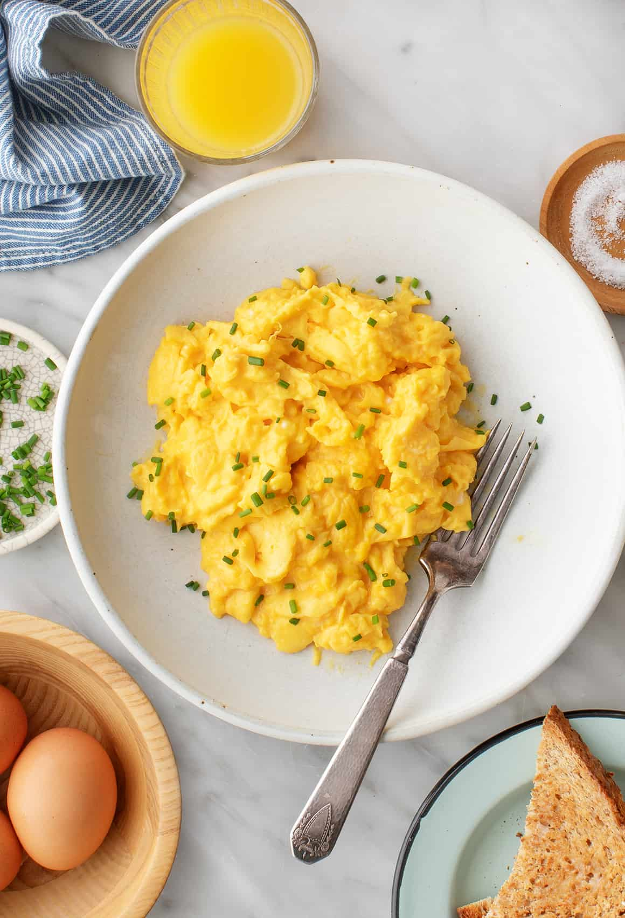

(Figure 3)

This is a recipe that I had to find online (*How to Make Scrambled Eggs Recipe - Love and Lemons*). I do not like eggs so please have as much as you’d like. To make this recipe, you will need to know how to whisk and fry eggs. The recipe doesn’t list any quantities, so you should also have an idea of the how much you’ll need based on what you want.

## Ingredients/Instruments

* Eggs
  + Located in the fridge
* Milk
  + Located in the fridge
* Butter
  + Located in the fridge
* Salt
  + Located to the right of the stove
* Pepper
  + With the salt
* Bowl
  + Located in the cabinet above the counter, to the left of the sink
* Plate
  + Located in the cabinet above the counter, to the left of the sink
* Whisk
  + Located in the drawer immediately to the left of the oven
* Spatula
  + Located in the top drawer, immediately to the left of the oven
* Fry pan
  + Located in the leftmost, bottom cabinet when facing the family room

Warning: Do not use the fry pan and spatula that are currently on the stove. Those are Stevo’s. He does not like to clean them.

## Instructions

1. Whisk the eggs in the bowl until yolk and whites are thoroughly combined
2. Add milk to the bowl with the eggs
3. Whisk again
4. Put pan on the big burner on the stove
5. Turn on stove to medium heat (dial should point to 5)
6. Let pan heat up for about a minute
7. Melt a little butter inside the pan

Caution: butter may splatter

1. Pour egg mixture into pan
2. Let cook for a few seconds undisturbed
3. Pull spatula across the bottom of the pan to form large, soft curds of scrambled eggs

Note: Repeat this step throughout step 11

1. Fold/Stir every few seconds
2. Stop when the eggs are mostly set, but a little liquid egg remains
3. Remove pan from heat
4. Season eggs with salt and pepper to taste
5. Transfer eggs from pan to plate

You have now made scrambled eggs! Please clean up when done.

# How to Make Corn Flakes (VEGAN)

(See Figure 4)

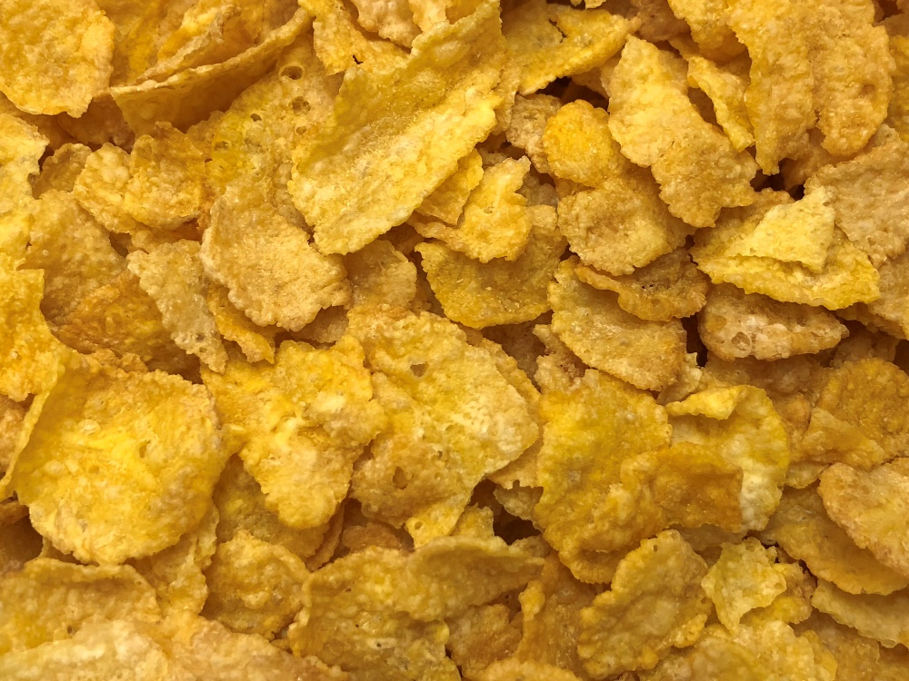

(Figure 4)

Sorry Armando, we don’t have many vegan options in the apartment yet so your choices will be quite lame for the time. I hope you know how to pour things without spilling because that’s pretty much the only thing you need to know for this recipe (or at least how to clean up if you don’t pour neatly).

## Ingredients/Instruments

* Corn Flakes
  + Located in the pantry, upper door, top shelf
* Almond milk
  + Located in the fridge
* Raisins
  + Located in the pantry, upper door, bottom shelf
* Bowl
  + Located in the cabinet above the counter, to the left of the sink
* Spoon
  + Located in the second leftmost drawer when facing the family room
* 1c measuring cup
  + Second drawer from bottom, immediately left of the oven

## Instructions

1. Gather ingredients
2. Measure out 1c of Corn Flakes into the measuring cup
3. Pour the Corn Flakes into the bowl

Note: I would recommend you add a second cup of Corn Flakes, though it is not necessary

1. Measure out 1c of Raisins into the measuring cup
2. Pour the Raisins into the measuring cup
3. Pour the almond milk into the bowl until only the top few layers of cereal are uncovered

Caution: I am allergic to almond milk, so please be careful with what it comes in direct contact with and please wash the bowl and spoon thoroughly when done

1. Use the spoon to stir your mixture until the cereal becomes soggy

You have now made Corn Flakes! Please clean up when you are done and please be careful regarding my allergies.

# How to Make Avocado French Toast (VEGAN)

(See Figure 5)

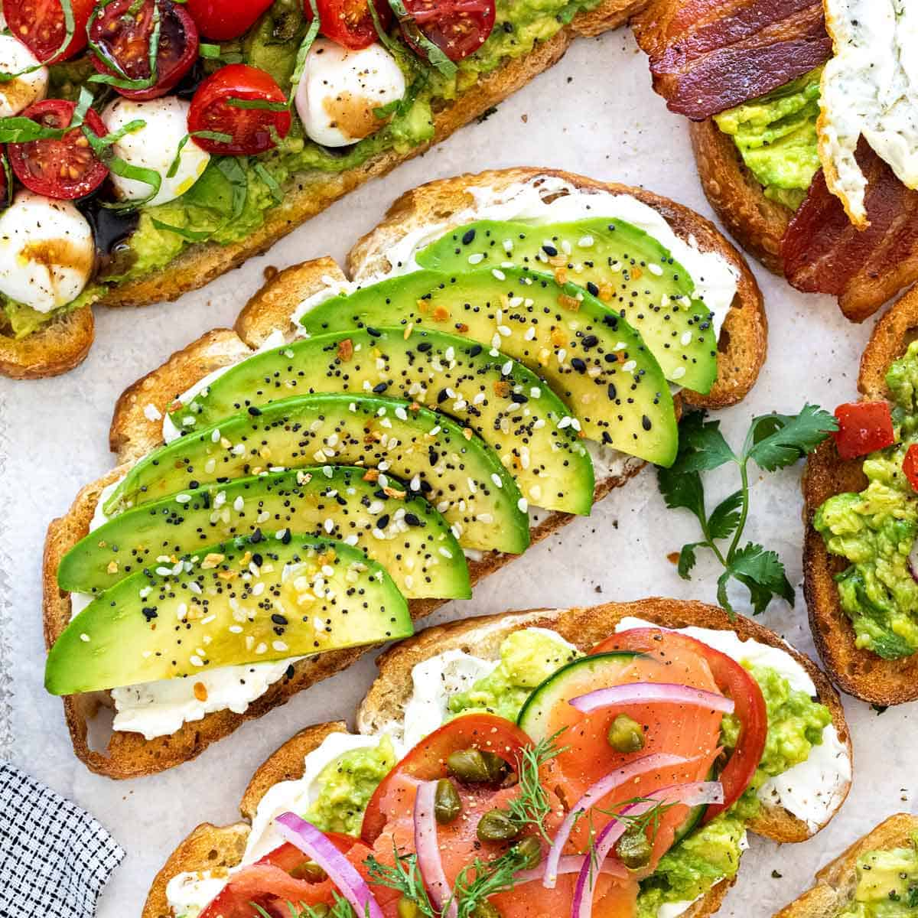

(Figure 5)

This option, thankfully, isn’t so bad, Armando. Our recipe won’t too much like the picture above, but the picture kind of gives us the gist. To follow this recipe, you’ll need to know how to operate a toaster oven and slice up an avocado.

## Ingredients/Instruments

* French toast swirl bread
  + Located immediately to the left of the toaster oven
* Avocado
  + Located in the fruit basket next to the bread
* Margarine
  + Located in the fridge
* Sesame seeds
  + Located in the cabinet immediately to the right of the microwave
* Salt
  + Located on the counter immediately to the right of the stove
* Pepper
  + Located with the salt
* Cutting knife
  + Located behind the spices on the counter (immediately to the right of the stove)
* Cutting board
  + Located in the bottom cabinet immediately right of the oven
* Butter Knife
  + Located in the second leftmost drawer when looking at the family room
* Plate
  + Located in the cabinet directly to the right of the sink

## Instructions

1. Put 2 slices of bread onto the rack in the toaster oven
2. Set the toaster oven to “Toast”
3. Change the number of slices to 3

Note: I know you have 2 slices in the toaster oven, but trust me, you’ll want to set the toaster oven to 3 slices. If you like your toast darker, you can set the number of slices to 4 or 5

1. Press start
2. Place the avocado on the cutting board
3. Cut the avocado in half while leaving the pit intact

Note: You may think that it is common knowledge to leave the pit intact, but I have seen some people struggling to unnecessarily do it

1. Cut the avocado halves into however many slices you would like
2. Season the Avocado with salt, pepper, and sesame seeds to taste
3. Take the toast out of the toaster oven

Note: Only take the toast out once it is finished toasting. Do not proceed with further instructions until the toast is done toasting.

Caution: The toast and/or toaster oven may be hot.

1. Put the toast on the plate
2. Spread the margarine onto the toast using the butter knife
3. Place the seasoned avocado slices onto the toast

You have just made avocado toast! Please clean up when done.

# References

*How to Make Scrambled Eggs Recipe - Love and Lemons*. https://www.loveandlemons.com/scrambled-eggs-recipe/. Accessed 1 Feb. 2022.