# Overview of the Assignment:

Let’s focus on the ETL Process.

Fist iteration of ETL: Take a part of your design and implement ETL. The scope at this point is limited and should include just two of your dimensions and one fact table. Using Python, SQL document and walk through the initial process of loading your data into staging (SQL staging or a data frame) doing some transformation and loading into your dimensions and a fact table.

**Part 7**: Provide code and screenshots of loading your data into staging/data frame\

*#!/usr/bin/env python*

*# coding: utf-8*

*# In[32]:*

**import** pandas **as** pd

**import** numpy **as** np

**import** pyodbc **as** odbc

*# In[69]:*

Airbnb_df **=** pd.read_csv('AB_NYC_2019.csv')

Airbnb_df.head()

*# In[3]:*

Taxi_df **=** pd.read_csv('train.csv')

Taxi_df.head()

*# In[4]:*

Taxi_df2 **=** pd.read_csv('test.csv')

Taxi_df2.head()

*# In[6]:*

*# Combine the train and test df as Taxi_df*

*# Add a new column to identify the source*

Taxi_df['source'] **=** 'train'

Taxi_df2['source'] **=** 'test'

*# Reset Index*

Taxi_df2 **=** Taxi_df2.reindex(columns**=**Taxi_df.columns)

*# Concatenate train and test dataframe*

Taxi_df **=** pd.concat([Taxi_df, Taxi_df2], ignore_index**=True**)

*# Fill any missing value with NaN*

Taxi_df['trip_duration'] **=** Taxi_df['trip_duration'].fillna(**-**1)

*# Save the new df as CSV file*

Taxi_df.to_csv('NYC_Taxi.csv', index**=False**)

*# In[7]:*

*# Check the new df*

Taxi_df.head()

*# In[8]:*

*# Total rows in our target dfs*

Taxi_total_rows **=** Taxi_df.shape[0]

Airbnb_total_rows **=** Airbnb_df.shape[0]

print('Taxi total rows: ', Taxi_total_rows, '\nAirbnb total rows: ', Airbnb_total_rows)

*# In[11]:*

*# Count the total columns*

Taxi_total_cols **=** Taxi_df.shape[1]

Airbnb_total_cols **=** Airbnb_df.shape[1]

print('Taxi total columns: ', Taxi_total_cols, '\nAirbnb total columns: ', Airbnb_total_cols)

*# In[14]:*

*# Dtypes*

Airbnb_df.dtypes

*# In[15]:*

Taxi_df.dtypes

*# In[19]:*

*# PART 2 - Creating SCD Type 2 and 3 Dim and Key Maintenance*

*# dfs Cleaning*

Airbnb_df.isnull().sum()

*# Duplication check*

duplicate_counts **=** Airbnb_df.groupby(['id','host_id','host_name']).size().reset_index(name**=**'Count')

*# Filter the rows where the count is greater than 1 to find the combinations*

Airbnb_duplicate **=** duplicate_counts[duplicate_counts['Count'] **>** 1]

print("Duplicate combinations of Columns in Airbnb:\n")

print(Airbnb_duplicate['Count'].sum())

print('\n',Airbnb_duplicate)

*# In[43]:*

*# Data normalization*

Airbnb_df['host_name'] **=** Airbnb_df['host_name'].str.slice(stop**=**255)

Airbnb_df['host_name'] **=** Airbnb_df['host_name'].str.encode('ascii', errors**=**'replace').str.decode('ascii')

Airbnb_df['name'] **=** Airbnb_df['name'].str.slice(stop**=**255)

Airbnb_df['name'] **=** Airbnb_df['name'].str.encode('ascii', errors**=**'replace').str.decode('ascii')

Airbnb_df['last_review'] **=** pd.to_datetime(Airbnb_df['last_review'])

Airbnb_df['reviews_per_month'] **=** Airbnb_df['reviews_per_month'].fillna(0)

*# In[45]:*

*# Filter and load data*

Airbnb_filtered **=** Airbnb_df[['id','name','host_id','host_name','neighbourhood_group','neighbourhood',

                            'room_type','longitude','latitude','price','calculated_host_listings_count',

                             'availability_365','last_review','reviews_per_month']]

Airbnb_filtered.head()

*#Airbnb_filtered.dtypes*

*# In[66]:*

*# Estiblish the connection*

conn **=** odbc.connect(Trusted_Connection **=** 'YES',

                    Driver **=** '{ODBC Driver 17 for SQL Server}',

                    Server **=** 'DESKTOP-IAN\JLM_SQLSERVER',

                    Database **=** 'CS689_fINALpROJ')

print(conn)

*# In[67]:*

*# Create table*

cursor **=** conn.cursor()

cursor.execute("""

CREATE TABLE Airbnb_staging (

    airbnb_id INT PRIMARY KEY,

    name NVARCHAR(255),

    host_id INT,

    host_name NVARCHAR(255),

    neighborhood_group NVARCHAR(255),

    neighborhood NVARCHAR(255),

    room_type NVARCHAR(255),

    longitude FLOAT,

    latitude FLOAT,

    price INT,

    calculated_host_listings_count INT,

    availability_365 INT,

    last_review DATETIME,

    reviews_per_month FLOAT

)

""")

conn.commit()

conn.close()

*# In[68]:*

*# Load data*

conn **=** odbc.connect(Trusted_Connection **=** 'YES',

                    Driver **=** '{ODBC Driver 17 for SQL Server}',

                    Server **=** 'DESKTOP-IAN\JLM_SQLSERVER',

                    Database **=** 'CS689_fINALpROJ')

cursor **=** conn.cursor()

**for** row **in** Airbnb_filtered.itertuples():

**try**:

        cursor.execute("""

            INSERT INTO Airbnb_staging (

                airbnb_id,

                name,

                host_id,

                host_name,

                neighborhood_group,

                neighborhood,

                room_type,

                longitude,

                latitude,

                price,

                calculated_host_listings_count,

                availability_365,

                last_review,

                reviews_per_month

            )

            VALUES (?, ?, ?, ?, ?, ?, ?, ?, ?, ?, ?, ?, ?, ?)

            """,

            row.id,

            row.name **if** **not** pd.isna(row.name) **else** 'Unknown',

            row.host_id,

            row.host_name **if** **not** pd.isna(row.host_name) **else** 'Unknown',

            row.neighbourhood_group,

            row.neighbourhood,

            row.room_type,

            float(row.longitude),

            float(row.latitude),

            row.price,

            row.calculated_host_listings_count,

            row.availability_365,

            row.last_review **if** **not** pd.isna(row.last_review) **else** **None**,

            row.reviews_per_month **if** **not** pd.isna(row.reviews_per_month) **else** **None**

        )

**except** odbc.ProgrammingError **as** e:

        print(**f**"Error occurred for row: {row}")

        print(**f**"Error message: {e}")

**break**

conn.commit()

conn.close()

SELECT * FROM Airbnb_staging;

**Part 8:** Provide code and screenshots of transforming the data. Perhaps you are adjusting for consistency of data or calculating aggregates.

In the Python part, we already have filtered some of the data in Airbnb_df, such as NA value check and columns’ normalization, such as transform the data type of last_review into dattime format and so on.

DELETE FROM Airbnb_staging

WHERE last_review IS NULL;

Since last_review will become an important parameter for us to create the measures between DimDate and FactAirbnb, so we dropped all the NULL values in last_review.

Before dropped: 48895 rows.

After dropped: 38843 rows.

**Part 9:** Provide code and screenshots of loading the data into the two dimensions and the fact. At this time, you do not need to worry about maintenance of slowly changing dimensions, the focus is on the initial data load. If you are loading into SCD2 or SCD3, make sure to show the SCD maintenance attributes populated.

-- Create DimAirbnb_Property

CREATE TABLE DimAirbnb_Property (

Airbnb_id INT IDENTITY(1,1) PRIMARY KEY,

Leasing_id INT,

Room_name NVARCHAR(255),

Room_type NVARCHAR(50),

Price INT,

Neighborhood NVARCHAR(255),

Neighborhood_group NVARCHAR(255),

Latitude DECIMAL(9,6),

Longitude DECIMAL(9,6),

Availability_365 INT,

Price_prev INT

);

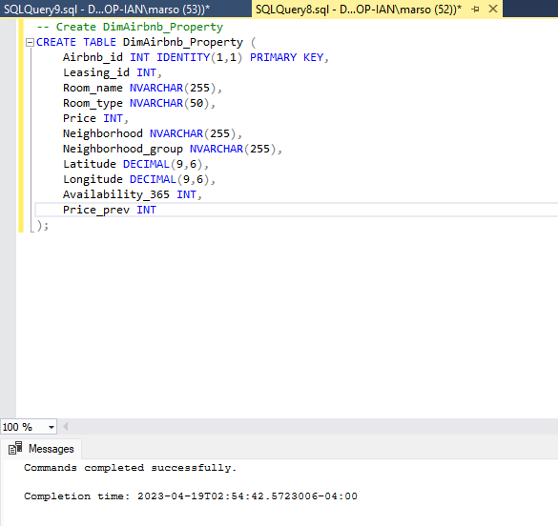

-- Insert data into DimAirbnb_Property

INSERT INTO DimAirbnb_Property (Airbnb_id, Room_name, Room_type, Price, Neighborhood, Neighborhood_group, Latitude, Longitude, Availability_365)

SELECT airbnb_id, name, room_type, price, neighborhood, neighborhood_group, latitude, longitude, availability_365

FROM Airbnb_staging;

-- Create DimAirbnb_Host

CREATE TABLE DimAirbnb_Host (

Host_id INT IDENTITY(1,1) PRIMARY KEY,

Listing_host_id INT,

Host_name NVARCHAR(255),

Host_name_prev NVARCHAR(255)

);

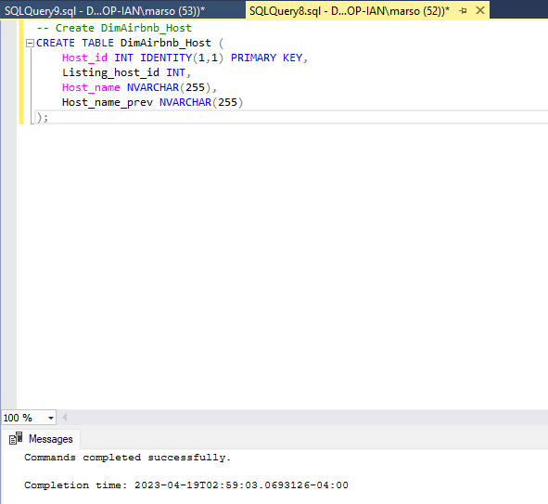

-- Insert data into DimAirbnb_Host

INSERT INTO DimAirbnb_Host (Listing_host_id, Host_name)

SELECT DISTINCT host_id, host_name

FROM Airbnb_staging;

CREATE TABLE DimDate (

Date_id INT IDENTITY(1,1) PRIMARY KEY,

DateHour DATETIME NOT NULL,

Hour INT NOT NULL,

Day INT NOT NULL,

Month INT NOT NULL,

Year INT NOT NULL,

Week INT NOT NULL

);

WITH DateRange (DateHour) AS (

SELECT CAST('2010-01-01 00:00:00' AS DATETIME)

UNION ALL

SELECT DATEADD(hour, 1, DateHour)

FROM DateRange

WHERE DateHour < '2023-12-31 23:00:00'

)

INSERT INTO DimDate (DateHour, Hour, Day, Month, Year, Week)

SELECT

DateHour,

DATEPART(hour, DateHour) AS Hour,

DAY(DateHour) AS Day,

MONTH(DateHour) AS Month,

YEAR(DateHour) AS Year,

DATEPART(wk, DateHour) AS Week

FROM DateRange

OPTION (MAXRECURSION 0);

-- Create FactAirbnb

CREATE TABLE FactAirbnb (

Id INT IDENTITY(1,1) PRIMARY KEY,

Airbnb_id INT FOREIGN KEY REFERENCES DimAirbnb_Property(Airbnb_id),

Date_id INT FOREIGN KEY REFERENCES DimDate(Date_id),

Availability INT,

Price INT,

Revenue DECIMAL(10,2),

Available_rooms INT,

Booked_rooms INT,

Occupancy_rate DECIMAL(5,2),

Average_daily_rate DECIMAL(10,2)

);

-- Insert data into FactAirbnb

INSERT INTO FactAirbnb (Airbnb_id, Date_id, Price)

SELECT

DP.Airbnb_id,

DD.Date_id,

ASG.price

FROM

Airbnb_staging ASG

INNER JOIN DimDate DD ON ASG.last_review = DD.DateHour

JOIN DimAirbnb_Property DP ON ASG.Airbnb_id = DP.Leasing_id;

(The measures in FactAirbnb are still developing by utilize the availability_365 column)

If you update any of the previous parts and would like feedback for a specific part, please make a note:

Updates in PART 4, PART 5, and PART 6.

**Part 1**: Are you working on your own or with a partner? If with a partner provide their name. If on your own, just state that this is the case.

Individual work.

**Part 2**: Determine the project scope

* In a short paragraph, describe the topic you wish to explore – an update if any
* Update the five business questions that your data warehouse will answer.

The topic is about building a full-stack data warehouse with ETL pipelines, and visualization plots or queries based on the questions we want to answer.

In this project, I plan to use the datasets of NYC Taxi Trip Duration and NYC Airbnb Open Date. These two data are deeply relative to New York City’s tourism activity. The goal is to explore the relationship between taxi passengers, trip duration and Airbnb rentals in NYC and provide insights by using the data warehouse.

Updated business questions:

1. Does people who rent in high average rental rate region also pay high fare for their taxi rides?
2. What is the relation between Airbnb density and the taxi taking rate?
3. How does the average trip duration for taxi rides vary depending on the number of passengers and the pickup/ drop-off location in relation to popular Airbnb rental neighborhoods?
4. What is the most common pickup/ drop-off locations for Airbnb renters?
5. How does the average fare and trip duration for taxi rides vary based on the distance between Airbnb rental locations and popular tourist attractions in the city?

**Part 3:** Data Sources

* Provide two data sources you will be using, for each data source list the number or columns and rows that are in each data source. Provide a header and first 5 rows from each source in separate file.

1. NYC Taxi Trip Duration

Train.csv: (columns: 11, rows: 1458644)

Test.csv: (columns: 9, rows: 625134)

1. New York City Airbnb Open Data

AB_NYC_2019.csv (columns: 16, rows: 48895)

* What is the URL or location of the data?

1. NYC Taxi Trip Duration: [**https://www.kaggle.com/c/nyc-taxi-trip-duration/data**](https://www.kaggle.com/c/nyc-taxi-trip-duration/data)
2. NYC Airbnb Open Data: [**https://www.kaggle.com/dgomonov/new-york-city-airbnb-open-data**](https://www.kaggle.com/dgomonov/new-york-city-airbnb-open-data)

* What information does this data provide that will help answer one or more of the above questions?

The latitude, longitude, and neighborhood in the NYC Airbnb data can let us know the location of the Airbnb. Drop-off longitude, latitude, and drop-off datetime in the NYC Taxi trip Duration can also let us know where the most common destination of the passenger is, and when do they arrive. According to the location, we might know whether there is relation between Airbnb and Taxi taking rate. We might also get to predict the level of convenience in the neighborhood.

* Do you see any issues in the data that will require transformation.

The length (amount) of rows in these two datasets has a huge difference. Therefore, we may need to sample the taxi dataset for better combination. Luckily, both datasets have latitude and longitude columns, which make the analysis more easily.

Also, in taxi dataset, train and test datasets have the different columns, which will need to be integrated.

**Part 4**: Dimensions - Review the data and the business questions from part 2.

* What fields (attributes) are in the data that will be used for the dimensions.

Based on the questions above, we can identify the attributes that can be used for the dimensions from both datasets. In the preliminary stage of selecting attributes, we will focus on

NYC Taxi Trip Duration:

* + pickup_datetime
  + passenger_count
  + pickup_longitude
  + dropoff_longitude
  + trip_duration
  + fare_amount
  + vendor_id
  + store_and_fwd_flag

NYC Airbnb Open Data:

* + longitude
  + latitude
  + host_id
  + neighbourhood
  + neighbourhood_group
  + room_type
  + price
  + host_name
  + calculated_host_listings_count
  + name
  + last_review
  + review_per_month
  + availability_365
* Determine the dimension tables. There should be at least two non-date dimensions and one date dimension for each fact table.

Dimension table:

DimDate:

Date_id (PK)

Hour

Day

Week

Month

Year

DateHour

DimLocation:

Location_id (PK)

Location_type

Neighborhood

Borough

Latitude

Longitude

DimTaxi:

Taxi_id (PK)

Vendor_id

Passenger_count

Pickup_datetime

Dropoff_datetime

Store_and_fwd_flag

Trip_duration

Effective_date

End_date

Is_current

DimAirbnb_Property:

Airbnb_id (PK)

Leasing_id (original Airbnb_id)

Room_name

Room_type

Price

Neighborhood

Neighborhood_group

Latitude

Longitude

Availability_365

Price_prev

DimAirbnb_Host:

Host_id (PK)

Listing_host_id (original Host_id)

Host_name

Host_name_prev

Fact table:

FactTrip (Cumulative)

Trip_id (PK)

Taxi_id (FK)

Location_id (FK)

Date_id (FK)

Pickup_datetime_key (FK to DimDate)

Dropoff_datetime_key (FK to DimDate)

Pickup_location (FK to DimLocation)

Dropoff_location (FK to DimLocation)

Passenger_count

Trip_distance

Trip_duration

Fare_amount

Total_amount

FactAirbnb (Snapshot)

Id (PK)

Airbnb_id (FK)

Date_id (FK)

Host_id (FK)

Availability

Price

Revenue

Available_rooms

Booked_rooms

Occupancy_rate

Average_daily_rate

FactTaxiMonthlySummary (Cumulative)

Sum_id (PK)

Month_id (FK to DimDate)

Host_id (FK)

Vendor_id

Total_passengers

Total_trip_duration

Total_revenue

* At least one (non-date) dimension in your design should have a hierarchy.

For the hierarchy, we design a parent-child relationship between boroughs and neighborhoods in DimLocation. The boroughs are the higher-level grouping and neighborhoods are the lower-level grouping.

(e.g., {Boroughs: Manhattan}, {Neighborhoods: Battery Park City})

Also, in DimDate, we have a hierarchy of time from Year, month, day to time.

* What are the attributes that will be tracked via slowly changing dimensions?

For DimAirbnb_Property table, the price could be tracked by using SCD Type 3 with new column for the price to capture any changes over time.

Also, in the DimAirbnb_Host table, we can use SCD Type 3 to capture the host name changes.

For DimTaxi table, we added effective date and end date as SCD Type 2 to record any changes in vendor id.

DimLocation using SCD Type 1 would be enough.

* What attributes within the dimensions will need transformation before they are loaded into the dimension, for example it could be to build consistency or any other issues? This is where for example you might build case statements in your code to handle various scenarios. Two to three examples showing some sample data and what you think the transformation will be during your ETL would be helpful here.

1. Date parsing: In the DimDate table, the pickup_datetime or dropoff_datetime attribute may need to be parsed into separate columns to aggregate data by different period.
2. Dealing with missing values in some tables can be beneficial to our analysis.

1. Name standardization: In the DimTaxi table, the vendor’s name attribute may need to be standardized to ensure consistency.
2. Address normalization: In the DimAirbnb table, the address attribute may need to be normalized to make sure the address format is consistency. Also, normalized address can help avoiding duplication. For this problem, I would like to try deriving a new column called pickup_neighborhood based on the latitude and longitude.
3. In the DimAirbnb table, I found some values in the neighborhood column have the different format.
4. Date parsing: In the DimDate table, the pickup_datetime or dropoff_datetime attribute may need to be parsed into separate columns to aggregate data by different period.
5. Dealing with missing values in some tables can be beneficial to our analysis.

1. Name standardization: In the DimTaxi table, the vendor’s name attribute may need to be standardized to ensure consistency.
2. Address normalization: In the DimAirbnb table, the address attribute may need to be normalized to make sure the address format is consistency. Also, normalized address can help avoiding duplication. For this problem, I would like to try deriving a new column called pickup_neighborhood based on the latitude and longitude.
3. In the DimAirbnb table, I found some values in the neighborhood column have the different format.

**Part 5**: Facts – Review the data and the business questions from step 1.

* What measurements are in the data that will be used for the fact tables?

Trip_duration

Trip_distance

Total_passengers

Total_trip_duration

Total_revenue

Available_rooms

Booked_rooms

Average_daily_rate

Occupancy_rate

* What measures will you be calculating (i.e. using an aggregate function, or some other transformation – recall as an example some of the aggregation you did in assignment 1A)

1. Average fare per pickup location

Average rental rate per pickup location

Correlation coefficient between average rental rate and average fare per pickup location

Code example:

SELECT

DimTaxi.vendor_id,

AVG(FactTaxi.fare_amount) AS avg_fare,

AVG(FactTaxi.trip_duration) AS avg_duration

FROM

DimTaxi

INNER JOIN FactTaxi ON DimTaxi.taxi_id = FactTaxi.taxi_id

GROUP BY

DimTaxi.vendor_id

1. Total number of Airbnb rentals per pickup location

Total number of taxi rides per pickup location

Code example:

SELECT

DimAirbnb.neighborhood,

COUNT(FactAirbnb.listing_id) AS total_listings,

AVG(FactAirbnb.price) AS avg_rental_rate

FROM

DimAirbnb

INNER JOIN FactAirbnb ON DimAirbnb.listing_id = FactAirbnb.listing_id

GROUP BY

DimAirbnb.neighborhood

1. Average trip duration per number of passengers

Average trip duration per pickup location and Airbnb rental neighborhood

1. Percentage of Airbnb rentals that occur at these pickup/ drop-off locations.
2. Average fare per distance between Airbnb location and popular tourist spots.

Average trip duration per distance between Airbnb location and popular tourist spots.

**Part 6**: Design – Create a Draw.io, Visio or Lucidchart diagram of your constellation data warehouse design.

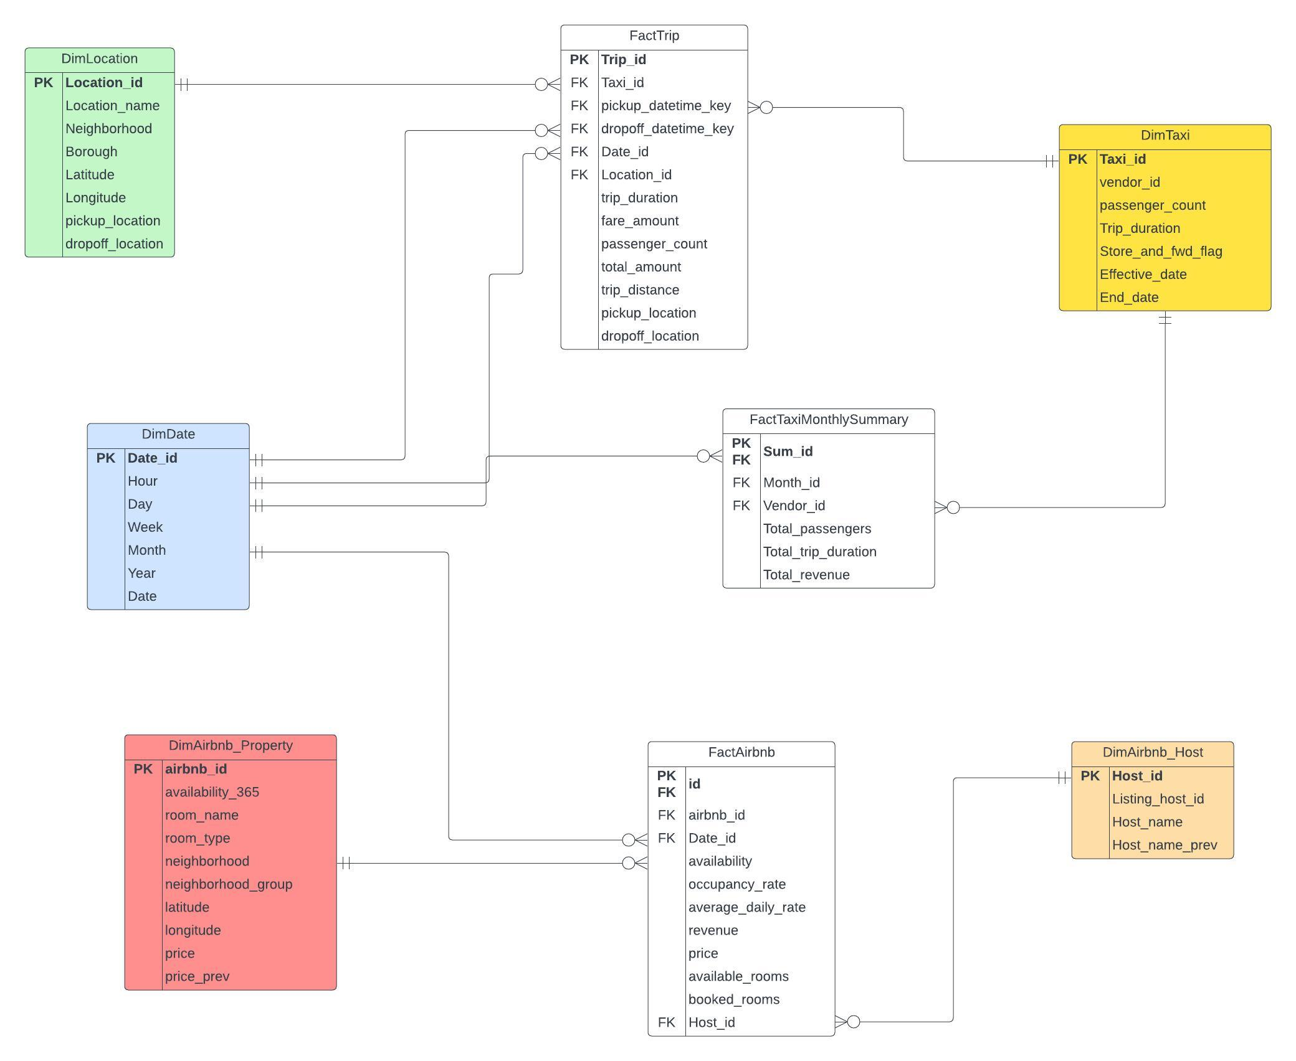

Use the **Ask the Teaching Team Discussion Forum** if you have any questions regarding the how to approach this assignment.

Save your assignment as ***lastnameFirstname_ProjectUpdate2.docx*** and submit it in the *Assignments* section of the course.

For help uploading files please refer to the *Technical Support* page in the syllabus.

Project scoping is graded based on the following:

1 – On track, 0-Off track, .5 – partially on track