GradeTrack: A Console-based Grade Monitoring System
---------------------------------------------------------------------
Introduction To Computing Project
Presented to the
Faculty of the College of Information Technology
Cagayan de Oro College
Cagayan de Oro City

-------------------------------------------------------------------------------

In Partial Fulfillment
of the Requirements for the Degree
Bachelor of Science in Information Technology

-------------------------------------------------------------------------------

NAME OF RESEARCHER

BEROU, JHON CLARK BACALA
OBLAD, ARVIN JAMES APOL
MAKI, NEL JHON UNSAY
MARDOQUIO, JASON
TUPAG, IAN SUSHAT
VERTUDAZO, SHEENA ATHENA DACLAG

OCTOBER 26, 2026

1.1 Introduction
Technology can help schools organize student grade records and make academic information easier to review. Grade monitoring systems provide a structured way to record grades, calculate results, and check student performance. Python can be used to develop simple applications using data, functions, and program logic (Python Software Foundation, 2025). Related projects have explored computerized systems for monitoring student performance and grades (Bacla-an et al., 2023; Krongpol et al., 2024). These sources provide background for developing a small grade-monitoring application, but they do not prove that the same problems occur in a particular school.

Grade records may be difficult to manage when information is kept in separate documents or when grades must be checked manually. Manual entry and calculation may also result in mistakes, while locating a student's grades can take extra time. These are general challenges that can occur in grade-recording processes; this project does not claim that they have been confirmed at a specific school through interviews or observations. The project therefore focuses on building a basic tool for organizing grade information, calculating final grades consistently, and displaying grade status.

To address this need, the proponents developed GradeTrack: A Console-Based Grade Monitoring System using Python. The program allows an administrator to manage student, subject, teacher, and section records; teachers to enter, update, and view grades for their assigned subjects; and students to view their own grade reports. It validates inputs, records Period 1 (P1), Period 2 (P2), and Period 3 (P3) grades, calculates a final grade, and displays whether the student passed or failed. The final grade is the average of the three period grades, and a grade of 80.00 or higher is considered passing. The program uses a console menu and local JSON-file storage to keep records between sessions.

1.2 Statement of the Problem
General Problem
The general problem addressed by GradeTrack is how to organize student and subject grade records and calculate and display students' grade results consistently. When grade information is kept in separate records or checked manually, users may need extra time to locate information, and calculations may not always be performed consistently. This project develops a console-based program to demonstrate how records can be managed in one place and how final grades and pass/fail remarks can be calculated using the same rule. These are project design concerns, not findings from a school-specific investigation.

Specific Problems
The project focuses on the following problems and the functions designed to address them:
- Manual Recording of Student Grades
When grade details are recorded in separate places, finding or updating a student's information may take extra time. GradeTrack provides structured student and subject records that users can view through the console menu.

- Inconsistent Grade Calculations
Calculating the average of three period grades by hand can result in inconsistent calculations. GradeTrack calculates the final grade using the same formula for each record.
The final grade is calculated as:
- Final Grade = (P1 + P2 + P3) ÷ 3
- The system marks a final grade of 80.00 or higher as PASSED and a grade below 80.00 as FAILED.

- Difficulty Checking Student Grades
Finding a student's grades and academic status may require checking several records. GradeTrack provides a student report showing recorded subject grades and calculated grade information. The program is intended to make information easier to review, but it does not replace official school records or confirm the accuracy of the grades originally entered.

1.3 General Objectives
The general objective of GradeTrack: A Console-Based Grade Monitoring System is to develop a Python-based console application that organizes student and subject records, allows authorized roles to manage or view grade information, calculates final grades from three grading periods, and displays pass/fail status using a defined rule.

1.4 Specific Objectives
Specifically, the GradeTrack system aims to:
- Provide a console menu for managing and viewing student, subject, teacher, section, and grade records according to the functions available to each user role.
- Validate student IDs and grade inputs, including checking that grade values are within the allowed range of 0 to 100.
- Calculate each subject's final grade using the formula (P1 + P2 + P3) ÷ 3.
- Display PASSED when the final grade is 80.00 or higher and FAILED when it is below 80.00, and show the available grade report and general average.
- To provide a console menu for managing and viewing student, subject, teacher, section, and grade records according to the functions available to each user role.
- To validate student IDs and grade inputs, including checking that grade values are within the allowed range of 0 to 100.
- To calculate each subject's final grade using the formula (P1 + P2 + P3) ÷ 3.
- To display PASSED when the final grade is 80.00 or higher and FAILED when it is below 80.00, and to show the available grade report and general average.

Scope & Limitation
1.5 Scope
GradeTrack is a Python console application for managing and monitoring student grade information. Its functions are limited to the features implemented in the program: administrator management of student, subject, teacher, and section records; teacher entry, updating, and viewing of grades for assigned subjects; and student read-only access to their own grade report. The program records P1, P2, and P3 grades, calculates a final grade using (P1 + P2 + P3) ÷ 3, and applies a passing mark of 80.00. It uses a local data.json file for storing records.

- Users access the system through a text-based console menu.
- Administrators can manage student, subject, teacher, and section records using the available menu options.
- Students can view their own grade report; student access is read-only.
- Teachers can enter, update, and view P1, P2, and P3 grades for their assigned subjects.
- The system calculates the final grade as (P1 + P2 + P3) ÷ 3.
- The system displays PASSED for a final grade of 80.00 or higher and FAILED for a grade below 80.00.
- The program performs basic input validation and displays error messages for invalid entries.
- Records are stored locally in a data.json file and are loaded when the program starts.
- The program uses Python variables, lists or dictionaries, conditional statements, loops, and functions.
- The system displays available student, subject, section, and grade information through console menus and reports.
- The system is designed for one local session at a time.

1.6 Limitation
GradeTrack is a basic console-based grade-monitoring application and is not a full school information system. It runs locally and does not provide web access, remote login, cloud syncing, or simultaneous access by multiple users. The program stores records in a local data.json file, so data can remain available after the program closes and can be loaded the next time it runs. However, the data depends on that local file being present and intact; deleting or damaging the file may result in data loss. The system has limited security and does not provide a complete institutional authentication or encryption system. It does not include enrollment, tuition payment, attendance, scheduling, or messaging features. Its calculations depend on the grades entered by users, so incorrect input can still affect the result. The system is intended for demonstration and basic grade monitoring, not as a replacement for official school records.

1.7 System Requirements
Hardware Requirements
- Processor: Intel Core i3 or equivalent
- RAM: Minimum 4 GB
- Storage: At least 100 MB of free disk space for the program
- Monitor: 14-inch or larger with 1024×768 resolution or higher
- Input Devices: Keyboard and mouse
- Network: None required

Software Requirements
- Operating System: Windows 10 or later
- Programming Language: Python
- Development Environment: Visual Studio Code
- Interface: Command-Line Interface (Console)

Teacher/Instructor Functional Requirements
- Enter, update, and view grades for assigned subjects
- View student grade records
- Update student grades
- Check student grade status
- View student academic performance

Student Functional Requirements
- View their own recorded grade report (read-only access)
- View recorded grades
- View their grade status
- Monitor their academic performance

Administrator Functional Requirements
- View student grade records
- View student subjects and grades
- Monitor student academic performance
- Add, update, and view student, subject, teacher, and section records

1.8 Code Snippet of GradeTrack: A Console-Based Grade Monitoring System
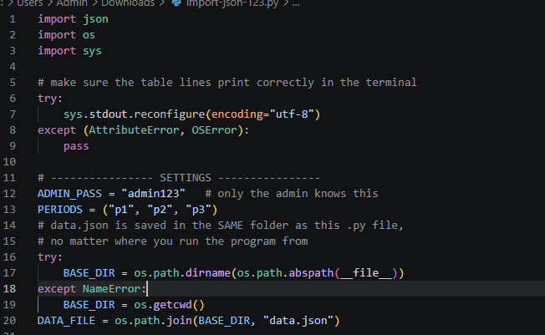
- Imports & Encoding: Configures standard output UTF-8 encoding so unicode table characters (like ┌, │, ─) render properly in Windows/Unix terminals.
- Global Constants: Defines the admin credentials, grade periods (p1, p2, p3), and determines the file path to read/write data.json relative to where the script resides.
- load_data() & save_data(): Loads the structured JSON file into three primary global dictionaries: subjects, students, and sections. Includes fallback logic to convert older single-grade formats into period-based grade entries.

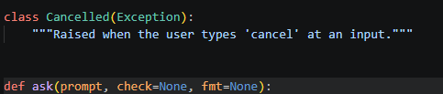
- Custom Exception (Cancelled): Allows users to exit any multi-step prompt sequence cleanly at any time by typing cancel.
- Input Loop (ask): Keeps reprompting for a single input if validation fails, satisfying the core rule that incorrect input retry stays on that specific question rather than resetting the menu.
- Validation Functions:
  - parse_grade / check_grade: Ensures grades are valid numbers between 0 and 100.
  - check_units: Validates subject unit counts (must be integers $\ge 1$).
  - confirm: Handles standard y/n confirmation checks.

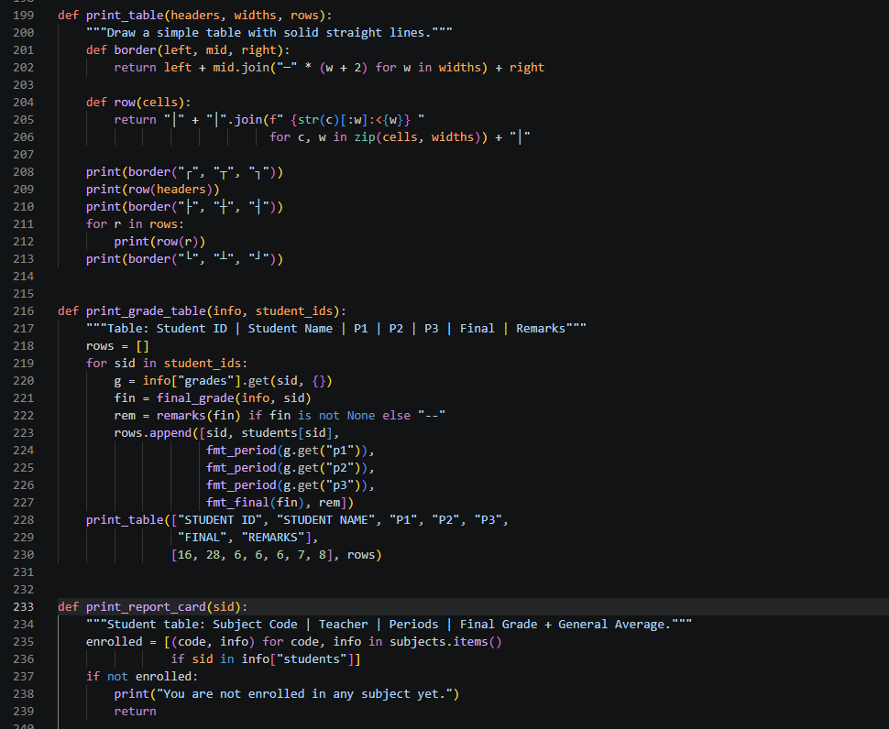

- print_table: Renders dynamic ASCII/Unicode boxed tables given dynamic widths and string vectors.
- print_grade_table: Formats student rows showing P1, P2, P3, computed FINAL (average of periods), and REMARKS (PASSED if grade $\ge 80$, else FAILED).
- print_report_card: Computes a student's enrolled subjects into a formatted grade report card and calculates their overall General Average.

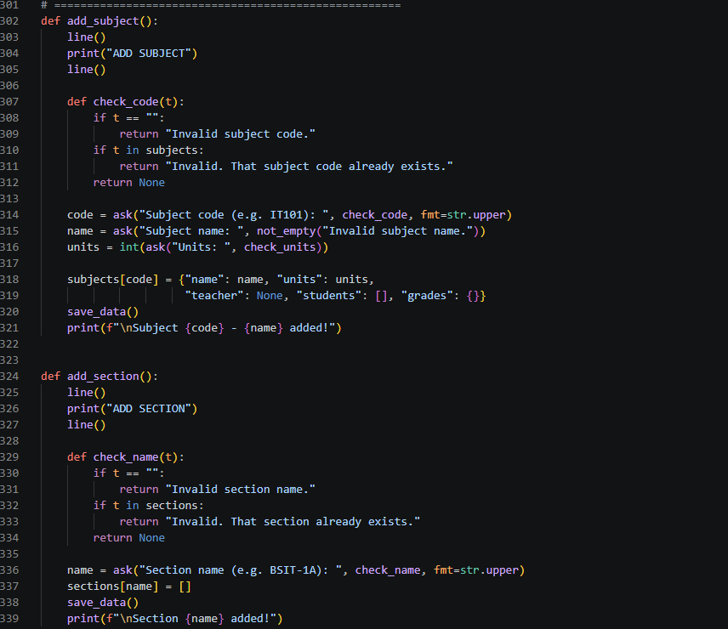
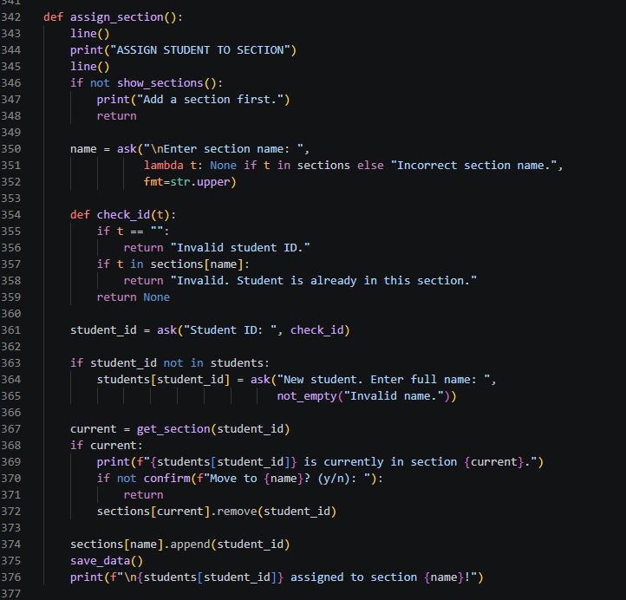
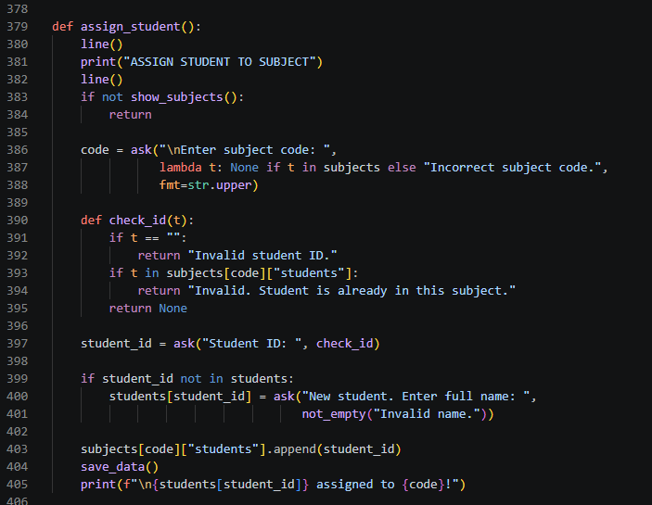
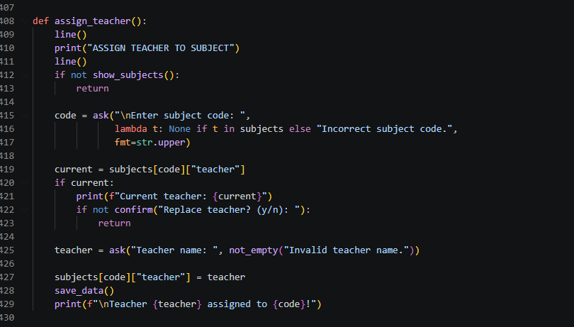
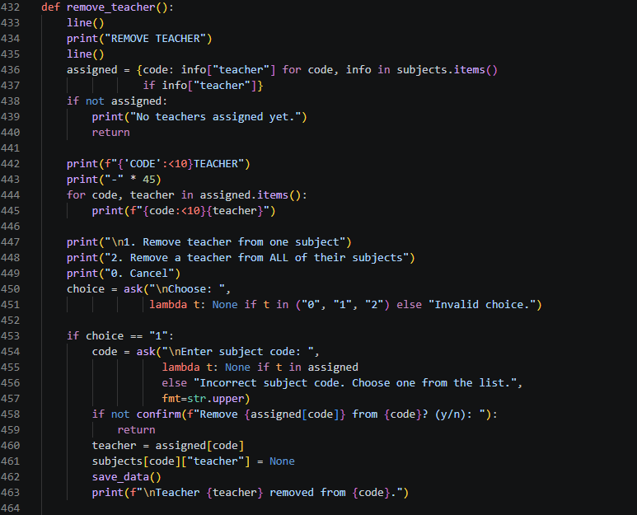
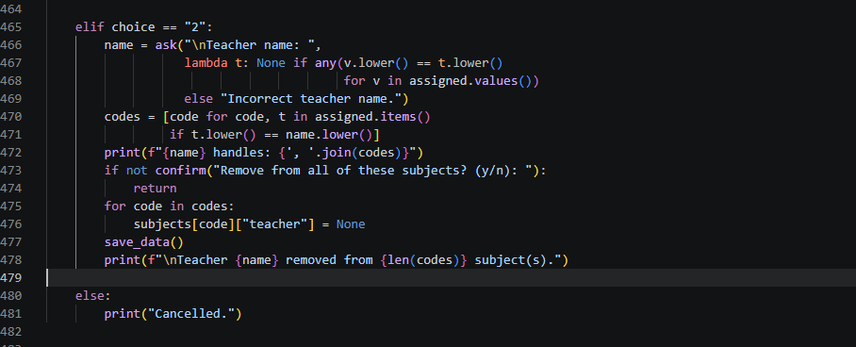

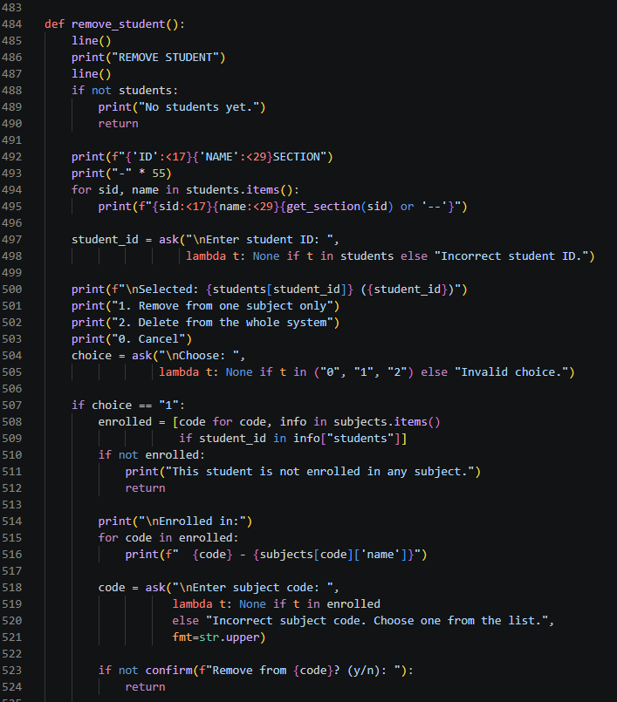
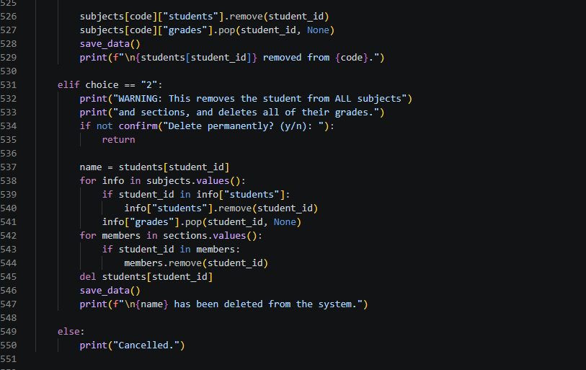
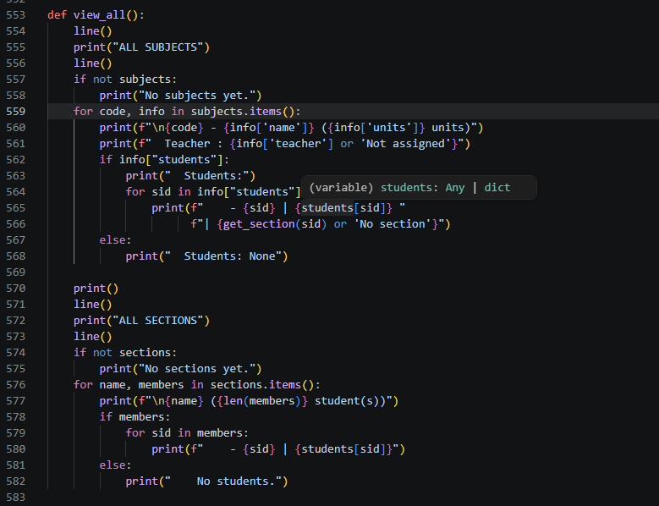
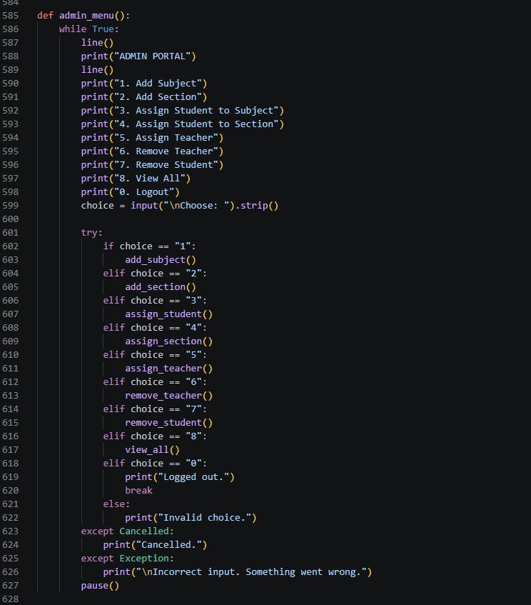
- Subject & Section Creation: Adds unique subject codes and section names to system storage.
- Assignments: Links students to subjects or sections and assigns teachers to specific subjects. Auto-registers new student IDs if they do not yet exist in global storage.
- Removal & Deletion: Supports soft removal (removing a student from one specific class) or hard deletion (scrubbing a student ID from all sections, subjects, and grade histories).

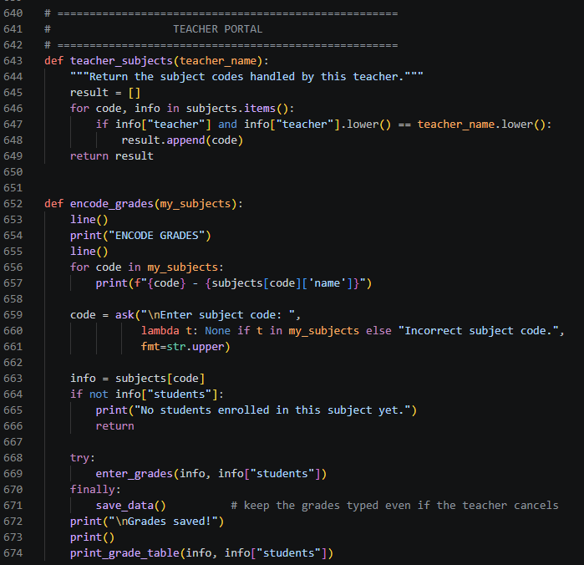

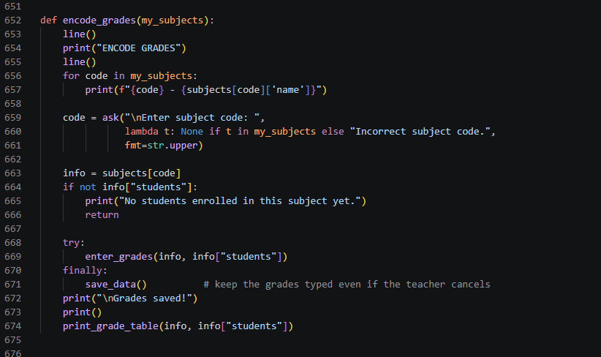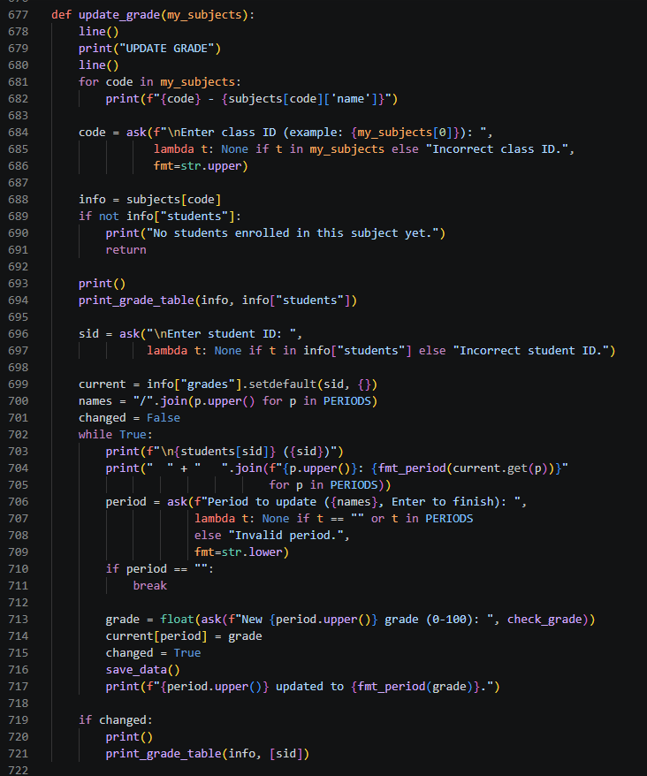
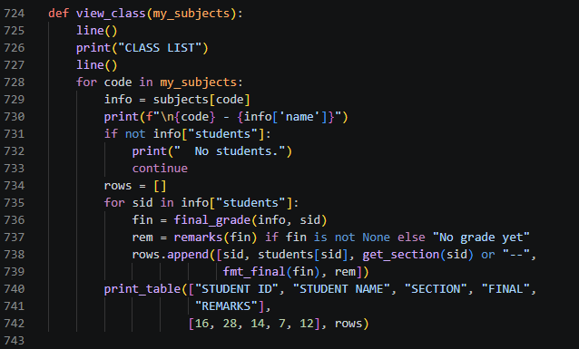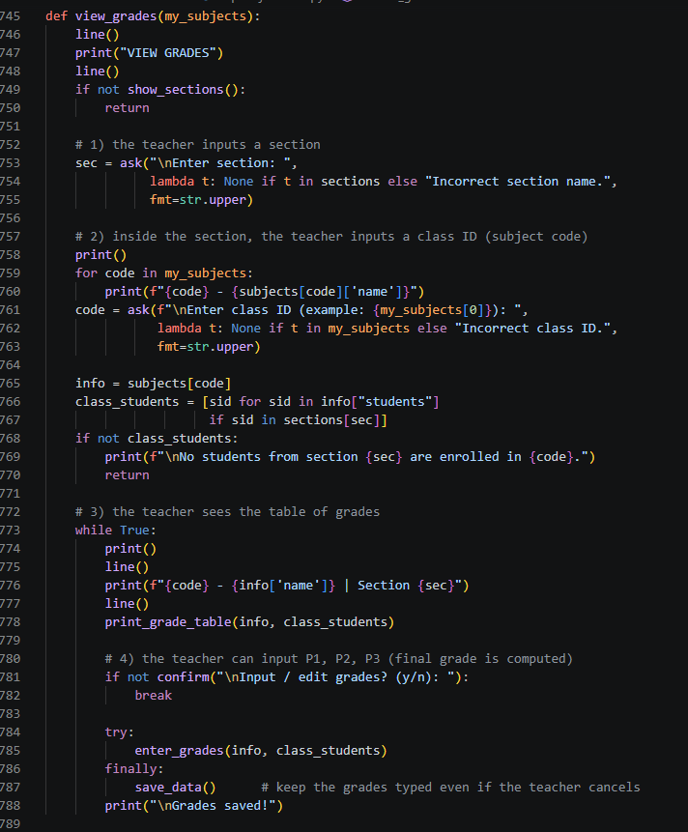

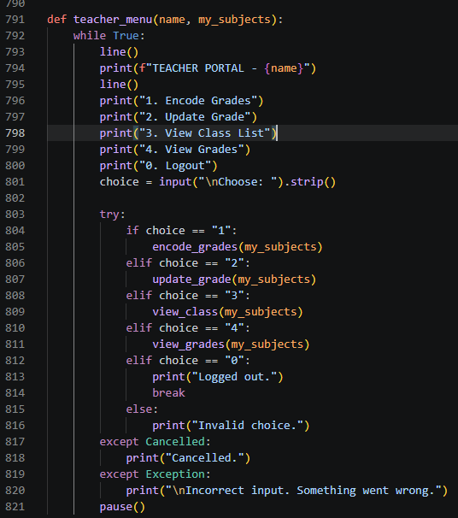
- Access Control: Scopes access so teachers can only view and modify subjects matching their assigned name.
- Grade Management:
  - Encode: Sequential entry for P1, P2, and P3 for all students enrolled in a subject.
  - Update: Target a specific student and specific period (P1/P2/P3) to revise existing records.
  - View Grades by Section: Filter subject grade lists down to students belonging to a target section.
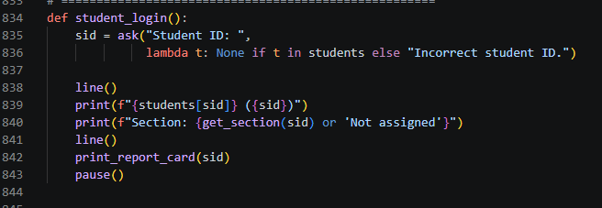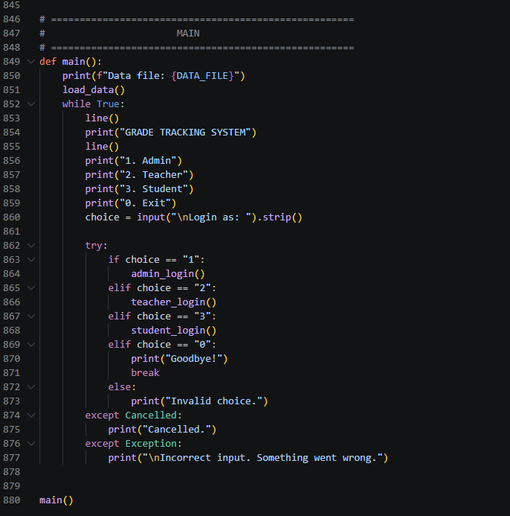

- Student View: Authenticates using a Student ID and renders a read-only report card detailing subject grades, instructor names, and the overall calculated general average.
- Main(): Serves as the outer entry point, presenting the primary authentication options (1. Admin, 2. Teacher, 3. Student, 0. Exit), loading local storage on boot, and managing active session

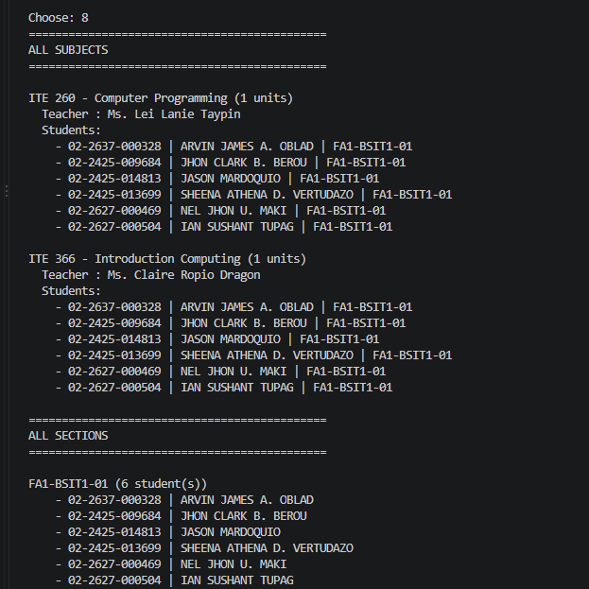

- ALL SUBJECTS: Shows ITE 260 and ITE 366, their assigned teachers, and the 6 enrolled students with their IDs and sections.
- ALL SECTIONS: Shows section FA1-BSIT1-01 containing those 6 students.

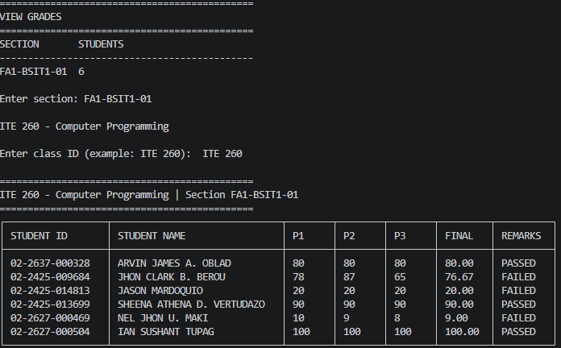

- User Input: The user selects section FA1-BSIT1-01 and class ID ITE 260.
- Grade Calculation: The system averages three term grades ($P1 + P2 + P3 \div 3$) to compute the FINAL mark.
- Passing Standard: The passing threshold is set at 80% (e.g., 76.67 is marked FAILED, while 80.00+ is PASSED).
- Results: Out of 6 students, 3 passed (including Ian Sushant Tupag with a perfect 100.00) and 3 failed.
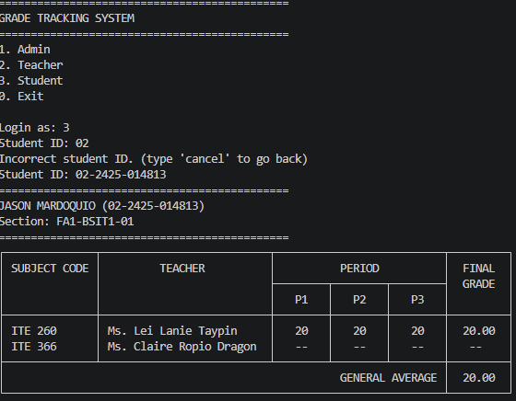

- Role Selection & Validation: The user selects option 3 (Student). Entering an incomplete ID (02) triggers an error message, requiring the full ID 02-2425-014813.
- Student Record: Displays the personal grade portal for Jason Mardoquio (Section FA1-BSIT1-01).
- Enrolled Subjects:
  - ITE 260 (Instructor: Ms. Lei Lanie Taypin): Has period scores of 20, 20, 20 and a final grade of 20.00.
  - ITE 366 (Instructor: Ms. Claire Ropio Dragon): Shows empty grades (--), indicating scores haven't been entered yet.
- Overall Metrics: Displays a calculated General Average of 20.00 based on available graded subjects.

REFERENCE
Bacla-an, M. C., De Atras, L., Frejoles, N. C., Ocampo, J. L., Rabac, A. C., & Valles, I. C. (2023). Students’ performance and grade monitoring system. Metro Dumaguete College, Inc.
Krongpol, K. B., Espino, J. V. M., & Keh, L. M. D. (2024). Periodical performance monitoring system. Philippine E-Journals. https://www.ejournals.ph/article.php?id=30686
Python Software Foundation. (2025). Python documentation. https://docs.python.org/

