Artificial Intelligence System
Interconnection (AISI) Model
Version 2.0 | A reference architecture for how AI systems are built, connect and stay governed
Seven layers, two boundaries, one audit trail
Copyright 2026 Jason Robbins. Licensed under the Apache License, Version 2.0; see the LICENSE and NOTICE files in the repository. Adaptations and forks must not imply the author's endorsement.
AI agents call other agents, Model Context Protocol (MCP) servers and tool APIs in production, under authority that somebody delegated to them, and there is still no shared way to describe how those systems are built or how they should connect. The AISI Model is a seven-layer reference architecture, in the spirit of the OSI model, that gives engineering, security and compliance teams one vocabulary for how an AI system is put together on the inside and how it talks to anything on the outside.
Four internal layers (physical through data) are reached only through interfaces the owner controls. Three exposed layers (agent logic through interface) are where agents, tools and MCP servers meet, and where authorization, oversight and containment get enforced. Governance and a signed audit trail span all seven. A six-phase trust sequence covers identity, trust, the behavioral contract and the oversight level before any work runs, and a baseline of 45 controls says what has to be in place, who builds it and when.

Before You Start
The AISI Model is a reference architecture, not a standard, a regulation or a compliance requirement. It carries no force of law and no certification authority. No organization is obligated to adopt it, and adopting it does not make anyone compliant with any regulatory framework.
Everything in this document set is a starting point. The layer definitions, protocol structures, control baselines, configurations, code examples and operating procedures are reference material that your organization has to adapt to its own infrastructure, threat model, risk posture and regulatory obligations. Nothing here is production-ready as written. Test in a non-production environment, adjust for your context and validate before you promote anything.
Where these documents reference regulatory frameworks, such as the EU AI Act, the NIST AI Risk Management Framework (AI RMF), ISO/IEC 42001 and the Cloud Security Alliance (CSA) AI Controls Matrix, those references are informational mappings. Consult qualified legal, security and compliance professionals for decisions specific to your environment.

Why This Exists
A customer-facing agent routes to a research agent, which calls a knowledge agent, which checks policy with a compliance agent, and somewhere along that chain an MCP server hands one of them a tool that can write to a production system. Every team draws a different diagram of that chain. Every vendor uses different terms for the same control. Every integration is bespoke, and the security review starts from zero each time. Networking went through the same thing decades ago and settled it with the OSI model: seven layers, a common vocabulary, and a way to say which layer a problem belongs to. The AISI Model does the same job for AI systems.
What makes securing an agent different from securing an application is that the model can behave differently from one run to the next even when nothing around it changed, and no patch fixes that. So the authorization decision, the list of places the agent can reach and the limits on what it can commit all have to be enforced outside the model, at a point the agent cannot get around. The model gives those enforcement points a home: a layer, a boundary and a phase in the trust sequence where each one belongs.
None of this replaces the identity, application, data and infrastructure controls you already run. What is new is the chain: from the originating authority, to the agent, to the tools it calls, to the business action that results, kept intact as context shifts and work gets delegated, with evidence that it held. A filter on prompts and outputs can block what it sees, and it has no way to tell you whether the action was ever approved.

The Seven Layers
Every AI system can be described with these seven layers. They are logical responsibilities, not seven services or seven network hops: one process can carry several of them, and a small deployment often does. The split into exposed and internal layers is what makes the model useful for security work, because the two halves are secured at different points by different controls, and the controls for one half do not reach the other.
A system without an agent maps the same way. An image classifier or a forecasting service has no planner, tools or memory at layer 5; that layer is whatever application logic prepares the input and interprets the output, layer 6 is whatever approves and limits what happens with the result, and layer 7 is the API it is served from. A plain MCP server may have no model at all: it carries layers 7 and 6 in front of whatever system it wraps. Keeping layers 1 to 4 behind controlled interfaces is a design constraint the model asks you to meet, not a property every deployed AI system already has.
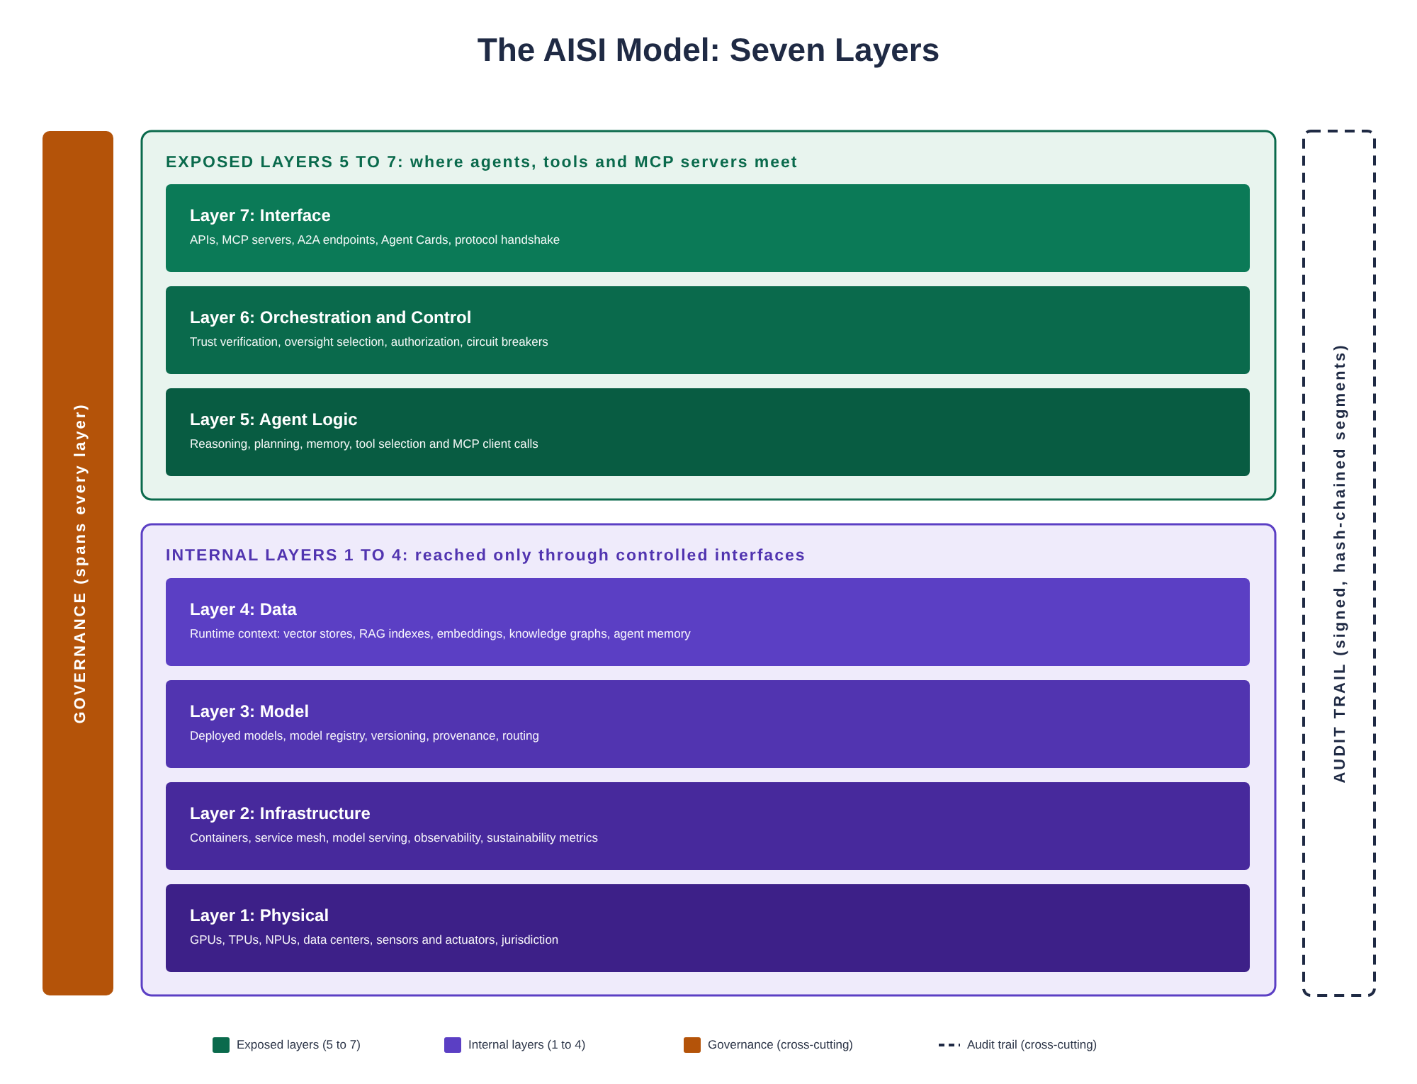
Figure 1: The AISI Model, seven layers with cross-cutting governance and audit trail

The Exposed Layers (5 to 7)
These are the layers that take part in interaction across a system boundary. Exposed means a layer participates in cross-system interaction, not that layers 5 and 6 are reachable from the network; only layer 7 is. They handle everything from reasoning to multi-step coordination to the interfaces that connect a system to the rest of the world, and they are where authorization, oversight and containment get enforced.

Layer 7: Interface
The front door. Requests arrive and results go back out through APIs, webhooks, conversational surfaces, MCP servers, endpoints for the Agent2Agent (A2A) protocol, and Agent Cards, the signed, machine-readable descriptions of what an agent can do. MCP for reaching tools and A2A for agents calling agents are the protocols the model names; it is built so that when another one shows up, this layer adapts and nothing below it has to change. Between systems, layer 7 is where discovery and identity exchange happen: the caller presents its credentials and a trace ID, retrieves the other side's Agent Card or MCP server metadata, and proposes a behavioral contract.

Layer 6: Orchestration and Control
The traffic controller. This layer coordinates multi-step workflows, decides whether an action may proceed, runs approval workflows and enforces containment: supervisor patterns, kill switches, circuit breakers and human-in-the-loop gates. Between systems, layer 6 is the governance checkpoint. It validates the identity chain, selects the oversight level based on risk, enforces the behavioral contract, and keeps the accountability chain intact: who authorized the action, which policy permitted it, and who carries the consequences.

Layer 5: Agent Logic
The brain. Reasoning, planning, memory management, tool selection and the MCP client calls that invoke tools all live here, along with context window management and state that carries forward between steps. Layer 5 is where the work actually runs, inside whatever scope the contract allowed.

The Internal Layers (1 to 4)
These layers are reached only through interfaces the owner controls. When one system talks to another, none of this crosses the wire directly; anything the caller gets from them comes back through an interface that authenticated and authorized it. That is a boundary you enforce, and content can still walk out through an interface when the controls above it fail, which is why the exposed layers carry most of the control weight.

Layer 4: Data
The information an agent reasons over at runtime: vector stores, retrieval-augmented generation (RAG) indexes, embeddings, knowledge graphs and agent memory. This is not training data or fine-tuning corpora; those are upstream supply chain inputs. Layer 4 is data that gets updated, rotated and audited during operation, and it includes the derived copies (summaries, caches, memory) that keep existing after access to the source changes.

Layer 3: Model
The callable intelligence as deployed. Foundation models, fine-tuned specialists, the model registry, version management, provenance and routing between models. The training pipeline is an upstream dependency, not part of the runtime stack.

Layer 2: Infrastructure
Container orchestration, service mesh, the serving and deployment side of MLOps (training pipelines live upstream of the runtime stack), observability and autoscaling. Also where operational sustainability belongs: energy, water and carbon tracked as engineering requirements. For general-purpose AI models, the EU AI Act asks for documentation of training-phase energy consumption (Annex XI).

Layer 1: Physical
GPUs, TPUs, NPUs, memory, storage, networking and data centers. For embodied AI, sensors and actuators. Where the hardware sits is one of the inputs to which jurisdictions' rules apply, alongside where the system is placed on the market and where its output is used, which is why jurisdiction starts as a layer 1 concern and ends up in governance.

What Spans Every Layer

Governance
Policy, accountability and evidence that follow every action across the layers and across agents. A single agent with no downstream agent still needs an interface, an authorization decision and someone watching. Governance is drawn on both sides of a connection because each party is accountable for its own side of it, with a governance checkpoint at layer 6 where trust, policy, the behavioral contract and the oversight level are decided.

The Audit Trail
Every request that enters the stack gets a trace ID, and that ID follows it through every layer, every agent hop and every delegation. Segments are signed and hash-chained so that the record shows if anyone changed it later. A trace ID ties events together so you can follow one action end to end; it does not stop anyone editing them, which is what the signing and chaining are for. The Security Reference covers the audit trail in detail.

How Systems Connect
When a calling agent needs something from another agent or from an MCP server, the request only ever touches the other side's exposed layers. It goes in through the interface, gets checked at the governance checkpoint for trust, policy, the behavioral contract and the oversight level, and the work runs inside whatever scope was agreed. The other side's data, models, infrastructure and hardware sit behind an internal access boundary that the caller never crosses directly. You can swap your model, change your data sources or migrate infrastructure, and the systems connected to you never know the difference.
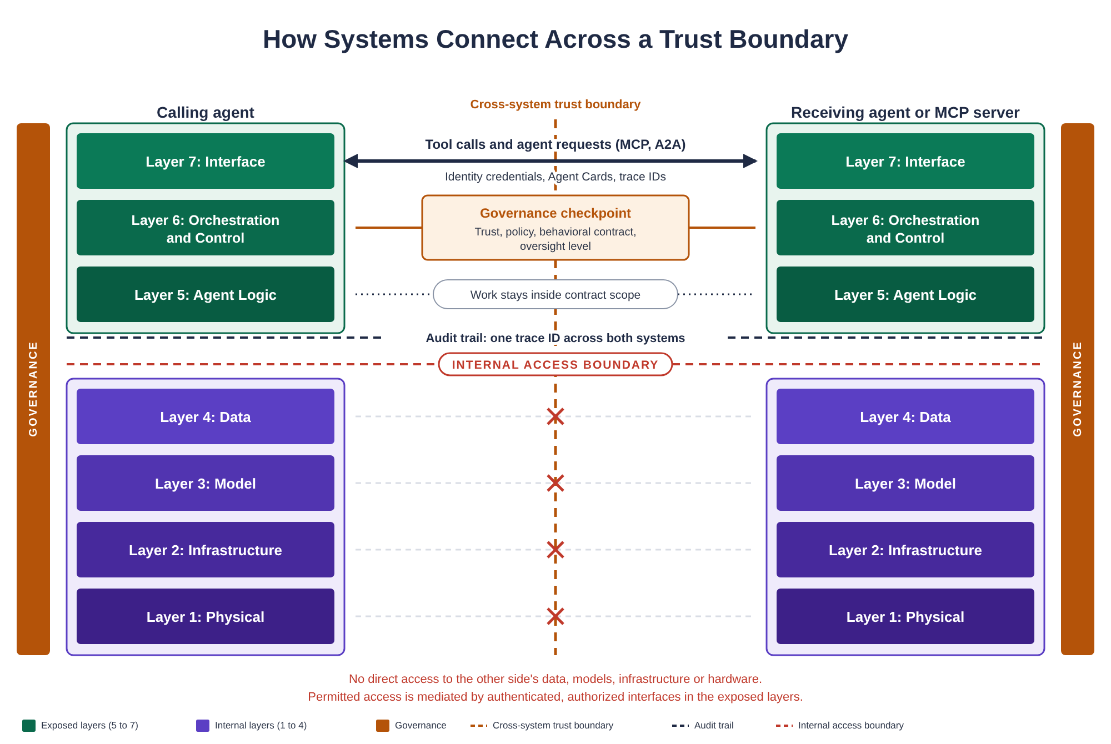
Figure 2: How a calling agent reaches another agent or an MCP server across a trust boundary
The dashed line down the middle is the trust boundary between the two systems. The audit trail runs across both so one trace ID follows the whole action. Governance sits on both sides because each party keeps its own policy, its own accountability and its own evidence. The receiving side is drawn with a full stack for illustration; an MCP server that fronts a single tool may carry only layers 7 and 6 and whatever system it wraps.

What Crosses the Boundary
- Identity credentials and trace IDs, the correlation identifiers that follow a request through the chain
- Agent Cards or MCP server metadata: capability descriptions and default contract terms
- Behavioral contracts: the terms agreed before work starts
- Structured requests and responses, validated against published schemas
- Oversight metadata: trust verification results, policy decisions, accountability records
- Validated output payloads with the receiver's compliance evidence

What Stays Internal
- Model weights and architecture details
- Training data, embeddings, RAG indexes and agent memory
- Infrastructure configuration and compute details
- Internal reasoning traces and decision logs
Internal does not mean secret. It means reachable only through an interface you control, under terms you set, with a record of what went out.

How an Agent Establishes Trust Before It Acts
This is what makes the AISI Model work like the OSI model: not only anatomy but also a sequence for how communication happens. The six phases are protocol-agnostic. They describe what has to happen regardless of whether the agents talk over MCP, A2A, REST or whatever comes next. Neither MCP nor A2A defines this sequence; the protocols give you the transport and the authentication, and the rest has to be designed in.
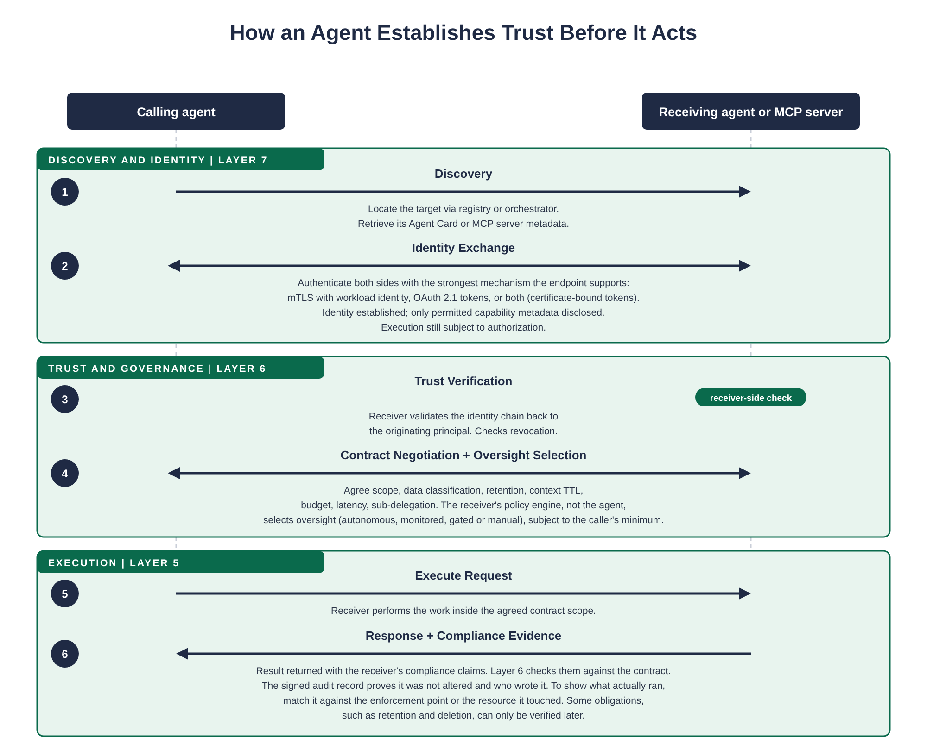
Figure 3: The six-phase trust sequence, from discovery to compliance evidence
- Discovery (layer 7): the caller locates the target through a registry, a direct reference or an orchestrator, and retrieves its Agent Card or MCP server metadata: capabilities, supported protocols and default contract terms.
- Identity Exchange (layer 7): both sides authenticate with the strongest mechanism the endpoint supports: mutual TLS (mTLS) with workload identity, OAuth 2.1 tokens, or both in the form of tokens bound to the client's certificate or key. Identity is established and only permitted capability metadata is disclosed. Execution is still subject to authorization; a valid identity is not approval for every action.
- Trust Verification (layer 6): the receiver validates the identity chain back to the originating principal and checks revocation. Is the credential valid, is the issuer trusted, has trust been pulled since it was issued. This is the receiver's check, and it is the equivalent of certificate validation in TLS.
- Contract Negotiation and Oversight Selection (layer 6): both sides agree scope, data classification, retention, context time to live (TTL), budget, latency and sub-delegation. The receiver's policy engine, not the agent, selects the oversight level (autonomous, monitored, gated or manual), subject to whatever minimum the caller required. Agents never pick their own oversight.
- Execute Request (layer 5): the receiver performs the work inside the agreed contract scope.
- Response and Compliance Evidence (layer 5, checked at layer 6): the result comes back with the receiver's compliance claims, and layer 6 checks them against the contract. The signed audit record proves it was not altered and who wrote it. To show what actually ran, match it against the enforcement point or the resource it touched. Some obligations, retention and deletion among them, can only be verified later.
Session-based negotiation lets the handshake run once and reuse a sender-constrained session token for later requests while conditions stay stable. Re-negotiation triggers when scope, classification or oversight requirements change. The A2A Protocol Specification covers Agent Cards, behavioral contracts, authentication and the four oversight levels in detail.

Protocol Notes

MCP, A2A and RAG
Three terms come up in every design review, and only two of them are protocols. MCP exposes tools, resources and prompts to a client over stdio or HTTP; its authorization model for HTTP is built on OAuth 2.1 and it does not define mTLS. A2A is a separate protocol for agents calling agents; it uses Agent Cards for discovery and allows API keys, bearer tokens, OAuth 2.0, OpenID Connect or mTLS. RAG is an architecture pattern, retrieval feeding generation; it can ride on MCP, and it defines no wire protocol of its own. None of the three hands you behavioral contracts or the trust sequence above. Those have to be designed in.
MCP has no protocol-level session, so every request carries its own token; what application state a server keeps for its own purposes is its business. That helps with revocation and does not guarantee it: whether a server notices a revoked token depends on how it checks tokens, how fast revocation gets around, what is cached and how long the token lives, and a stateless transport does not pull back work the server already took on. Measure how long revocation actually takes in your setup and hold that number. The A2A Protocol Specification covers client registration, token binding and enterprise-managed authorization for MCP channels, and says how to treat clients and servers on revisions of MCP earlier than July 28, 2026, which still carry protocol-level sessions and dynamic client registration.

mTLS and OAuth
mTLS with workload identity is the strongest option when both ends run on infrastructure you control, and A2A supports it natively. Most stacks also need OAuth, because MCP's authorization framework is OAuth-based and a lot of SaaS agents offer nothing else, so check what each implementation supports. The rule is to use the strongest mechanism the endpoint supports, and where you can, both: an OAuth token bound to the client's certificate or key, which is what RFC 9700, the OAuth 2.0 security best current practice, recommends. A bearer token anyone can replay is the floor, and when an otherwise acceptable endpoint cannot do better than that, write the exception down with a compensating control next to it.

Getting Started
The model is designed to be adopted incrementally. Where you start depends on what you are building and what you already have in place, and every control in the baseline describes an outcome rather than a product, so a hundred-person company and a hundred-thousand-person enterprise can both meet it with very different amounts of tooling.

Single-Agent Systems
A single agent with one credential and one tool can already do damage, so the internal layers need governance whether or not another agent is ever in the picture. Focus on layers 1 through 5 and the AI/ML and IT infrastructure families in the Baseline Controls. Start with the P1 controls: model registry, provenance attestation, prompt versioning, container isolation, secrets management and resource quotas. Then write down, for that one agent, the business task, the owner, the authority, the data it can reach and the actions it may take, and prove that a prohibited action is denied before it executes. The discovery and negotiation controls (A2A-2, A2A-4) can wait until a second party exists; the action controls cannot. Oversight (A2A-6), sandboxing and egress (A2A-8), the audit trail (A2A-11) and budgets (A2A-13) apply as soon as the agent can act on anything, whether that is another agent, an MCP server, a REST API, a file system or a browser.

Multi-Agent Systems Within One Organization
Once agents call each other or call MCP servers, the exposed layers and the trust sequence come into play. Start with the A2A Protocol Specification: Agent Cards for discovery, behavioral contracts for accountability, and the oversight model. The P1 agent-to-agent and agent-to-tool controls (A2A-1, A2A-2, A2A-5, A2A-6, A2A-7) come first, then the P2 controls (A2A-3, A2A-4, A2A-10, A2A-11, A2A-12). Sandboxing and egress control (A2A-8) and budgets (A2A-13) move up to before production for any agent that runs code, reaches sensitive systems or can delegate without a limit. The Security Reference's threat vectors should shape your threat model before anything goes live.

Cross-Organization Agents and Third-Party MCP Servers
When your agents interact with agents or MCP servers that someone else owns, every layer matters and the trust boundary stops being only a technical concern; it is a contractual one. Approve the counterpart and whoever sits downstream, establish trusted identities, constrain the authority you delegate, and get the data and operating terms in writing. Then build to them: per-hop authorization, tool execution that cannot be bypassed, session revocation, and an incident process both sides agreed to. A signed Agent Card proves integrity and identity binding when you validate it. It does not prove the other side behaves or deletes what you sent, so the third-party agent risk control (SEC-9) and the Security Reference's supply chain section are where to get independent evidence for both.

Compliance-Driven Adoption
If regulatory obligations are the primary driver, start with the Security Reference's framework mapping. It maps NIST AI RMF, the EU AI Act and ISO/IEC 42001 to specific layers and controls, and places the CSA AI Controls Matrix alongside them. Use it to find which layers and controls your obligations touch, then work through the Baseline Controls in priority order. The mapping gives you the traceability an auditor will ask for; the running control is what shows it is implemented.

Companion Documents
This document is the core of the AISI Model document set. Each companion is self-contained and cross-referenced to the others.
- Quick Start Guide: the core model and the Baseline Controls condensed into one starting point, with the Agent Card, behavioral contract and oversight tables.
- A2A Protocol Specification: Agent Cards, behavioral contracts, authentication and authorization (workload identity, mTLS, sender-constrained tokens), and the four oversight levels.
- Baseline Controls: the 45 controls for production agent deployments, grouped by the team that builds them: agent-to-agent and agent-to-tool, AI/ML, IT infrastructure, and security operations, with priorities and the conditions that move a control up.
- Security Reference: OWASP Top 10 for LLM Applications, OWASP Top 10 for Agentic Applications and MITRE ATLAS mapped to the layers, agent-specific threat vectors, the agent supply chain, the audit trail, and governance framework mapping.
- Implementation Guide: how to deploy on production infrastructure: namespaces, workload identity (SPIFFE and SPIRE), mTLS, network policy, Open Policy Agent, OpenTelemetry, Vault and the container supply chain.
- Operations and Lifecycle Reference: how to run it after deployment: behavioral drift detection, shadow AI discovery, RAG index freshness, prompt versioning, agent memory hygiene, change control and decommission.

