AISI Model v2.0
Quick Start Guide
A condensed reference for the Artificial Intelligence System Interconnection Model
Copyright 2026 Jason Robbins. Licensed under the Apache License, Version 2.0; see the LICENSE and NOTICE files in the repository. Adaptations and forks must not imply the author's endorsement.
AI agents call other agents, Model Context Protocol (MCP) servers and tool APIs in production, under authority somebody delegated to them, and there is no shared framework for how they connect. The AISI Model is a seven-layer reference architecture, in the spirit of the OSI model, that gives engineering, security and compliance teams one vocabulary for how an AI system is built on the inside and how it talks to anything on the outside. Four internal layers, three exposed layers, governance and an audit trail that span all seven, a six-phase trust sequence, and 45 baseline controls.
This guide condenses the core model and the Baseline Controls into one starting point and carries the Agent Card, behavioral contract and oversight tables from the A2A Protocol Specification. For full detail on any topic, go to the companion document that covers it.

Before You Start
The AISI Model is a reference architecture, not a standard, a regulation or a compliance requirement. It carries no force of law and no certification authority. Everything in this document set is a starting point your organization has to adapt to its own infrastructure, threat model, risk posture and regulatory obligations. Nothing here is production-ready as written. Where these documents reference regulatory frameworks, those references are informational mappings; consult qualified legal, security and compliance professionals for decisions specific to your environment.

The Seven Layers
Every AI system can be described with seven layers. Layers 1 to 4 are internal and are reached only through interfaces the owner controls. Layers 5 to 7 are exposed: they take part in interaction across a system boundary, which is where agents, tools and MCP servers meet and where authorization, oversight and containment get enforced. The layers are logical responsibilities rather than seven services; one process can carry several, and a system without an agent maps the same way, with layer 5 as ordinary application logic.
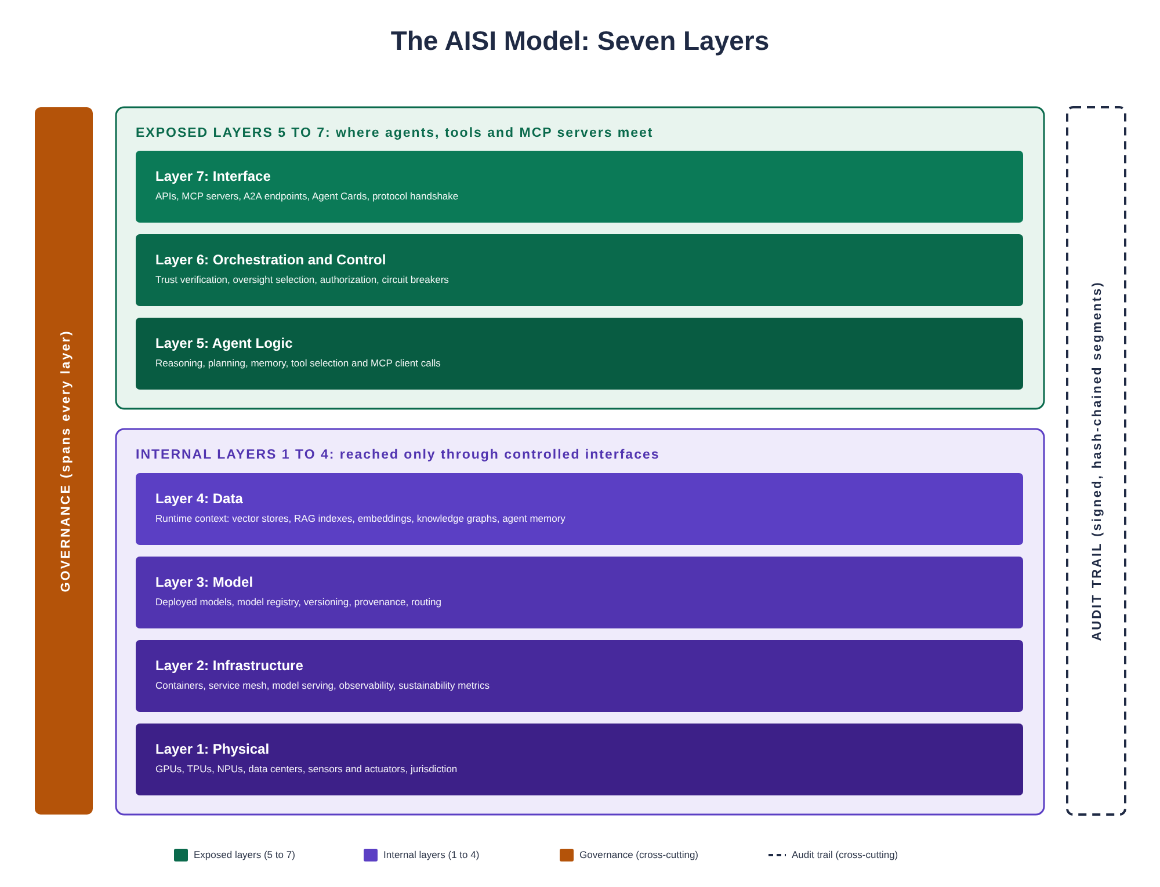
Figure 1: The AISI Model, seven layers with cross-cutting governance and audit trail
- Layer 7 (Interface): the front door. APIs, MCP servers, endpoints for the Agent2Agent (A2A) protocol, Agent Cards and the protocol handshake. Where requests arrive and results go back out.
- Layer 6 (Orchestration and Control): the traffic controller. Coordinates multi-step workflows, verifies trust, selects the oversight level, enforces behavioral contracts, and runs the circuit breakers and kill switches. Between systems, this is the governance checkpoint.
- Layer 5 (Agent Logic): the brain. Reasoning, planning, memory, tool selection and the MCP client calls that invoke tools.
- Layer 4 (Data): runtime context the agent reasons over: vector stores, retrieval-augmented generation (RAG) indexes, embeddings, knowledge graphs and agent memory. Not training data.
- Layer 3 (Model): the callable intelligence as deployed. Deployed models, the model registry, versioning, provenance and routing.
- Layer 2 (Infrastructure): containers, service mesh, model serving and deployment pipelines, observability, autoscaling and sustainability metrics.
- Layer 1 (Physical): GPUs, TPUs, NPUs, storage, networking, data centers, sensors and actuators. Where the hardware sits is one input to which jurisdictions' rules apply, with where the system is offered and where its output is used.
Governance and the audit trail cut across all seven layers, on both sides of every connection. Every request that enters the stack gets a trace ID, and that ID follows it through every layer, every agent hop and every delegation. Audit trail segments are signed and hash-chained so the record shows if anyone changed it later and the whole action can be reconstructed end to end.

How Systems Connect
When a calling agent needs something from another agent or an MCP server, the request only ever touches the other side's exposed layers. It goes in through the interface, gets checked at the governance checkpoint for trust, policy, the behavioral contract and the oversight level, and the work runs inside whatever scope was agreed. The other side's data, models, infrastructure and hardware sit behind an internal access boundary the caller never crosses directly; anything it gets from them comes back through an interface that authenticated and authorized it. You can swap your model, change your data sources or migrate infrastructure, and the systems connected to you never know the difference.
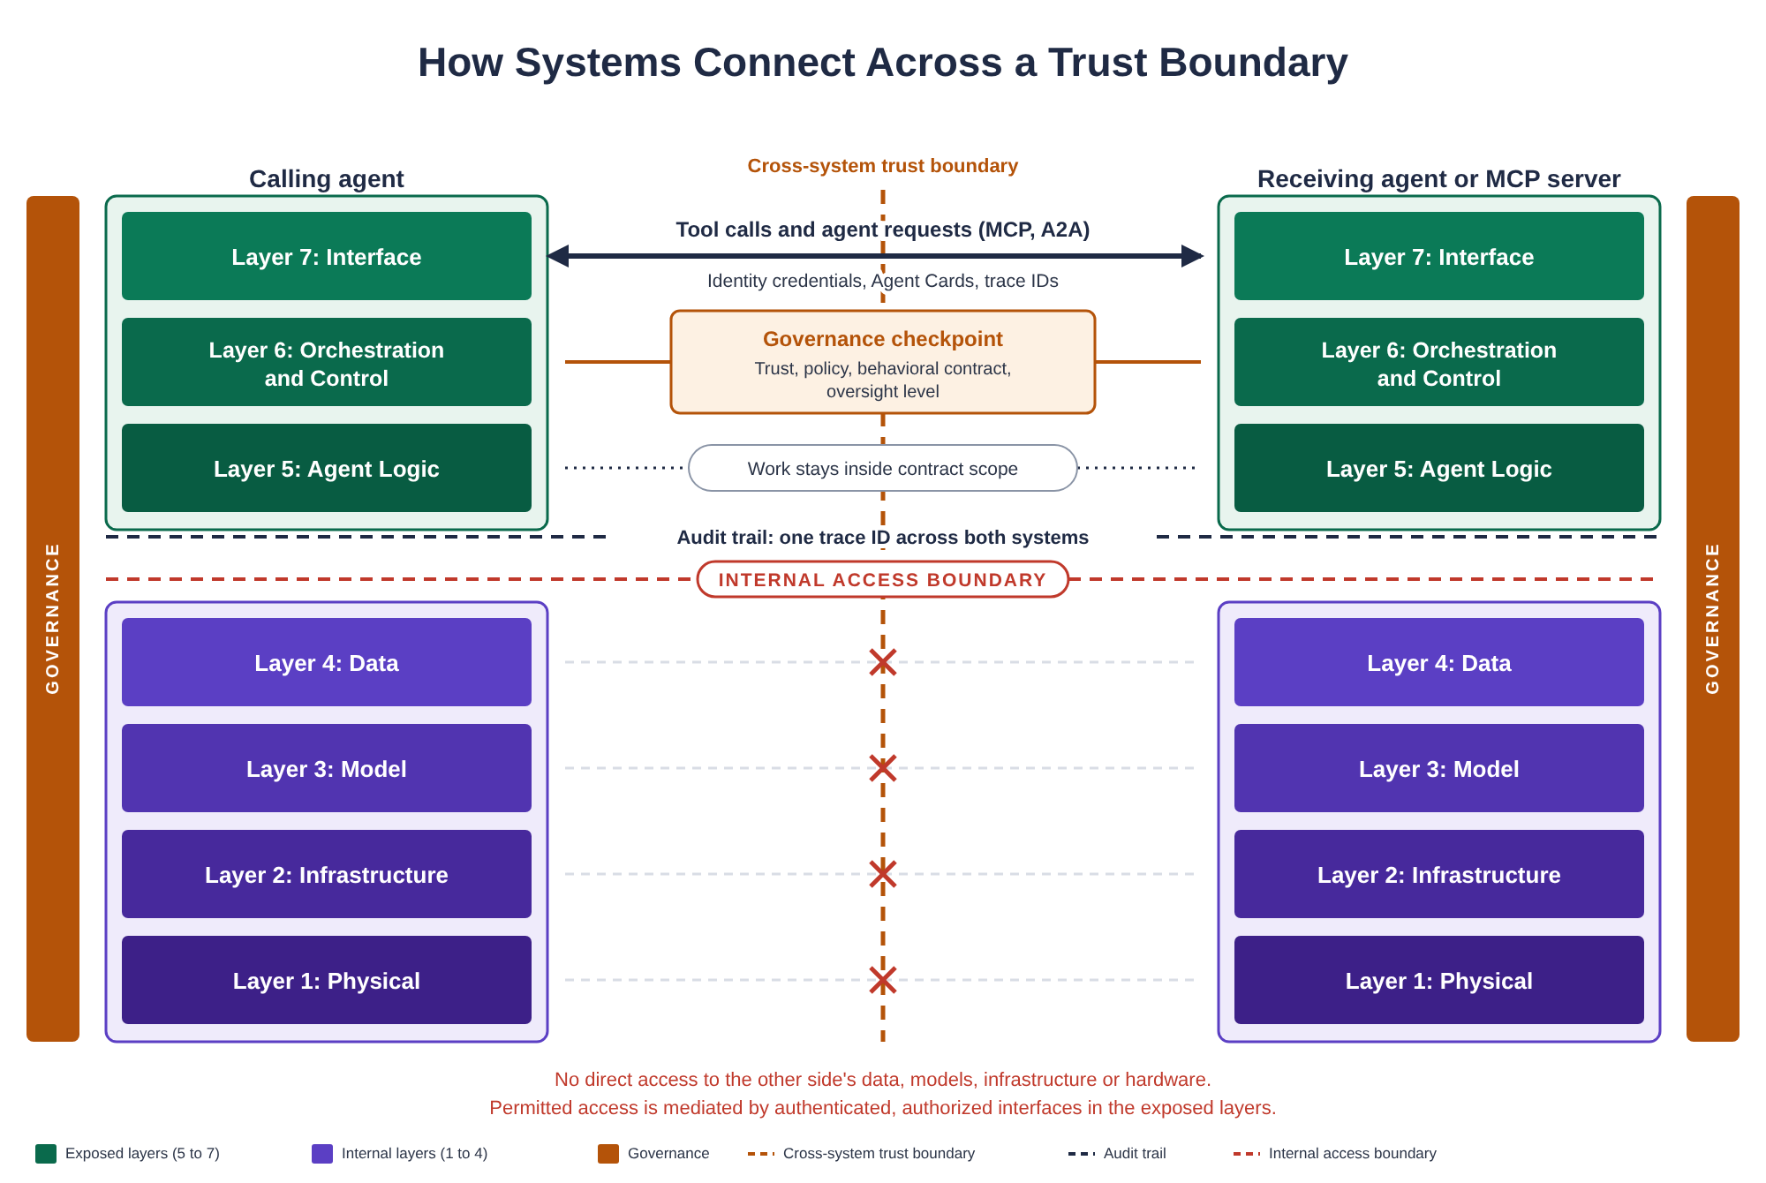
Figure 2: How a calling agent reaches another agent or an MCP server across a trust boundary

How an Agent Establishes Trust Before It Acts
Every interaction, agent-to-agent or agent-to-tool, follows the same six-phase sequence. Discovery and identity happen at layer 7, trust verification and contract negotiation at layer 6, and execution at layer 5. The trace ID runs through all six. Neither MCP nor A2A defines this sequence; the protocols give you transport and authentication, and the rest has to be designed in.
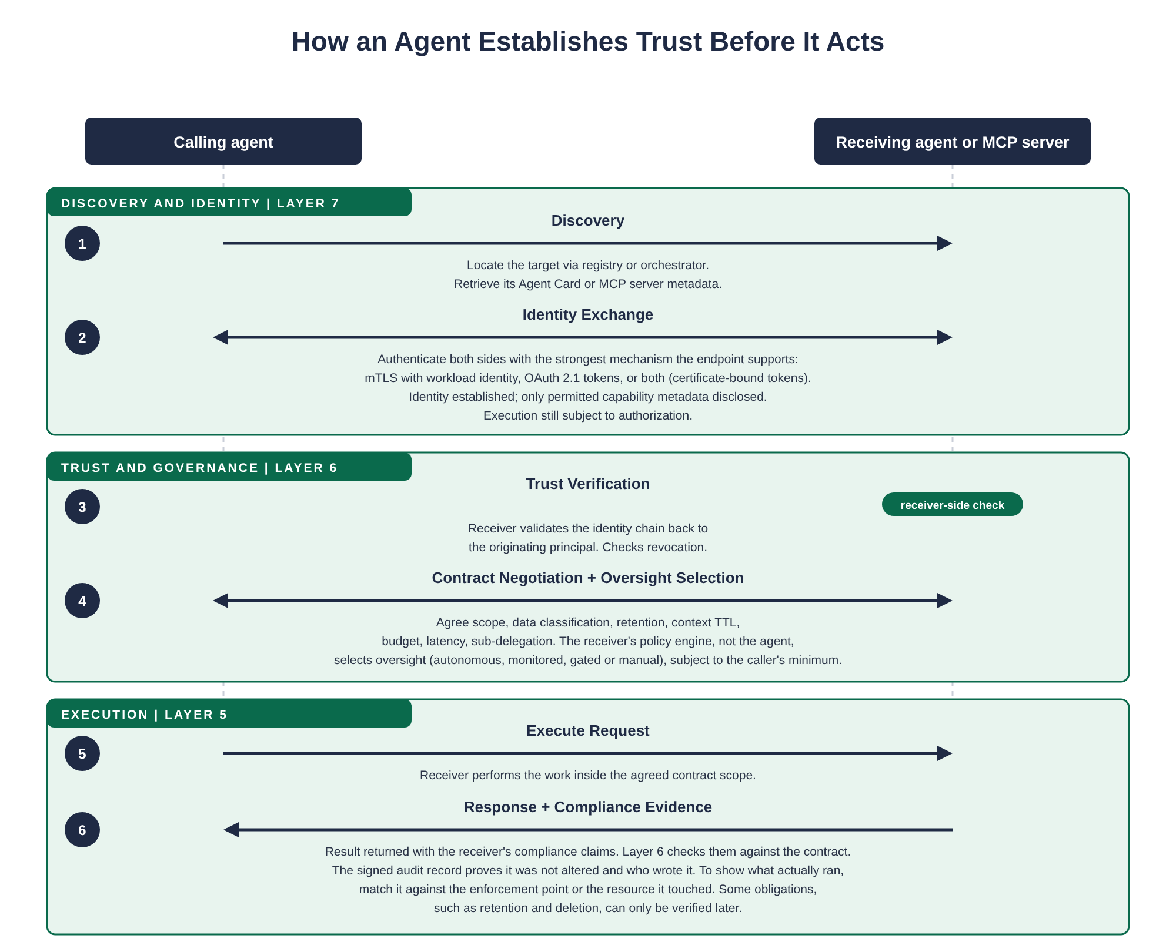
Figure 3: The six-phase trust sequence, from discovery to compliance evidence
- Phase 1, Discovery (layer 7): the caller locates the target through a registry or orchestrator and retrieves its Agent Card or MCP server metadata.
- Phase 2, Identity Exchange (layer 7): both sides authenticate with the strongest mechanism the endpoint supports: mutual TLS (mTLS) with workload identity, OAuth 2.1 tokens, or both as certificate-bound tokens. Only permitted capability metadata is disclosed, and execution is still subject to authorization.
- Phase 3, Trust Verification (layer 6): the receiver validates the identity chain back to the originating principal and checks revocation.
- Phase 4, Contract Negotiation and Oversight Selection (layer 6): both sides agree scope, data classification, retention, context time to live (TTL), budget, latency and sub-delegation. The receiver's policy engine, not the agent, selects the oversight level (autonomous, monitored, gated or manual), subject to the caller's minimum.
- Phase 5, Execute Request (layer 5): the receiver performs the work inside the agreed contract scope.
- Phase 6, Response and Compliance Evidence (layer 5, checked at layer 6): the result comes back with the receiver's compliance claims and layer 6 checks them against the contract. The signed audit record proves it was not altered and who wrote it; some obligations, retention and deletion among them, can only be verified later.
Session-based negotiation lets the handshake run once and reuse a sender-constrained session token (RFC 8705 or RFC 9449) for later requests while conditions stay stable. Re-negotiation triggers when scope, classification or oversight requirements change.

A Word on the Protocols
MCP exposes tools, resources and prompts to a client over stdio or HTTP; its authorization model for HTTP is built on OAuth 2.1 and it does not define mTLS. A2A is a separate protocol for agents calling agents; it uses Agent Cards for discovery and allows API keys, bearer tokens, OAuth 2.0, OpenID Connect or mTLS. RAG is an architecture pattern, retrieval feeding generation, with no wire protocol of its own. MCP keeps no session state between calls, so every request carries its own token. The rule for authentication is the strongest mechanism the endpoint supports, and where you can, both: an OAuth token bound to the client's certificate or key, as RFC 9700 recommends. The core model's Protocol Notes section has the detail.

Getting Started
Every control in the baseline describes an outcome rather than a product, so a hundred-person company and a hundred-thousand-person enterprise can both meet it with very different amounts of tooling and process. Where you start depends on what you are building.

Single-Agent Systems
Focus on layers 1 through 5 and the AI/ML and IT infrastructure controls. Discovery and negotiation (Agent Cards, contract negotiation, per-hop verification) can wait until there is a second party to discover or negotiate with. The action controls cannot: oversight (A2A-6), sandboxing and egress (A2A-8), the audit trail (A2A-11) and budgets (A2A-13) apply as soon as the agent can act on anything, whether that is a REST API, a file system, a browser or an MCP server. Write down, for that one agent, the business task, the owner, the authority, the data it can reach and the actions it may take, and prove that a prohibited action is denied before it executes.

Multi-Agent Systems Within One Organization
Add the A2A Protocol Specification. Implement Agent Cards and behavioral contracts. Start with the P1 agent-to-agent and agent-to-tool controls: A2A-1 (mTLS + workload identity), A2A-2 (signed Agent Cards), A2A-5 (delegation scope monotonicity), A2A-6 (oversight policy engine) and A2A-7 (kill switch + circuit breakers). Move to the P2 controls (schema validation, per-hop trust, contract compliance verification, the audit trail, revocation) once P1 is stable, and pull sandboxing and egress (A2A-8) and budgets (A2A-13) forward for any agent that runs code, reaches sensitive systems or can delegate without a limit.

Cross-Organization Agents and Third-Party MCP Servers
Everything above, plus identity federation, explicit data classification and retention, budget limits, sub-delegation constraints, and the Security Reference's supply chain and third-party risk controls. Tiered discovery matters here: serve a public Agent Card at an unauthenticated endpoint and require authentication for the full capability card. A signed card proves identity binding when you validate it; it does not prove the other side behaves or deletes what you sent.

Compliance-Driven Adoption
Start with the Security Reference's framework mapping, find which layers and controls your obligations touch, then work through the Baseline Controls in priority order.

Agent Cards
An Agent Card is the signed, machine-readable description of an agent that discovery and trust decisions start from. In this document set it means two documents that travel together: the A2A protocol's own Agent Card, which any A2A client can read, and an AISI manifest, which carries what this model adds and is bound to the card by a digest. The A2A schema makes signatures optional; the binding to a runtime identity, the issuance window and the tool allowlist are this model's requirements on top of the protocol.

Native A2A Card Fields the Model Relies On
A2A field | What it is used for
name, description, version | Identity and the agent release version
supportedInterfaces | Endpoints and protocol bindings; TLS on every interface
capabilities | Protocol capabilities, the extended-card flag for tiered discovery, and the extension entry that declares the AISI profile and points to the manifest
skills | What the agent can do; the list the contract's scope is checked against
securitySchemes and security | The authentication methods a caller has to use
signatures | JSON Web Signatures over the canonical card; at least one is required

AISI Manifest, Required Fields
Field | Type | Description
aisi_profile | string | The profile version the manifest conforms to
agent_id | string | Globally unique identifier for this agent instance
agent_card_digest | string | SHA-256 of the canonical native card; binds the manifest to one card
runtime_identity | URI | SPIFFE ID (Secure Production Identity Framework for Everyone) or equivalent workload identity the card is bound to
tools | array | The tools this agent may invoke, with schemas and permission requirements; the allowlist tool execution is checked against
issued_at | ISO 8601 | When the manifest was signed
expires_at | ISO 8601 | When it stops being valid; expired manifests are rejected and healthy agents renew before expiry
issuer | string | Identity of the signing authority, traceable to a trusted root
signatures | array | JSON Web Signatures over the canonical manifest

AISI Manifest, Selected Optional Fields
Field | Type | Description
default_contract | object | Pre-published behavioral contract terms callers can accept or counter-propose
max_chain_depth | integer | Maximum downstream hops this agent supports
oversight_minimum | enum | Lowest oversight level this agent will accept
dependencies | array | Other agents, MCP servers or services this agent requires (supports supply chain auditing)
pricing | object | Cost structure: model (per_request, per_token, per_session), currency (ISO 4217), rate
model_fingerprint | string | Identifier for the current model version (drift detection)

Agent Cards support tiered discovery through A2A's own extended-card mechanism. A public card served at an unauthenticated endpoint carries only name, version, supportedInterfaces, securitySchemes, the provider and the extension declaration. The full card and the manifest are available only after identity verification. Both tiers are signed with the same key. The agent release version, the issuance window and the profile version are versioned separately, so renewing a manifest never implies that the agent changed.

Behavioral Contracts
A behavioral contract is a per-session or per-request agreement that binds both parties. The caller proposes terms, the receiver accepts or counter-proposes, and the negotiated result governs the interaction.

Required Contract Terms
Term | Type | Description
scope | string | What the requesting agent is asking for, specific enough for policy evaluation
permitted_actions | array | Explicit list of actions the receiver is authorized to perform
max_latency | duration | Response time bound; the receiver must respond or report failure within this window
error_handling | enum | Failure mode: retry (with backoff), fallback (degraded response), or abort
oversight_level | enum | Agreed oversight level: autonomous, monitored, gated or manual
trace_id | string | Correlation ID for end-to-end tracing, propagated through every hop
data_classification | enum | Sensitivity of data crossing the boundary: public, internal, confidential, restricted
retention_policy | duration | How long the receiver may retain request and response data and derived artifacts

Selected Optional Contract Terms
Term | Type | Description
max_tokens | integer | Token budget cap for the interaction (maps to OWASP LLM10)
callback_url | URI | Endpoint for asynchronous result delivery
escalation_path | object | Who to notify if the contract is violated: team, channel, alert severity
sub_delegation | object | Whether the receiver may call other agents, with allowed agents, depth and scope constraints
context_ttl | enum | What to do with the context buffer on session end: immediate (wipe), session (wipe on close), retain
budget_limit | object | Maximum cost: currency (ISO 4217), max_amount, scope (per_request or per_session)
cost_reporting | boolean | When true, every response includes cost_incurred for spend tracking

Scope, classification and budget can only narrow through a delegation chain, never widen. If Agent A grants Agent B a budget of $5.00 per session, Agent B cannot grant Agent C more than $5.00. The same monotonic rule applies to data classification and capability scope.

Graduated Oversight
The receiver's layer 6 selects one of four oversight levels for each request based on risk, classification and policy, subject to whatever minimum the caller required. Agents never select their own level.
Level | Human role | When to use
Autonomous | None | Low-risk, well-understood operations within established scope
Monitored | Watches in real time and can intervene | Operations a human should see as they happen and be able to stop: data retrieval with filtering, standard API calls, moderate-cost operations
Gated | Approves before execution | High-value, high-risk or cross-boundary operations that need human sign-off
Manual | Performs the action | Operations that policy or regulation requires a human to carry out directly

When a request requires gated or manual oversight and the approver is not immediately available, the receiver returns a structured hold response with status pending_approval, the trace_id, the oversight_level, a reason, an estimated_wait and a resume_url. The caller does not retry; it polls the resume_url or waits for a callback. Bind the approval to the operation, the target and the arguments that matter, and require a fresh one when any of those change.

Baseline Controls
The Baseline Controls document defines 45 controls across four families, grouped by the team that builds them. Each control describes an outcome, not a product. Priorities are the published baseline: P1 before production, P2 for production where the risk warrants it, P3 planned, P4 for mature programs. The last column says when a control moves up ahead of its published priority; five of them (A2A-8, A2A-13, SEC-9, AI-9 and IT-9) belong before production for most agent deployments, and replay protection (A2A-9) joins them for agents whose actions commit or cannot be undone. Within each family, controls are ordered by priority first and then by ID.

Agent-to-Agent and Agent-to-Tool Controls
Platform engineering and AI infrastructure build these. The business owner of the calling agent is accountable.
ID | Control | Priority | Layer | Before production when
A2A-1 | mTLS + workload identity | P1 | L7 | Always, sized to the deployment
A2A-2 | Signed Agent Cards | P1 | L7 | Wherever Agent Cards are used; elsewhere, an equivalent trusted discovery control
A2A-5 | Delegation scope monotonicity | P1 | L6 | Always, before any delegation is enabled
A2A-6 | Oversight policy engine | P1 | L6 | Always, sized to the deployment
A2A-7 | Kill switch + circuit breakers | P1 | L6, L2 | Always, sized to the deployment
A2A-3 | Strict schema validation | P2 | L7, L5 | When the agent's risk warrants it
A2A-4 | Per-hop trust verification | P2 | L6 | When the agent's risk warrants it
A2A-10 | Contract compliance verification | P2 | L6, L7 | Always in its basic form, the receiver's own check; independent verification as the program matures
A2A-11 | Tamper-evident trace logging | P2 | Audit trail | When the agent's risk warrants it
A2A-12 | Revocation propagation | P2 | L6, L7 | When the agent's risk warrants it
A2A-8 | Tool sandboxing + egress control | P3 | L5, L2 | Always, for any agent that runs code or reaches sensitive systems
A2A-9 | Replay protection | P3 | L7 | Before production for agents whose actions commit or cannot be undone
A2A-13 | Budget enforcement | P4 | L6, L5 | Always, before turning on calls or delegation that could run without limit

AI and ML Controls
AI and ML engineering and data science build these. The business owner of the agent and the data owner of what it retrieves are accountable.
ID | Control | Priority | Layer | Before production when
AI-1 | Model registry + versioning | P1 | L3 | Always, sized to the deployment
AI-2 | Model provenance attestation | P1 | L3 | Always, sized to the deployment
AI-4 | Prompt / system policy versioning | P1 | L5 | Always, sized to the deployment
AI-3 | Agent-BOM | P2 | L3, L5 | When the agent's risk warrants it
AI-5 | Hallucination + grounding controls | P2 | L5, L4 | When the agent's risk warrants it
AI-6 | RAG data access governance | P2 | L4, L6 | Whenever retrieval reaches access-controlled data
AI-12 | Output content filtering | P2 | L7 | When the agent's risk warrants it
AI-7 | Embedding integrity | P3 | L4 | As the program matures
AI-8 | Training pipeline governance | P3 | Lifecycle | As the program matures
AI-9 | Evaluation + red-teaming | P3 | Lifecycle | Always; adversarial testing scaled to the risk
AI-11 | Behavioral drift detection | P3 | L5, L6 | As the program matures
AI-10 | Synthetic data controls | P4 | Lifecycle | Mature programs

IT Infrastructure Controls
IT operations, DevOps and platform engineering build these. Whoever owns the hosting platform is accountable.
ID | Control | Priority | Layer | Before production when
IT-1 | Container + runtime isolation | P1 | L2 | Always, sized to the deployment
IT-3 | Secrets management | P1 | L2, L7 | Always, sized to the deployment
IT-4 | Resource quotas + autoscaling limits | P1 | L2 | Always, sized to the deployment
IT-2 | Network segmentation | P2 | L2 | When the agent's risk warrants it
IT-5 | Infrastructure-as-Code | P2 | L1, L2 | When the agent's risk warrants it
IT-6 | Observability stack | P2 | L2, L6 | When the agent's risk warrants it
IT-7 | Backup + recovery | P3 | L1, L2, L4 | As the program matures
IT-10 | Change management | P3 | L2, L3, L5 | As the program matures
IT-8 | Sustainability metrics | P4 | L2 | Mature programs
IT-9 | Geographic compliance | P4 | L1 | Always, for the applicability check and any control an applicable obligation requires

Security Operations Controls
Security engineering, the security operations center (SOC) and governance, risk and compliance (GRC) build these. The CISO is accountable, and the business owner makes the incident calls about their own agent.
ID | Control | Priority | Layer | Before production when
SEC-1 | Agent threat modeling | P1 | All | Always, sized to the deployment
SEC-5 | Incident response playbooks | P1 | All | Always, sized to the deployment
SEC-2 | Adversarial testing in CI/CD | P2 | Build + runtime | When the agent's risk warrants it
SEC-4 | SIEM integration | P2 | L6, L2 | When the agent's risk warrants it
SEC-7 | Data loss prevention | P2 | L4, L7 | When the agent's risk warrants it
SEC-3 | Penetration testing | P3 | L7, L6, L5 | As the program matures
SEC-6 | Vulnerability management | P3 | L2, L3, L5 | Dependency assessment and patch ownership before production; automate as the program matures
SEC-8 | Access reviews | P3 | L6, L7 | As the program matures
SEC-9 | Third-party agent risk | P4 | L5, L7 | Always, when a third party is anywhere in the chain
SEC-10 | Compliance evidence | P4 | Governance | Whenever an applicable obligation or contract calls for evidence

Security and Compliance Alignment
The Security Reference maps the layers and controls to recognized threat catalogs and governance frameworks: the OWASP lists and MITRE ATLAS on the threat side, and the NIST AI Risk Management Framework (AI RMF), the EU AI Act, ISO/IEC 42001 and the Cloud Security Alliance (CSA) AI Controls Matrix on the governance side.

Threat Mappings
The OWASP Top 10 for LLM Applications (2025) maps to layers and controls. Key mappings: LLM01 prompt injection to layers 5 and 7 with schema validation, sandboxing and adversarial testing (A2A-3, A2A-8, SEC-2); LLM05 improper output handling to layer 7 with output filtering and schema enforcement (AI-12, A2A-3); LLM06 excessive agency to layers 5 and 6 with graduated oversight, scope monotonicity and sandboxing (A2A-5, A2A-6, A2A-8); LLM08 vector and embedding weaknesses to layer 4 (AI-6, AI-7); LLM10 unbounded consumption to layers 6 and 2 with quotas and contract-level budget enforcement (IT-4, A2A-13). MITRE ATLAS covers adversary techniques against the model and against agents, tools and memory; the Security Reference maps them to the layers with the case study that shows each one in practice.

Regulatory Framework Mappings
The table maps regulatory requirements to the specific controls and artifacts that address them. The left column is the obligation, the middle column the source, and the right column what in the model covers it.
Requirement | Source | How the model addresses it
Risk management system | EU AI Act Art. 9 | SEC-1 threat models every agent before production, mapped to the layers. The Baseline Controls give a prioritized control framework (P1 to P4) as the risk management backbone. Layer 6 enforces oversight policies that escalate with risk.
Logging and traceability | EU AI Act Art. 12 | A2A-11 produces a tamper-evident audit trail with hash-chained segments across every agent hop. IT-6 collects telemetry into a central observability stack. Behavioral contracts carry a trace_id that propagates end to end.
Human oversight | EU AI Act Art. 14 | A2A-6 assigns every request an oversight level: autonomous, monitored, gated or manual. Gated and manual levels require human approval before the agent acts. Callers can set a minimum the receiver cannot downgrade.
Provider log retention | EU AI Act Art. 19 | A2A-11 produces structured, tamper-evident audit records across the full chain, and IT-6 centralizes them with retention aligned to the provider's obligation to keep the logs under its control for at least six months. AI-11 detects behavioral drift so providers can show ongoing compliance.
Deployer record retention | EU AI Act Art. 26(6) | The retention_policy contract term governs how long the receiver may keep data, with duration-based retention that supports regulatory minimums. IT-7 backup and recovery keeps retained records through infrastructure events.
Governance and policy | NIST AI RMF: GOVERN | Governance spans all seven layers on both sides of every connection. A2A-4 re-verifies trust at every hop so policy is re-evaluated at each boundary. A2A-6 enforces the oversight policy that decides when humans must be involved.
Context and risk mapping | NIST AI RMF: MAP | SEC-1 maps each agent's attack surface to specific layers. Every control is assigned to layers and to the team that builds it. Contracts carry data_classification so risk context travels with every request.
Metrics and testing | NIST AI RMF: MEASURE | AI-11 continuously monitors behavioral drift against declared contracts. AI-9 runs adversarial evaluation and red teaming with versioned test suites. SEC-2 gates every deployment on automated adversarial and safety tests.
Monitoring and response | NIST AI RMF: MANAGE | A2A-7 provides kill switches and circuit breakers that halt chains when thresholds are exceeded. SEC-5 provides incident response playbooks for agent compromise scenarios. IT-6 dashboards surface anomalies for operations teams.
AI management system | ISO/IEC 42001 Cl. 5 to 10 | The Baseline Controls provide 45 controls organized by team and priority, each mapped to layers, with P1 to P4 as a phased adoption path aligned to organizational maturity.
Reference controls | ISO/IEC 42001 Annex A | 13 agent-to-agent and agent-to-tool controls, 12 AI/ML controls, 10 IT infrastructure controls and 10 security operations controls complete the control set.
Cloud AI security | CSA AI Controls Matrix | IT-1 isolates each agent in its own runtime with restricted system call profiles. IT-2 segments agent traffic from internal traffic with explicit allowlist policies. IT-3 keeps all credentials in a secrets manager with automated rotation. AI-12 filters every output crossing a system boundary.

These mappings are informational. They show where the model aligns with regulatory requirements and are not authoritative interpretations of any framework. The Security Reference carries the per-control mappings for NIST AI RMF, the EU AI Act and ISO/IEC 42001, and a summary of where the CSA AI Controls Matrix overlaps.

Companion Documents
This guide condenses the six companion documents. Each is self-contained and cross-referenced to the others.
Document | What it covers
AISI Model | The core reference architecture: seven layers, two boundaries, the six-phase trust sequence, protocol notes and adoption guidance
A2A Protocol Specification | Agent Cards and the AISI manifest, behavioral contracts, authentication and authorization, graduated oversight, session-based negotiation, tiered discovery
Baseline Controls | 45 controls across agent-to-agent and agent-to-tool, AI/ML, IT infrastructure and security operations, with priorities, owners and the conditions that move a control up
Security Reference | OWASP and MITRE ATLAS threat mappings, agent-specific threats, the agent supply chain, the audit trail, regulatory framework alignment
Implementation Guide | Kubernetes-native implementation patterns for runtime isolation, workload identity, policy, observability and data controls
Operations and Lifecycle Reference | Drift detection, shadow AI discovery, RAG index freshness, prompt versioning, memory hygiene, change control, decommission

