AISI Model v2.0
Security Reference
OWASP LLM and Agentic Top 10, MITRE ATLAS, trust sequence threats, the audit trail, agent supply chain, lifecycle controls, governance mapping
Copyright 2026 Jason Robbins. Licensed under the Apache License, Version 2.0; see the LICENSE and NOTICE files in the repository. Adaptations and forks must not imply the author's endorsement.
The threat side of the model. This document maps the OWASP Top 10 for LLM Applications, the OWASP Top 10 for Agentic Applications and MITRE ATLAS onto the seven layers, defines the threat vectors that target the six-phase trust sequence, specifies the audit trail, covers the agent supply chain and the model lifecycle (Annex A), and maps the NIST AI Risk Management Framework (AI RMF), the EU AI Act, ISO/IEC 42001 and the Cloud Security Alliance (CSA) AI Controls Matrix to the layers and controls. For the control set itself, see the Baseline Controls.

How to Use This Document
This is a companion to the AISI Model reference architecture. The core document defines the seven layers, the two boundaries and the six-phase trust sequence. This document says where threats land and where the controls go. Because each layer has one clear responsibility, it is possible to say which layer a threat manifests at and which team's controls address it, and that is what every table here does. The first three sections cover the published catalogs (OWASP LLM, OWASP Agentic, MITRE ATLAS). The next two address what is specific to agents calling agents and tools, including tools reached through Model Context Protocol (MCP) servers: attacks on the trust sequence, and the agent supply chain. The audit trail gets its own section because every other control depends on it. Annex A covers the lifecycle controls that the running system depends on but that live upstream of it.

Before You Start
The AISI Model is a reference architecture, not a standard, a regulation or a compliance requirement. It carries no force of law and no certification authority. Everything here is a starting point your organization has to adapt to its own infrastructure, threat model, risk posture and regulatory obligations. Where this document references regulatory frameworks, those references are informational mappings; consult qualified legal, security and compliance professionals for decisions specific to your environment. Catalog versions are stated where they matter, because every catalog cited here changes between releases.

OWASP Top 10 for LLM Applications (2025)
The OWASP Top 10 for LLM Applications (2025 edition) comes from the OWASP GenAI Security Project. The figure maps each entry to the layer where it shows up, the controls that address it and what to watch for; the table after it is the quick reference.
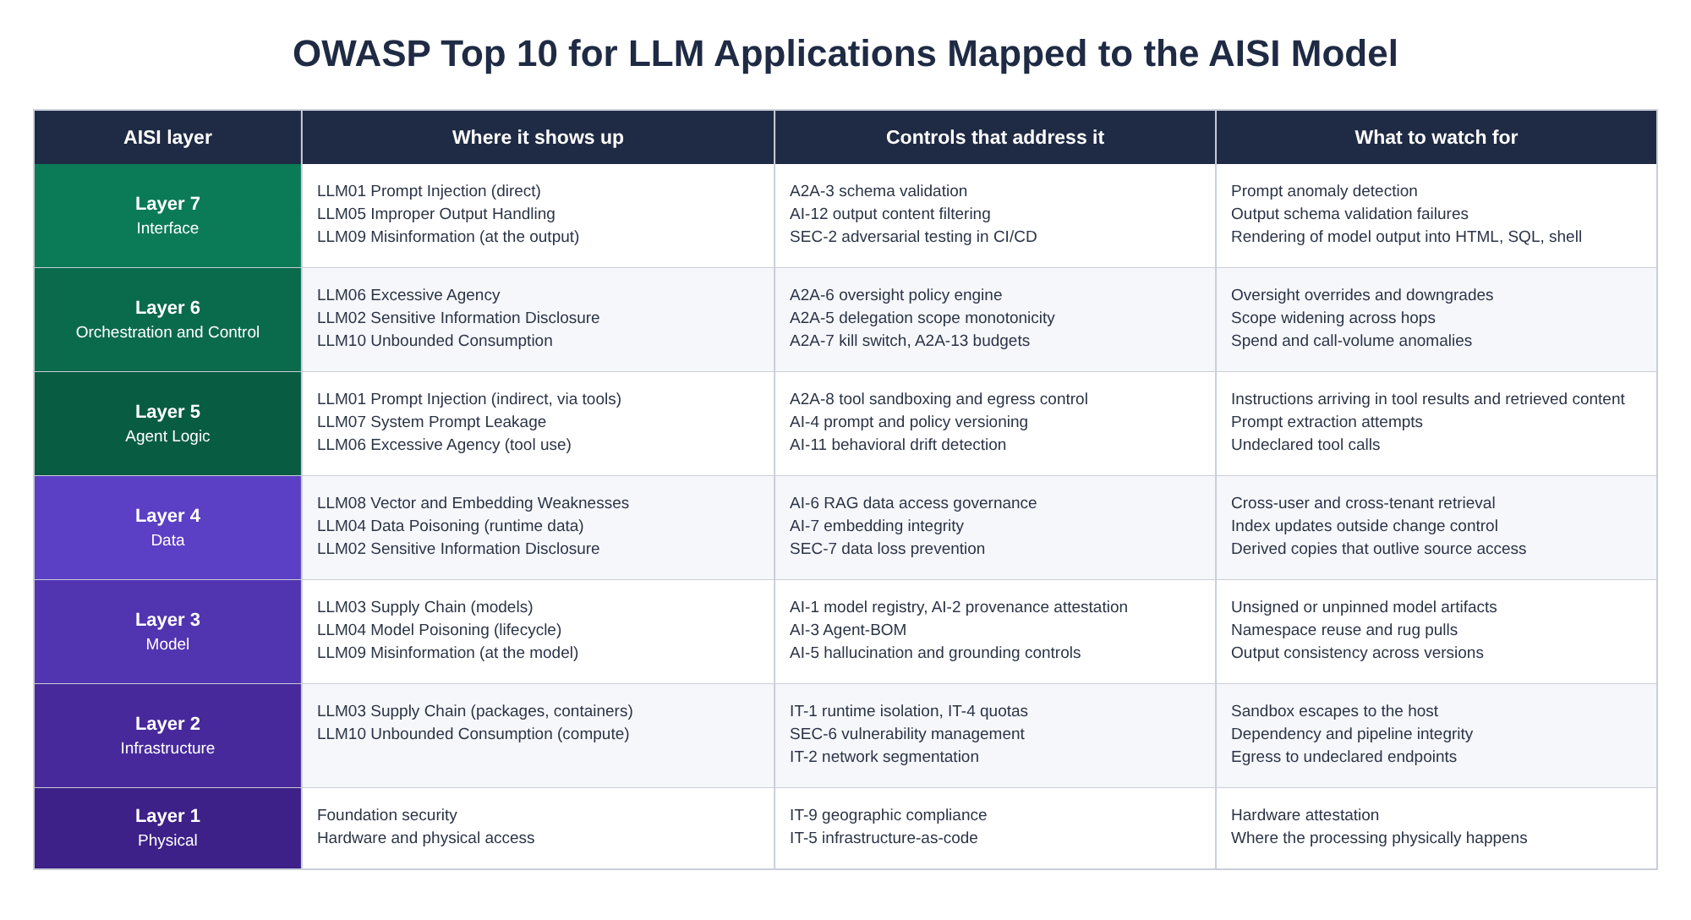
Figure 1: OWASP Top 10 for LLM Applications mapped to the AISI Model
ID | Vulnerability | Layers | Controls | Key mitigations
LLM01 | Prompt Injection | L7, L5 | A2A-6, A2A-8, SEC-2, A2A-3 | Action restrictions enforced outside the model (tool allowlist, declared egress, oversight gates), context isolation, adversarial tests for instructions arriving in retrieved content and tool results. Schema validation rejects malformed payloads and cannot see an instruction inside a valid string
LLM02 | Sensitive Information Disclosure | L6, L4 | SEC-7, AI-6 | Per-query access evaluation on retrieval, data classification before content enters context, data loss prevention (DLP) on responses and tool calls
LLM03 | Supply Chain | L3, L2, L1 | AI-2, AI-3, SEC-9 | Model provenance attestation, Agent-BOM, container and dependency scanning. See Agent Supply Chain
LLM04 | Data and Model Poisoning | L4, L3, lifecycle | AI-7, AI-8, AI-10 | Runtime: index integrity and lineage. Lifecycle: training data provenance and backdoor scanning (Annex A)
LLM05 | Improper Output Handling | L7 | AI-12, A2A-3 | Output encoding, content filtering, schema enforcement before model output reaches HTML, SQL, a shell or a downstream call
LLM06 | Excessive Agency | L6, L5 | A2A-5, A2A-6, A2A-8 | Least privilege on tools, graduated oversight, scope that only narrows through delegation, containment
LLM07 | System Prompt Leakage | L5, L7 | AI-12, SEC-2, AI-4 | No secrets or authorization logic in the prompt, so a leak reveals nothing that grants access; extraction attempts detected in testing and filtered at the output; prompts versioned so a leak traces to a release
LLM08 | Vector and Embedding Weaknesses | L4 | AI-6, AI-7 | Access control on indexes, tenant isolation, embedding integrity checks, audit-logged index updates
LLM09 | Misinformation | L7, L3 | AI-5 | Grounding with source attribution, confidence checked against evaluation results, rules for when the agent declines or escalates
LLM10 | Unbounded Consumption | L6, L2 | IT-4, A2A-13, A2A-7 | Rate limiting, resource quotas, bounded autoscaling, contract-level budget enforcement, circuit breakers

OWASP Top 10 for Agentic Applications (2026)
The OWASP Top 10 for Agentic Applications (2026 edition) is the GenAI Security Project's list for systems that act. Where the LLM list describes what can go wrong with a model, this list describes what can go wrong when the model is given authority, tools, memory and other agents to talk to. That is the problem the AISI Model exists for, so most entries land on the exposed layers and on specific phases of the trust sequence.
ID | Risk | Layers | Trust sequence phase | Controls
ASI01 | Agent Goal Hijack | L5, L7 | Execute Request | A2A-3, A2A-8, AI-4, SEC-2. Untrusted content in prompts, tool results and retrieved documents handled as data; tools, arguments and destinations constrained outside the model
ASI02 | Tool Misuse and Exploitation | L5, L6 | Execute Request | A2A-8, A2A-6, A2A-3. Tool allowlists in the Agent Card, argument schemas enforced, sandboxed execution, declared egress only
ASI03 | Identity and Privilege Abuse | L7, L6 | Identity Exchange, Trust Verification | A2A-1, A2A-4, A2A-5, A2A-12, IT-3. Workload identity per agent, per-hop verification, scope that only narrows, short-lived credentials with tested revocation
ASI04 | Agentic Supply Chain Vulnerabilities | L3, L5, L7 | Discovery | AI-2, AI-3, SEC-9, A2A-2. Signed Agent Cards, Agent-BOM verified at onboarding and before delegated execution, approved external agent and MCP server registry
ASI05 | Unexpected Code Execution | L5, L2 | Execute Request | A2A-8, IT-1. Agent-generated code runs in a microVM or sandboxed kernel with declared egress; tool calls that were not declared are blocked
ASI06 | Memory and Context Poisoning | L4, L5 | Execute Request | AI-6, AI-7, AI-11. Memory and derived stores scoped per user and session, written under the same access rules as the source, drift detected against the contract
ASI07 | Insecure Inter-Agent Communication | L7, L6 | Identity Exchange, Contract Negotiation | A2A-1, A2A-3, A2A-9, A2A-10, A2A-11. Mutual TLS (mTLS) or bound tokens, schema validation, replay protection, contract compliance verification, signed audit trail
ASI08 | Cascading Failures | L6, L2 | Execute Request, Response | A2A-7, A2A-13, IT-4, A2A-4. Circuit breakers and kill switches wired to anomaly triggers, budgets that follow delegation, chain depth limits, bounded resources
ASI09 | Human-Agent Trust Exploitation | L6, L7 | Contract Negotiation and Oversight Selection | A2A-6, AI-12. Oversight chosen by the receiver's policy engine subject to the caller's minimum, approvals bound to the operation and arguments, output filtering
ASI10 | Rogue Agents | L6, L5 | All phases | A2A-7, A2A-12, AI-11, SEC-4, SEC-8. Drift detection against declared contracts, revocation that reaches work in flight, security information and event management (SIEM) correlation across the chain, access reviews that catch agents nobody registered

The two lists overlap at the edges (LLM01 and ASI01, LLM06 and ASI02) and that is fine; the controls that address the LLM entry are mostly the same controls that address the agentic one. Where they differ is ASI03, ASI07, ASI08 and ASI10, which have no LLM-list equivalent at all. Those four are the reason the trust sequence and the audit trail exist.

MITRE ATLAS
MITRE ATLAS (Adversarial Threat Landscape for AI Systems) catalogs adversary tactics and techniques against AI systems, with case studies drawn from incidents and published research. The catalog names the agent-specific techniques this model is built around: context poisoning, tool poisoning, exfiltration and data destruction through tool invocation, autonomous attack orchestration, and supply chain rug pulls. The figure maps the techniques that matter most for agent deployments to the layer where they land, with the ATLAS case study that shows each one in practice. Technique and case study IDs are from v2026.09; ATLAS renumbers and renames between releases, so check the ID against the current release before you cite it.
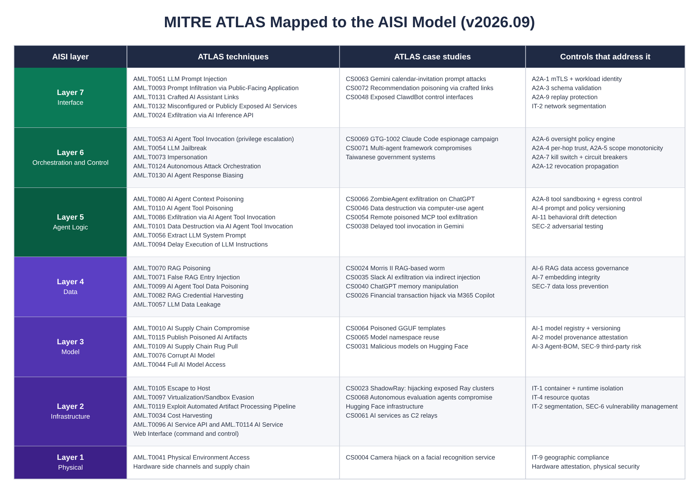
Figure 2: MITRE ATLAS techniques and case studies mapped to the AISI Model (v2026.09)

Case Studies Worth Knowing
These are the ATLAS case studies I point people at most often, because each one shows a control from the baseline doing its job or failing to.
- ShadowRay (AML.CS0023): exposed Ray clusters with no authentication were hijacked for months, with the attackers running cryptomining and stealing credentials from the compute. A layer 2 failure: an inference and training framework exposed to the internet with its job API open. IT-2 and IT-1.
- EchoLeak (AML.CS0059): a zero-click prompt injection against Microsoft 365 Copilot: an email that the assistant retrieved carried instructions that exfiltrated data through a rendered link, with no user interaction. Layers 4 and 7, and the reason AI-6 governs retrieval before content enters context and AI-12 filters what leaves.
- MCP tools as the way in (AML.CS0054, CS0053, CS0045): three cases that differ in a way that matters for the controls. In CS0054, a remote tool's description carried instructions the agent followed, and it sent the user's credentials to the server that published the tool. In CS0053, an npm package posing as the Postmark MCP server built up a following with legitimate versions and then shipped one whose implementation copied every email sent through it to the attacker; ATLAS codes that as implementation poisoning and a supply chain rug pull. In CS0045, the tool itself was clean and the instructions arrived in a web page it fetched for the Cursor editor, which is indirect injection through a tool result. Definitions, implementations and results are all attack surface, which is why Agent Cards carry a tool allowlist (A2A-2), tool execution is sandboxed with declared egress (A2A-8), the Agent-BOM pins server versions (AI-3), and third-party MCP servers go through the due diligence in SEC-9.
- Data destruction via a computer-use agent (AML.CS0046): indirect prompt injection drove an agent with filesystem access to delete data. Oversight was autonomous for an action that should have been gated. A2A-6 and A2A-8.
- GTG-1002 (AML.CS0069): a state-sponsored campaign in which an agentic coding tool was driven to perform most of the intrusion work across roughly thirty targets, with the operator stepping in at a handful of decision points. ATLAS codes it with Autonomous Reconnaissance (AML.T0116) and Autonomous Attack-Path Adaptation (AML.T0117); the multi-agent techniques, Autonomous Attack Orchestration (AML.T0124) and Autonomous AI Agent Communication (AML.T0118), belong to the Taiwanese government case (AML.CS0071). On the defending side it is the argument for behavioral drift detection (AI-11) and for SIEM correlation that can see an agent chain rather than a single call (SEC-4).
- Model namespace reuse and poisoned GGUF templates (AML.CS0065, CS0064): two model supply chain cases. In one, a deleted or renamed model namespace was re-registered by an attacker so that pipelines pulling by name got a different model; in the other, chat templates inside GGUF model files (the llama.cpp file format) carried injected instructions that execute at inference time. AI-1 pins versions, AI-2 requires attestations, and neither helps if the pipeline pulls by name.
- 250-document backdoor (research): Anthropic, the UK AI Security Institute and the Alan Turing Institute showed that about 250 poisoned documents were enough to plant a backdoor in models from 600 million to 13 billion parameters, with the count not growing with model size. The behavior they planted was narrow, a trigger phrase that made the model emit gibberish, under one experimental setup, and the authors did not test larger models or more harmful behaviors. Not an ATLAS case study, but the number that justifies Annex A: training data poisoning is a lifecycle problem, and it is cheap.

Threat Vectors Against the Trust Sequence
The six-phase trust sequence (Discovery, Identity Exchange, Trust Verification, Contract Negotiation and Oversight Selection, Execute Request, Response and Compliance Evidence) is where the model puts its enforcement points, so it is also where an adversary who understands the model will aim. Each phase has attack surface that does not exist in a single-agent system. The vectors are labeled AT-1 through AT-8 (agent threats) so they do not share a prefix with the A2A control IDs; the last two cover agent-to-tool calls.
ID | Threat vector | Layers | Phase | Key mitigations | Controls
AT-1 | Agent or MCP Server Impersonation | L7 | Discovery, Identity Exchange | Cryptographic identity bound to the runtime, mutual authentication before any data exchange, identity chain verified back to a human or accountable principal | A2A-1, A2A-2, A2A-4
AT-2 | Contract Manipulation | L7, L5 | Contract Negotiation | Schema validation of contract claims, runtime behavior monitored against the declared contract, contract integrity checks | A2A-3, A2A-10, AI-11
AT-3 | Trust Chain Poisoning | L6, L5 | Trust Verification | Chain depth limits, per-hop re-verification of identity and scope, anomaly detection at each handoff | A2A-4, A2A-5, AI-11
AT-4 | Delegation Escalation | L6 | Execute Request | Scope, classification and budget that only narrow, every delegation logged, layer 6 enforcing scope independently of agent claims | A2A-5, A2A-13, A2A-11
AT-5 | Audit Trail Manipulation | L6, L7 | Response and Compliance Evidence | Signed, hash-chained segments, completeness checked at every governance checkpoint, gaps raised as security events, segments stored where the agent cannot delete them | A2A-11, IT-6, SEC-4
AT-6 | Oversight Bypass | L6 | Contract Negotiation and Oversight Selection | Oversight classified by the receiver's policy engine, caller-set minimums that cannot be downgraded, every oversight decision logged | A2A-6, A2A-11
AT-7 | Tool Poisoning | L7, L5 | Discovery, Execute Request | Tool allowlists in the signed Agent Card, tool definitions treated as untrusted input, arguments and destinations constrained outside the model, sandboxed execution with declared egress | A2A-2, A2A-3, A2A-8, SEC-9
AT-8 | Context and Memory Poisoning | L5, L4 | Execute Request | Retrieval governed before content enters context, memory and derived stores scoped per user and session under the source's access rules, index updates audit-logged with rollback | AI-6, AI-7, AI-11

Threat Details

AT-1: Agent or MCP Server Impersonation
An adversary presents itself as a trusted agent or MCP server during discovery or identity exchange. Unlike credential theft against a human, this exploits the fact that agents negotiate identity programmatically with nobody checking the counterparty. The mitigations are cryptographic identity bound to the runtime environment, for example a SPIFFE ID (Secure Production Identity Framework for Everyone), mutual authentication before any data exchange, and identity chain verification that traces delegation back to a human or an accountable non-human principal. ATLAS covers the technique as AML.T0073 Impersonation and AML.T0074 Masquerading.

AT-2: Contract Manipulation
A malicious agent presents a behavioral contract during negotiation that differs from its actual behavior: it declares read-only data access and performs writes, or declares no sub-delegation and delegates anyway. The equivalent of a service advertising a safe API and doing something else. Mitigations are schema validation of contract claims, runtime behavioral monitoring against the declared contract, and contract integrity checks on the way back (A2A-10).

AT-3: Trust Chain Poisoning
An attacker compromises one agent in a chain and uses its trusted position to inject malicious payloads downstream. Because agents inherit trust from their callers, a compromised mid-chain agent can reach every agent below it. Mitigations are chain depth limits, per-hop re-verification of identity and permissions, and anomaly detection at each handoff.

AT-4: Delegation Escalation
An agent grants a downstream agent more authority than it was given by its own caller. This is the confused deputy problem with an agent in the middle, and ATLAS tracks the tool-call form of it as AML.T0053 AI Agent Tool Invocation under privilege escalation. Mitigations are scope, classification and budget that can only narrow (never widen), every delegation event logged, and layer 6 enforcing scope boundaries independently of what the agent claims.

AT-5: Audit Trail Manipulation
An agent falsifies, strips or replays trace IDs and segments to evade accountability. If the audit trail relies on agents propagating trace context faithfully, a malicious agent can break it. Mitigations are signing every segment so tampering is detectable, hash-chaining so gaps are detectable, validating completeness at governance checkpoints, and storing segments somewhere the agent that wrote them cannot delete them. The Audit Trail section below covers the mechanics.

AT-6: Oversight Bypass
An agent manipulates oversight selection to obtain autonomous execution for a task that warrants gated or manual oversight: misrepresenting risk, claiming false context, or exploiting permissive defaults. Mitigations are oversight classified by the receiver's policy engine (never the requesting agent), caller-specified minimums that cannot be downgraded, and every oversight decision in the audit trail.

AT-7: Tool Poisoning
The tool definitions an MCP server advertises, the tool's implementation, or the responses it returns carry instructions or behavior the agent was never meant to follow. ATLAS tracks it as AML.T0110 AI Agent Tool Poisoning, with sub-techniques for the definition and the implementation, and AML.T0099 AI Agent Tool Data Poisoning; two of the MCP case studies are exactly this, one through a tool description (CS0054) and one through a backdoored server implementation (CS0053). Mitigations are tool allowlists carried in the signed Agent Card, tool definitions and tool results handled as untrusted input, arguments and destinations constrained outside the model, and sandboxed execution with declared egress so a poisoned tool has nowhere to send what it took.

AT-8: Context and Memory Poisoning
Content placed in a document repository, an index, a chat history or the agent's own memory changes what the agent does later, in a later session or for a different user. ATLAS tracks it as AML.T0080 AI Agent Context Poisoning and, for retrieval-augmented generation (RAG) sources, AML.T0070 RAG Poisoning. Mitigations are retrieval governed before content enters the context window, memory and derived stores scoped per user and session and written under the same access rules as their source, index updates audit-logged with rollback, and drift detected against the declared contract.

The Audit Trail
Traditional governance is vertical. Each system enforces its own policies at each layer. Agents calling agents and tools create a horizontal dimension: a request that crosses three, five or ten systems in sequence. Without horizontal governance you have logs on each system and no way to reconstruct what happened across the chain. The audit trail is how you answer the questions that come after an incident: why did the system make that decision, which agent in the chain introduced the error, and who authorized the action that led here.

How It Is Built
An audit trail record in the AISI Model is not a log. A log records what happened on one system. The audit trail reconstructs what happened across an entire chain, including the governance decisions that allowed each step to proceed, and it operates independently of the data path: when a request fails or is blocked, the trail records why.
Every trail consists of segments. Each segment is produced by one system and covers one hop. A segment records the trace ID, the agent's identity (its SPIFFE ID or equivalent), the layer where the decision was made, the governance action taken (identity verified, contract accepted, oversight level selected, action permitted or blocked), a timestamp, and a cryptographic signature over the segment. Segments are hash-chained: each one carries the hash of the previous segment, so the sequence is tamper-evident. The trace ID is created by the first system in the chain at layer 7 and travels as a required field in every behavioral contract. At each hop, layer 6 writes a new segment before any action executes. If a segment is missing, modified or out of sequence, any downstream system or an auditor can see the gap.
A trace ID ties events together so you can follow one action end to end; it does not stop anyone editing them. Tamper evidence is the separate property, and the outcome is what matters: signed and chained segments are one way to get it, and protected central collection with immutable storage (object lock on the log bucket, for example) is another. Most deployments want both.

Example: Reconstructing a Three-Agent Chain
A customer-facing agent (Agent A) calls a research agent (Agent B), which delegates embedding generation to a specialized service (Agent C). An auditor needs to know why Agent C processed confidential data.
// Trace ID: trace-abc123-def456-789
// Segment 1, Agent A (customer-facing), layer 7
{
"trace_id": "trace-abc123-def456-789",
"segment_index": 1,
"agent": "spiffe://acme.example/agent/customer-facing-v3",
"layer": 7,
"action": "initiate_request",
"details": {
"target": "spiffe://acme.example/agent/research-v2",
"human_principal": "user:jane.doe@acme.example",
"data_classification": "confidential"
},
"timestamp": "2026-03-29T14:00:01Z",
"prev_hash": null,
"signature": "EdDSA:..."
}

// Segment 2, Agent B (research), layer 6
{
"trace_id": "trace-abc123-def456-789",
"segment_index": 2,
"agent": "spiffe://acme.example/agent/research-v2",
"layer": 6,
"action": "trust_verified_contract_accepted",
"details": {
"identity_chain": ["user:jane.doe@acme.example", "customer-facing-v3"],
"oversight_level": "monitored",
"contract_id": "ctr-8f3a2b1c-20260329",
"sub_delegation_permitted": true,
"sub_delegation_scope": ["embedding-service-01"]
},
"timestamp": "2026-03-29T14:00:03Z",
"prev_hash": "sha256:a1b2c3...",
"signature": "EdDSA:..."
}

// Segment 3, Agent B (research), layer 6, delegating to Agent C
{
"trace_id": "trace-abc123-def456-789",
"segment_index": 3,
"agent": "spiffe://acme.example/agent/research-v2",
"layer": 6,
"action": "sub_delegation_initiated",
"details": {
"target": "spiffe://acme.example/agent/embedding-service-01",
"delegated_scope": ["generate_embeddings"],
"data_classification": "confidential",
"contract_permits_delegation": true
},
"timestamp": "2026-03-29T14:00:05Z",
"prev_hash": "sha256:d4e5f6...",
"signature": "EdDSA:..."
}

// Segment 4, Agent C (embedding service), layer 6
{
"trace_id": "trace-abc123-def456-789",
"segment_index": 4,
"agent": "spiffe://acme.example/agent/embedding-service-01",
"layer": 6,
"action": "trust_verified_execution_complete",
"details": {
"identity_chain": ["user:jane.doe@acme.example", "customer-facing-v3", "research-v2"],
"oversight_level": "monitored",
"data_classification": "confidential",
"tokens_used": 450,
"latency_ms": 1200
},
"timestamp": "2026-03-29T14:00:06Z",
"prev_hash": "sha256:g7h8i9...",
"signature": "EdDSA:..."
}

The auditor's question was why Agent C processed confidential data. Segment 1 establishes that a human principal (jane.doe) initiated a request classified as confidential. Segment 2 shows Agent B accepted a contract permitting sub-delegation to the embedding service. Segment 3 shows Agent B delegated with the confidential classification carried along. Segment 4 shows Agent C verified the full identity chain and processed the request under monitored oversight. Every link is signed and hash-chained. Had Agent B tried to delegate to an agent not listed in the contract, segment 3 would show the delegation blocked, and the trail would still record the attempt.

Integrity and the Threat Model
The audit trail is only as trustworthy as its integrity guarantees, and AT-5 targets exactly that: an agent that can falsify, strip or forge segments can evade accountability. The countermeasures are signing each segment (tampering is detectable), hash-chaining (gaps are detectable), validation at every layer 6 governance checkpoint (a missing or invalid segment halts the chain), and independent storage (a compromised agent cannot delete its own segments after the fact). Baseline control A2A-11 specifies these requirements, and IT-6 and SEC-4 cover where the segments go and who correlates them.
Signatures and hash links do not prove completeness. A chain shows edits and gaps inside the sequence; a chain cut short is still internally consistent, and a segment that was never written leaves no gap to find. Completeness needs an anchor the writer does not control: the central collector signs and stores a checkpoint of the latest segment hash on a schedule (or publishes it to an external timestamping service), and layer 6 writes a closing segment when the action completes, so a trail without one is known to be incomplete rather than assumed to be whole. Parallel delegation produces a tree rather than a chain: each branch chains to the parent segment that spawned it, and the parent records the branch heads when it closes, so an auditor can walk every branch from the root.

Agent Supply Chain
OWASP LLM03 covers the model supply chain: poisoned training data, compromised weights, malicious packages. Agents add a second supply chain on top of it: the agents and MCP servers themselves. When your system delegates work to a third-party agent or calls a third-party MCP server, you are trusting that party's model, tools, data access and behavior, and none of that is visible at the interface. A model can be safe and wrapped in an agent that misuses it. An agent can declare certain capabilities and quietly invoke undisclosed tools. A tool can change behavior after you approved it, which ATLAS names as AML.T0109 AI Supply Chain Rug Pull.
Control | Layers | What it requires
Agent and MCP server provenance | L5, L3 | Verify the origin, version and integrity of third-party agents and MCP servers before allowing them into a chain. Pin versions; pull by identity, not by name.
Tool access verification | L6, L5 | Confirm that a third party's declared tool access matches its actual capabilities and permissions, and re-check when its tool definitions change.
Behavioral contract honoring | L7, L5 | Monitor whether agents fulfill the contracts they advertised during negotiation, and treat a mismatch as a security event rather than a bug.
Agent bill of materials | L3, L2 | Require an Agent-BOM listing the model, tools, data sources and dependencies an agent relies on (AI-3).
Runtime attestation | L6, L2 | Continuously verify that an agent's runtime environment matches its declared configuration.

How This Differs From the Model Supply Chain
- Scope: the model supply chain (LLM03) covers weights, training data and packages. The agent supply chain covers the whole runtime: model, tools, data, behavioral contracts and orchestration logic, plus every MCP server in reach.
- Dynamism: models are mostly static after deployment. Agents change behavior at runtime based on instructions, tool availability and delegated context, and a tool definition can change under you. Supply chain verification has to be continuous.
- Composition: one agent may compose several models, tools and data sources. The supply chain is a graph, not a list, and the Agent-BOM captures that structure.
- Trust propagation: when Agent A delegates to Agent B, Agent A's users are trusting Agent B's entire supply chain without knowing it. Delegation creates transitive trust that has to be bounded explicitly (A2A-5, SEC-9).

Annex A: Model Lifecycle and Supply Chain Controls
The seven layers describe a runtime architecture. Several of the risks that matter most originate before runtime, in the training, fine-tuning, evaluation and release pipeline. These are external dependencies of the stack: they decide the integrity of what gets deployed, and they do not map cleanly to a single runtime layer.
The boundary matters because of where you will look: if you treat training data poisoning as a layer 4 problem, you will look for it in your vector stores and RAG indexes, and it happens upstream, before the model reaches layer 3. Layer 4 is runtime data: vector stores, indexes, embeddings and agent memory that get updated, rotated and audited during operation. Training data is consumed during model development and baked into the weights; you cannot inspect, rotate or patch it at runtime. Different controls, different attack surface, different team.
The control objectives below keep the seven-layer runtime architecture clean while making lifecycle controls explicit. They line up with the EU AI Act's Annex XI documentation requirements for general-purpose AI models (training process, data provenance, computational resources and, for systemic-risk models, evaluation strategies and adversarial testing). A provenance and attestation framework such as Supply-chain Levels for Software Artifacts (SLSA) is the practical way to meet the build and artifact integrity goals. For models a provider runs for you, the equivalents are the provider's published model version, its evaluation evidence and its attestations, pinned (AI-1, AI-2).

1. Dataset Governance
- Provenance and acquisition records: keep a record of every data source used in training and fine-tuning: version, date, source, licensing, and the curation or filtering method applied. Document cleaning, deduplication and filtering. This is the training equivalent of a software bill of materials (SBOM).
- Poisoning detection and source management: run automated poisoning detection. Keep source allowlists and blocklists. About 250 documents can backdoor models from 600 million to 13 billion parameters; the threshold is low.
- Synthetic data tracking: label and track all synthetic data in training corpora. Limit synthetic-to-human ratios. Verify the provenance and quality of synthetic data generators, since feedback loops are how model collapse starts (AI-10).

2. Training and Fine-Tuning Run Governance
- Training run manifest: record training configuration, code version, hyperparameters and compute used for every run. Keep a reproducible mapping from inputs to outputs. This is the training equivalent of a build manifest (AI-8).
- Pipeline access controls: the training and fine-tuning pipeline gets access controls at least as strict as the production deployment pipeline. Audit every modification to training data, hyperparameters and fine-tuning datasets. This is where fine-tuning hijacking, changing model behavior by compromising the pipeline rather than the weights, gets stopped.

3. Evaluation and Red Teaming
- TEVV metrics and adversarial tests: define test, evaluation, verification and validation (TEVV) metrics and adversarial test suites before training. Version every evaluation artifact alongside the model. Public benchmark scores on their own prove little; models can be tuned to score well without the capability improving (AI-9).
- Regression and safety tracking: track regression and safety and security change across releases. Flag any capability jump or behavioral change the evaluation suite did not predict.

4. Release Engineering
- Versioned release artifacts: version models, system prompts and policies, tool schemas and Agent Cards as release artifacts. Every deployment traces to a specific release (AI-4).
- Change approval gates: require explicit approval for releases that introduce new capabilities, expand tool access or cross systemic-risk thresholds, with both engineering and governance at the table (IT-10).

5. Artifact Signing and Attestation
- Signed model artifacts: sign model weights, adapters and configuration files. Publish provenance attestations that bind the artifact to its training run manifest, evaluation results and approval record (AI-2).
- Deployment pipeline verification: enforce provenance verification in the deployment pipeline. Unsigned or unverified artifacts fail closed. This is code signing for models, and pulling a model by name instead of by pinned identity is how namespace reuse gets past it.

6. Post-Release Monitoring
- Drift and misuse monitoring: monitor for behavioral drift, misuse indicators and exploit attempts in production, and feed findings back into retraining and evaluation decisions (AI-11).
- Incident-to-retrain pipeline: when a runtime incident traces back to a model-level issue rather than a data or orchestration issue, there is a governed path from incident analysis to retraining decision to new release, with every control above applied again.

Relationship to the Runtime Stack
Lifecycle controls decide what gets deployed at layer 3 and indirectly shape layer 4 through fine-tuning on domain data, but they live outside the runtime stack. Treat the model lifecycle as a governed upstream dependency, the way software teams treat their CI/CD pipeline. Governance in the model extends upstream to cover lifecycle audits; the seven layers describe the running system, not the build. The handoff point is layer 3: a model artifact that passes lifecycle controls (provenance attestation, evaluation thresholds, safety benchmarks) is eligible for deployment. One that fails them does not reach layer 3, whatever the state of readiness at the other layers.

Governance Across the Stack
Governance is not a layer. It is drawn as a bar that spans all seven layers on both sides of every connection, with a governance checkpoint at layer 6 where trust, policy, the behavioral contract and the oversight level are decided. Layer 6 is where enforcement is most visible; the requirements from NIST AI RMF, the EU AI Act and ISO/IEC 42001 cascade through the entire stack. If you only enforce governance at the orchestration layer, you miss data provenance at layer 4, supply chain controls at layer 3 and infrastructure monitoring at layer 2. The figure makes those gaps visible by mapping each framework's requirements to the layers where they apply. The per-control mappings below cover NIST AI RMF, the EU AI Act and ISO/IEC 42001; the CSA AI Controls Matrix is described rather than mapped control by control.
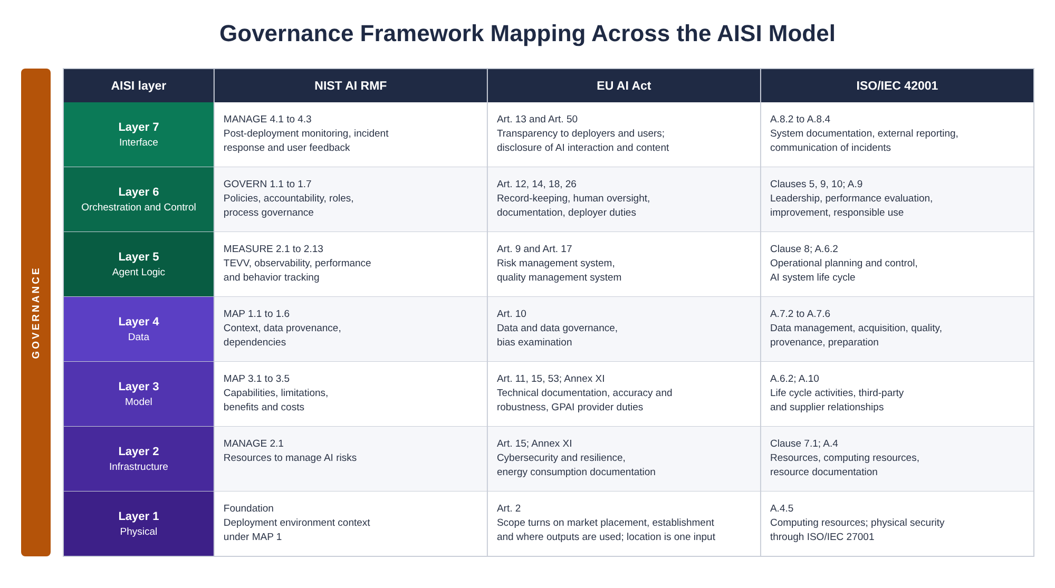
Figure 3: Governance framework mapping across the AISI Model

Framework Highlights
- NIST AI RMF 1.0: the GOVERN function spans all layers. MEASURE requires observability throughout the stack for TEVV. The Generative AI Profile (NIST AI 600-1) adds twelve risk categories specific to generative AI.
- EU AI Act (high-risk systems): Article 12 requires high-risk AI systems to technically enable automatic logging. Article 19 requires providers of high-risk systems to keep the automatically generated logs that are under their control for at least six months, and Article 26(6) requires the same of deployers for the logs under their control, in each case unless Union or national law provides otherwise, which includes data protection law and can shorten the period as well as lengthen it. Article 14 requires human oversight interfaces. Article 18 requires providers to keep technical documentation for ten years after the system is placed on the market. Article 53 and Annex XI set the documentation duties for general-purpose AI model providers.
- ISO/IEC 42001: a certifiable AI management system standard. Management system clauses 4 through 10 and 38 reference controls in Annex A, with implementation guidance in Annex B. Clauses are the system; Annex A is the controls.
- CSA AI Controls Matrix: the AI Controls Matrix (AICM) organizes its control objectives into domains that include a dedicated Model Security domain, with mappings to ISO/IEC 42001, NIST AI RMF and AI 600-1, the EU AI Act, BSI AIC4 and AIUC-1 for agentic systems.

NIST AI RMF Mapping
Function | Controls | How the model meets it
GOVERN (organizational governance) | SEC-10 compliance evidence, IT-10 change management, A2A-6 oversight policy engine | GOVERN spans all seven layers and requires policy enforcement at layer 6 with evidence collection across the stack.
MAP (context and risk identification) | SEC-1 agent threat modeling | MAP requires understanding the system's operating context, which the seven-layer decomposition supports by making attack surface visible per layer.
MEASURE (assessment and monitoring) | AI-9 evaluation and red teaming, AI-11 behavioral drift detection, IT-6 observability stack, A2A-11 tamper-evident audit trail | MEASURE's TEVV requirements map to continuous monitoring at layers 5 and 6 with infrastructure telemetry at layer 2. For drift detection in operation (baselines, thresholds, response playbooks), see the Operations and Lifecycle Reference.
MANAGE (risk treatment and response) | A2A-6 oversight policy engine, A2A-7 kill switch and circuit breakers, SEC-5 incident response playbooks | MANAGE requires controls that layer 6 can act on in real time.
Generative AI Profile (AI 600-1) | AI-12 (content provenance, layer 7), AI-5 (confabulation, layers 5 and 4), SEC-7 (data privacy, layers 4 and 7), AI-5 and AI-9 (information integrity, layer 5) | The profile's risk categories land on the layers where the control for each one already sits.

EU AI Act Mapping
Article | Controls | How the model meets it
Article 9, risk management system | SEC-1 agent threat modeling, A2A-6 oversight policy engine, SEC-5 incident response | A risk management system established, documented and maintained across the lifecycle; governance in the model provides the frame, the Baseline Controls provide the mechanisms.
Article 10, data and data governance | AI-6 RAG data access governance, AI-7 embedding integrity, AI-8 training pipeline governance, AI-10 synthetic data controls | Covers training, validation and testing data with provenance, bias examination and gap identification. Layer 4 is the runtime enforcement point; Annex A covers pre-deployment data governance.
Article 12, record-keeping | A2A-11 tamper-evident audit trail, IT-6 observability stack | High-risk systems technically enable automatic recording of events relevant to identifying risks and substantial modifications. The audit trail provides it end to end across a chain. For retention enforcement across agent storage, see the Operations and Lifecycle Reference.
Article 14, human oversight | A2A-6 oversight policy engine | Human oversight interfaces that let a person understand capacities and limitations, monitor operation and intervene, including a stop. Graduated oversight at layer 6 with kill switches and human-in-the-loop gates supports these requirements; human oversight under the Act is broader than assigning a gated status, and the interface, training and competence requirements sit outside the control.
Article 15, accuracy, robustness and cybersecurity | AI-5 hallucination and grounding controls, AI-11 behavioral drift detection, SEC-2 adversarial testing, A2A-1 mTLS and workload identity | Accuracy through grounding and drift detection, robustness through adversarial testing, cybersecurity through authenticated channels.
Articles 19 and 26(6), log retention | A2A-11, IT-6, IT-7 and the retention_policy contract term | Providers and deployers each keep the logs under their control for at least six months, unless Union or national law, including data protection law, provides otherwise.
Article 53 and Annex XI, general-purpose AI model documentation | AI-1 model registry, AI-2 provenance attestation, AI-8 training pipeline governance, IT-8 sustainability metrics | Capabilities, limitations, training methodology, evaluation results and energy consumption.

ISO/IEC 42001 Mapping
Phase | Controls | How the model meets it
Plan | SEC-1 agent threat modeling, SEC-10 compliance evidence | AI policy, objectives and risk assessment; the layer decomposition is the structure for risk identification.
Do | All A2A, AI and IT controls | Each layer has corresponding controls in the Baseline Controls.
Check | AI-9 evaluation and red teaming, AI-11 behavioral drift detection, SEC-8 access reviews, IT-6 observability | Monitoring, measurement, evaluation and internal audit.
Act | SEC-5 incident response playbooks, AI-8 training pipeline governance, IT-10 change management | Nonconformity, corrective action and continual improvement.

Companion Documents
This document is part of the AISI Model document set.
- AISI Model: the seven-layer reference architecture, the two boundaries and the six-phase trust sequence.
- Quick Start Guide: the core model and the Baseline Controls condensed into one starting point.
- A2A Protocol Specification: Agent Cards, behavioral contracts (including data classification and retention enforcement), authentication and the four oversight levels.
- Baseline Controls: the 45 controls, grouped by the team that builds them, with priorities and the conditions that move a control up.
- Implementation Guide: how to deploy on production infrastructure: namespaces, workload identity (SPIFFE and SPIRE), mTLS, network policy, Open Policy Agent, OpenTelemetry, Vault and the container supply chain.
- Operations and Lifecycle Reference: how to run it after deployment: behavioral drift detection, shadow AI discovery, RAG index freshness, prompt versioning, agent memory hygiene, change control and decommission.

