Artificial Intelligence System Interconnection
(AISI) Model
Version 1.0 – A Reference Architecture for How AI Systems Are Built, Connect, and Stay Governed
At a Glance
AI agents are calling other AI agents in production. There’s no shared framework for how they connect. The AISI Model is a seven-layer reference architecture (like the OSI model, but for AI) that gives engineering, security, and compliance teams a common language for how AI systems are built internally and how they communicate externally.
The bottom four layers stay private. The top three are where agent-to-agent interaction happens. The model defines a negotiation sequence (identity, trust, contracts, oversight) and governance spans the full stack. Result: interoperability, security boundaries, accountability, and auditability by default.

Before You Start
The AISI Model is a reference architecture, not a standard, a regulation, or a compliance requirement. It does not carry the force of law or certification authority. No organization is obligated to adopt it, and adopting it does not guarantee compliance with any regulatory framework.
Everything in this document set is a starting point. The layer definitions, protocol structures, control baselines, configs, code examples, and operational procedures are reference material that your organization must adapt to its own infrastructure, threat model, risk posture, and regulatory obligations. Nothing here is production-ready out of the box. Test in a non-production environment, adjust for your context, and validate before promoting to production.
Where these documents reference regulatory frameworks (EU AI Act, NIST AI RMF, ISO/IEC 42001), those references are informational mappings, not authoritative interpretations. Consult qualified legal, security, and compliance professionals for decisions specific to your environment.

Why This Exists
AI agents are calling other AI agents in production. A customer-facing agent routes to a research agent, which calls a knowledge agent, which checks policy with a compliance agent. But there’s no shared way to describe how these systems are built or how they should connect. Every team draws a different diagram. Every vendor uses different terms. Every integration is bespoke. The networking world solved this with the OSI model. The AISI Model does the same thing for AI: seven layers, a common vocabulary, and a protocol-agnostic framework that engineering, security, and compliance teams can all point to.

How It’s Built: The Seven Layers
Every AI system can be described using these seven layers. The bottom four are internal and never shared. The top three are where systems interact with the outside world and with each other.
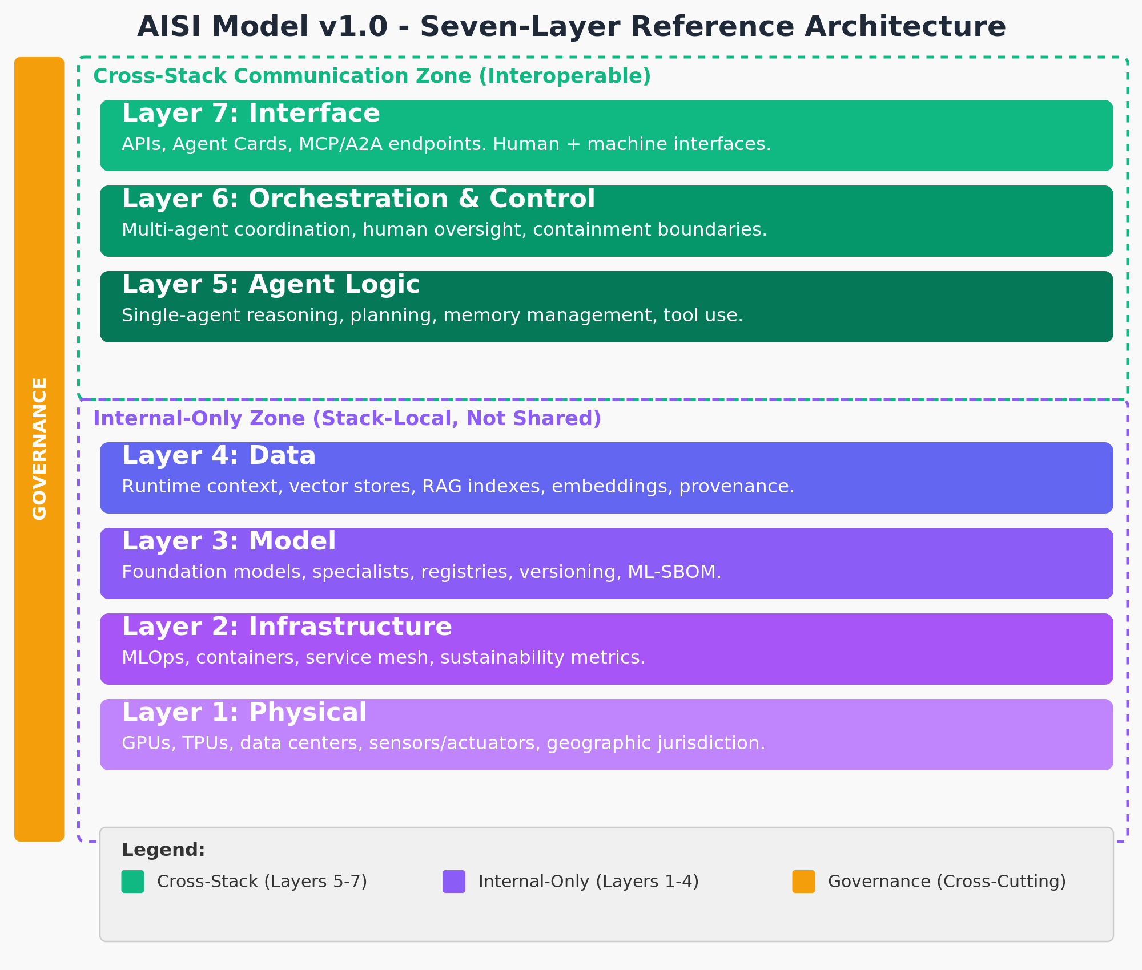
Figure 1: The AISI Model v1.0 – Seven Layers with Cross-Cutting Governance

The Shared Layers (5–7)
These are the layers visible when AI systems communicate. They handle everything from raw reasoning to multi-agent coordination to the external APIs that connect to the rest of the world.
Layer 7 – Interface. The front door. This is where requests arrive and results get returned through APIs, webhooks, conversational surfaces, and Agent Cards (structured descriptions of capabilities). Current protocols include MCP for tool integration and A2A for agent coordination, but the model is designed so that when the next protocol standard shows up, this layer adapts without requiring changes below it. Between systems, Layer 7 is where the A2A handshake happens: the initiating agent presents its identity credentials and a trace ID, publishes its Agent Card, and proposes a behavioral contract. The receiving system validates the identity, evaluates the capabilities, and either accepts the contract or negotiates different terms.
Layer 6 – Orchestration and Control. The traffic controller. This layer coordinates multi-step workflows, decides whether an action should proceed, manages approval workflows, and enforces containment boundaries: supervisor patterns, kill switches, circuit breakers, and human-in-the-loop gates. Between systems, Layer 6 validates the identity chain, selects the appropriate oversight level based on risk, enforces behavioral contracts, and maintains the accountability chain: who authorized the action, which policy permitted it, and who bears liability.
Layer 5 – Agent Logic. The brain. Reasoning, planning, and memory management happen here. ReAct loops, chain-of-thought processing, tool selection and invocation, context window management, and state persistence all live at Layer 5.

The Private Layers (1–4)
These layers are never exposed across system boundaries. When System A talks to System B, none of this crosses the wire. That isolation is fundamental to how the architecture works.
Layer 4 – Data. The information an agent reasons over at runtime: vector stores, RAG indexes, embeddings, knowledge graphs, and persistent memory. This is explicitly not training data or fine-tuning corpora. Those are upstream supply chain inputs. Layer 4 is data that can be updated, rotated, and audited during operation.
Layer 3 – Model. The callable intelligence as deployed. Foundation models, fine-tuned specialists, model registries, version management, and routing logic. The training pipeline is an upstream dependency, not part of the runtime stack.
Layer 2 – Infrastructure. Container orchestration, MLOps pipelines, service mesh, monitoring, and autoscaling. Also where operational sustainability metrics belong: energy, water, and carbon tracked as engineering requirements. For GPAI models, the EU AI Act requires documentation of training-phase energy consumption (Annex XI).
Layer 1 – Physical. GPUs, TPUs, NPUs, memory, storage, networking, data centers, and geographic locations. For embodied AI, this includes sensors and actuators. Where your hardware sits determines which regulations apply.

How Systems Connect
When AI System A needs something from AI System B, communication only flows through the top three layers. The bottom four stay completely isolated on each side. Systems can collaborate without exposing their internal structure. You can swap your model, change your data sources, or migrate infrastructure, and connected systems never know the difference.
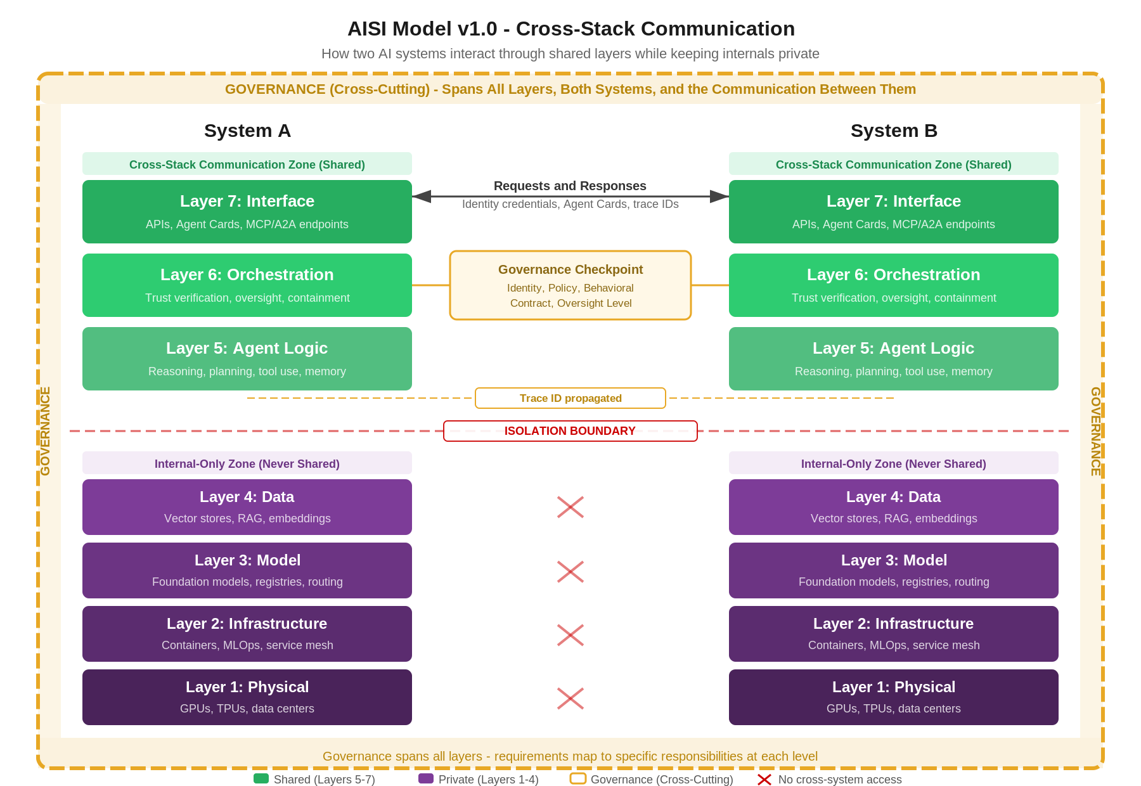
Figure 2: Cross-Stack Communication – How Two AI Systems Interact

What Crosses the Boundary
- Identity credentials and trace IDs (correlation identifiers that follow requests across the chain)
- Agent Cards: structured capability descriptions and behavioral contracts
- Structured requests and responses (with schema validation)
- Oversight metadata: trust verification results, policy decisions, accountability records
- Validated output payloads with contract compliance attestation

What Stays Private
- Model weights and architecture details
- Training data, embeddings, and RAG indexes
- Infrastructure configuration and compute details
- Internal reasoning traces and decision logs

The A2A Negotiation Sequence
This is what makes the AISI Model work like the OSI model: not just anatomy, but a specification for how communication happens. The sequence is protocol-agnostic: it describes the phases that must happen regardless of whether agents talk over MCP, Google A2A, REST, or whatever comes next.
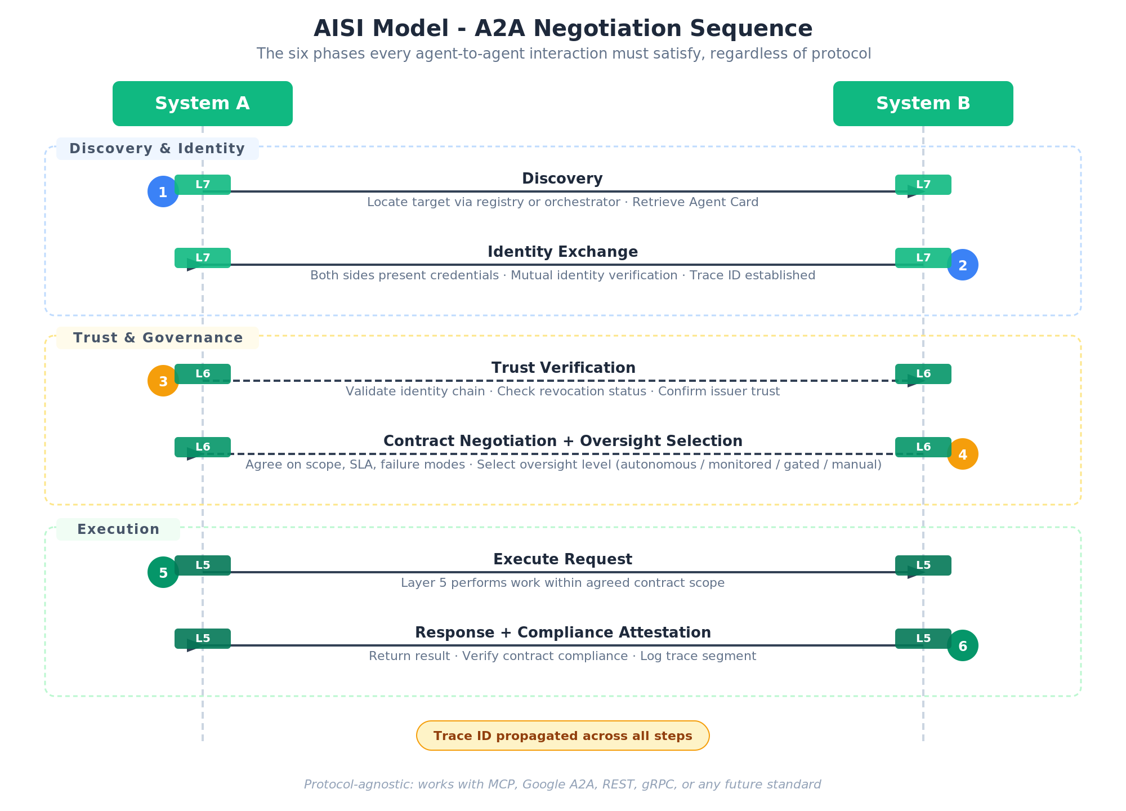
Figure 3: A2A Negotiation Sequence – How Agents Establish Trust and Communicate
- Discovery. The requesting agent locates a target agent through a registry, direct reference, or orchestrator. The target’s Agent Card (published at Layer 7) describes its capabilities, supported protocols, and behavioral contract terms.
- Identity Exchange. Both systems present credentials at Layer 7. These can be certificates, tokens, or verifiable claims. The model doesn’t prescribe the mechanism, but it requires that identity is established before any request is processed.
- Trust Verification. Layer 6 on the receiving side verifies the requesting agent’s identity chain. Is the credential valid? Is the issuer trusted? Has trust been revoked? This is the equivalent of TLS certificate validation in networking.
- Contract Negotiation. The requesting agent proposes terms (or accepts the target’s published defaults): what it’s asking for, what scope of action it authorizes, what response time it expects, and what happens on failure. Both sides agree before execution begins.
- Oversight Selection. Layer 6 on the receiving side evaluates the request against policy and selects the appropriate oversight level: autonomous, monitored, gated, or manual.
- Execution and Response. Layer 5 performs the work. The response travels back through Layer 6 (where contract compliance is verified and logged) and Layer 7 (where it’s formatted and returned to the caller). The trace ID follows every step.
When the next protocol standard emerges, you swap the protocol at Layer 7 and everything below it stays the same. For the detailed specifications of Agent Cards, Behavioral Contracts, Authentication mechanisms, and Graduated Oversight levels, see the companion A2A Protocol Specification.

Getting Started
The AISI Model is designed to be adopted incrementally. Where you start depends on what you’re building and what you already have in place.

Single-Agent Systems
If you’re deploying a single AI agent without agent-to-agent communication, focus on Layers 1 through 5 and the Baseline Controls document. The private layers (data, model, infrastructure, physical) need governance regardless of whether A2A is in your future. Start with the P1 controls in the AI/ML and IT Infrastructure categories: model registry, provenance attestation, prompt versioning, container isolation, secrets management, and resource quotas. These are table stakes for any production AI deployment.

Multi-Agent Systems Within a Single Organization
Once your agents need to talk to each other, the top three layers (Agent Logic, Orchestration and Control, Interface) and the A2A negotiation sequence come into play. Start with the A2A Protocol Specification: implement Agent Cards for discovery, behavioral contracts for accountability, and the graduated oversight model. The P1 A2A Protocol Controls (A2A-1, A2A-2, A2A-6, A2A-7) are your first priorities, followed by the P2 controls (A2A-3, A2A-4, A2A-5). The companion Security Reference’s A2A threat vectors (A2A-01 through A2A-06) should inform your threat model before you go to production.

Cross-Organization Agent Integration
When your agents interact with agents owned by other organizations, every layer of the model matters. The trust boundary is no longer just a technical concern; it’s a legal and contractual one. Start with identity and authentication (SPIFFE/SPIRE workload identities, mutual TLS), then layer on behavioral contracts with explicit data classification, retention policies, budget limits, and sub-delegation constraints. The Security Reference’s agent supply chain section and the Baseline Controls’ third-party agent risk control (SEC-9) become critical.

Compliance-Driven Adoption
If regulatory compliance is your primary driver, start with the Security Reference’s governance framework mapping. It maps NIST AI RMF, EU AI Act, ISO/IEC 42001, and CSA AI Controls Matrix requirements to specific AISI layers. Use this mapping to identify which layers and controls are relevant to your obligations, then work through the Baseline Controls in priority order. The framework mapping gives you the traceability auditors will ask for.

What’s Ahead
Self-improvement containment. As AI systems approach recursive self-improvement, Layer 6 needs containment protocols: sandboxing, verification of improvement claims, and automatic rollback.
Deeper trust mechanisms. Cryptographic proof-of-computation, behavioral anomaly detection across agent chains, and formal verification of agent contracts.
Model collapse prevention. Layer 4 needs data provenance tracking to distinguish human-generated from AI-generated content, with controls on synthetic data ratios.
Sustainability. AI infrastructure is projected to consume 731–1,125 million cubic meters of water annually by 2030 in the US alone. Layer 2 should treat energy, water, and carbon as operational engineering requirements.

What This Version Covers
This version focuses on LLM-based and agentic AI, the architectures driving most enterprise adoption today. The seven-layer structure applies broadly to other modalities, but the patterns and examples here reflect generative AI and multi-agent systems in 2025.

Companion Documents
- A2A Protocol Specification. Detailed specifications for Agent Cards, Behavioral Contracts, Authentication and Authorization (SPIFFE/SPIRE, mTLS, sender-constrained tokens), and Graduated Oversight levels.
- Security Reference. OWASP Top 10 and MITRE ATLAS mapped to AISI layers, A2A-specific threat vectors, agent supply chain risks, model lifecycle controls, and governance framework mapping across the stack.
- Baseline Controls. The minimum required controls for production A2A deployments, organized by team: A2A protocol, AI/ML, IT infrastructure, and security operations.
- Implementation Guide. How to deploy A2A systems on production infrastructure: namespaces, SPIRE, mTLS, NetworkPolicy, OPA, OpenTelemetry, Vault, and container supply chain.
- Operations and Lifecycle Reference. How to operate, monitor, and manage A2A systems after deployment: behavioral drift detection, shadow AI discovery, RAG index freshness, prompt versioning, agent memory hygiene, change control, and decommission.

Bottom Line
Agent-to-agent communication is here. The question isn’t whether your AI systems will need to talk to each other. It’s whether they’ll do it through a coherent architecture or through ad-hoc integrations that break at scale.
The AISI Model gives you the coherent architecture. Seven layers with clear responsibilities. A communication boundary that separates what’s shared from what’s private. A negotiation sequence for identity, trust, contracts, and oversight. Governance that spans the full stack, vertical within each system and horizontal across agent chains through the trace plane.
The organizations that adopt a common framework for A2A now will be the ones that can scale their AI systems reliably. AISI gives you the framework.

