AISI Model v1.0
Quick-Start Guide
A condensed reference for the Artificial Intelligence System Interconnection Model

What This Is
AI agents are calling other AI agents in production. A customer-facing agent routes to a research agent, which calls a knowledge agent, which checks policy with a compliance agent. There is no shared framework for how they connect.
The AISI Model is a seven-layer reference architecture (like the OSI model, but for AI) that gives engineering, security, and compliance teams a common language for how AI systems are built internally and how they communicate externally. The bottom four layers stay private. The top three are where agent-to-agent interaction happens. The model defines a negotiation sequence, a control baseline, and governance that spans the full stack.
This Quick-Start Guide condenses six companion documents (the core architecture, A2A Protocol Specification, Baseline Controls, Security Reference, Implementation Guide, and Operations and Lifecycle Reference) into a single starting point. For full detail on any topic, refer to the companion that covers it.

Before You Start
The AISI Model is a reference architecture, not a standard, a regulation, or a compliance requirement. It does not carry the force of law or certification authority. No organization is obligated to adopt it, and adopting it does not guarantee compliance with any regulatory framework.
Everything in this document set is a starting point. The layer definitions, protocol structures, control baselines, and operational procedures are reference material that your organization must adapt to its own infrastructure, threat model, risk posture, and regulatory obligations. Nothing here is production-ready out of the box.
Where these documents reference regulatory frameworks (EU AI Act, NIST AI RMF, ISO/IEC 42001), those references are informational mappings, not authoritative interpretations. Consult qualified legal, security, and compliance professionals for decisions specific to your environment.

The Seven Layers
Every AI system can be described using seven layers. Layers 1 through 4 are private to each system and never cross trust boundaries. Layers 5 through 7 are where systems interact. Governance spans the full stack.
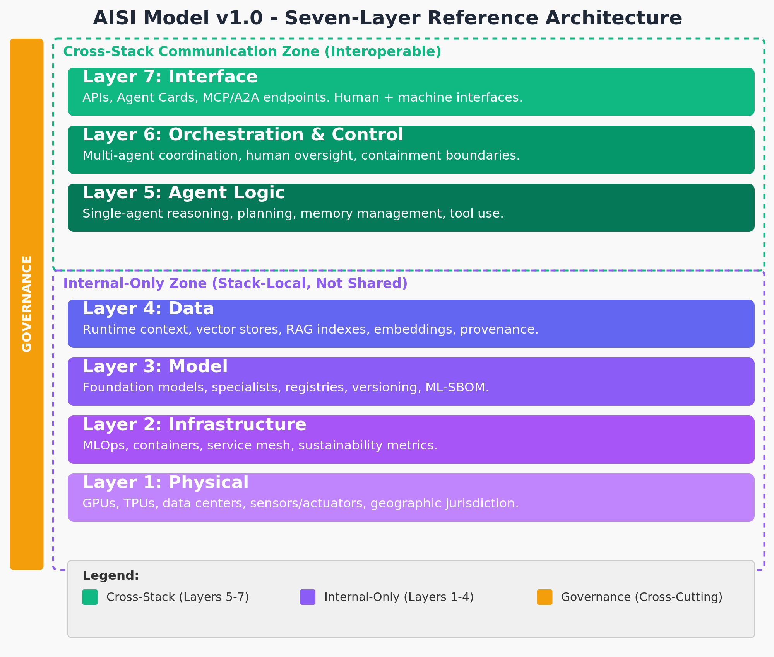
Figure 1: The AISI Model v1.0: Seven Layers with Cross-Cutting Governance
- Layer 7 (Interface): The front door. Agent Cards, APIs, and protocol handshake (MCP, A2A). Where requests arrive and results get returned.
- Layer 6 (Orchestration/Control): The traffic controller. Coordinates multi-step workflows, enforces behavioral contracts, selects oversight levels, and manages circuit breakers and kill switches.
- Layer 5 (Agent Logic): The brain. Reasoning, planning, memory management, tool selection, and context window management.
- Layer 4 (Data): Runtime information the agent reasons over: RAG indexes, vector stores, embeddings, knowledge graphs, and persistent memory. Not training data.
- Layer 3 (Model): The callable intelligence as deployed. Foundation models, fine-tuned specialists, model registry, and version routing.
- Layer 2 (Infrastructure): Containers, orchestration, service mesh, MLOps pipelines, autoscaling, and operational sustainability metrics.
- Layer 1 (Physical): GPUs, TPUs, storage, networking, data centers, and geographic location. Where your hardware sits determines which regulations apply.

Governance and tracing cut across all seven layers. Every request that enters the stack gets a trace ID, and that ID follows the request through every layer, every agent hop, and every delegation. The trace plane uses OpenTelemetry with hash-chained spans so that audit trails are tamper-evident and can be reconstructed end to end.

How Systems Connect
When AI System A needs something from AI System B, communication only flows through the top three layers. The bottom four stay completely isolated on each side. You can swap your model, change your data sources, or migrate infrastructure, and connected systems never know the difference.
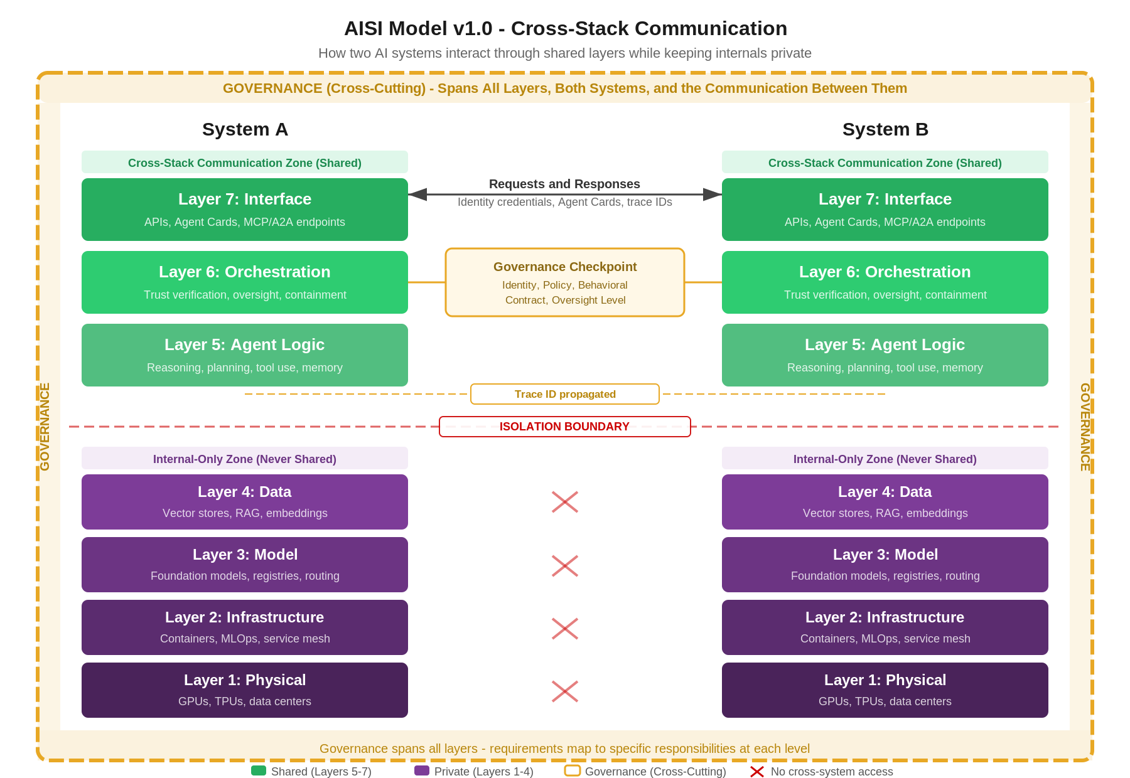
Figure 2: Cross-Stack Communication: Shared Layers Above, Isolation Below

The A2A Negotiation Sequence
Every agent-to-agent interaction follows a structured handshake sequence. Discovery and identity happen at Layer 7, trust verification and contract negotiation happen at Layer 6, and execution happens at Layer 5. The trace ID propagates across all steps.
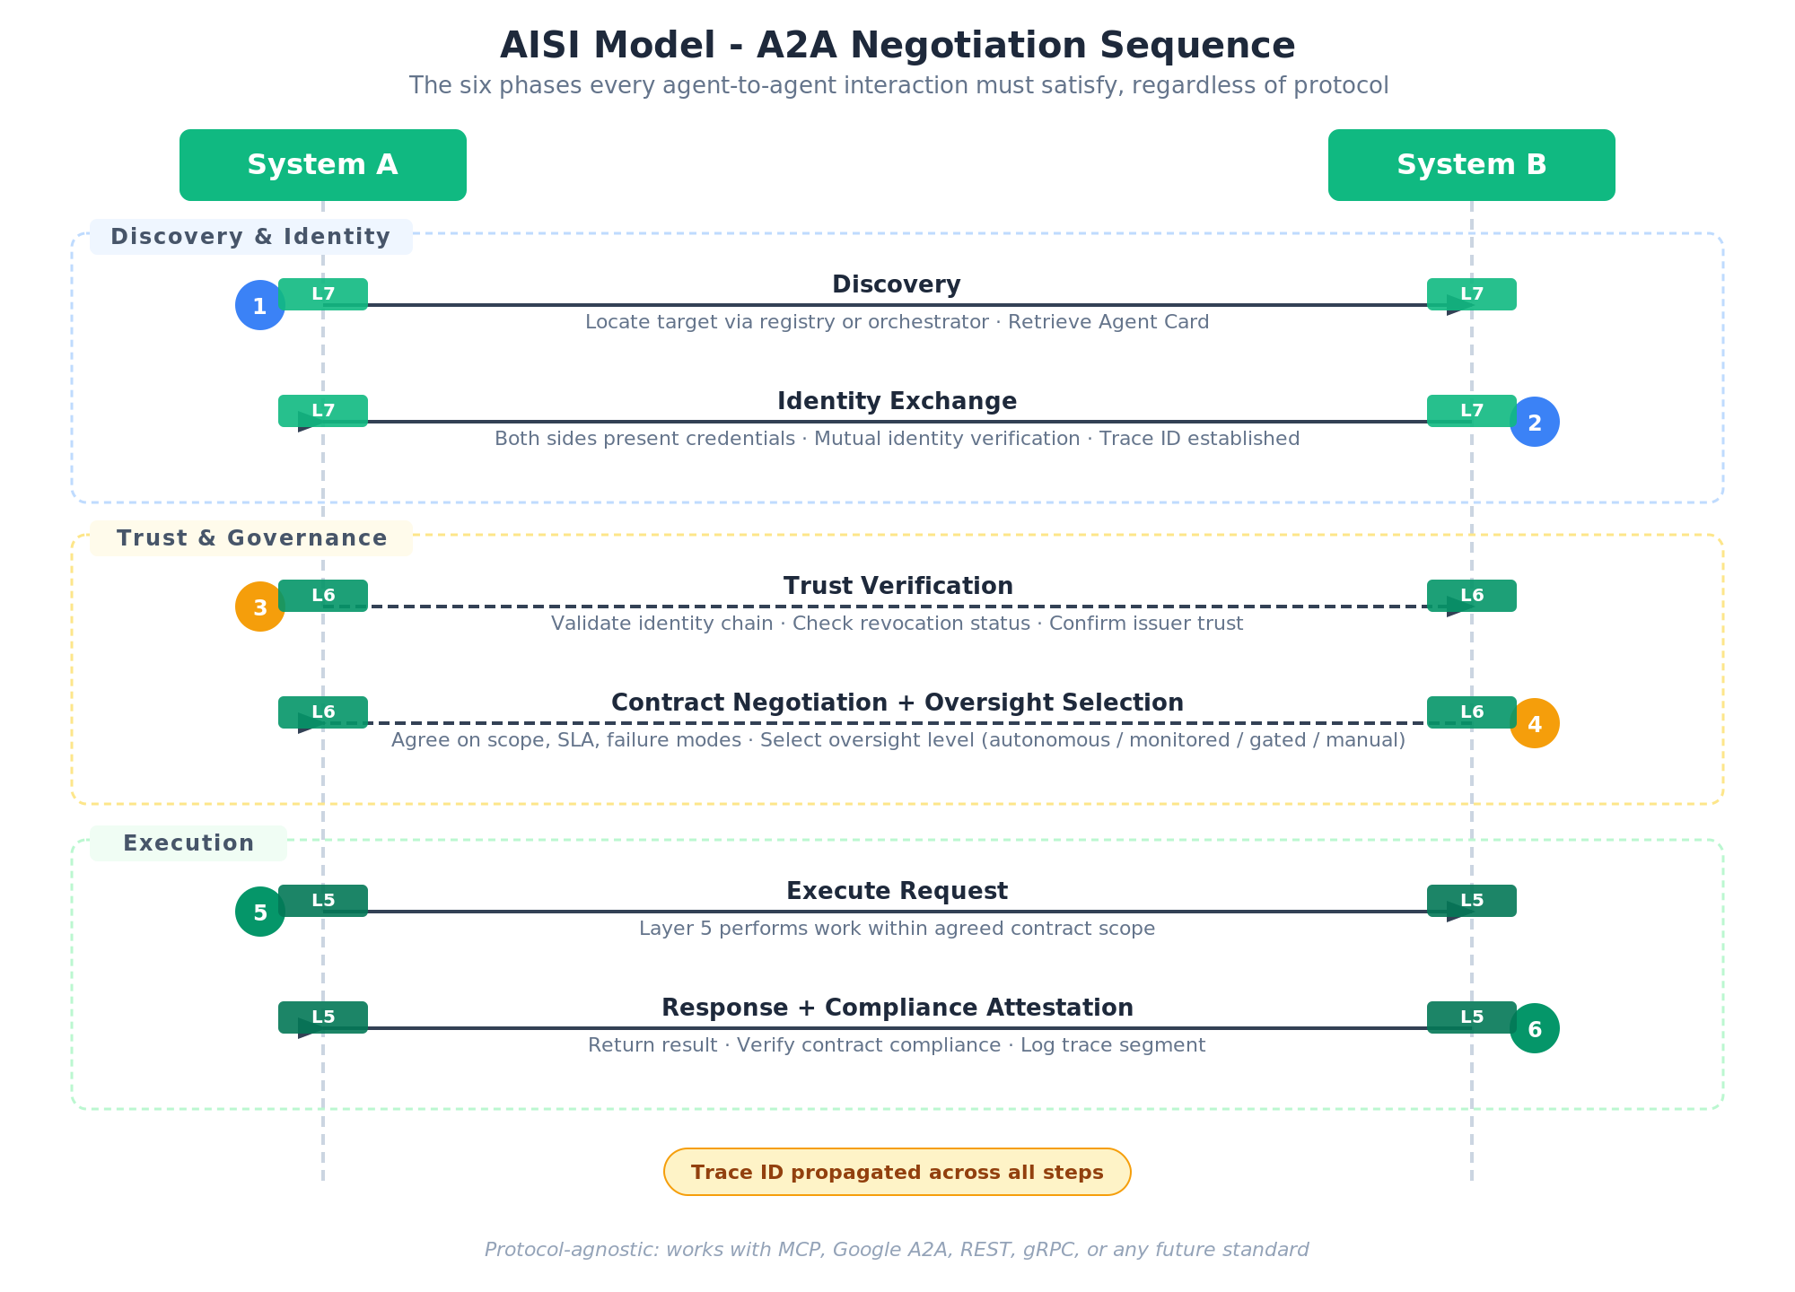
Figure 3: A2A Negotiation Sequence: Six Phases Across Three Layers
- Phase 1: Discovery (Layer 7): The caller locates the target via a registry or orchestrator and retrieves its Agent Card.
- Phase 2: Identity Exchange (Layer 7): Both sides present credentials (SPIFFE IDs via mTLS), verify each other's workload identity, and establish a trace ID.
- Phase 3: Trust Verification (Layer 6): The receiver validates the full identity chain back to the originating principal and checks revocation status.
- Phase 4: Contract Negotiation and Oversight Selection (Layer 6): Both sides agree on scope, data classification, retention, budget, and latency. The receiver selects an oversight level (autonomous, monitored, gated, or manual).
- Phase 5: Execute Request (Layer 5): The agent performs work within the agreed contract scope.
- Phase 6: Response and Compliance Attestation (Layer 5): The result is returned with contract compliance verification and a logged trace segment.

Session-based negotiation allows this handshake to run once and reuse a sender-constrained JWT session token (RFC 8705/9449) for subsequent requests under stable conditions. Re-negotiation triggers when scope, classification, or oversight requirements change.

Getting Started

Single-Agent System
Focus on Layers 1 through 5 and the AI/ML and IT Infrastructure controls in the Baseline Controls. You do not need Agent Cards, behavioral contracts, or the A2A protocol controls until you have multiple agents communicating.

Multi-Agent, Single Organization
Add the A2A Protocol Specification. Implement Agent Cards and behavioral contracts. Start with the P1 A2A controls: A2A-1 (mTLS + workload identity), A2A-2 (signed Agent Cards), A2A-6 (oversight policy engine), and A2A-7 (kill switch + circuit breakers). Move to P2 controls (schema validation, per-hop trust, delegation scope, trace logging, revocation) once P1 is stable.

Cross-Organization Agents
Everything above, plus identity federation, explicit data classification and retention policies, budget limits, sub-delegation constraints, and the Security Reference's agent supply chain and third-party risk controls. Tiered discovery becomes important here: serve a public Agent Card at an unauthenticated endpoint and require mTLS for the full capability card.

Agent Cards
An Agent Card is a signed, machine-readable document that describes an agent's identity, capabilities, and default contract terms. It is the entry point for discovery and the foundation for trust decisions.

Required Fields
Field | Type | Description
agent_id | string | Globally unique identifier for this agent instance
spiffe_id | URI | SPIFFE ID or equivalent runtime identity binding
display_name | string | Human-readable name shown in registries and audit logs
version | semver | Agent version (major version changes signal breaking contract changes)
capabilities | array | Structured capability descriptors for what this agent can do
supported_protocols | array | Protocols this agent speaks (MCP, A2A, REST, gRPC) with versions
endpoint | URI | Network endpoint where this agent accepts requests (must use TLS)
signature | string | Cryptographic signature over all card fields
issued_at | ISO 8601 | Timestamp when this card was signed
expires_at | ISO 8601 | Expiration timestamp (expired cards must be rejected unconditionally)
issuer | string | Identity of the signing authority, traceable to a trusted root

Selected Optional Fields
Field | Type | Description
default_contract | object | Pre-published behavioral contract terms callers can accept or counter-propose
max_chain_depth | integer | Maximum downstream hops this agent supports
oversight_minimum | enum | Lowest oversight level this agent will accept
tools | array | Tools this agent can invoke, including schemas and permission requirements
dependencies | array | Other agents or services this agent requires (supports supply chain auditing)
pricing | object | Cost structure: model (per_request/per_token/per_session), currency (ISO 4217), rate
model_fingerprint | string | Identifier for the current model version (drift detection)
discovery_tier | string | "public" (minimal card) or "full" (complete capabilities, post-authentication)

Agent Cards support tiered discovery. A public card served at an unauthenticated endpoint contains only agent_id, display_name, version, endpoint, supported_protocols, and issuer. The full capability card is available only after identity verification via mTLS. Both tiers are signed with the same key.

Behavioral Contracts
A behavioral contract is a per-session or per-request agreement that binds both parties. The caller proposes terms, the receiver accepts or counter-proposes, and the negotiated result governs the interaction.

Required Contract Terms
Term | Type | Description
scope | string | What the requesting agent is asking for, specific enough for policy evaluation
permitted_actions | array | Explicit list of actions the receiver is authorized to perform
max_latency | duration | Response time bound; receiver must respond or report failure within this window
error_handling | enum | Failure mode: retry (with backoff), fallback (degraded response), or abort
oversight_level | enum | Agreed oversight level: autonomous, monitored, gated, or manual
trace_id | string | Correlation ID for end-to-end tracing, propagated through every hop
data_classification | enum | Sensitivity level of data crossing the boundary: public, internal, confidential, restricted
retention_policy | duration | How long the receiver may retain request/response data and derived artifacts

Selected Optional Contract Terms
Term | Type | Description
max_tokens | integer | Token budget cap for the interaction (maps to OWASP LLM10)
callback_url | URI | Endpoint for asynchronous result delivery
escalation_path | object | Who to notify if the contract is violated: team, channel, alert severity
sub_delegation | object | Whether the receiver may call other agents, with allowed agents, depth, and scope constraints
context_ttl | enum | What to do with context buffer on session end: immediate (wipe), session (wipe on close), retain
budget_limit | object | Maximum cost: currency (ISO 4217), max_amount, scope (per_request or per_session)
cost_reporting | boolean | When true, every response includes cost_incurred for spend tracking

Scope, classification, and budget can only narrow through delegation chains, never widen. If Agent A grants Agent B a budget of $5.00 per session, Agent B cannot grant Agent C more than $5.00. The same monotonically decreasing principle applies to data classification and capability scope.

Graduated Oversight
The receiver's Layer 6 (Orchestration/Control) selects one of four oversight levels for each request based on risk, classification, and policy:
Level | Human Role | When to Use
Autonomous | None | Low-risk, well-understood operations within established scope
Monitored | Watches | Normal operations where audit trail is sufficient and human reviews after the fact
Gated | Approves before execution | High-value, high-risk, or cross-boundary operations that need human sign-off
Manual | Performs the action | Operations that policy or regulation requires a human to carry out directly

When a request requires gated or manual oversight and the approver is not immediately available, the receiver returns a structured hold response with status pending_approval, a trace_id, the oversight_level, a reason, an estimated_wait, and a resume_url. The caller must not retry; it polls the resume_url or waits for a callback.

Baseline Controls
The full Baseline Controls document defines 45 controls across four categories. Priority levels indicate deployment urgency: P1 (must have before production), P2 (should have before production), P3 (within 90 days), P4 (mature programs). Below are the 13 A2A Protocol Controls that govern agent-to-agent communication.

A2A Protocol Controls
ID | Control | Priority | Layers
A2A-1 | mTLS + workload identity | P1 | 7
A2A-2 | Signed Agent Cards | P1 | 7
A2A-6 | Oversight policy engine | P1 | 6
A2A-7 | Kill switch + circuit breakers | P1 | 6, 2
A2A-3 | Strict schema validation | P2 | 7, 5
A2A-4 | Per-hop trust verification | P2 | 6
A2A-5 | Delegation scope monotonicity | P2 | 6
A2A-11 | Tamper-evident trace logging | P2 | Trace plane
A2A-12 | Revocation propagation | P2 | 7, 6
A2A-8 | Tool sandboxing + egress control | P3 | 5, 2
A2A-9 | Replay protection | P3 | 7
A2A-10 | Contract compliance verification | P4 | 7, 6
A2A-13 | Budget enforcement | P4 | 6, 5

AI/ML Controls
ID | Control | Priority | Layers
AI-1 | Model registry + versioning | P1 | 3
AI-2 | Model provenance attestation | P1 | 3
AI-4 | Prompt / system policy versioning | P1 | 5
AI-3 | Agent-BOM | P2 | 5, 3
AI-5 | Hallucination + grounding controls | P2 | 5, 4
AI-6 | RAG data access governance | P2 | 6, 4
AI-12 | Output content filtering | P2 | 7
AI-7 | Embedding integrity | P3 | 4
AI-8 | Training pipeline governance | P3 | Lifecycle
AI-9 | Evaluation + red-teaming | P3 | Lifecycle
AI-11 | Behavioral drift detection | P3 | 6, 5
AI-10 | Synthetic data controls | P4 | Lifecycle

IT Infrastructure Controls
ID | Control | Priority | Layers
IT-1 | Container + runtime isolation | P1 | 2
IT-3 | Secrets management | P1 | 7, 2
IT-4 | Resource quotas + autoscaling limits | P1 | 2
IT-2 | Network segmentation | P2 | 2
IT-5 | Infrastructure-as-Code | P2 | 2, 1
IT-6 | Observability stack | P2 | 6, 2
IT-7 | Backup + recovery | P3 | 4, 2, 1
IT-10 | Change management | P3 | 5, 3, 2
IT-8 | Sustainability metrics | P4 | 2
IT-9 | Geographic compliance | P4 | 1

Security Operations Controls
ID | Control | Priority | Layers
SEC-1 | Agent threat modeling | P1 | All
SEC-5 | Incident response playbooks | P1 | All
SEC-2 | Adversarial testing in CI/CD | P2 | Build + runtime
SEC-4 | SIEM integration | P2 | 6, 2
SEC-7 | Data loss prevention | P2 | 7, 4
SEC-3 | Penetration testing | P3 | 7, 6, 5
SEC-6 | Vulnerability management | P3 | 5, 3, 2
SEC-8 | Access reviews | P3 | 7, 6
SEC-9 | Third-party agent risk | P4 | 7, 5
SEC-10 | Compliance evidence | P4 | Governance

Within each category, controls are ordered by priority (P1 first, then P2, P3, P4), not by control ID. Each control in the full Baseline Controls document includes a detailed description and the responsible team.

Security and Compliance Alignment
The Security Reference maps AISI layers and controls to recognized threat catalogs and governance frameworks.

Threat Mappings
The OWASP Top 10 for LLM Applications maps to AISI layers and controls. Key mappings include: LLM01 (Prompt Injection) to Layers 5 and 7 with input validation and output filtering controls, LLM02 (Insecure Output Handling) to Layer 5 with structured output validation, LLM06 (Excessive Agency) to Layers 5 and 6 with graduated oversight and scope constraints, and LLM10 (Unbounded Consumption) to Layers 5 and 6 with rate limiting and contract-level budget enforcement (A2A-13). MITRE ATLAS provides adversarial threat coverage for model-layer attacks.

Regulatory Framework Mappings
The table below maps regulatory requirements to the specific AISI controls and artifacts that address them. Read across: the left column is the compliance obligation, the middle column is the source regulation, and the right column tells you exactly what in AISI covers it and how.
Requirement | Source | How AISI Addresses It
Risk management system | EU AI Act Art. 9 | - SEC-1 requires threat modeling for every agent before production, mapped to AISI layers  - Baseline Controls provide a prioritized control framework (P1-P4) as the risk management backbone  - Layer 6 enforces oversight policies that escalate based on risk classification
Logging and traceability | EU AI Act Art. 12 | - A2A-11 produces tamper-evident trace logs with hash-chained spans across every agent hop  - IT-6 collects all telemetry into a centralized observability stack for review  - Behavioral contracts carry a trace_id that propagates end-to-end for full audit trails
Human oversight | EU AI Act Art. 14 | - A2A-6 assigns every request an oversight level: autonomous, monitored, gated, or manual  - Gated and manual levels require human approval before the agent acts  - Callers can set a minimum oversight level that the receiver cannot downgrade
GPAI provider logging | EU AI Act Art. 19 | - A2A-11 produces structured, tamper-evident trace logs across the full agent chain  - IT-6 centralizes logging with retention aligned to provider obligations  - AI-11 detects behavioral drift so providers can demonstrate ongoing compliance
Deployer record retention | EU AI Act Art. 26(6) | - The retention_policy contract term governs how long the receiver may keep data  - Duration-based retention supports regulatory minimums (six-month floors configurable)  - IT-7 backup and recovery controls ensure retained records survive infrastructure events
Governance and policy | NIST AI RMF: GOVERN | - The Governance plane cuts across all seven layers, enforcing policy at every level  - A2A-4 verifies trust at every hop so policy is re-evaluated at each agent boundary  - A2A-6 enforces oversight policies that determine when humans must be involved
Context and risk mapping | NIST AI RMF: MAP | - SEC-1 maps each agent's attack surface to specific AISI layers  - Every control in the Baseline is assigned to specific layers and responsible teams  - Behavioral contracts include data_classification so risk context travels with every request
Metrics and testing | NIST AI RMF: MEASURE | - AI-11 continuously monitors behavioral drift against declared contracts  - AI-9 runs adversarial evaluation and red-teaming with versioned test suites  - SEC-2 gates every deployment on automated adversarial and safety tests in CI/CD
Monitoring and response | NIST AI RMF: MANAGE | - A2A-7 provides kill switches and circuit breakers that halt chains when thresholds are exceeded  - SEC-5 provides incident response playbooks specific to agent compromise scenarios  - IT-6 dashboards surface anomalies in real time for operations teams
AI management system | ISO 42001 Cl. 5-10 | - The Baseline Controls framework provides 45 controls organized by team and priority  - Each control maps to AISI layers, giving a structured management system for AI operations  - Priority levels (P1-P4) provide a phased adoption path aligned to organizational maturity
Reference controls | ISO 42001 Annex A | - 13 A2A Protocol Controls cover agent-to-agent communication security  - 12 AI/ML Controls cover model, data, and inference safeguards  - 10 IT Infrastructure + 10 Security Operations Controls complete the control set
Cloud AI security | CSA AI Controls | - IT-1 isolates each agent in its own container with restricted system call profiles  - IT-2 segments A2A traffic from internal traffic with explicit allow-list policies  - IT-3 stores all credentials in a secrets manager with automated rotation  - AI-12 filters all outputs crossing system boundaries for content safety and PII

These mappings are informational. They show where AISI concepts align with regulatory requirements but are not authoritative interpretations of any framework. The full Security Reference provides detailed cross-walks for each framework.

Companion Documents
This Quick-Start Guide is derived from six companion documents. Each is self-contained but cross-referenced to the others:
Document | What It Covers
AISI Model v1.0 | The core reference architecture: seven layers, A2A negotiation sequence, governance framework, adoption guidance
A2A Protocol Specification | Agent Cards, Behavioral Contracts, Authentication and Authorization, Graduated Oversight, session-based negotiation, tiered discovery
Baseline Controls | 45 controls across A2A Protocol, AI/ML, IT Infrastructure, and Security categories with priority levels and team assignments
Security Reference | OWASP and MITRE ATLAS threat mappings, A2A-specific threats, agent supply chain controls, regulatory framework alignment
Implementation Guide | Kubernetes-native implementation patterns for runtime isolation, identity, policy, observability, and data controls
Operations and Lifecycle Reference | Drift detection, shadow AI discovery, RAG freshness, prompt versioning, memory hygiene, change control, decommission

