AISI Model v1.0
Security Reference
OWASP Top 10 • MITRE ATLAS • A2A Threats • Agent Supply Chain • Lifecycle Controls

How to Use This Document
This is a companion to the AISI Model v1.0 reference architecture. The main document defines the seven-layer runtime model and the A2A negotiation sequence. This document maps security threats and controls to specific AISI layers using industry-standard frameworks, introduces threat vectors specific to A2A communication, covers model lifecycle and supply chain controls (Annex A), and provides the governance framework mapping that shows how NIST AI RMF, the EU AI Act, ISO/IEC 42001, and CSA AI Controls Matrix requirements cascade across the stack. For the baseline control set required for production A2A deployments, see the separate Baseline Controls companion document.
Because each AISI layer has a clear responsibility, it's possible to map where threats manifest and where controls should be applied. The first two sections cover well-known vulnerability catalogs (OWASP, MITRE ATLAS). The next two address threats unique to multi-agent systems: attacks against the A2A negotiation sequence and agent supply chain risks. Annex A covers pre-deployment lifecycle controls that the runtime stack depends on but that live outside the seven layers.

Before You Start
The AISI Model is a reference architecture, not a standard, a regulation, or a compliance requirement. It does not carry the force of law or certification authority. No organization is obligated to adopt it, and adopting it does not guarantee compliance with any regulatory framework.
Everything in this document set is a starting point. The layer definitions, protocol structures, control baselines, configs, code examples, and operational procedures are reference material that your organization must adapt to its own infrastructure, threat model, risk posture, and regulatory obligations. Nothing here is production-ready out of the box. Test in a non-production environment, adjust for your context, and validate before promoting to production.
Where these documents reference regulatory frameworks (EU AI Act, NIST AI RMF, ISO/IEC 42001), those references are informational mappings, not authoritative interpretations. Consult qualified legal, security, and compliance professionals for decisions specific to your environment.

OWASP Top 10 for LLM Applications 2025
The OWASP Top 10 for LLMs (v2.0, November 2024) is an OWASP Flagship Project covering the most critical vulnerabilities in LLM-based applications. The diagram and table below map each vulnerability to the AISI layers where it manifests and the controls that address it.
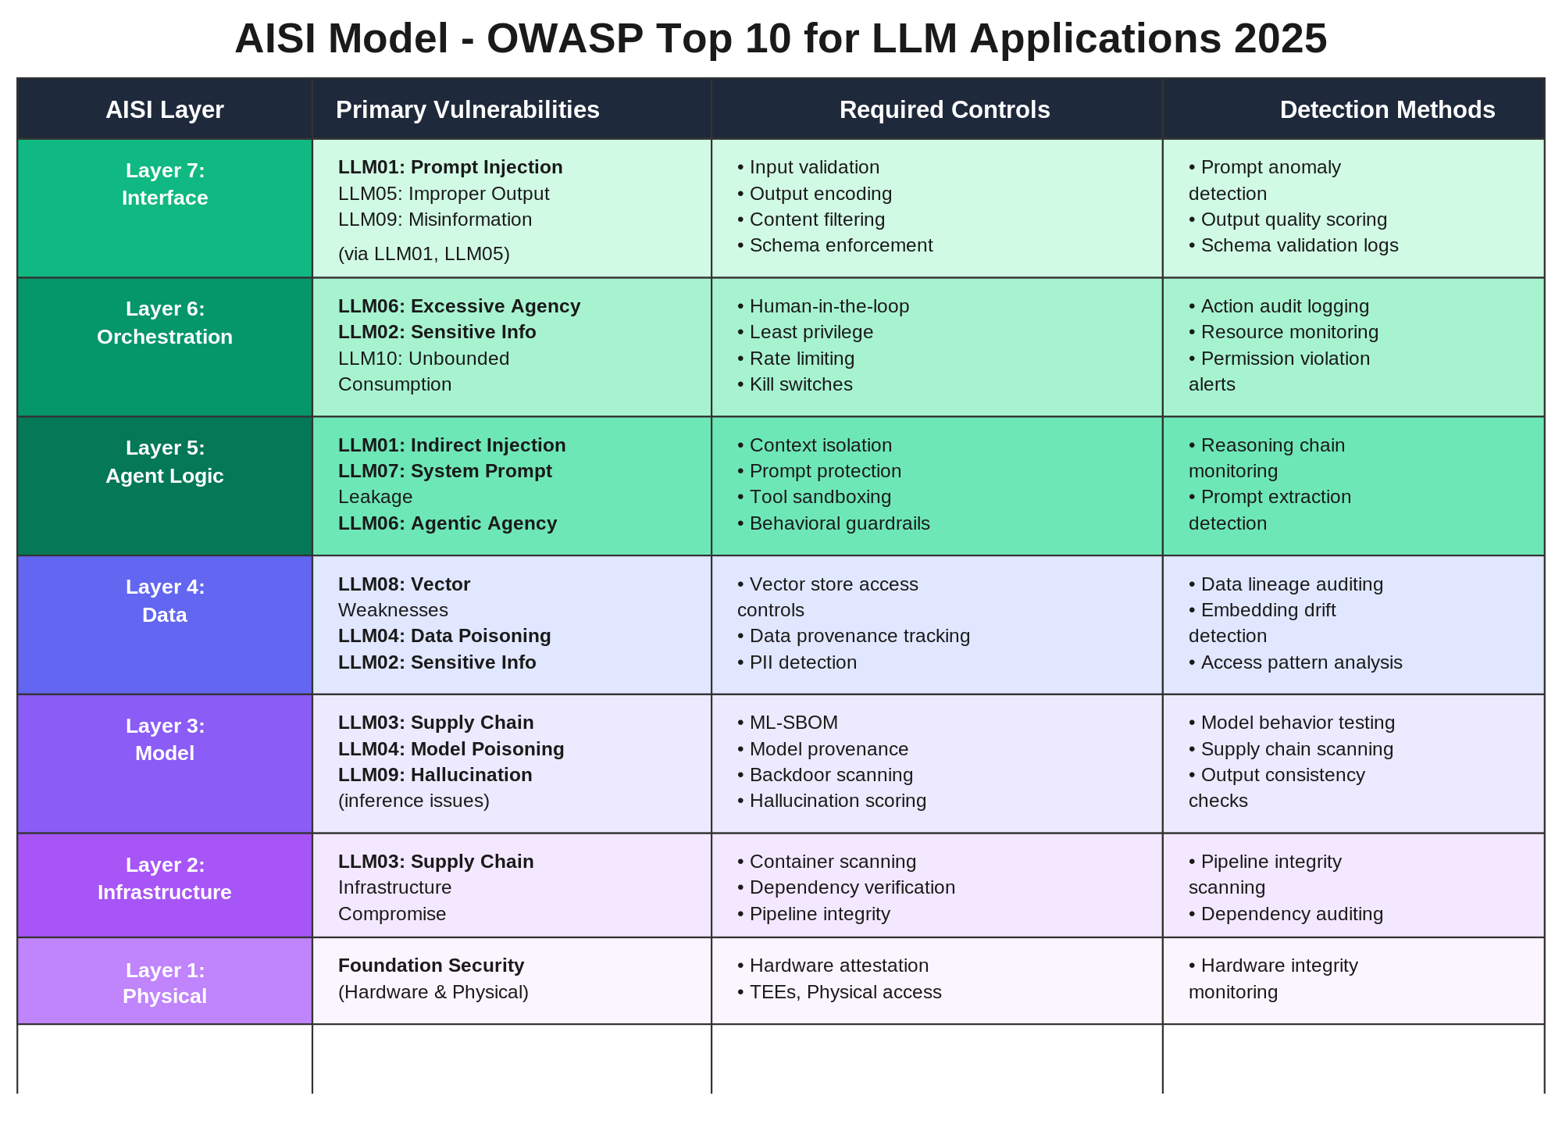
Figure 1: OWASP Top 10 for LLM Applications 2025 - Mapped to AISI Layers

Quick Reference
ID | Vulnerability | AISI Layers | Key Mitigations
LLM01 | Prompt Injection | Layers 7, 5 | Input validation, context isolation, tool sandboxing
LLM02 | Sensitive Info Disclosure | Layers 6, 4 | Access controls, PII detection, data classification
LLM03 | Supply Chain | Layers 3, 2, 1 + agent supply chain | Model provenance, ML-SBOM, container scanning. See also: Agent Supply Chain section
LLM04 | Data / Model Poisoning | Layers 4, 3 + training pipeline | RAG/runtime: data lineage, source validation. Pre-deployment: training data provenance, backdoor scanning
LLM05 | Improper Output Handling | Layer 7 | Output encoding, content filtering, schema enforcement
LLM06 | Excessive Agency | Layers 6, 5 | Least privilege, human-in-the-loop, containment
LLM07 | System Prompt Leakage | Layer 5 | Prompt protection, instruction hiding, behavioral guardrails
LLM08 | Vector / Embedding Weaknesses | Layer 4 | Vector store access controls, embedding integrity checks
LLM09 | Misinformation | Layers 7, 3 | Hallucination scoring, fact-checking, content provenance
LLM10 | Unbounded Consumption | Layers 6, 2 | Rate limiting, resource quotas, auto-scaling controls, contract-level budget enforcement (A2A-13)

MITRE ATLAS
MITRE ATLAS catalogs real-world adversary tactics and techniques against AI systems. As of October 2025, it covers 15 tactics, 66 techniques, 46 sub-techniques, and 33 documented case studies, including 14 techniques added in 2025 specifically targeting AI agents and generative AI. The diagram below maps these to AISI layers alongside real incidents.
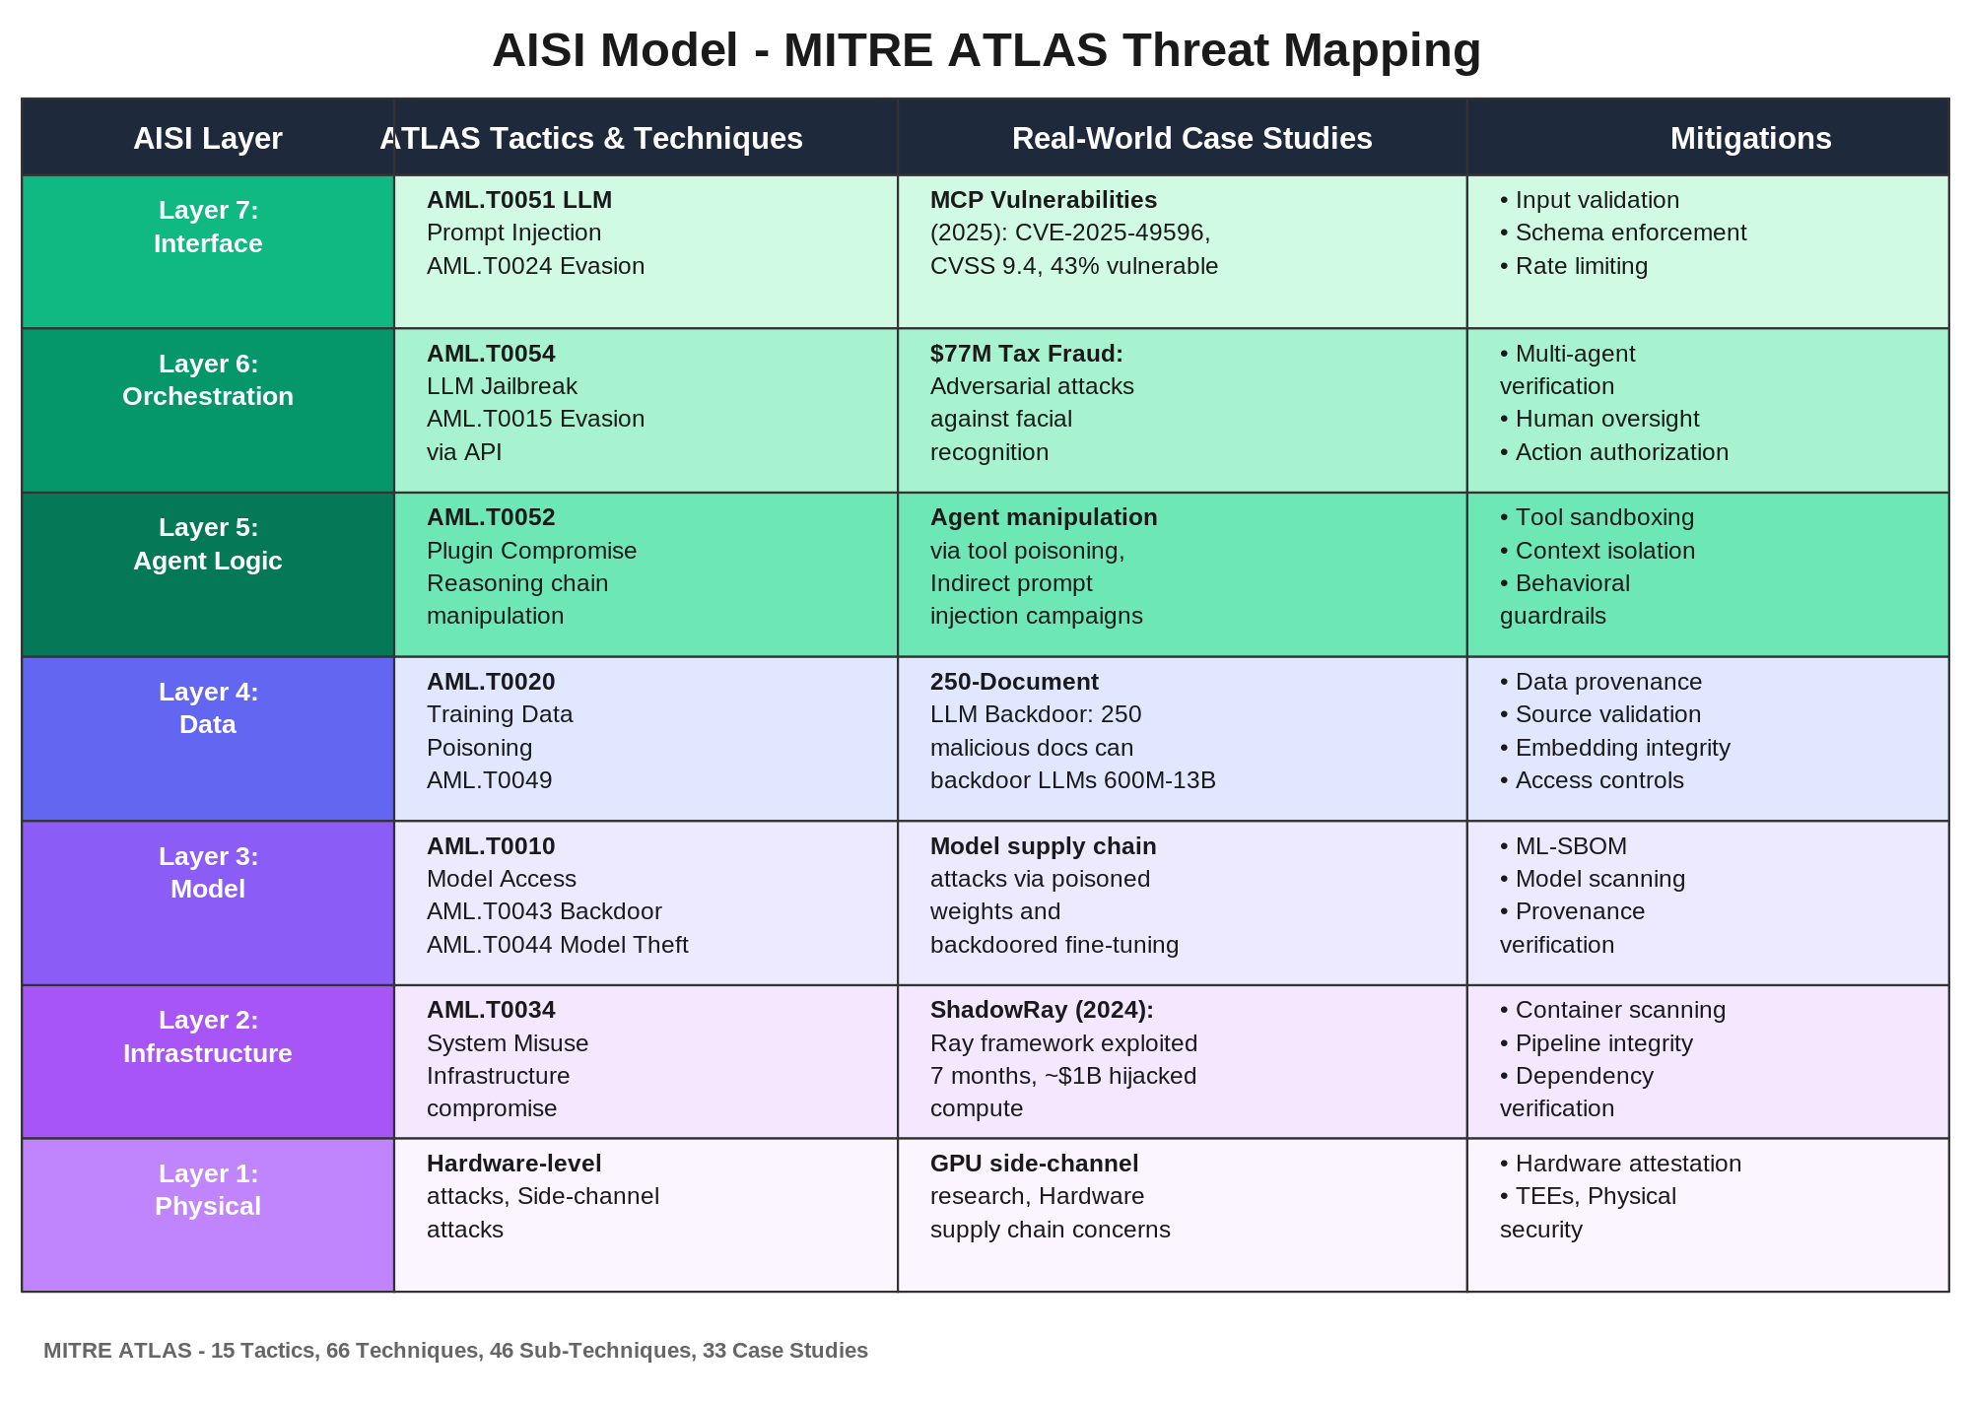
Figure 2: MITRE ATLAS Threat Mapping to AISI Layers

Notable Incidents
- ShadowRay (2024): Ray framework vulnerabilities exploited for seven months. Nearly $1B in hijacked compute. Layer 2.
- $77M Tax Fraud: Adversarial attacks against facial recognition enabled large-scale fraud. Governance bypass.
- MCP Vulnerabilities (2025): CVE-2025-49596 (CVSS 9.4), 43% of MCP servers vulnerable to command injection. Layers 7 and 5.
- 250-Doc LLM Backdoor: Research showed 250 malicious documents can backdoor LLMs from 600M to 13B parameters. Training pipeline supply chain risk (pre-deployment, not runtime Layer 4).
A2A-Specific Threat Vectors
The AISI Model v1.0 defines an A2A negotiation sequence with six phases: Discovery, Identity Exchange, Trust Verification, Contract Negotiation, Oversight Selection, and Execution. Each phase introduces attack surface that doesn't exist in single-agent systems. The threats below are specific to multi-agent communication and map directly to the sequence phases defined in the main document.

Quick Reference
ID | Threat Vector | AISI Layers | Sequence Phase | Key Mitigations
A2A-01 | Agent Impersonation | Layer 7 | Identity Exchange | Cryptographic identity, mutual authentication, identity chain verification
A2A-02 | Contract Manipulation | Layers 7, 5 | Contract Negotiation | Contract schema validation, behavioral monitoring, integrity checks
A2A-03 | Trust Chain Poisoning | Layers 6, 5 | Trust Verification | Chain depth limits, per-hop verification, anomaly detection at handoff
A2A-04 | Delegation Escalation | Layer 6 | Execution | Monotonically decreasing permissions, delegation auditing, scope enforcement
A2A-05 | Trace ID Manipulation | Layers 6, 7 | Execution | Cryptographic trace signing, tamper detection, trace completeness validation
A2A-06 | Oversight Bypass | Layer 6 | Oversight Selection | Independent oversight classification, caller-set minimums, override audit logging

Threat Details
- A2A-01 - Agent Impersonation: An adversary spoofs the identity of a trusted agent during the Identity Exchange step. Unlike traditional credential theft, agent impersonation exploits the fact that agents negotiate identity programmatically without a human verifying the counterparty. Mitigations include cryptographic identity bound to the agent's runtime environment, mutual authentication before any data exchange, and identity chain verification that traces delegation back to a human principal.
- A2A-02 - Contract Manipulation: A malicious agent presents a behavioral contract during negotiation that differs from its actual behavior. For example, an agent might declare read-only data access but execute write operations. This is analogous to a service advertising a safe API but performing destructive operations. Mitigations include schema validation of contract claims, runtime behavioral monitoring against declared contracts, and contract integrity checksums.
- A2A-03 - Trust Chain Poisoning: An attacker compromises a single agent in a multi-agent chain and uses its trusted position to inject malicious payloads downstream. Because agents inherit trust from their callers, a compromised mid-chain agent can propagate attacks to every agent below it. Mitigations include enforcing chain depth limits, requiring per-hop re-verification of identity and permissions, and running anomaly detection at each handoff point.
- A2A-04 - Delegation Escalation: An agent grants a downstream agent more authority than it was given by its own caller, violating the principle of monotonically decreasing permissions. This is the AI equivalent of the confused deputy problem. Mitigations include enforcing that delegated scopes can only narrow (never widen), auditing every delegation event, and having the orchestration layer (Layer 6) enforce scope boundaries independently of agent claims.
- A2A-05 - Trace ID Manipulation: An agent falsifies, strips, or replays trace IDs to evade observability. If the trace plane (described in the main document) relies on agents to propagate trace context honestly, a malicious agent can break the audit trail. Mitigations include cryptographically signing trace segments so tampering is detectable, validating trace completeness at governance checkpoints, and flagging any gap in the trace chain as a security event.
- A2A-06 - Oversight Bypass: An agent manipulates the oversight level selection during the A2A handshake to obtain autonomous execution when the task warrants gated or manual oversight. This could involve misrepresenting risk level, claiming false context, or exploiting permissive default settings. Mitigations include independent oversight classification by the orchestration layer (not the requesting agent), caller-specified minimum oversight levels that cannot be downgraded, and audit logging of every oversight decision.

The Trace Plane
Traditional governance is vertical. Each system enforces its own policies at each layer. But A2A communication creates a horizontal dimension: a request that crosses three, five, or ten agents in sequence. Without horizontal governance, you have audit logs on each system but no way to reconstruct what happened across the chain.
The trace plane solves this. A trace ID, initiated at Layer 7 of the first system in a chain, propagates through every subsequent system. Each Layer 6 logs its decisions against that trace ID. The result is an end-to-end record of the entire multi-agent interaction that any system in the chain (or an external auditor) can reconstruct. This is how you answer: “Why did the system make that decision?” “Which agent in the chain introduced the error?” “Who authorized the action that led to the incident?”

Trace Architecture
A trace in the AISI Model is not a log. Logs record what happened on a single system. A trace reconstructs what happened across an entire agent chain, including the governance decisions that allowed each step to proceed. The trace plane operates independently of the data plane: even if a request fails or is blocked, the trace records why.
Every trace consists of segments. Each segment is produced by a single system and covers one hop in the chain. A segment records: the trace ID, the agent’s identity (SPIFFE ID), the layer where the decision was made, the governance action taken (identity verified, contract accepted, oversight level selected, action permitted or blocked), a timestamp, and a cryptographic signature over the segment. Segments are hash-chained: each segment includes the hash of the previous segment, creating a tamper-evident sequence.
The trace ID is initiated by the first system in the chain at Layer 7. It propagates as a required field in every behavioral contract (see the A2A Protocol Specification). At each hop, Layer 6 produces a new trace segment before any action is executed. If a segment is missing, modified, or out of sequence, any downstream system or auditor can detect the gap.

Example: Reconstructing a 3-Agent Chain
A customer-facing agent (Agent A) calls a research agent (Agent B), which delegates embedding generation to a specialized service (Agent C). An auditor needs to reconstruct why Agent C processed confidential data.
// Trace ID: trace-abc123-def456-789

// Segment 1 - Agent A (customer-facing), Layer 7
{
"trace_id": "trace-abc123-def456-789",
"segment_index": 1,
"agent": "spiffe://acme.example/agent/customer-facing-v3",
"layer": 7,
"action": "initiate_request",
"details": {
"target": "spiffe://acme.example/agent/research-v2",
"human_principal": "user:jane.doe@acme.example",
"data_classification": "confidential"
},
"timestamp": "2026-03-29T14:00:01Z",
"prev_hash": null,
"signature": "EdDSA:..."
}

// Segment 2 - Agent B (research), Layer 6
{
"trace_id": "trace-abc123-def456-789",
"segment_index": 2,
"agent": "spiffe://acme.example/agent/research-v2",
"layer": 6,
"action": "trust_verified_contract_accepted",
"details": {
"identity_chain": ["user:jane.doe@acme.example", "customer-facing-v3"],
"oversight_level": "monitored",
"contract_id": "ctr-8f3a2b1c-20260329",
"sub_delegation_permitted": true,
"sub_delegation_scope": ["embedding-service-01"]
},
"timestamp": "2026-03-29T14:00:03Z",
"prev_hash": "sha256:a1b2c3...",
"signature": "EdDSA:..."
}

// Segment 3 - Agent B (research), Layer 6 -> delegating to Agent C
{
"trace_id": "trace-abc123-def456-789",
"segment_index": 3,
"agent": "spiffe://acme.example/agent/research-v2",
"layer": 6,
"action": "sub_delegation_initiated",
"details": {
"target": "spiffe://acme.example/agent/embedding-service-01",
"delegated_scope": ["generate_embeddings"],
"data_classification": "confidential",
"contract_permits_delegation": true
},
"timestamp": "2026-03-29T14:00:05Z",
"prev_hash": "sha256:d4e5f6...",
"signature": "EdDSA:..."
}

// Segment 4 - Agent C (embedding service), Layer 6
{
"trace_id": "trace-abc123-def456-789",
"segment_index": 4,
"agent": "spiffe://acme.example/agent/embedding-service-01",
"layer": 6,
"action": "trust_verified_execution_complete",
"details": {
"identity_chain": ["user:jane.doe@acme.example", "customer-facing-v3", "research-v2"],
"oversight_level": "monitored",
"data_classification": "confidential",
"tokens_used": 450,
"latency_ms": 1200
},
"timestamp": "2026-03-29T14:00:06Z",
"prev_hash": "sha256:g7h8i9...",
"signature": "EdDSA:..."
}
The auditor’s question was: why did Agent C process confidential data? The trace reconstruction shows: Segment 1 establishes that a human principal (jane.doe) initiated a request classified as confidential. Segment 2 shows Agent B accepted a contract permitting sub-delegation to the embedding service. Segment 3 shows Agent B delegated with the confidential classification propagated. Segment 4 shows Agent C verified the full identity chain and processed the request under monitored oversight. Every link is signed and hash-chained. If Agent B had attempted to delegate to an agent not listed in the contract, Segment 3 would show the delegation was blocked, and the trace would still record the attempt.

Trace Integrity and the Threat Model
The trace plane is only as trustworthy as its integrity guarantees. A2A threat vector A2A-05 (Trace ID Manipulation) directly targets this: an agent that can falsify, strip, or forge trace segments can evade accountability. The countermeasures are: cryptographic signing of each segment (so tampering is detectable), hash-chaining (so gaps are detectable), validation at every Layer 6 governance checkpoint (so a missing or invalid segment halts the chain), and independent trace storage (so a compromised agent cannot delete its own segments after the fact). Baseline Control A2A-11 specifies these requirements.

Agent Supply Chain
OWASP LLM03 covers model supply chain risks: poisoned training data, compromised model weights, and malicious packages. But multi-agent systems introduce a separate supply chain concern: the agents themselves. When your system delegates work to a third-party agent, you're trusting that agent's model, tools, data access, and behavioral integrity. None of these are visible at the interface layer.
Agent supply chain risk is distinct from model supply chain risk. A model might be safe but wrapped in an agent that misuses it. An agent might declare certain capabilities but silently invoke undisclosed tools. The controls below address this gap.

Controls
Control | AISI Layers | Description
Agent Provenance | Layers 5, 3 | Verify the origin, version, and integrity of third-party agents before allowing them into a chain.
Tool Access Verification | Layers 6, 5 | Confirm that a third-party agent's declared tool access matches its actual capabilities and permissions.
Behavioral Contract Honoring | Layers 7, 5 | Monitor whether agents fulfill the behavioral contracts they advertised during negotiation.
Agent Bill of Materials | Layers 3, 2 | Require an Agent-BOM listing the model, tools, data sources, and dependencies an agent relies on.
Runtime Attestation | Layers 6, 2 | Continuously verify that an agent's runtime environment matches its declared configuration.

How This Differs from Model Supply Chain
- Scope: Model supply chain (LLM03) covers weights, training data, and packages. Agent supply chain covers the full agent runtime: model + tools + data + behavioral contracts + orchestration logic.
- Dynamism: Models are typically static after deployment. Agents can change behavior at runtime based on instructions, tool availability, or delegated context. Supply chain verification must be continuous, not one-time.
- Composition: A single agent might compose multiple models, tools, and data sources. The supply chain is a graph, not a list. An Agent Bill of Materials (Agent-BOM) captures this structure.
- Trust propagation: When Agent A delegates to Agent B, Agent A's users are implicitly trusting Agent B's entire supply chain. Delegation creates transitive trust that must be explicitly bounded.

Annex A - Model Lifecycle and Supply Chain Controls
The AISI Model v1.0's seven layers describe a runtime architecture. The system operates in production, but several critical risks originate before runtime, in the training, fine-tuning, evaluation, and release pipeline. These risks are external dependencies to the AISI stack: they affect the integrity of what gets deployed, but they don't map cleanly to a single runtime layer.
This annex exists because the boundary matters. If you treat training data poisoning as a Layer 4 problem, you'll look for it in your vector stores and RAG indexes. But training data poisoning happens upstream, before the model reaches Layer 3. Layer 4 in the AISI Model is runtime data: vector stores, RAG indexes, embeddings, and persistent memory that can be updated, rotated, and audited during operation. Training data, by contrast, is consumed during model development and baked into the model weights. You can't inspect, rotate, or patch training data at runtime. The controls are different, the attack surface is different, and the responsible team is different.
The control objectives below preserve the clean seven-layer runtime architecture while making lifecycle controls explicit. They align with the EU AI Act's Annex XI requirements for GPAI model documentation, including training process, data provenance, computational resources, and for systemic-risk models, evaluation strategies and adversarial testing. We recommend adopting a provenance/attestation framework such as SLSA for build and artifact integrity goals.

1. Dataset Governance
- Provenance and acquisition records. Maintain a record of every data source used in training and fine-tuning, including version, date, source, licensing, and curation/filtering method. Document any cleaning, deduplication, or filtering applied. This is the training equivalent of an SBOM.
- Poisoning detection and source management. Implement automated poisoning detection workflows. Maintain source allowlists and blacklists. Research has shown that as few as 250 documents can backdoor models from 600M to 13B parameters. The threshold for meaningful poisoning is low.
- Synthetic data tracking. Label and track all synthetic data in training corpora. Enforce maximum synthetic-to-human data ratios. Verify the provenance and quality of synthetic data generators to prevent model collapse through feedback loops.

2. Training and Fine-Tuning Run Governance
- Training run manifest. Record training configuration, code version, hyperparameters, and compute resources used for every training and fine-tuning run. Maintain a reproducible mapping from inputs to outputs. This is the training equivalent of a build manifest.
- Pipeline access controls. The training and fine-tuning pipeline should have access controls at least as strict as the production deployment pipeline. Audit every modification to training data, hyperparameters, and fine-tuning datasets. This is where fine-tuning hijacking (modifying model behavior by compromising the pipeline rather than the weights) gets prevented.

3. Evaluation and Red-Teaming
- TEVV metrics and adversarial tests. Define Test-Evaluation-Verification-Validation metrics and adversarial test suites before training. Keep all evaluation artifacts versioned alongside the model. Don't rely solely on public benchmark scores. Models can be optimized to score well without genuine capability improvement.
- Regression and safety tracking. Track regression and safety/security change impact across model releases. Flag any capability jump or behavioral change that wasn't predicted by the evaluation suite.

4. Release Engineering
- Versioned release artifacts. Version models, system prompts/policies, tool schemas, and Agent Cards as release artifacts. Every deployment should be traceable to a specific release.
- Change approval gates. Require explicit approval gates for releases that introduce new capabilities, expand tool access, or cross systemic-risk thresholds. These gates should involve both engineering and safety/governance teams.

5. Artifact Signing and Attestation
- Signed model artifacts. Sign model weights, adapters, and configuration files. Publish provenance attestations that bind the artifact to its training run manifest, evaluation results, and approval record.
- Deployment pipeline verification. Enforce provenance verification in the deployment pipeline. Unsigned or unverified artifacts fail closed. They do not deploy. This is the AI equivalent of code signing in software supply chains.

6. Post-Release Monitoring
- Drift and misuse monitoring. Monitor for behavioral drift, misuse indicators, and exploit attempts in production. Feed findings back into retraining and evaluation decisions. Post-release monitoring closes the loop between runtime behavior and the next training cycle.
- Incident-to-retrain pipeline. When a runtime incident traces back to a model-level issue (not a data or orchestration issue), there should be a governed path from incident analysis to retraining decision to new release, with all the controls above applied again.

Relationship to the AISI Stack
Lifecycle controls affect what gets deployed at Layer 3 (Model) and indirectly influence Layer 4 (Data) through fine-tuning on domain data. But the controls live outside the runtime stack. Organizations should treat the model lifecycle as a governed upstream dependency. This is similar to how software teams treat their CI/CD pipeline. The AISI Model v1.0's governance plane can extend upstream to cover lifecycle audits, but the seven-layer stack itself describes the running system, not the build process.

Governance Across the Stack
Governance is not a single layer. It’s a cross-cutting concern that touches all seven layers. While Layer 6 is where enforcement happens most visibly, the requirements from frameworks like NIST AI RMF, the EU AI Act, and ISO/IEC 42001 cascade through the entire stack.
This matters practically. If you only enforce governance at the orchestration layer, you miss data provenance requirements at Layer 4, supply chain controls at Layer 3, and infrastructure monitoring at Layer 2. The model makes these gaps visible by mapping each framework’s requirements to the specific layers where they apply.
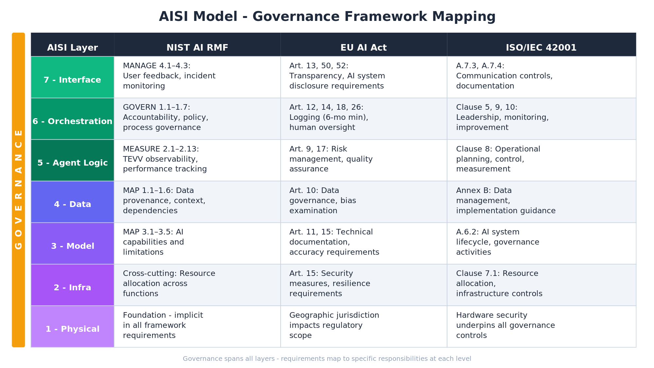
Figure 3: Governance Framework Mapping Across AISI Layers

Framework Highlights
- NIST AI RMF: The GOVERN function spans all layers. MEASURE requires observability throughout the stack for Test-Evaluation-Verification-Validation (TEVV). The Generative AI Profile (AI 600-1) adds 12 risk categories specific to generative AI.
- EU AI Act (high-risk systems): Article 12 requires high-risk AI systems to technically enable automatic logging. Article 19 requires GPAI providers to retain automatically generated logs under their control. Article 26(6) requires deployers to retain logs for at least six months where the logs are under the deployer's control. Article 14 requires human oversight interfaces. Article 18 requires providers to keep technical documentation for 10 years after the system is placed on the market.
- ISO/IEC 42001: 38 controls with a Plan-Do-Check-Act methodology. The first globally certifiable AI Management System standard.
- CSA AI Controls Matrix: 243 control objectives across 18 domains (July 2025). Includes Model Security as a dedicated domain.

Compliance Matrix: Controls by Framework Requirement
The matrix below maps specific regulatory and framework requirements to the AISI Baseline Controls that address them. Use this as the starting point for compliance evidence collection.

NIST AI RMF Mapping
GOVERN (organizational governance): SEC-10 (compliance evidence), IT-10 (change management), A2A-6 (oversight policy engine). The GOVERN function spans all seven AISI layers and requires policy enforcement at Layer 6 with evidence collection across the stack.
MAP (context and risk identification): SEC-1 (agent threat modeling). MAP requires understanding the AI system’s operating context, which the AISI Model’s seven-layer decomposition directly supports by making attack surface visible per layer.
MEASURE (assessment and monitoring): AI-9 (evaluation and red-teaming), AI-11 (behavioral drift detection), IT-6 (observability stack), A2A-11 (tamper-evident trace logging). MEASURE’s Test-Evaluation-Verification-Validation (TEVV) requirements map to continuous monitoring at Layers 5 and 6 with infrastructure telemetry at Layer 2. For operational drift detection implementation (baselines, thresholds, response playbooks), see the Operations and Lifecycle Reference, Section 1.
MANAGE (risk treatment and response): A2A-6 (oversight policy engine), A2A-7 (kill switch and circuit breakers), SEC-5 (incident response playbooks). MANAGE requires actionable controls that the orchestration layer (Layer 6) enforces in real time.
Generative AI Profile (AI 600-1): Adds 12 risk categories specific to generative AI. Key mappings include content provenance (AI-12, Layer 7), confabulation/hallucination (AI-5, Layers 5 and 4), data privacy (SEC-7, Layers 4 and 7), and information integrity (AI-5, AI-9, Layer 5).

EU AI Act Mapping
Article 9, Risk Management System: SEC-1 (agent threat modeling), A2A-6 (oversight policy engine), SEC-5 (incident response). Requires a risk management system established, documented, and maintained throughout the AI system’s lifecycle. The AISI Model’s governance plane provides the framework; the Baseline Controls provide the specific mechanisms.
Article 10, Data and Data Governance: AI-6 (RAG data access governance), AI-7 (embedding integrity), AI-8 (training pipeline governance), AI-10 (synthetic data controls). Covers training, validation, and testing datasets with requirements for data provenance, bias examination, and gap identification. Layer 4 (Data) is the primary enforcement point for runtime data; lifecycle controls in Annex A cover pre-deployment data governance.
Article 12, Record-Keeping: A2A-11 (tamper-evident trace logging), IT-6 (observability stack). Requires that high-risk AI systems technically enable automatic recording of events (logs) relevant to identifying risks and substantial modifications. The trace plane provides end-to-end logging across multi-agent chains. For retention enforcement mechanics across agent storage layers, see the Operations and Lifecycle Reference, Section 5.
Article 14, Human Oversight: A2A-6 (oversight policy engine). Requires human oversight interfaces including the ability to understand system capacities and limitations, monitor operation, and intervene with a stop button. Graduated oversight at Layer 6 with kill switches and human-in-the-loop gates directly implements this requirement.
Article 15, Accuracy, Robustness, and Cybersecurity: AI-5 (hallucination and grounding controls), AI-11 (behavioral drift detection), SEC-2 (adversarial testing), A2A-1 (mTLS). Requires appropriate levels of accuracy, robustness against errors and inconsistencies, and resilience against unauthorized access and manipulation.
Annex XI, GPAI Model Documentation: AI-1 (model registry), AI-2 (model provenance attestation), AI-8 (training pipeline governance), IT-8 (sustainability metrics). Requires documentation of model capabilities, limitations, training methodology, evaluation results, and energy consumption.

ISO/IEC 42001 Mapping
Plan: SEC-1 (agent threat modeling), SEC-10 (compliance evidence). Establish AI policy, objectives, and risk assessment processes. The AISI Model’s layer decomposition provides the structural framework for risk identification.
Do: All A2A controls, all AI controls, all IT controls. Implement the planned controls across the stack. Each AISI layer has corresponding controls in the Baseline Controls document.
Check: AI-9 (evaluation and red-teaming), AI-11 (behavioral drift detection), SEC-8 (access reviews), IT-6 (observability). Monitor, measure, and evaluate the AI management system’s performance and effectiveness.
Act: SEC-5 (incident response playbooks), AI-8 (training pipeline governance), IT-10 (change management). Take corrective and preventive actions based on findings from the Check phase.

Lifecycle Controls and the Runtime Stack
The lifecycle controls documented earlier in this reference (training pipeline governance, evaluation and red-teaming, synthetic data controls) exist outside the seven-layer runtime stack but directly influence what gets deployed at Layer 3 (Model) and Layer 4 (Data). Organizations should treat the model lifecycle as a governed upstream dependency, similar to a software CI/CD pipeline. The AISI governance plane can extend upstream to cover lifecycle audits, but the seven-layer stack describes the running system. The handoff point is Layer 3: a model artifact that passes lifecycle controls (provenance attestation, evaluation thresholds, safety benchmarks) is eligible for deployment into the runtime stack. A model that fails lifecycle controls must not reach Layer 3 regardless of operational readiness at other layers.

Effective Dates and Applicability
The EU AI Act entered into force on 1 August 2024 and applies in phases. Prohibited-practice provisions applied from 2 February 2025. GPAI model obligations (Article 53, Annex XI) applied from 2 August 2025. Broad application to high-risk AI systems, deployer obligations, and enforcement begins around mid-2026. Pre-existing GPAI models have until 2 August 2027 to comply. For the official implementation timeline, consult the European Commission’s AI Act Service Desk.

Baseline Controls
The baseline control set for production A2A deployments has been moved to a standalone companion document: AISI Model v1.0 - Baseline Controls. That document defines controls organized by audience: A2A protocol controls, AI/ML-specific controls, IT infrastructure controls, and security operations controls. Treat those controls as the non-negotiable floor for any organization deploying agent-to-agent systems.

Companion Documents
This document is part of the AISI Model v1.0 document set:
AISI Model v1.0. The seven-layer reference architecture and A2A negotiation sequence.
A2A Protocol Specification. Agent Cards, Behavioral Contracts (including Data Classification Enforcement and Retention Policy Enforcement), Authentication, and Graduated Oversight.
Baseline Controls. The minimum required controls for production A2A deployments, organized by team.
Implementation Guide. How to deploy A2A systems on production infrastructure: namespaces, SPIRE, mTLS, NetworkPolicy, OPA, OpenTelemetry, Vault, and container supply chain.
Operations and Lifecycle Reference. How to operate, monitor, and manage A2A systems after deployment: behavioral drift detection, shadow AI discovery, RAG index freshness, prompt versioning, agent memory hygiene, change control, and decommission.

