NEBRASKA MEDICINE HEALTH SERIES · BOOK ONE
Healthy Living Guide
Your Everyday Blueprint for Living Longer and Feeling Better

Dr. Jason Patera
Family Medicine · Nebraska Medicine

Based on guidance from USPSTF, AHA/ACC, ADA, ACSM, the American Cancer Society, CDC, and the Dietary Guidelines for Americans.

WHAT'S INSIDE
- The 10 Habits That Matter Most
- Eat Mostly Real Food
- Build Better Meals
- Healthy Snacks
- Exercise
- Healthy Weight
- Sleep, Stress & Connection
- Preventive Health
- Healthy Grocery Guide
- Frequently Asked Questions

START HERE

The 10 Habits That Matter Most
You don't need to change everything at once. These ten habits have the strongest evidence for helping you live longer and feel better — pick one to start tomorrow.
1. Move every day
150–300 minutes a week of moderate activity, plus strength training twice a week, lowers your risk of heart disease, diabetes, and early death.
Try this: Take a 10-minute walk after dinner.
2. Eat mostly real food
Build meals around vegetables, fruits, whole grains, lean protein, and healthy fats instead of packaged, ultra-processed foods.
Try this: Choose foods with a short ingredient list.
3. Fill half your plate with produce
Vegetables and fruit provide fiber, vitamins, and antioxidants that protect your heart, gut, and metabolism.
Try this: Add a vegetable to two meals today.
4. Make protein a priority
Protein helps preserve muscle, control appetite, and support healthy aging — at every stage of life.
Try this: Include a protein source at every meal.
5. Choose water first
Water supports nearly every process in your body and has zero calories or added sugar.
Try this: Keep a water bottle where you'll see it.
6. Protect 7–9 hours of sleep
Sleep restores your brain, balances hunger hormones, and supports a healthy weight and mood.
Try this: Set a consistent bedtime, even on weekends.
7. Build strength & balance
Strength training preserves muscle and bone as you age and lowers your risk of falls and injury.
Try this: Start with two short sessions this week.
8. Nurture your mind & relationships
Managing stress and staying socially connected are linked to a longer, healthier life.
Try this: Reach out to one person you care about today.
9. Know your numbers
Blood pressure, cholesterol, blood sugar, and weight trends are early warning signs your body gives you.
Try this: Ask your care team what your numbers are.
10. Stay current on screenings & vaccines
Preventive care catches problems early — when they are most treatable.
Try this: See the Preventive Health section for the schedule that fits your age.

NUTRITION

Eat Mostly Real Food
There is no single perfect diet — but a Mediterranean-style pattern, built mostly from whole foods, has the strongest evidence for a longer, healthier life.
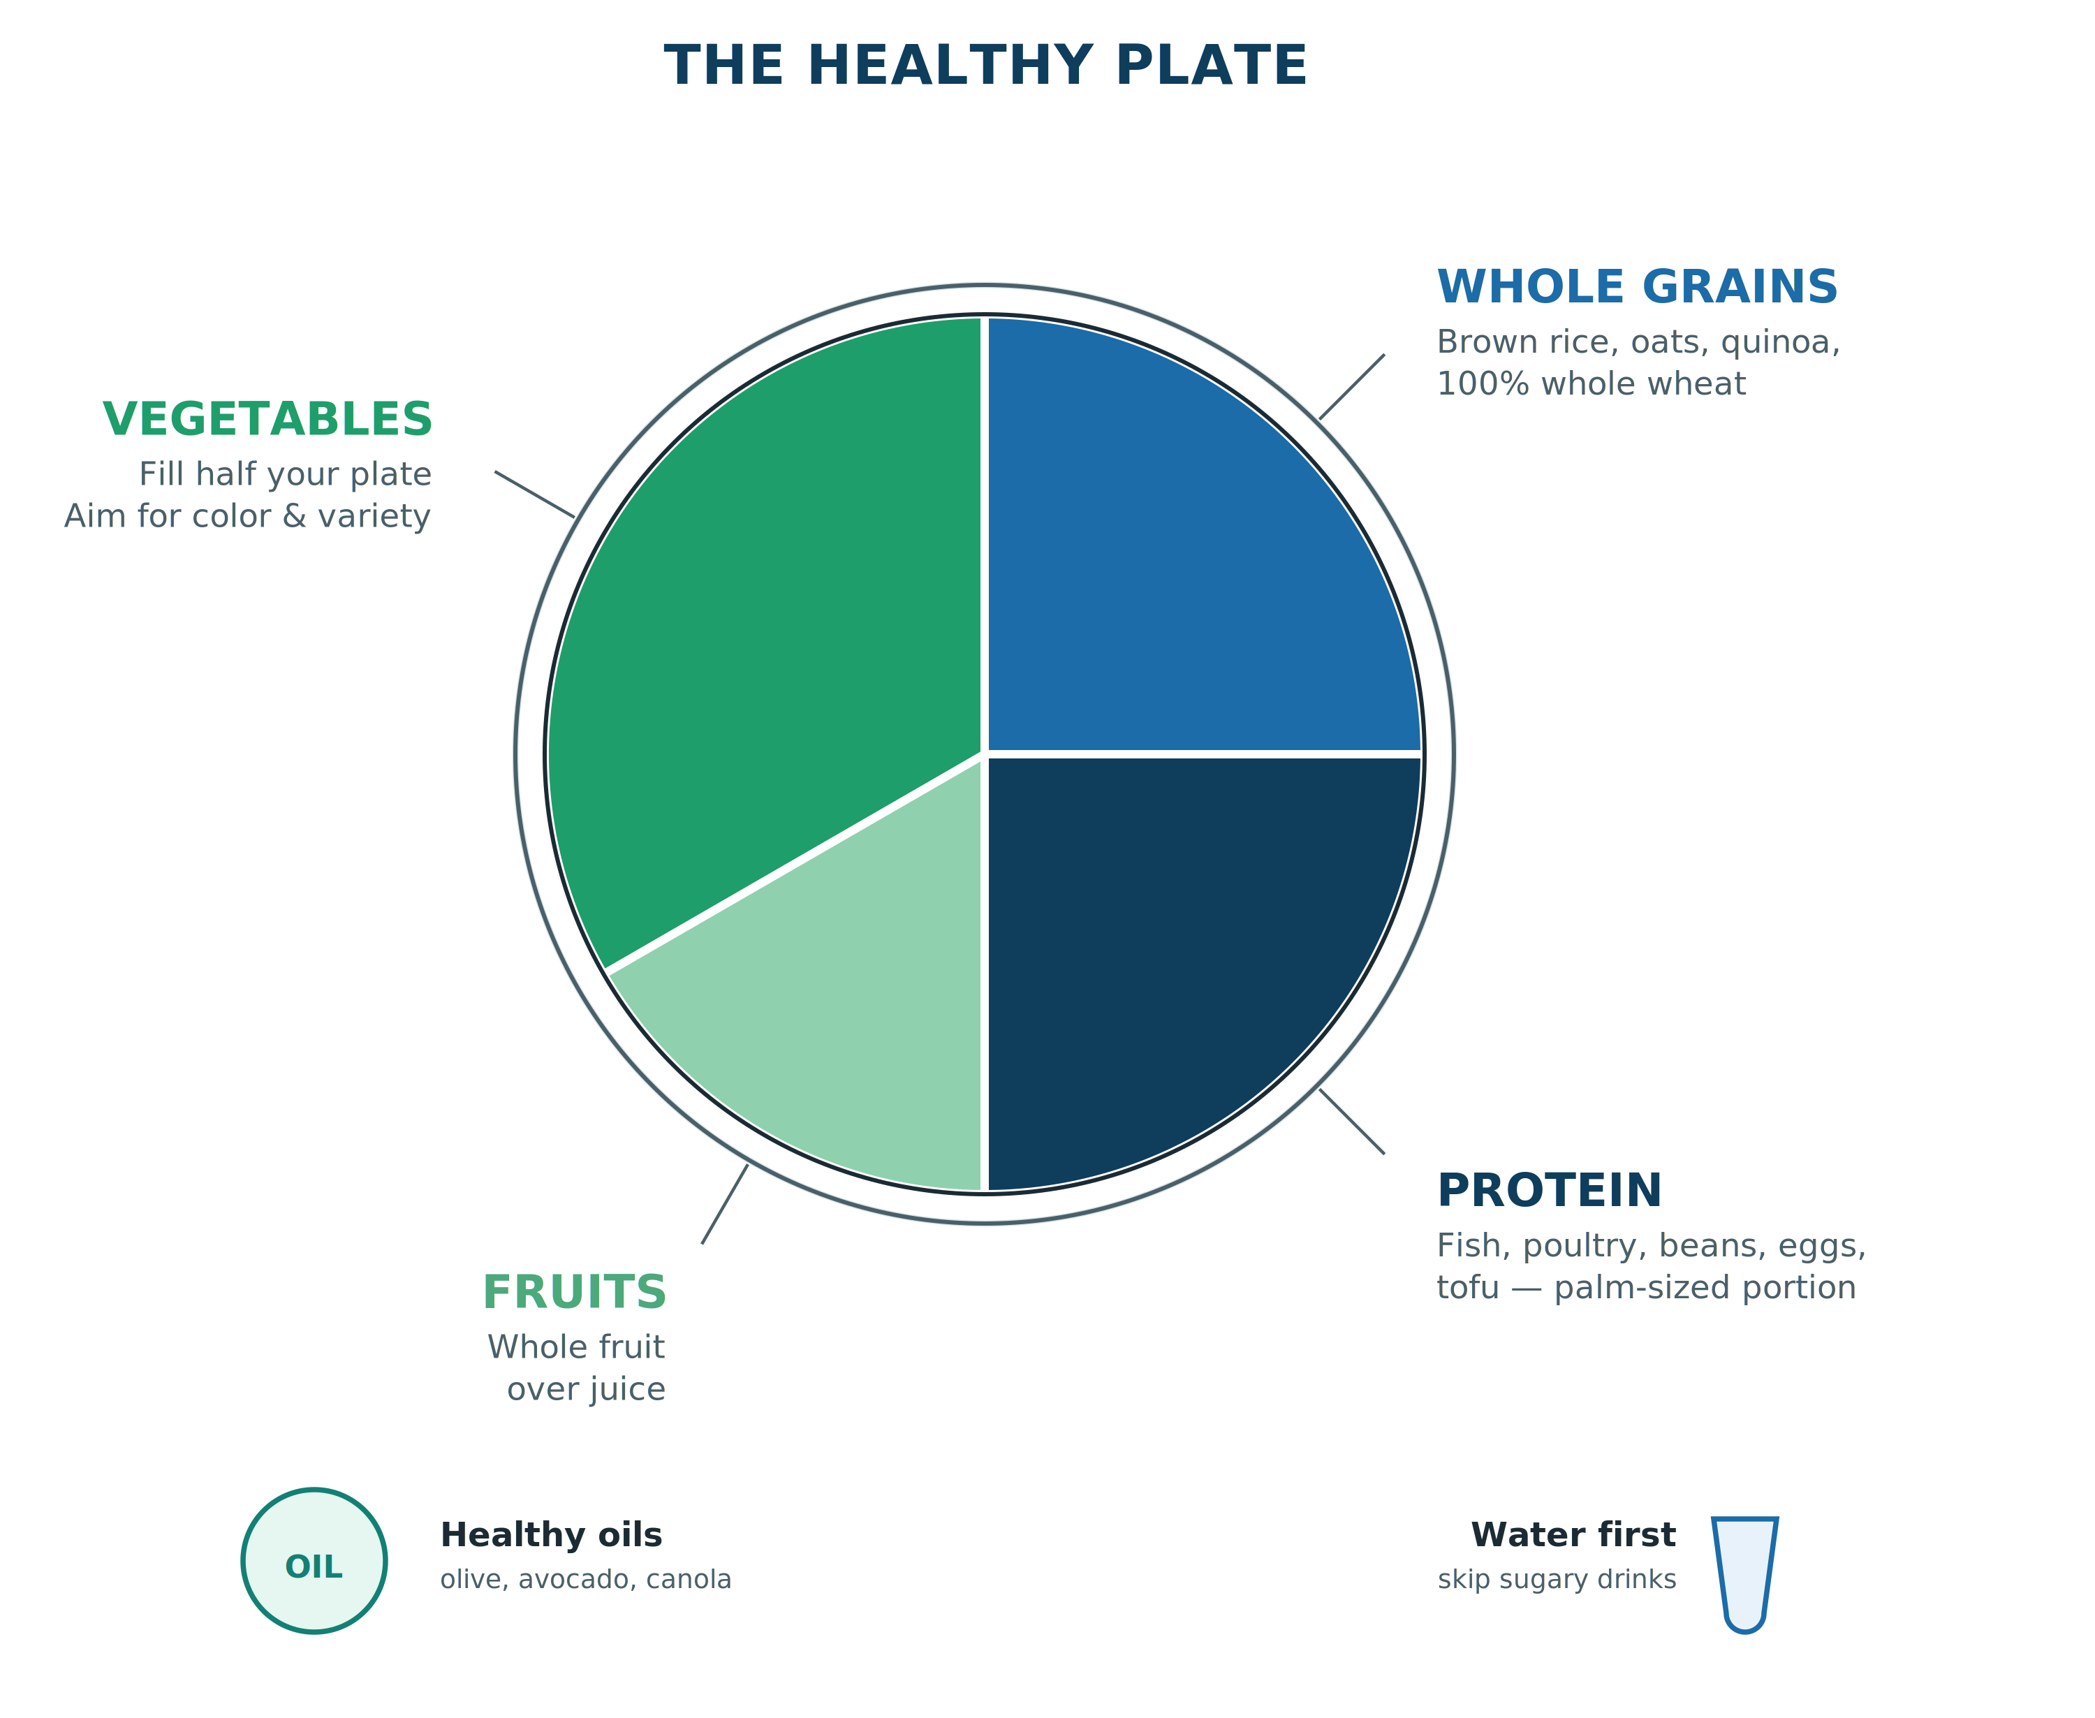
Nutrient | Choose more often | Enjoy less often
Protein | Fish, poultry, eggs, beans, lentils, tofu, Greek yogurt | Bacon, sausage, deli & cured meats
Fiber | Vegetables, fruit, beans, oats, whole grains | Refined white bread & pastries
Fats | Olive oil, nuts, seeds, avocado, fatty fish | Fried foods, stick margarine
Carbohydrates | 100% whole grains, legumes, starchy vegetables | Sugary cereal, refined snack foods
Added sugar | Whole fruit for something sweet | Soda, candy, sweetened coffee drinks
Processed foods | Home-prepared, minimally processed meals | Packaged snacks, fast food, sugary drinks

DID YOU KNOW?
Only about 5% of American adults eat enough fiber. Most need 25–38 grams a day.

DID YOU KNOW?
Large clinical trials show a Mediterranean eating pattern lowers the risk of heart attack and stroke.

WHAT TO DO TOMORROW
No food group is off-limits. Progress comes from what you add — more vegetables, more fiber, more protein — not from what you eliminate.

NUTRITION

Build Better Meals
A simple formula works for almost any meal: protein + fiber + healthy fat + color.

Breakfast
- ✓ Greek yogurt, berries & walnuts
- ✓ Eggs, whole-grain toast & avocado
- ✓ Oatmeal, peanut butter & banana
- ✓ Cottage cheese & fruit

Lunch & Dinner
- ✓ Palm-sized protein
- ✓ Half the plate vegetables
- ✓ Quarter plate whole grain or starchy veg
- ✓ A drizzle of olive oil

Meal Planning
- ✓ Plan 3–4 dinners before you shop
- ✓ Cook once, eat twice — make extra
- ✓ Keep a running grocery list
- ✓ Prep produce right after shopping
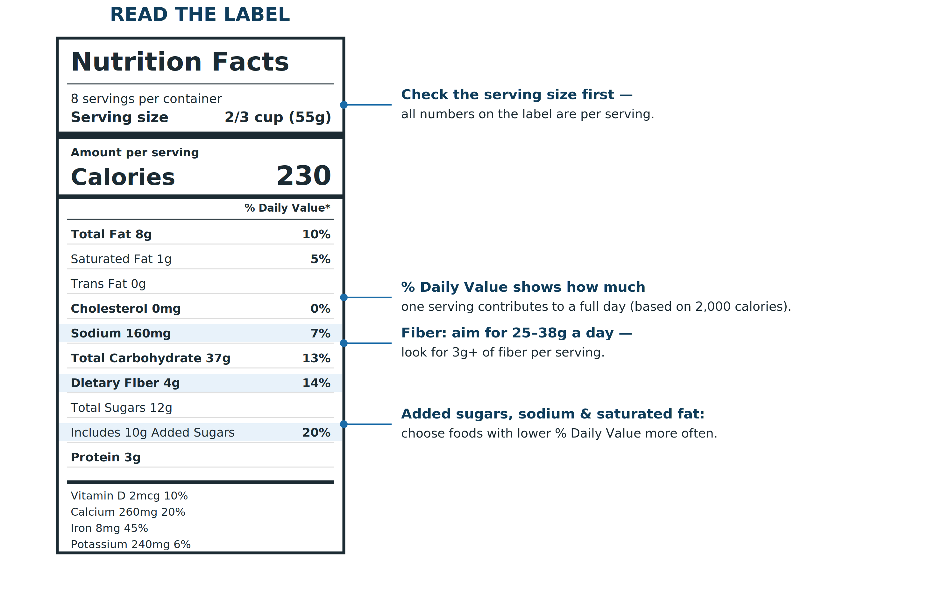

Eating Out
- Look at the menu ahead of time and decide before you arrive
- Ask for dressing and sauce on the side
- Choose grilled, baked, or roasted over fried
- Start with a vegetable-based side or salad
- Box up half your meal before you start eating
- Choose water or unsweetened tea over soda

NUTRITION

Healthy Snacks
A good snack pairs protein or fiber with something you enjoy. Values are approximate and will vary by brand and portion.
Snack | Protein / Fiber / Calories | Why it helps
Apple + 1 tbsp peanut butter | P 4g · F 4g · ~190 Cal | Fiber + protein keeps you full
Plain Greek yogurt (3/4 cup) | P 17g · F 0g · ~100 Cal | High protein, gut-healthy
Almonds (1 oz, ~23) | P 6g · F 3.5g · ~160 Cal | Healthy fats + fiber
Baby carrots + hummus (2 tbsp) | P 3g · F 4g · ~100 Cal | Crunchy fiber boost
Hard-boiled egg (1) | P 6g · F 0g · ~70 Cal | Portable protein
Cottage cheese + pineapple | P 12g · F 1g · ~120 Cal | Slow-digesting protein
Edamame, steamed (1 cup) | P 17g · F 8g · ~190 Cal | Plant protein + fiber
String cheese (1 stick) | P 7g · F 0g · ~80 Cal | Quick, portable protein
Trail mix, unsweetened (1/4 cup) | P 5g · F 2.5g · ~170 Cal | Energy + healthy fats
Banana + 1 tbsp almond butter | P 4g · F 4g · ~200 Cal | Potassium + protein
Whole-grain crackers + cheese | P 6g · F 2g · ~150 Cal | Balanced carb + protein
Roasted chickpeas (1/2 cup) | P 6g · F 5g · ~120 Cal | Crunchy plant fiber
Popcorn, air-popped (3 cups) | P 3g · F 3.5g · ~90 Cal | Whole grain, low calorie
Cherry tomatoes + mozzarella | P 7g · F 1g · ~110 Cal | Protein + produce
Protein smoothie (small) | P 20g · F 2g · ~150 Cal | Convenient post-activity fuel
Orange + 12 almonds | P 4g · F 5g · ~150 Cal | Vitamin C + healthy fat
Tuna (2 oz) + whole-grain crackers | P 12g · F 2g · ~140 Cal | Omega-3s + protein
Cucumber slices + tzatziki | P 3g · F 2g · ~90 Cal | Low-cal hydration + fiber
Overnight oats (1/2 cup) | P 6g · F 4g · ~150 Cal | Fiber-rich, make ahead
Dark chocolate square + walnuts | P 3g · F 2g · ~140 Cal | Satisfying, antioxidant-rich

WHAT TO DO TOMORROW
Keep two or three of these on hand at home, at work, and in your bag so a healthy option is always within reach.

MOVEMENT

Exercise
Adults need 150–300 minutes of moderate aerobic activity a week, plus strength training at least twice a week. Any amount of movement is better than none.
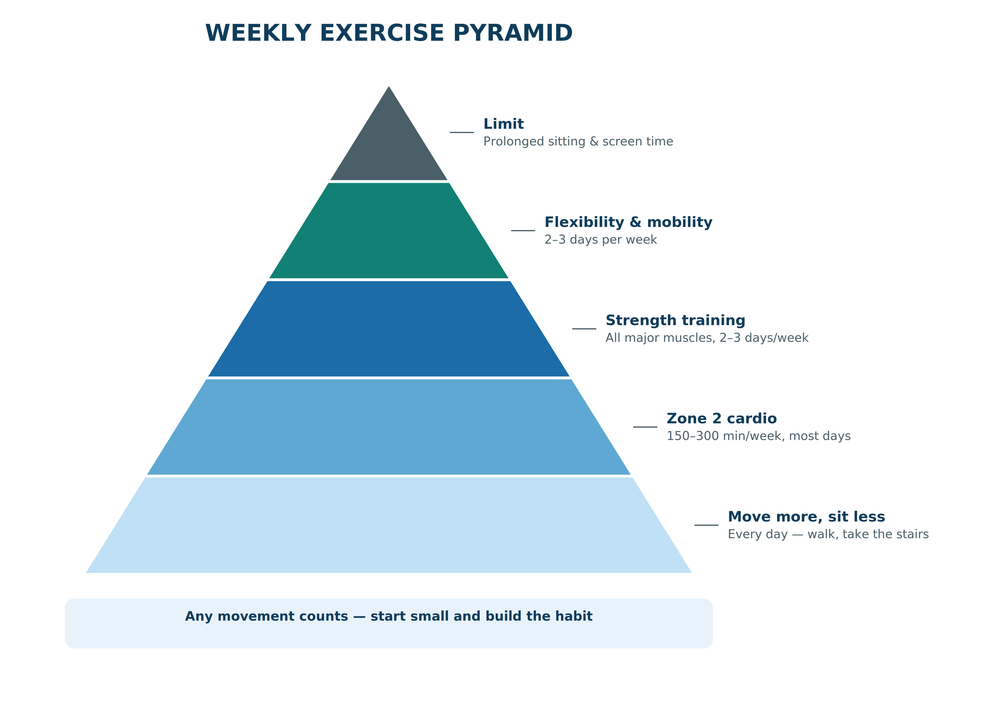
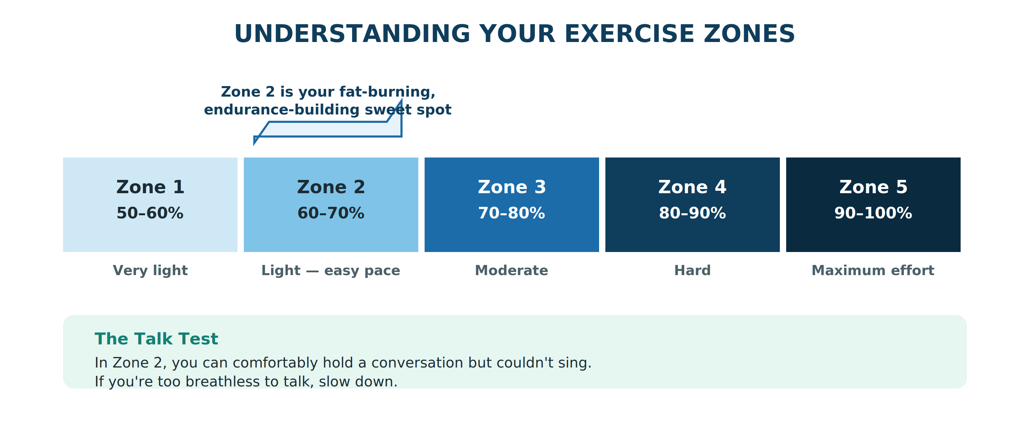
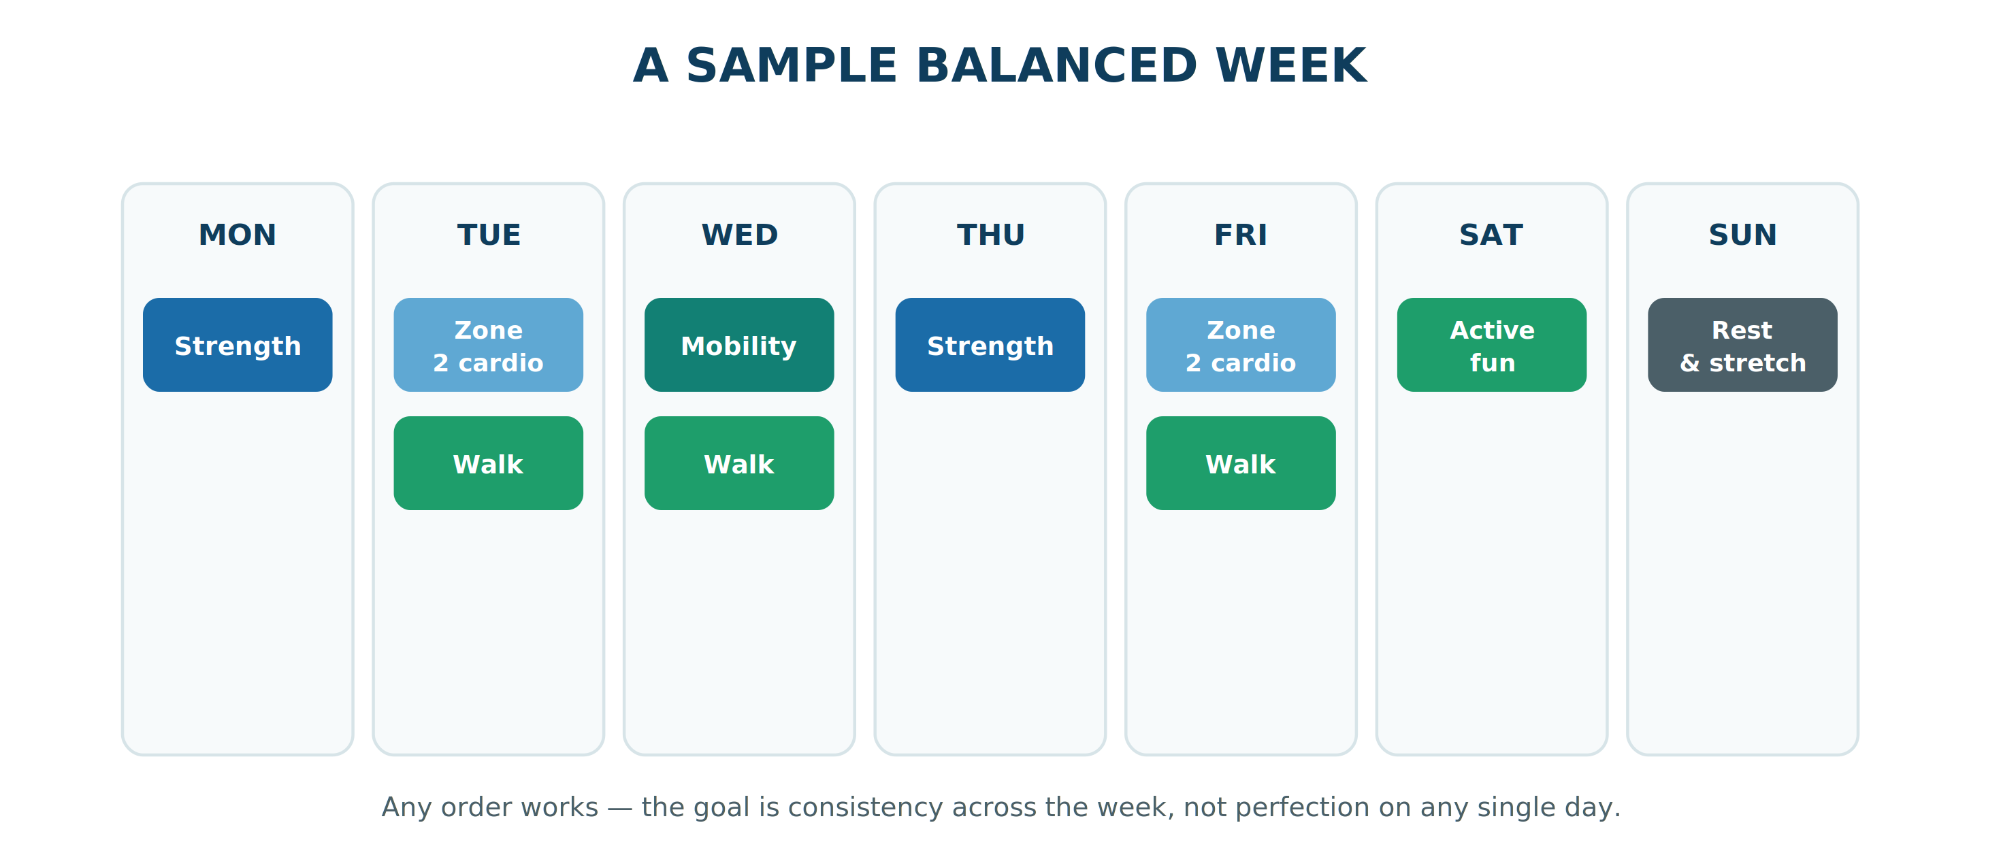

How to begin, at any fitness level
- ✓ Start with 10 minutes of walking, most days
- ✓ Add 2 short strength sessions a week
- ✓ Use the talk test to find your Zone 2 pace
- ✓ Add 5 minutes of mobility work after warming up
- ✓ Increase time or distance by about 10% a week
- ✓ Choose an activity you actually enjoy — it will last longer

MOVEMENT & NUTRITION

Healthy Weight
DID YOU KNOW?
Losing just 5–10% of body weight can improve blood pressure, blood sugar, fatty liver disease, and joint pain.

Timing & Fasting
What you eat matters more than exactly when you eat. Intermittent fasting can be a helpful tool for some people to manage calorie intake, but it isn't required and isn't right for everyone — including those who are pregnant, have a history of an eating disorder, or take medications for diabetes. Ask your care team first.

GLP-1 Medications
GLP-1 medications can be an effective option for some adults with obesity or type 2 diabetes. They work best alongside — not instead of — healthy eating, strength training, and sleep, which help preserve muscle while losing weight. Talk with your care team about whether one is right for you.
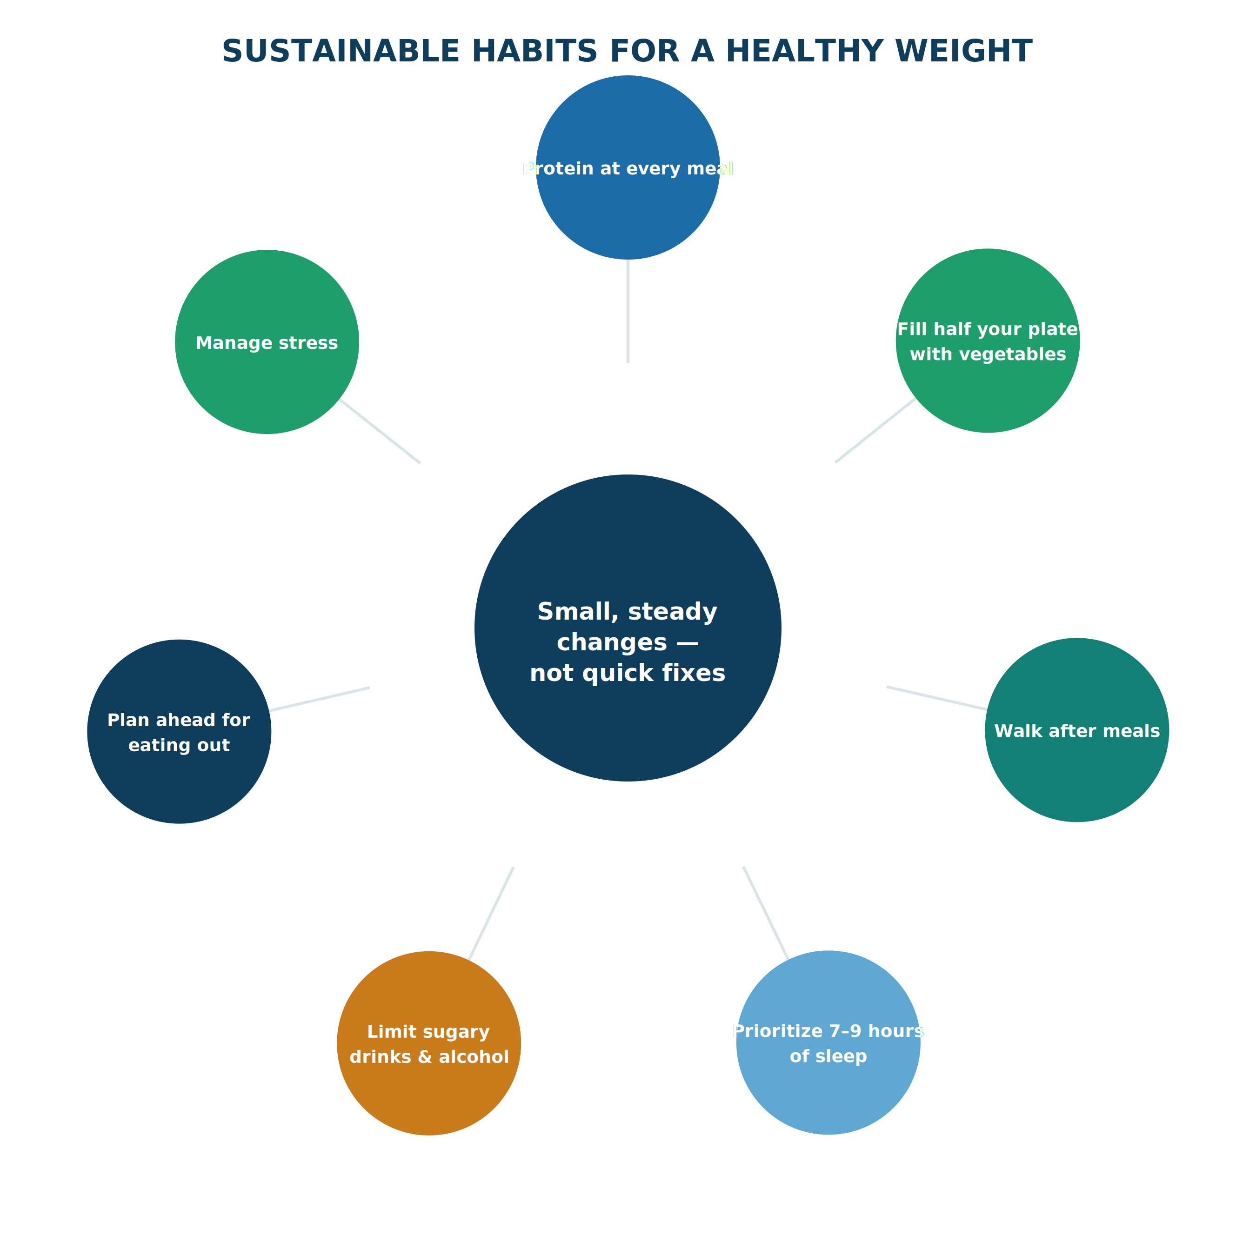

Behavior Change That Lasts
- ✓ Change one habit at a time
- ✓ Track progress with more than the scale — energy, sleep, and clothes fit all count
- ✓ Protect your sleep — poor sleep increases hunger hormones
- ✓ Manage stress — it drives cravings and emotional eating
PROTECT YOUR MUSCLE
Whether or not you use medication, pairing weight loss with adequate protein and regular strength training helps preserve muscle and keep your metabolism strong.

WELL-BEING

Sleep, Stress & Connection
Most adults need 7–9 hours of sleep a night. Sleep, stress, and relationships all shape your physical health.

Sleep Hygiene
- ✓ Keep a consistent sleep & wake time
- ✓ Keep your room cool, dark & quiet
- ✓ Limit screens for 30+ minutes before bed
- ✓ Avoid caffeine after early afternoon
- ✓ Get morning sunlight when you can

Managing Stress
- ✓ Try slow breathing for 2 minutes
- ✓ Take a short walk outside
- ✓ Write down what's on your mind
- ✓ Limit news & social media before bed
- ✓ Notice tension without judging it

Social Connection
- ✓ Reach out to one person most days
- ✓ Say yes to shared meals & activities
- ✓ Join a group tied to an interest
- ✓ Ask for help — and offer it
DID YOU KNOW?
The U.S. Surgeon General has identified loneliness and social isolation as risk factors for heart disease, stroke, and dementia — comparable in impact to other well-known health risks.

WHEN TO REACH OUT FOR HELP
If low mood, anxiety, or stress are affecting your daily life for more than two weeks, talk with your care team. Effective treatment is available, and asking for help is a sign of strength, not weakness.

A 2-Minute Reset for a Stressful Moment
- 1. Pause — stop what you're doing and sit or stand comfortably.
- 2. Breathe — inhale for 4 counts, hold for 4, exhale slowly for 6. Repeat 5 times.
- 3. Reset — name one thing you can do next, then take that one small step.

PREVENTION

Preventive Health
Screenings and vaccines catch problems early. Ask your care team which of these apply to you.
Screening | Who | How often
Blood pressure | All adults | Every visit; at least annually
Cholesterol | Adults 20+ | Every 4–6 years, more often with risk factors
Blood sugar / diabetes | Adults 35–70 who are overweight, or with other risk factors | Every 3 years
Breast cancer (mammogram) | Women 40–74 | Every 2 years
Cervical cancer | Women 21–65 | Every 3–5 years (Pap/HPV)
Colorectal cancer | Adults 45–75 | Colonoscopy every 10 yrs, or annual stool test
Lung cancer (low-dose CT) | Adults 50–80 with a significant smoking history | Annually
Dental exam & cleaning | All adults | Every 6–12 months
Vision exam | All adults | Every 1–2 years, more often after age 60
Hearing check | All adults | Baseline, then as needed
Skin check | All adults, especially with risk factors | Annually, or if a mole changes

Vaccines
- Influenza — every year
- Tdap/Td — once, then booster every 10 years
- Shingles — age 50+
- Pneumococcal — age 65+, or earlier with certain conditions
- COVID-19 — per current CDC guidance
SUN & SKIN PROTECTION
Use SPF 30+ daily, seek shade midday, and check your skin monthly for new or changing spots — remember the ABCDEs: Asymmetry, Border, Color, Diameter, Evolving.

NUTRITION

Healthy Grocery Guide
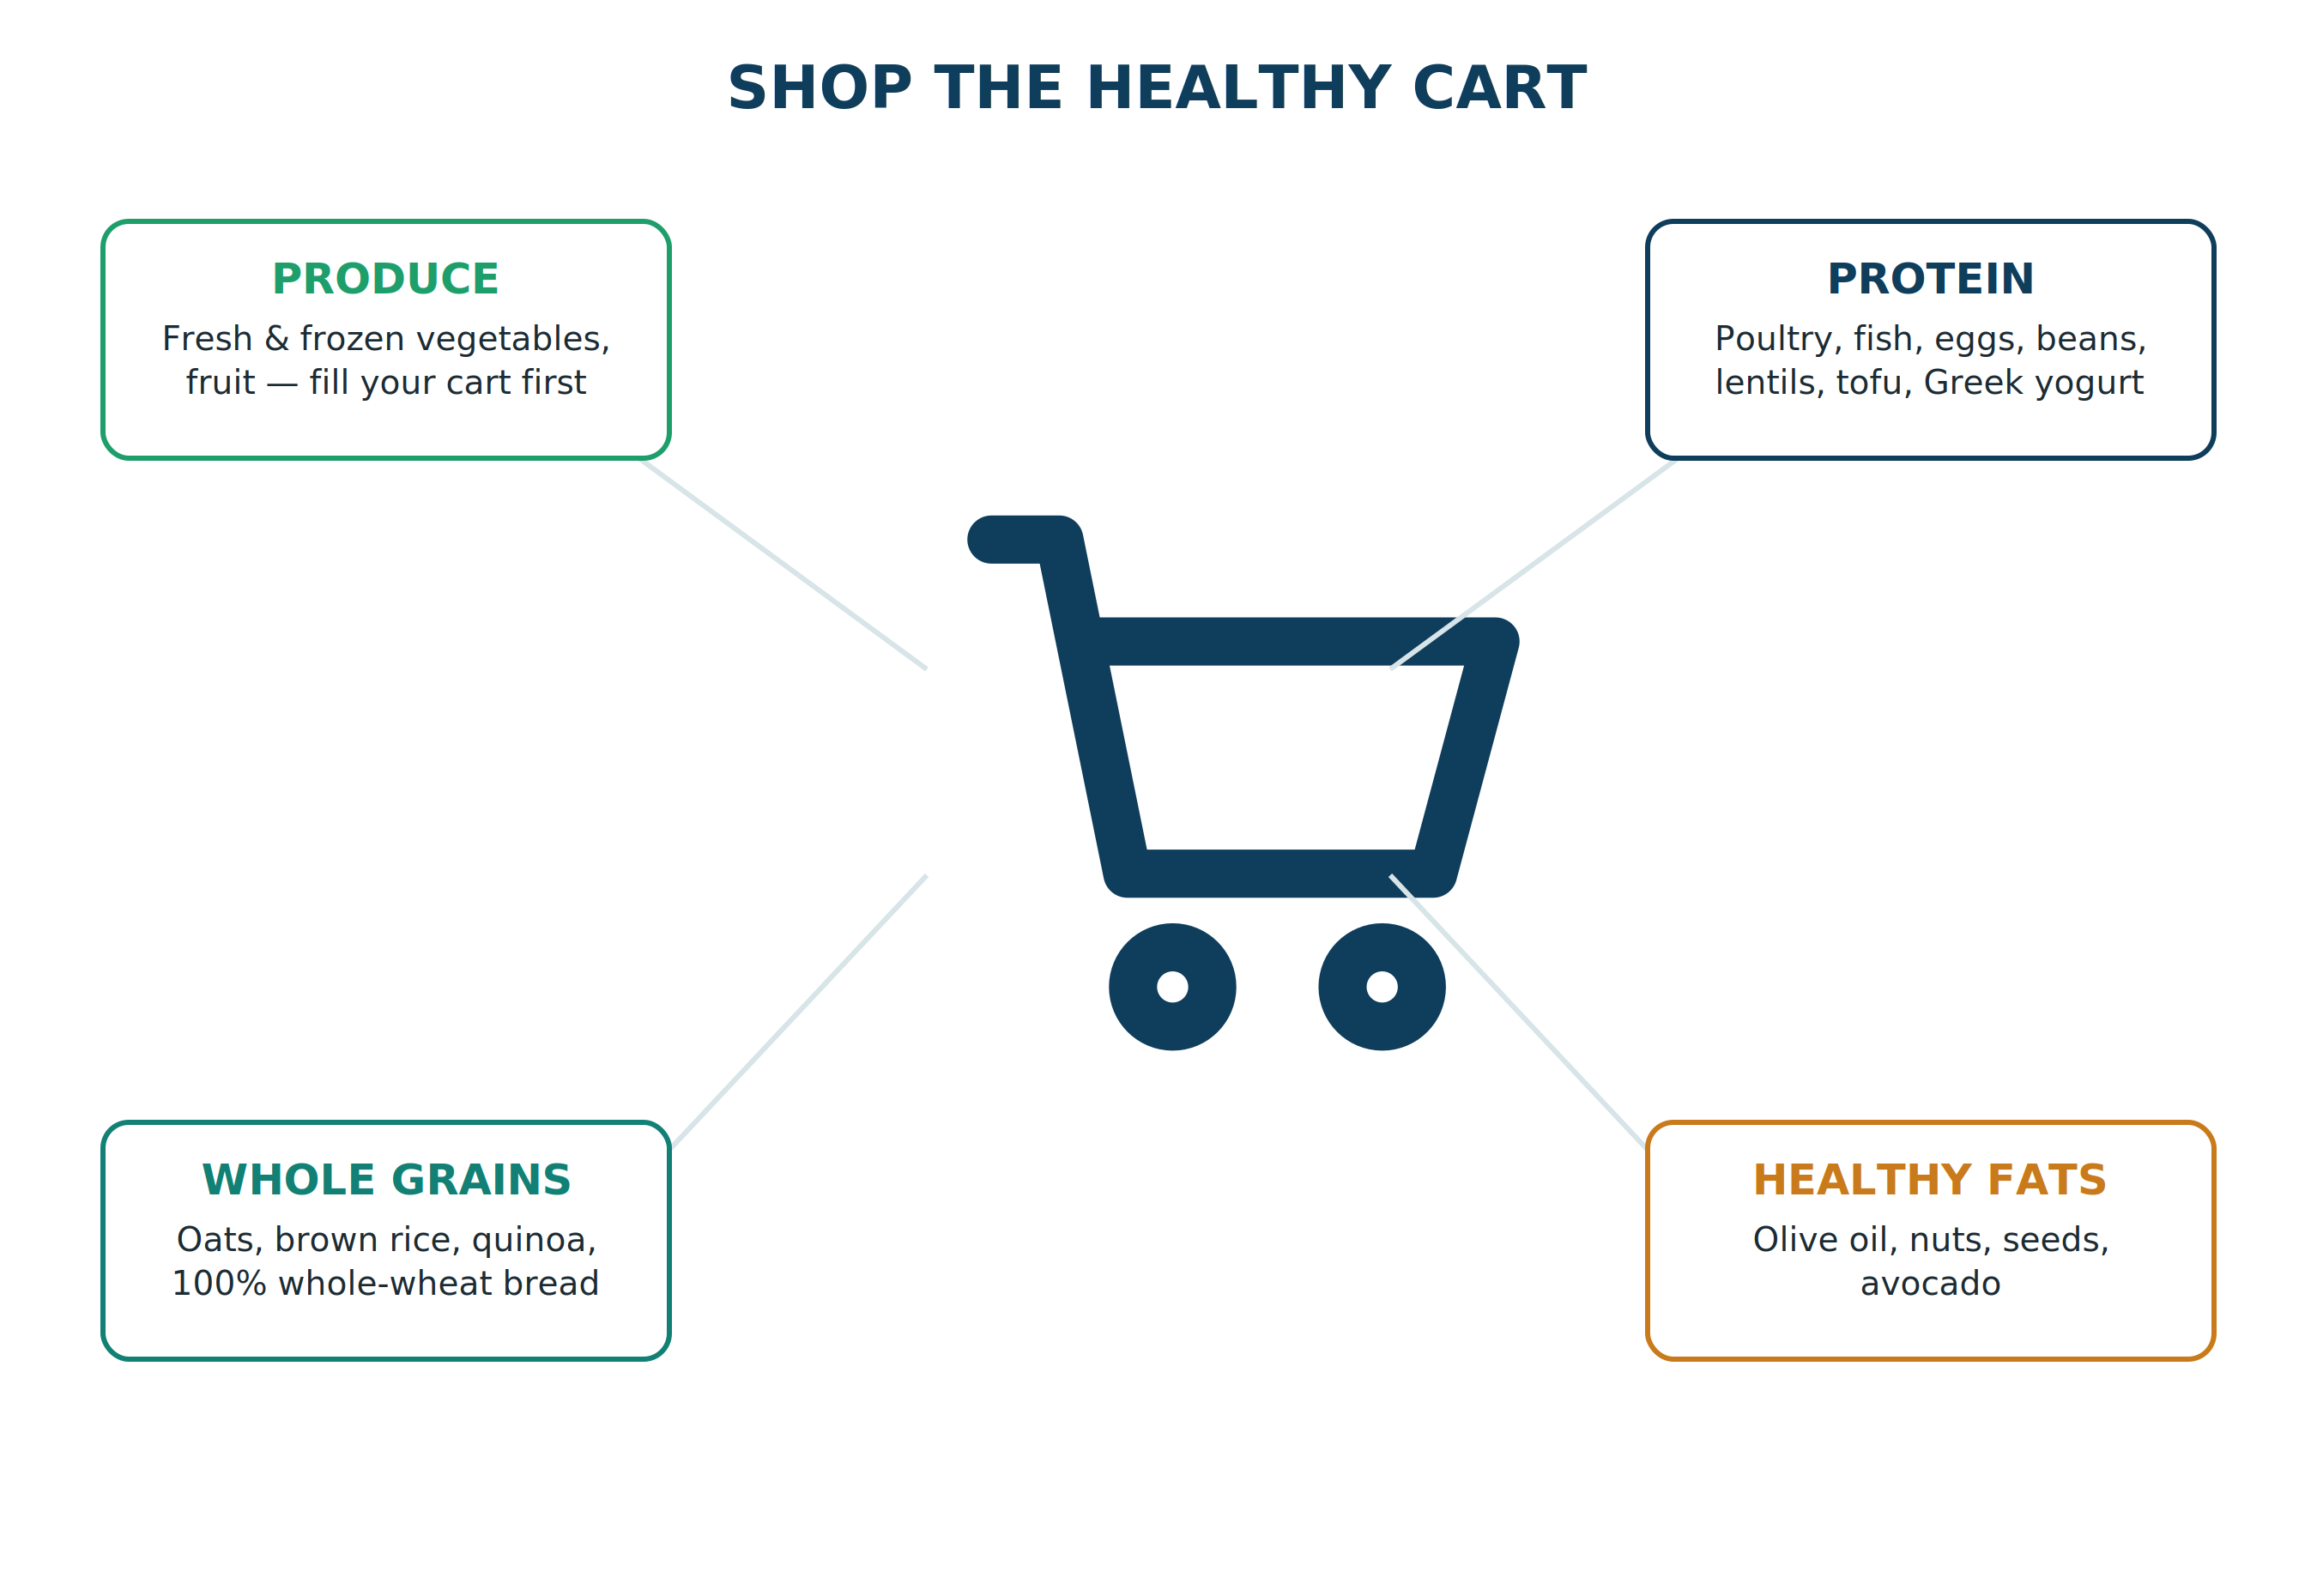
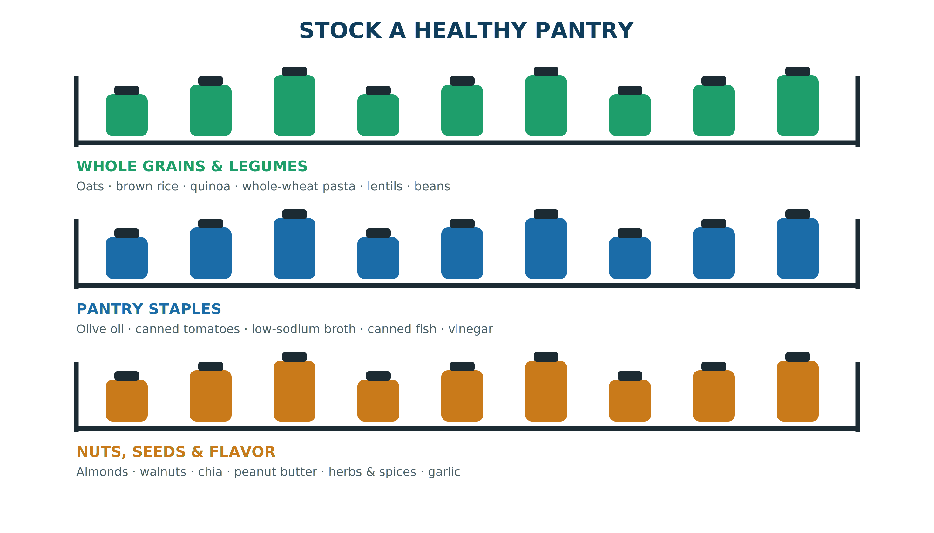

Simple Swaps
Instead of | Choose more often
White bread | 100% whole-grain or whole-wheat bread
Sugary breakfast cereal | Oats or a lower-sugar, whole-grain cereal
Soda or sweetened tea | Sparkling water or unsweetened tea
Potato chips | Air-popped popcorn or nuts
Regular pasta | Whole-wheat or legume-based pasta
Creamy salad dressing | Olive oil & vinegar
Frozen meals, highly processed | Plain frozen vegetables & proteins you season yourself

YOUR QUESTIONS

Frequently Asked Questions
Is fruit too sugary?
No. The fiber in whole fruit slows sugar absorption. Whole fruit is linked to better, not worse, health outcomes.
Are eggs bad for cholesterol?
For most people, eggs in moderation (about one a day) fit well into a healthy eating pattern.
Is coffee healthy?
Moderate coffee (3–4 cups/day) is linked to neutral or lower risk of several conditions. Watch the added sugar and cream.
Are artificial sweeteners safe?
FDA-approved sweeteners are generally safe in moderation and can help reduce added sugar. Water is still the best default.
Do I need protein shakes?
Not necessarily. They're a convenient option if you struggle to get enough protein from food — choose a lower-sugar option.
How much alcohol is safe?
Less is better. If you drink, current guidance suggests limiting to 2 drinks/day or fewer for men and 1 or fewer for women.
Do I have to eat breakfast?
Not necessarily — it depends on the person. If you do eat breakfast, prioritize protein and fiber to help you feel full.
Do I need a multivitamin?
Most nutrients are best absorbed from food. Some people benefit from specific supplements (like vitamin D) — ask your care team.
Does intermittent fasting work?
It can help some people manage calorie intake, but it isn't more effective than other approaches when calories are matched, and isn't right for everyone.
STILL HAVE QUESTIONS?
Bring this guide to your next visit. Your care team can help you turn any of these habits into a plan that fits your life.

EVIDENCE BASIS

References & Guidelines
This guide reflects current guidance from major medical and public health organizations. It is educational and does not replace personalized medical advice from your care team.
Nutrition
- U.S. Dietary Guidelines for Americans, 2020–2025
- American Heart Association dietary guidance
- PREDIMED & related Mediterranean diet trials
Exercise
- American College of Sports Medicine (ACSM) guidelines
- Physical Activity Guidelines for Americans, HHS
Weight & Diabetes
- American Diabetes Association (ADA) Standards of Care
- AHA/ACC/Obesity Society guidance
Cancer Screening
- American Cancer Society screening guidelines
- U.S. Preventive Services Task Force (USPSTF)
Cardiovascular Health
- American Heart Association / American College of Cardiology (AHA/ACC)
Sleep & Mental Health
- American Academy of Sleep Medicine
- U.S. Surgeon General's Advisory on Loneliness (2023)
General Prevention
- Centers for Disease Control and Prevention (CDC)
- U.S. Preventive Services Task Force (USPSTF)

About the Author
Dr. Jason Patera is a family medicine physician with Nebraska Medicine. This guide is part of a series of patient education booklets designed to help patients build sustainable, evidence-based habits for lifelong health.

© Nebraska Medicine. This material is for general educational purposes and is not a substitute for professional medical advice, diagnosis, or treatment. Always ask your physician or qualified health provider with questions about a medical condition.

