**Chapter 11: Analyze and Store Logs**

Chapter 11, Section 04

## Guided Exercise: Review Syslog Files

Before exiting (step 3.3) run the history command, take a screenshot and paste to Word document.

Chapter 11, Section 06

## Guided Exercise: Review System Journal Entries

Before exiting (step 7) run the history command, take a screenshot and paste to Word document.

Chapter 11, Section 08

## Guided Exercise: Preserve the System Journal

In case **step 3.1** isn’t clear:

Run **sudo vim /etc/systemd/journald.conf**

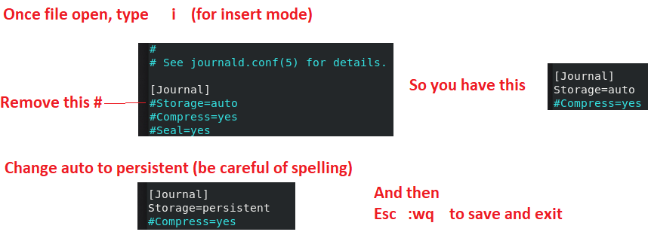

**Before exiting (step 4.4)** run the history command, take a screenshot and paste to Word document.

Chapter 11, Section 10

## Guided Exercise: Maintain Accurate Time

Continued next page . . .

In case **step 3.1** isn’t clear:

Run **sudo vim /etc/chrony.conf**

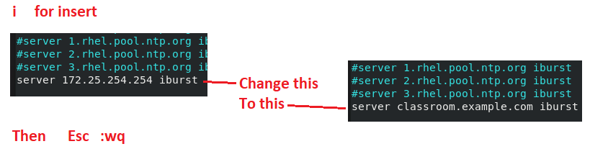

**Before exiting (step 4.3)** run the history command, take a screenshot and paste to Word document.

Upload the file of history screenshots to Canvas