**Chap 13: Archive/Transfer files**

## Chapter 13 Section 02:

## Guided Exercise: Manage Compressed Tar Archives

* Follow the instructions within this Guided Exercise
* When finished, run the history command
* Take a screenshot of as many of the most recent commands as you can
* Paste to your Word document (the one you’ll submit when this lab is finished)

## Chapter 13 Section 04:

## Guided Exercise: Transfer Files Between Systems Securely

* Follow the instructions within this Guided Exercise
* When finished, run the history command
* Take a screenshot of as many of the most recent commands as you can
* Paste to your Word document (the one you’ll submit when this lab is finished)

## Chapter 13 Section 06:

## Guided Exercise: Synchronize Files Between Systems Securely

* Follow the instructions within this Guided Exercise
* When finished, run the history command
* Take a screenshot of as many of the most recent commands as you can
* Paste to your Word document (the one you’ll submit when this lab is finished)

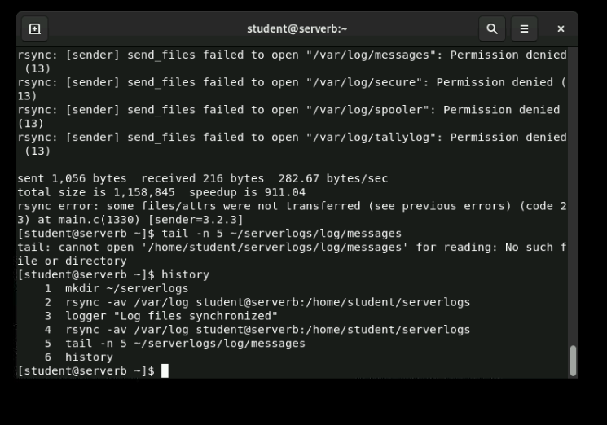

## Chapter 13 Section 07:

## Lab: Archive and Transfer Files

* Follow the instructions within this Lab
* Click the ‘Show Solution’ button if you are not sure what command to enter
* When finished, run the history command
* Take a screenshot of as many of the most recent commands as you can
* Paste to your Word document (the one you’ll submit when this lab is finished)
* Text

  Description automatically generated

Upload the file containing the screenshots of the history outputs to Canvas for this lab