SVD Example 1

Evaluate System and Compare to SVD Calculation 2

## SVD Example

% Define System  
sys =tf({1,1;1,1},{[1 1],[1 2];[1 0],[1 1]});  
  
% create singular values plot  
sigma(sys)  
  
% evaulate transfer function matrix at omega = 2 rad/sec  
w = 2; % rad/sec  
G_jw = evalfr(sys, 1i*w);  
  
% calculate SVD to find singular values, input proportions, input phase,  
% output proportions, and output phase  
[U,S,V] = svd(G_jw);  
  
fprintf('For omega = %.4frad/sec\n',w);  
fprintf('sigma_1 = %f, sigma_2 = %f\n\n',S(1,1),S(2,2))  
  
fprintf('Input vector corresponding to sigma_1 amplitude proportion:\n[mag = %.4f phase = %.4frad ]\n[mag = %.4f phase = %.4frad]\n\n',abs(V(1,1)),angle(V(1,1)),abs(V(2,1)),angle(V(2,1)))  
fprintf('Output vector corresponding to sigma_1 amplitude proportion:\n[mag = %.4f phase = %.4frad ]\n[mag = %.4f phase = %.4frad]\n\n',abs(U(1,1)),angle(U(1,1)),abs(U(2,1)),angle(U(2,1)))

For omega = 2.0000rad/sec  
sigma_1 = 0.879422, sigma_2 = 0.040203  
  
Input vector corresponding to sigma_1 amplitude proportion:  
[mag = 0.7622 phase = 3.1416rad]  
[mag = 0.6473 phase = 2.7367rad]  
  
Output vector corresponding to sigma_1 amplitude proportion:  
[mag = 0.6473 phase = 2.0011rad]  
[mag = 0.7622 phase = 1.5962rad]

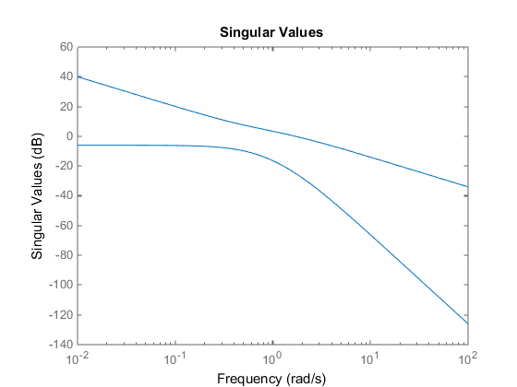

## Evaluate System and Compare to SVD Calculation

% Evaluate system at maximum gain  
t = linspace(0,20,100000);  
input =[ abs(V(1,1))*sin(w*t + angle(V(1,1)));  
 abs(V(2,1))*sin(w*t + angle(V(2,1)))];  
[y,t] = lsim(sys,input,t);  
  
index = t>12; % time greater than 12 seconds for system to find steady state  
  
% find peak to peak amplitude and divide by 2  
amplitude = [(max(y(index,1))-min(y(index,1)))/2;  
 (max(y(index,2))-min(y(index,2)))/2];  
  
% divide by norm of amplitudes to find amplitude proportions  
amplitudeProportion = amplitude/norm(amplitude);  
  
%output to command line  
fprintf('Output proportion simulation at max gain for omega = %.4frad/sec: \n[%.4f]\n[%.4f]\n\n',w,amplitudeProportion(1), amplitudeProportion(2));  
fprintf('Note that output proportion corresponds to the values found earlier via SVD\n')

Output proportion simulation at max gain for omega = 2.0000rad/sec:   
[0.6473]  
[0.7622]  
  
Note that output proportion corresponds to the values found earlier via SVD

[*Published with MATLAB® R2014b*](http://www.mathworks.com/products/matlab)