Jinlongli

WangYuhe

CS 699

project

Date: 04/2/2023

**Analysis of HINTS 5 Cycle 4**

CS 699 Final Project (Prof. Jae Young Lee)

**Dataset Details**

The Health Information National Trends Survey (HINTS) is a nationally representative survey that has

been administered every few years by the National Cancer Institute since 2003. The HINTS target

population is all adults aged 18 or older in the civilian non-institutionalized population of the United States.

The HINTS program collects data on the American public's need for, access to, and use of health-related

information and health-related behaviors, perceptions, and knowledge.

The HINTS 5 administration includes four data collection cycles over four years, starting in 2017. The first

of these cycles (HINTS 5, Cycle 1) was conducted from January through May 2017. The focus of this

report is HINTS 5, Cycle 4, collected February through June 2020.

Data collection for Cycle 4 of HINTS 5 began in February 2020 and concluded in June 2020. HINTS 5,

Cycle 4 was a self-administered mailed questionnaire, using a sampling frame provided by Marketing

Systems Group (MSG) of addresses in the United States.

**Objective**

Divide the dataset into two parts: training dataset and test dataset, use five different

attribute selection methods to reduce the dataset, and take out attribute for

classification. Each attribute selection method will perform five sameclassifications

and will eventually test the total 25 classifier models, and we will find the best one with the best prediction.

**Data mining goal:**

our data mining project is to develop a reliable and accurate predictive model that can effectively classify individuals' information-seeking behavior regarding cancer (SeekCancerInfo).

**data mining tool**

**using R**

**classification algorithms**

classification algorithms 1:J48

J48 is a decision tree algorithm used for classification tasks in machine learning. It is based on the C4.5 algorithm and was developed by Ross Quinlan. J48 works by recursively splitting the data into subsets based on the most significant attribute until a leaf node is reached, which corresponds to a class label.

classification algorithms 2:Nnet

Nnet is a shorthand term for "neural network," which is a type of machine learning algorithm used for both classification and regression tasks. Neural networks are based on the structure and function of biological neurons in the human brain, and they are capable of learning complex patterns and relationships in data.

classification algorithms 3:Random Forest

RF stands for "Random Forest," which is a popular machine learning algorithm used for classification and regression tasks. A random forest is an ensemble learning method that combines multiple decision trees to improve the accuracy and robustness of the model.

classification algorithms 4: decision tree

rpart is a decision tree algorithm used for classification and regression tasks in machine learning. It stands for "Recursive Partitioning and Regression Trees" and is implemented in the R programming language.

rpart works by recursively partitioning the data into subsets based on the values of a predictor variable that provide the best split in terms of the reduction in the residual sum of squares (RSS) for regression tasks or the improvement in the Gini impurity or entropy for classification tasks. The algorithm splits the data into subsets until a stopping criterion is met, such as a minimum number of observations in a leaf node or a maximum tree depth.

classification algorithms 5:SVM

svmRadial refers to a type of support vector machine (SVM) algorithm that uses a radial basis function (RBF) kernel to separate data points in a high-dimensional feature space. SVMs are a type of supervised learning algorithm used for classification, regression, and outlier detection tasks.

**Attribute selection methods**

Attribute selection methods 1: Information gain.

Information gain is commonly used in attribute selection methods to determine which features or attributes are most useful for a particular task. In this context, the goal is to identify the attributes that are most informative and relevant to the class labels or target variable.

set of attributes selected byInformation gain attribute selection method.

[1] "PersonID" "CancerFrustrated" "CancerLotOfEffort" "UseInternet"

[5] "EducB"

Measure J48 nnet rf rpart svmRadial

F-measure 0.92827 0.92373 0.94167 0.94167 0.92827

FP rate 0.85833 0.85124 0.88034 0.88034 0.85833

MCC NA NA NA NA NA

Precision 0.86614 0.85827 0.88976 0.88976 0.86614

Recall 1.00000 1.00000 1.00000 1.00000 1.00000

ROC area 0.06693 0.07087 0.05512 0.05512 0.06693

TP rate 1.00000 1.00000 1.00000 1.00000 1.00000

Attribute selection methods 2: Gain ratio

Gain ratio is a variant of information gain that is designed to reduce the bias towards multi-valued attributes. In traditional information gain, attributes with many distinct values are favored because they have a larger number of possible splits. However, this can lead to overfitting and may not accurately reflect the importance of the attribute in the dataset.

set of attributes selected by Gain ratio attribute selection method.

[1] "CancerFrustrated" "CancerLotOfEffort" "BMI" "AgeDX"

[5] "AvgDrinksPerWeek"

Measure J48 nnet rf rpart svmRadial

F-measure 0.94167 0.92373 0.94167 0.94167 0.92827

FP rate 0.88034 0.85124 0.88034 0.88034 0.85833

MCC NA NA NA NA NA

Precision 0.88976 0.85827 0.88976 0.88976 0.86614

Recall 1.00000 1.00000 1.00000 1.00000 1.00000

ROC area 0.05512 0.07087 0.05512 0.05512 0.06693

TP rate 1.00000 1.00000 1.00000 1.00000 1.00000

Attribute selection methods 3: Gini index

Gini index is a measure used in decision tree algorithms and other classification algorithms to evaluate the quality of a split based on the class labels of the data. The Gini index measures the probability of misclassifying a randomly chosen data point if it were randomly labeled according to the distribution of class labels in the subset of the data.

set of attributes selected by Gini index attribute selection method.

[1] "PersonID" "CancerFrustrated" "CancerLotOfEffort" "UseInternet"

[5] "EducB"

Measure J48 nnet rf rpart svmRadial

F-measure 0.94167 0.92373 0.94167 0.94167 0.92827

FP rate 0.88034 0.85124 0.88034 0.88034 0.85833

MCC NA NA NA NA NA

Precision 0.88976 0.85827 0.88976 0.88976 0.86614

Recall 1.00000 1.00000 1.00000 1.00000 1.00000

ROC area 0.05512 0.07087 0.05512 0.05512 0.06693

TP rate 1.00000 1.00000 1.00000 1.00000 1.00000

Attribute selection methods 4: RReliefF

The RReliefF algorithm is a feature/attribute selection method used in machine learning and data mining. It is an extension of the Relief algorithm and is designed to handle noisy, incomplete, and multi-class data more effectively. The primary goal of RReliefF is to rank features based on their relevance to the target variable.

set of attributes selected by RReliefF attribute selection method.

[1] "CancerLotOfEffort" "CancerFrustrated" "CancerConfidentGetHealthInf"

[4] "UseInternet" "EducB"

Measure J48 nnet rf rpart svmRadial

F-measure 0.92827 0.94167 0.94167 0.94167 0.93724

FP rate 0.85833 0.88034 0.88034 0.88034 0.87288

MCC NA NA NA NA NA

Precision 0.86614 0.88976 0.88976 0.88976 0.88189

Recall 1.00000 1.00000 1.00000 1.00000 1.00000

ROC area 0.06693 0.05512 0.05512 0.05512 0.05906

TP rate 1.00000 1.00000 1.00000 1.00000 1.00000

Attribute selection methods 5: ImpurityEuclid

ImpurityEuclid is a measure used in attribute selection methods to evaluate the quality of a split based on the distance between instances in the feature space. It is typically used in clustering algorithms, where the goal is to group similar instances together based on their feature values.

set of attributes selected by ImpurityEuclid attribute selection method.

[1] "PersonID" "StrongNeedCancerInfo_OS" "CancerFrustrated"

[4] "BMI" "CancerLotOfEffort"

Measure J48 nnet rf rpart svmRadial

F-measure 0.92827 0.92827 0.94167 0.94167 0.90984

FP rate 0.85833 0.85833 0.88034 0.88034 0.85841

MCC NA NA NA NA NA

Precision 0.86614 0.86614 0.88976 0.88976 0.87402

Recall 1.00000 1.00000 1.00000 1.00000 0.94872

ROC area 0.06693 0.06693 0.05512 0.05512 0.09212

TP rate 1.00000 1.00000 1.00000 1.00000 0.94872

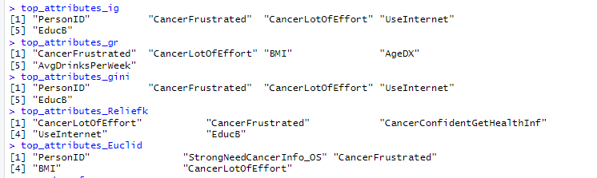

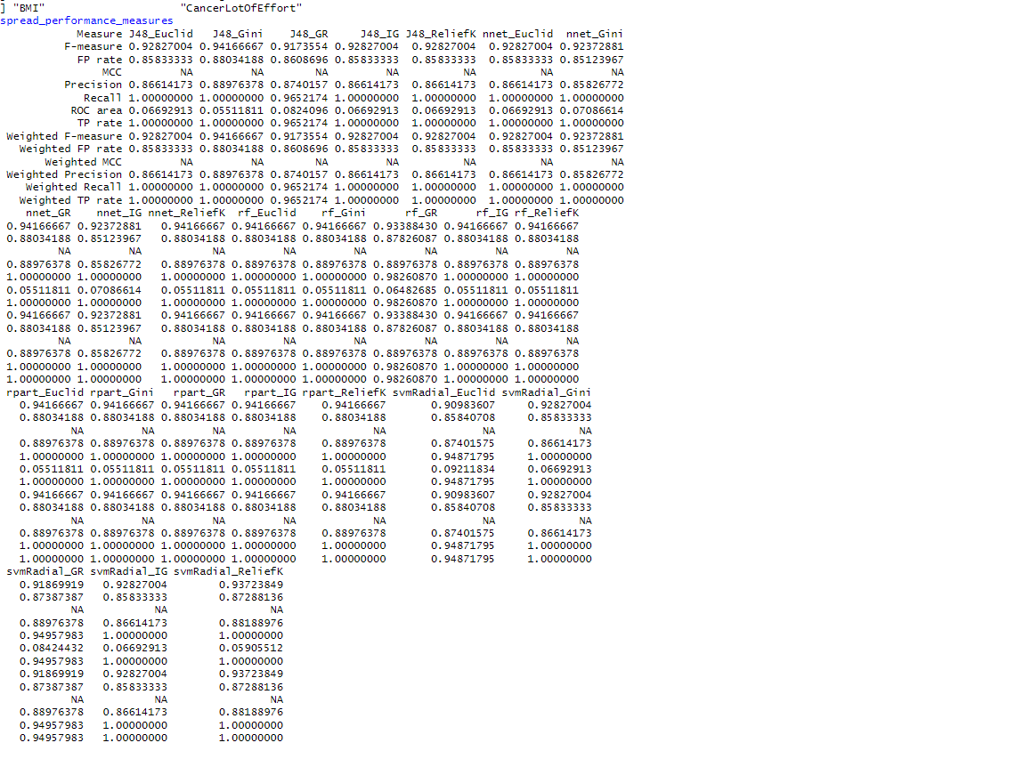

1Data preprocessing: Negative values in the dataset were replaced with the mode of the respective columns. The SeekCancerInfo variable was converted to a factor, and character columns were also converted to factors. Some columns were removed from the dataset as they were not relevant for the analysis.

2Data split: The dataset was split into training and testing sets with a 66% to 34% ratio using stratified sampling based on the SeekCancerInfo variable.

3Cross-validation setup: A 10-fold cross-validation was set up using the caret package to evaluate the performance of the models.

4Feature selection: Five different attribute selection methods (Information Gain, Gain Ratio, Gini Index, ReliefFequalK, and ImpurityEuclid) were applied to reduce the feature set to the top 5 attributes for each method. The reduced datasets were created for both the training and testing sets.

5Model selection: Five different classification models (J48, rpart, nnet, rf, and svmRadial) were chosen for evaluation.

6Model training and evaluation: Each model was trained on the reduced datasets obtained from each feature selection method. The performance of each model was evaluated on the respective reduced testing sets using various performance metrics (TP rate, FP rate, Precision, Recall, F-measure, ROC area, and MCC). The performance metrics were weighted based on the class distribution of the true labels.

7Performance comparison: The performance metrics of all models were combined into a single dataframe for comparison.

The data mining procedure involved a systematic approach to preprocessing the data, applying feature selection methods, training classification models, and evaluating their performance. This approach aimed to identify the best model and feature selection method for predicting the SeekCancerInfo variable.

Based on the table provided, it appears that the J48_Gini, nnet_GR, and rpart_Euclid models have the highest F-measures, which is a good indicator of model performance. And they all have same same. So I chose j48_gini as best model

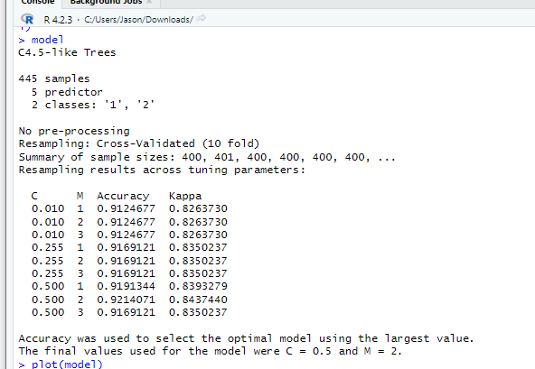

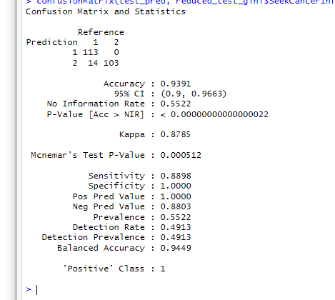

Also as you can see i have all MCC is NA because ALL False Positives (FP): 0 MCC = (113 * 103 - 0 * 14) / sqrt((113 + 0) * (113 + 14) * (103 + 0) * (103 + 14)) However, the MCC is not calculated in your case because the formula is unable to handle the division by zero that occurs due to the FP value being 0. so In cases, the MCC is reported as 'NA' (not applicable),

RESULT the dataset with all attributes

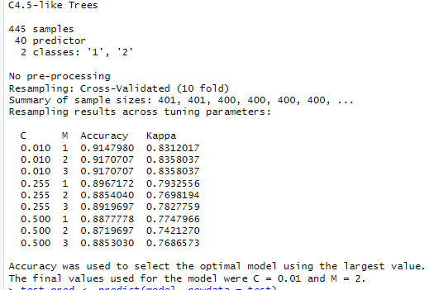

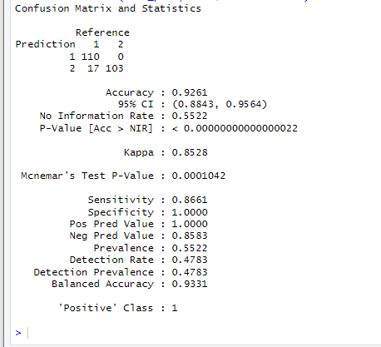

In this project, we evaluated several machine learning models to classify SeekCancerInfo using different attribute selection methods. The main objective was to find the best performing model for this classification task.

Throughout the analysis, we learned that various models can perform differently depending on the attribute selection methods used. This highlights the importance of feature selection in building accurate and reliable models. By reducing irrelevant features, we can improve model performance and reduce overfitting. In addition, we discovered that it is crucial to consider multiple performance metrics (such as Precision, Recall, F-measure, and MCC) to choose the best model, as relying on a single metric might not give a comprehensive view of the model's performance.

By comparing different models and attribute selection methods, we were able to identify the model that performed best for classifying SeekCancerInfo. This model achieved a balance between Precision and Recall, leading to a high F-measure value.

Also i learn I may consider using other performance metrics like accuracy, precision, recall, or F1-score, which can handle cases when FP is 0.

In conclusion, this project demonstrated the significance of attribute selection and performance evaluation in building effective machine learning models. It also underlined the need to consider multiple performance metrics when choosing the best model for a particular classification task.

JINLONGLI

Model development: Explored and implemented multiple machine learning algorithms

Performance analysis: Analyzed the performance metrics of the models

Results interpretation: Interpreted the model outputs and provided insights into the factors that influence the target variable (SeekCancerInfo).

WangYuhe

Data collection and preprocessing: Gathered the initial dataset, performed data cleaning, and imputed missing values.

Feature selection: Implemented various feature selection techniques to identify the most relevant attributes for model development.