LOCKEDME.COM

HCL AMERICA INC. | SAN ANTONIO, TX

FILE HANDLING

DIEMI PHAM

2020

**Table of Contents**

Project objective:

Background of the problem statement:

Specification

Sprints

Sprint 1:

Sprint 2:

Sprint 3:

Sprint 4:

Sprint 5:

Sprint 6:

Repository

Java concepts

Data structures

File:

Array:

Features

Flow of the application

Welcome screen:

Main screen:

View Files screen:

Operation screens:

Modules

Comparator package:

Driver package:

Exceptions package:

Filehandling package:

Screenshots

Welcome screen and main screen:

View Files screen:

Add screen:

Delete screen:

Search screen:

Closing application:

**LOCKEDME.COM**

Developer: Diemi Pham - HCL America Inc.

Date: December, 2020

# **Project objective:**

As a Full Stack Developer, complete the features of the application by planning the development in terms of sprints and then push the source code to the GitHub repository. As this is a prototyped application, the user interaction will be via a command line.

# **Background of the problem statement:**

Company Lockers Pvt. Ltd. hired you as a Full Stack Developer. They aim to digitize their products and chose LockedMe.com as their first project to start with. You’re asked to develop a prototype of the application. The prototype of the application will be then presented to the relevant stakeholders for the budget approval.

# **Specification**

As this is a prototyped application, the user interaction will be via a command line. For the scope of this project, the application will store, display, and operate files from resources directory and its sub-directories only. Resources directory is placed in the same directory as the source codes.

# **Sprints**

In order to achieve the goal of the company, deliver a high-end quality product as early as possible, the project was planned with the following sprints.

## Sprint 1:

Document the flow of the application and prepare a flow chart

Estimate time:

Actual time:

## Sprint 2:

Implement option to retrieve the file names in an ascending order and option to close the application

Estimate time:

Actual time:

## Sprint 3:

Business-level operation - Option to search a user specified file from the application

Estimate time:

Actual time:

## Sprint 4:

Business-level operation - Option to delete a user specified file from the application

Estimate time:

Actual time:

## Sprint 5:

Business-level operation - Option to add a user specified file to the application

Estimate time:

Actual time:

## Sprint 6:

Document technical report for the application and prepare for the release

Estimate time:

Actual time:

# **Repository**

[Project page with planned sprints and tasks](https://github.com/pdiemi/FullStackJavaDevelopement/projects/1)

[Source codes](https://github.com/pdiemi/FullStackJavaDevelopement/tree/main/lockedme.com)

[Technical documentations](https://docs.google.com/document/d/1pRhgay66rm__-CzBmAaX-LG3nQlXNgoho95shLDzB78/edit?usp=sharing) (online version)

# **Java concepts**

This application is developed using Java programming language and Java concepts as listed below.

* Regular expression: Used for validating filename
* Comparator: Used for sorting the list of files by filename
* Custom exceptions: Extends CustomException class, which extends Exception class, and used for validating user's input such as
  + Filename invalid exception
  + Filename not found exception
  + Filename is null exception
  + Filename is too long exception
  + User’s choice is invalid exception

# **Data structures**

## File:

* Used to retrieve filenames from the given directory and perform operations on files such as create a new file, delete a file, or search for a file.

## Array:

* Used to store the list of files read from the given directory.
* Used as an input for file handling methods.

# **Features**

The application delivered with the LockedMe.com project offers the following features and operations:

* Retrieving the file names in an ascending order
* Business-level operations:
  + Option to add a user specified file to the application
  + Option to delete a user specified file from the application
  + Option to search a user specified file from the application
  + Navigation option to close the current execution context and return to the main context
* Option to close the application

# **Flow of the application**

## Welcome screen:

The welcome screen displays the welcome message as well as information of the developer and the application.

## Main screen:

The main screen displays the details of the user interface such as options displaying the user interaction information and features to accept the user input to select one of the options listed.

The flowchart below (Figure 1) shows the flow of the application. The application displays the main screens with options that users can choose from as well as instructions to users how to select the options. Users input their choice as desired and the application then validates the user’s input. If the user’s input is invalid, the application will ask users to enter their input again. Otherwise, the application then checks whether users choose to exit the application. if so, the application will show the goodbye message and close. Otherwise, the application will process to perform the operation chosen by users. After the operation is completed, the application will show the main screen again and wait for users to input their choice.

Output Main Display

Input User’s Choice

Process User’s Choice

Validate User’s Input

Is valid?

Yes

No

Exit?

Yes

No

***Figure 1: Main Flowchart***

## View Files screen:

The View Files screen displays the title of the view and options to list all files and sub-directories in the root directory or to list all files in the application.

The flowchart below (Figure 2) shows the flow of the process listing all files chosen by users. The application reads all files either in the directory or in the whole application, based on the user’s choice, and sorts those files in ascending order, then displays the list of those files to users. After displaying the file list, the application will switch back to the main screen.

## Operation screens:

Read List of Files in Current Directory

Sort Read Files in Ascending Order

Output Sorted List of Files

***Figure 2: View File Flowchart***

The Operation screen can be either Add, Search, or Delete screen. Those screen display details of the user interface for the following operations:

* Add a file to the existing directory list
* Delete a user specified file from the existing directory list
* Search a user specified file from the main directory
* Option to navigate back to the main context

The flowchart below (Figure 3) shows the flow of the processing the operation chosen by users. The operation processing is similar for add, delete, and search operation. In particular, the application allows users to add text files (.txt), search for file names ignoring extensions, and delete files with the exact filename given by users including the extension. Similar to the main screen, the operation screen shows the options that users can choose from as well as the instructions how to select the options. Users enter their input as instructed and the application then validates the input. If the input is invalid, the application asks users for re-entering their input. Otherwise, the application checks whether users choose to exit the operation screen. If users choose to exit the operation screen, the application will close the operation screen and switch back to the main screen and wait for users input. Otherwise, the application will ask users to enter a filename that they want to work with. After users input the filename, the application validates the filename and may ask users to re-enter the filename if the filename is invalid. For instance, a valid filename must be not null, no longer than 128 characters, and not contain special characters such as @, $, %, etc.

If the filename is valid, the application then performs the operation chosen by users regarding the filename. Once the operation is completed, the application displays the result and confirmation of the operation, then shows the operation screen with options again and waits for users to input responses.

Output Sub Display

Input User’s Choice

Validate User’s Input

Validate User’s Input

Is Valid?

Yes

No

Input the File Name

Exit?

Yes

No

Is Valid?

Yes

No

Perform Operation

Output Result Confirmation

***Figure 3: Operations Flowchart***

Once users input an invalid filename, the application will ask whether users would like to re-enter another filename or cancel the operation. If users choose to cancel the operation, the application will close the operation screen and switch back to the main screen.

# **Modules**

The source codes of this application is designed and packed into four packages:

## Comparator package:

Contains two comparators that are used for sorting file names in ascending and descending order.

## Driver package:

Contains driver classes to display the screens and to run the application.

## Exceptions package:

Contains custom exception classes used in the application.

## Filehandling package:

Contains the file handler interface and class that offer methods for handling and operating files.

# **Screenshots**

## Welcome screen and main screen:

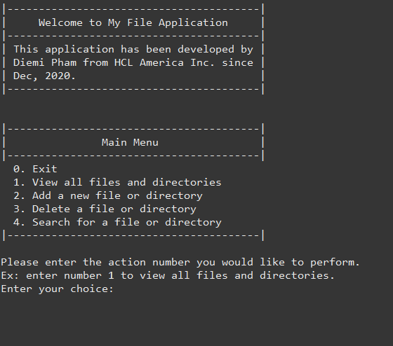

## View Files screen:

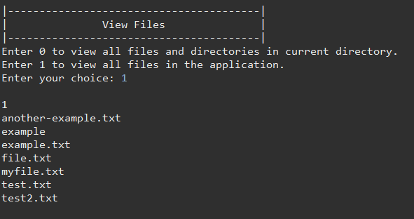

## Add screen:

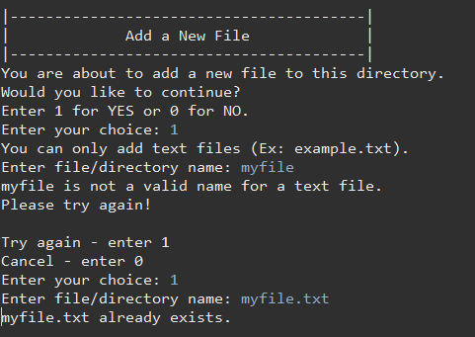

## Delete screen:

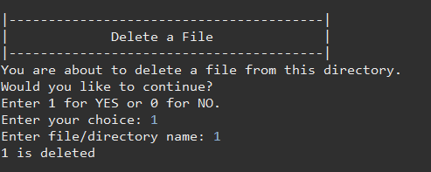

## Search screen:

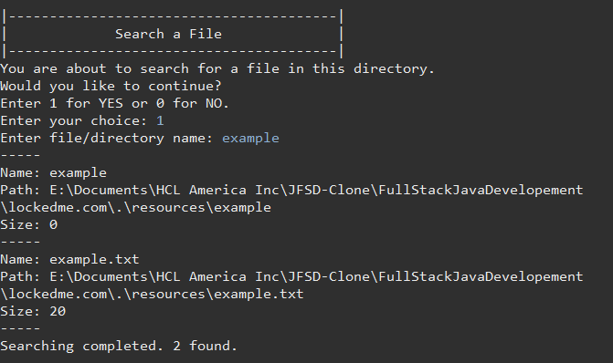

## Closing application:

