**STUDENT INSIGHTS 12-Hour QA TASK TEST PLAN**

**Author:** Jason Ogayon, Software Tester

**Date**: September 22 1PM – September 23 1AM

A Github repository exists for the test scripts and everything else, please visit <https://github.com/jasonogayon/af-studentinsights> .

**Download Project**

Please make sure that you have the following tools installed in your machine:

* [Git](<https://git-scm.com/downloads>)

* [NodeJS](<https://nodejs.org/en/download/>)

To check if said tools are installed, run *git --version*, *node -v*, and *npm -v* and see if versions of each are displayed.

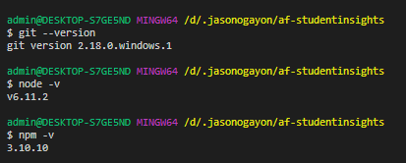

Clone the project by running on a terminal:

*git clone https://github.com/jasonogayon/af-studentinsights.git*

And then go inside the project directory:

*cd af-studentinsights*

**Install Test Dependencies**

* [Cypress](<https://www.cypress.io/>)

* [Mochawesome](<https://www.npmjs.com/package/mochawesome>)

To install test dependencies, run the following:

*npm install*

For this 12-hour quick task it was more important to focus on exploring the application and writing the scripts for the given stories. It was necessary to not lose time in test tool setup. The tool should be something that is user-friendly for both devs and managers. And it would be great if it has reporting and video recording built-in too. For these reasons I chose [Cypress](https://www.cypress.io/).

**Run Tests**

Run tests by running the following command:

*npm test*

My thought process for the quick testing task can be summarized into several stages:

* Initial app exploration without stories

* Stories walkthrough

* Test tool setup

* Test scripts

* Documentation and review

**Test Report**

Sample HTML test report (using *mochawesome*) inside the *mochawesome-report* directory (which includes a zip file of the report):

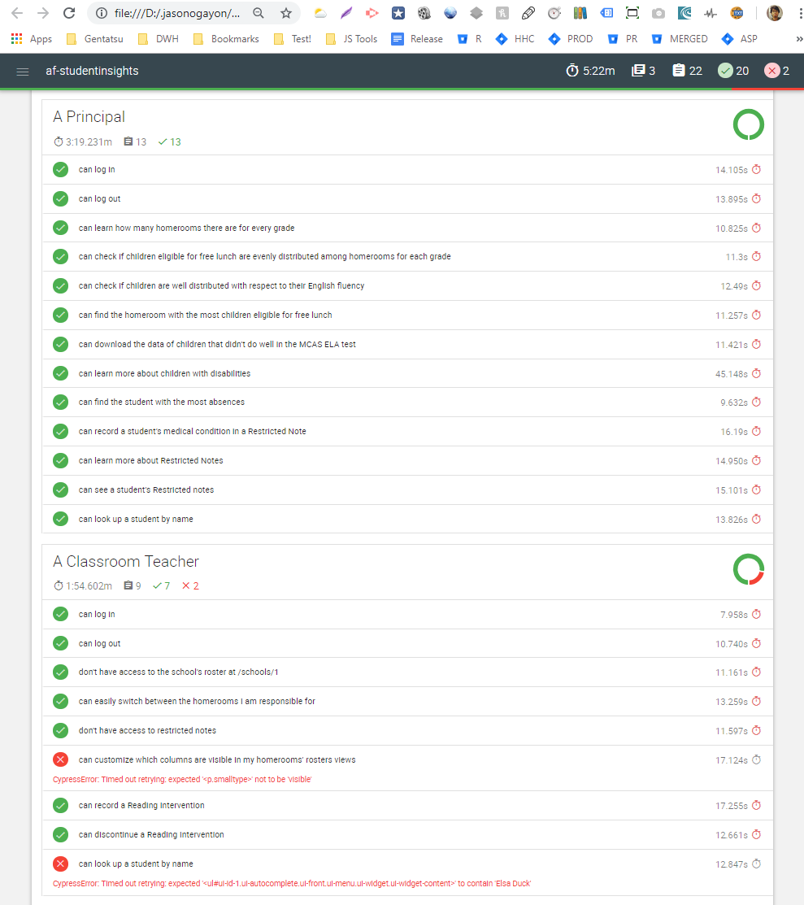

Other notable observations:

* Application is flagged as not secure (SSL Certificate Error)

* Application is not mobile-friendly, user interface is not mobile responsive or adaptive

* Application has several accessibility contrast and link-text warnings

* Google Lighthouse has several recommendations regarding performance, accessibility, best practices, and SEO

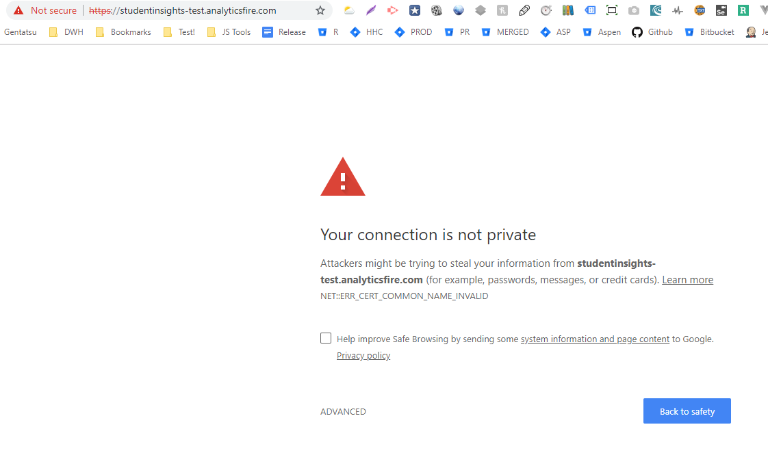

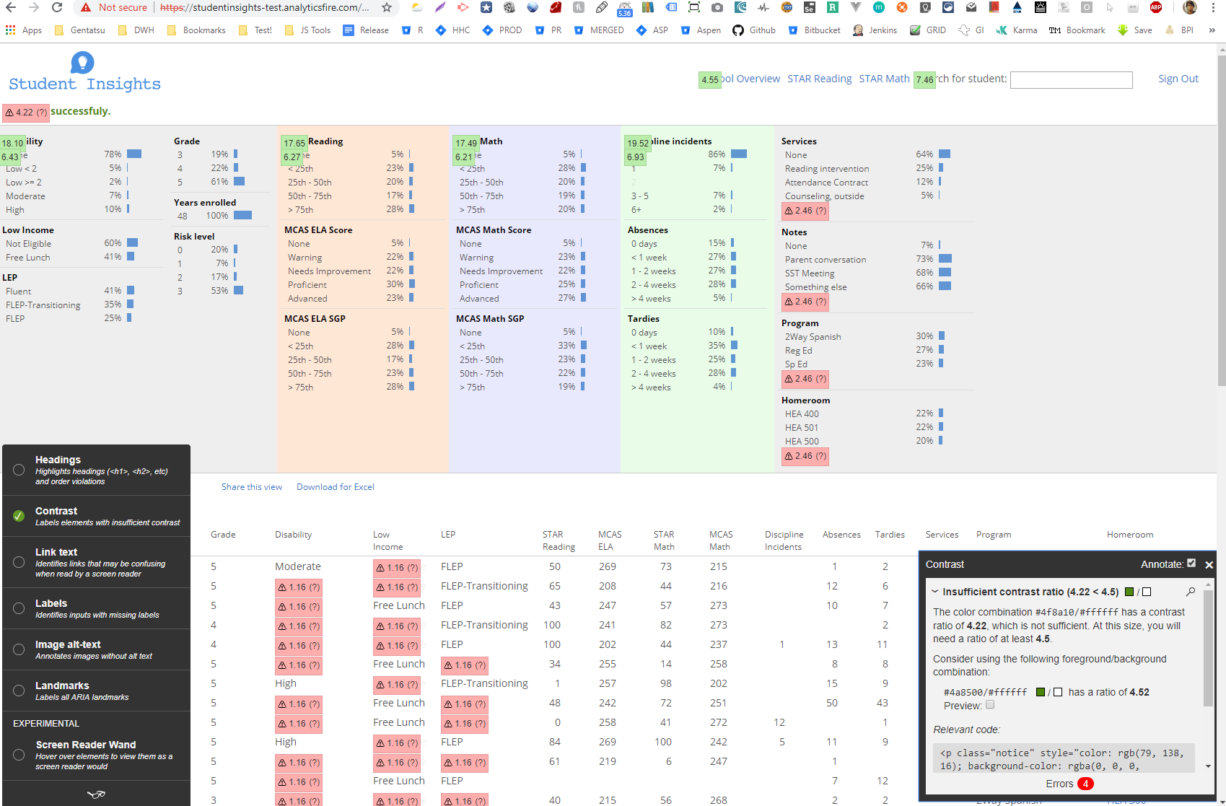

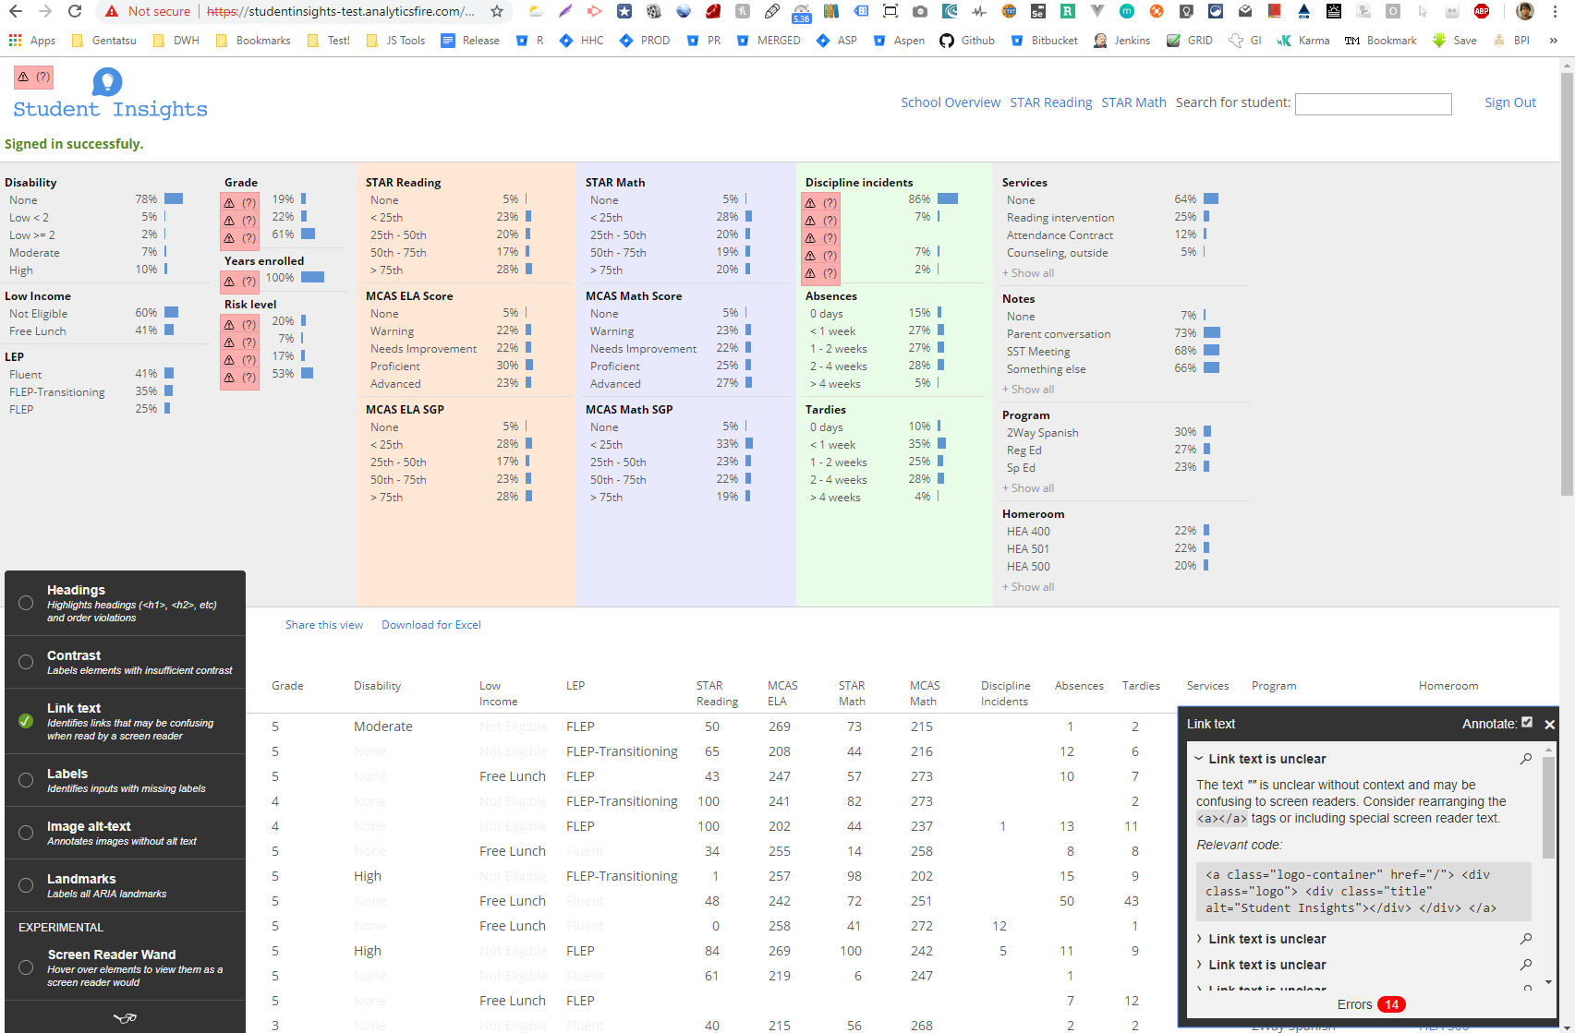

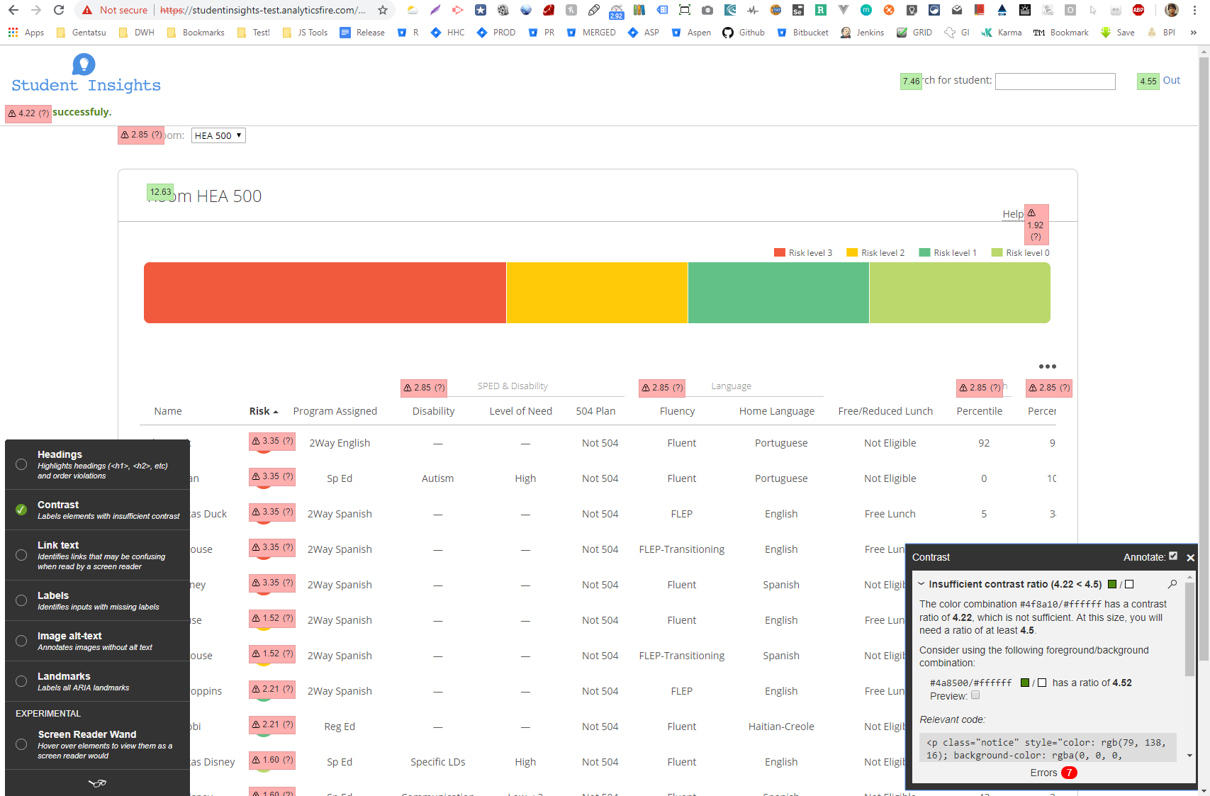

Test report as displayed on a terminal:

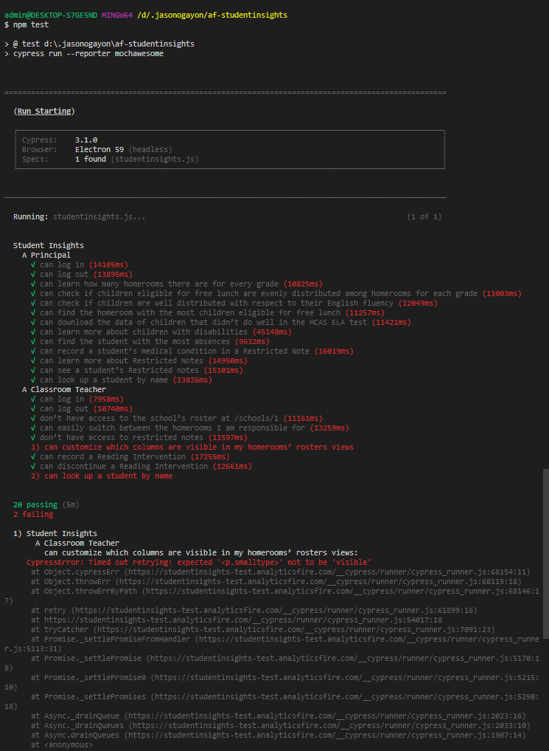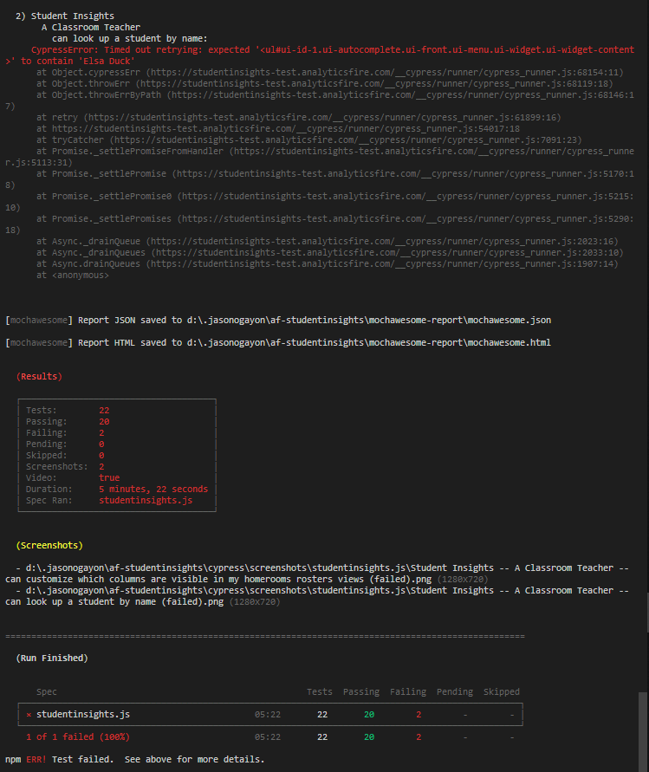

You can also run the tests on Cypress's user interface. Open Cypress by running:

*npm run cy*

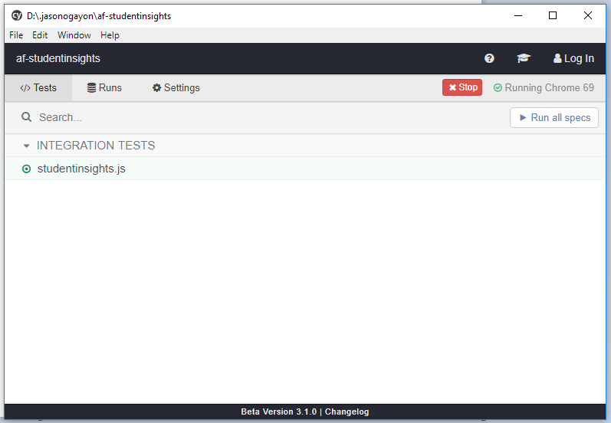

Clicking *studentinsights.js* will run the tests and the report on the UI looks something like this:

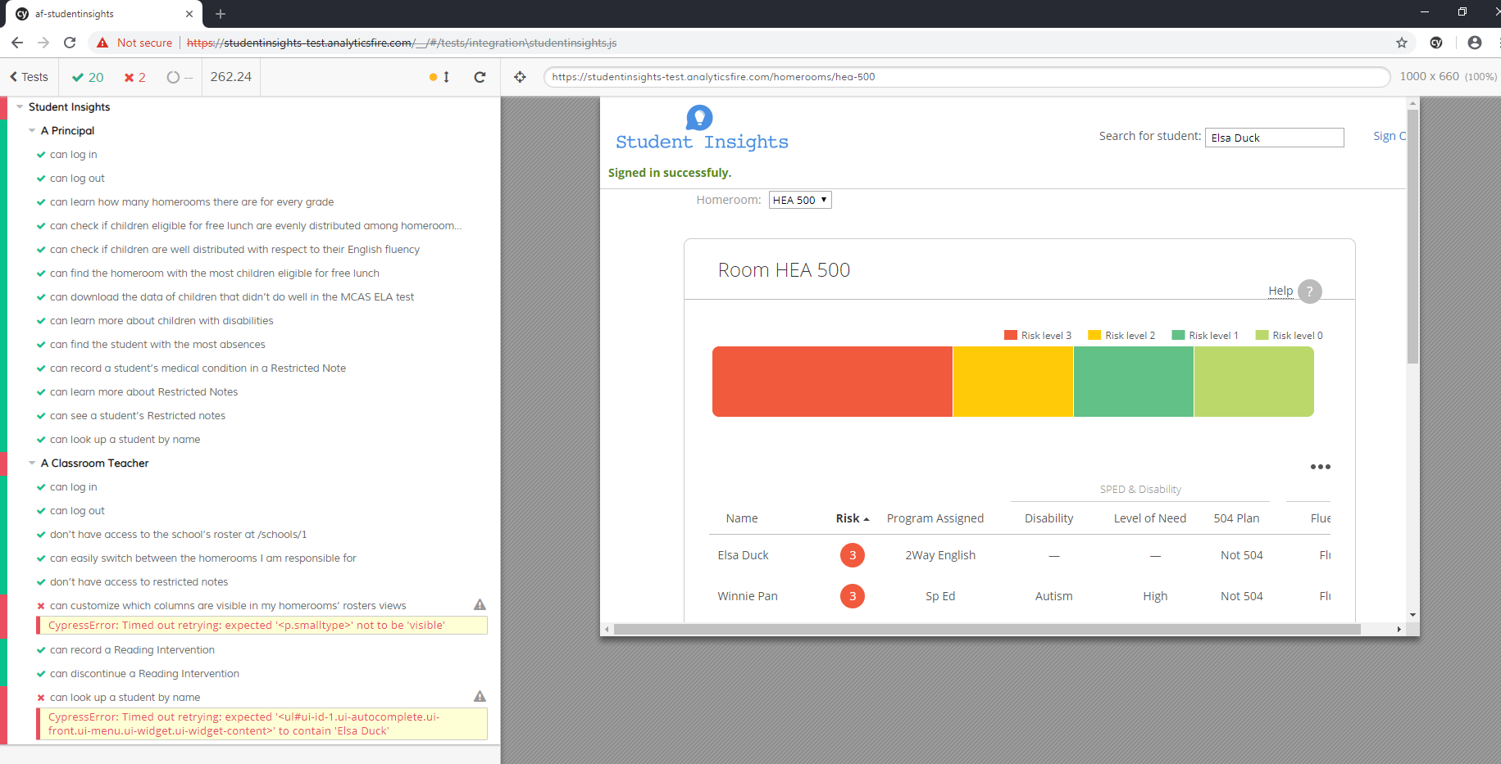

**Demo Video**

A video recording of the tests is automatically recorded when the *npm test* command is executed and is saved inside the *cypress/videos* directory.

Video Demo Link: <http://www.youtube.com/watch?feature=player_embedded&v=Iym99Yn_Wy4>