CS3376 Assignment 2 C++ programming Due: 7/03 Monday Noon

Last Name: ___Olmos_______________________

First Name: ___Jason__________________

NetID (email): __jxo081000@utdallas.edu_________

Submission requirements.
Submit (1) a word document (this file with your answers and listing of any program & its run [log or screenshots]) and (2) a zip file of a folder which will contain all the codes (all the source codes and executables, Makefile, and the instruction for how to compile and run) and a document file (.doc or .docx).

This word document (this file) is your documentation (as a basis to add your answers) to be included here - all your answers, all your program-listings, instructions to compile and run [screen-shots, terminal text, or session log] to show your work done, including how to compile and run for each cases.

The word file should also have (1) in header with the course & section number, your name (Name: last name, first name), your netID (email), and Assignment #, (2) in footer with page number, (3) line number (restart from each page in left margin. Page Layout => Line Numbers). (4) Your program should have some comments (minimal or reasonable), to tell the code-reader what a segment of code is doing, and with the comment in the front/head of the program about you, this course and assignment, etc. (you may copy and paste some out of this document for your comment).
** Your executable codes (that you submit) should run in cs1 without any change or recompilation.
** Bring this cover sheet (this page) to TA for your demo.
Upload this document file (with your answers) and a zip file (containing all the codes [source and binary etc.] where each binary or shell program should run as it is in cs1).

Assignment2 Score-sheet
Part1  20%  CLO2 | bash script | #1
Part2  30%  CLO2,6 | Python with OpenCV | #1 | #2
Part3  40%  CLO4,6,9 | C/C++  file redirect | #1 exit | #2 read | #3 write | #4 append | #5 pipe | Demo
 |  | #6  Create  Makefile  CLO4 | #7  Version Control – git, github or SVN  CLO9

Penalty

Up to -10% - Documentation (this .doc file) and zip file

Up to -10% - Demo (with TA during his office hours. Please check with TA or TA's announcement on Demo)

Total 100%

Note. Any "poor" documentation (that is, this document with your answers etc.) may result in a penalty (up to -10%).

Part1. Bash shell scripting

#1. Write a Bourne Again Shell script (name it "user1.sh") to do the following task:
(1) prompts you for a user ID, (2) then read passwd1.txt file in the present working directory (as shown below) and then (3) displays login name, user’s name, uid and gid, pathname for user’s home directory, and user's default shell.

Note. This example shows the user (rkm010300) for Dr. Min. You should insert your record in this passwd1.txt file to include one line for your userid (netid), userid=2000, gid=514, comment with your name and UTD email (NetID), your home directory, and your default shell.

$ cat passwd1.txt
SYSTEM:*:18:544:,S-1-5-18::
LocalService:*:19:544:U-NT AUTHORITY\LocalService,S-1-5-19::
NetworkService:*:20:544:U-NT AUTHORITY\NetworkService,S-1-5-20::
Administrators:*:544:544:S-1-5-32-544::
Administrator:*:500:513:U-richard-PC\Admin:/home/Administrator:/bin/bash
Guest:*:501:513:U-richard-PC\Guest:/home/Guest:/bin/bash
rkm010300:*:1000:513:Richard Min – email - rkm010300:/home/rkm010300:/bin/bash
john:*:1010:600:John-Staff:/home/john:/bin/sh

$ ./user1.sh rkm010300
userid: rkm010300
uid: 1000
gid: 513
home directory: /home/rkm010300
shell:/bin/bash

Answer (copy and paste your anwer here) and mark it yellow (for background color).
Jasons-MacBook-Pro:Assignment 2 jasonolmos$ ./user1.sh
Please input your User ID:
jxo081000
Thank You

UserID: jxo081000
UID: 2000
GID: 514
User Name: Jason Olmos
Email: jxo081000@utdallas.edu
Home Directory: /home/jxo081000
Shell: /bin/bash

#!/bin/bash

echo Please input your User ID: #Part 1.1
read userid
echo Thank You
echo ""

grep $userid passwd1.txt > myinfo.txt #Part 1.2 Reading from passwd1.txt
a=$(cat myinfo.txt | awk 'BEGIN {FS=":"}{print $3;}')
b=$(cat myinfo.txt | awk 'BEGIN {FS=":"}{print $4;}')
c=$(cat myinfo.txt | awk 'BEGIN {FS=":"}{print $5;}')
d=$(cat myinfo.txt | awk 'BEGIN {FS=":"}{print $6;}')
e=$(cat myinfo.txt | awk 'BEGIN {FS=":"}{print $8;}')
f=$(cat myinfo.txt | awk 'BEGIN {FS=":"}{print $9;}')

echo "UserID: $userid " #Part 1.3 Displaying relative information
echo "UID: $a"
echo "GID: $b"
echo "User Name: $c"
echo "Email: $d"
echo "Home Directory: $e"
echo "Shell: $f"

exit 0

Paste here the screenshots or Terminal text or Session log of the run.

Part2. Python programming

#1. Write a Python script (name it "user2.py") to do the following task:
(1) prompts you for a user ID, (2) then read passwd1.txt file in the present working directory (as shown below) and then (3) displays login name, user’s name, uid and gid, pathname for user’s home directory, and user's default shell.

Note. This example shows the user (rkm010300) for Dr. Min. Please update this passwd1.txt file to include one line for your userid (netid), userid=2000, gid=514, comment with your name and UTD email (NetID), your home directory, and your default shell.

$ cat passwd1.txt
SYSTEM:*:18:544:,S-1-5-18::
LocalService:*:19:544:U-NT AUTHORITY\LocalService,S-1-5-19::
NetworkService:*:20:544:U-NT AUTHORITY\NetworkService,S-1-5-20::
Administrators:*:544:544:S-1-5-32-544::
Administrator:*:500:513:U-richard-PC\Admin:/home/Administrator:/bin/bash
Guest:*:501:513:U-richard-PC\Guest:/home/Guest:/bin/bash
rkm010300:*:1000:513:Richard Min – email - rkm010300:/home/rkm010300:/bin/bash
john:*:1010:600:John-Staff:/home/john:/bin/sh

$ ./user2.py rkm010300
userid: rkm010300
uid: 1000
gid: 513
home directory: /home/rkm010300
shell:/bin/bash

Answer (copy and paste your anwer here) and mark it yellow (for background color).

#!/usr/bin/python

#Part 2.1
askForId = raw_input('Please enter your User ID: ')

#Part 2.2
with open("passwd1.txt") as myFile:
for line in myFile:
if askForId in line:
strOfLine = line

arrayOfValues = strOfLine.split(":")

myFile.close()

#Part 2.3
netID = arrayOfValues[0]
print( 'Net ID: ' + netID)
uID = arrayOfValues[2]
print( 'uid: ' + uID)
gID = arrayOfValues[3]
print( 'gid: ' + gID)
usersName = arrayOfValues[4]
print( 'User Name: ' + usersName)
email = arrayOfValues[5]
print( 'Email: ' + email)
homeDir = arrayOfValues[7]
print( 'Home Directory: ' + homeDir)
shell = arrayOfValues[8]
print( 'Shell: ' + shell)

exit (0);

Paste here the screenshots or Terminal text or Session log of the run.
Jasons-MacBook-Pro:Assignment 2 jasonolmos$ python user2.py
Please enter your User ID: jxo081000
Net ID: jxo081000
uid: 2000
gid: 514
User Name: Jason Olmos
Email: jxo081000@utdallas.edu
Home Directory: /home/jxo081000
Shell: /bin/bash

#2. Python with OpenCV.

You need to do the Lab (For python-opencv exercise) in Assignment folder. The video tutorial is provided with ppt and zip file containing all the materials for this lab.

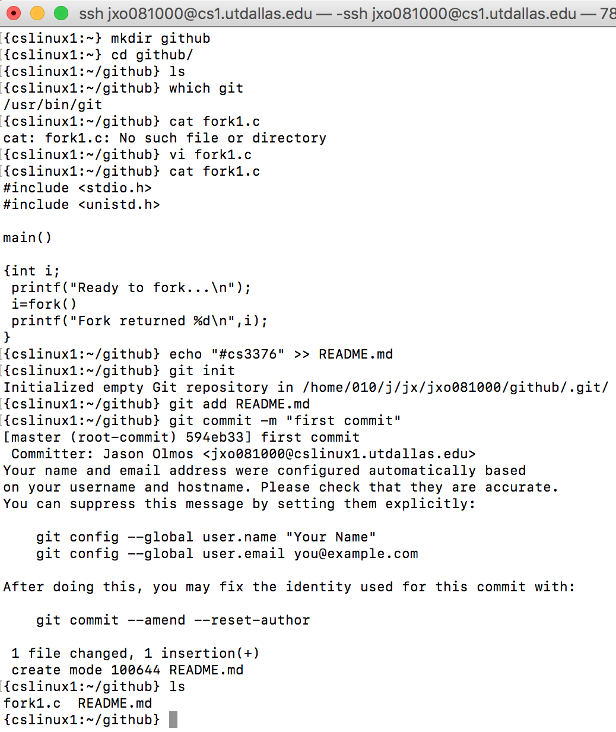
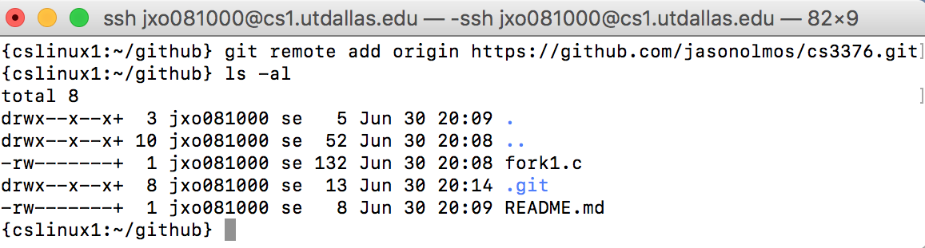
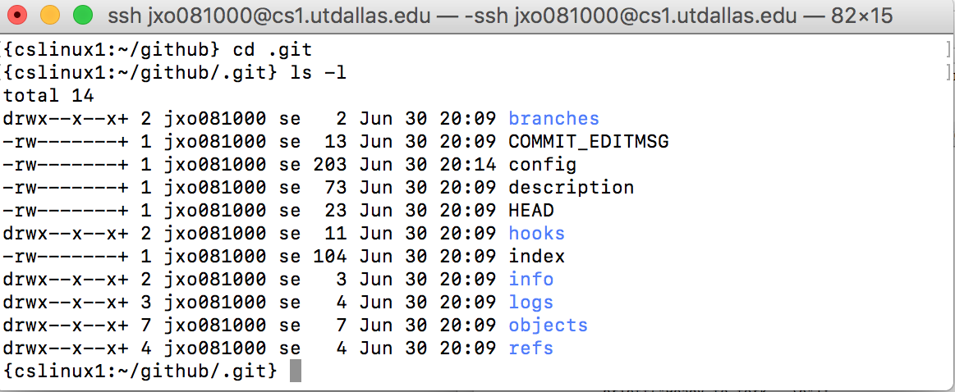
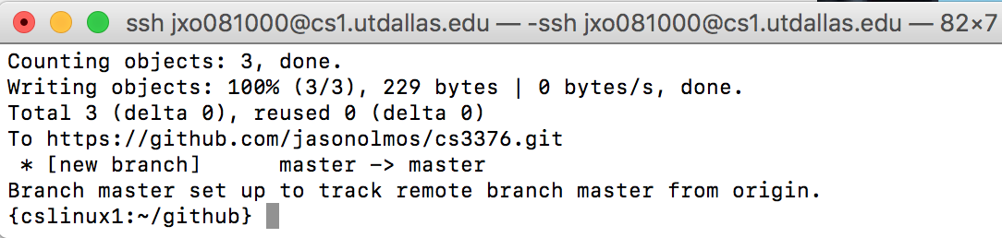
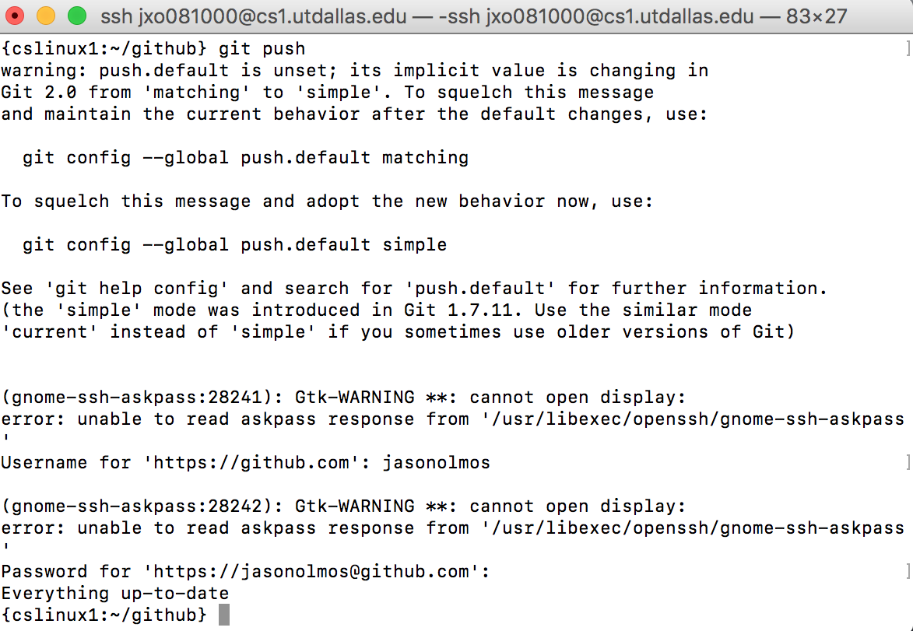
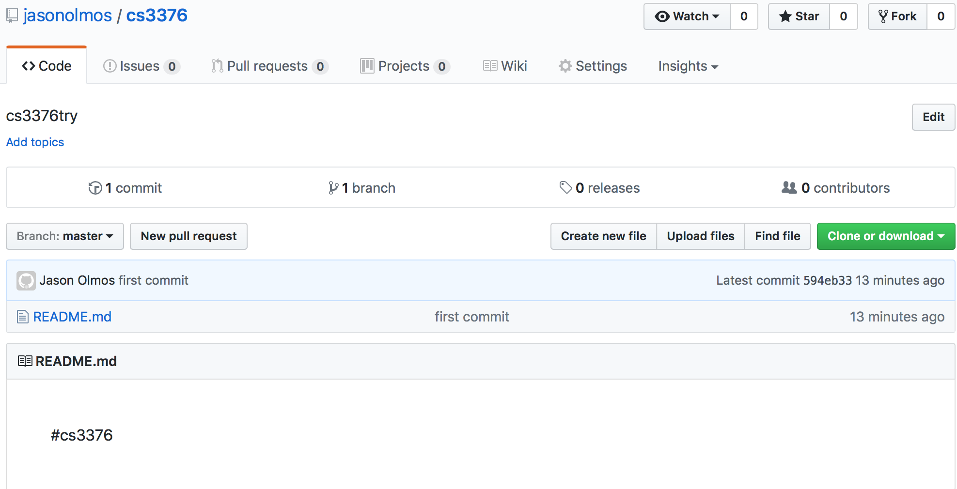

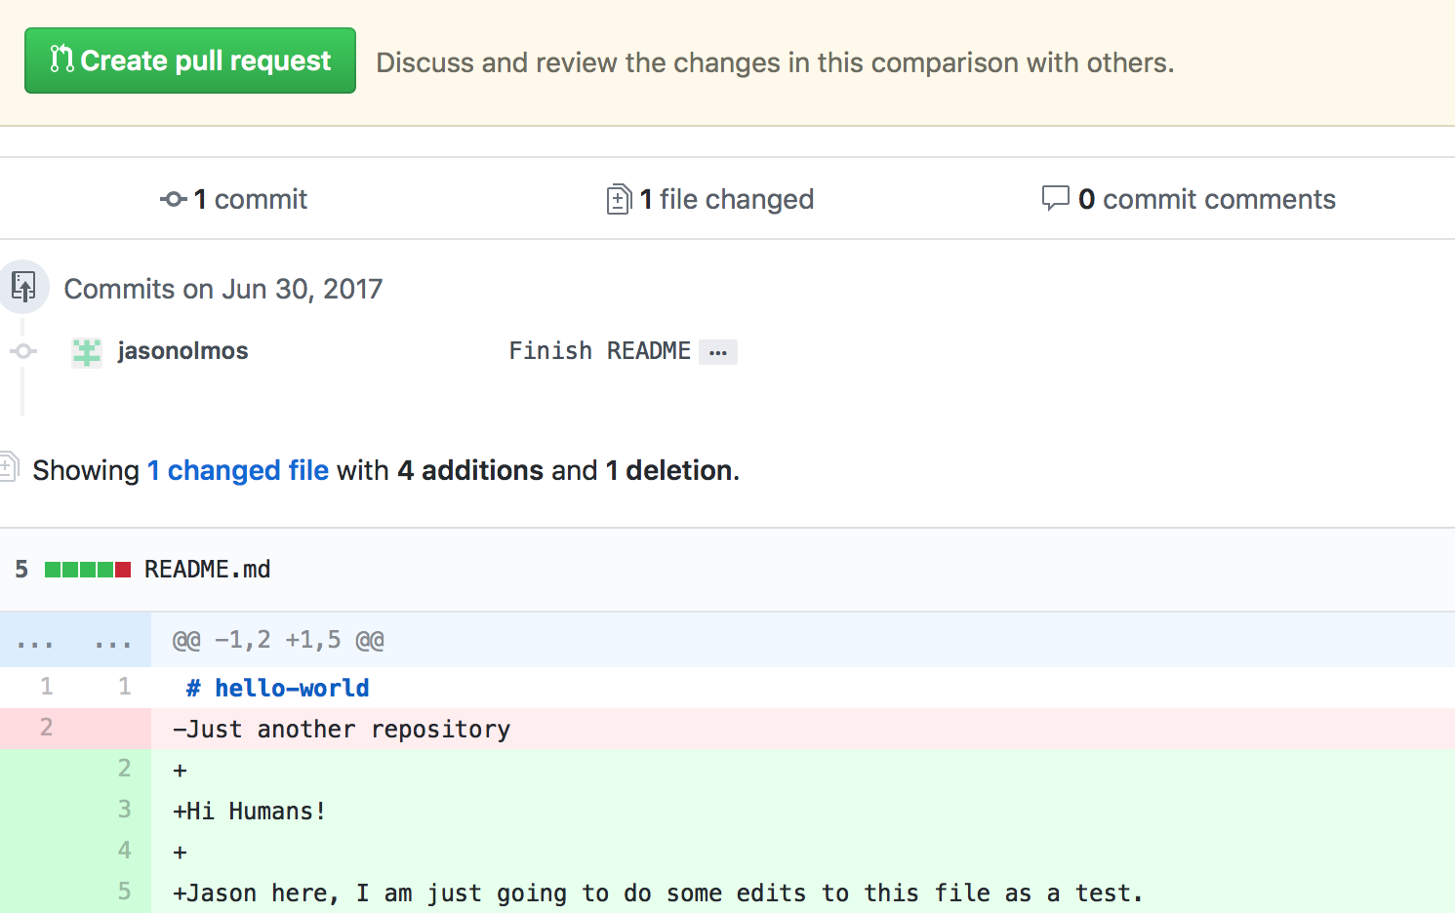

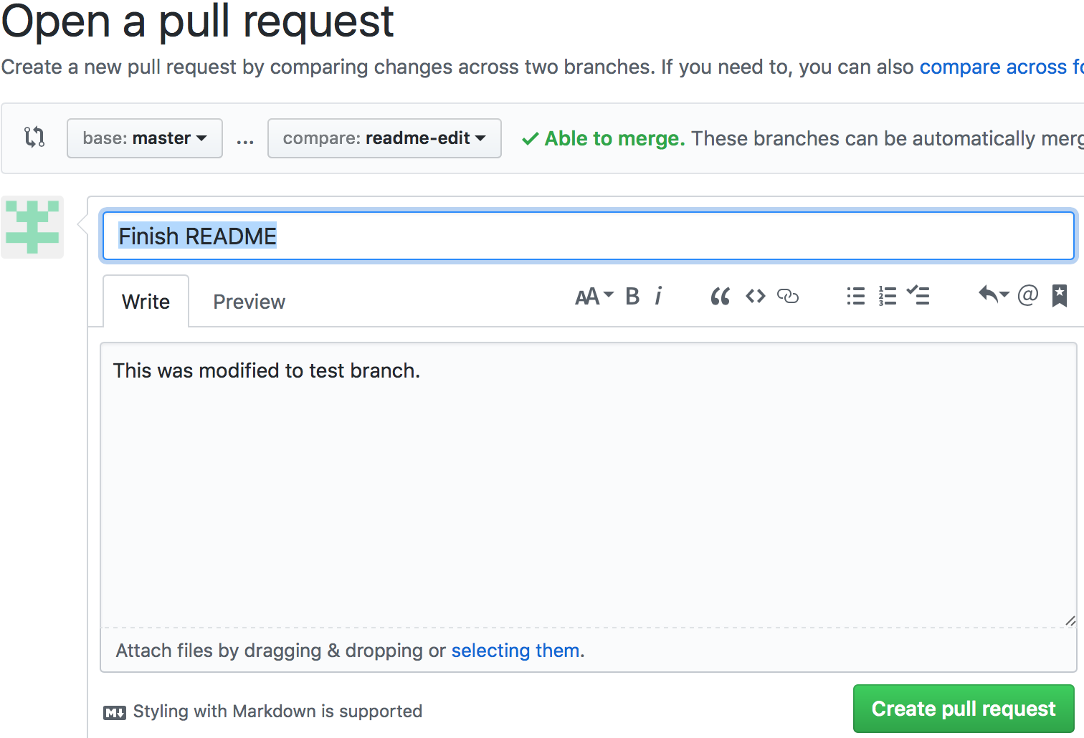

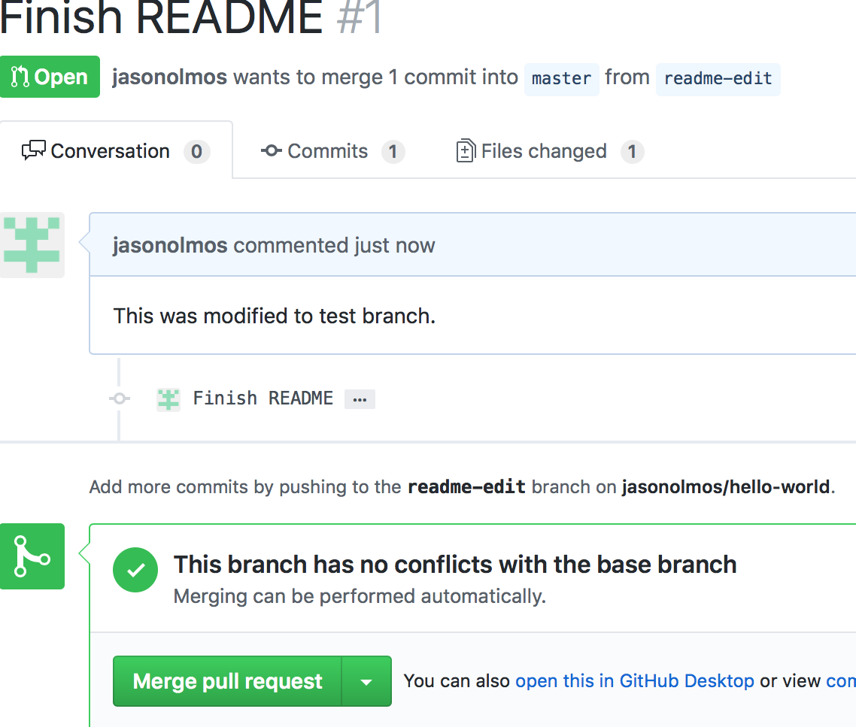

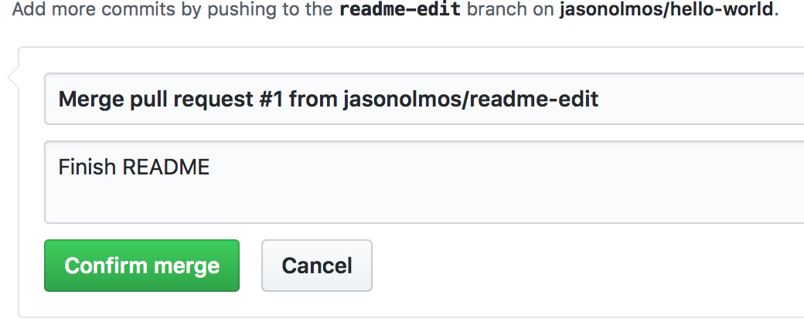

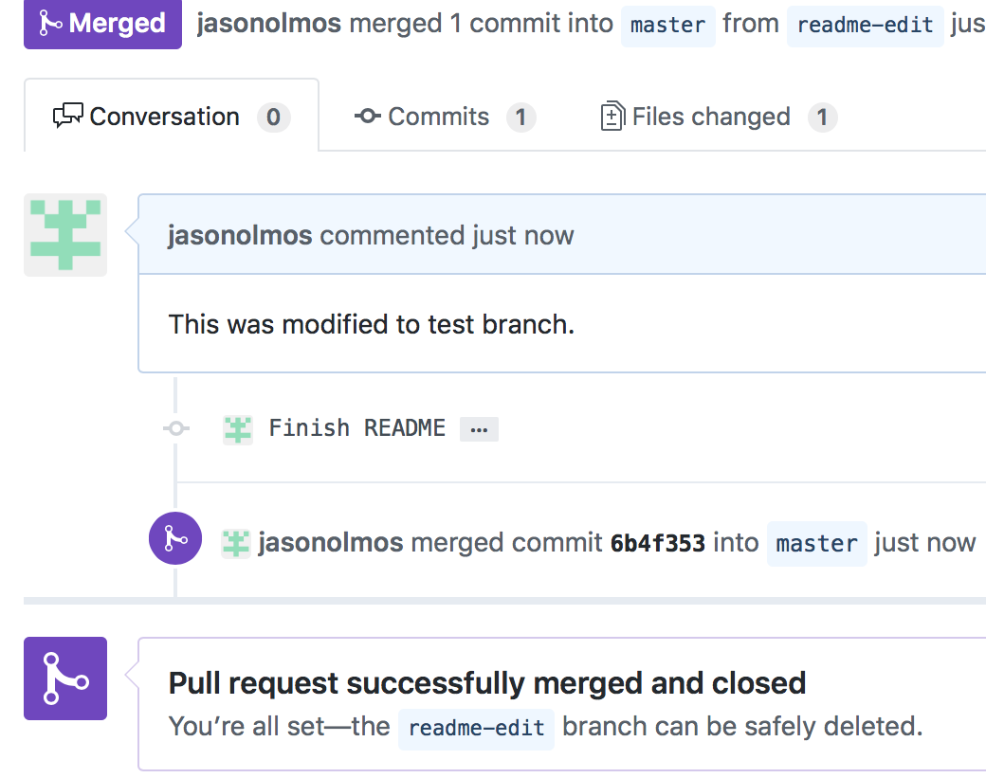

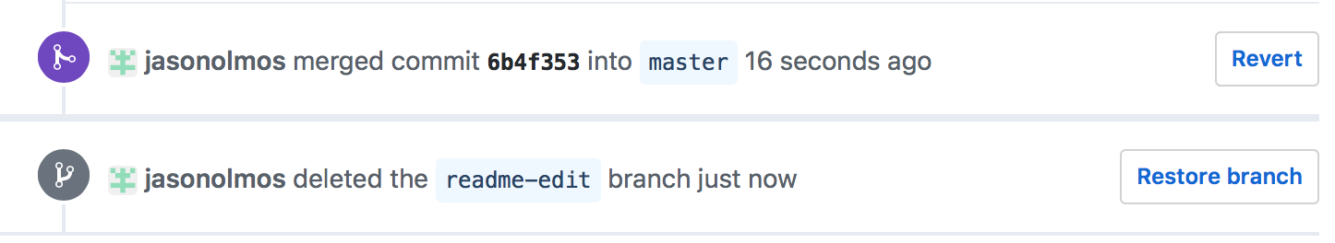

You may copy and paste the screenshots to show that you have done the exercise in the video tutorial here.

Part 3. C/C++ program
Handling File Redirection (< input, > output, >> output-append).

Design and implement C/C++ program (myfile.c) in a loop: (1) to prompt for a command, (2) to read a command (from keyboard as you type), (3) to echo the command, (4) to fork a child process to process command while the parent process is waiting for child process to complete this part, and then (5) the parent is back to the command prompt for next command.

The commands are: read, write, and append, and exit. The following tasks (that is, test cases) are to be implemented.

Task1. When the command is "exit", then the program terminates with exit(0).

Task2. The "read" command will do a file-redirection for a file to be read and to be written to a temporary file. For example, "read < hello.c" will read a file "hello.c" and write it to a temporary file ("temp.txt").

Task3. The "write" command will do a file-redirection for a file ("temp.txt") to be read and written to a file. For example, "write > out1.c" will read the save temp file "temp.txt" and write it to the file ("out1.c").

Task4. The "append" command has a file-redirection for a file (temp.txt) to be appended to a file. For example, "append >> out2.c" will read the save temp file "temp.txt" and write it to the file ("out2.c").

Task5. You may have two commands with a pipe. For example, "read < hello.c | write > hello2.c" will read hello.c file and write it to hello2.c via temp.txt file.

Task6. Create a Makefile to build the executable for the codes in this part.

Task7. For version control, create a code repository using git, github, or SVN (or any version control tool that you are familiar with). If this is your first time trial, you may consider github tool (with GUI). Please check Korn Lecture08 (Week04 Activity).

** Copy and paste your program code here, Makefile to compile, and the program-run results (screenshots, session log, or the part of MobaXterm "save terminal text" file to show your program runs for each test case). Submit (1) this document and (2) a zip file containing all the files including source, executable, Makefile, etc. For Version Control (e.g., github), you may provide here a few screenshots to show that you have done the task.

Before:

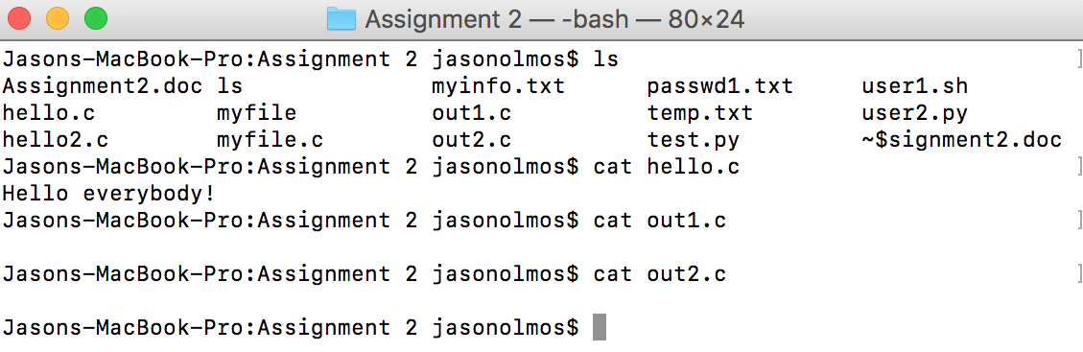

After:
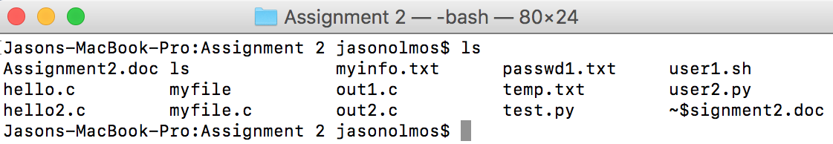

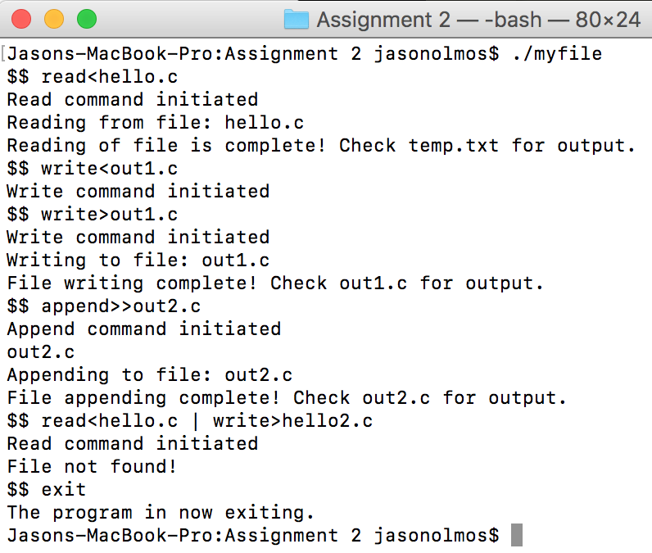
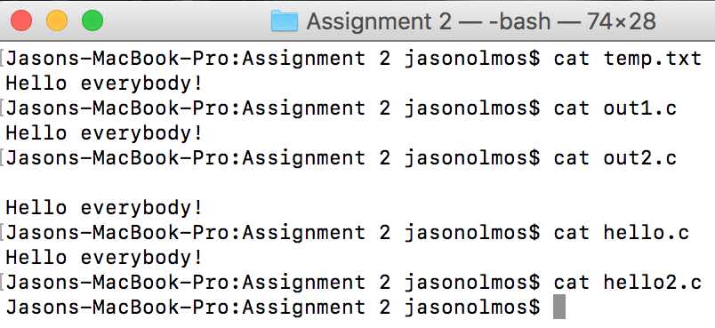

Source Code:

#include <sys/types.h>
#include <sys/wait.h>
#include <errno.h>
#include <stdio.h>
#include <stdlib.h>
#include <string.h>
#include <sysexits.h>
#include <unistd.h>

char *getinput(char *buffer, size_t buflen) {
printf("$$ ");
return fgets(buffer, buflen, stdin);
}

int main(int argc, char **argv) {
char buf[1024];
char command[20], opr2[10], filename[30], chr;
pid_t pid;
int status, i;
char *target_filename="temp.txt";
FILE *source_file, *target_file;

while (getinput(buf, sizeof(buf))) {
buf[strlen(buf) - 1] = '\0';
/* Place your code to check "exit". If so, then exit */
if(strcmp(buf,"exit")==0){
printf("The program in now exiting.\n");
exit(0);
}

if((pid=fork()) == -1) {
fprintf(stderr, "shell: can't fork: %s\n", strerror(errno));
continue;
} else if (pid == 0) {
/* child process to do each command
– place your code here to handle read, write, append */
if(strstr(buf,"read")!=NULL) //This beging the Reading section
{ //References if "read" is in buf and continues as long as it is not a NULL value.
printf("Read command initiated\n"); //This lets you know know that the read portion of the program started
for(i=0;i<strlen(buf);i++){ //This will tell the program what file to read from based off of user input.
if(buf[i]=='<')
break;
}
strncpy(command,buf,i-1);
strncpy(filename,buf+(i+1),strlen(buf)-(i+1));
source_file=fopen(filename,"r"); //Opens and reads from the source file
target_file=fopen(target_filename,"w"); //Opens and writes from the target file
if(!source_file){
fprintf(stderr,"File not found!\n"); //Errors if file is not found
}
else{
printf("Reading from file: %s\n",filename); //Lets user know what file is being read from
chr=fgetc(source_file);
while(chr!=EOF){
fputc(chr,target_file);
chr=fgetc(source_file);
}
printf("Reading of file is complete! Check %s for output.\n",target_filename);
}
fclose(source_file); //Closes the source file
fclose(target_file); //Closes the target file
}

else if(strstr(buf,"write")!=NULL) //This begins the Writing section
{ //References if "write" is in buf and continues as long as it is not a NULL value.
printf("Write command initiated\n"); //This lets you know know that the write portion of the program started
for(i=0;i<strlen(buf);i++){ //This will tell the program what file to write to based off of user input
if(buf[i]=='>')
break;
}
strncpy(command,buf,i-1);
strncpy(filename,buf+(i+1),strlen(buf)-(i+1));
source_file=fopen(target_filename,"r"); //Opens and reads from the source file
target_file=fopen(filename,"w"); //Opens and writes from the target file
if(!source_file){
fprintf(stderr,"File not found!\n");
}
else{
printf("Writing to file: %s\n",filename); //Lets user know what file is being written to
chr=fgetc(source_file);
while(chr!=EOF){
fputc(chr,target_file);
chr=fgetc(source_file);
}
printf("File writing complete! Check %s for output.\n",filename);
}
fclose(source_file);
fclose(target_file);
}

else if(strstr(buf,"append")!=NULL) //This begins the Appending section
{ //References if "append" is in buf and continues as long as it is not a NULL value.
printf("Append command initiated\n"); //This lets you know know that the append portion of the program started
for(i=0;i<strlen(buf);i++){
if(buf[i]=='>')
break;
}
strncpy(command,buf,i-1);
strncpy(filename,buf+(i+2),strlen(buf)-(i+2)); //Below essentially runs the same thing as the top two, however you will
printf("%s\n",filename); //type in what file you want to read from and then append it to a file
source_file=fopen(target_filename,"r");
target_file=fopen(filename,"a");
if(!source_file){
fprintf(stderr,"File not found!\n");
}
else{
printf("Appending to file: %s\n",filename);
chr=fgetc(source_file);
while(chr!=EOF){
fputc(chr,target_file);
chr=fgetc(source_file);
}
printf("File appending complete! Check %s for output.\n",filename);
}
fclose(source_file);
fclose(target_file);
}

exit(EX_OK); //Ends the program
}

if ((pid=waitpid(pid, &status, 0)) < 0)
fprintf(stderr, "shell: waitpid error: %s\n",
strerror(errno));
}
exit(EX_OK);
}

