HW2 User’s Manual

21700034 YeongHye Kwak

1. Execution Result

1. Explanation

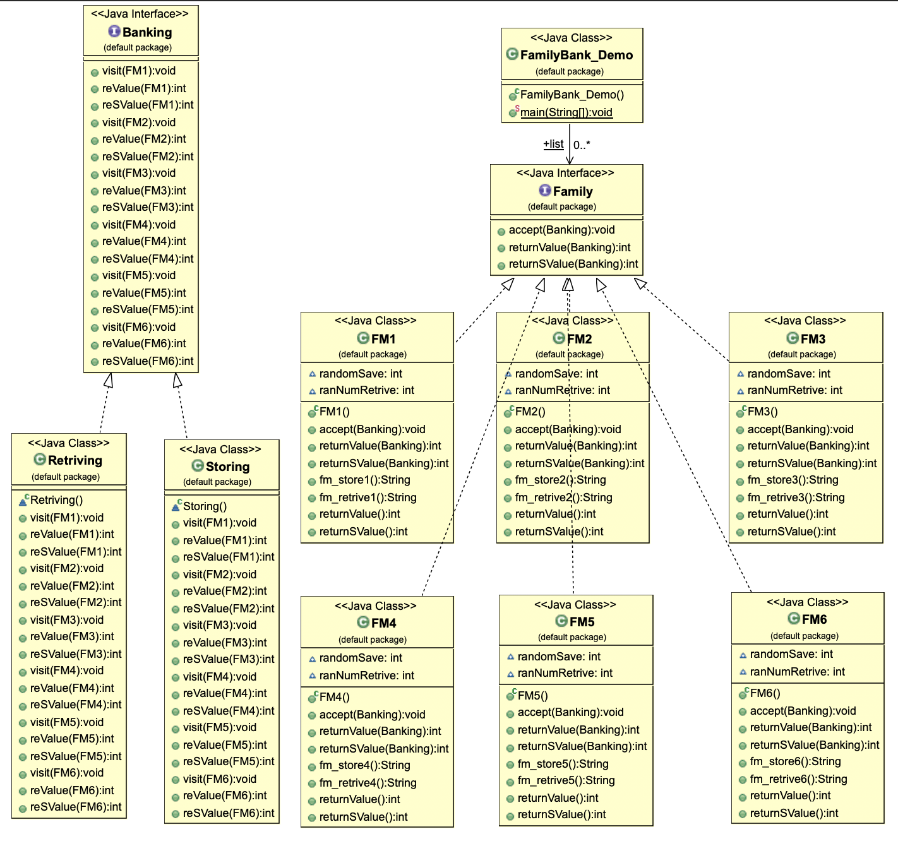

Banking Class : connect the Retriving & Storing class and FM(family members) to activate the FM’s function.

Retriving Class : activate the visit & reValue(return the FM’s random retriving money) to get the FM’s retriving money information to FamilyBank_Demo Class.

Storing Class : activate the visit & reValue(return the FM’s random retriving money) to get the FM’s saving money information to FamilyBank_Demo Class.