Personalized Recommendation System
On Online E-commerce Platform
Yuhang Zhang
Jifan Yao
Jiachun Qiu

Introduction
In modern e-commerce, customers are often overwhelmed by the vast number of products available online. While some users know exactly what they want, many others struggle to make purchasing decisions due to information overload and lack of personalized guidance. Our application aims to solve this problem by developing a personalized product recommendation system that analyzes user interactions and predicts their shopping preferences.
Our system is designed as a cloud-based application hosted entirely on AWS. The system helps users discover products that best suit their interests and needs, improving their shopping experience and increasing sales conversions for the platform. It continuously learns from user behaviors — such as clicks, views, and purchases — and uses machine learning models to provide intelligent recommendations in real time.

System Architecture
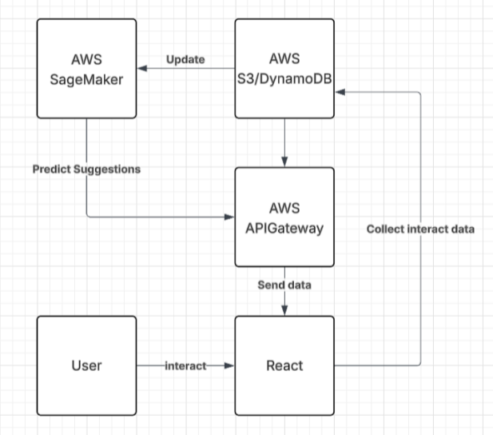

Technical Approach
Frontend: React + Bootstrap – Allows users to browse products, interact with recommendations, and make purchases.
Backend: AWS Lambda + API Gateway – Handles user interactions, processes requests, and manages communication between the frontend, database, and machine learning module.
Data Storage: AWS S3 + DynamoDB for storing large datasets, logs, and ML training data and fast, scalable storage of user interaction data and product information.
Machine Learning: AWS SageMaker – Uses user activity data to train and deploy a predictive model that estimates user preferences and generates personalized product recommendations.
Asynchronous Processing: Batch processing for periodic updates.Pipeline (stream-based) processing for near real-time learning and inference.
When a user visits the site, the frontend fetches the product list from the backend. As the user interacts (clicks, views, buys), their actions are logged to DynamoDB. Once sufficient data is collected, the backend asynchronously triggers an ML update process via SageMaker to refine predictions and improve recommendation accuracy.

Data Sources
Amazon Product Reviews / Metadata
AWS S3/DynamoDB
Kaggle E-commerce Datasets

