**MyCON Internal Announcements Widget**

The following outlines the features, functionality and maintenance of the Internal Announcements Widget on the MyCON Intranet.

**Widget Placement**

As of 6/13/2018, the widget resides on the on the Faculty Affairs landing page and Human Resources landing page (a limited number of categories display on the HR page as per the initial build request).

**Main Features**

* Used to display internal announcements in key places on the MyCON Intranet
* Announcements managed from single “Internal Announcements” list
* Each announcement is displayed in a Twitter-style feed within the page
* Each entry consists of a title, category, description/content, category icon and publication date
* Announcements are ordered by publication date (newest at the top)
* Announcements are filterable by category
  + The total number of category entries displayed by the category choice on the filter tool
  + Categories with no results are grayed out and cannot be selected
* Publish and Expiration date fields available to add/remove entries on specific dates.

**Creating New Announcements**

Authorized users are able to create a new announcement by visiting the following link and clicking “new announcement”: <https://mycon.ucdenver.edu/Lists/Internal%20Announcements/hr-edit-view.aspx>

The Announcement, Description, Category and Publish Date fields are all required; the Publication Date field defaults to the current date.

**Notice:** When selecting a category **DO NOT** choose “Dean Message”. That category is reserved for Dean’s Messages, which display on an entirely separate page, outside of the widget.

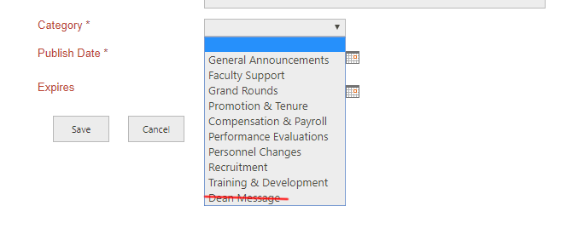

**New Announcement Form and Field Mappings**

The following graphic displays the required announcement fields and where they are displayed on the page.

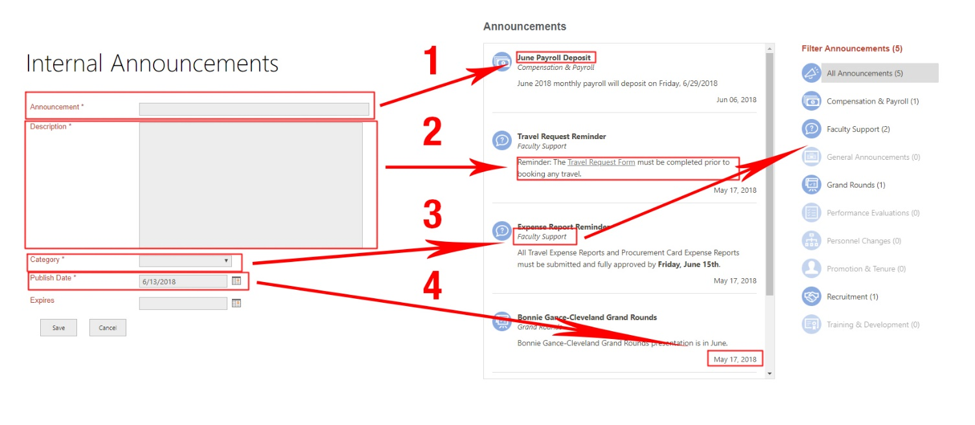

1. The **Announcement Field** displays as the bold title of the entry in the feed. Choose something short, yet descriptive.
2. **Description** is the main body of the entry. You are able to add links, text and images to the description. Take into account the limited available space on the page display and limit your description size accordingly. This isn’t meant to be a blog.
3. **Category** displays below the title and adds to the total number of entries for that category in the filter.
4. The **Publish Date** shows at the bottom right-hand corner of each entry. The entries themselves are ordered by publish date with the most recent publish date at the top.

**Editing and Maintenance**

From this link: <https://mycon.ucdenver.edu/Lists/Internal%20Announcements/hr-edit-view.aspx>, users are able to edit entries inline by clicking on the “edit” link; this is similar to managing items on the OnBoarding and OffBoarding tables.

To recycle a post (re-display one that has expired) simply change the expiration and publish dates. You only need to change the expiration date to make it re-appear in the feed, but updating the publish date will bump it back to the top of the list.

