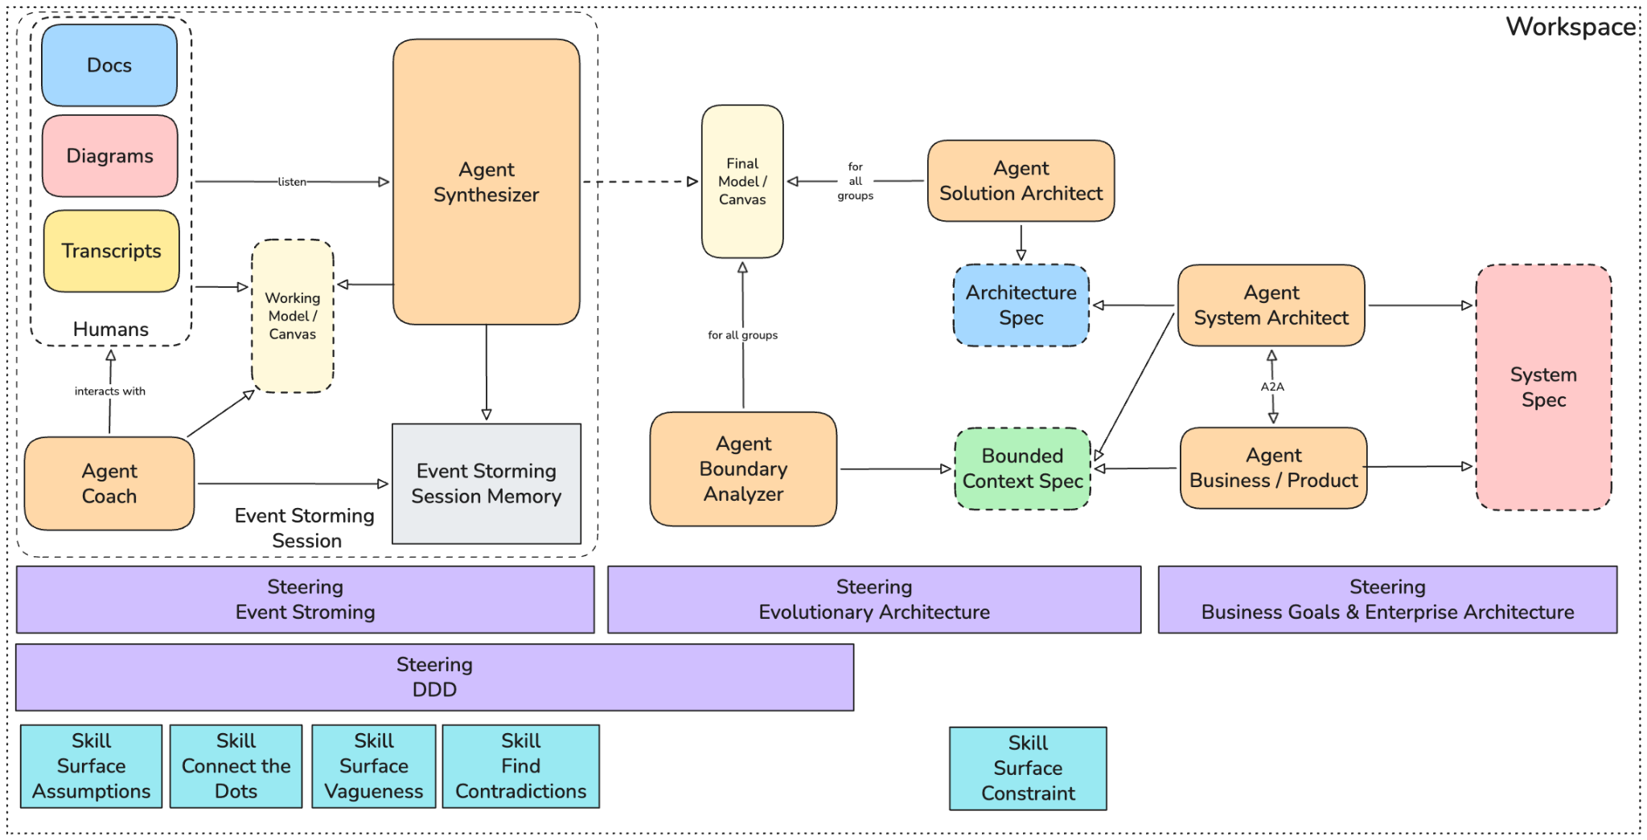

Overview
This project will aid the running and synthesis of one or more EventStorming sessions. The session will play out as usual, but will utilize digital assets and agents to enhance the experience. The session takes place over a remote meeting tool where a live transcription log can be captured. Participants will work on documents in shared digital space.

Two agents will run in the background watching the transcripts and documents for changes. One is a synthesizer agent, which will construct a read-only ‘Canvas’ that represents the potential output of the session. This will involve the typical EventStorming ‘stickies’ as well as one or more Bounded Context Canvases. The second agent is the Coach. Users can chat directly with the coach, asking questions about their conversation history, what gaps they have, and get general advice on the EventStorming process and domain driven design. Both agents share a common ‘memory’ of the session, which includes all the raw inputs and synthesized knowledge.

After a session is finished, a final artifact is produced capturing the full output & synthesis of the session and phase two of the workflow begins. Here two parallel agentic workflows begin, both of which use the output of one or more EventStorming sessions as input. The first workflow will pressure test the boundaries discovered during the EventStorming sessions. The ‘Boundary Analyzer’ agent will check for boundary consistency across all the inputs and resolve overlap, and identify any conflicts that can’t be resolved without more data. It will then produce a series of specifications for each bounded context. This spec should be optimized for input into a Spec-driven development process.

The second workflow will evaluate the inputs from an architectural point of view. It will consider messaging patterns, resiliency strategies, scaling and elasticity, etc. Its output will be an architecture specification, defining the non-functional requirements. It should define NFRs that apply to the entire system as well as NFRs that apply to specific bounded contexts.

After both of those workflows run, the final phase begins. It involves an adversarial agentic loop with a ‘System Architect’ agent and a ‘Business/Product Agent’. The product agent focuses only on the bounded context specs evaluating it from a high level business requirements perspective. The system architect agent will read both the bounded context specs and the architecture spec evaluating them from a systems and enterprise architecture perspective. They will use A2A to communicate with each other when they need input that falls outside of their expertise. They will collaboratively produce a final ‘System Specification’. As with the other specs, this should be optimized for being used as the input for a downstream spec-driven development process.

The format of the System spec should be:
- Business value primer
- System overview
  - Architectural patterns
  - State/persistence mechanisms
  - Communication mechanisms
  - System diagram
  - External integrations
  - Standards (e.g. OpenTelemetry)
- Bounded context definitions
  - Service definitions (hosting and scaling)
  - Functional requirements
  - Non-functional requirements

Steering & Skills for Agent

Agent Synthesizer

Steering
- EventStorming
- Domain-driven design

Skills
- Connect the dots
- Surface vagueness
- Find contradictions
- Surface assumptions

Agent Coach

Steering
- EventStorming
- Domain-driven design

Skills
- Surface vagueness
- Surface assumptions

Agent Boundary Analyzer

Steering
- Domain-driven design
- Evolutionary architecture

Skills
- Connect the dots
- Surface vagueness
- Find contradictions

Sub-agents & Tools
- Sub-agent: SDD fitness evaluator

Agent Solution Architect

Steering
- Evolutionary architecture

Skills
- Surface constraints

Sub-agents & Tools
- Sub-agent: SDD fitness evaluator

Agent System Architect

Steering
- Enterprise architecture

Skills
- A2A mediation

Sub-agents & Tools
- Sub-agent: SDD fitness evaluator

Agent Business / Product Owner

Steering
- Business goals

Skills
- A2A mediation

Sub-agents & Tools
- Sub-agent: SDD fitness evaluator

