What is Gamesense?
GotFrag is proud to introduce GameSense™, the definitive statistical database for competitive eSports. GameSense™ tracks detailed statistics on players and teams in competitive eSports. A GotFrag.com project, GameSense™ was created to give real statistical backing to the often-voiced question "Who's the best player in the world?" Moreover, the information in GameSense is used in GotFrag.com's proprietary Content Management System to provide the latest and most detailed information in eSports news and coverage.
Inside of GameSense™, you can find in-depth information on your favorite (or least favorite) players, teams and events. It provides detailed statistics based on official matches and events from tournaments around the world. How many Frags do they have? How many Aces? Who has the best K:D ratio? Who has the worst? Who has the highest FPR? GameSense™ is the definitive source for the answers to these questions and many more.
Highlights of Gamesense

- Gamesense was started January 16, 2004
- Gamesense 2.0 and Gamesense Live went online July 8, 2006
- FPR – Frags per Round – We have coined this as the Batting Average or Points per Game of Counter-Strike and Counter-Strike:Source. It’s the standard benchmark by which players are compared.
- 121 Tournaments/Events currently tracked by Gamesense
- 828 Teams currently tracked by Gamesense
- 4407 Players currently tracked by Gamesense
- 3933 Maches currently tracked by Gamesense
- Gamesense breaks stats down by event, map, round, tournament and much more.
- GotFrag operates Gamesense.net a direct portal to Gamesense’s front page.
- Gamesense has processed stats from tournaments in 13 different countries including Sweden, UK, Spain, China, Brazil and Korea.

Gamesense Platform

- Continued viewing by the public on the latest matches from around the World for direct page views
- Introduction of Fantasy eSports with baseline free play for page views, upgrade users to more hardcore audience and potential up-sales of GamesenseLive and enhanced features.
- Team tool is a new system where we give the public a tool to input their matches in near real time with page views and up-sales of GamesenseLive.
- Sales of branding directly related associated such as recent deal with SteelSeries.

Gamesense Engine

- Automated process for PC games with server logs.
- Gamesense Live provides near live updating of matches streaming from server logs.
- Engine can handle non-server log based games though manual process.

Gamesense Front Page

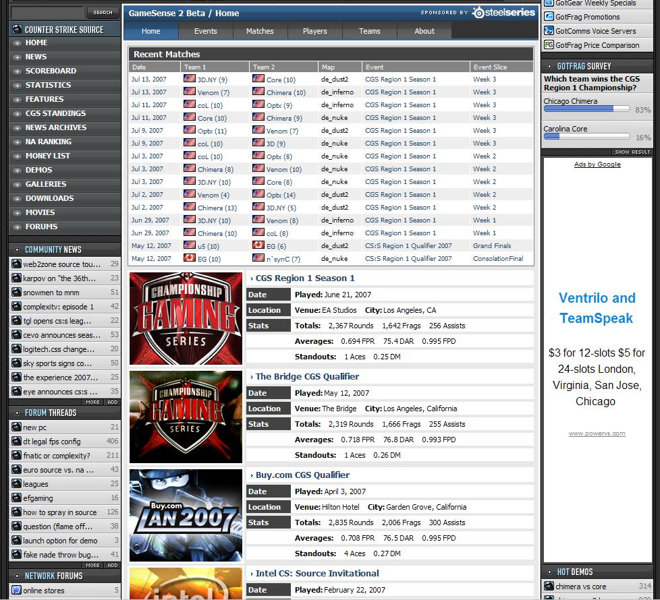

*Breakdown of recent matches with links to each team and box scores for individual matches.
*Recent event/tournament breakdown with quick overall stats to get audience interested.

Gamesense Player Profile

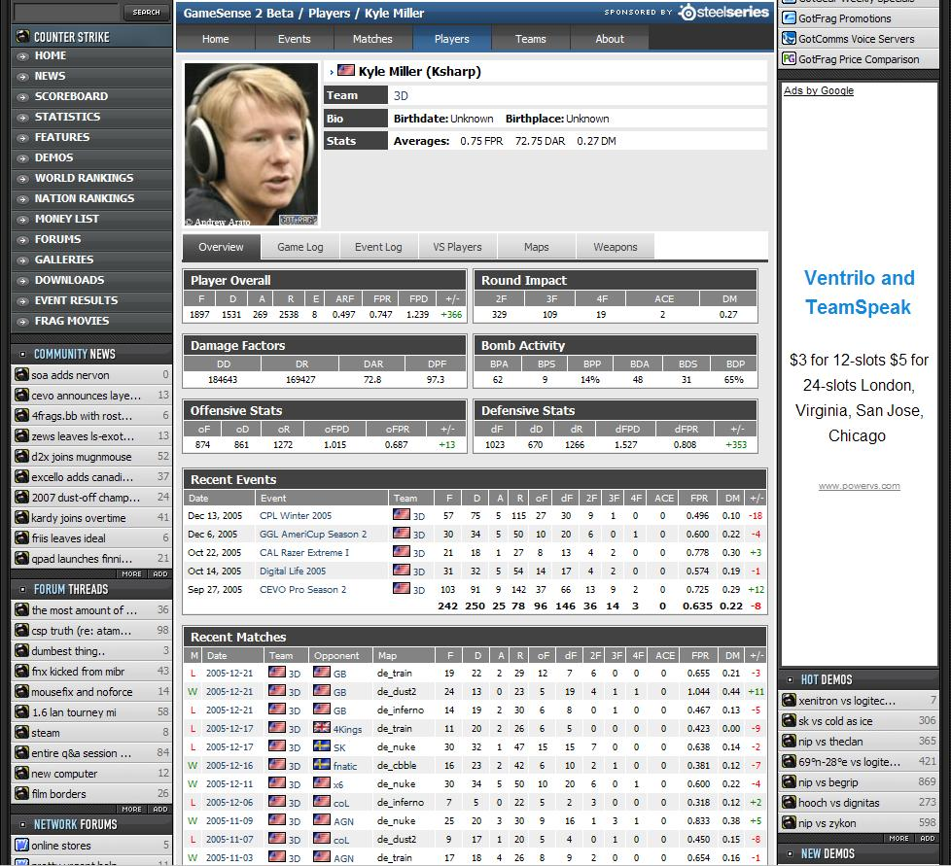

*Player Personal information with potential for more in-depth fields.
*Breakdown of his personal stats which can be done by many different sortable functions.
*Quick links to the individual players Map, Weapon, Event and match stats.
*Listings of recent events and matches the player has played in.
Gamesense Box Score (Individual Match)

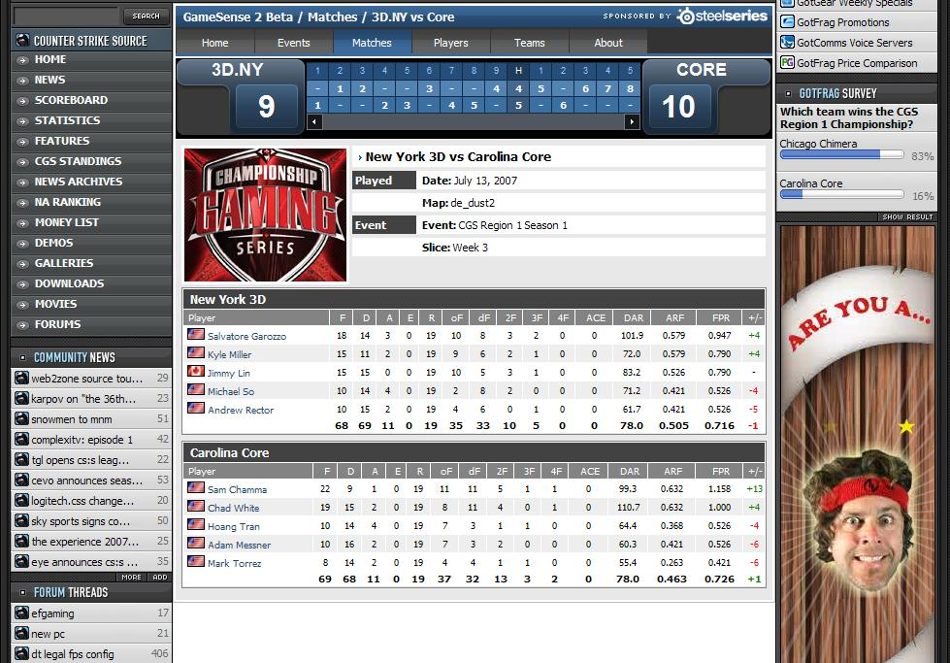

*Concept of this page is to breakdown a single match into an easy to understand format.
*Each round by round information showing who won which rounds.
*Each player’s stats from the match.

Gamesense Event/Tounament Page

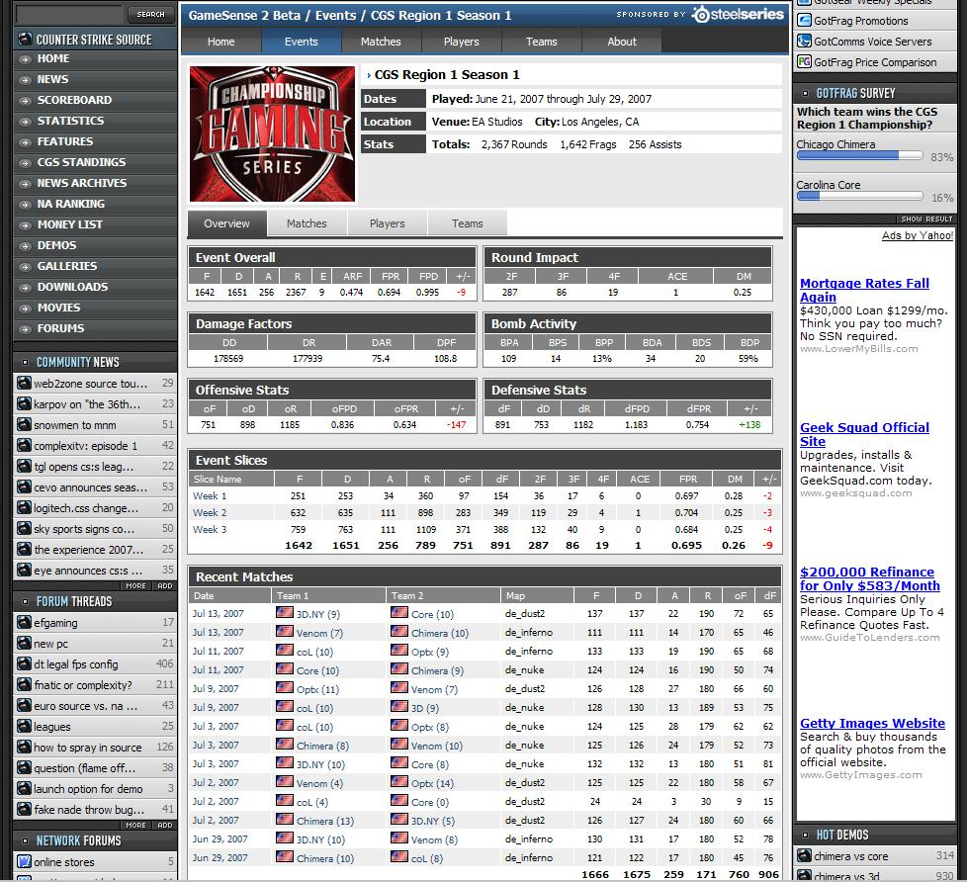

*An event breakdown with location and baseline facts about the event.
*Listing of the overall stats recorded from the event.
*A list of the event slices from the match which is our way have breaking down the entire tournament into more manageable pieces for the audience.
*Also included is a list of the recent matches from the tournament.

Gamesense Live

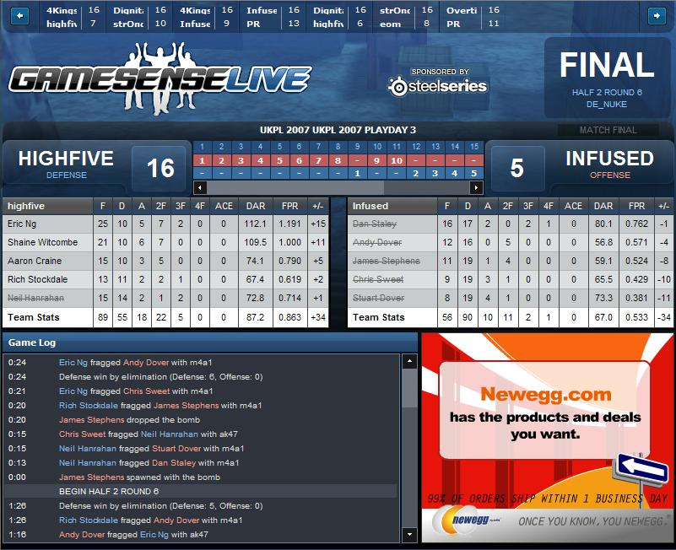

*GamesenseLive is a near real time updating system of the match as it goes along.
*GamesenseLive receives the stats from the server in a live stream and processes them instantly while the match is underway.
*Across the top is a direct link to other matches currently underway.
*The player information shows the current stats for each player. The player name is also crossed out when he dies in a given round, when the round restarts this is all removed.
*The game log across the bottom shows real-time actions beyond just frags/kills.
GameSense Glossary

Individual Stats
+/- | This stat is a correlation between Frags and Deaths with Frags minus Deaths. A number can be both positive and negative.
2F | Number of rounds where a player scores two frags.
3F | Number of rounds where a player scores three frags.
4F | Number of rounds where a player scores four frags.
A | Assists are the Number of times a player scores greater then 50% Damage to an opposition player but does not score a Frag, the opposition must also be fragged by a fellow teammate to receive an Assist.
ACE | The home run of CS, the Ace is where a player frags the entire opposing team, 5 Frags in one round.
ARF | Average Rounds with a Frag, is the number of rounds with at least one frag giving a basic percentage.
CTF | Counter-Terrorist Frags scored during Rounds played on the Blue (Counter-Terrorist) Team.
CTW | Counter-Terrorist Winning percentage, rounds won as Counter-Terrorist (Blue Team) over total rounds played as Counter-Terrorist (Blue Team).
D | Total Number of Deaths during Rounds played.
D+/- | DAR minus Average Damage Received, Average Damage given minus Average Damage received.
DAR | Average Damage per Round (or Damage Average per Round) is the Damage a player or team does to the opposing players on average during a round not counting friendly fire but including all grenade damage. (When DAR is calculated per weapon only rounds where that weapon was used in any attack count)
DM | Domination, tracks the effectiveness of a player or team during the course of the rounds played. This complex formula provides multipliers for larger number of frags during a single round.  [ (# of Frags during 1F rounds) * 1 + (# of Frags during 2F rounds) * 2 + (# of Frags during 3F rounds) * 3 + (# of Frags during 4F rounds) * 4 + (# of Frags during ACE rounds) * 5 ] / [ # of Rounds * # of Players on Each Side (Normally 5 for CS) ]
E | Errors, a combination of team friendly-fire frags (frags against teammates) and world spawns (a player frags him/herself).
EF | Entry Frag, the number of times the player or team scored the first frag of the round.
F | Total Number of Frags scored during Rounds played.
FPR | Frags Per Round, the batting average of Counter-Strike allows people to see how effective a player is at quick glance. It is calculated by dividing Total Frags during a given period (or total history of the player) over the Number of Rounds played during the same period.
K:D or Ratio | Frags during a given period over Deaths during the same given period.
R | Rounds played during matches. Does not include Rounds where player/team dropped due to server problems or substitutions.
TF | Terrorist Frags scored during Rounds played on the Red (Terrorist) Team.
TW | Terrorist Winning percentage, rounds won as Terrorist (Red Team) over total rounds played as Terrorist (Red Team).
Team Only Stats
B | Bomb explosions, rounds where the bomb successfully exploded resulting in a win for the Terrorists (Red Team) by that method.
BP | Bomb Plants, rounds where Terrorist (Red Team) plants the bomb..
BS (currently BPA) | Bomb Success, the number of rounds the bomb successfully exploded over the number of rounds the bomb was planted.
D | Defuses completed, rounds where the Counter-Terrorist (Blue Team) successfully defuses the bomb.
DA | Defuse Attempts, rounds where the Counter-Terrorist (Blue Team) touches the bomb in an attempt to defuse the bomb.
DAA | Defuse Attempts Average, the number of times the bomb was successfully defused over the times it was attempted to be defused.
W:L | Wins over Losses, number of rounds won over the number of rounds lost.
 | Terrorist (Red Team) wins by eliminating opposition.
 | Counter-Terrorist (Blue Team) wins by eliminating opposition.
 | Counter-Terrorist (Blue Team) wins. Terrorist (Red Team) failed to eliminate opposition or plant the bomb.
 | Terrorist (Red Team) wins by completing the objective (bombing the target).
 | Counter-Terrorist (Blue Team) wins by defusing the bomb.

Background on Gamesense
GameSense™ was originally conceived by Jason "Warthog" Roman, Trevor "Midway" Schmidt, Lee Chen and Jason Coene. During a series of late-night debates about who the best player really was, Trevor, Lee and Jason lamented that there was not a statistical basis for determining who the best was. Particularly given that the data needed to generate this information was already presentable on many public game servers, this seemed to be a deficiency without excuse.
More late night sessions were spent debating how a system should be designed, what would be required and how to present this information. Parts of those debates resulted in some innovative hand-calculated statistics in the trademark feature "Midway's Melee" on GotFrag.com. Several months later, after one aborted attempt to build a statistical system by GotFrag, Jason "Warthog" Roman, who had been independently developing a general statistical system for almost a year, brought his beta to Trevor.
Hours later, Project GameSense™ was born. Roman quickly became core to the development of the project and worked closely with Trevor on the statistical breakdowns and formulas. Trevor researched the statistical models in mainstream sports extensively, drawing pertinent formulas and stats from baseball, basketball, football and many other sports. 200 code hours later, Roman and Coene had developed the first public release of GameSense™. As the project entered its alpha stages, Phil "aztk" Therien brought his graphical expertise to the table to design the look and feel of the first iteration of the project.
GameSense 2.0 encompassed another 100 code hours, dozens of new features and a brand-new design by Surreal-Media. It includes a brand new feature, GameSense Live! which streams live, play-by-play action to your web-browser from our GameSense Servers.
More Information
Today, GameSense™ supports Counter-Strike 1.6 and Counter-Strike Source, but the system is designed to be scalable and to expand to support many different games.

