**a)** **Evaluating concordance between ecosystem services and conservation priorities**

Ecosystem services provided by nature are vital to humans. Some ecosystem services, such as pollination (valued at $200 billion wordwide in 2009; *1*), are artificially elevated for human benefit through the use of introduced species, such as *Apis mellifera* (honey bees; *2, 3*). However, the availability of honey bees has recently declined due to Colony Collapse Disorder (CCD; *4*). Fortuitously, native bees can substitute for honey bees as crop pollinators. For example, the presence of native bees enhanced honey bee pollination of crop sunflowers 5-fold (*5*), and native bees were the dominant visitors to three of four crops recently studied in the northeastern USA (*6*). Further, some native bees are more efficient pollinators than honey bees in some crops (e.g., *7*). Yet, we still lack a complete understanding of the extent to which native pollinators contribute to ecosystem services (*8-11*). Importantly, we don’t know exactly how to promote native bees for crop pollination (*11*). Proximity to natural habitat is a factor that substantially increases native bee pollination of crops (*12*). A recent review (*12*) of observational studies revealed crop pollination by native bees decreased dramatically with distance from natural habitat. However, an experimental approach will unravel the relative importance of natural habitat and native pollinators, among many potential contributing factors, for crop pollination.

Anthropogenic disturbances, such as habitat loss, urbanization, invasive species, and agricultural intensification reduce diversity of species and genotypes within populations (*13*). In fact, declines in genetic diversity within species often precedes the loss of species (*14*). As genetic diversity is altered with anthropogenic change, we have begun to notice that evolutionary trajectories of native species are altered as well. For example, the presence of invasive plants can alter selection on herbivore resistance of native plants (*15*), and increased temperatures due to climate change has caused heritable changes in breeding season of red squirrels (*16*). Despite advances in our understanding of evolution in native species due to anthropogenic change, these studies are largely restricted to single populations. However, natural selection is spatially and temporally variable (e.g., *17*). Now, we need to examine natural selection across many populations and years. Homogenization of landscapes, such as agricultural monocultures, may lead to a homogenous abiotic and biotic environment, potentially reducing variation in selection pressures on native plant and pollinator species. Reduced variation in natural selection pressures can lead to genetic homogenization, which is known to reduce ecosystem functions (*18*). A landscape-level approach is required to understand how evolutionary trajectories are altered with anthropogenic homogenization of the environment.

There are potential conflicts between the goal of maintaining ecosystem services and the goal of preserving biodiversity, or reducing genetic homogenization. Here, I address the potential conflict between the ecosystem service of crop pollination and the novel alteration of evolutionary trajectories of native plant species in an agricultural landscape. In short, crops should benefit by increased pollination by native pollinators when in close proximity to natural habitat, but native plant species in the same natural habitat may simultaneously suffer from a homogeneous selective environment. I will characterize this potential conflict for the first time, and identify conditions that may help mitigate this conflict. The proposed work is novel in several ways. (i) This will be the first study to examine whether an anthropogenic disturbance reduces diversity within a native species by experimentally homogenizing the selective environment. (ii) I take an important step forward in experimentally manipulating proximity of natural habitat to a crop to estimate how important natural habitat is to the provision of crop pollination. (iii) I simultaneously investigate a fundamental problem in conservation biology with how to maintain ecosystem services.

**b)** **RESEARCH GOALS:** **Evaluating concordance between ecosystem services and conservation priorities.** This research will address the following two questions:

Question 1. *To what extent does proximity to native habitat enhance pollination services to crop sunflowers by promoting greater abundance and diversity of native pollinators?* This question will greatly expand our knowledge of the value of native habitat for the promotion of crop pollination.

Question 2. *To what extent do crop sunflowers alter (i) the pollinator communities, and (ii) natural selection on floral traits, of related native sunflowers*? We know that land use change, including intensive agriculture, negatively impacts wild species, but we know little of the consequences of agriculture for landscape level evolutionary processes.

**c)** **PROPOSED METHODS:** Study system: I will study cultivated sunflower (*Helianthus annuus*), and its common wild relative, *H. annuus texanus*, native to TX. In sunflower growing regions in the US, crop and wild sunflowers overlap in flowering for 5-6 mo./yr, thus generating substantial potential for crop-wild interactions through shared pollinators and herbivores. Texas hosts abundant crop sunflower production (~140,000 acres in 2009) and 20 native *Helianthus* species. I chose *H. a. texanus* as a model to represent native sunflowers because they are self-incompatible (require pollinators for reproduction), sexually compatible with their crop relative and annual so lifetime seed set (essential to measuring selection) can be measured in one season.

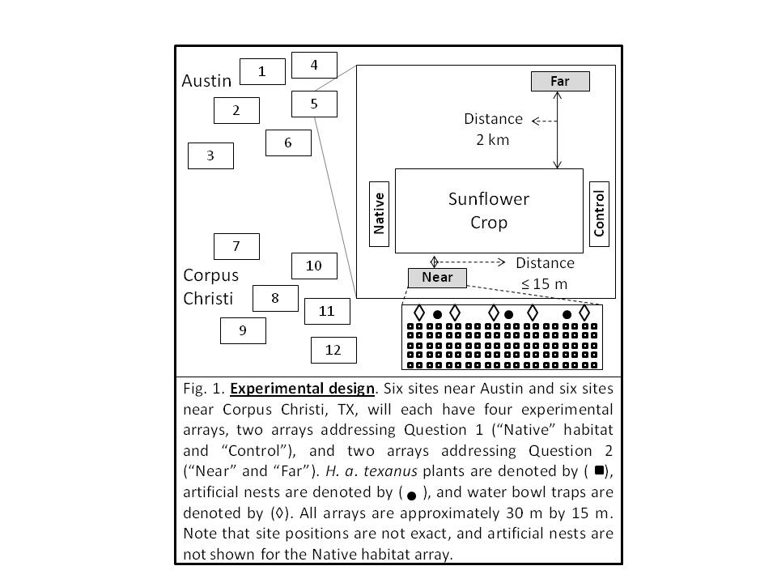Question 1. In the fall of 2010, at each of 12 sunflower crop fields across two ecoregions in Texas, I will plant native seed mix (includes 30 species of annual and perennial forbs and grasses) in one array (“Native”), and a control plot on the other side of the field will receive no seeds (“Control”), both within 15 m of the sunflower crop (Fig. 1). To simulate nesting habitat that cavity-nesting native bees require, I will place 3 artificial bee nests (PVC pipe with paper straws) within each array of Native habitat. Twelve sites are needed to assess how native plants influence native bee crop visitation at the landscape scale.

In 2011, during three visits to each of the 12 sites, I will quantify all pollinator species visiting 30 randomly selected crop sunflower plants at each of 0, 10, and 50 m from the Native habitat and Control arrays; pollination is likely to be reduced farther within the crop field. I will also sample pollinators with water bowl traps, a commonly used method to sample bees (*19*), at each 0, 10, and 50 m location. Adjacent to both Native habitat and Control arrays within the sunflower crop I will estimate crop pollination efficiency of each bee species (10 individuals per species). I will estimate pollination efficiency by calculating seed set per flower head after single visits to flower heads by each bee species. Using ANOVAs, I will ask if crop visitation to flowers and efficiency differs by treatment (Native habitat vs. Control), and distance (0, 10, or 50 m) to the Native habitat or Control arrays.

Question 2. Experimental Design. In April of both 2010 and 2011, at each of the 12 sunflower crop fields, I will plant two arrays of *H. a. texanus*, one adjacent (within 15 m) to the sunflower crop (“Near” distance treatment), and the other 2 km away near naturally occurring native habitat (“Far”; Fig. 1). Twelve sites are needed to assess whether the crop causes a homogenization effect at the relevant, landscape scale. Each array will consist of 100 *H. a. texanus* plants (greenhouse grown). To simulate nesting habitat that cavity-nesting native bees require and sample the bee community, I will place three artificial bee nests within each array of plants.

i) Pollinator communities. During four visits to all 12 sites throughout the flowering season, I will identify all pollinator species visiting sunflowers in the Near and Far arrays, and quantify their visitation to 30 plants/array. I will also sample pollinators with bowl traps. These four visits will capture seasonal variation in pollinator communities. I will use non-metric multidimensional scaling (NMS) and analysis of similarities (ANOSIM) to test if agricultural-wild proximity alters pollinator species composition, and ANOVA for effects on diversity indices and abundance, using per plant observations of pollinator visitation to flowers, artificial nests that specifically track colonization by native bees, and bowl traps that sample a diversity of potential insect pollinators. 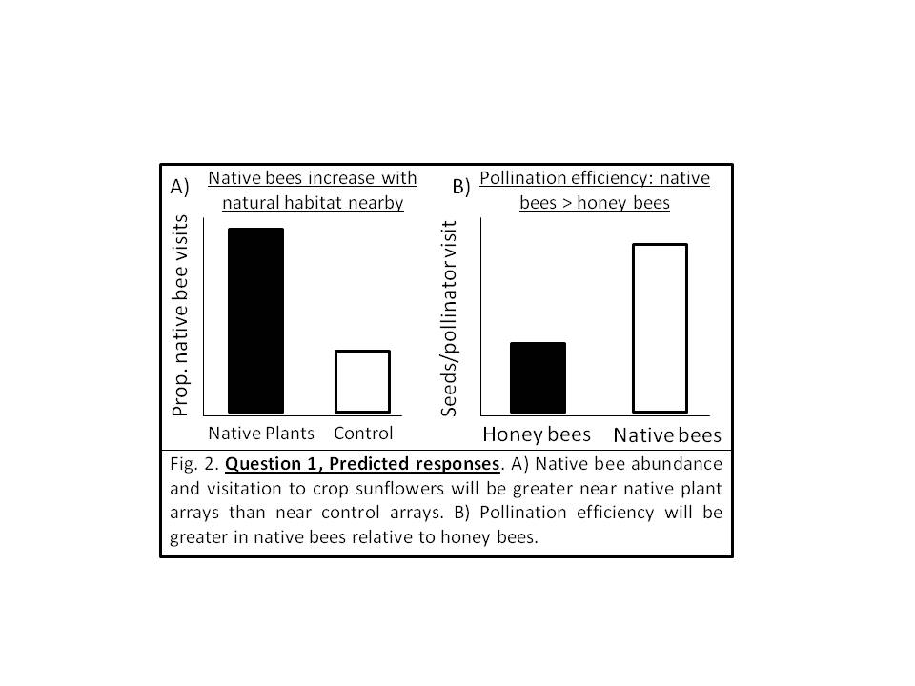

ii) Natural selection on flower traits. Natural selection is measured using phenotypic selection analysis (*20*), which regresses plant fitness (seed set) against a plant trait (or set of traits); a significant slope (selection gradient, *β*) is consistent with natural selection on the trait. I will measure six floral traits per plant (100 plants/array). I will estimate fitness by multiplying mean seed set per head (3 heads/plant) by the number of heads per plant. Using multiple regression, I will calculate selection gradients for the traits. A significant distance (Near vs. Far) effect (ANCOVA) will demonstrate that selection is altered by proximity to the crop. I will also compare the coefficient of variation (CV) of selection gradients between Near and Far treatments (chi-square test).

**d)** **EXPECTED RESULTS:** Question 1. I expect native pollinator visitation and diversity in crop sunflowers to be greater near Native habitat arrays than Control arrays (Fig. 2A). In addition, I predict that pollination efficiency will be greater in native bees than honey bees (Fig. 2B) because native bees have been shown to be more efficient than honey bees in many studies (*7, 21, 22*). Together, these results may suggest management strategies for increasing native bee habitat as a way to reduce reliance on increasingly unreliable honey bees (*11*).

Question 2. I expect bee communities visiting *H. a. texanus* arrays will be more homogenized in Near arrays relative to Far arrays (Fig. 3A). I expect that across the range of *H. a. texanus*, the selection gradients on floral traits will be more similar (i.e., homogenized) near crops and will be divergent in arrays planted far from crops due to natural, geographic variation in the selective environment that accompanies native habitat (Fig. 3B). Homogenization of trait evolution may ultimately lead to decreased genetic variation within *H. a. texanus*. In addition, wild *Helianthus* can hybridize with crop sunflowers (*23*), further homogenizing biodiversity within and across wild *Helianthus* populations; this is a topic I intend to pursue in future research.

Altogether, I predict the proximity of sunflower crops to native habitat will increase pollination to the crop, but proximity of native sunflowers to the crop will homogenize selection on native plant traits. This presents a conflict between ecosystem services and conservation priorities (preserving native biodiversity). If this conflict occurs in my research findings, it will be important to conduct management to mitigate the conflict. If the conflict does not occur, we can manage for ecosystem services and some conservation priorities relatively independently. 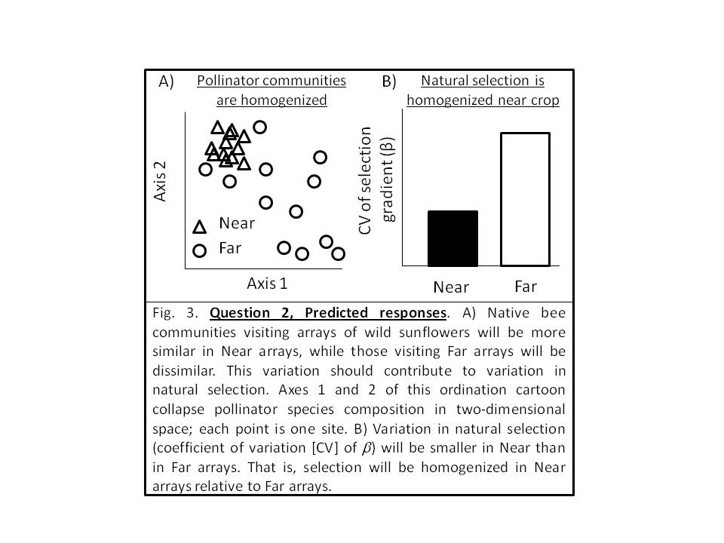

**References: 1.** N. Gallai, *et al*., (Oxford University Press, Oxford, UK, 2009). **2.** C. Kremen *et al.*, *Ecol. Lett.*  10, 299 (2007). **3.** M. E. Watanabe, *Science* 265, 1170 (1994). **4.** F. L. W. Ratnieks, N. L. Carreck, *Science* 327, 152 (2010). **5.** S. S. Greenleaf, C. Kremen, *PNAS* 103, 13890 (2006). **6.** R. Winfree, *et al*., *J. Appl. Ecol.* 45, 793 (2008). **7.** F. D. Parker, *J. Kans. Ent. Soc.* 54, 61 (1981). **8.** C. A. Kearns, *et al*., *Ann. Rev. Ecol. Syst.* 29, 83 (1998). **9.** C. Kremen, T. Ricketts, *Cons. Biol.* 14, 1226 (2000). **10.** G. Allen-Wardell *et al.*, *Cons. Biol.* 12, 8 (1998). **11.** Committee on the Status of Pollinators in North America, *Status of pollinators in North America*. (The National Academies Press, Washington, DC, 2007). **12.** T. H. Ricketts *et al.*, *Ecol. Lett.* 11, 499 (2008). **13.** J. A. Foley *et al.*, *Science* 309, 570 (2005). **14.** N. C. Ellstrand, D. R. Elam, *Ann. Rev. Ecol. Syst.* 24, 217 (1993). **15.** J. A. Lau, *Ecology* 89, 1023 (2008). **16.** D. Réale, *et al*., *PRSL-B* 270, 591 (2003). **17.** A. M. Siepielski, *et al*., *Ecol. Lett.* 12, 1261 (2009). **18.** P. Hoehn, *et al*., *PRSL-B* 275, 2283 (2008). **19.** C. Westphal *et al.*, *Ecol. Monog.* 78, 653 (2008). **20.** R. Lande, S. J. Arnold, *Evolution* 37, 1210 (1983). **21.** F. D. Parker, *J. Kans. Ent. Soc.* 55, 171 (1982). **22.** B. M. Freitas, R. J. Paxton, *Journal of Applied Ecology* 35, 109 (1998). **23.** K. L. Mercer, *et al*., *Ecol. Appl.* 16, 845 (2006). **24.** J. A. Lau, *Evolution* 60, 56 (2006). **25.** N. C. Ellstrand, *et al*., *Ann. Rev. Ecol. Syst.* 30, 539 (1999).