- Add notes e.g. Notes: '5 bottles shattered inside crate upon unloading.'
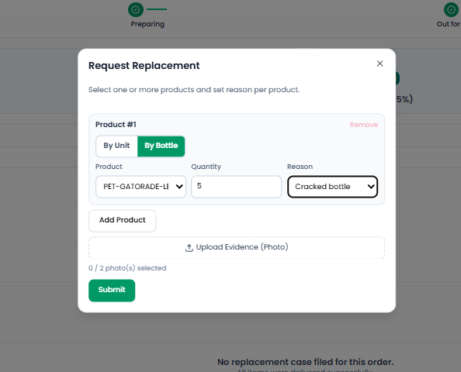

- Enlarged photo preview modal opens allowing detailed inspection of bottle damage.
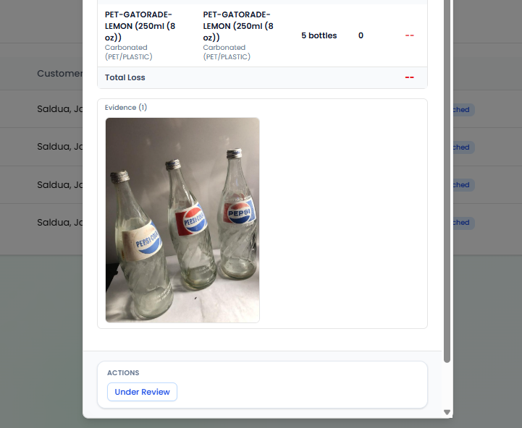

- Replacement Management – Add Status Sorting Tab

The Warehouse Portal > Replacement page should include a status sorting/filter dropdown similar to the provided example. The dropdown should allow warehouse staff to filter replacement requests by statuses such as All Statuses, Pending, Under Review, Approved, Rejected, Completed, and In Progress.

- Driver Portal – “View My Trips” Button Not Clickable
The “View My Trips” button on the Driver Portal dashboard is not clickable and does not navigate to the driver’s trip list. The system should make the button functional and allow the driver to access and view their assigned trips

- Customer Portal – Replacement Claim Status
The Customer Portal > Replacement page should display a claim card containing the Claim ID, Product, Quantity, Defect Reason, and Current Status. The status badge should accurately reflect the claim’s current state, such as Verified, Assigned for Redelivery, or Completed, and the displayed status and timeline should match the latest database state.
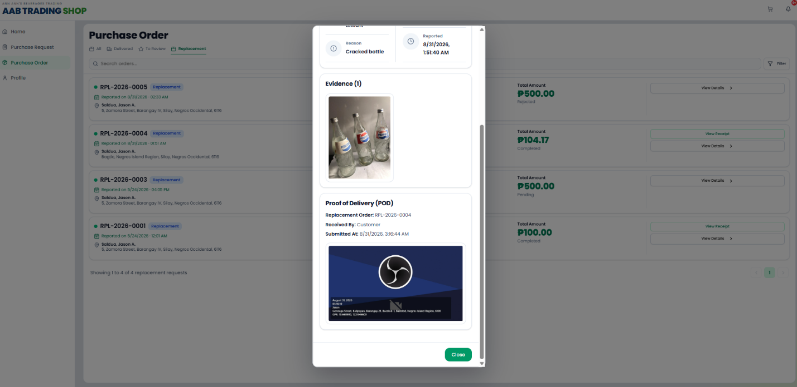
put also ratings in the replacement, you decide what feed are they supposed to givefor each stars but it shoud still be check box or pre defined

