**Vending machine System**

1. Title:

Vending machine system

1. Problem:

As a vending machine system, we need to store as many as goods’ names and their prices. Therefore, we must need an efficient data structure to store these data. And when a customer wants to buy some of them, we’ll quickly show them the descriptions and total prices of the stuffs.

As for back-end, it needs to store all of the descriptions and prices of the goods, and it need be quick enough to search for the data we want. As for front-end, we need to provide the customer an interface to show the names of the goods, and they need to type the names of the aim goods. Then the interface will show them if the stuff exists and the description and total prices of the things.

1. Primary Stakeholder:

The primary stakeholder will be the all of the customers in the shopping mall or convenience store.

1. User Interface (front-end):

First, we need to click an exe file to start/call our user interface. At the first page, the front-end will show user a list of names of all goods. Then, user could click “start my shopping” button. Then it pops an input box, which the user could type the number of the goods they want. After that, user will click “done” button.

So, the front-end will call the back-end to solve the problem. After that, it will show the description of the customer’s receipt and the total price of the goods. Now the user just needs to click check, so they could complete the shopping.

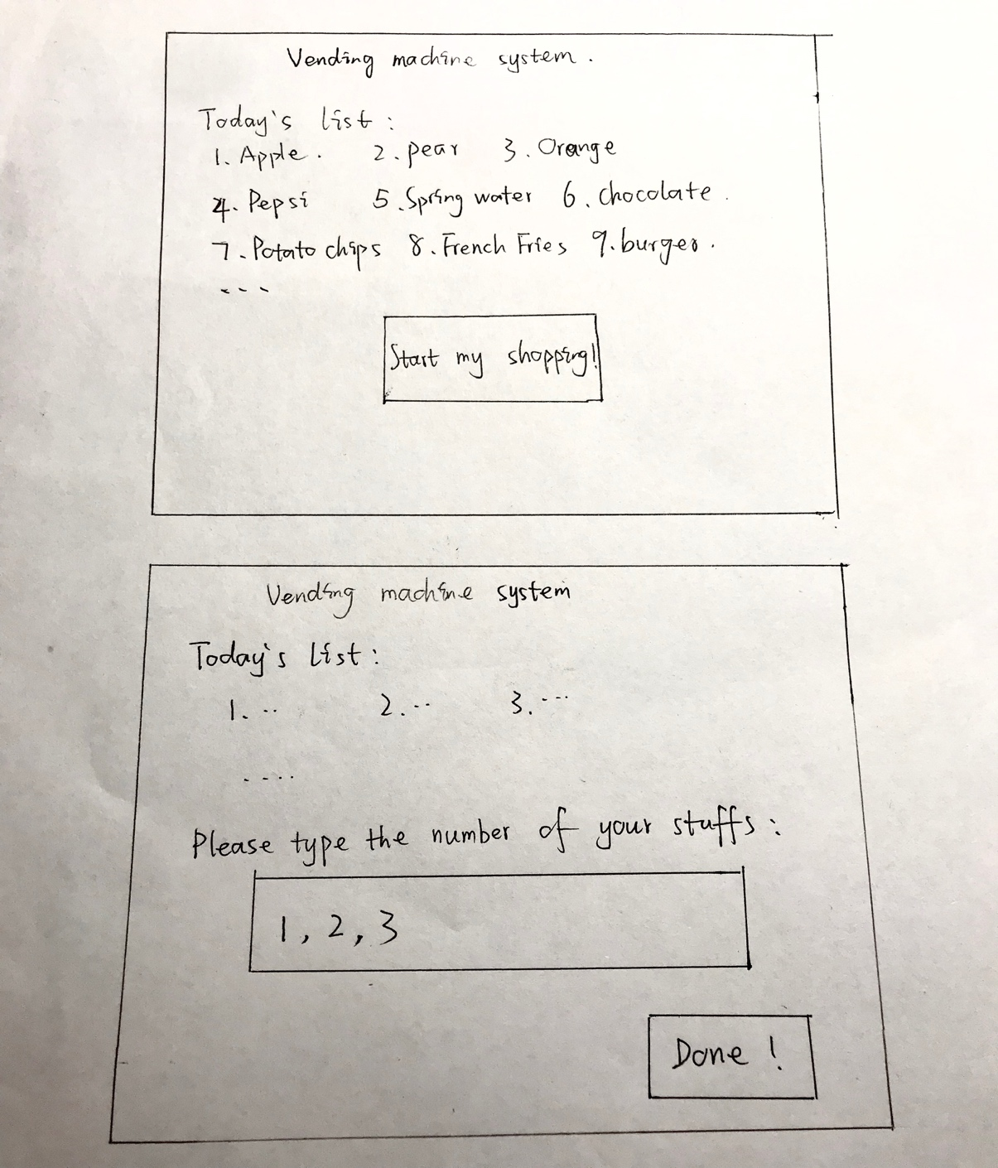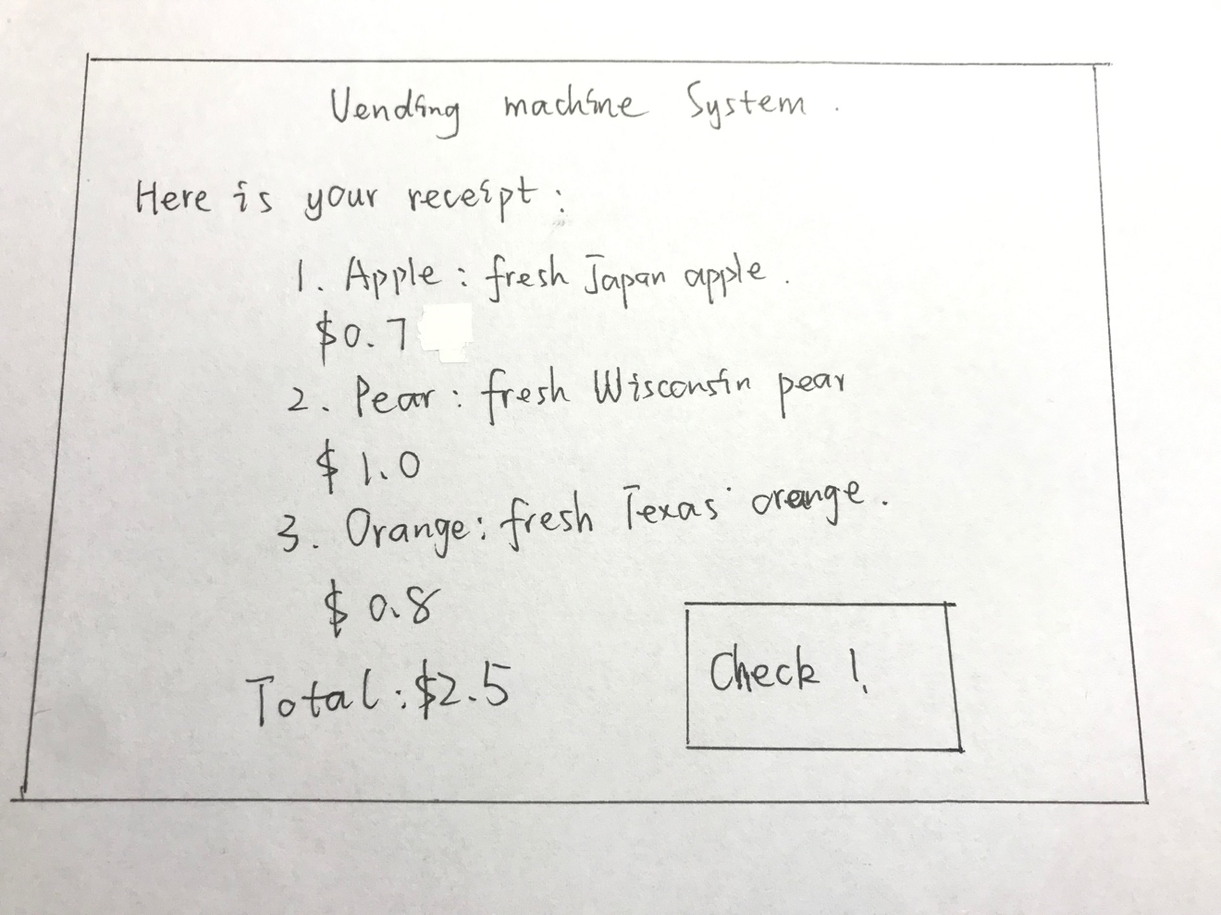

1. Data (back-end):

I decide to use binary search tree as my data structure since it’ll be fast when searching for the aiming things. Every node will store a key, a description string and a value, the key will be the number of the node and the value will be the price of it. And it’ll be a class of binary search tree. And the stuffs in the receipt will be stored in an arraylist.

1. Class (Type) Summary:

Class names: binary search tree.java, BSTnode.java, receipt.java, display.java.

binary search tree.java will be the database of the system. It will store all of the nodes about the stuffs by inserting them into the tree. It also needs to include contains, search methods.

BSTnode.java will be the node of class, it will define the key, string and value of the node. It also has set and get methods.

receipt.java includes an arraylist to store all of the searched nodes from the tree, then it will tell the total price of the shopping.

display.java include the today list, which is the list of all nodes’ names of string. Also, it will print the receipt/arraylist of the shopping to the customer.