1. HOME PAGE OF AEM WORK SPACE

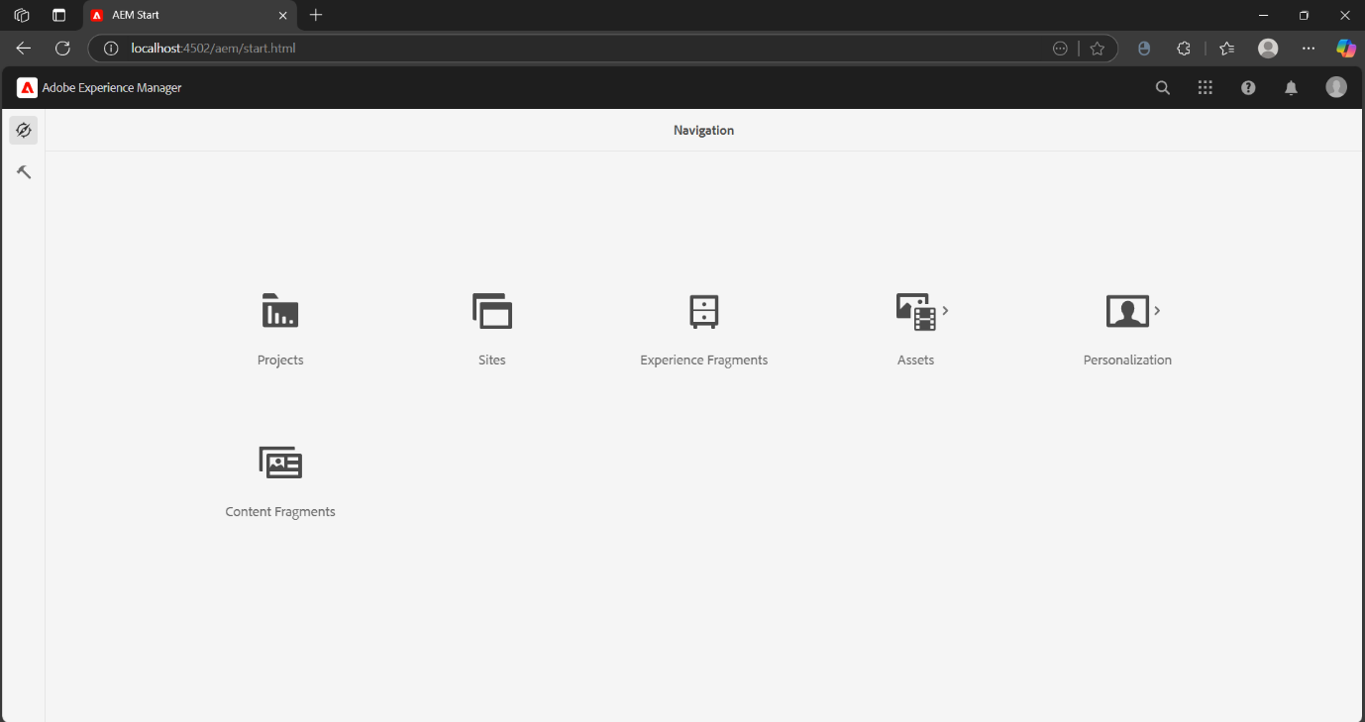

1. REQUIRED PAGES FOR THE SITE

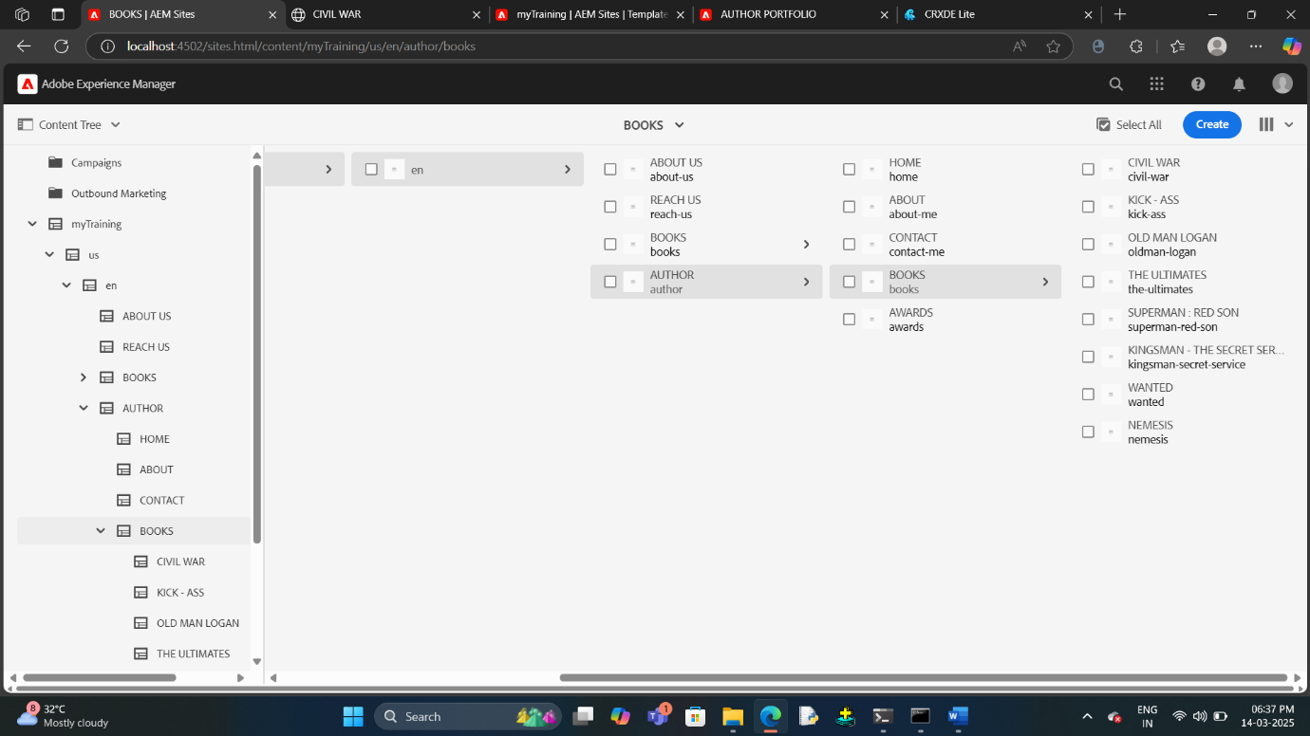

3 .CREATION OF THE DIFFERENT COMPONENTS OF THE WEBPAGE

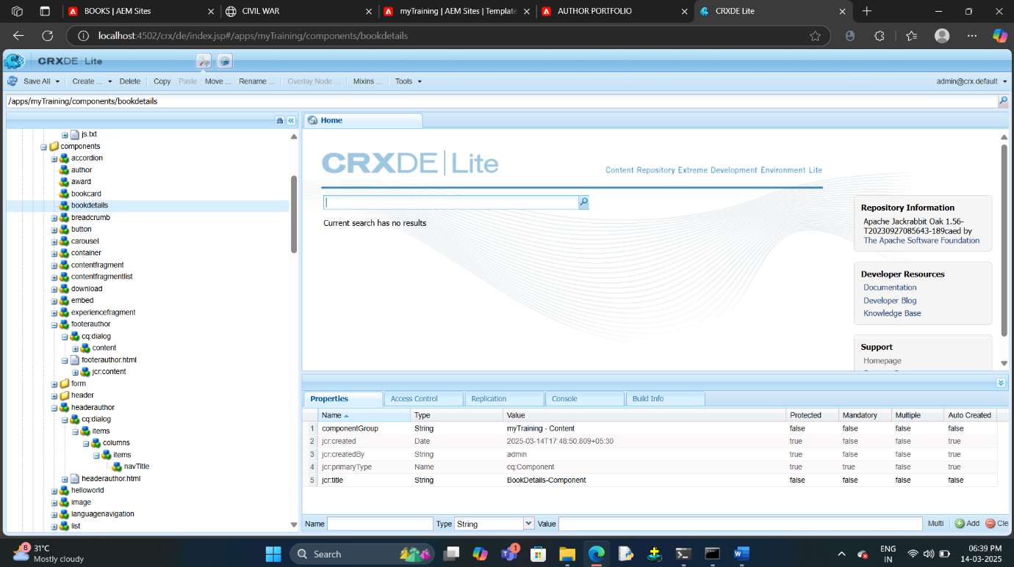

4.CUSTOMIZED HEADER’S CODE WITH STYLING SHEET

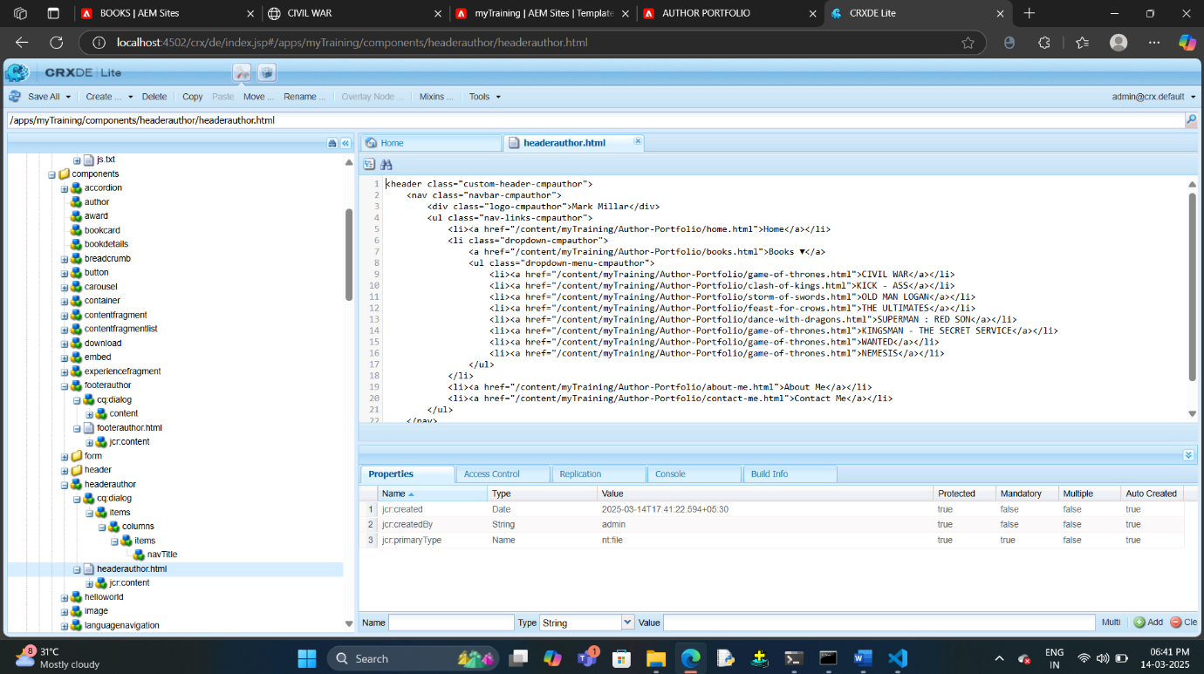

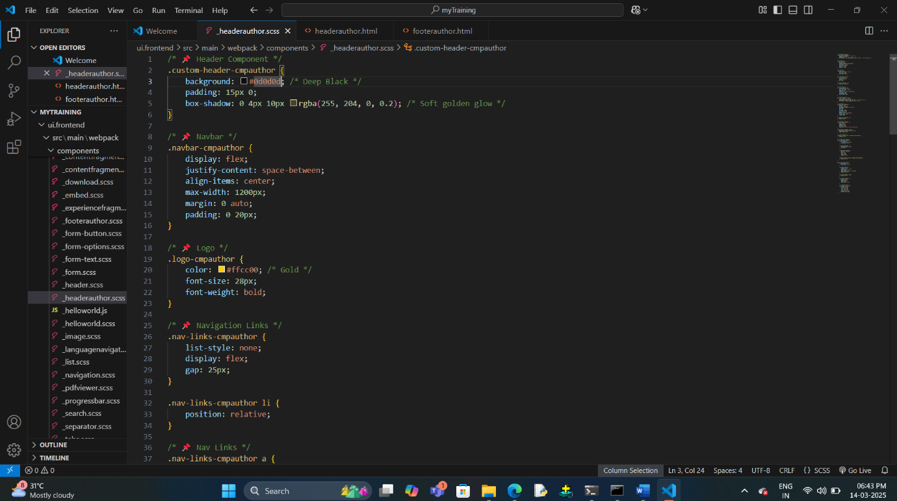

5. CUSTOMZED FOOTER’S CODE WITH STYLING SHEET

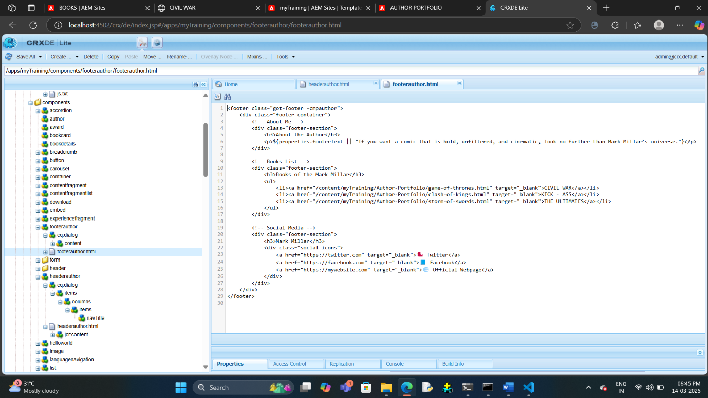

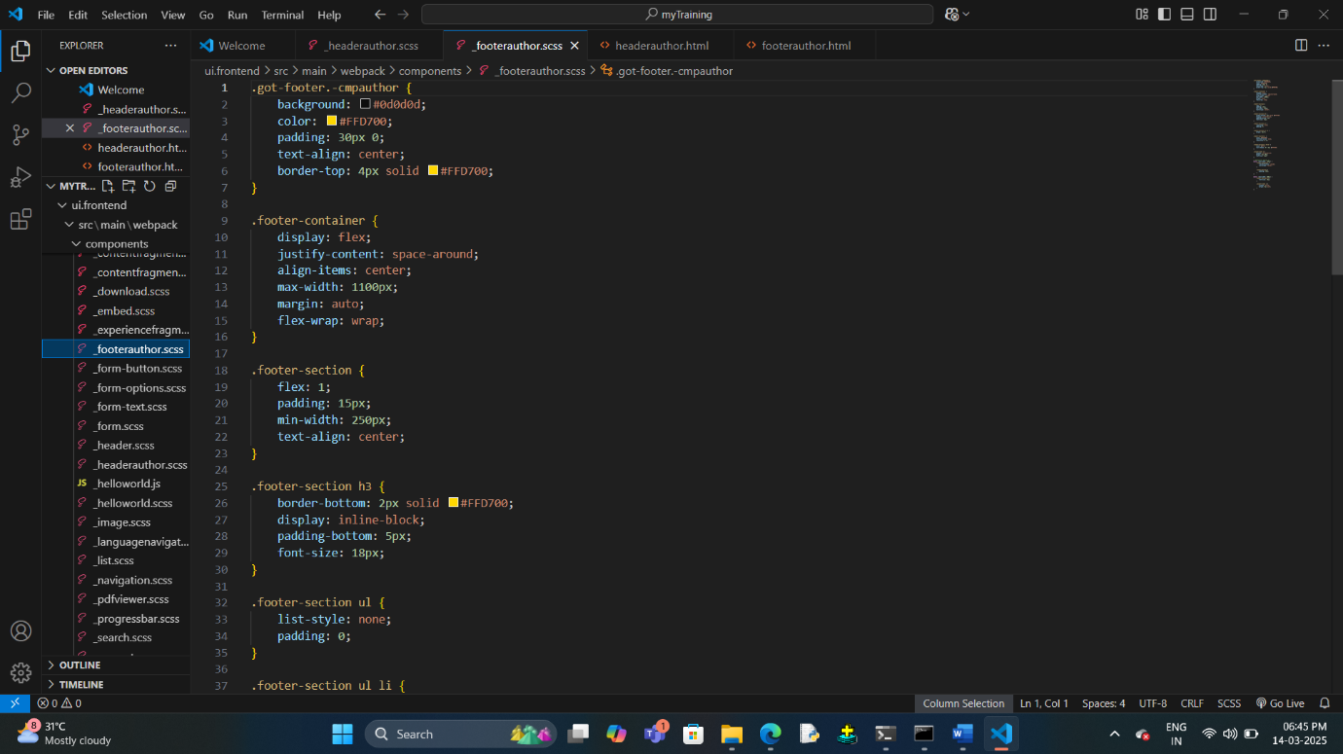

HEADER WITH DROPDOWN

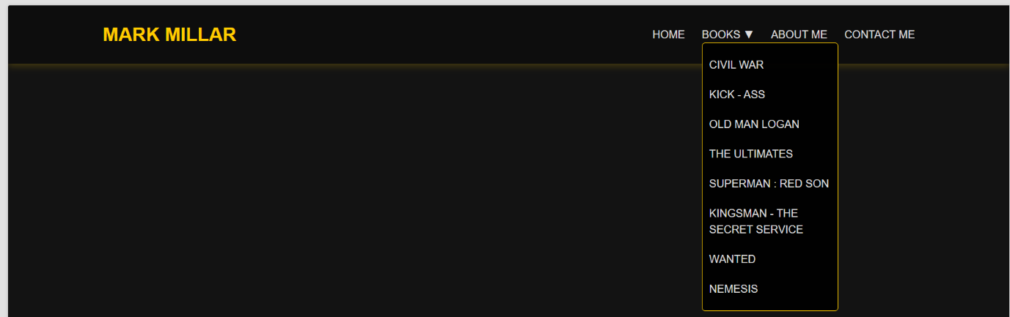

7.2 HOME PAGE

7.3 AWARDS PAGE

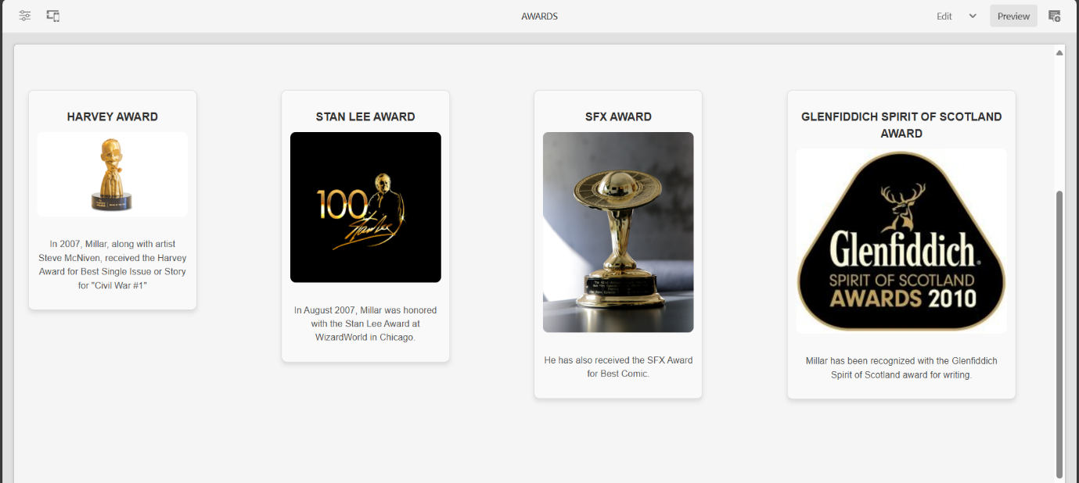

7.5.2.SUPERMAN : RED SON

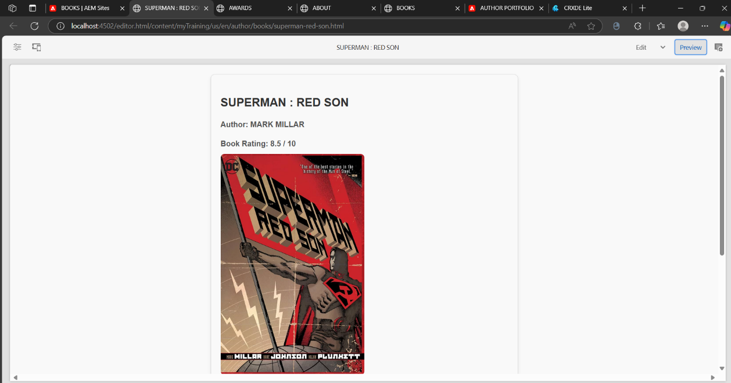

7.7. FOOTER SECTION

