STEP 1: RUNNING AEM IN THE COMMAND PROMPT

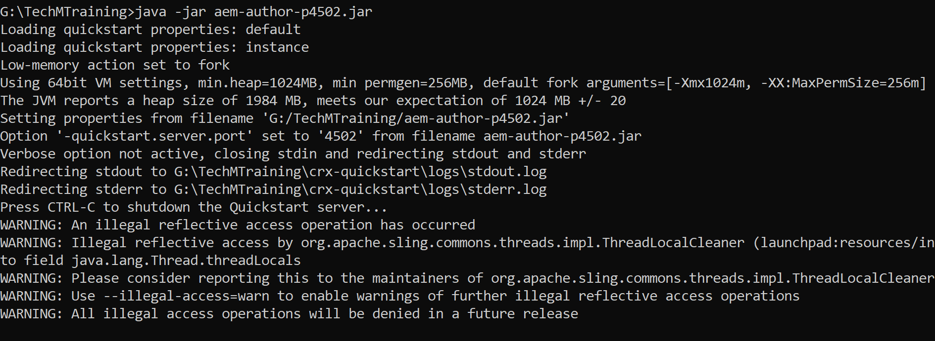

STEP 2: AEM SETUP PAGE

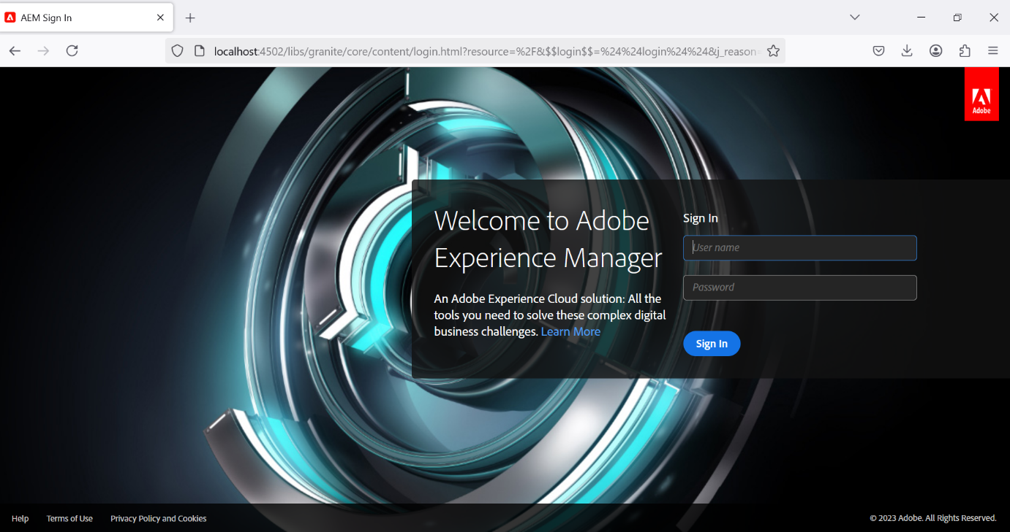

STEP 3: CREATING A AEM PROJECT

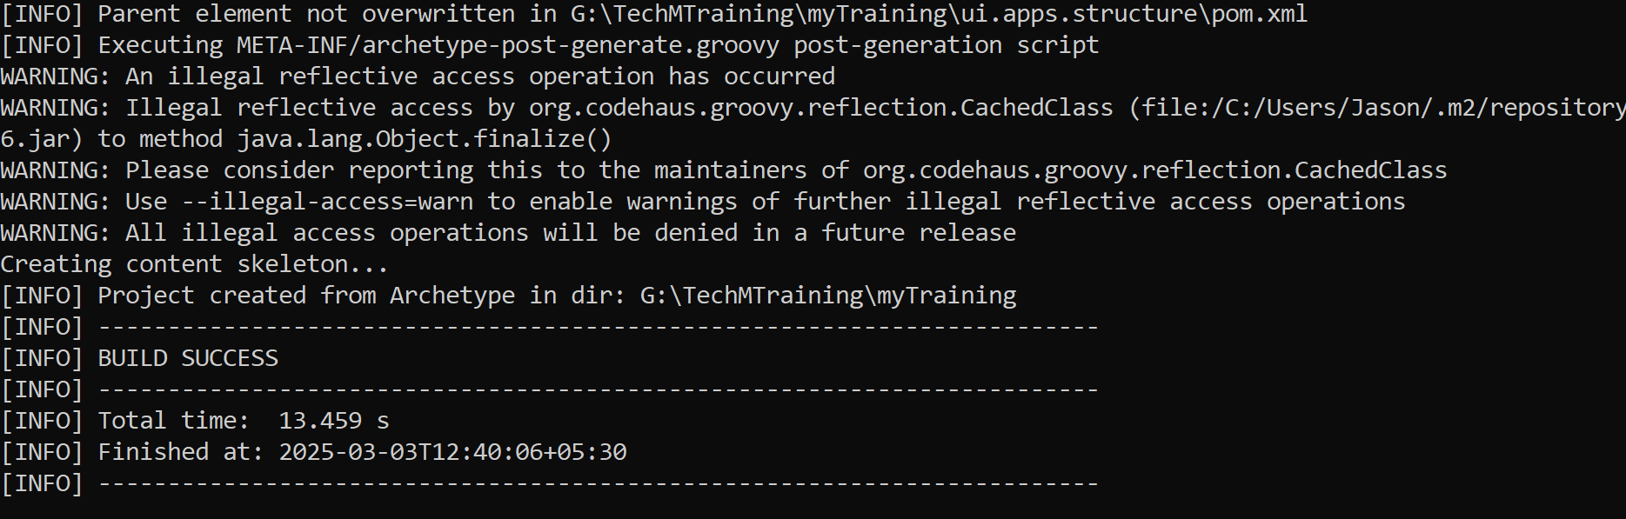

STEP 4: AEM FILE STRUCTURE

