**AUTHOR COMPONENT CREATION IN AEM**

1. **Create the Author Component**

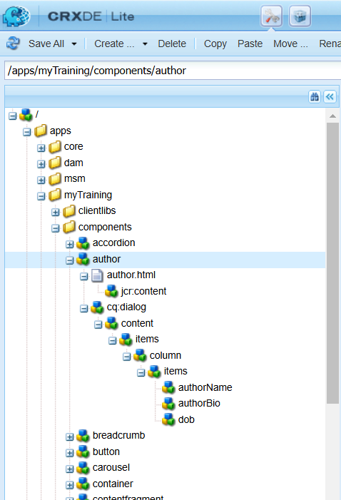

1. Create the node items for the authorname, authorbio and dob.
2. Set the properties for all these fields.
   1. Author name

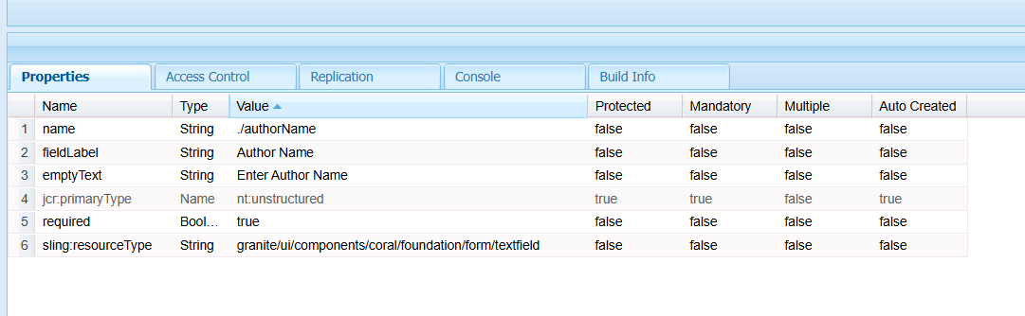

* 1. Authorbio

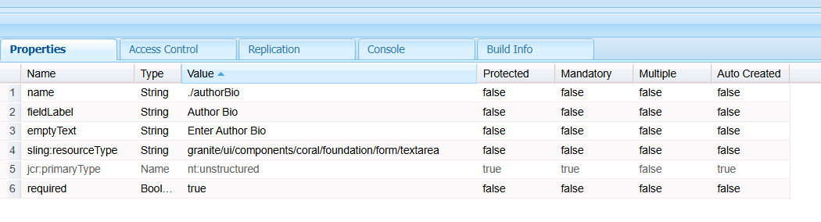

* 1. Dob

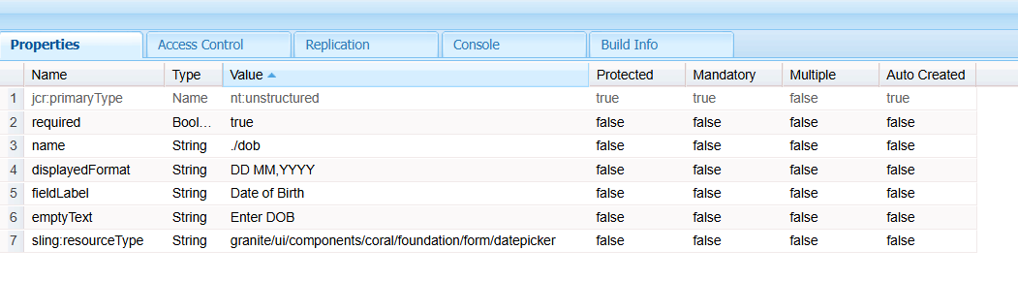

1. Create the HTL File. It fetches the value from the author.

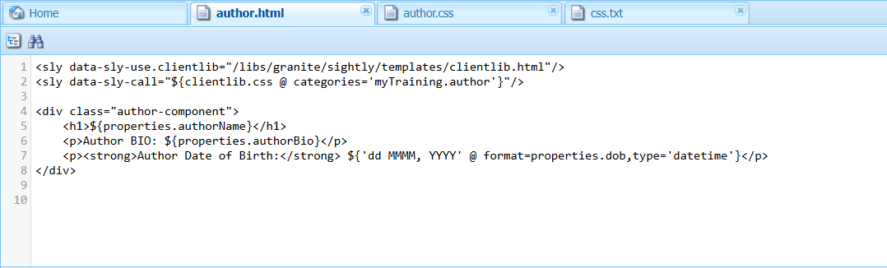

1. Implement the client library with author.css and css.txt.
2. Drag and drop the component.

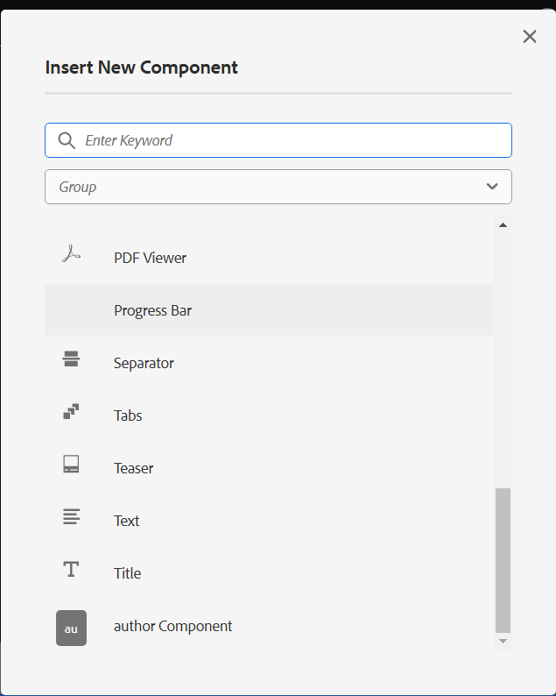

1. Enter the values for the author component.

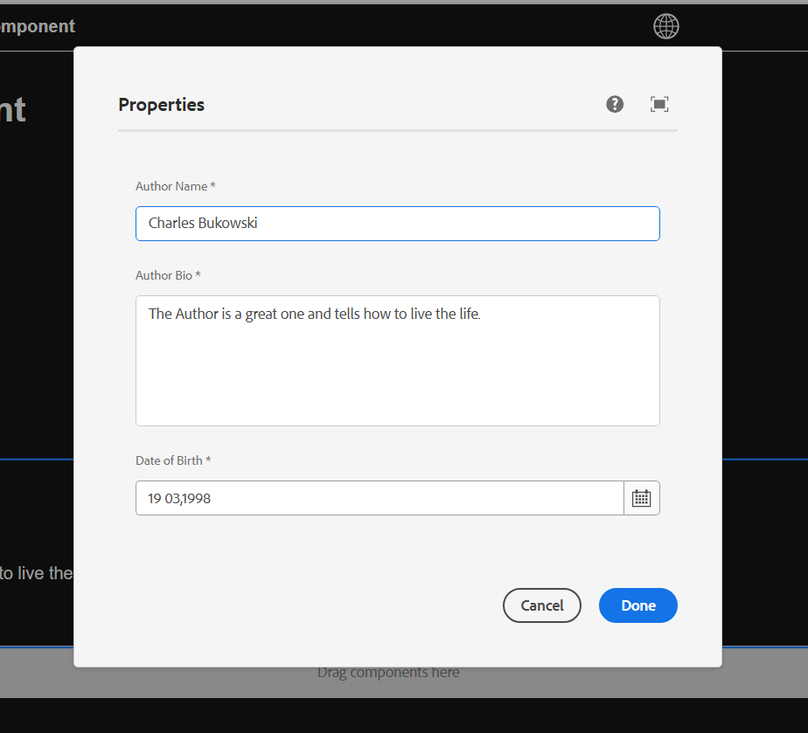

The Final Output

