CREATION OF CUSTOM TEMPLATE WITH 10 PAGES

1.HOME PAGE

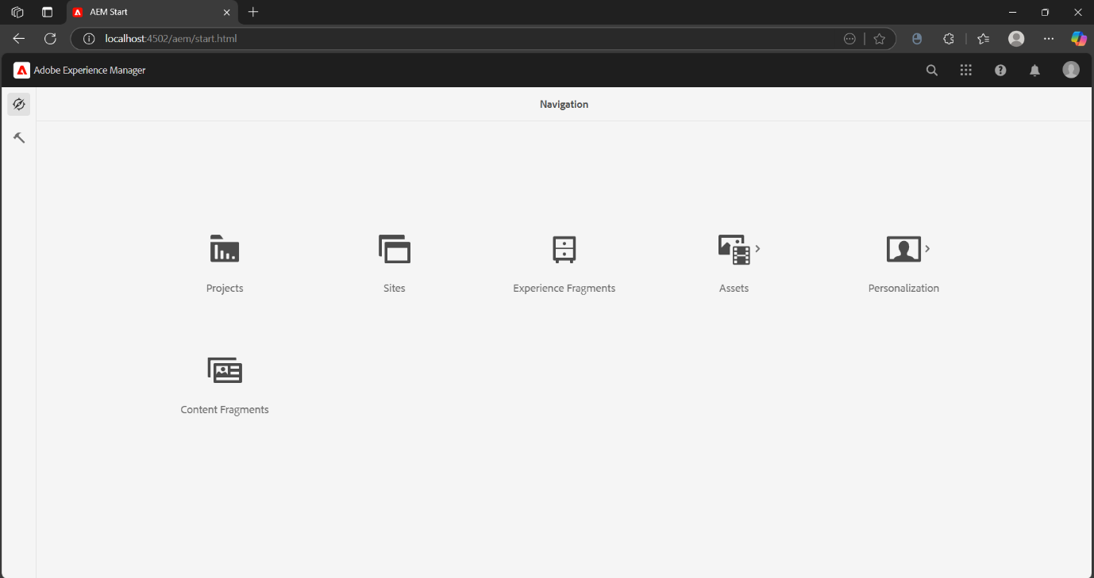

2.TEMPLATE CREATION

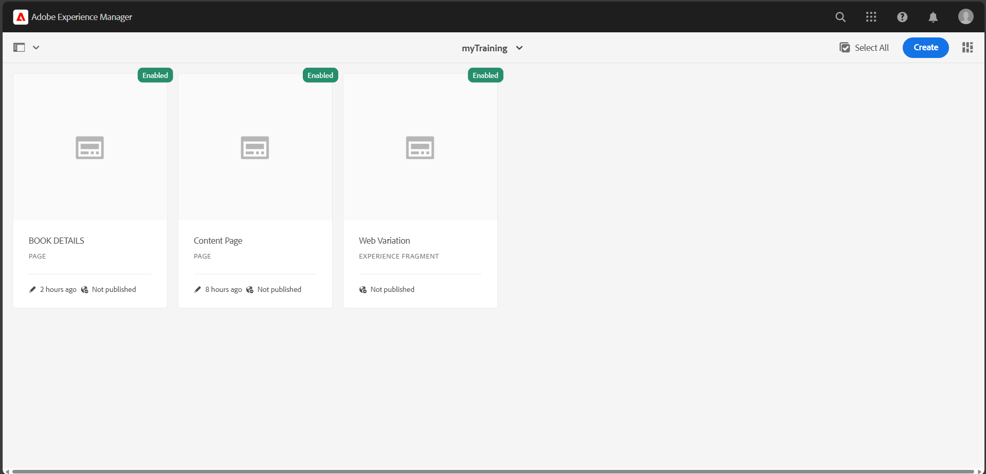

3.CREATION OF PAGES

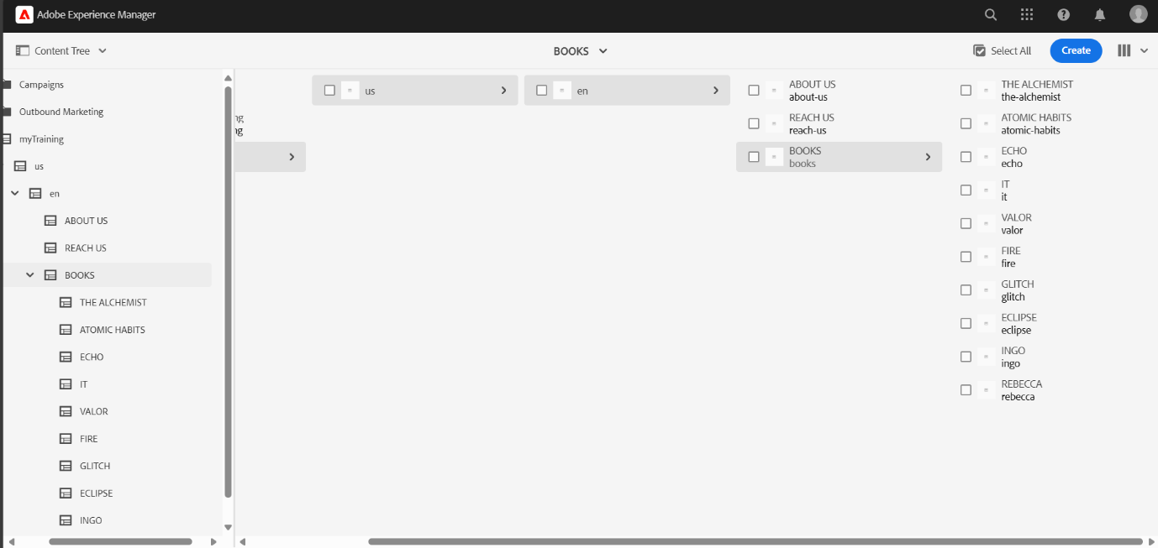

5.HOME PAGE AFTER CREATION

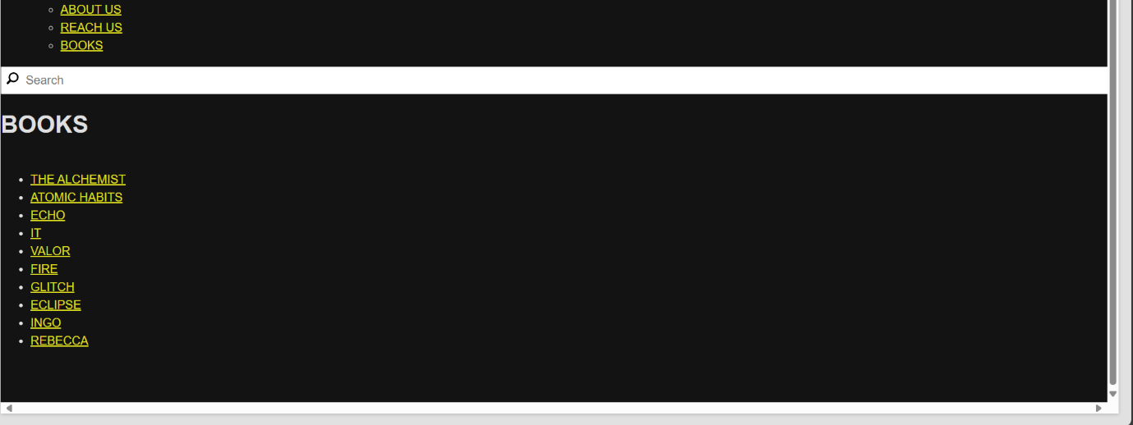

6. ABOUT US PAGE

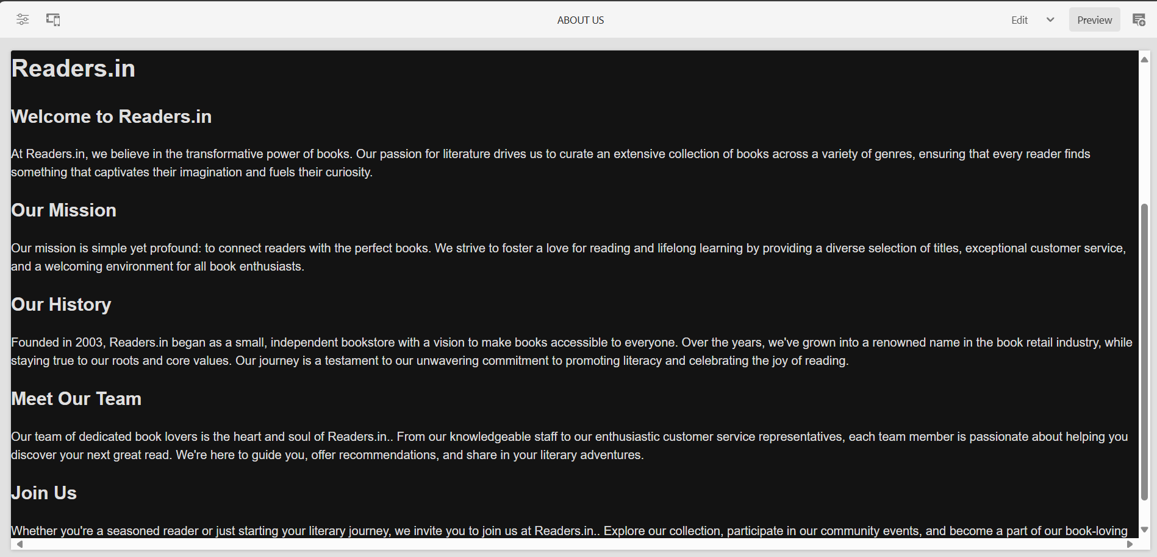

7. REACH US PAGE

