Task 5

1.HOME PAGE HEADER



2.EXPERIENCE FRAGMENT OF HEADER

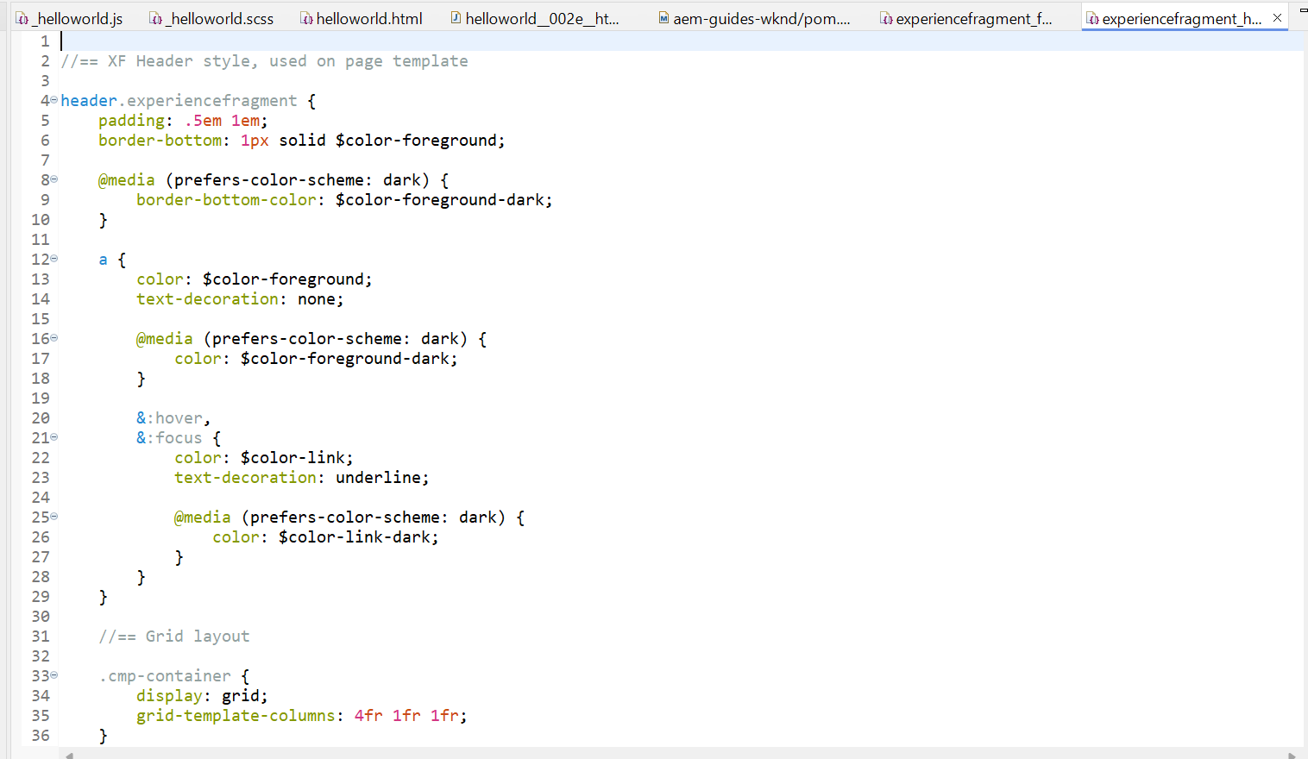

3.EXPERIENCE FRAGMENT OF FOOTER

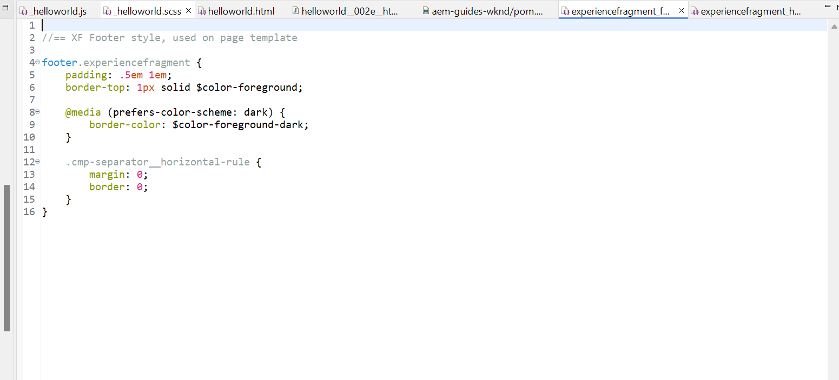

4.CUSTOM BOOK COMPONENT

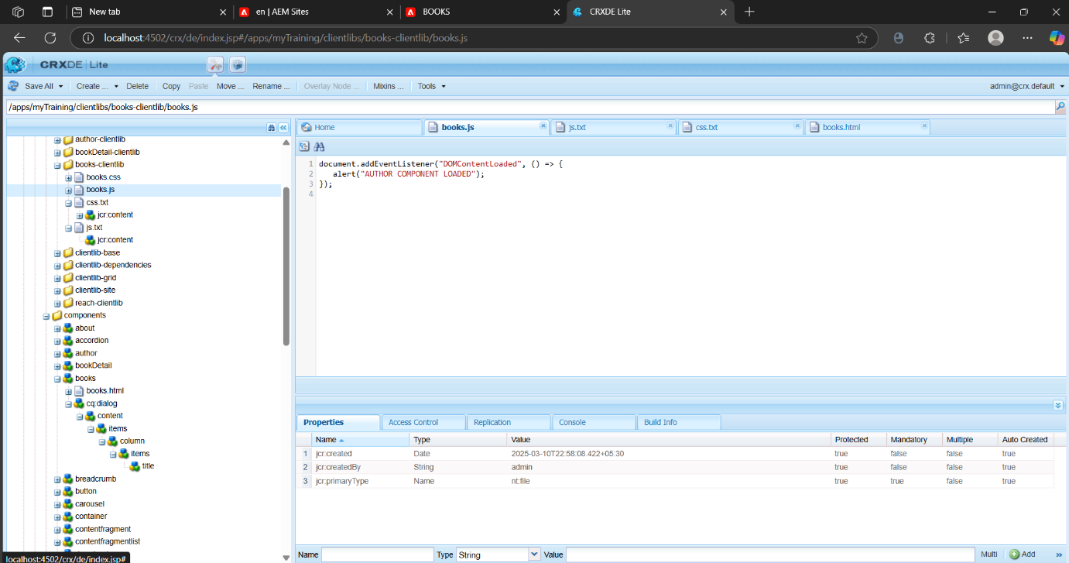

5.UPDATE TO BOOK DETAILS COMPONENT

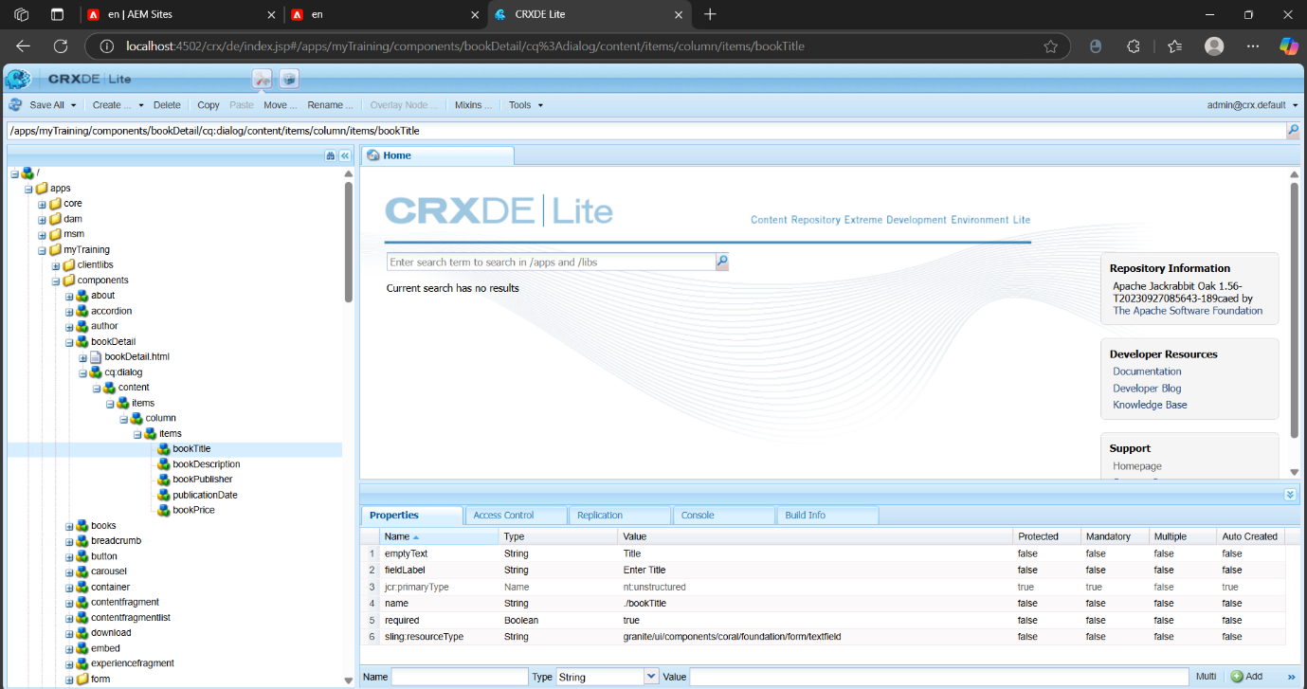

6. BOOK PAGE

