GPU 1660

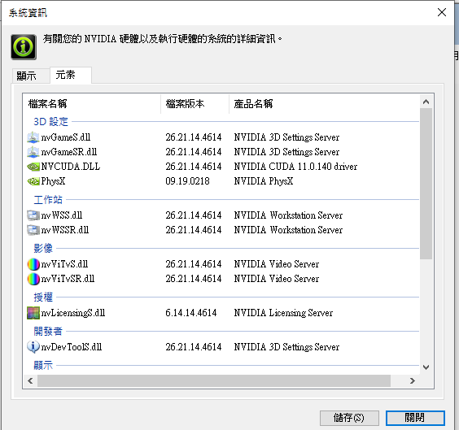

conda env remove -n ENV_NAME

python = 3.7

[cuDNN v7.4.1 (Nov 8, 2018), for CUDA 10.0](https://developer.nvidia.com/rdp/cudnn-archive#a-collapse7415-10)

[CUDA Toolkit 10.0](https://developer.nvidia.com/cuda-10.0-download-archive) (Sept 2018), [Online Documentation](https://docs.nvidia.com/cuda/archive/10.0/)

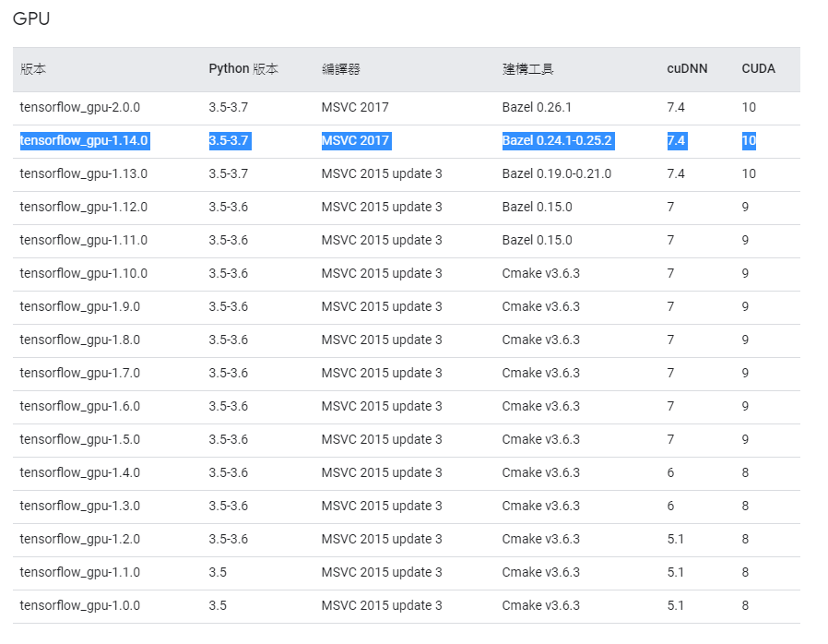

Keras version on tensorflow<https://docs.floydhub.com/guides/environments/>

2.2.5

