BSc in Software Development

Year 3

COMP07030 Software Design Project

*<G00317349 >*

*<Jason Thorne>*

Contents

[Introduction 3](#_Toc447884727)

[Architecture of the solution 4](#_Toc447884728)

[Overview of content 5](#_Toc447884729)

[Technologies used 9](#_Toc447884730)

[Problems Encountered/Solved 9](#_Toc447884731)

[Conclusions 10](#_Toc447884732)

[Recommendations 10](#_Toc447884733)

Student Number: G00317349

Student Name: Jason Thorne

Supervisor: Kevin OBrien

GitHub Link: <https://github.com/jasonthorne/3rdYearProject>

# 

# Introduction

### Aims

This app is being made for a gaming store in Galway, called [Dungeons and Donuts](http://www.dungeonsanddonuts.net/). It is being made for use by the local community of players of the card game [Magic The Gathering](https://en.wikipedia.org/wiki/Magic:_The_Gathering).

As such, there are two audiences for which the app is aimed to be of benefit for: The players of the game, and the shop itself.   
  
It will be of benefit to the players by providing all of the possible requirements needed to play a game, barring the cards (gaming pieces) themselves. These are as follows:

* Score pad – The ability to track the life totals (scores) of both players in a game.
* Notes – provide the ability for users to take important notes in a game.
* Info – Provide any relevant information to a player that may not be at hand.

The benefit for the store itself is that it will allow the owner to directly target players with information regarding sales and events for the game. This way he can reach this player base more efficiently, whilst promoting his brand through the apps use.

### Objectives

The specific steps that I will take in order to reach these goals are as follows:

I will design the app to accommodate the needs of the game, by separating each into its own section.   
There will be a score pad page which will show the life totals for players. This will be the opening page of the app, as it will be the most used. It will purposely be made for ease of use when playing, with large text for scores, and easy to understand buttons. There will be a series of buttons for altering life totals. These will provide changes in increments of both 1 and 5, for speed of use. There will also be a button for resetting the game. This will reset the scores to their starting values.

The rules page will be designed to accommodate any searches that may be necessary, through use of a search bar. The information will be stored on the app itself. It will not be pulled from online, so that it will be available to the user.

Finally, I will have a page allowing players to add and remove notes as necessary.

I will incorporate push notifications into my app, to allow the store to send targeted messages to users of the app. This will be provided to him through a webpage, so that updates can be sent by the manager from any location with internet.

# Architecture of the solution

The architecture is as follows:   
  
The app itself is written in Ionic. This is in order to take advantage of its one code base for use on multiple platforms. There is an android APK of this app provided in my Github repository. To accommodate the push requests, there is a webpage, found at the following address: <http://ossrvr.cloudapp.net/sendMsg.html>. This webpage is hosted on a virtual machine, running on a Microsoft Azure account, provided to me by GMIT. I have chosen this as it is available for me to use free of charge. It will be hosted on the shop’s own server space in the future. This webpage takes in a message from the user, adds it to a post method, and sends it as a push notification to the app using Ionic’s push service.

# Overview of content

Scorepad

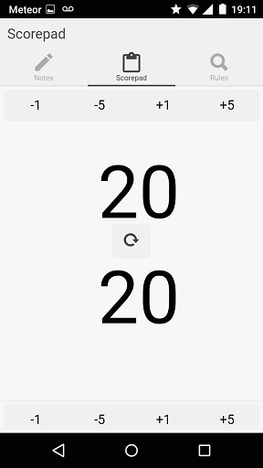

This is the main page that will be used by players. It is the page users will be directed to when opening the app. It shows values for both player’s scores. These are set to twenty, as that is their starting value within the game.

There are sets of buttons on opposite sides of the screen for altering scores, by their stated value. There is also a ‘refresh’ button in the middle of the page, for resetting both scores to their starting value, for beginning a new game.

Notes

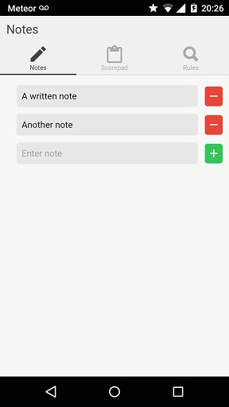

This page is to allow players to take notes of any important information they may want to keep track of during a game. It allows them to add and delete multiple notes during a game.

Rules

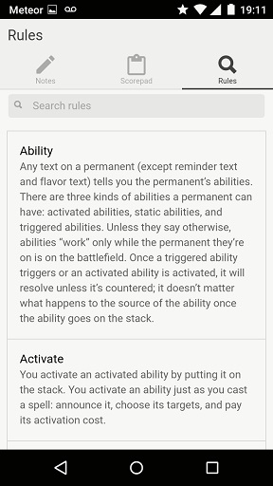

This page allows players to look up any information they may need during a game.

The information is read from a json file. It is tied to the input field of the search bar, using two way data binding. It is in the following format:

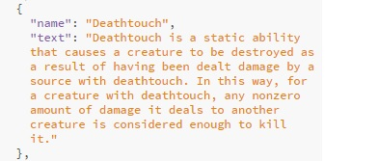

Push notifications

# Screenshot_2016-04-26-19-11-58.jpg

This is an example of a notification, having been sent to the app.

It uses the following data model:   
  
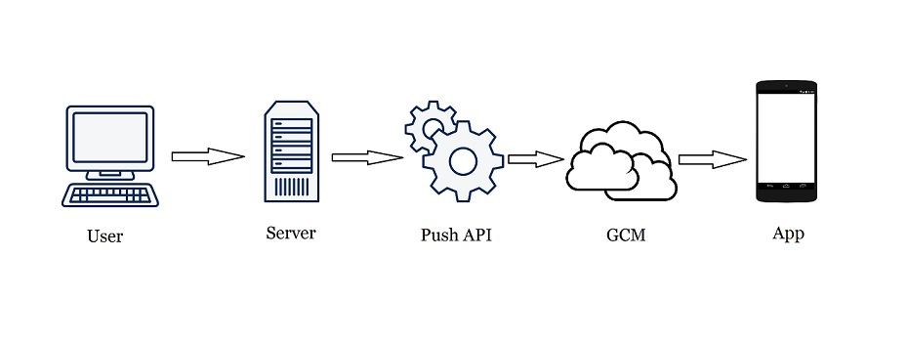

Made from free for use pictures, taken from pixabay.co

* User enters message into their browser
* Server sends message in post to Ionic push API
* Sent to Google Cloud Messaging for android
* Sent to device as notification

Picture of webpage for sending notification:   
  
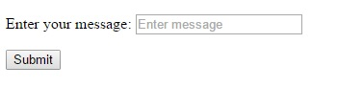

# Technologies used

I used a number of different types of technologies to create this project:

* I used ionic creator to build with the initial frame of the project.
* Code was written using Brackets text editor
* Microsoft azure to host my webpage
* Xampp was used as a local server for testing
* Git bash for ionic installations and serves
* Github to store a repository of my project
* Android studio was used to view the console of my app as it ran in a device

# Problems Encountered/Solved

The main problem I encountered was the app not giving me a device token as I attempted to test full pushes using Google Cloud Management. After a lot of trouble shooting, the solution was the use of a [cordova white list plug-in](https://github.com/apache/cordova-plugin-whitelist) to change the security settings of my app. There were of course, many other smaller problems, but they were all fixed a lot quicker than this one.

The biggest change I made to the app was that of the information provided in the rules section. Originally, I had planned to have the page display card images to provide information. I realised that wouldn’t be enough however, as many of the rules on cards are merely named, with no explanation given.

# Conclusions

I learnt a lot from doing this project in regard to Ionic, and angular in general. I found it very confusing to get to grips with the various layers upon which the software is build however. For example, figuring out which specific plug-ins may be needed for certain things. I found it hard to problem solves issues I had with full push notifications as well. This was mainly due to Ionic having changed the way they do this recently, so a lot of information people have put online in regard to this is outdated. I think this may be one of the main issues in regard to using newer technologies such as this. There’s simply a lot more information online in regard to issues with older software, due to more people having had any issue you may encounter.

# Recommendations

There are many ways in which I will develop this project further. The first is to set up a database to store created device tokens. This will store the token as it’s generated, and can then be pulled from in order to send push notifications to multiple devices.

The next thing I will do is work on the design of the app itself in relation to that of the image of the shop. Incorporating things such as the shop logo, and using colours and fonts tied to the design of the business.

I will work on the edits necessary to compile an ios version of this app, such as differing css. I will then publish versions of both ios and android on the marketplace.   
  
Finally, I will then look at adding support for additional games that are played in the shop by other communities. An extra benefit of supporting multiple games is that player’s who may want to start playing/try out a different game, already then have the resources needed to do so.

I could also set up the database to allow the shop to send notifications targeted towards specific games. This could be done by giving the user the option to select which games they would like to receive information on. These values could be associated with the user’s device token in the database. This way only the tokens associated with specified games could be pulled from the database for use with selected pushes.