First install xampp, which can be found at this address

<https://www.apachefriends.org/download.html>

next download MySQL Workbench

<https://www.mysql.com/products/workbench/>

now open up xampp and you will see a screen like this

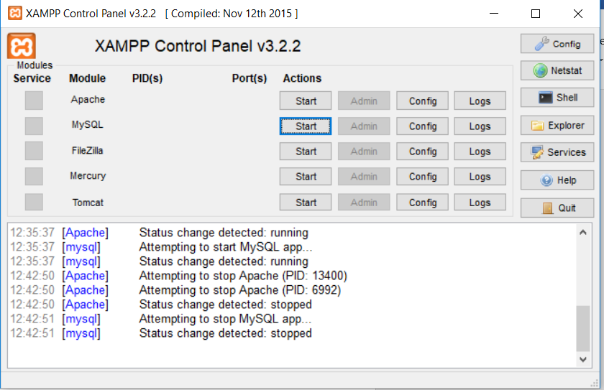

Click on the start button for MySQL, and should get something like this

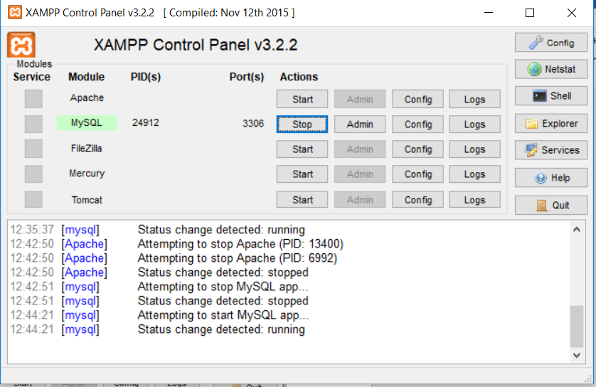

You now have SQL up and running and can now create databases that we can connect to using Java.

Next we have to run the MySQL scripts that you can find in the folder called MySQLScripts.

Open up MySQL workbench

When you open up MySQL workbench, go to the “plus” + button beside MySQL connections and popup appears and fill in the form with the exact same values as seen on next page

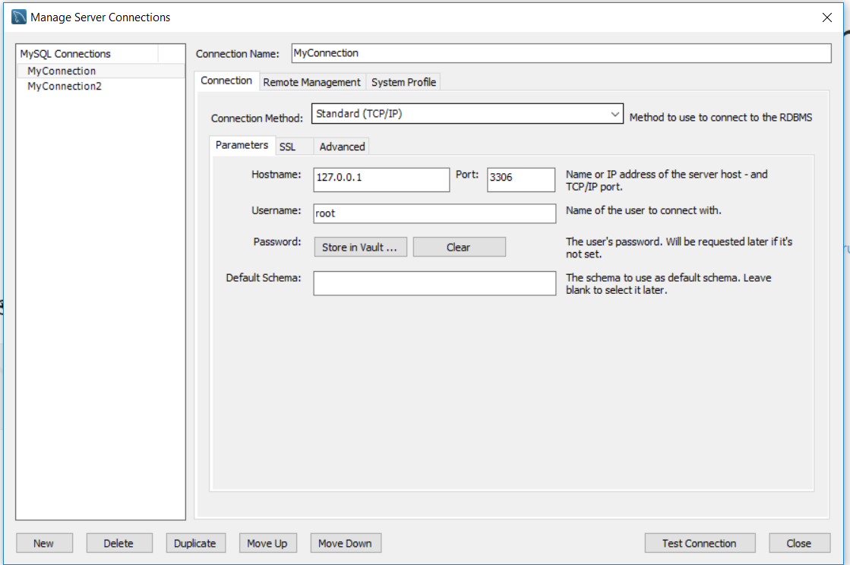

Click on “Test Connection” to make sure connection is working.

Click on close

Now click on your connection, in my case the connection on my machine is called MyConnection

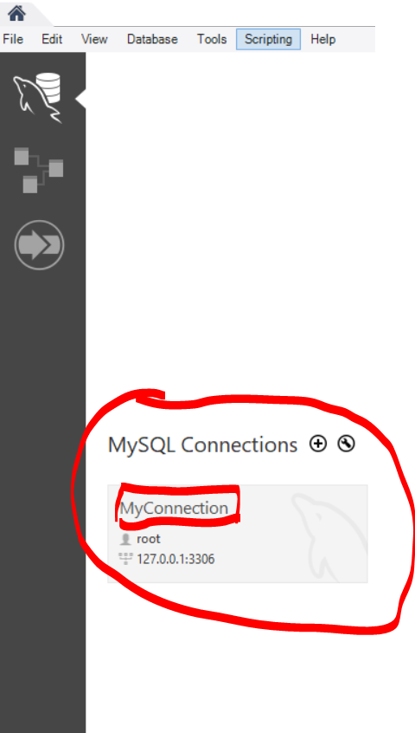

Now go to File – Open SQL Script – and navigate to the MySQLScripts folder and open CreateWorld, CreateMyDatabase and any other scripts in this folder.

Each script opens in you editor. For each script, go to File – Run SQL Script. On the left hand side of your screen under “Schema” , click on the refresh button as highlighted in the below graphic

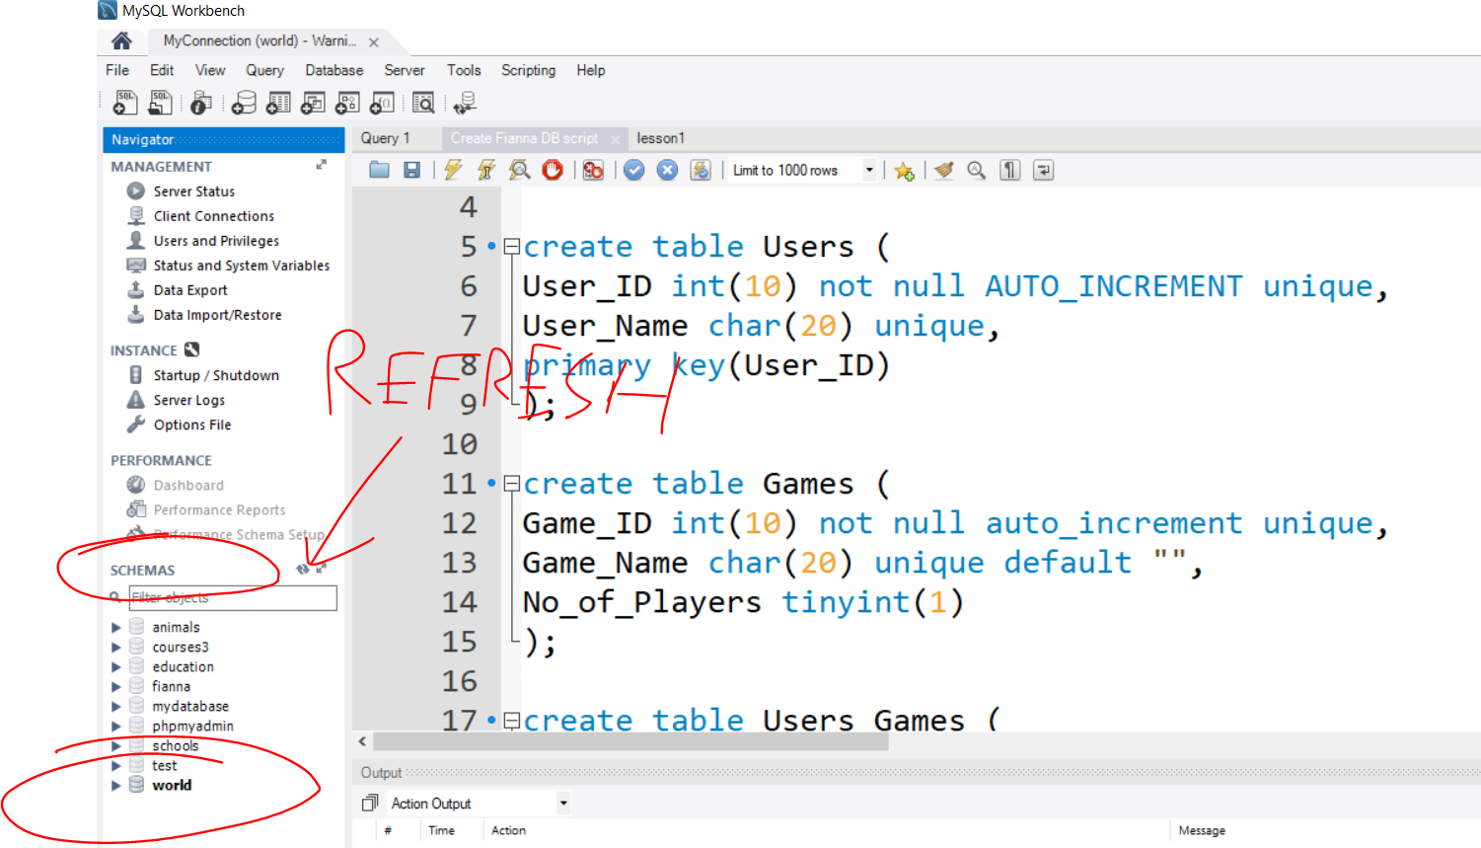

After pressing refresh your databases should appear. Now close down MySQL workbench, but make sure xampp and MySQL is running any time you want to run a java program that connects to our database. If you do not have xampp running then your databases can’t be connected too.