CPE301 – SPRING 2019

Design Assignment 1B

Student Name: Jason Villanueva

Student #: 2001255420

Student Email: villaj21@unlv.nevada.edu

Primary Github address: github.com/jasonvillanuevagit

Directory: <https://github.com/jasonvillanuevagit/submission_designAssignments-/tree/master/DesignAssignment1B>

Submit the following for all Labs:

1. In the document, for each task submit the modified or included code (only) with highlights and justifications of the modifications. Also, include the comments.
2. Use the previously create a Github repository with a random name (no CPE/301, Lastname, Firstname). Place all labs under the root folder ESD301/DA, sub-folder named LABXX, with one document and one video link file for each lab, place modified asm/c files named as LabXX-TYY.asm/c.
3. If multiple asm/c files or other libraries are used, create a folder LabXX-TYY and place these files inside the folder.
4. The folder should have a) Word document (see template), b) source code file(s) and other include files, c) text file with youtube video links (see template).

1. **COMPONENTS LIST AND CONNECTION BLOCK DIAGRAM w/ PINS**

Atmel Studio 7

1. **INITIAL/MODIFIED/DEVELOPED CODE OF TASK 1/B**

.ORG 0X0000

.EQU STARTADDS = 0X0300;memory location for the 200 numbers

LDI XL,LOW(STARTADDS);pointer to initial set of numbers

LDI XH,HIGH(STARTADDS)

LDI YL,LOW(0X0700); ;pointer to numbers from initial set that are divisible by 7 and 3

LDI YH,HIGH(0X0700)

LDI ZL,LOW(0X0800);pointer to numbers not divisible by 7 and 3

LDI ZH,HIGH(0X0800)

LDI R22, 0;initialize r22 for holding current number being tested

LDI R21, 200;store iteration count

LDI R20, 25 ;where to start the loop

CLR r26 ;r26 for carry

CLR r25 ;registers to store numbers after tested conditions

CLR r24

CLR r23

CLR r22

STORE:

INC R20

ST X+, R20;storing intial numbers to memory

MOV R22, R20

MOV R19, R20

JMP check_div7

LOOP_COUNTER:;loop to parse through each number in initial set

DEC R21

BRNE STORE

JMP DONE

check_div7:;loop to check if number is divisible by 7

CPI R22, 7

BRLO Ndiv_7

SUBI R22, 7

CPI R22, 0

BREQ div_7

JMP check_div7

check_div3: ; check if number is divisible by 3 (if not divisible by 7)

CPI r19, 3

BRLO Ndiv_3

SUBI r19, 3

CPI r19, 0

BREQ div_3

JMP check_div3

div_7:;if divisible by 7 store to memory

ST Y+, R20

ADD r22, R20

ADC r23, r26

JMP LOOP_COUNTER

div_3:;store in memory if divisible by 3

ST Y+, R20

ADD r19, R20

ADC r23, r26

JMP LOOP_COUNTER

Ndiv_7:;if not divisible by 7 store to memory

ST Z+, R20

ADD r24, R20

ADC r25, r26

JMP check_div3

Ndiv_3: ;if not divisible by 3 store to memory

;ST Z+, R20

ADD r24, R20

ADC r25, r26

JMP LOOP_COUNTER

DONE: JMP DONE;end of program

1. **DEVELOPED MODIFIED CODE OF TASK 2/A from TASK 1/B**
2. #include <iostream>
3. #include <vector>
4. #include <numeric>
5. using namespace std;
6. void print(vector <int> const &a) {
7. for(int i=0; i < a.size(); i++)
8. cout << a.at(i) << ' ';
9. }
10. int main()
11. {
12. int array[200];
13. for(int i=0; i<200;i++){
14. array[i] = i+26;
15. }
17. vector<int> divboth;
18. vector<int> div7;
19. vector<int> div3;
20. vector<int> divnone;
22. for(int i=0; i<200; i++){
23. if(array[i]%7==0 && array[i]%3){
24. //cout<<"both"<<endl;
25. divboth.push_back(array[i]);
26. }
27. else if(array[i]%7==0){
28. //cout<<"seven"<<endl;
29. div7.push_back(array[i]);
30. }
31. else if(array[i]%3==0){
32. //cout<<"three"<<endl;
33. div3.push_back(array[i]);
34. }
35. else{divnone.push_back(array[i]);}
36. //cout<<array[i]<<endl;}
38. }
40. int bothsum = accumulate(divboth.begin(), divboth.end(), 0);
41. int sevsum = accumulate(div7.begin(), div7.end(), 0);
42. int threesum = accumulate(div3.begin(), div3.end(), 0);
43. int nonesome = accumulate(divnone.begin(), divnone.end(), 0);
45. cout<<"Div by 7\n ";
46. print(div7);
47. cout<<endl;
48. cout<<"sum div by 7 = "<<sevsum<<endl;
49. cout<<"Div by 3\n ";
50. print(div3);
51. cout<<endl;
52. cout<<"sum div by 3 = "<<threesum<<endl;
53. cout<<"Div by both\n ";
54. print(divboth);
55. cout<<endl;
56. cout<<"sum div by both = "<<bothsum<<endl;
57. cout<<"Div by none\n ";
58. print(divnone);
59. cout<<endl;
60. cout<<"sum div by non = "<<nonesome<<endl;
61. return 0;

}

1. **SCHEMATICS**

n/a

1. **SCREENSHOTS OF EACH TASK OUTPUT (ATMEL STUDIO OUTPUT)**

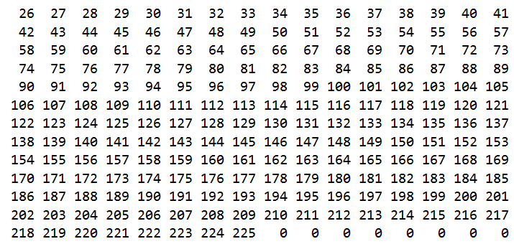

0x300

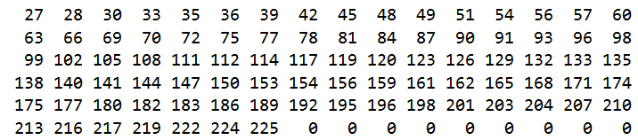

0x700

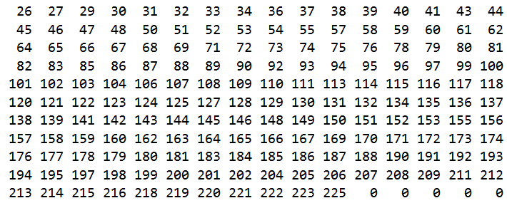

0x800

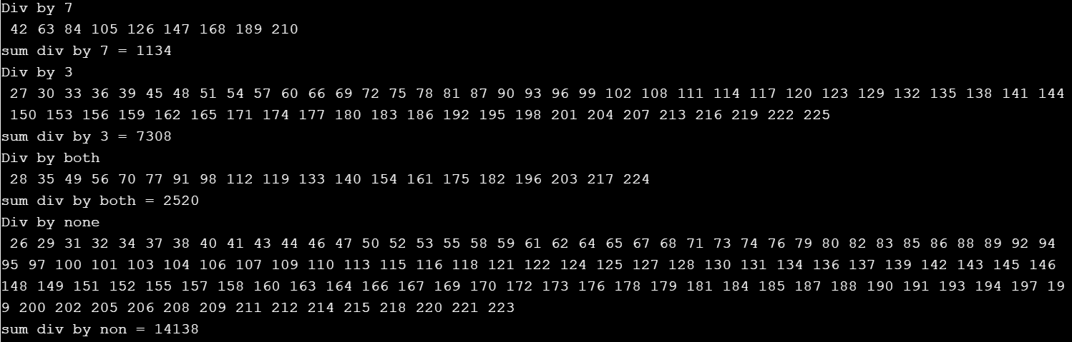

C++ output

1. **SCREENSHOT OF EACH DEMO (BOARD SETUP)**

n/a

1. **VIDEO LINKS OF EACH DEMO**

n/a

1. **GITHUB LINK OF THIS DA**

<https://github.com/jasonvillanuevagit/submission_designAssignments-/tree/master/DesignAssignment1B>

**Student Academic Misconduct Policy**

<http://studentconduct.unlv.edu/misconduct/policy.html>

“This assignment submission is my own, original work”.

Jason Villanueva