CPE301 – SPRING 2020

MIDTERM 2

Student Name: Jason Villanueva

Student #: 2001255420

Student Email: villaj21@unlv.nevada.edu

Primary Github address: <https://github.com/jasonvillanuevagit/submission_designAssignments->

Directory: <https://github.com/jasonvillanuevagit/submission_designAssignments-/tree/master/Midterm2>

1. **COMPONENTS LIST AND CONNECTION BLOCK DIAGRAM w/ PINS**

Atmega328PB FIT0450 Micro DC Motor with Encoder-SJ01 Potentiometer

Wires Breadboard TB6612FNG

1. **INITIAL/MODIFIED/DEVELOPED CODE OF TASK 1/A**

if (Flag == 1)

{

PORTD |= (1<<DDD5);

PORTD &= ~(1<<DDD4);

_delay_ms(5000);

Flag = 1;

}

else

{

PORTD &= ~(1<<DDD5);

PORTD |= (1<<DDD4);

_delay_ms(5000);

Flag = 1;

}

CW and CCW code

ISR(TIMER1_CAPT_vect)

{

revTick = ICR1;

TCNT1 = 0;

revCtr++;

T10vs2 = 0;

}

ISR(TIMER1_OVF_vect)

{

t10vs2++;

}

int main()

{

while (1)

{

update_ADC();

scale_set_speed();

Period = (uint32_t)(revTick) + ((uint32_t)T10vs2 * 0x10000L);

calculate_speed_rpm();

USART_SendString("RPM ");

snprintf(outs, sizeof(outs), "%f rpm ", (float)RPM);

USART_SendString(outs);

USART_SendString(" \r\n");

}

}

1. **DEVELOPED MODIFIED CODE OF TASK 2/A from TASK 1/A**

#define F_CPU 16000000UL

#define BAUD 9600

#include <avr/io.h>

#include <avr/interrupt.h>

#include <util/delay.h>

#include <util/setbaud.h>

#include <stdio.h>

//adc functions

void adc_init();

void update_ADC();

volatile float pot;

//USART functions

void USART_init();

void USART_SendString(volatile char *data);

//timer functions

void Timer0_init();

void Timer3_init();

//RPM float functions

float RPM_1x();

float RPM_2x();

float RPM_4x();

volatile float r1;

volatile float r4;

static char data[10];

int main(void){

DDRD |= (1<<6); //speed control

DDRD &= ~(1<<4);//direction control

DDRD &= ~(1<<5);

PORTD &= ~(1<<4);

PORTD &= ~(1<<5);

DDRB |= (1<<0); //encoder speed capt for 1x and 2x

PORTB &= ~(1<<0);

DDRE |= (1<<2); //encoder speed cap for 4x

PORTE &= ~(1<<2);

DDRC |= (1<<0); //potentiometer

PORTC &= ~(1<<0);

//initialize

adc_init();

USART_init();

Timer0_init();

Timer3_init();

sei();

while (1){

if (pot < 5){

USART_SendString("1x encoding RPM: 0 \n");

}

else{

USART_SendString("1x encoding RPM: ");

snprintf(data, sizeof(data), "%f\n\r", RPM_1x());

USART_SendString(data);

USART_SendString(" \n");

}

_delay_ms(1000);

}

}

void adc_init(void){

ADMUX = (0<<REFS1) | (1<<REFS0) | (1<<ADLAR) | (0<<MUX2) | (0<<MUX1) | (0<<MUX0);

ADCSRA = (1<<ADEN) | (0<<ADSC) | (0<<ADATE) | (0<<ADIF) | (0<<ADIE) | (1<<ADPS2) | (0<<ADPS1) | (1<<ADPS0);

}

void update_ADC(void){

unsigned char i = 5;

pot = 0;

while(i--){

ADCSRA |= (1<<ADSC);

while(ADCSRA & (1<<ADSC));

pot += ADC;

}

pot = pot/5;

}

void USART_init(void){

UBRR0H = UBRRH_VALUE;

UBRR0L = UBRRL_VALUE;

UCSR0C = _BV(UCSZ01)|_BV(UCSZ00);

UCSR0B = _BV(RXEN0)|_BV(TXEN0);

}

void USART_SendString(volatile char *data){

while((*data != '\0')){

while(!(UCSR0A & (1<<UDRE0)));

UDR0 = *data;

data++;

}

}

void Timer0_init(void){

TCCR0A |= (2 << COM1A0);

TCCR0A |= (0 << WGM10);

TCCR0B |= (0 << WGM12);

TIMSK0 |= (0x01);

TCNT0 = 0x00;

OCR0A = 0x00;

TCCR0B |= (0x02 << CS10);

}

void Timer3_init(void){

TCCR3A = (0);

TCCR3B = (1 << WGM32);

OCR3A = (623);

}

float RPM_1x(){

float tempRPM1 = 0.0;

for (int i = 0; i < 20; i++){

TCNT3 = 0x00; //see the note for RPM4x for more info

TCNT4 = 0x00;

TIMSK4 |= (1 << 5);

TIMSK3 |= (1 << 1);

TCCR4B |= (0x07) | (1 << 6);

TCCR3B |= (0x04 << 0);

TCCR3B &= ~(0x07);

TCCR4B &= ~(0x07);

tempRPM1 = tempRPM1 + r4 * 60 / 96;

}

return tempRPM1 / 20;

}

float RPM_2x(){

float tempRPM2 = 0.0;

for (int i = 0; i < 20; i++){

EICRA = 0x01; //see the note for RPM4x for more info

EIMSK = 0x01;

TIMSK4 = (1 << 5);

TIMSK3 = (1 << 1);

TCNT3 = 0x00;

TCNT4 = 0x00;

TCCR4B = (0x07) | (1 << 6);

TCCR3B = (0x04 << 0);

EIMSK = 0x00;

EICRA = 0x00;

TCCR3B &= ~(0x07);

TCCR4B &= ~(0x07 | (1 << 6));

tempRPM2 = tempRPM2 + r4 * 60 / 192;

}

return tempRPM2 / 20;

}

float RPM_4x(){

float tempRPM4 = 0.0;

for (int i = 0; i <20; i++){

EICRA = 0x05;

EIMSK = 0x03; //Int1 is enabled

TIMSK1 = (1 << 5); //The input capture interrupts are enabled

TIMSK4 = (1 << 5);

TIMSK3 = (1 << 1); //The output capture interrupt is enabled

TCNT3 = 0x00; //Timer3 is reset

TCNT1 = 0x00; //Counter1 & 4 are reset

TCNT4 = 0x00;

TCCR1B = (0x07) | (1 << 6); //The counter1 & 4 are set as rising edges

TCCR4B = (0x07) | (1 << 6);

TCCR3B = (0x04); //The timer3 scaler is set

EIMSK = 0x00; //interrupts are reset

EICRA = 0x00;

TCCR3B &= ~(0x07); //clocks are cleared

TCCR1B &= ~(0x07 | (1 << 6));

TCCR4B &= ~(0x07 | (1 << 6));

tempRPM4 = tempRPM4 + (r1 + r4) * 60 / 384;

}

return tempRPM4 / 20;

}

ISR(USART0_TX_vect){

//from the previous assignments

UCSR0B &= ~((1 << TXCIE0) | (1 << TXEN0));

}

ISR(ADC_vect){

ADCSRA &= ~(1 << ADIE); //ADC interrupt is disabled

OCR0A = pot;

}

ISR(TIMER0_OVF_vect){

ADCSRA |= (1 << ADIE); //ADC interrupt is enabled

}

//detects the input b

ISR(TIMER1_CAPT_vect){

TIMSK1 &= ~(1<<5);

r1 = (ICR1);

}

//detects the input a

ISR(TIMER4_CAPT_vect){

TIMSK4 &= ~(1<<5);

r4 = (ICR4);

}

//Timer1 & 4 capture interrupt

ISR(TIMER3_COMPA_vect){

PORTE |= (1 << 0);

PORTB |= (1 << 0);

TIMSK3 &= ~(1 << 1);

}

1. **SCHEMATICS**

Timer0 PWM for controlling the speed of the motor to PD6, PD5 and PD4 for direction control, Timer1 ICP PB0 pin for encoder speed capture for 1x and 2x speed, Timer3 ICP PE2 pin for encoder speed capture for 4x speed, PC0 for the potentiometer

1. **SCREENSHOTS OF EACH TASK OUTPUT (ATMEL STUDIO OUTPUT)**

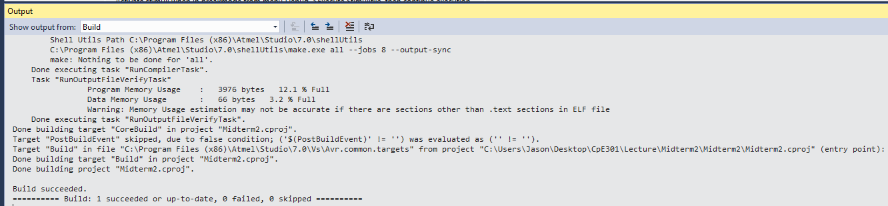

1. **SCREENSHOT OF EACH DEMO (BOARD SETUP)**

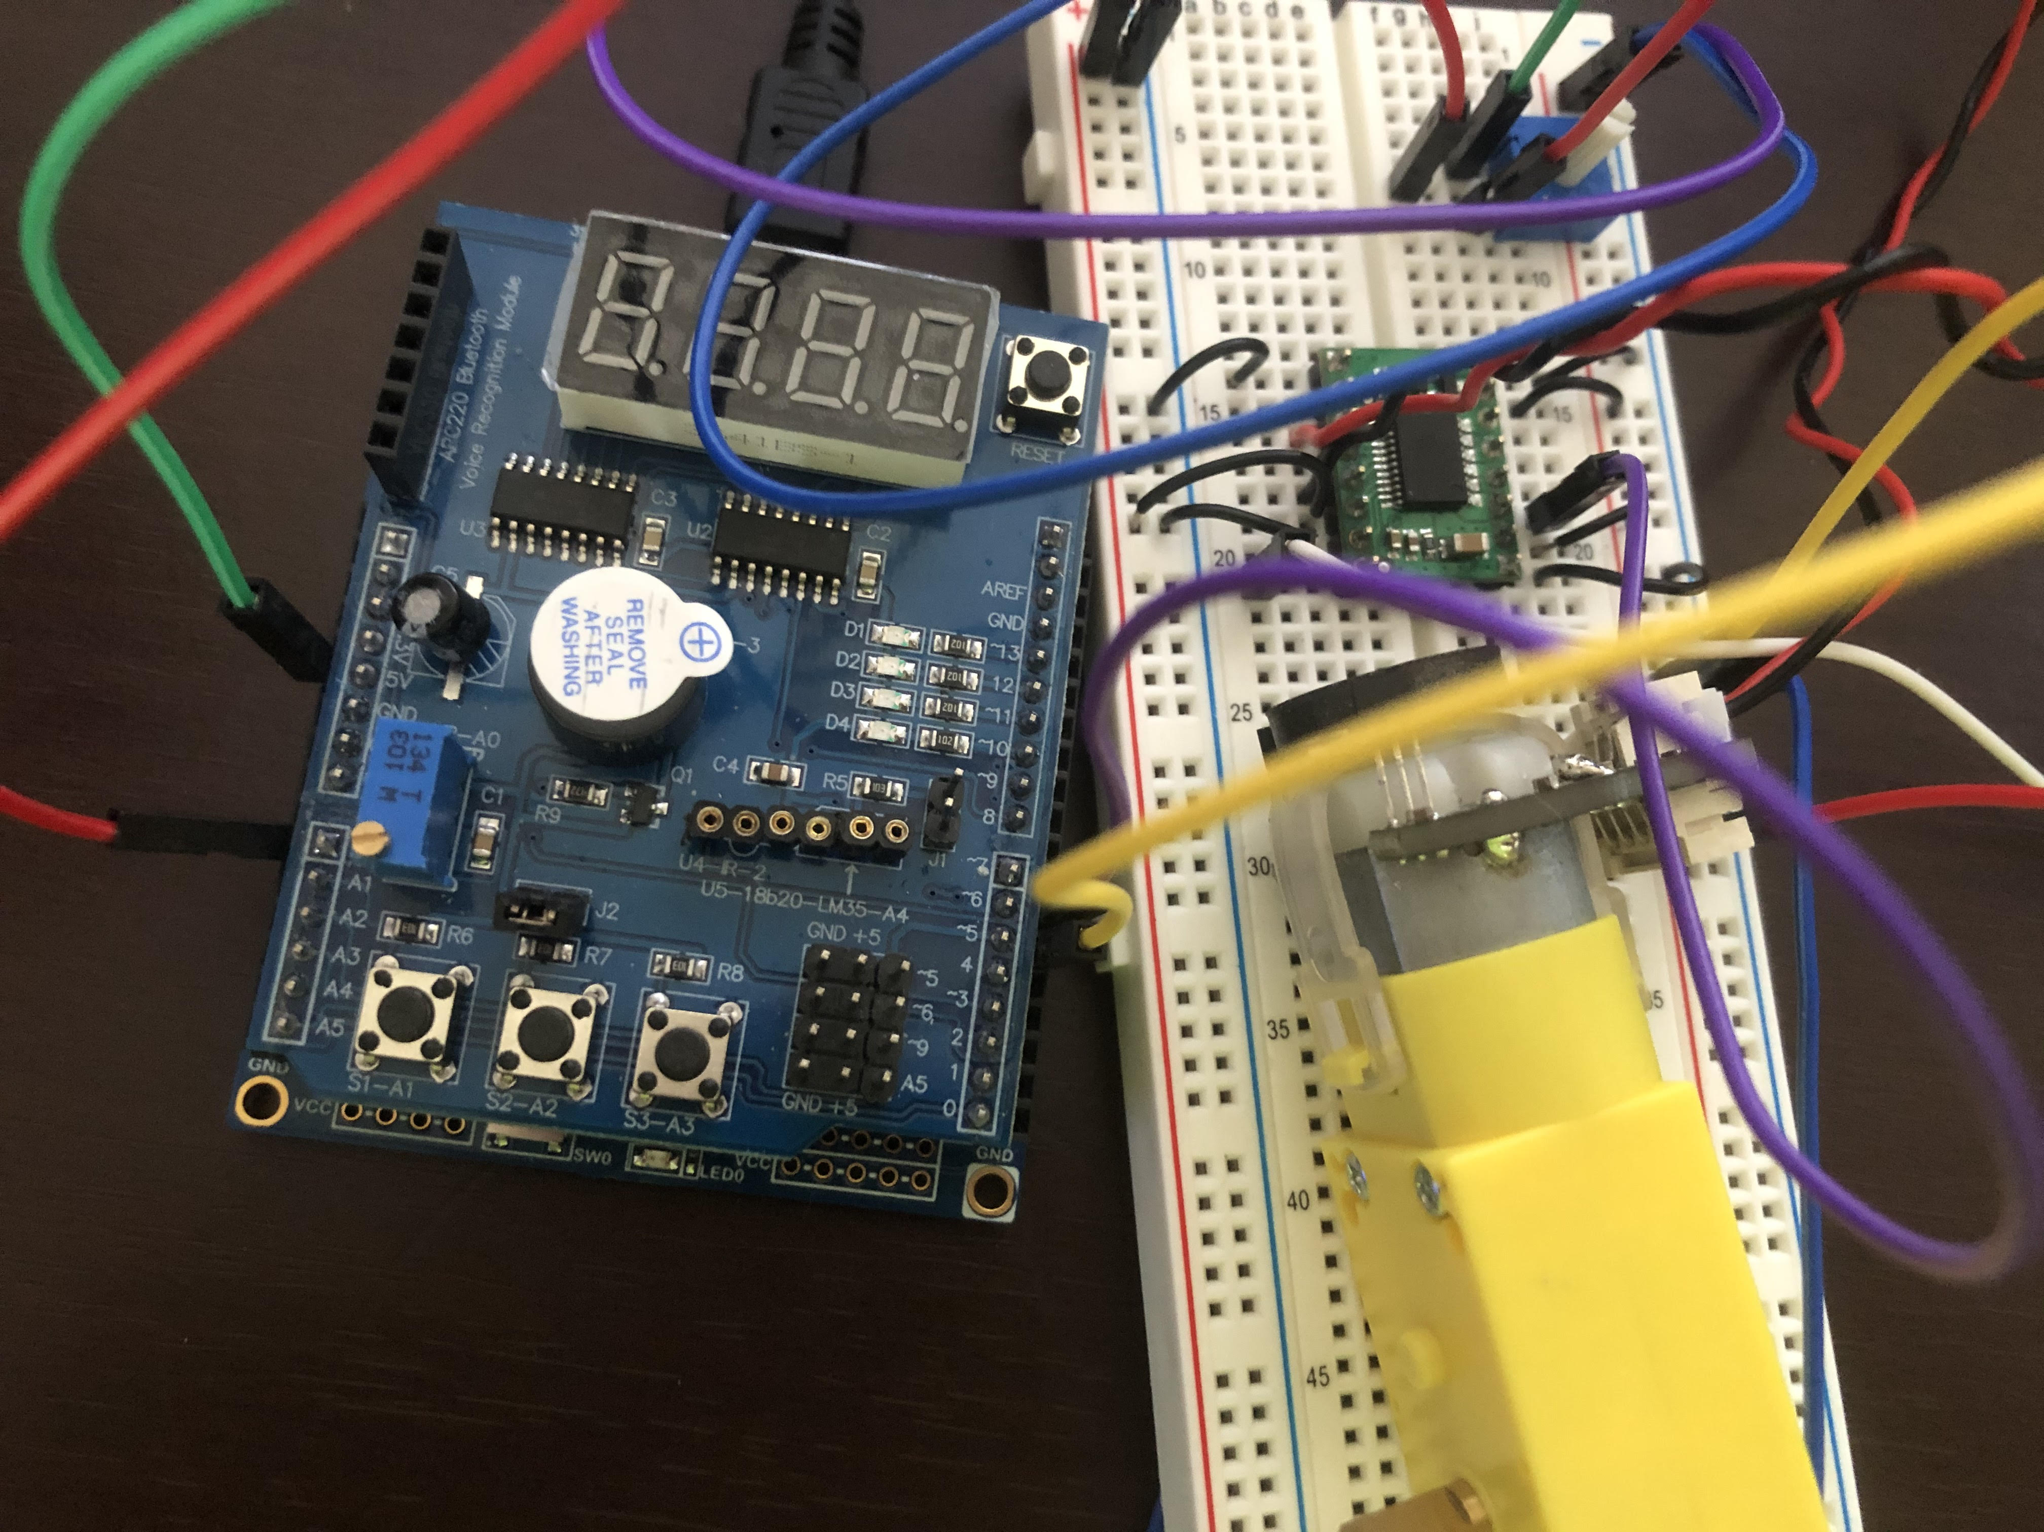

1. **VIDEO LINKS OF EACH DEMO**

<https://www.youtube.com/watch?v=a2p4B27e8fF>

1. **GITHUB LINK OF THIS DA**

<https://github.com/jasonvillanuevagit/submission_designAssignments-/tree/master/Midterm2>

**Student Academic Misconduct Policy**

<http://studentconduct.unlv.edu/misconduct/policy.html>

“This assignment submission is my own, original work”.

Jason Villanueva