ESM 206 Assignment 4 Problem 2

Robert Heim

11/14/2018

# Problem 2: Compare Mean Lobster Size By Site in 2017

# Get data into case and tidy format  
  
count <- as.data.frame(lobster_size) #Coerce to data.frame   
  
lobster_size_tidy <- expand.dft(count, freq = "COUNT") #Expand data to tidy format  
  
lobster_size_tidy_2017 <- lobster_size_tidy %>%   
 filter(YEAR == 2017) #Use only observations only from 2017

# Create a summary table for mean lobster carapace length in 2017 at each site  
  
size_mean_2017 <- lobster_size_tidy_2017 %>%  
 group_by(SITE) %>%  
 summarize(Mean_size= mean(SIZE),Standard_deviation= sd(SIZE), Sample_size= length(SITE), Standard_error= Standard_deviation/sqrt(Sample_size))

# Single factor: Site   
# Number of levels in the factor: 5 (AQUE, CARP, IVEE, MOHK, and NAPL)  
# Random variable: carapace length (mm)  
  
#Question: Is there a significant difference in carapace length (mm) for AQUE, CARP, IVEE, MOHK, and NAPL locations in 2017?  
  
# H0: Mean lobster carapace length across all sites are equal.   
# HA: At least two mean lobster caparace lengths differ significantly between sites.   
  
# Do some data exploring to find whether the assumption of normality is met for the carapace length data. Create a histogram and qq-plot.  
  
lobster_2017_hist <- lobster_size_tidy_2017 %>%  
 ggplot(aes(x= SIZE)) +  
 geom_histogram(binwidth = 1, aes(fill= SITE))+  
 facet_wrap((~SITE)) +  
 scale_y_continuous(expand = c(0,0), limits = c(0,9))+   
 scale_x_continuous(expand = c(0,0))  
  
lobster_2017_hist

## Warning: Removed 49 rows containing missing values (geom_bar).

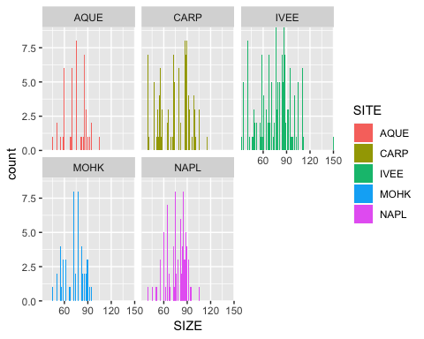

lobster_2017_qq <- lobster_size_tidy_2017 %>%  
 ggplot(aes(sample= SIZE)) +  
 geom_qq() +  
 facet_wrap(~ SITE)  
  
lobster_2017_qq

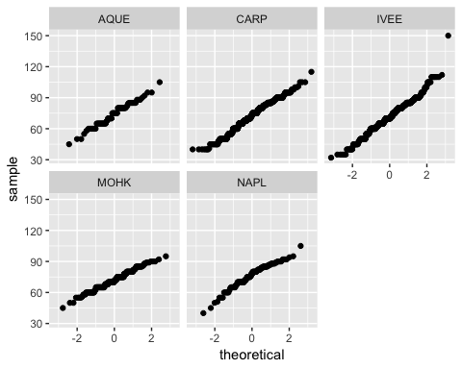

# Lobster size data for 2017 appear normally distributed at each site  
  
# Use a one-way ANOVA to test for a difference between any two of the sites  
  
lobster_aov <- aov(SIZE ~ SITE, data = lobster_size_tidy_2017)  
  
summary(lobster_aov)

## Df Sum Sq Mean Sq F value Pr(>F)   
## SITE 4 2355 588.6 3.424 0.0085 **  
## Residuals 1663 285871 171.9   
## ---  
## Signif. codes: 0 '***' 0.001 '**' 0.01 '*' 0.05 '.' 0.1 ' ' 1

# P-value= 0.009, meaning at least two samples of lobster carapance length were taken from sites with different means. Which ones are different? Are all five different from each other? Or something else?   
  
# Need to run a Post-hoc Tukey's test to find where the differences are.   
  
lobster_ph <- TukeyHSD(lobster_aov)   
  
lobster_ph

## Tukey multiple comparisons of means  
## 95% family-wise confidence level  
##   
## Fit: aov(formula = SIZE ~ SITE, data = lobster_size_tidy_2017)  
##   
## $SITE  
## diff lwr upr p adj  
## CARP-AQUE -1.6657352 -6.24294710 2.911477 0.8582355  
## IVEE-AQUE -2.4433772 -7.05292315 2.166169 0.5968998  
## MOHK-AQUE -1.8955224 -7.02720717 3.236162 0.8514711  
## NAPL-AQUE 2.3366205 -3.19311600 7.866357 0.7775633  
## IVEE-CARP -0.7776420 -2.76097123 1.205687 0.8216104  
## MOHK-CARP -0.2297872 -3.23309697 2.773523 0.9995765  
## NAPL-CARP 4.0023556 0.36042398 7.644287 0.0228728  
## MOHK-IVEE 0.5478548 -2.50450730 3.600217 0.9882889  
## NAPL-IVEE 4.7799976 1.09751057 8.462485 0.0037001  
## NAPL-MOHK 4.2321429 -0.08607271 8.550358 0.0579286

Mean lobster carapace length in 2017 differed significantly between Naples Reef and Carpinteria and between Naples Reef and Isla Vista (F(df) = statistic, P = 0.02 & 0.004 respectively, = 0.05 with post-hoc Tukey’s HSD, = 0.05.)

# Use a bar graph to show mean lobster carapace length at each site. Include error bars and letters.   
  
   
lobster_size_col <-ggplot(size_mean_2017, aes(x = SITE, y = Mean_size)) +  
 geom_col(aes(fill = SITE), position = "dodge") +  
 geom_errorbar(aes(ymin= Mean_size-Standard_error, ymax= Mean_size+Standard_error), width=.2) +   
 theme_classic() +  
 theme(legend.position= "none") +  
 labs(x= "Location", y= expression(Mean~Carapace~Length~(mm))) +  
 scale_y_continuous(limit= c(0,100), expand=c(0,0)) +  
 scale_x_discrete(labels=c("AQUE" = "Arroyo Quemado\nn=67",   
 "NAPL" = "Naples Reef\nn=705",  
 "MOHK" = "Mohawk Reef\nn=606",  
 "IVEE" = "Isla Vista\nn=178",  
 "CARP" = "Carpinteria\nn=112")) +  
 annotate("text", x = 1, y = 87, label = "A, B", family = "Times New Roman") +  
 annotate("text", x = 2, y = 87, label = "A", family = "Times New Roman") +  
 annotate("text", x = 3, y = 87, label = "A", family = "Times New Roman") +  
 annotate("text", x = 4, y = 87, label = "A, B", family = "Times New Roman") +  
 annotate("text", x = 5, y = 87, label = "B", family = "Times New Roman")  
  
lobster_size_col

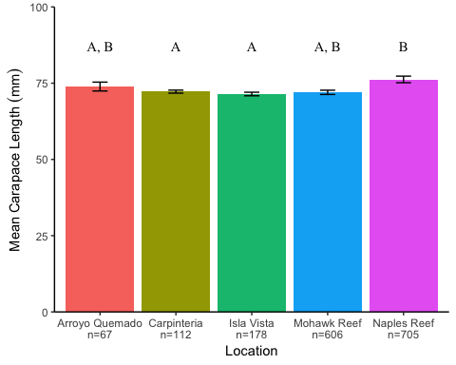

**Figure 1. Mean Lobster Carapace Length at five sites in the Santa Barbara Channel in 2017.** Error bars represent ± 1 standard error. Letters indicate significant difference. Data retreived from Santa Barbara Coastal Long-Term Ecological Research [1].

# 3 Changes in lobster size at each MPA and non-MPA site (comparing only 2012 and 2017 sizes).

# Use a one-sided, two-sample t-test to compare lobster size between 2012-2017 at each MPA site  
  
#HO: Lobsters at IVEE are not significantly larger in 2017 than in 2012  
#HA: Lobsters at IVEE are significantly larger in 2017 than in 2012  
  
# Create a new df with lobster size for IVEE at 2012 and 2017   
  
lobster_size_IVEE_2012 <- lobster_size_tidy %>%   
 filter(SITE == "IVEE") %>%   
 filter(YEAR == "2012")   
   
lobster_size_IVEE_2017 <- lobster_size_tidy %>%   
 filter(SITE == "IVEE") %>%   
 filter(YEAR == "2017")   
  
# Find the mean and sd for IVEE for 2012 and 2017  
  
IVEE_2017_mean <- mean(lobster_size_IVEE_2017$SIZE)  
  
IVEE_2017_sd <-sd(lobster_size_IVEE_2017$SIZE)  
   
IVEE_2012_mean <- mean(lobster_size_IVEE_2012$SIZE)  
  
IVEE_2012_sd <-sd(lobster_size_IVEE_2012$SIZE)  
   
# Run a one-sided t-test for each MPA, comparing 2012 to 2017   
  
lobster_IVEE_ttest<- t.test(lobster_size_IVEE_2017$SIZE, lobster_size_IVEE_2012$SIZE, var.equal= TRUE, alternative= "greater")  
  
lobster_IVEE_ttest

##   
## Two Sample t-test  
##   
## data: lobster_size_IVEE_2017$SIZE and lobster_size_IVEE_2012$SIZE  
## t = 1.885, df = 630, p-value = 0.02995  
## alternative hypothesis: true difference in means is greater than 0  
## 95 percent confidence interval:  
## 0.6777847 Inf  
## sample estimates:  
## mean of x mean of y   
## 71.45215 66.07692

# Need to do an effect size test using Cohen's D

Mean lobsters carapace length (mm) in 2017 [71.45 ± 14.32 ( ± ), n=26] was not signficantly different than in 2012 [66.08 ± 12.09 ( ± ), n=606] at Isla Vista [t(630) = 1.88, p < 0.03, = 0.05].

-also mention effect size and absolute difference in mean

# Run a one-sided, two-sample t-test to see if size in 2017 is greater than in 2012  
  
lobster_size_NAPL_2012 <- lobster_size_tidy %>%   
 filter(SITE == "NAPL") %>%   
 filter(YEAR == "2012")   
   
lobster_size_NAPL_2017 <- lobster_size_tidy %>%   
 filter(SITE == "NAPL") %>%   
 filter(YEAR == "2017")   
  
# Find the mean and sd for NAPL for 2012 and 2017  
  
NAPL_2017_mean <- mean(lobster_size_NAPL_2017$SIZE)  
  
NAPL_2017_sd <-sd(lobster_size_NAPL_2017$SIZE)  
   
NAPL_2012_mean <- mean(lobster_size_NAPL_2012$SIZE)  
  
NAPL_2012_sd <-sd(lobster_size_NAPL_2012$SIZE)  
  
# Run a one-sided t-test for to see if size in 2017 is greater than in 2012  
  
lobster_NAPL_ttest<- t.test(lobster_size_NAPL_2017$SIZE, lobster_size_NAPL_2012$SIZE, var.equal= TRUE)  
  
lobster_NAPL_ttest

##   
## Two Sample t-test  
##   
## data: lobster_size_NAPL_2017$SIZE and lobster_size_NAPL_2012$SIZE  
## t = 0.67636, df = 116, p-value = 0.5002  
## alternative hypothesis: true difference in means is not equal to 0  
## 95 percent confidence interval:  
## -6.232765 12.697051  
## sample estimates:  
## mean of x mean of y   
## 76.23214 73.00000

# Lobster sizes at NAPL in 2017 are not significantly different than in 2012

-need to write significance statment

# One-sided t-test for AQUE nonMPA   
  
lobster_size_AQUE_2012 <- lobster_size_tidy %>%   
 filter(SITE == "AQUE") %>%   
 filter(YEAR == "2012")   
  
lobster_size_AQUE_2017 <- lobster_size_tidy %>%   
 filter(SITE == "AQUE") %>%   
 filter(YEAR == "2017")   
  
lobster_AQUE_ttest<- t.test(lobster_size_AQUE_2017$SIZE, lobster_size_AQUE_2012$SIZE, var.equal= TRUE)  
  
lobster_AQUE_ttest

##   
## Two Sample t-test  
##   
## data: lobster_size_AQUE_2017$SIZE and lobster_size_AQUE_2012$SIZE  
## t = 1.2622, df = 103, p-value = 0.2097  
## alternative hypothesis: true difference in means is not equal to 0  
## 95 percent confidence interval:  
## -1.654312 7.445357  
## sample estimates:  
## mean of x mean of y   
## 73.89552 71.00000

# Lobster sizes at NAPL in 2017 are not significantly different than in 2012

-need to write significance statment

# One-sided t-test for CARP nonMPA   
  
lobster_size_CARP_2012 <- lobster_size_tidy %>%   
 filter(SITE == "CARP") %>%   
 filter(YEAR == "2012")   
  
lobster_size_CARP_2017 <- lobster_size_tidy %>%   
 filter(SITE == "CARP") %>%   
 filter(YEAR == "2017")   
  
lobster_CARP_ttest<- t.test(lobster_size_CARP_2017$SIZE, lobster_size_CARP_2012$SIZE,var.equal= TRUE)  
  
lobster_CARP_ttest

##   
## Two Sample t-test  
##   
## data: lobster_size_CARP_2017$SIZE and lobster_size_CARP_2012$SIZE  
## t = -1.3361, df = 781, p-value = 0.1819  
## alternative hypothesis: true difference in means is not equal to 0  
## 95 percent confidence interval:  
## -5.257332 0.998958  
## sample estimates:  
## mean of x mean of y   
## 72.22979 74.35897

# Lobster sizes at CARP in 2017 are not significantly greater than in 2012

-need to write significance statment

# One-sided t-test for MOHK nonMPA   
  
lobster_size_MOHK_2012 <- lobster_size_tidy %>%   
 filter(SITE == "MOHK") %>%   
 filter(YEAR == "2012")   
  
lobster_size_MOHK_2017 <- lobster_size_tidy %>%   
 filter(SITE == "MOHK") %>%   
 filter(YEAR == "2017")   
  
lobster_MOHK_ttest<- t.test(lobster_size_MOHK_2017$SIZE, lobster_size_MOHK_2012$SIZE,var.equal= TRUE, alternative = "less")  
  
lobster_MOHK_ttest

##   
## Two Sample t-test  
##   
## data: lobster_size_MOHK_2017$SIZE and lobster_size_MOHK_2012$SIZE  
## t = -4.0689, df = 259, p-value = 3.138e-05  
## alternative hypothesis: true difference in means is less than 0  
## 95 percent confidence interval:  
## -Inf -3.121847  
## sample estimates:  
## mean of x mean of y   
## 72.00000 77.25301

# Lobster sizes are signficantly different at MOHK in 2012 and 2017

-need to write significance statment

# 4 Proportion of legal lobsters at the five sites

# Make a new data frame with numbers of lobster that are and are not above the legal minimum of 82.6 mm.   
  
legal_2017 <- lobster_size_tidy_2017 %>%  
 mutate(above_legal= case_when(SIZE < 82.6 ~ 'No', SIZE >= 82.6 ~ 'Yes')) %>%  
 count(SITE, above_legal) %>%  
 spread(above_legal, n) %>%  
 select(-SITE)  
  
legal_2017

## # A tibble: 5 x 2  
## No Yes  
## <int> <int>  
## 1 51 16  
## 2 526 179  
## 3 476 130  
## 4 154 24  
## 5 75 37

# Rename rows in legal_2017  
  
rownames(legal_2017) <- c("Arroyo Quemado", " Carpinteria", "Isla Vista", "Mohawk Reef", "Naples Reef")

## Warning: Setting row names on a tibble is deprecated.

# Question: Does the proportion of lobsters of legal size differ significantly across the five sites?  
  
# Run a chi-square test  
  
legal_2017_prop <- prop.table(as.matrix(legal_2017), 1)  
size_x2 <- chisq.test(legal_2017_prop)

## Warning in chisq.test(legal_2017_prop): Chi-squared approximation may be  
## incorrect

size_x2

##   
## Pearson's Chi-squared test  
##   
## data: legal_2017_prop  
## X-squared = 0.11095, df = 4, p-value = 0.9985

legal_2017_prop

## No Yes  
## Arroyo Quemado 0.7611940 0.2388060  
## Carpinteria 0.7460993 0.2539007  
## Isla Vista 0.7854785 0.2145215  
## Mohawk Reef 0.8651685 0.1348315  
## Naples Reef 0.6696429 0.3303571

# Find the proportion of lobsters at each site that are above the legal minimum of 82.6 mm.  
  
size_prop <- prop.table(as.matrix(legal_2017_prop), 1)  
size_prop

## No Yes  
## Arroyo Quemado 0.7611940 0.2388060  
## Carpinteria 0.7460993 0.2539007  
## Isla Vista 0.7854785 0.2145215  
## Mohawk Reef 0.8651685 0.1348315  
## Naples Reef 0.6696429 0.3303571

Based on the samples from each Long-Term Ecological Research Site in 2017: Arroyo Quemado (n=67), Carpinteria (n=705), Isla Vista (n=606), Mohawk Reef (n=178), and Naples Reef (n=112), the proportion of lobsters that are above the legal minimum carapace length of 82.6 mm does not differ significantly between sites (X-squared(4) = 0.11095, p= 0.9985).