Jason Wong 1090292616 15/11/2017

**%Note, if you would like to run the plots, please comment out the close(x) lines**

**%Exercise 2.1.1**

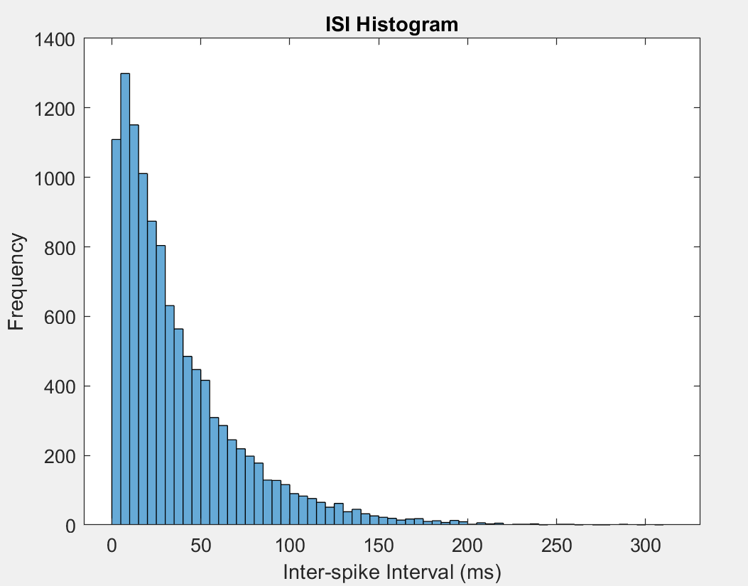

clear all

close all

load Spike_data_1.mat

spikeData1=d;

load Spike_data_2.mat

spikeData2=d;

load Spike_data_3.mat

spikeData3=d;

ISI = [];

n_trials = 1000;

T = 500;

for k=1:n_trials

spike_times = find(spikeData1(k,:) == 1);

isi0 = diff(spike_times);

ISI = [ISI,isi0];

end

figure(1)

histogram(ISI);

title('ISI Histogram')

ylabel('Frequency')

xlabel('Inter-spike Interval (ms)')

close(1)

**%Exercise 2.1.2**

%The neuron fires earlier rather than later.

%Because the curve fits inside a negative exponential curve, therefore the

%neuron is Poissonnian and follows Poisson distribution. This is because

%neurons fire randomly in a fixed average rate.

**%Exercise 2.1.3**

%meanTime=36.9525ms, that means it takes on average 36.9525 milliseconds for

%the neuron to fire again

meanTime = mean(ISI);

**%Exercise 2.1.4**

%modeTime=2ms, that means the most common time it took for the neuron to

%fire again was 2ms

modeTime = mode(ISI);

**%Exercise 2.1.5**

%meanTime(36.9525ms) is not equal to modeTime(2ms), because the average is

%not the same as the mode

**%Exercise 2.1.6**

%I binned each set of spikes into bins seperated by deltaT, and by changing

%deltaT from 2 to 20ms, I could remove noise until a clear spike train

%emerged.

**%Plotting deltaT from 2ms to 20ms**

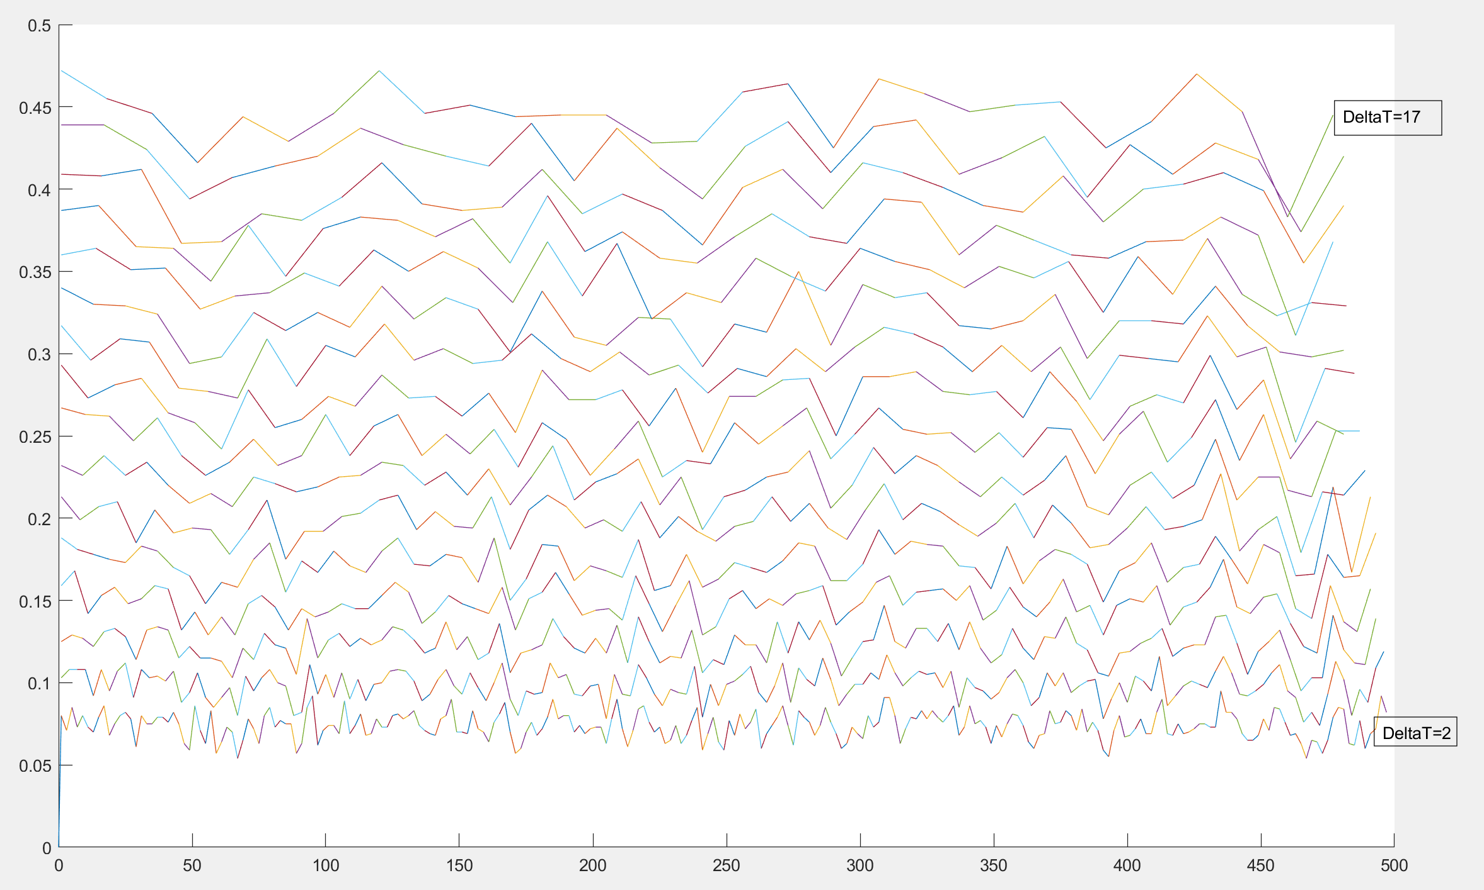

**%Plotting deltaT=14 as it’s the most clearest, note the ~12 spikes**

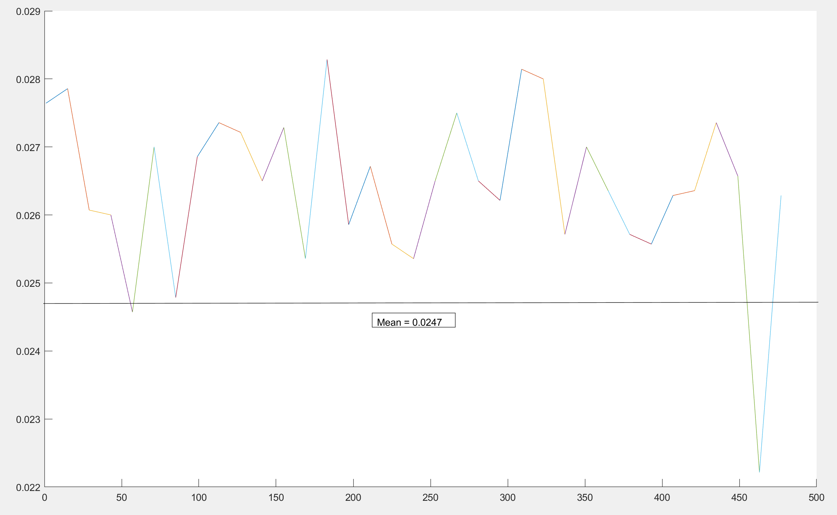

%Given the ISI histogram, I can guess the shape of the spike train, this is

%because I can guess the average ISI using the histogram and then I will

%know the average intervals between each spike in the spike train.

figure(2)

prob_spike = sum(spikeData1,1)/n_trials;

prevDot = 0;

prevT = 0;

hold on

for deltaT=2:1:17

for t=1:deltaT:500-deltaT

sumSpikes=0;

for i=t:1:t+deltaT

sumSpikes=sumSpikes+prob_spike(i);

end

if t>prevT

plot([prevT t], [prevDot sumSpikes]);

end

prevT = t;

prevDot = sumSpikes;

end

end

hold off

close(2);

figure(11)

prob_spike = sum(spikeData1,1)/n_trials;

hold on

for deltaT=14:1:14 %deltaT = 14 has the clearest spike train with n cloests to 12.344

for t=1:deltaT:500-deltaT

sumSpikes=0;

for i=t:1:t+deltaT

sumSpikes=sumSpikes+prob_spike(i);

end

sumSpikes=sumSpikes/deltaT

if t>prevT

plot([prevT t], [prevDot sumSpikes]);

end

prevT = t;

prevDot = sumSpikes;

end

end

hold off

close(11);

**%Exercise 2.2.1**

%This sums up every spike, and divides it by n_trials for the average spike

%per trial

%avgSpikePerTrial = 12.0750

avgSpikePerTrial = sum(sum(spikeData2))/n_trials;

%Exercise 2.2.2

%prob_Spike is an array of all the probability for a neuron to spike

%mean(prob_spike) gives the average firing rate probability

%avgProb_Spike = 0.0241

prob_spike = sum(spikeData2)/n_trials;

avgProb_spike = mean(prob_spike);

**%Exercise 2.2.3**

%Average ISI is found by using the mean function on the ISI.

%meanTime = 35.6245

ISI2 = [];

n_trials = 1000;

T = 500;

for k=1:n_trials

spike_times = find(spikeData2(k,:) == 1);

isi0 = diff(spike_times);

ISI2 = [ISI2,isi0];

end

meanTime = mean(ISI2);

**%Exercise 2.2.4**

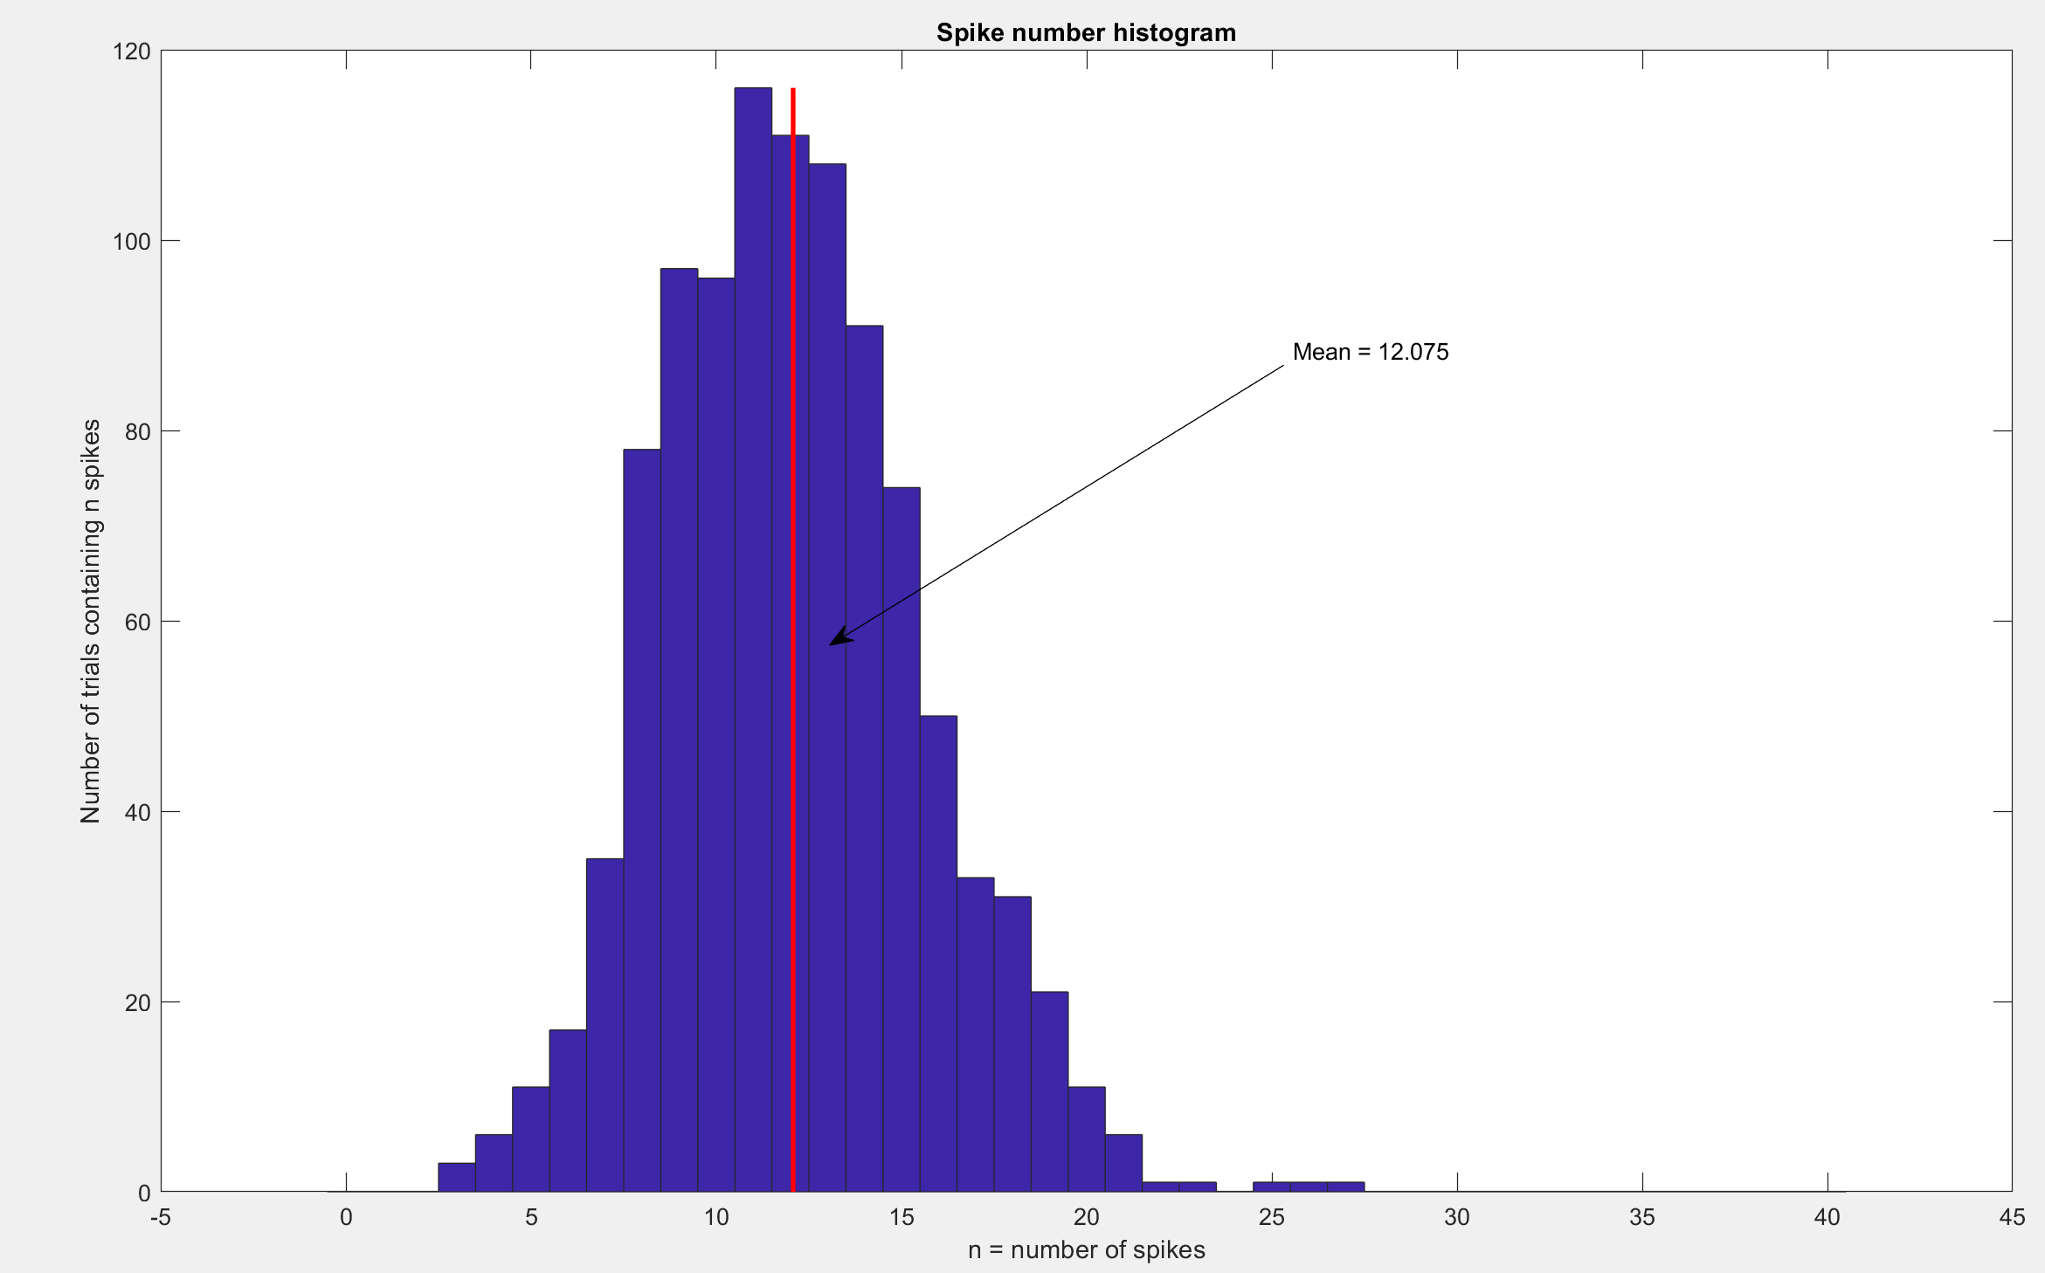

%Code adapted from Zenas Chao's Week 5 class. I made it as fancy as

%possible

%n_avg = 12.075 spikes

n_spikes_per_trial = sum(spikeData2,2);

n_avg = mean(n_spikes_per_trial);

figure(3)

hist(n_spikes_per_trial, [0:1:40])

xlabel('n = number of spikes');

ylabel('Number of trials containing n spikes');

title('Spike number histogram')

hold on

plot([n_avg, n_avg], [0, max(hist(n_spikes_per_trial, [0:1:40]))], 'r', 'LineWidth', 2)

x = [0.6 0.43];

y = [0.7 0.5];

annotation('textarrow',x,y,'String','Mean = 12.075') %Labels the mean

hold off

close(3)

%Exercise 2.2.5

figure(4)

hold on

histogram(ISI2);

title('ISI Histogram')

xlabel('Inter-spike Interval (ms)');

ylabel('Frequency');

line([meanTime, meanTime], ylim, 'LineWidth', 1, 'Color','k'); %Plots the mean of the histogram

x = [0.4 0.25];

y = [0.7 0.5];

annotation('textarrow',x,y,'String','Mean = 35.6245') %Labels the mean

hold off

close(4)

**%Exercise 2.2.6**

**%Look at 2.1.6 for explanation of this code**

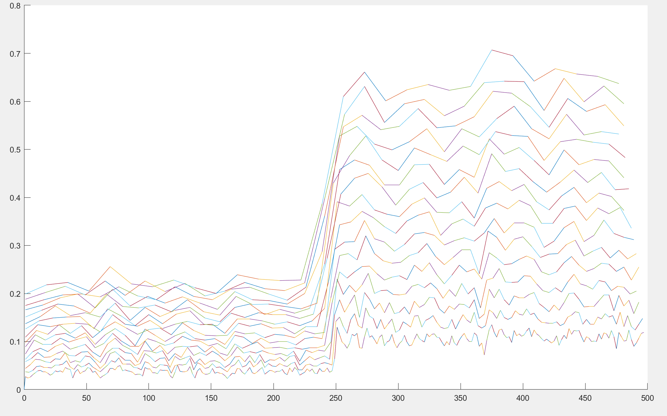

%Using deltaT=14ms, notice the 12 spikes.

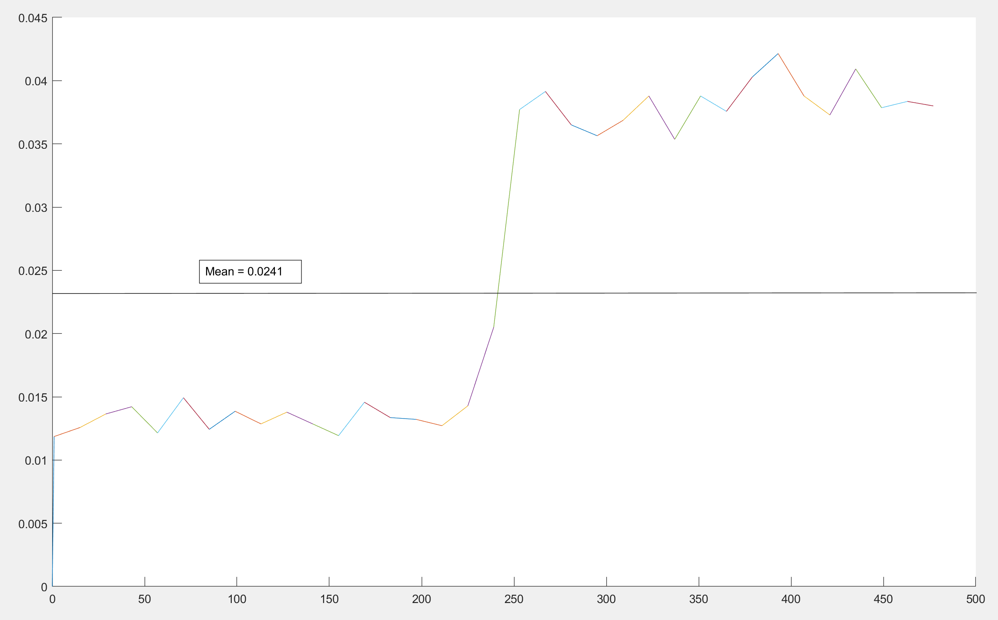

figure(5)

prob_spike = sum(spikeData2,1)/n_trials;

prevDot = 0;

prevT = 0;

hold on

for deltaT=2:1:17

for t=1:deltaT:500-deltaT

sumSpikes=0;

for i=t:1:t+deltaT

sumSpikes=sumSpikes+prob_spike(i);

end

if t>prevT

plot([prevT t], [prevDot sumSpikes]);

end

prevT = t;

prevDot = sumSpikes;

end

end

hold off

close(5);

figure(10)

prob_spike = sum(spikeData2,1)/n_trials;

prevDot = 0;

prevT = 0;

hold on

for deltaT=14:1:14 %DeltaT = 14ms for the most clearest spike train

for t=1:deltaT:500-deltaT

sumSpikes=0;

for i=t:1:t+deltaT

sumSpikes=sumSpikes+prob_spike(i);

end

sumSpikes=sumSpikes/deltaT

if t>prevT

plot([prevT t], [prevDot sumSpikes]);

end

prevT = t;

prevDot = sumSpikes;

end

end

hold off

close(10);

**%Exercise 2.2.7**

%Average ISI: Data1 = 36.9525ms, Data2 = 35.6245ms (Exercise 2.1.3 and

%Exercise 2.2.3 results)

%Data1 > Data 2

%Most common ISI: Data1 = 2ms 0.0251 occurance rate, Data2 = 1ms 0.0315

%occurance

%Occurance rate found using numel(find(ISI == 2))/numel(ISI)

%Data 1 mode > Data 2 mode. Data 2 occurance rate > Data 1 occurance

%Average probability of spiking: Data1 = 0.0247, Data2 = 0.0241

%This is very similar so it can't be used to reliably differentiate between Data 1 and 2

%Looking at the spike train of Data 2, the spike probability almost tripled

%halfway through the trial. This indicates that the subject

%underwent a stimulus event at the halfway point.

%For the spike train of Data 1, there wasn't such stimulus event, and the

%spike train had a single average.

%Because Data 1 doesn't have a jump in spike probability which is present

%in Data 2, my conclusion is that they display different activity.

%Exercise 2.3.8

%Activity in data2 has a massive jump halfway into the trial, most likely

%because of stimulation from an external source. Other than that there

%weren't a lot of unique identifiers.

**%Exercise 2.3.1**

%This sums up every spike, and divides it by n_trials for the average spike

%per trial

%avgSpikePerTrial = 13.4820

avgSpikePerTrial = sum(sum(spikeData3))/n_trials;

%Exercise 2.3.2

%prob_Spike is an array of all the probability for a neuron to spike

%mean(prob_spike) gives the average firing rate probability

%avgProb_Spike = 0.0270

prob_spike = sum(spikeData3)/n_trials;

avgProb_spike = mean(prob_spike);

**%Exercise 2.3.3**

%Average ISI is found by using the mean function on the ISI.

%meanTime = 32.4087

ISI3 = [];

n_trials = 1000;

T = 500;

for k=1:n_trials

spike_times = find(spikeData3(k,:) == 1);

isi0 = diff(spike_times);

ISI3 = [ISI3,isi0];

end

meanTime = mean(ISI3);

**%Exercise 2.3.4**

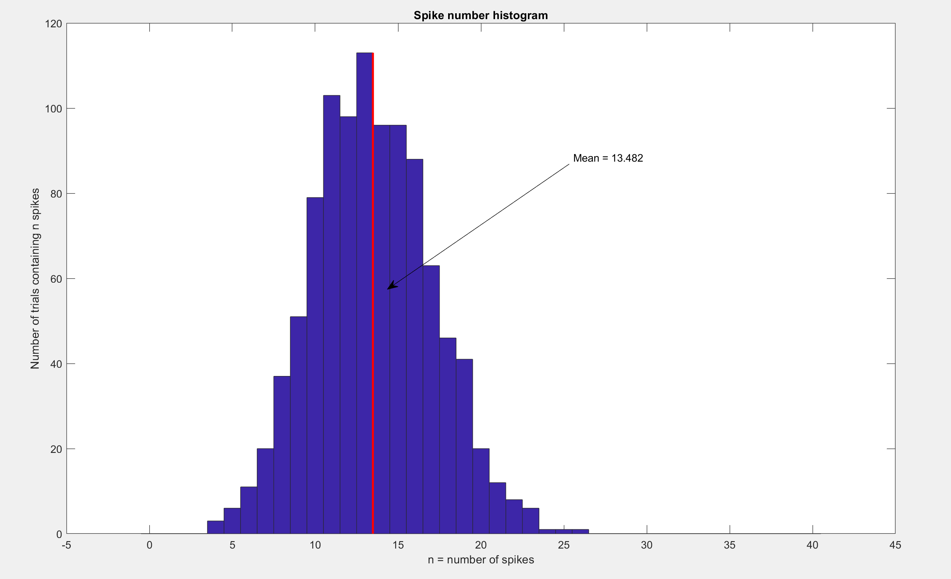

%Code adapted from Zenas Chao's Week 5 class. I made it as fancy as

%possible

n_spikes_per_trial = sum(spikeData3,2);

n_avg = mean(n_spikes_per_trial);

figure(6)

hist(n_spikes_per_trial, [0:1:40])

xlabel('n = number of spikes');

ylabel('Number of trials containing n spikes');

title('Spike number histogram')

hold on

plot([n_avg, n_avg], [0, max(hist(n_spikes_per_trial, [0:1:40]))], 'r', 'LineWidth', 2)

x = [0.6 0.43];

y = [0.7 0.5];

annotation('textarrow',x,y,'String','Mean = 13.482') %Labels the mean

hold off

close(6)

**%Exercise 2.3.5**

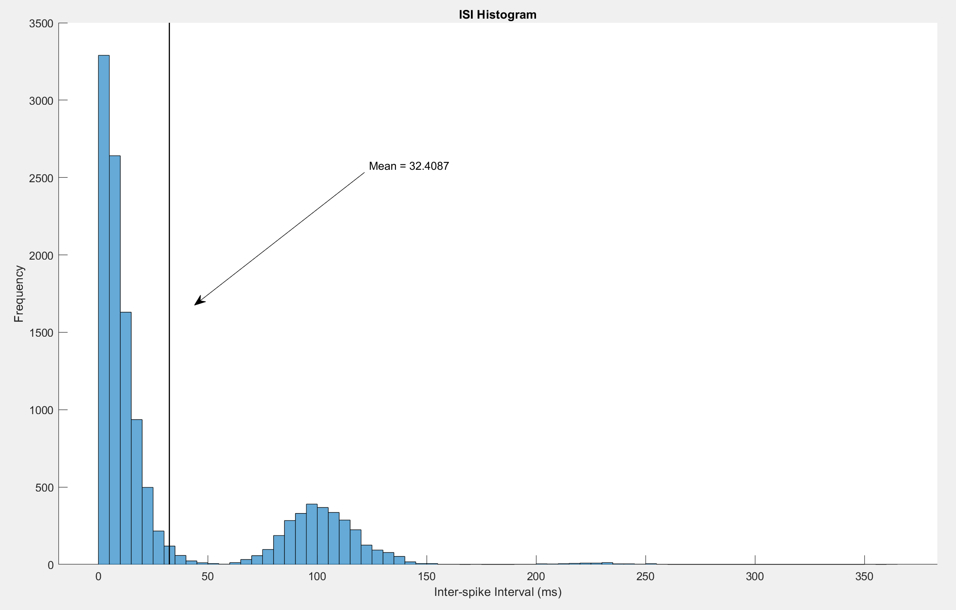

%Mean ISI = 32.4087

%There are two peaks, which allows us to separate data 3 from 1 and 2

figure(7)

hold on

histogram(ISI3);

title('ISI Histogram')

xlabel('Inter-spike Interval (ms)');

ylabel('Frequency');

line([meanTime, meanTime], ylim, 'LineWidth', 1, 'Color','k'); %Plots the mean of the histogram

x = [0.4 0.25];

y = [0.7 0.5];

annotation('textarrow',x,y,'String','Mean = 32.4087') %Labels the mean

hold off

close(7)

**%Exercise 2.3.6**

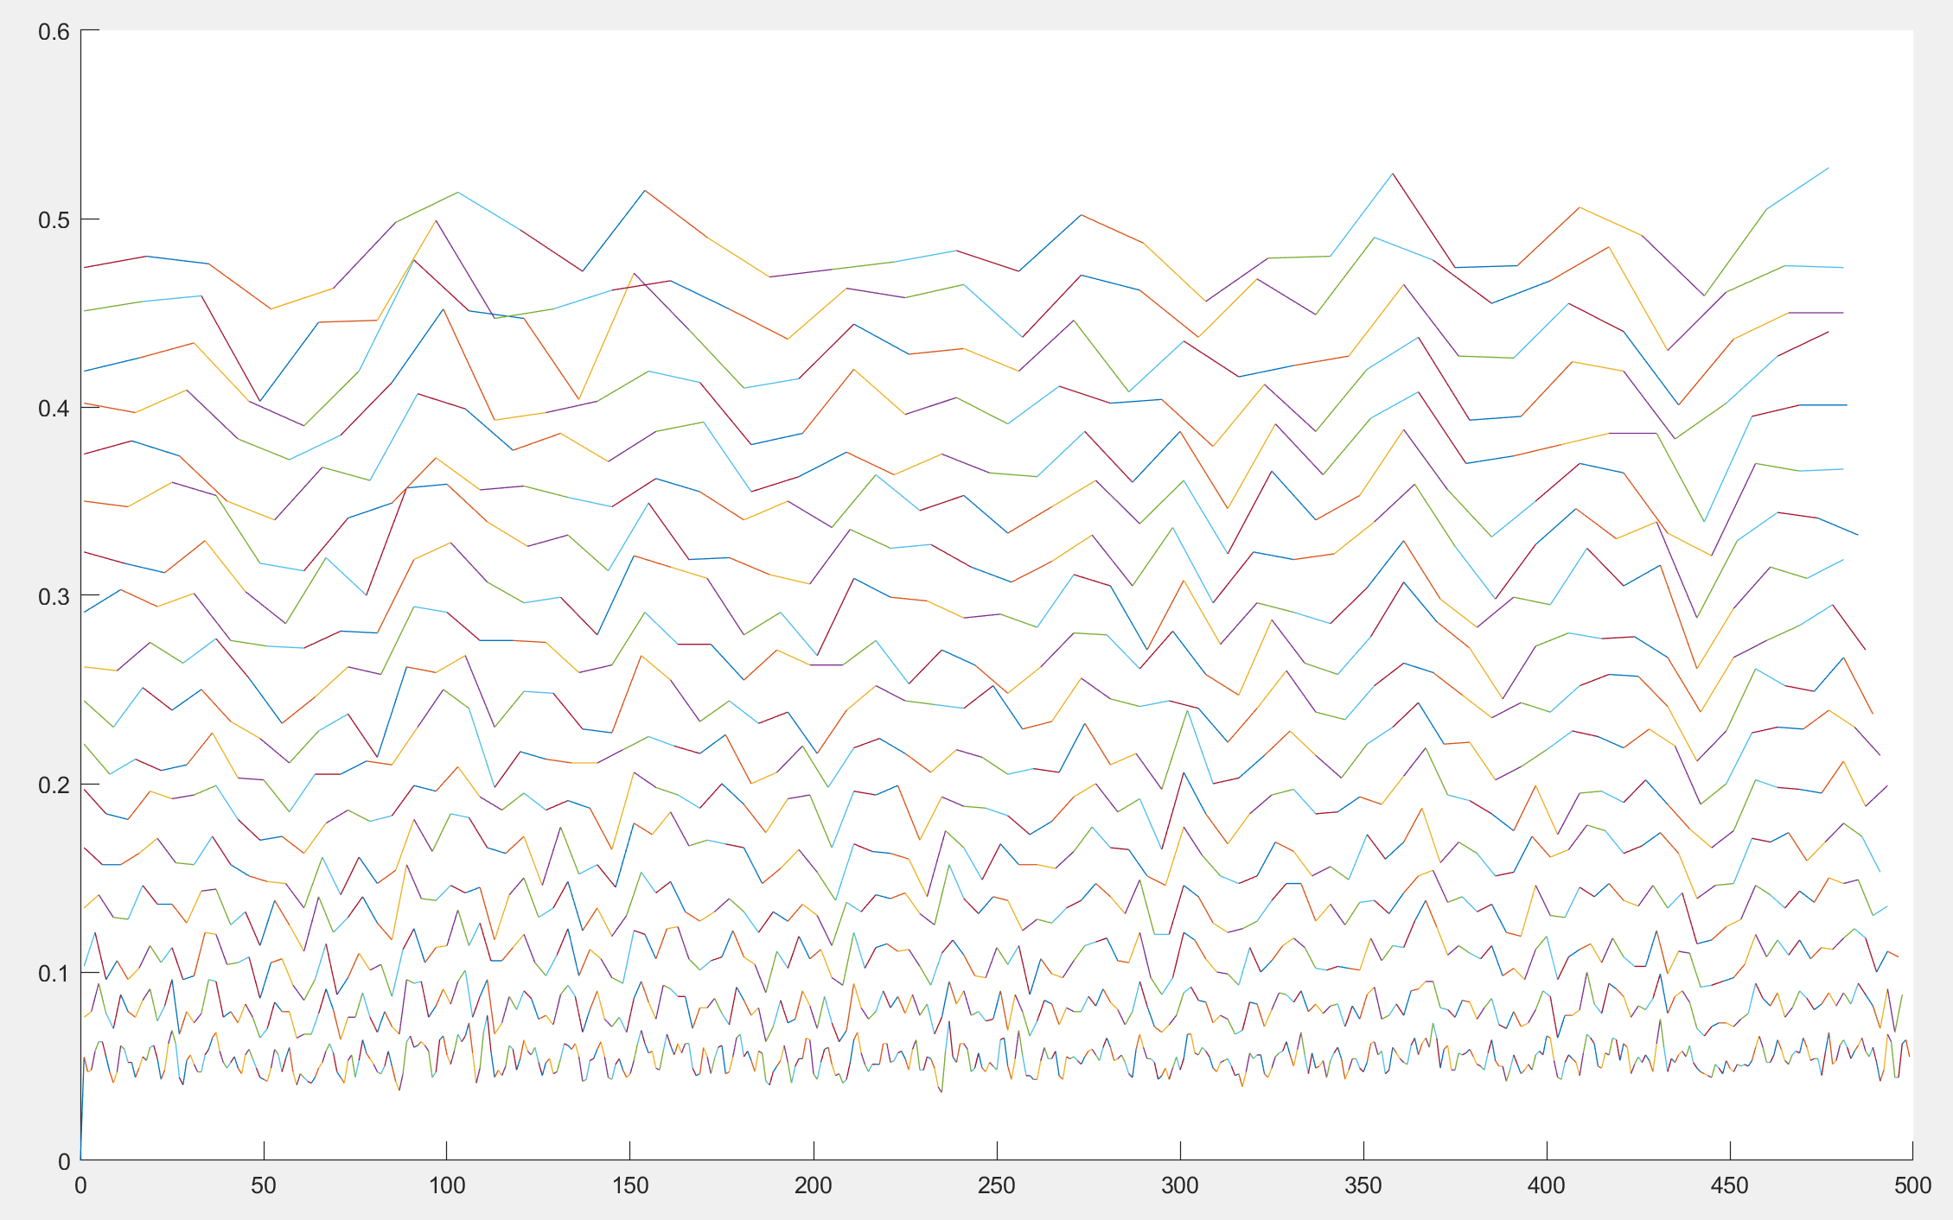

%I binned each set of spikes into bins seperated by deltaT, and by changing

%deltaT from 2 to 20ms, I could remove noise until a clear spike train

%emerged.

%The deltaT is 13ms for the clearest line for data 3, notice the 13 visible spikes

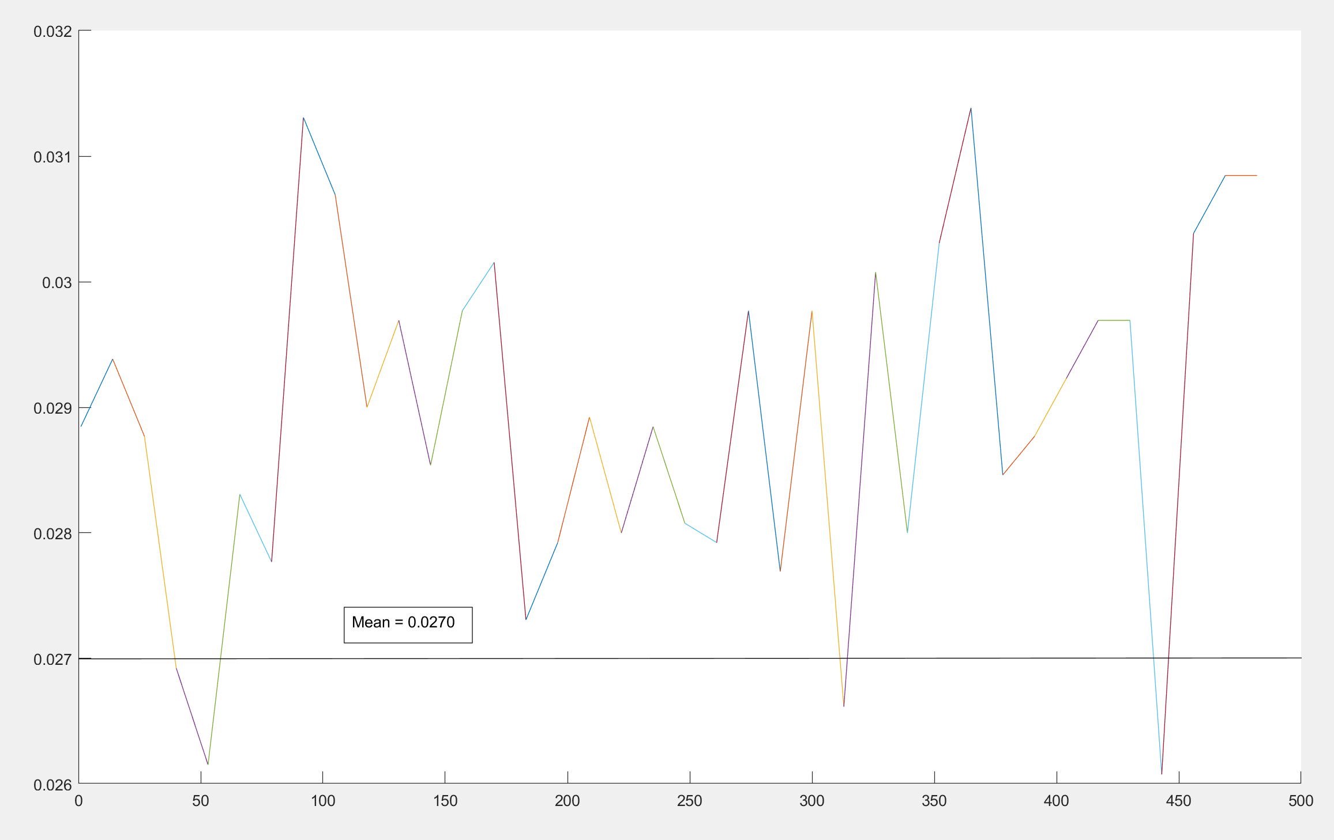

figure(8)

prob_spike = sum(spikeData3,1)/n_trials;

prevDot = 0;

prevT = 0;

hold on

for deltaT=1:1:17 %Plotting for deltaT = 1 to 17

for t=1:deltaT:500-deltaT

sumSpikes=0;

for i=t:1:t+deltaT

sumSpikes=sumSpikes+prob_spike(i);

end

if t>prevT

plot([prevT t], [prevDot sumSpikes]);

end

prevT = t;

prevDot = sumSpikes;

end

end

hold off

close(8)

figure(9)

hold on

for deltaT=[13] %Plotting for deltaT = 13 has the most clear spike train

for t=1:deltaT:500-deltaT

sumSpikes=0;

for i=t:1:t+deltaT

sumSpikes=sumSpikes+prob_spike(i);

end

sumSpikes=sumSpikes/deltaT

if t>prevT

plot([prevT t], [prevDot sumSpikes]);

end

prevT = t;

prevDot = sumSpikes;

end

end

hold off

close(9);

**%Exercise 2.3.7**

%The ISI histogram for data 3 is very different to those of 1 and 2, as it

%has another peak at about 100ms whereas 1 and 2 doesn't have that peak.

%Looking at the spike train of Data 3, it is very similar to Data 1, but

%the important difference is that the amplitude of the spikes in Data 3 are

%much greater.

%Average ISI: Data1 = 36.9525ms, Data2 = 35.6245ms Data3 = 32.4087ms

%Data1 > Data2 > Data3 in speed

%Most common ISI: Data1 = 2ms 0.0251 occurance rate, Data2 = 1ms 0.0315

%occurance Data3 = 1ms 0.0731 occurance rate

%Occurance rate found using numel(find(ISI == 2))/numel(ISI)

%Data 1 mode > Data 2 mode

%Average probability of spiking: Data1 = 0.0247, Data2 = 0.0241 Data3 =

%0.0270

%Data3 has a higher one than data1 and 2, so this can be used to

%differentiate it out of the other two

**%Exercise 2.3.8**

%Data 3 has a similar spike train to Data 1, the identifying feature for

%this data set is that for the ISI histogram, there is a second peak at

%100ms. The second peak may be because the neuron only fires at regular intervals.

**%Exercise 2.4.1**

%I will look at the ISI histogram and the spike train data, if the spike

%probability suddenly increases halfway through the trials, then it must be

%C2. If the ISI histogram has two peaks, then it must be C3. If it doesn't

%have two then it must be C1

load('Spike_data_test.mat')

spikeDataTest = d_test;

n_trials = 10;

%The ISI Histogram shows two peaks, so it must be C3

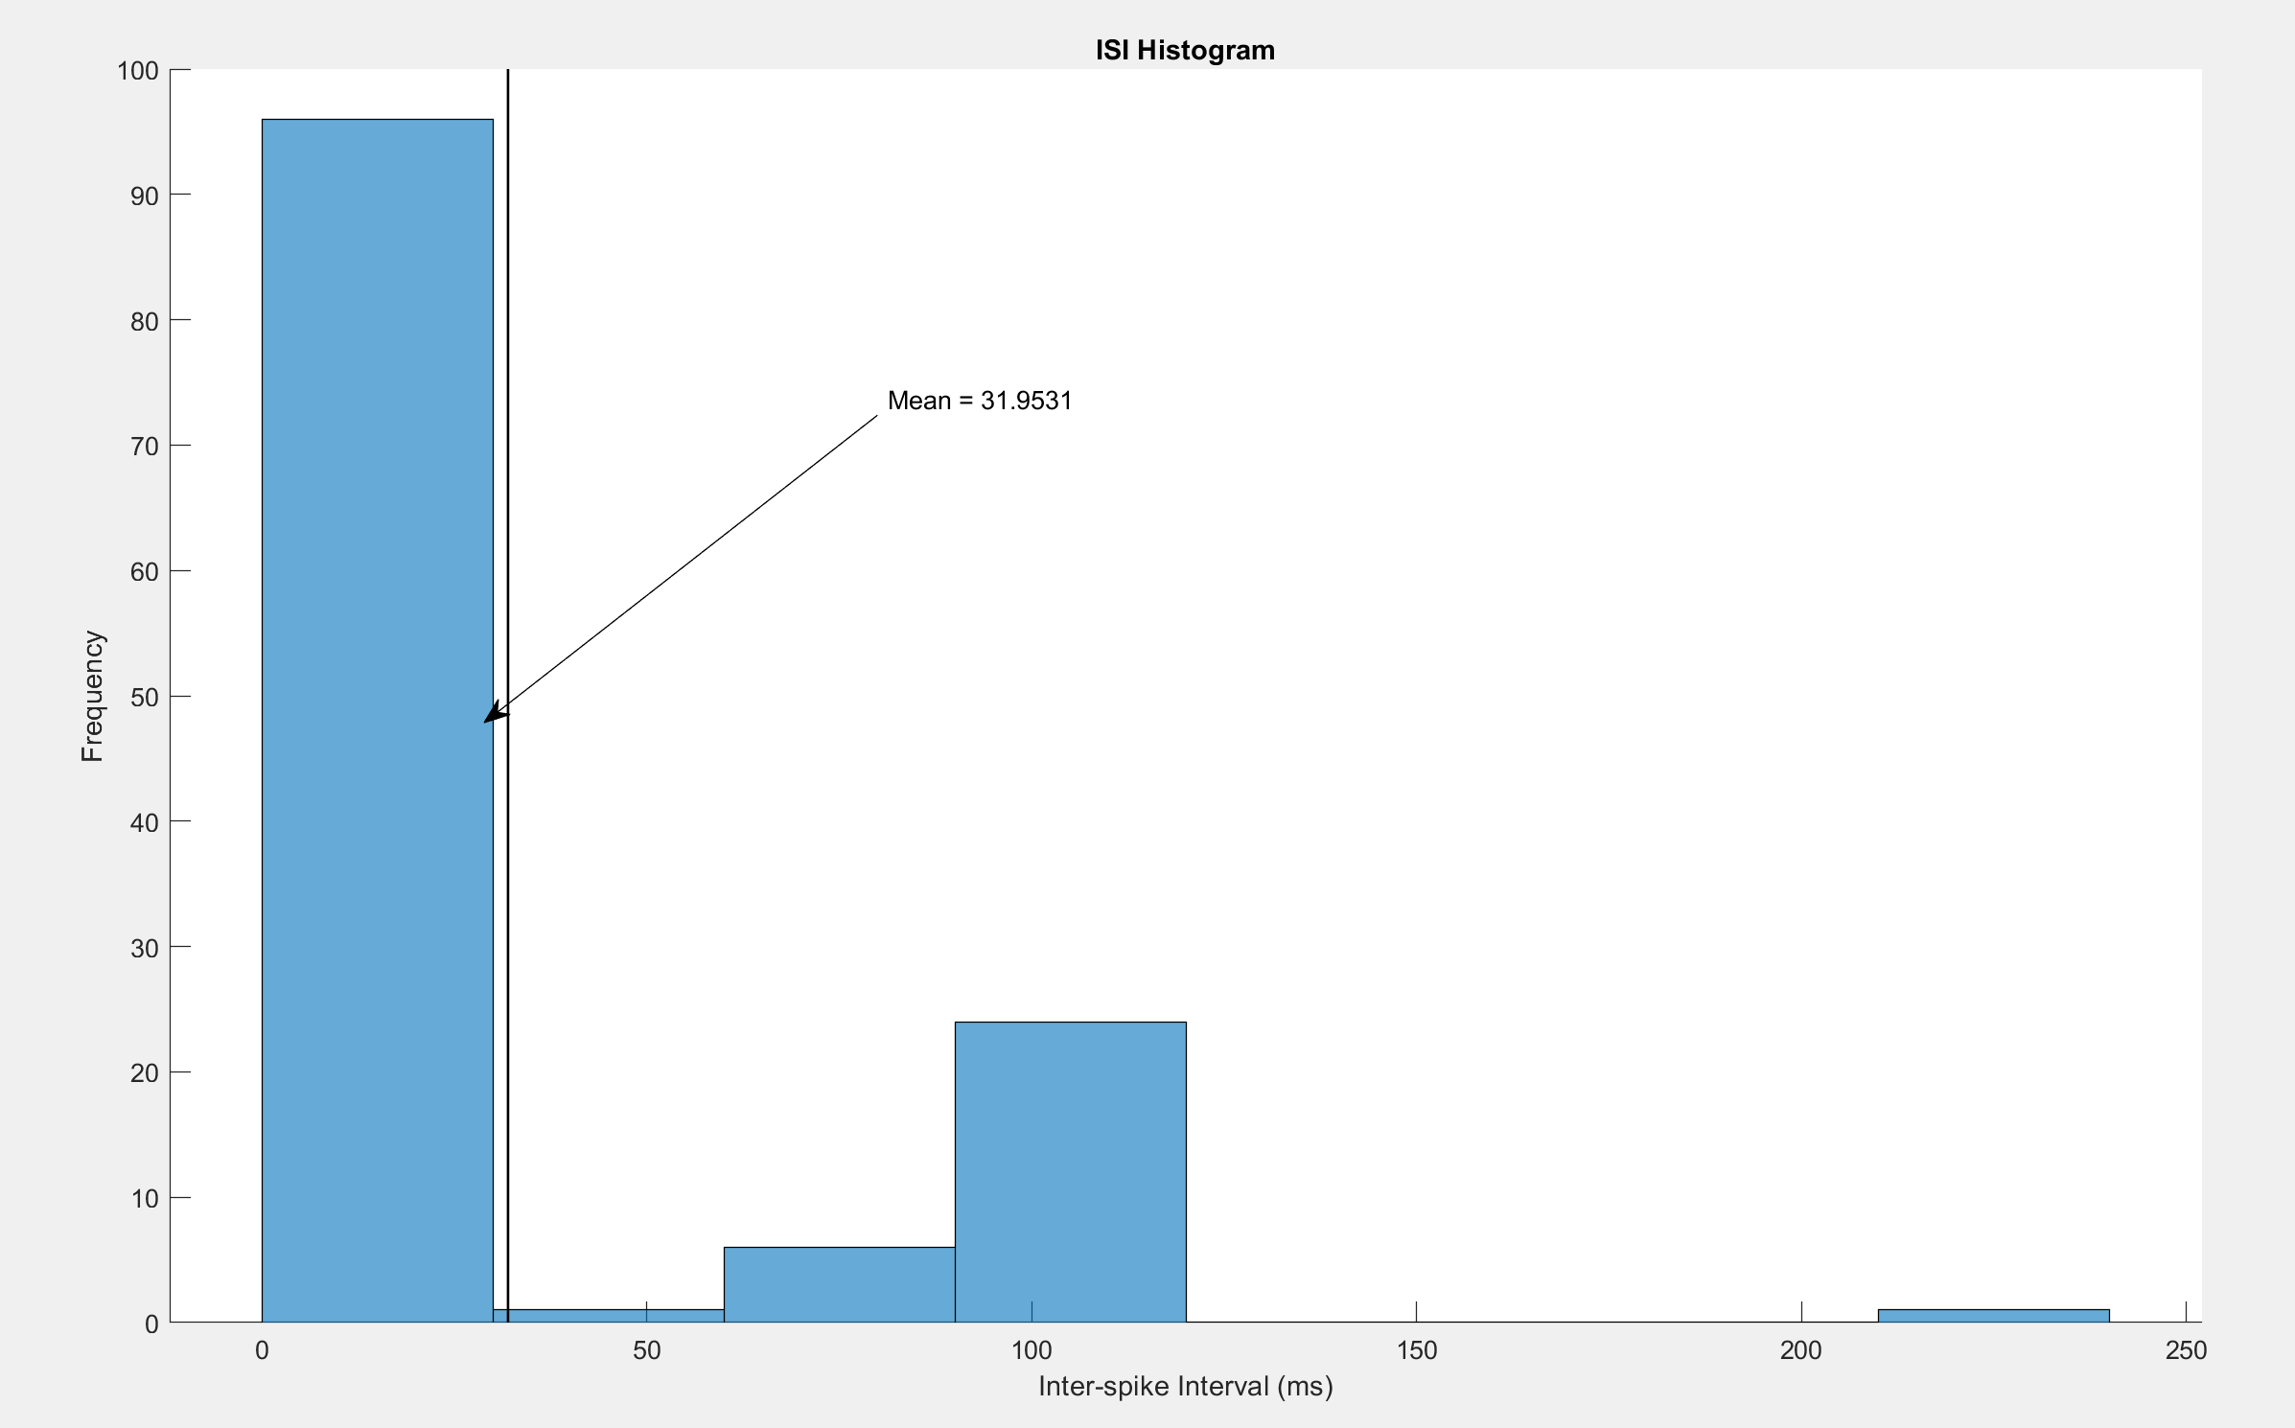

ISItest = [];

T = 500;

for k=1:n_trials

spike_times = find(spikeDataTest(k,:) == 1);

isi0 = diff(spike_times);

ISItest = [ISItest,isi0];

end

figure(13)

hold on

histogram(ISItest);

title('ISI Histogram')

xlabel('Inter-spike Interval (ms)');

ylabel('Frequency');

line([meanTime, meanTime], ylim, 'LineWidth', 1, 'Color','k'); %Plots the mean of the histogram

x = [0.4 0.25];

y = [0.7 0.5];

annotation('textarrow',x,y,'String','Mean = 32.4087') %Labels the mean

hold off

%close(13)

%Checking the spike train data, there doesn't seem to be an increase of

%spike probability halfway through the trial so it definitely isn't C2, also the mean is very similar to C3 (0.0270) so it must be C3.

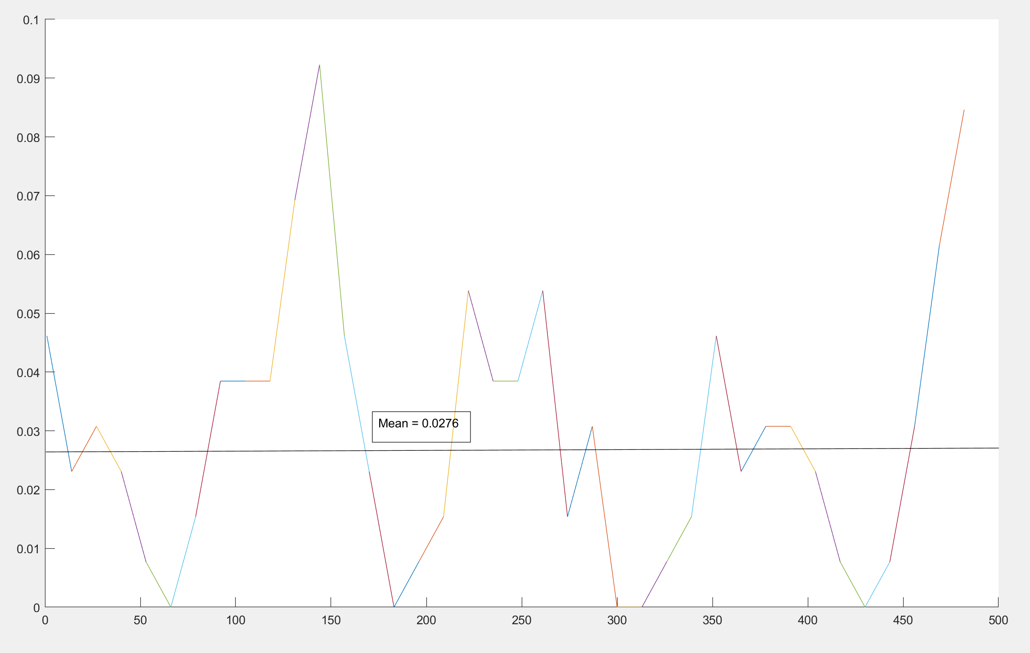

figure(15)

hold on

prob_spike = sum(spikeDataTest,1)/10;

for deltaT=[13] %Plotting for deltaT = 13ms has the most clear spike train

for t=1:deltaT:500-deltaT

sumSpikes=0;

for i=t:1:t+deltaT

sumSpikes=sumSpikes+prob_spike(i);

end

sumSpikes=sumSpikes/deltaT;

if t>prevT

plot([prevT t], [prevDot sumSpikes]);

end

prevT = t;

prevDot = sumSpikes;

end

end

hold off

%close(15);