Panono
www.panono.com
Backend programming challenge

General rules:
- You can use any programming language you’d like.
- You can use the Internet as much as you’d like, except don’t look at someone else’s solution to this same problem (this is a custom problem, so you might not find that anyways.)
- Please let us know if you want to open source your work (to help us later catch anyone who tries to cheat using your code.)
- We don’t care much about performance, as long as you’re not doing anything really stupid.

Instructions:
You’re given three files:
- (this one)
- shapes.db
- operations.data

The ‘shapes.db’ represents our data stored in one text file. The file looks like this:

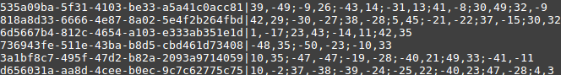
There’s two columns, separated by a pipe “|” symbol.
- The first column represents the id of the row.
- The second column represents points on a 2D coordinate plane (you can safely assume that each number in the point is less than 32bits in size.)
  - Points are separated by a semi-colon “;”
  - Where the x position is before the comma, y position is after it.
  - The points themselves having no real meaning or sort order.
  - There’s at most 7 points for a given shape, and minimum 3.

The ‘operations.data’ represents operations to be performed against the database.

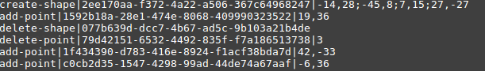
- To make things easier, you can safely assume that there’s no more than one operation per shape (meaning: ids are distinct within operations.data)
- The amount of columns are variable depending on the operation.
  - The second column is the id
    - For add, delete, and update, this represents the shape to modify.
    - For create-shape, this represents what the id of the new shape.
  - The first column is the operation to be performed
    - Operation: delete-shape (delete the shape)
    - Operation: create-shape
      - Create a new shape, it’s points are listed in the last column.
    - Operation: add-point
      - Append the point (last column) onto the list of points for that shape.
    - Operation: delete-point
      - The last column is the index of the point to delete (zero indexed.) So, if the last column is a 3, find the shape in the database, and delete fourth point.
    - Operation: update-point
      - The third index is the point index to update (similar to delete-point)
      - The fourth index is the operation to perform on the point-to-be-update.
      - The fifth (and last) index is the data to add/subtract
      - Example: “update-point|123412412-123412-12341234|2|-|33,2”
        - Find the 3rd point for that id, let’s say is 44,22, perform subtraction on it, like so: 44-33,22-2; so that new point should be: 11,19.

Your task
- Read in the ‘shapes.db’ file.
- Print (to the console or somewhere) the counts of: triangles, squares, pentagons, hexagons, and heptagons.
- Where a triangle has 3 points, square has 4 points, etc.
- The lengths of the sides of the square are not equal, we’re just calling it that, you can call it what you want, but it’s really just a polygon with 4 vertices.
- Perform the operations against the data.
- Repeat step 2 – meaning reprint the count of each shape.
- Print the updated database to a file named “updated.db”.
- Send us your code and the updated db.

Tests are optional but correction will be taken into consideration. (Meaning, we will try not to judge you for not having tests or having bad tests.)

If by chance, you find anything wrong, bugs, mis-matched results or anything else, feel free to let us know, and of course this could be attributed to your favor (in our scoring of you.)

Thank you and best wishes!

