Precision–Recall Curves

CONCEPTUAL FOUNDATIONS
Q1. What does a precision-recall curve plot, and how do you construct one from a model's scores?
ANSWER
- A PR curve plots precision (y-axis) against recall (x-axis) as the classification threshold varies.
- Construction: sort all predictions by score (highest first); sweep the threshold from high to low; at each distinct score, compute precision = TP/(TP+FP) and recall = TP/(TP+FN) for everything classified positive at that cutoff; plot the resulting (recall, precision) points.
- Each point is one operating point. Lowering the threshold admits more predictions as positive, generally raising recall while precision drifts.

Q2. How is the PR curve different from the ROC curve? When would you prefer one over the other?
ANSWER
- ROC plots TPR (recall) vs. FPR; PR plots precision vs. recall. The key difference is the x/quantity that captures the negatives.
- FPR = FP/(all negatives) — it dilutes false positives across a huge negative pool, so on imbalanced data ROC can look optimistic. Precision = TP/(TP+FP) reacts directly to false positives regardless of how many negatives exist.
- Prefer PR when the positive class is rare, and you care about the quality of positive predictions (fraud, disease, retrieval). Prefer ROC when classes are balanced, or you want a prevalence-independent view of ranking.
It means ROC-AUC gives you a measure of pure ranking ability that doesn't change when the proportion of positives vs.
It means ROC-AUC gives you a measure of pure ranking ability that doesn't change when the proportion of positives vs. negatives changes — whereas PR-AUC does change.
Here's the precise reason. ROC is built from two rates:
- TPR = TP / (all actual positives)
- FPR = FP / (all actual negatives)
Each rate has its own class in the denominator. TPR only divides by positives; FPR only divides by negatives. So, if you keep the same model and just change the mix — say, throw in 10× more negatives — TPR is computed entirely within the positive group and FPR entirely within the negative group. Neither rate is affected by how many of the other class exist. The ROC curve, and therefore ROC-AUC, stays the same.
Precision breaks this property:
- Precision = TP / (TP + FP)
Here positives and negatives share a denominator. Add more negatives and you get more false positives, so precision drops — even though the model and its ranking are identical. That's why PR-AUC shifts with prevalence and ROC-AUC doesn't.
What "view of ranking" means. ROC-AUC has a clean interpretation: it's the probability that a randomly chosen positive is scored higher than a randomly chosen negative. That's a statement purely about ordering — how well the model sorts positives above negatives — independent of how common either class is.
Why you'd want that. It's useful when you want to judge the model's intrinsic discriminative power separately from the operating environment:
- Comparing models across datasets or time periods with different base rates, where you don't want prevalence differences contaminating the comparison.
- Asking "how good is the ranker itself?" as a model-quality question, before layering on deployment concerns.
The flip side — and why your flashcards still favor PR for fraud — is that prevalence-independence is exactly the wrong thing when prevalence is the whole problem. In a 0.1%-fraud setting you care that rare positives drown in false positives, and ROC-AUC deliberately ignores that. So: ROC for "is the ranking good in the abstract," PR for "will this actually work at my real base rate."

Q3. Why is PR-AUC (or AP) often preferred over ROC-AUC for imbalanced datasets?
ANSWER
- ROC-AUC uses FPR, which has the (large) negative count in its denominator, so even thousands of false positives barely move it when negatives dominate. The metric stays high even when precision is poor.
- Precision puts FP and TP in the same denominator, so PR-AUC stays sensitive to false positives no matter the imbalance.
- In fraud (~0.1% positives) a model can have ROC-AUC 0.95 yet be useless in production because nearly every alert is a false positive — PR-AUC exposes that, ROC-AUC hides it.

Q4. What does the baseline / random-classifier line look like on a PR curve, and why?
ANSWER
- It is a horizontal line at y = P / (P + N), i.e. the positive-class prevalence.
- A random classifier's precision at any recall equals the base rate of positives, because a random subset of predictions contains positives at the prevalence rate (number of positives / total instances).
- Contrast: ROC's random baseline is the diagonal y = x. The PR baseline moving with prevalence is exactly why PR curves are prevalence-sensitive — a 0.4 PR-AUC is great at 1% prevalence but terrible at 40%.

Q5. Why isn't the PR curve monotonic the way the ROC curve is?
ANSWER
- Recall is monotonic in threshold (lowering the threshold can only add TPs, never remove them), but precision is not.
- Admitting the next prediction as positive: if it's a TP, precision rises; if it's an FP, precision falls. So the curve zig-zags / saw-tooths as you alternate between hitting TPs and FPs.
- ROC is monotonic because both TPR and FPR only increase as the threshold drops, so the curve always moves up-and-right.

METRICS & COMPUTATION
Q6. Define Average Precision. How does it relate to the area under the PR curve?
ANSWER
- AP = Σₙ (Rₙ − Rₙ₋₁) · Pₙ — a weighted mean of precisions, each weighted by the increase in recall it produced.
- It is a discrete estimate of the area under the PR curve: Pₙ is the height, (Rₙ − Rₙ₋₁) is the width of each slice, and the sum is the area.
- Equivalently: the mean of the precision values measured at exactly the points where a true positive is retrieved (recall steps are zero at false positives, so they drop out).

Q7. Difference between AP, interpolated AP (11-point), and trapezoidal PR-AUC? Why can they disagree?
ANSWER
- AP (sklearn): step-function sum Σ(Rₙ − Rₙ₋₁)·Pₙ — no interpolation between points.
- 11-point interpolated AP (old PASCAL VOC): average of the max precision at recall ∈ {0, 0.1, …, 1.0}; uses interpolated (max-to-the-right) precision, smoothing the saw-tooth upward.
- Trapezoidal PR-AUC: auc(recall, precision) connects points with straight lines and integrates — but linear interpolation in PR space is geometrically wrong and tends to be optimistic.
- They disagree because the saw-tooth curve is interpolated differently: step vs. max-envelope vs. linear. Interpolated/trapezoidal methods usually give higher numbers.

Q8. How does sklearn's average_precision_score differ from auc(recall, precision), and which is more correct?
ANSWER
- average_precision_score uses the step-wise weighted sum Σ(Rₙ − Rₙ₋₁)·Pₙ.
- auc(recall, precision) does trapezoidal integration — it linearly interpolates between adjacent PR points.
- Prefer average_precision_score. Linear interpolation between PR points is not achievable by any real classifier and biases the area upward, so trapezoidal PR-AUC overstates performance.
Here's an explanation you can use:
The setup. Both metrics try to summarize a precision-recall curve as a single number — the "area under the PR curve." They just integrate it differently.
average_precision_score (step sum). It treats the PR curve as a staircase. As you lower the classification threshold, recall increases in jumps, and at each jump it weights the current precision by the change in recall:
AP = ∑ₙ (Rₙ − Rₙ₋₁) · Pₙ
Each term is the width of a recall step times the height (precision) at the right edge of that step. No assumption is made about what happens between the points — it just uses the value actually observed at each threshold.
auc(recall, precision) (trapezoidal). This connects consecutive PR points with straight diagonal lines and sums the trapezoids underneath. The implicit claim is that as recall moves from Rₙ₋₁ to Rₙ, precision slides linearly from Pₙ₋₁ to Pₙ.
Why that linear claim is wrong. Precision and recall don't trade off linearly. When you add the next batch of predictions to push recall up, precision can move sharply and non-monotonically — it's governed by how many of those newly-included predictions are true positives, which is lumpy, not smooth. There's no real classifier whose behavior between two measured thresholds traces a straight line in PR space. So the diagonal is a fiction.
Why it inflates the score. Because precision generally falls as recall rises (you're scraping deeper into lower-confidence predictions), the straight line drawn between two points usually sits above the staircase the data actually traces. Area gets counted that the classifier never earned. That's the upward bias — trapezoidal PR-AUC tends to flatter the model.
The honest caveat (good to volunteer in an interview). It's not a universal law that the trapezoid is always too high. On any single segment, whether the diagonal lands above or below the step depends on whether precision is rising or falling there. The reason the net effect is overstatement is that the falling-precision case dominates real curves. So "trapezoidal overstates" is an empirical tendency driven by the typical shape, not an algebraic guarantee.
Bottom line. Prefer average_precision_score because it reports what the classifier actually achieved at observed operating points, with no interpolation artifact. sklearn itself recommends against pairing auc with precision-recall data for exactly this reason.
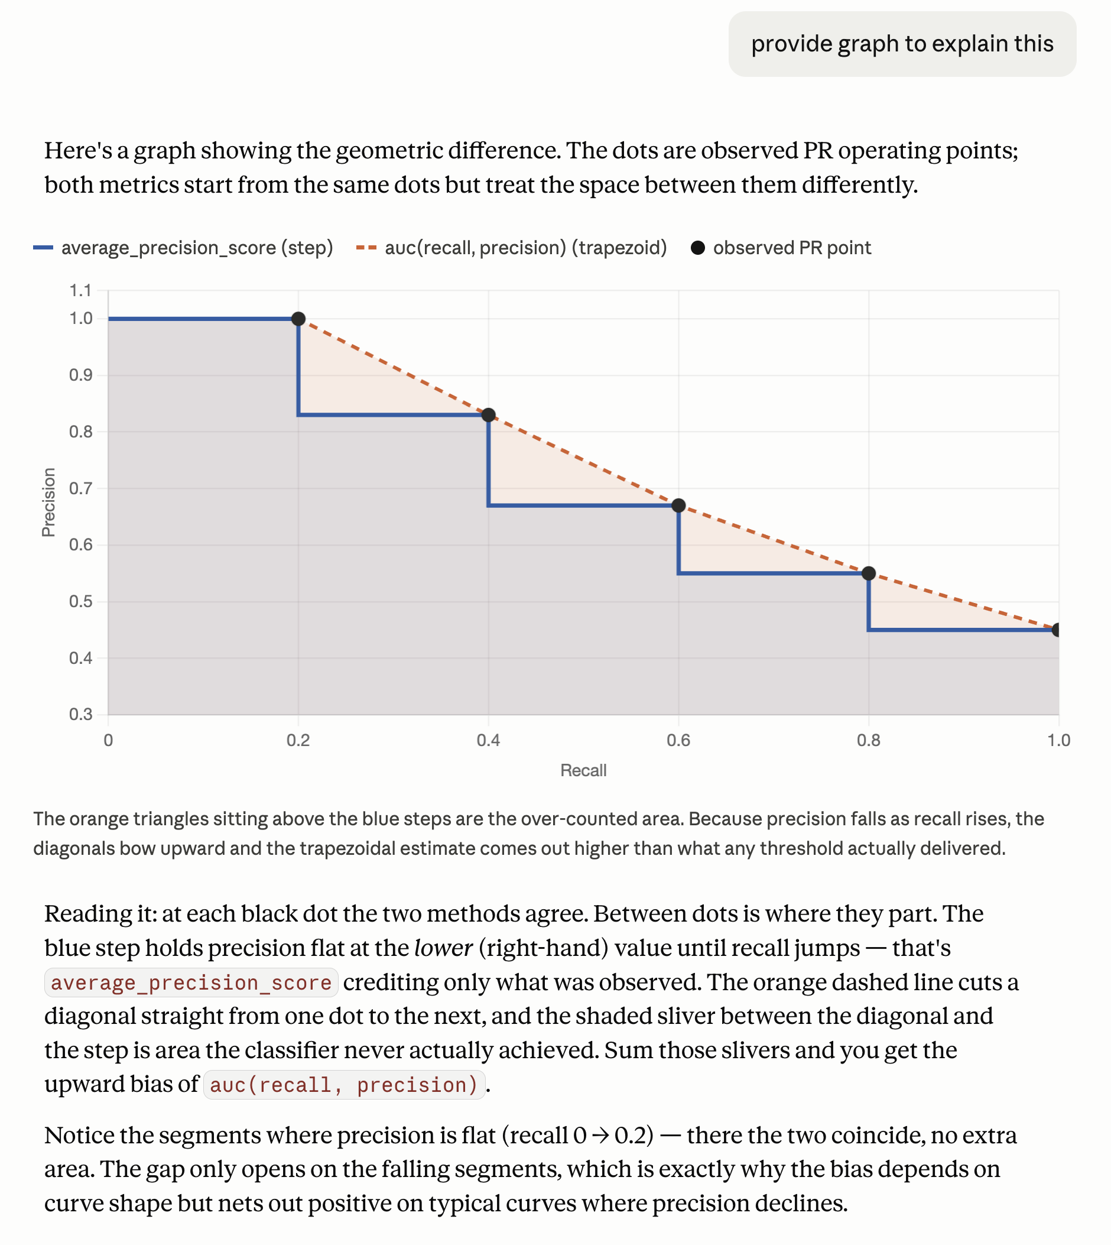

Q10. How do you compute F1 from a PR curve, and find the threshold that maximizes it?
ANSWER
- At each PR point, F1 = 2·P·R / (P + R) — the harmonic mean of that point's precision and recall.
- Compute F1 for every threshold on the curve and take the argmax to get the F1-optimal operating threshold.
- Caveat: F1 weights precision and recall equally; if your costs are asymmetric use Fβ (β>1 favors recall, β<1 favors precision) or pick the threshold from a cost function instead.

INTERPRETATION & TRADEOFFS
Q11. A model has high ROC-AUC (0.95) but low PR-AUC (0.40). What does this tell you?
ANSWER
- The data is heavily imbalanced and the model ranks reasonably but produces many false positives among its top predictions.
- High ROC-AUC says it separates classes in a prevalence-diluted (FPR) sense; low PR-AUC says that at usable recall levels, precision is poor.
- Practically: most of your positive predictions would be wrong. Trust PR-AUC for the deployment decision when positives are rare.

Q12. Two models have the same PR-AUC but different curve shapes. How do you choose?
ANSWER
- Pick based on your operating region, not the aggregate area. Compare the curves only where you'll actually set the threshold.
- Need high precision (limited review capacity / costly false positives)? Choose the model whose curve is higher at low recall.
- Need high recall (must catch nearly all positives)? Choose the one higher at high recall. Also weigh precision@k, calibration, latency, and stability.

Q13. How does class prevalence affect the PR curve? Prevalence drops 5% → 0.5% — what happens?
ANSWER
- PR curves are prevalence-dependent. As positives get rarer, precision at any given recall tends to fall, the whole curve shifts down, and the baseline drops from 0.05 to 0.005.
- AP / PR-AUC therefore typically decreases even if the model's ranking ability is unchanged.
- Consequence: you can't directly compare AP across periods or datasets with different prevalence — normalize against the baseline or compare lift over base rate.

Q14. Why can a single false positive high in the ranking hurt AP significantly?
ANSWER
- AP weights each precision by the recall step at a true positive. A false positive ranked above many true positives lowers the precision recorded at every one of those subsequent TPs.
- So one early FP is paid for repeatedly, across all the recall increments that follow it.
- This is exactly the desired behavior: it rewards models that put true positives at the very top of the ranking.

Q15. How do you pick an operating threshold from a PR curve for a real business problem?
ANSWER
- Translate the business objective into a constraint or cost, then read the threshold off the curve. Don't default to 0.5 or to max-F1 blindly.
- Examples: 'precision must be ≥ 90%' → pick the highest-recall point meeting that; 'review team handles 500/day' → pick the threshold yielding ~500 alerts (precision@k); minimize expected cost = c_FP·FP + c_FN·FN.
- Validate the chosen threshold on a held-out / recent slice, since the right point shifts with prevalence and data drift.

APPLIED — FRAUD & PAYMENTS
Q16. Fraud model: blocking legit transactions is costly, missing fraud is costlier. How do PR curves help set a threshold?
ANSWER
- The PR curve shows the precision (share of blocks that are truly fraud) achievable at each recall (share of fraud caught). It maps the whole precision↔recall tradeoff you must balance.
- Encode the asymmetric costs: expected cost = c_FN·(missed fraud) + c_FP·(blocked legit). Sweep thresholds along the curve and choose the cost-minimizing point.
- Because missing fraud costs more, you'll sit at higher recall / lower precision than F1-optimal — the curve quantifies exactly how much precision that costs.

Q17. Fraud is ~0.1% of transactions. Why report PR-AUC instead of accuracy or ROC-AUC?
ANSWER
- Accuracy is meaningless: predicting 'never fraud' scores 99.9% while catching zero fraud.
- ROC-AUC uses FPR over a massive negative pool, so it stays high even when almost every alert is a false positive — it hides the precision problem.
- PR-AUC focuses on the positive (fraud) class and reacts to false positives directly, so it reflects the metric the business actually feels: are our alerts real?

Q18. How do you incorporate asymmetric FP vs FN costs beyond just reading the PR curve?
ANSWER
- Define an explicit cost function: total cost = c_FP + c_FN (extend to per-transaction dollar amounts for fraud, weighting by amount at risk).
- Choose the threshold that minimizes expected cost on validation data — equivalently, set the decision boundary where the cost-weighted marginal FP equals marginal FN.
- Optionally bake costs into training via class weights / cost-sensitive loss, and report expected-cost or net-dollars-saved alongside PR-AUC.

Q19. PR-AUC looks great offline but the model underperforms in production. What could explain the gap?
ANSWER
- Prevalence shift: fraud rate in production differs from the eval set, moving the PR baseline and real precision.
- Label leakage / look-ahead: offline features encode information unavailable at scoring time, inflating offline metrics.
- Train/serve skew: feature computation differs between pipelines; or concept drift as fraud patterns evolve. Also delayed/*noisy* labels making offline 'truth' optimistic, and threshold set on a non-representative slice.

Q20. How do you compare PR curves across model versions when prevalence has changed between periods?
ANSWER
- Raw AP isn't comparable across different base rates. Normalize or re-weight first.
- Options: re-sample/re-weight each eval set to a common prevalence; report lift over baseline (AP / prevalence); or fix the operating point and compare precision@k / recall@k / dollars-saved.
- Best practice: evaluate both models on the same fixed, recent dataset rather than each on its own period.

TRICKY / DEEPER
Q21. Can PR-AUC ever be misleading? Give an example.
ANSWER
- Yes. Because it depends on prevalence, a 0.40 PR-AUC may be excellent at 0.5% base rate but poor at 40% — the number alone is not interpretable without the baseline.
- It also summarizes the entire curve, so a high aggregate can hide poor precision in the specific region you operate in.
- And trapezoidal PR-AUC can be optimistically inflated by incorrect linear interpolation. Always report prevalence and inspect the relevant region.

Q22. Why is linear interpolation between PR points technically incorrect, and what's the right way?
ANSWER
- A straight line between two PR points doesn't correspond to any achievable classifier — precision and recall are coupled through the confusion-matrix counts, and the true path between points is nonlinear.
- Linear interpolation can cut across regions of precision that no threshold attains, overstating the area.
- Correct approaches: the step-function sum used by average_precision_score, or the proper PASCAL-VOC interpolation (max precision to the right of each recall level).

Q24. If you only care about the top 100 predictions (manual review), is AP the right metric?
ANSWER
- No — AP integrates over all recall levels, including regions you'll never act on.
- Use top-k metrics: precision@k (what fraction of the 100 reviewed are real) and recall@k (what fraction of all positives the top 100 capture).
- Also consider AP@k / a truncated PR curve, or NDCG if some catches are worth more than others. Match the metric to the fixed-capacity decision.

Q25. How would you build a confidence interval around PR-AUC?
ANSWER
- Bootstrap: resample the evaluation set with replacement many times (e.g. 1,000), recompute AP each time, and take percentiles (2.5/97.5) of the distribution.
- For grouped data (e.g. multiple transactions per user), use a stratified or cluster bootstrap to respect dependence and avoid optimistic intervals.
- Report the CI alongside the point estimate; for model comparison, bootstrap the difference in AP and check whether its interval excludes zero.

