Mai Hoang- 82%
Overall, it’s nicely done and gets the key information across. The design is well arranged which makes it easy for people to follow(how the bodies of text go down diagonally), elements are not cluttered so there is room to breathe in, and the colours are consistent throughout the text and it’s easy to read(clear difference from background).
There are a few minor errors in the poster. The heading is spelled wrong; it should be “CATS Insights” ; it should be written like this throughout all projects, not only design. You should use more relevant pictures such as ones that include discussions in the meetings as you said “following the first session of CATS Insights”. The subheading is too small in ratio to the heading and the font for the bodies of text should match the heading/subheading or be the same as the subheading. Keep in mind that every project should include the CATS Insights logo and the Worthgate logo, it is okay if you didn’t have access to it.

https://www.canva.com/design/DAG_0Eb0X8s/5SXQF7tdTuoyECB1Kq2ZEA/edit?utm_content=DAG_0Eb0X8s&utm_campaign=designshare&utm_medium=link2&utm_source=sharebutton

Nurmuhammet- 85%
Amazing concept of design making it look like a news report. It looks orderly and the picture showcases our meeting which is relevant to the information written below. The heading and subheading is distinct(sizing and clear difference from the background) and the white coloured body of text is easy to read on the navy background as well.
However, there are a few things to point out. The CATS Insights logo is very messy, should’ve been cleaned up better(it is okay if you didn’t have access to the png but you should’ve asked for it), Worthgate logo colour makes it difficult to see and it clashes with the design, I know the colours can’t be altered but the logo comes in many colours like white which would suit the design better. The dots on the up right corner is a bit random and sticks out, if it is there for the aesthetics then maybe lower the opacity. Great idea for mentioning the official instagram but you didn’t include the username. Finally, be professional next time when work is tasked, you are not superior to the other designers who had to do the same baseline.

https://www.canva.com/design/DAHAHcLi7ag/UNzkUKD-kmnBfk4vKRomYA/view?utm_content=DAHAHcLi7ag&utm_campaign=designshare&utm_medium=link2&utm_source=uniquelinks&utlId=h698346a8b5

Min Thit Oo- 24%
The colour combination is good, it does not clash with each other. The white texts also make it easy to read, a good idea on making the background for the texts dark blue. Pictures also showcase our meetings very well, using multiple of them to show productivity in CATS Insights. Good space for the logo since you didn’t have access to it but just ask for it next time.
There is no heading for the poster which makes it confusing because people won’t know what the topic is. Be more professional about the text and add more as well so you can clearly inform people. Inconsistency in the design, there are borders for the first two pictures but none for the other two, why is there a random blue line in the middle of the two pictures at the bottom, why is “recruits” in all capitals but the rest of the subheadings are written normally. As a designer you should be able to provide a link to your canva design since downloaded pictures sent to other people will lower the quality. Do not screenshot your designs and submit it, I can see the select border on the picture. This design overall seems very rushed and not much thought was put into it, it does not showcase your potential.
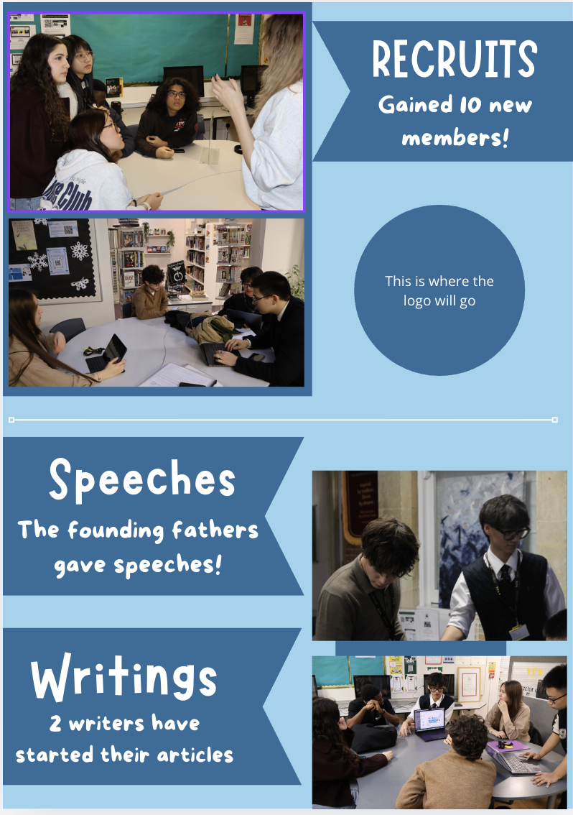

Helen- 92%
Amazing style of design, it really grabs people’s attention with the colours. The heading is explicit from the background, the subheadings and bodies of text can also be read clearly since you added shapes beneath it to separate it from the background. The text also gets the key information across. Pictures included demonstrate the environment of our meetings in CATS Insights. You also left breathing room in between the elements and shapes so it is not cluttered. Finally, thank you for remembering to include the logos which have to be included in all projects and they are visible.
Though I can tell there is a body of text, it is too small, especially the small bits on the lower left side. This makes it difficult to read and if a person were to try and read it while passing by they might not have enough time to look at it closely. The small bits of elements(the zigzags) look a bit out of place, maybe something similar to the hand element you included on the side. The row of pictures at the bottom should be kept consistent in size since some are bigger or wider than others, this will make it look more uniform. Finally, you should include the specific date for the meeting we had(mid january).

https://www.canva.com/design/DAG_0CEkLhY/3ym0W5Zd2xFRNIdDbkMl0A/edit

Kateryna- 37%
Good use of pictures from our meeting, it shows people our working environment. The colours you used are also great and work well together(the turquoise and olive green). Great job for including the CATS Insights logo, a lot of people forgot this vital detail.
The heading is not clearly distinct from the background, maybe using a darker green or a darker shade of the turquoise, it also doesn’t make sense. The font of the bodies of text do not match the heading and the colour doesn’t match as well. The information is also not clear, you were supposed to use the information given to write your own text, not copy them exactly. Instead of highlighting the graphics you should’ve made the pictures the focus since it shows our team, some of the picture’s borders do not match them. Irrelevant elements make the design unprofessional(the fairy light strings). Overall, the design is quite messy and more effort should’ve been put into it since it is a baseline for you to show your current skills.

https://www.canva.com/design/DAG_0FkPtvA/GGUZD6femy3msftANuoa3A/edit

Aygul- 52%
Great use of pictures from our meeting, it shows people how well we cooperate during the meetings. The text is easy to read and it includes all of the key details we’ve asked to be included. It's also nice that you’ve included the mission statement.
The heading should be clearer, the font makes it difficult to read. Subheading should also be bigger than the text or bolder. Irrelevant elements like the flower border makes it confusing for people to tell what the topic is(misleading), the flower border also makes it look cluttered. The background also contributes to the cluttering, the texture leaves no breathing room in between the texts, pictures, and elements. Finally, remember to include the CATS Insights logo(it is okay if you didn’t have access to it) as it should be included in all projects.

https://www.canva.com/design/DAG_0GEsDgw/TwuN1oVXbjp-hy7lbcNE2A/view?utm_content=DAG_0GEsDgw&utm_campaign=designshare&utm_medium=link2&utm_source=uniquelinks&utlId=hea58b8d10e

1. Helen
2. Nurmuhamet
3. Mai
4. Aygul
5. Kateryna
6.Min Thit Oo

