KICKSTARTER CROWDFUNDING ANALYSIS

Executive:
Choosing what to focus on to achieve a successful project with Kickstarter is not as straightforward as one may think. What must be focused on are the natures of the parent categories, subcategories, and the time of year that the project is launched. The results of this analysis dictate that the type of entertainment the parent category focuses on plays a key role in a project’s success. Furthermore, due to the preference extremities with subcategories, choosing the incorrect subcategory can sometimes be the sole reason for failure. Finally, the point in time one chooses to launch a project can result in failure regardless of how perfectly the other two choices are made. Every choice is crucial in its own right, and all elements must be chosen wisely or one may set themselves up for disaster.

Introduction:
The major sections of this report are the limitations, results, and summary. The limitations describe what factors cannot be accounted for and how they may influence the analysis. The results section provides detailed information that was garnered from the analysis. The results are what Kickstarter prospects should read to learn what works and what fails when deciding how to launch a project with Kickstarter. Finally, the summary section simplifies the results section into short paragraphs that cover the most prominent factors of the analysis.

The projects and their backers are the primary focus of this analysis. The projects are the foundation of Kickstarter and the backers are the ones who ultimately determine whether a project succeeds.

People considering using the Kickstarter crowdfunding service and those who have already decided to use Kickstarter will benefit greatly from this analysis.

Background:
Kickstarter is a global crowdfunding platform focused on creativity and merchandising. Over two billion dollars has been pledged to Kickstarter projects with over nine million backers. However, despite the popularity of Kickstarter and the massive amount of support not every project achieves success. A requirement for getting funded on Kickstarter requires a project to meet or exceed its initial funding goal. As a result, prospects that are considering using Kickstarter as their crowdfunding service may spend years researching past projects to uncover a secret to success.

Purposes:
The purpose of this analysis is to uncover any hidden trends that may lead to success with the Kickstarter crowdfunding platform. This analysis is aimed towards helping Kickstarter prospects determine whether Kickstarter is a feasible option for them to utilize. This analysis is also aimed at prospects who have already decided to use Kickstarter to raise funds for their project by providing them with crucial insight related to achieving a successful project.

Limitations:
The most significant limitation is the disproportionate number of projects launched in each year in the data. The number of projects launched for a year in the data set being used can range anywhere from 14 projects launched in a year to 1,225 projects launched in a year. Furthermore, the years 2009 and 2017 do not include full years of data. The missing time for 2009 and 2017 will be discussed with the third limitation. As a result, the characteristics of the overrepresented group can skew the results, so drawing conclusions based on the Kickstarter data set being used will be less accurate and reliable.

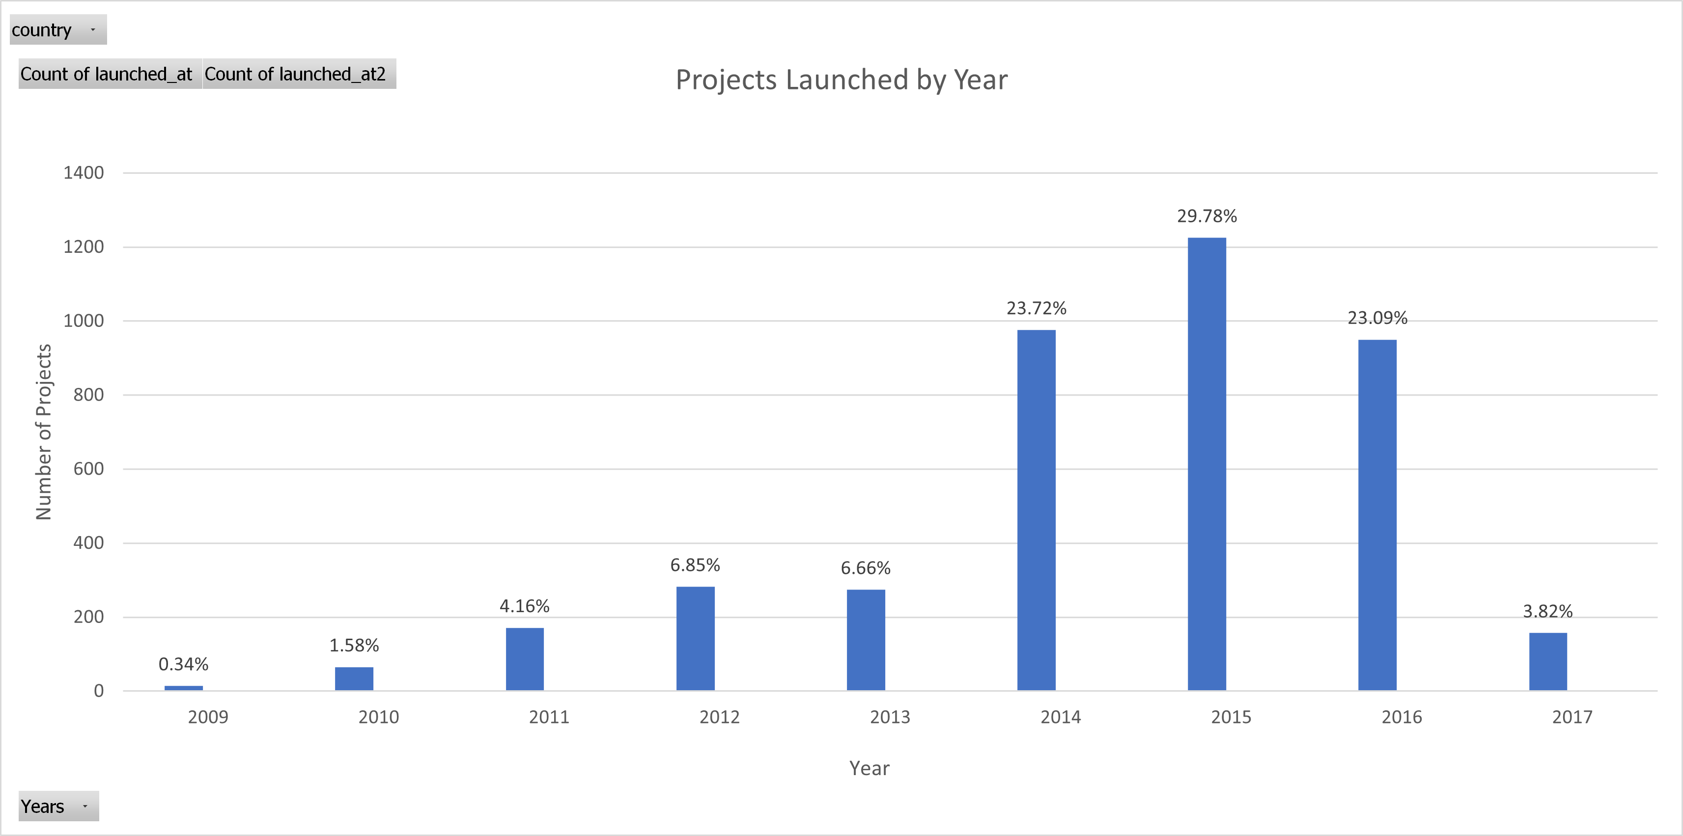

The second limitation also involves a disproportionate number of projects among categories, but this time the misrepresentation is of each country. The data for most countries is nearly negligible. This misrepresentation is most clearly understood by the fact that the US comprises 73.85% of the projects included in the data set. The countries with the second and third highest number of projects are GB and CA with 14.68% and 3.55%, respectively, leaving a meager 7.92% to represent the other 18 countries in the data set.

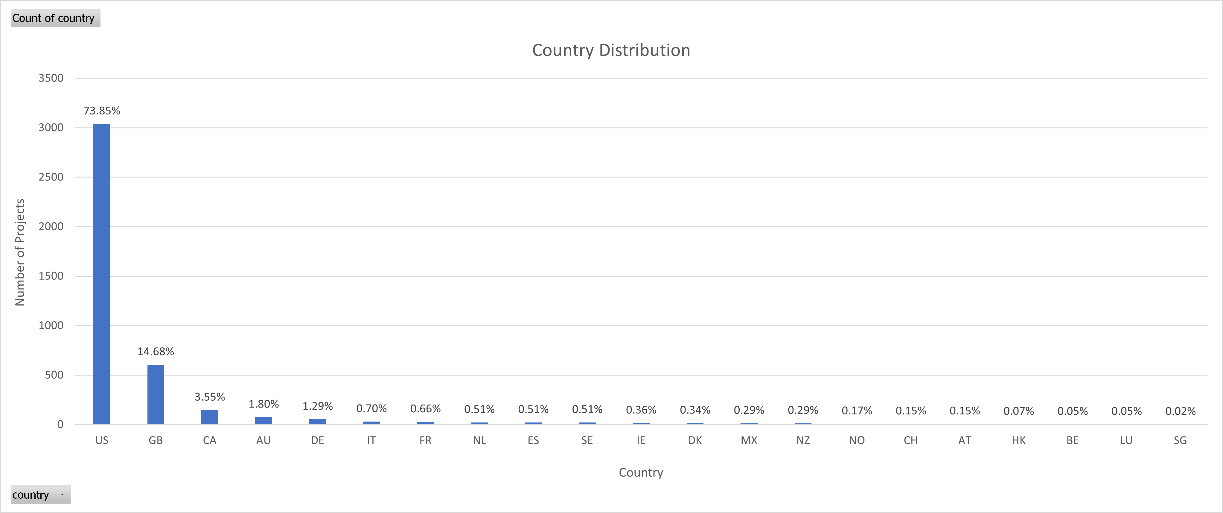
A third limitation is that some of the data analyzed is outdated or incomplete. The “live” projects included in the data set have already ended and the data is from May 2009-May 2017. This is important because interests and preferences may have changed since that time period. Also, the years 2009 and 2017 do not provide full years of data. The year 2009 provides data for months of May-November, and 2017 provides data from January-March. The missing data will result in a misrepresentation for those two years. This threatens the validity of the instruments used for this analysis as well as the effectiveness of applying the results of this analysis to future Kickstarter projects.

The fourth limitation is the number of times a category or subcategory was used for Kickstarter projects. This can skew the results in a variety of ways such as providing a greater number of current or past projects to choose from, enabling more intricate research opportunities for future projects, and boosting the ability to hire more experienced personnel in each category or subcategory.

A fifth limitation is related to geographical locations. There are many cultural differences that influence the outcome of what projects are most successful in each country. Some locations may have backers with different quality or contrasting expectations than other areas. There may also be resource limitations that can influence the quality the of the projects.

The final limitation is that there is no other crowdfunding service to compare Kickstarter to. Without a competitor to compare against it is impossible to say whether Kickstarter is the best option for successful crowdfunding.

Questions:
The questions this analysis focuses on are the following:
-What are the keys to success for Kickstarter?
-Are there any hidden trends that can be used as a guide to achieve success?
-What data needs to be considered to determine the keys to success?
-Have enough Kickstarter projects had success to consider Kickstarter to be the best crowdfunding source available?

Methods:
A variety of methods were used in this analysis. The main program used was Microsoft Excel which analyzed and organized over 4,000 past projects from a Kickstarter database. Visualizations were employed for each method when organizing this information by utilizing many of Excel’s analytical features. Style formatting was employed and multiple columns were added to make the data easier to understand as well.

The first step was to use conditional formatting to fill each cell in the “outcome” (originally titled “state”) column with a different color depending on the cell’s outcome value to enhance usability.

The second step was to create a “Percentage Funded” column for the amount each campaign made towards reaching its initial monetary goal to account for possible differences among the project goal amounts. The cell values were calculated by dividing a project’s “pledged” value by its corresponding “goal” value.

The third step was to create an “Average Donation” column to determine approximately how much each backer pledged to a project on average. The cell values were calculated using an IF function to prevent #DIV/0! values from populating if a value was being divided by 0. If the “backers_count” value did not equal 0 the “Average Donation” value was calculated by dividing the “pledged” value by its corresponding “backers_count” value. If the “backers_count” value equaled 0 the “Average Donation” cell would use 0 as its value.

The fourth step was to use the =LEFT and =RIGHT functions to split the “Category and Sub-Category” column into two columns, “Category” (later renamed “Parent Category”) and “Sub-Category”, which allowed us to separately analyze the outcome rates relative to the chosen parent categories and subcategories.

The final step involved adding two new columns, “Date Created Conversion” and “Date Ended Conversion”, to convert the Unix timestamps in the “launched_at” and “deadline” columns to a normal date format so the projects’ dates would be easier to understand. This conversion was calculated using the formula ([X]/86400)+DATE(1970,1,1) with [X] representing the “launched_at” values to calculate the “Date Created Conversion” values and the “deadline” values to calculate the “Date Ended Conversion” values.

After modifying the data, we focused on creating summaries of the data that could be quickly and easily understood by utilizing pivot tables and their corresponding pivot charts. The first two pivot tables, one for parent categories and the other for subcategories, use stacked column charts to count and compare the outcomes of the number of campaigns that were “successful,” “failed,” “canceled,” or “live.” The third pivot table uses a line chart to analyze all project outcomes except for the “live” projects based on their launch dates, and the fourth pivot table uses a bar chart to analyze the distribution of projects by country. The fifth chart is based on a separate table, which uses the data from the Kickstarter database to calculate its values, and analyzes outcomes based on each project’s goal amount using a line chart. The final pivot table is based on the original data table and analyzes the disproportionate number of projects launched each year using a bar chart.

The first pivot chart analyzes the parent categories by counting the number of projects launched for each parent category. The data can be filtered by country and the different outcomes for each project are represented using a color scheme.

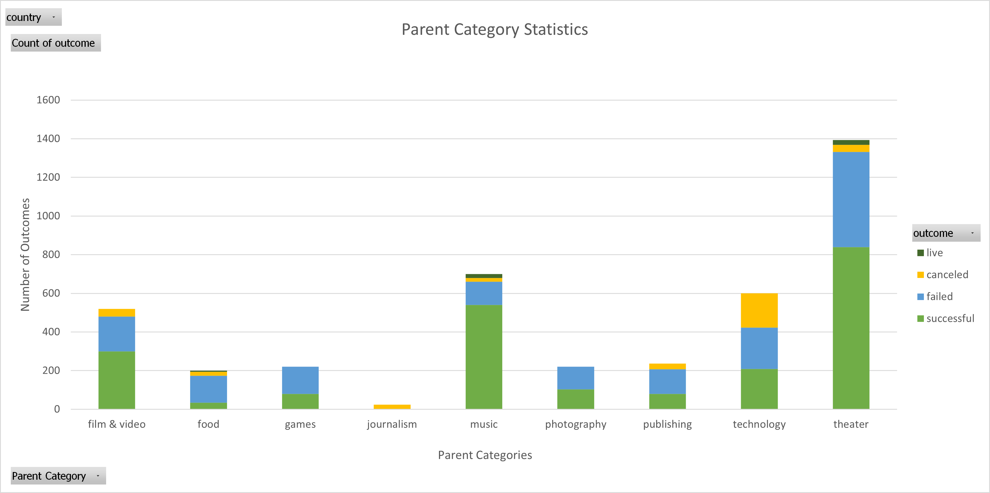

The second pivot chart analyzes the subcategories by counting the number of projects launched for each subcategory. The data can be filtered by country and parent category, and the different outcomes for each project are represented using a color scheme.

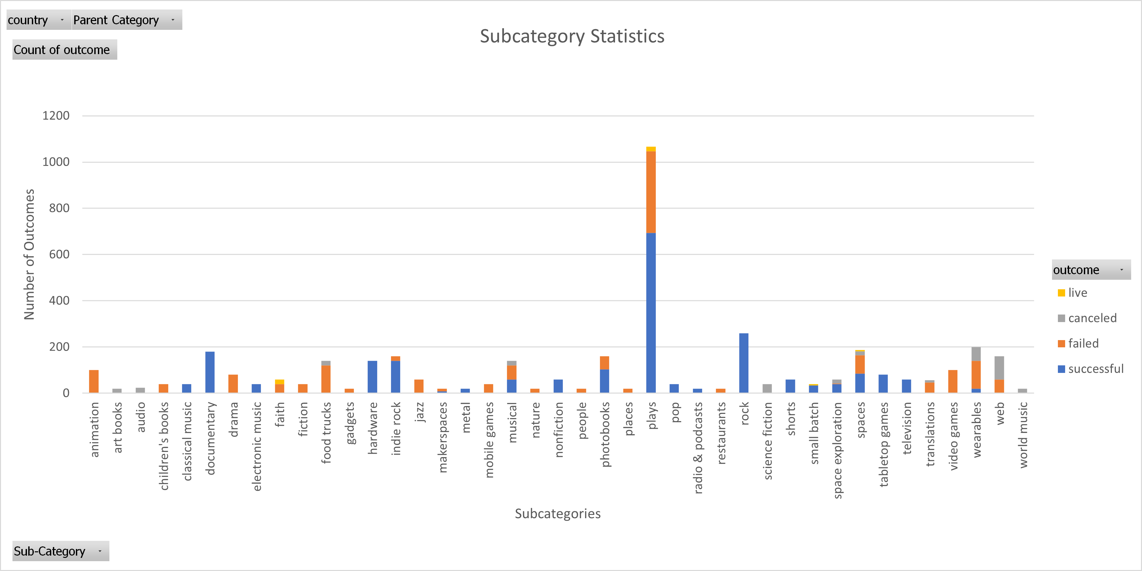

The third pivot chart measures the outcomes of a campaign based on the project’s launch date. The data can be filtered by parent category and year, and the different outcomes for each project are represented using a color scheme. The “live” outcome is filtered out because there are only a handful of “live” outcomes recorded in the data set and those records are present only during the months of January-March.

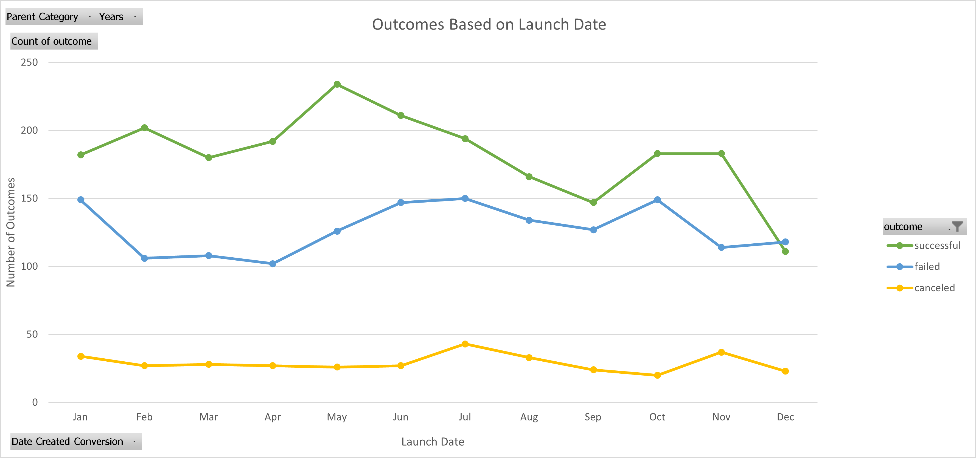

The fourth pivot chart analyzes the distribution of projects by country and uses a bar chart to compare the total number of projects launched by each country. Percentage labels were added above each bar because several countries launched so few projects that the size of their bars cannot be differentiated from other countries that launched different numbers of projects. This chart is found under the second paragraph in the “Limitations” section of this analysis report.

A fifth chart is used to analyze project outcomes based on the project’s initial goal amount and uses ranges of goal amounts to count the number of times each outcome was recorded. The counts are then used to calculate the percentage each outcome occurred by range, and the different outcomes are represented using a color scheme.

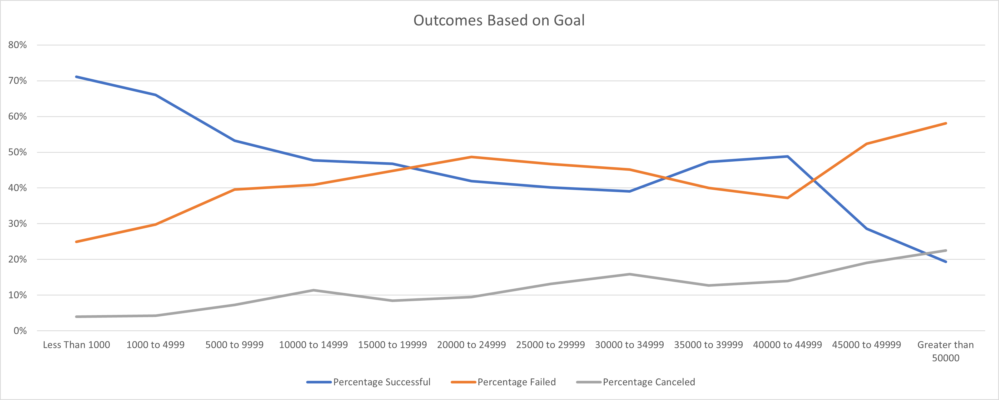
The final pivot chart is used to analyze the unbalanced distribution of projects that were launched by year. The corresponding pivot table counts the number of projects launched each year and divides those counts by the total number of projects in the data to calculate the percentage of projects that were launched each year. The results are visualized using a bar chart and can be filtered by country. This chart can be found under the first paragraph in the “Limitations” section of this analysis report.

Sample:
The sample analyzed was 4,114 projects that were launched from 2009-2017 in 21 different countries taken from a Kickstarter database. All the projects fall under one of nine parent categories which are further broken down into one of forty-one subcategories with a different number of projects launched for each parent category and subcategory.

Personnel included the backers who pledged money towards each project. They were one of the most important elements in determining whether a project succeeded.

Students were also taken into consideration. A trend for the number of successful and failed projects appears during the months that comprise the school year compared to the months when students are out of school.

Instrumentation:
Multiple instruments were used to conduct this analysis. The first instrument was the projects derived from the Kickstarter database. The second instrument was Microsoft Excel which organized the detailed information for the projects analyzed. Many of Excel’s analytical features were used to enhance usability, generate visualizations, and make the data easier to understand. The features utilized for the initial table are conditional formatting to color coordinate the “outcome” and “Percentage Funded” columns as well as Excel functions to convert information into easily understood formats. Lastly, pivot tables and pivot charts were used to summarize the data to display information in a format that can be quickly and easily understood.

Results:
The pivot tables (the tables below) and the pivot chart (the first chart in the Methods section) used to analyze the parent categories imply that categories related to popular forms of entertainment are the most successful. The success rates display an increasing trend as the parent category is related to progressively more popular forms of entertainment. Music’s exceptional success rate may be related to its convenience since music can be listened to anywhere and at any time while all the other parent categories require the person to be in certain places or situations. On the other hand, food, which is the only parent category that is not related to entertainment, has success and failure rates that are nearly inverses of music’s success and failure rates. These contrasting values support the hypothesis that choosing an entertainment related parent category is one of the keys to success.

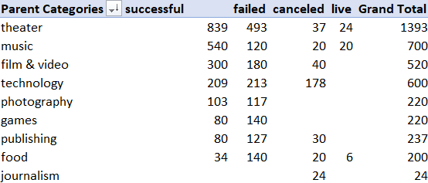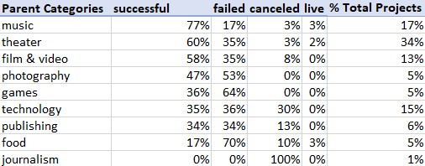

Theater and film & video have identical roles for the viewers, nearly identical success rates and matching failure rates. If the correlation between entertainment and success is accurate, then it makes sense that forms of entertainment that require the participants to do the same thing should have similar success and failure rates. The relationship between forms of entertainment that include identical roles for the participants having nearly identical success and failure rates support the hypothesis that choosing an entertainment related parent category is one of the keys to success.

The success rates of games and publishing are within 1% of technology’s success rate. This may be connected to the popularity of electronic games, such as phone apps and video game consoles, which are directly connected to technology. This could explain why technology’s hardware subcategory, which comprises nearly a quarter of technology’s projects, has a 100% success rate. Publishing’s relationship to technology has to do with the advent of digital information systems that led publishing to expand its scope to include electronic publishing such as ebooks, academic journals, micropublishing, websites, blogs, video game publishing and so on. The similar success rates of entertainment categories that have centers of interest being directly connected to another entertainment category’s center of interest further supports the hypothesis that choosing an entertainment related parent category is one of the keys to success.

The pivot chart (the second chart under “Methods”) used to analyze subcategories displays that almost every parent category has one or two subcategories that more or less determine whether a project is successful. Subcategories with a significant number of projects attempted for the same parent category would often display divergent extremities. The extremities can be so strong that two subcategories with similarly high numbers of projects launched often exhibit one subcategory achieving a 100% success rate while the other subcategory has a 0% success rate.

The line chart used for analyzing the outcomes of a project based on its launch date implies that students have a significant impact on the times of the year that have the highest chance of resulting in a successful project. This pattern is made evident when comparing the points on the chart with the times of the year that students are in school. Students typically have three major breaks from school – spring break, summer vacation, and winter vacation. The number of successful and failed projects start to converge during the months these vacations take place, namely: March for spring break, June-September for summer vacation and December for winter break. Furthermore, the sharpest spikes in successful projects occur in May and October, which are the month before summer vacation starts and one month after summer vacation ends, respectively.

There is a variety of arguments for why this may be the case. One hypothesis is that parents, potential backers, are more likely to put the money they would normally pledge towards paying for activities to keep their children busy, make up for increases in food spending and utility bills and so on as a result of their children being home all day.

A second hypothesis is related to family vacations. Family vacations, which can be costly, usually need more than a weekend to enjoy. As a result, it is common for families to plan their vacations when their children are out of school for long periods so they don’t jeopardize the student’s education. Most parents would prefer to spend their money on family vacations rather than use it for Kickstarter pledges.

In addition to winter break, December may have the history of being the worst month to launch a project for another reason. People spend enormous amounts of money on Christmas shopping every year to the point that many of them use up everything in their savings accounts. The lack of money may explain the sharp drop in the rate of successful projects in December. Also, the amount of time people dedicate to Christmas shopping may not leave people with enough time to manage Kickstarter projects which would explain why the lowest number of projects are launched in December.

Recommendations:
Parent categories should be used as a guide to help get a project started. The number one priority should be choosing the correct subcategory. As this analysis shows, even the most successful parent categories can have subcategories with no history of success.

The time a project is launched also heavily influences a project’s chances of success. People will be more likely to pledge funds during the times of the year when they have more money which will increase the likelihood of achieving the project’s initial goal amount. This analysis concludes that launching a project during the school year when students are in school will lead to a higher chance of success.

Summary:
1) The first key to success for a project is its relationship with entertainment. The more popular the form of entertainment a category focuses on, the more likely a project will be successful. The three most successful parent categories - music, theater, and film & video - are also distinguishable from the rest by how all of them require minimal exertion by the user. This suggests that the most successful projects will focus on the types of entertainment that people can enjoy and help them relax after a busy day.

2) Another key to success involves choosing the correct subcategory. Subcategories have such drastic differences in success rates that the success of a project may be completely determined by choosing the wrong subcategory. The reason behind this is that most parent categories have hit-or-miss subcategories, either a 100% success rate or a 0% success rate.

3) A third key to success is choosing the right time of the year to launch a project. Projects are most likely to be successful during the school year with the exceptions of spring break and winter break. The months with the best chances of success are February, April, and May. March, the month of spring break, is the only reduction in the rate of successful projects from January through May, and the months from June-September, summer vacation, display a consistent decrease in the rate of successful projects. Although winter break may contribute to December’s record low success rate and number of projects launched, the enormous amounts of time and money people spend on Christmas shopping every year may be the main reason for December being the worst month to launch a project.

