World Navigation Hat - Development of a Wearable Navigation Aid using AIoT for the Visually Impaired

An Undergraduate Design Project Presented to Faculty of the
Computer Engineering Department College of Technology
University of San Agustin

In Partial Fulfillment of the
Requirement of the Course
CPE 413 – CpE Practice and Design I
By:
Jason C. D’Souza
Ethel Herna Pabito
ChenLin Wang
Vince Ginno Daywan
Engr. Glenda S. Guanzon
October 2025

TABLE OF CONTENTS
LIST OF TABLES 4
LIST OF FIGURES 5
INTRODUCTION 6
Background of the Study 6
Rationale 8
Objectives of the Study 9
General Objectives 9
Specific Objectives 9
Significance of the Study 10
Scope and Delimitations 14
Related Studies 15
Review Literature 17
Sensory Substitution and Assistive Technology 17
Sensory substitution devices for the visually impaired to enhance environmental perception. 18
Neuroscience of sensory substitution, specifically how the brain adapts to information presented through non-visual channels. 19
Assistive technology for blind individuals, including electronic navigation aids and their effectiveness in real-world environments. 20
Point Cloud Projection for Navigation 21
Point cloud data and its application in environmental modeling . 21
Use of 3D point cloud data in robotics and autonomous navigation to help with the precise location of objects in real-time. 22
Previous work on point cloud visualization technologies and haptic feedback systems for improving spatial awareness in visually impaired individuals. 23
IoT Sensors in Assistive Devices 23
Research on IoT sensors and their integration with assistive technologies, including their role in providing real-time environmental data for blind users. 23
The use of wearable IoT devices (such as smart glasses, smart hats, or vests) for real-time navigation and obstacle detection. 24
Investigations on sensor fusion (e.g., combining ultrasonic, infrared, and vision sensors) to improve the accuracy of navigation systems for the blind. 25
Haptic Feedback and Tactile Interfaces 25
Studies on haptic feedback technology for navigation, including wearable devices that convert data into tactile sensations. 26
Research on the integration of tactile feedback with auditory cues, allowing visually impaired users to navigate using both sensory modalities. 26
Wearable Technology for the Visually Impaired 27
Research on the development of wearable devices such as glasses, hats, or vests that use various sensory inputs (like sound or touch) to help blind individuals navigate. 27
Work on the development of smart hats and headgear with built-in sensors for location tracking and environmental mapping. 27
Studies exploring the effectiveness of wearable navigation aids, including systems that combine environmental sensing, GPS, and real-time feedback. 28
Exploration of real-time object detection and collision avoidance systems for visually impaired individuals, using sensors such as ultrasonic, LiDAR, or radar. 28
Investigation of auditory navigation aids, such as real-time audio feedback systems that guide the user through audio cues about their environment. 28
User studies on the usability and accessibility of wearable technologies for the blind and visually impaired. 29
Research into the human factors in the design of assistive devices, focusing on comfort, ease of use, and learning curve. 29
User-centered design principles and testing of tactile and auditory interfaces in sensory substitution devices. 30
METHODS AND MATERIALS 30
Research Design/Methods 30
Materials and Processes 31
Hardware Material Specification 32
Software Specifications 32
Library and Board Managers 33
System Requirements 34
Prototype Building Procedure 35
Data Presentation & Analysis 36
REFERENCES 37

LIST OF TABLES
Table 1 : Hardware Specification 32
Table 2 : Software Specification 33
Table 3 : Libraries and Board Manages 33

LIST OF FIGURES
Figure 1: IPO Model of the Conceptual Framework of System 12
Figure 2 : Hardware Wireframe of the System 34
Figure 3 : Block diagram of the System 35
Figure 4 : Basic Architecture of the System 36

INTRODUCTION

Background of the Study
Visual impairment is a global health problem that significantly affects individuals' daily lives by impeding independent navigation, social interaction, and overall quality of life (Theodorou et al., 2023). There is an estimation of 2.2 billion people globally who are identified as visually impaired and this number could still increase to 2.5 billion by 2050 as stated by the World Health Organization (WHO) (2023). In the Philippines, 2.17 million Filipinos are identified as visually impaired as quantized by reports from the Philippines Eye Research Institute (PERI) and Department of Health (DOH) (Shinagawa Lasik Center, 2025). (Insert stats for iloilo city once retrieved). Visual impairment does not pertain to total blindness. According to WHO (2023), visual impairment can be identified and categorized based on the presenting visual acuity a) Mild Vision Impairment,visual acuity is better than 6/18, b) Moderate Vision Impairment, visual acuity is worse than 6/18 but better than 6/60, c) Severe Vision impairment, visual acuity is worse than 6/60 but better than 3/60, and d) Blindness, visual acuity is worse than 3/60. Blindness can be further categorized into d.1) Blindness with light perception, individuals can only perceive light and, d.2) Total Blindness, individuals who have no light perception. Other common types include astigmatism, near-sightedness (myopia) and far-sightedness (hyperopia), which account for a large share of impairments, alongside conditions like cataracts, glaucoma, and age-related macular degeneration (AMD), with AMD alone affecting 8.06 million people globally in 2021 (Yon, 2025). Visually impaired individuals face safety concerns and challenges such as accidents, falls, and collisions, as well as difficulties with navigation, including road crossings and destination location (Ikram et al., 2024; Gao et al., 2025; Muhsin et al., 2023). Beyond these practical difficulties, social isolation and reduced access to information further compound the challenges, often limiting educational and employment opportunities (Arvind, 2023). Current existing solutions or aid for visually impaired individuals are guide dogs, white canes, and electronic travel aids (Muhsin et al., 2023).
According to Mishra, A., Bai, Y., Narayanasamy, P., Garg, N., & Roy, N. (2025), sensory substitution devices (SSDs) are assistive technology that converts information typically perceived through one sensory modality into another, enabling individuals with sensory impairments to access environmental cues they lack. In the context of visual impairment, such devices translate visual data, such as depth or object presence, into haptic or auditory signals to assist the visually impaired in perceiving their environment (Jiayu, 2025). This intermodal conversion allows users to develop a novel form of perception, effectively substituting the impaired sense with an intact one, enhancing the understanding of the surroundings(Jiang et al., 2025). These devices could significantly enhance independence by enabling obstacle detection, navigation, and object recognition, particularly for the fully blind who rely on traditional aids like white canes or guide dogs.(Tokmurziyev et al., 2025). However, SSDs are not widely adopted globally due to challenges such as cognitive overload from processing substituted sensory data, extensive training requirements for intuitiveness, ergonomic discomfort in wearables, and processing constraints of non-visual senses like hearing or touch, which have lower bandwidth than vision (Hou et al., 2025) Discuss variables

Rationale
More than 2.17 million people in the Philippines live with visual impairment, which restricts their perception, mobility, navigation, and accessibility to information—depriving them of work opportunities and independence. Wearable SSD is an assistive technology that an individual can wear on their body to supplement a missing sense, helping users navigate both their physical surroundings and digital applications. Additionally, it promotes social interaction that aligns with one of the United Nations' Sustainable Development Goals for health and equality. Supporting local innovation by developing a low-cost, locally made device increases access to technology, thereby enhancing the technology sector.
In previous studies, SSDs have been limited in their applicability, as existing devices often perform poorly in real-world situations, encountering cognitive overload problems that overwhelm users with excessive information, making navigation difficult. Another identified concern is that the device design is uncomfortable, as it is bulky and requires extensive training, which limits its practicality. In addition, many devices lack digital integration as capabilities, focusing mainly on obstacle detection and not connecting well with digital tools. These deficiencies underscore the pressing need for higher SSDs that can outperform and enhance existing devices. Therefore, there is a need for a smart navigation hat that improves the functional efficiency and performance of SSDs. This navigation hat integrates AIoT, introducing a smart navigation hat that uses 3D point cloud data to give audio feedback and connects to IoT services for navigation in both physical and digital environments. Furthermore, it enhances sensory processing, focusing on reducing cognitive overload in the system and making navigation simpler for VIP users. Additionally, the hat features customizable options, including a modular operating system that allows users to choose between gesture or voice commands.

Objectives of the Study

General Objectives
To develop an AIoT visual sensory substitution hat device that converts real-time environment information through emulating human sensory processes into audio cues for the visually impaired people (VIP)

Specific Objectives
- To develop a working photogrammetry (2D to 3D) system that
  - Creates a depth map based on the stereo camera
  - Transforms it into a point cloud projection
  - Matches the point cloud project to existing virtual map with help from IMU
  - Can include additional information such as color and movement
- To develop a system of representing environmental information though audio cues that:
  - Includes different modes of representing audio based on human sensory processes
  - Each mode prioritizes a specific aspect of the environment compromising other aspects
  - The modes can transition from one mode to another
- To develop controllable system that:
  - Recognizes hand gestures given by the user
  - Interprets that hand gesture to a dictionary of instructions
  - Instructions include the current mode of audio representation
  - Instructions can also navigate the operating system
- To develop an AIoT server that:
  - Keep tracks of user’s information such has location, credentials, etc.
  - Use that information to process API requests of that users
  - API methods can include accessing other APIs like Google maps, or towards AI like Language Models
- To develop the modular operating system such that:
  - More features can be added even if the prototype only includes the core features
  - Organizes these features include containers called Applications
  - Applications can be client-sided or server-sided

Significance of the Study
The proposed AIoT navigation hat has the potential to escalate the performance of existing assistive devices by
- Enhancing independence and mobility
- Improving cognitive comfort and ease of use
- Bridging physical and digital accessibility participation
- Promoting Social Inclusion and Employment Opportunities for the VIP
In addition, this system innovates the research for Assistive Technology in the Philippines.
- VIP can navigate safely and confidently with less assistance
- the system simplifies understanding spatial information, reducing mental strain (cognitive overload) and allowing quick interpretation without long training
- with AIoT integration, users can access navigation apps and online services hands-free using voice or gesture commands
- As VIP gain independence, they can engage more in education, work, and community activities, boosting their self-esteem and reducing reliance on others
The project's success may inspire further studies on brain-inspired computing and wearable assistive devices, paving the way for more innovative tools. This project device will specifically benefit to the following:
- Visually Impaired and Blind Individuals. They are the primary beneficiaries, gaining increased mobility, safety, and access to digital and social spaces through sensory substitution and IoT assistance.
- Families and Caregivers. With the device promoting user independence, caregivers will experience reduced physical and emotional strain while maintaining peace of mind about the user’s safety.
- Educators and Accessibility Advocates. Teachers and advocates working with visually impaired students can integrate the technology into learning environments to enhance inclusivity and accessibility. Such as allowing them to access resources and infrastructure that did not take the visually impaired into account (Sites, Media, etc.)
- Medical and Rehabilitation Specialists. Eye health professionals and rehabilitation centers can use the system as a tool for sensory training and mobility rehabilitation programs, especially in fill in aspects the patent lacks or have trouble with.
- Researchers and Engineers in Assistive Technology. The project offers a novel framework that combines virtual world modeling, IoT, and sensory emulation, providing a foundation for future innovations in human-computer interaction and embedded systems.
- Government and NGOs for Disability Support. Organizations involved in disability welfare can adopt or fund similar low-cost solutions to support national accessibility programs and meet inclusive development goals.
Conceptual Framework
Figure 1: IPO Model of the Conceptual Framework of System
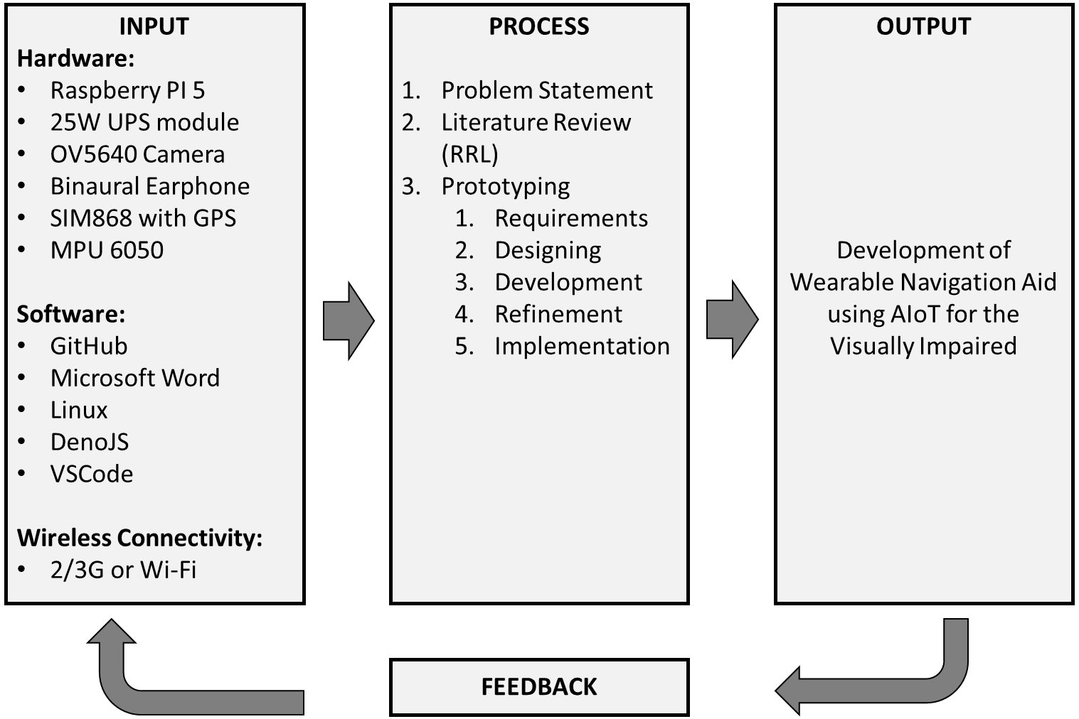

Figure 1 states the conceptual framework of our research in a form of an Input-Process-Output (IPO) model. We start with three kinds of required input such has Hardware for our Microcontroller, Sensors, Actuators, and SIM Module, Software for our Project management, Client-side device, and Server-side device, and the Wireless Connectivity used in our device which can be either 2/3G which is used on deployment doors, or Wi-Fi which is used deployment indoors or development. Our method of research mimics typical development cycle with addition to literature review and research, such has literature review, prototyping, designing, etc. By the end of each iterative development we are to expect to be closer to the end goal, with a feedback from either advisor or mentor to start the cycle again until our end goal of an wearable navigation aid is developed.
Theoretical Framework
This research is grounded in theories of human cognitive senses, such as logarithmic scaling (Weber-Fechner law), where sensory perception is relative to stimulus change, allowing automatic filtering of static elements to prevent overload (Fechner, 1960). Focus scoping draws from attentional theories, prioritizing foveal (central) over peripheral vision to manage information (Orienting of Attention, 1980). We theorize that emulating these processes in SSDs can resolve sensory overload and fatigue by delivering intuitive, context-aware feedback, unlike raw data in traditional devices.
Additionally, modularity is based on user-centered design theory, positing that customizable systems better accommodate diverse impairments and preferences (Norman, 2013). By integrating IoT for generalized situations (e.g., API-driven apps), the framework hypothesizes improved adoption, solving lab-to-real-world gaps through adaptive, brain-like processing.

Scope and Delimitations
Our research focuses on Sensory Substitution Devices, more specifically on Vision Substitution. Our device aims to fill in what different variety of visually impaired individuals lacks, like if fully blind our device should be able to act as an artificial eye providing information the person wants, or if the person is near sighted it could read text from afar from the user and warn of objects rapidly approaching the user, and so on. It does this by having a modular system running the main pipeline, the main pipeline inputs images from the stereo camera, creates a point cloud, maps it to a virtual physical map, follows an algorithm to emulate human vision processes, and finally generate the necessary audio cues for the individual. This pipeline allows applications to take into account more varied needs such has hand gesture recognition to control the parameters of the main pipeline so the person can navigate the device without seeing anything, image recognition to read text near or far, face recognition to recognize friends and family, and even more personalized interest like keeping track of expenses.
This research is conducted in the University of San Agustin and thus the prototype is initially to be tested by the researchers who only half of them are little bit near sighted, our testing sample is to soon include members of Iloilo blind associations such as the Association of Disabled Persons – Iloilo Inc. The main pipeline is prioritized over other features has it is the central component and partially answers the research question of solving existing sensory substitution issues. Has a result our prototype doesn’t take into much consideration the much varied range of visual imparities, and since our study prioritize the main function over the physical design, the prototype would be heavier than what it could be if optimized for weight. However, our main objective is to build the main pipeline and the capability of support applications anywhere in the pipeline (modular operating system) showing it is possible that some of the issues facing most sensory substitution devices could be solved.

Related Studies
Several studies inform our work:
- Stereo Vision Based Sensory Substitution for the Visually Impaired (Simona Caraiman, 2019): The most closest related literature to our research, it also uses stereo camera to extract depth mimicking stereopsis, allows controllable focus (Volume of Interest), and is physically modular allowing swappable sensors. Device name is Sound of Vision (SoV)
- AuralVision (AuralVision, n.d.): Converts depth via ToF lasers to stereo sound; provides depth encoding insights but lacks modularity.
- Eyesynth’s NIIRA (Eyesynth NIRRA, 2021): Uses RealSense D415 for spatial audio; highlights semantic integration, aiding our point cloud approach.
- Unfolding Space Glove (Jakob Kilian, 2022): Haptic feedback for hand-object distance; informs ergonomics but is hand-specific.
- Virtual Whiskers (Junchi Feng, 2024): AI-driven vibration for paths; supports obstacle density mapping in our virtual world.
- Depth Sonification (Louis Commère, 2023): LiDAR-to-repetition rate; guides our spectrogram design for depth.
- SoundSight App (Giles Hamilton-Fletcher, 2021): Mobile color/depth to audio; inspires multi-feature translation.
- Smart Hat (Memoona Sami, 2024): Object detection to voice; aids IoT integration.
- Clearway Companion (Akshay Vijay Panchal, 2024): Haptic/audio with motion; informs user feedback.
- Multi-faceted SSD (Ligao Ruan, 2025): Audio-based curb detection; enhances real-time alerts in our system.
- Multi-path Navigation (Zaidao Han, 2025): Low-vision mobility; supports virtual pathfinding.
- BrainPort Vision Pro (Yiming Zhao, 2025): Functional evaluation; guides our testing protocols.
- Smart Vision Glasses (Devi Udayakumar, 2025): AI-powered glasses; informs gesture/voice interfaces.
The Sound of Vision (SoV) is the most closest to our paper because it similarily attempted to solve the sensory overloading problem through controllable focus radius (VOI) and also partially attempted to solve the limited generalizability issue through modular components. What seperates us is that we explicitly mimic as much human perception like the modes system and that we made this process as a modular pipeline that applications could embed themselves in it allowing navigation in not only the physical but also digital world. This should also solve some issues SoV faces like Training needs and Real-World performance. AuralVision uses ToF lasers for depth-to-stereo sound via bone conduction, achieving lab-based navigation but limited by sensor range (AuralVision, n.d.). Eyesynth’s NIIRA integrates RealSense cameras for semantic audio, outperforming in object recognition but causing overload without human emulation (Eyesynth NIRRA, 2021). Unfolding Space Glove employs haptic motors for distance feedback, effective for grasping but non-wearable for head-based navigation (Jakob Kilian, 2022). Virtual Whiskers uses cameras/AI for vibration belts, reducing collisions by 30% in tests but lacking digital integration (Junchi Feng, 2024). Depth Sonification recommends repetition rates for depth, improving intuitiveness over raw tones (Louis Commère, 2023). SoundSight translates LiDAR/thermal to timbre/volume, enabling color/depth perception on mobiles but app-limited (Giles Hamilton-Fletcher, 2021). Smart Hat detects objects via camera for voice output, cost-effective but non-modular (Memoona Sami, 2024). Clearway uses PIR sensors for haptic alerts, user-friendly but sensor-constrained (Akshay Vijay Panchal, 2024). Newer studies like multi-faceted SSDs show 85% accuracy in curb detection, aligning with our audio focus (Ligao Ruan, 2025). Our work builds on these by adding brain emulation and IoT for superior overload reduction and versatility

Review Literature

Sensory Substitution and Assistive Technology
The incorporation of computing technologies, including smartphones and wearable devices, has transformed human engagement with the environment by granting access to extensive data networks (Real & Araújo, 2023). This progress has profoundly influenced assistive technology, resulting in the development of tools that enhance independence and improve the quality of life for individuals with visual impairments through the fusion of multi-sensor data for navigation and obstacle detection (Muhsin et al., 2023; Theodorou et al., 2023). For instance, algorithms for object detection, when paired with user-friendly interfaces, facilitate greater autonomy in perceiving and navigating surroundings, catering to the needs of over 2.2 billion people affected by visual impairment, a figure expected to increase significantly by 2050 (Ikram et al., 2024; Chandra et al., 2025; Xu et al., 2023). Cutting-edge solutions utilize a variety of sensors and deep learning techniques to convert visual information into alternative sensory signals, such as audio and haptic feedback in smart canes that identify obstacles, moisture, and terrain (Theodorou et al., 2023; Farooq et al., 2022; Ikram et al., 2024; Okolo et al., 2025). Nevertheless, despite these advancements, there remains a challenge of low user acceptance, primarily due to the insufficient involvement of visually impaired individuals in the design processes. This highlights the need for co-creative methodologies that emphasize user experiences to enhance usability and acceptance, while artificial intelligence contributes to navigation and adaptation (Muhsin et al., 2023; Manzoor et al., 2022; Martiniello et al., 2023).

Sensory substitution devices for the visually impaired to enhance environmental perception.
Historically, assistive devices have primarily focused on technical solutions aimed at total blindness, neglecting the needs of individuals with partial vision and usability considerations. Only 35.2% of the aids were assessed by the intended users, resulting in a low rate of adoption (Muhsin et al., 2023; Soltani et al., 2025). For technologies to be effective, they must be designed with the user in mind, incorporating feedback from a wide range of visually impaired individuals, including those with co-existing conditions, to guarantee intuitive usability in practical situations (Muhsin et al., 2023; Ortiz-Escobar et al., 2023). AI-driven tools such as smart glasses and applications utilize computer vision and natural language processing to facilitate independent navigation and access to information, thereby enhancing cognitive capabilities (Naayini et al., 2025; Muhsin et al., 2023; Xie et al., 2024). Nevertheless, there are significant gaps in addressing Cerebral Visual Impairment, which necessitates inclusive research that considers neurological challenges and involves co-design with both users and specialists (Gamage et al., 2025; Arora et al., 2024; Muhsin et al., 2023; Martiniello et al., 2023). This collaborative methodology ensures that new technologies are compatible with existing aids, such as guide dogs, thereby fostering equity and enabling full participation in society, while ongoing development addresses usability challenges (Pucci et al., 2024; Sahoo & Choudhury, 2023).

Neuroscience of sensory substitution, specifically how the brain adapts to information presented through non-visual channels.
Neuroplastic adaptation allows individuals with visual impairments to employ compensatory strategies, reallocating visual cortical resources to improve touch and hearing for spatial awareness and object recognition (Bennett et al., 2019; Due & Lange, 2016). This reorganization fosters the development of new neural pathways for navigation, as evidenced by auditory and tactile frequency mapping for distance perception (Bennett et al., 2019; Jiang et al., 2025). Despite the promising results observed in laboratory settings, sensory substitution techniques have not achieved widespread adoption in real-world applications, necessitating a user-centric design approach and integration with mobility aids (Lloyd-Esenkaya et al., 2020; Soltani et al., 2025). Recent advancements in audio-based virtual reality enable controlled studies aimed at understanding neural mechanisms and enhancing devices for practical implementation (Bleau et al., 2022; Maidenbaum, 2015).

Assistive technology for blind individuals, including electronic navigation aids and their effectiveness in real-world environments.
Sensory substitution devices utilize the brain's plasticity to activate visual cortices for spatial processing through alternative modalities such as hearing or touch, thereby facilitating navigation (Ueda et al., 2019; Netzer et al., 2021; Allum et al., 2022). Virtual reality platforms connect laboratory research with real-world applications by evaluating assistive technologies in ecologically valid settings, incorporating haptic feedback to enhance multisensory experiences (Fialho et al., 2021; Ricci et al., 2023; Kang et al., 2024; Kang et al., 2022). These innovations promote adaptive rehabilitation for conditions such as hemianopia, leveraging neuroplasticity to restore functionality (Lucchesi et al., 2025). Systems like vOICe and EyeMusic transform visual information into auditory landscapes; however, the perceptual discrepancies from natural vision necessitate optimized mappings to alleviate cognitive burden (Ueda et al., 2019; Negen et al., 2023; Tivadar et al., 2023). There is a need for standardization and a more profound understanding of transfer effects to enable practical applications beyond laboratory settings (Culicetto et al., 2024).

Point Cloud Projection for Navigation
Haptic feedback that utilizes tactile and kinesthetic input significantly enhances the sense of "reality" in virtual reality applications for rehabilitation. This improvement fosters depth perception and neuroplasticity through the integration of multi-sensory systems (Muhsin et al., 2023; Wenk et al., 2022; Lerousseau et al., 2021). Participants who are blind are able to identify details within virtual environments following training, employing vibrotactile maps to receive dynamic, multimodal feedback (Memeo et al., 2023; Tivadar et al., 2023). In the context of virtual reality, skin-stretch cues are more effective than vibrotactile cues for indicating the location and movement of objects (Li et al., 2025). Furthermore, digital haptics that utilize ultrasound technology contribute to spatial rehabilitation and the restoration of tactile sensations in prosthetics, effectively mimicking human sensory modalities (Tivadar et al., 2023; Raisamo et al., 2019).

Point cloud data and its application in environmental modeling .
Point cloud data generates intricate 3D representations of environments for virtual and augmented realities, facilitating advanced spatial analysis and interaction with improved tactile feedback (Memeo et al., 2021; Kim et al., 2021). Haptic feedback within these settings provides greater intuitiveness and immersion compared to conventional visualizations, effectively addressing gaps in mixed reality (Masud et al., 2023; Wang, 2024). AI-powered interfaces convert physical objects into haptic props, connecting digital and physical worlds by interpreting user intentions and integrating tactile sensations (Hu et al., 2024; Wang, 2024). Smart environments utilize sensor networks to cater to human needs, thereby improving quality of life, although the lack of haptic feedback in head-mounted displays underscores the necessity for more advanced technologies (Yamaguchi et al., 2024; Wang, 2024). This facilitates complex interactions where virtual objects are perceived as physical, revolutionizing sectors such as health and art through multi-dimensional immersion (Joolee & Uddin, 2024; Kari et al., 2023; Dima & Daylamani-Zad, 2024; Alessandrini & Rognoli, 2023; Yin et al., 2023; Imbesi et al., 2023).

Use of 3D point cloud data in robotics and autonomous navigation to help with the precise location of objects in real-time.
Advancements in neural rendering and artificial intelligence are making 3D content creation more accessible, allowing for the intuitive processing of low-quality point clouds for mixed reality applications (Imbesi et al., 2023; González et al., 2023; Wang, 2024). Mixed reality is being applied in fields such as medicine and industry, providing high-fidelity visualizations that utilize multimodal data to achieve reliable object recognition even in noisy environments (Bonsmann et al., 2024; Wang et al., 2024; Agha et al., 2024). Point clouds facilitate quick object recognition and pose estimation in dynamic environments, enabling the development of 3D semantic models for robotics (Lee et al., 2021; Vishnyakov et al., 2021; Tohidi et al., 2024). Generative AI is capable of creating immersive experiences by merging virtual objects with real-world settings, although issues such as data scarcity continue to pose challenges (Wang, 2024; Ratican et al., 2023; Zhao & Larsen, 2024).

Previous work on point cloud visualization technologies and haptic feedback systems for improving spatial awareness in visually impaired individuals.
Point cloud visualization enhances navigation for visually impaired individuals through non-visual cues, integrating 3D scene understanding with textual descriptions for embodied AI (Zha et al., 2025; Zhu et al., 2024; Liu et al., 2024). Computational demands in Web-AR frameworks require optimized structures like Octrees for real-time mobile interaction (Kharroubi et al., 2020).

IoT Sensors in Assistive Devices
IoT sensors provide real-time data, combined with AI point cloud analysis, for enhanced navigational aids and object recognition for visually impaired users (Kharroubi et al., 2020). Integrating 3D understanding with generative AI enables interactive environments, addressing static scene limitations (Qian, 2024).

Research on IoT sensors and their integration with assistive technologies, including their role in providing real-time environmental data for blind users.
Multimodal large language models are capable of processing video feeds for interactions in the real world; however, they face challenges related to dynamics, accuracy, and trust (Chang et al., 2025; Ainary, 2025; Xie et al., 2024). The involvement of visually impaired individuals in user-centered design is crucial for achieving efficacy, particularly in addressing the underrepresentation of datasets (Muhsin et al., 2023; Xie et al., 2025; Karamolegkou et al., 2025; Sahoo & Choudhury, 2023; Sheng et al., 2024). The expansion of sensors, such as depth cameras, improves data quality and promotes the development of vision-to-audio/touch translators through interdisciplinary research (Muhsin et al., 2023; Chang et al., 2025). Collaborative design efforts with users and professionals lead to the creation of robust and adaptable aids that are informed by real-life experiences (Martiniello et al., 2023; Ortiz-Escobar et al., 2023).

The use of wearable IoT devices (such as smart glasses, smart hats, or vests) for real-time navigation and obstacle detection.
Wearable IoT devices, which are integrated with applications, preprocess sensor data to provide directional guidance and enhance security, thereby improving user independence (Ikram et al., 2024; Soltani et al., 2025). Comprehensive feedback and active user participation are essential for ensuring the devices' utility, with evaluations conducted in real-world environments to confirm reliability (Martiniello et al., 2023; Ortiz-Escobar et al., 2023; Messaoudi et al., 2022; Muhsin et al., 2023). These devices utilize cameras and ultrasonic technology, which are processed by microcontrollers or artificial intelligence, to deliver haptic, auditory, or speech-based feedback (Farooq et al., 2022; Ikram et al., 2024; Soltani et al., 2025; Bouteraa, 2021). Smart hats and walking sticks employ machine learning for detection purposes, incorporating GPS for alerts and enabling the identification of terrains and dynamics that surpass the capabilities of traditional aids (Muhsin et al., 2023; Farooq et al., 2022; Okolo et al., 2025). Vests are designed to provide tactile feedback; however, there are challenges related to data fusion and processing that require further optimization (Muhsin et al., 2023; Oladele et al., 2021).

Investigations on sensor fusion (e.g., combining ultrasonic, infrared, and vision sensors) to improve the accuracy of navigation systems for the blind.
Sensor fusion integrates ultrasonics, infrared, and cameras to achieve a comprehensive understanding of the environment, employing Kalman filters or deep learning techniques (Bala et al., 2023; Farooq et al., 2022; Ikram et al., 2024; Theodorou et al., 2023). There are discrepancies in the comparison between research and commercial methodologies, with innovative devices designed to tackle transparent obstacles (Theodorou et al., 2023; Bai et al., 2017; Muhsin et al., 2023). These systems utilize data from Kinect and RealSense to handle various obstacles, drawing inspiration from autonomous vehicle technology (Muhsin et al., 2023; Toro et al., 2021; Kolar et al., 2020; Kovács & Nagy, 2020). Adaptive feedback mechanisms, including haptic responses, alleviate the burden in noisy settings, while machine learning enhances precision (Bai et al., 2017; Gao et al., 2025; Ikram et al., 2024; Manzoor et al., 2022). Techniques such as LiDAR and RGB-D combined with YOLOv5 enhance mapping capabilities, although prototypes require thorough user evaluation (Mai et al., 2024; Oladele et al., 2021; Warule et al., 2024; Muhsin et al., 2023; He & Saha, 2023; Maya-Martínez et al., 2023; Ikram et al., 2024).

Haptic Feedback and Tactile Interfaces
Haptic and tactile interfaces provide alternative information delivery, beneficial in noisy environments, conveying spatial data through vibrations or pressure (Angelopoulos et al., 2019; He & Saha, 2023; Martiniello et al., 2023). Integrating with cross-modal learning enhances interpretation, improving awareness (Muhsin et al., 2023; Gao et al., 2025; Tivadar et al., 2023; Dudley et al., 2023; Memeo et al., 2023; Zhu & Yang, 2023). Vibrotactile patterns aid VR locomotion and non-visual presentation (Anderton et al., 2024; Khusro et al., 2022; Joolee & Uddin, 2024).

Studies on haptic feedback technology for navigation, including wearable devices that convert data into tactile sensations.
Skin-stretch cues effectively convey spatial data over vibrotactile, though continuous vibrations limit graphic exploration (Li et al., 2025; Zhao et al., 2020). Variations in intensity and frequency encode nuanced information, with microdevices supplementing senses (Anderton et al., 2024; Jiang et al., 2025; Nyasulu et al., 2021). Integration with AI enhances guidance, improving autonomy (Paratore & Leporini, 2023; Tokmurziyev et al., 2025; Muhsin et al., 2023). Exploration strategies align with natural behaviors, with advancements enabling complex sensations (Sadia et al., 2021; Tivadar et al., 2023; Stein et al., 2023).

Research on the integration of tactile feedback with auditory cues, allowing visually impaired users to navigate using both sensory modalities.
Multimodal approaches enhance spatial understanding in digital environments, with ultrasonic haptics conveying layouts (Giraud et al., 2017; Tivadar et al., 2023; Vardar et al., 2018). Surface haptics expand to various surfaces, integrating sensations with audiovisuals for immersion (Başdoğan et al., 2020; Yang et al., 2025; Lim et al., 2024).

Wearable Technology for the Visually Impaired
Wearables use haptic vibrations for navigation, enhancing mobility and awareness (Tachiquin et al., 2021; Muhsin et al., 2023; Reinhardt et al., 2019). Miniaturization improves integration, though human factors and impairment degrees affect adoption (Muhsin et al., 2023). Foot-placed interfaces translate instructions effectively, with users finding them useful (Tachiquin et al., 2021). Glasses with AR provide multimodal cues, reducing mental load via adaptive interfaces (Ren et al., 2025; Parker et al., 2021). Multimodal feedback balances information, with personalization optimizing accessibility (Ren et al., 2025; Parker et al., 2021; Bai et al., 2017; Lupu et al., 2020; Wang et al., 2020; Muhsin et al., 2023; Khusro et al., 2022; Parker et al., 2021).

Research on the development of wearable devices such as glasses, hats, or vests that use various sensory inputs (like sound or touch) to help blind individuals navigate.
This focus on diverse wearable form factors underscores a design philosophy that prioritizes hands-free operation and seamless integration with daily activities, aligning with user preferences for discrete and convenient assistive technologies (Parker et al., 2021).

Work on the development of smart hats and headgear with built-in sensors for location tracking and environmental mapping.
Smart hats integrate with apps for multimodal feedback, guiding through environments (Ohn-Bar et al., 2018). User-centric design addresses needs, with real-time adjustments enhancing accuracy (Muhsin et al., 2023; Soltani et al., 2025; Ohn-Bar et al., 2018; Parker et al., 2021). Personalized solutions build mental maps, though gaps in integrating with existing aids persist (Soltani et al., 2025; Abidi et al., 2024).

Studies exploring the effectiveness of wearable navigation aids, including systems that combine environmental sensing, GPS, and real-time feedback.
Research needs to address indoor-outdoor transitions and transit integration, identifying essential cues (Parker et al., 2021; Messaoudi et al., 2022). Analyses of methods like speech recognition and deep learning are critical for inclusive interfaces (Messaoudi et al., 2022; Martiniello et al., 2023). AI enhances detection, but user participation ensures alignment with needs (Martiniello et al., 2023).

Exploration of real-time object detection and collision avoidance systems for visually impaired individuals, using sensors such as ultrasonic, LiDAR, or radar.
Fusion efficacy depends on algorithms for diverse conditions, optimizing for navigation tasks (Oladele et al., 2021; Martiniello et al., 2023; Muhsin et al., 2023). Human-centered design avoids overload, with benchmarking against commercial solutions needed (Martiniello et al., 2023; Muhsin et al., 2023; Theodorou et al., 2023; Ikram et al., 2024). Deep learning processes images for classification, drawing from autonomous vehicles (He & Saha, 2023; Theodorou et al., 2023; Farooq et al., 2022; Ikram et al., 2024; Nawaz et al., 2023; Toro et al., 2021).

Investigation of auditory navigation aids, such as real-time audio feedback systems that guide the user through audio cues about their environment.
Personalized soundscapes convey information, balancing richness and load (Muhsin et al., 2023; Ikram et al., 2024). Haptic augments auditory for awareness (Muhsin et al., 2023; Farooq et al., 2022; Shukurov, 2024; Okolo et al., 2025). Systems like VocalEyes provide descriptions, though refinements in language generation are needed (Chavan et al., 2024; Choi et al., 2025).

User studies on the usability and accessibility of wearable technologies for the blind and visually impaired.
Studies explore integration into routines and impact on mobility, with feedback modalities affecting performance (Choi et al., 2025; Oladele et al., 2021; Meinhardt et al., 2025). Personalization improves experiences, with multimodal cues enhancing awareness (Nadolskis, 2021; Wang et al., 2024). Gaps in VR locomotion accessibility require guidelines and empirical data (Anderton et al., 2024; Cardoso & Perrotta, 2019).

Research into the human factors in the design of assistive devices, focusing on comfort, ease of use, and learning curve.
Optional features allow customization, with adaptive algorithms optimizing feedback (Dudley et al., 2023; Wang et al., 2024; Sahoo & Choudhury, 2023). Interdisciplinary collaborations ensure effective development under "Nothing About Us Without Us" (Zheleva et al., 2024; Dudley et al., 2023; Ortiz-Escobar et al., 2023; Bonello et al., 2023). Comfort encompasses psychological aspects, with neuro-ergonomics enhancing symbiosis (Hutson, 2023; Bonello et al., 2023). Features like voice control and affordability aid adoption (Arora et al., 2024; Bonello et al., 2023; Ortiz-Escobar et al., 2023).

User-centered design principles and testing of tactile and auditory interfaces in sensory substitution devices.
Principles emphasize wearability, intuition, and non-interference, with iterative user feedback refining designs (Bonello et al., 2023; Ortiz-Escobar et al., 2023). Participatory approaches align with experiences, avoiding overload (Ortiz-Escobar et al., 2023; Muhsin et al., 2023; Arora et al., 2024; Jiang et al., 2025; Zhao et al., 2020; Sait et al., 2020). Ignoring involvement leads to failures, highlighting needs for diverse testing (Muhsin et al., 2023; Ortiz-Escobar et al., 2023). Iterative testing uses objective and subjective measures for efficacy (Jiang et al., 2025; Senjam et al., 2021; Ortiz-Escobar et al., 2023). Incorporating contexts addresses constraints, ensuring applicability (Ortiz-Escobar et al., 2023; Muhsin et al., 2023).

METHODS AND MATERIALS

Research Design/Methods
The main process translates visual/environmental data to audio/haptic via stereo projection to point clouds, spectrograms, and binaural output through emulating human sensory processes. Secondary processes network users via IoT for sensor/actuator/API interactions (e.g., maps, weather). Qualitative research tests comfort, overload, and modularity through user experiments: Physical proficiency (obstacle navigation, movement detection, ball catching); Digital proficiency (communication, browsing). Timeline: Concept (Aug 2025), Prototype (Sep 2025), Testing (Oct 2025), Paper/Defense (Nov 2025). Ethical considerations: Informed consent, privacy via API security, inclusivity in design. For the main processes that emulates human sensory processes, these processes are grouped into modes that the user can gradually switch to through hand gestures but if there is no hand detected then there is no audio generated. Modes includes:
- Nothing – There is no hand so don’t generate any audio
- Complete – The whole front view of the user is translated into audio cues, the depth is mapped to volume, the vertical placement is mapped to frequency, and the horizontal placement is mapped to Binaural channels. This audio map is however smoothened out through blurring to give a general and summarized environment (Triggered if a back whole hand is detected)
- Focused - The visual close to the center of the user is translated to audio cues and gradually fades off has it goes away from the origin point, here color is included has the audio texture (Triggered if a back closed hand is detected)
- Movement - Any movement across the user is transformed into audio cues (Triggered if a back closed hand with thumbs up is detected)
- Text - Reads the text infront of the user (Triggered if back closed hand with index finger up)
- Face - Gives a unique audio cue representing the user's face structure (Triggered if back closed hand with thumbs up and index finger is up)

Materials and Processes
Inputs Visual via cameras, audio/commands via microphone. Processes Convert to 3D environment/point clouds, emulate human shortcuts (logarithmic changes, focus prioritization), apply equal-loudness contours, Fourier transform to audio. Outputs Selected audio slices. Data flow is from Stereo images → Depth map (Q matrix) → Point cloud (X,Y,Z) → Scaled virtual map → Prioritized info → Spectrogram/audio.

Hardware Material Specification
Table 1 : Hardware Specification
Quantity | Material | Description
1 | Raspberry PI 5, 8GB RAM (Raspberry PI Zero 2W if feasible) | Main controller
1 | UPS Module (25W if PI 5, else 12.5W) | Power supply
2 | OV5640 USB Camera 5MP and 160° POV | Image input
1 | Wired Binaural Earphone with Microphone | Audio input and output
1 | SIM868 with GPS | Internet and GPS access
1 | MPU 6050 | Orientation detection

Software Specifications
To format the SD card, a bash script is executed through Ubuntu a Debian-based linux operating system to install Raspberry PI into the SD card, the main program for the device uses C++ has the main program running OpenCV to process the images and virtual worlds. In the server the device is connected to, it runs DenoJS and Puppeteer to keep track of IoT data and run automation scripts connecting to other services like Meta, or Ollama of AI

Table 2 : Software Specification
Software | Description
GitHub | Version Control
Microsoft Word | Documentation
Linux (Modified Raspberry PI OS) | Operating System
DenoJS | IoT Central Server
Ollama | IoT Server Assistant
VSCode | IDE

Library and Board Managers
Table 3 : Libraries and Board Manages
Library | Description
OpenCV (Python) | Image Processing
Langchain (NPM) | Allows language model through Ollama
MediaPipe (Python) | Hand gesture recognition

System Requirements

Figure 2 : Hardware Wireframe of the System
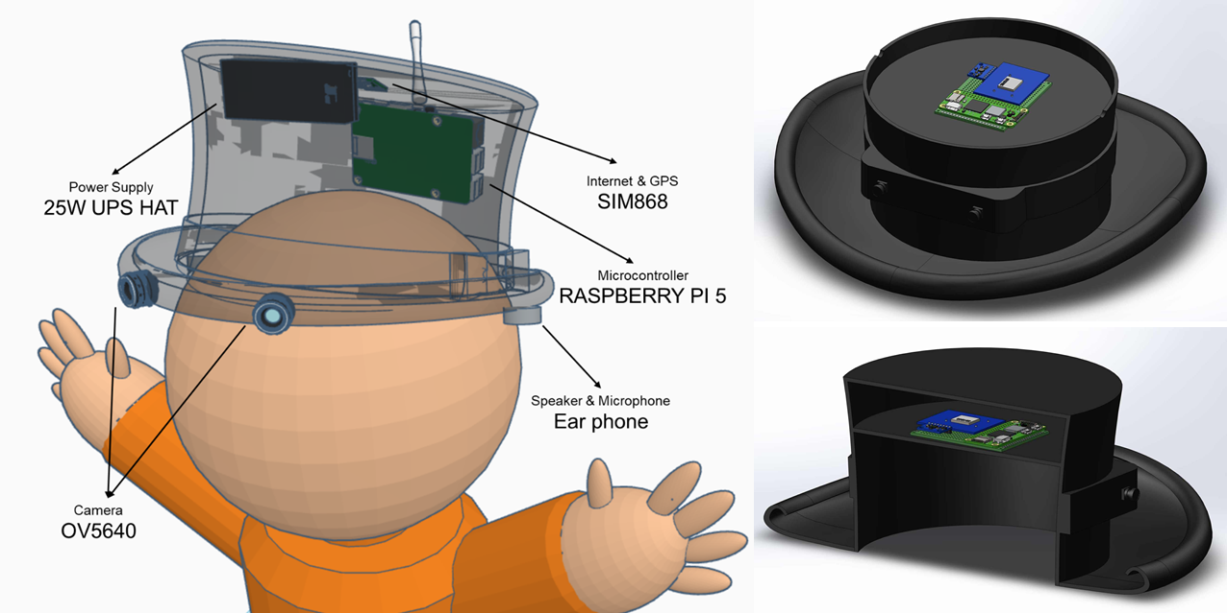
Figure 2 shows the placement of the components, the two cameras are to be placed parallel to each other at the same distance so that the Stereo can working properly, the UPS and Raspberry PI should be on top of the hat to prevent the heat from transferring into the person’s head, the speaker is to be attached to the hat near the ear so that the device is has simple has wearing the hat and no need to manually put the earphones near the head. The SIM868 and antenna is located in the very top to minimize has much signal blocking possible to maximize possible signal strength

Prototype Building Procedure

Figure 3 : Block diagram of the System
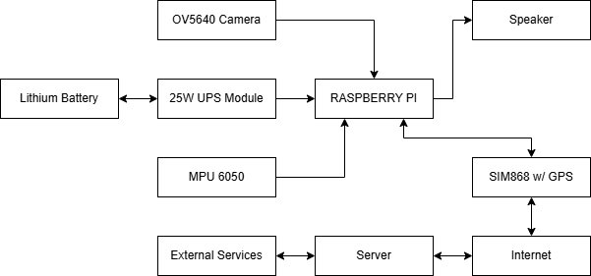
Figure 3 explains how to build the setup by connections, it first starts with the Raspberry PI which is powered by a 25W (5V at 5A at high performance) UPS module that is connected to a lithium battery, it reads from two primary sensors the Camera for visual information, and the MPU 6050 to position the generated point cloud. After all is processed the raspberry pi and it additional applications can send the API request to the server through the SIM868, where the server can process the request through external services like AI models or external APIs like google maps, the response is then retrieved by the raspberry pi. After all is done the final generated audio cue is sent to the speakers.

Figure 4 : Basic Architecture of the System
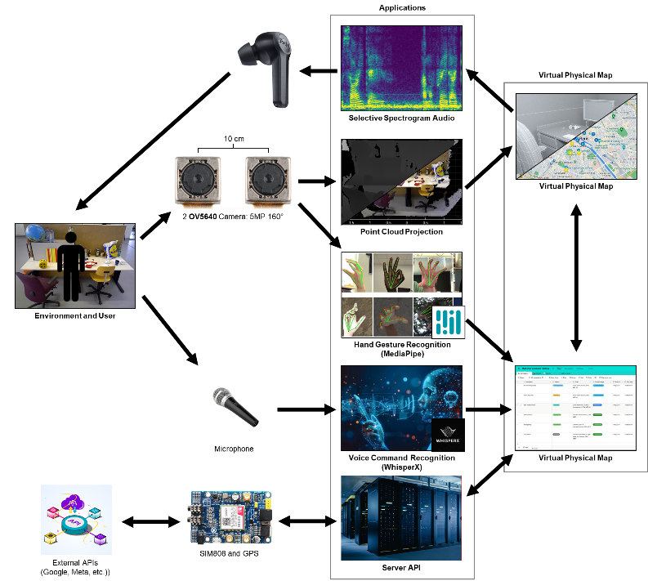

Data Presentation & Analysis
- Stereo Projection Formula: Makes a depth map from the two stereo cameras
$$C_{1}=\left[\begin{matrix}\begin{matrix}f & 0 \\ 0 & f \\ 0 & 0\end{matrix} & \begin{matrix}cx_{1} & 0 \\ cy & 0 \\ 1 & 0\end{matrix}\end{matrix}\right],C_{2}=\left[\begin{matrix}\begin{matrix}f & 0 \\ 0 & f \\ 0 & 0\end{matrix} & \begin{matrix}cx_{2} & T_{x}f \\ cy & 0 \\ 1 & 0\end{matrix}\end{matrix}\right], ∴Q=\left[\begin{matrix}\begin{matrix}\begin{matrix}1 & 0 \\ 0 & 1\end{matrix} \\ \begin{matrix}0 & 0 \\ 0 & 0\end{matrix}\end{matrix} & \begin{matrix}\begin{matrix}0 & -cx_{1} \\ 0 & -cy\end{matrix} \\ \begin{matrix}0 & f \\ -T_{x}^{-1} & T_{x}^{-1}c\left(x_{1}-x_{2}\right)\end{matrix}\end{matrix}\end{matrix}\right]$$
- Point Cloud Projection Formula: Makes a point cloud from a depth map
$$\left[\begin{matrix}\begin{matrix}X \\ Y\end{matrix} \\ \begin{matrix}Z \\ W\end{matrix}\end{matrix}\right]=Q\left[\begin{matrix}\begin{matrix}x \\ y\end{matrix} \\ \begin{matrix}disparity(x,y) \\ 1\end{matrix}\end{matrix}\right]$$

REFERENCES
(n.d.). Retrieved from AuralVision: https://auralvision.org/
(1980). In M. I. Posner, Orienting of Attention (pp. 32(1), 3-25). Quarterly Journal of Experimental Psychology.
Akshay Vijay Panchal, M. C. (2024, April 27). Clearway Companion - an Ai Powered Aid for Visually Impaired. Retrieved from SSRN: https://papers.ssrn.com/sol3/papers.cfm?abstract_id=4809356
Cristina Eusebio, H. K. (2007, December). Rapid assessment of avoidable blindness in Negros Island and Antique District, Philippines. Retrieved from ResearchGate: https://www.researchgate.net/publication/6268823_Rapid_assessment_of_avoidable_blindness_in_Negros_Island_and_Antique_District_Philippines
Cruz, B. D. (2023, March 13). Population of visually impaired in Iloilo City. Retrieved from Freedom of Information Philippines: https://www.foi.gov.ph/requests/population-of-visually-impaired-in-iloilo-city/
Cubillan. (2025, May 27). Perfect Vision and Eye Health in the Philippines. Retrieved from Shinagawa Lasik & Aesthetics: https://shinagawa.ph/perfect-vision-and-eye-health-in-the-philippines/
Devi Udayakumar, S. G. (2025, May 30). Artificial intelligence-powered smart vision glasses for the visually impaired. Retrieved from National Center for Biotechnology Information: https://pmc.ncbi.nlm.nih.gov/articles/PMC12178407/
Eyesynth NIRRA. (2021). EE Journal. Retrieved from RealSense: https://realsenseai.com/case-studies/powering-sonic-vision-for-the-blind/
Farina, M. (2013, April 4). Neither touch nor vision: sensory substitution as artificial synaesthesia? In M. Farina, Biology & Philosophy (pp. 32(4), 639-655). Pringer Nature. Retrieved from PhilArchive: https://philarchive.org/rec/FARNTN
Fechner, G. T. (1960). Elemente der Psychophysik. Breitkopf und Härtel.
Fleck, A. (2024, January 4). Vision Loss Predicted to Surge 55% by 2050. Retrieved from Statista: https://www.statista.com/chart/31502/expected-number-of-people-with-vision-loss-globally/
Giles Hamilton-Fletcher, J. A. (2021, July 2). SoundSight: a mobile sensory substitution device that sonifies colour, distance, and temperature. Retrieved from Home | SpringerLink: https://link.springer.com/article/10.1007/s12193-021-00376-w
Hoffmann, R. M., Spagnol, S. P., Kristjánsson, Á. P., & Unnthorsson, R. P. (2018, September). Evaluation of an Audio-haptic Sensory Substitution Device for Enhancing Spatial Awareness for the Visually Impaired. Retrieved from Optometry and Vision Science: https://journals.lww.com/optvissci/fulltext/2018/09000/evaluation_of_an_audio_haptic_sensory_substitution.10.aspx
Jakob Kilian, A. N. (2022, Febuary 26). The Unfolding Space Glove: A Wearable Spatio-Visual to Haptic Sensory Substitution Device for Blind People. Retrieved from PubMed: https://pubmed.ncbi.nlm.nih.gov/35271009/
Jamie Ward, P. M. (2010). Visual experiences in the blind induced by an auditory sensory substitution device. In P. M. Jamie Ward, Consciousness and Cognition (p. March). ELSEVIER.
Jr., M. J. (2024, April 8). Country report from the Philippines to the mid-term regional general assembly, Thailand, 27-29 November 2023. Retrieved from World Blind Union - Asia Pacific: https://wbuap.org/archives/1587
Junchi Feng, G. H.-F.-R. (2024, August 26). Haptics-based, higher-order Sensory Substitution designed for Object Negotiation in Blindness and Low Vision: Virtual Whiskers. Retrieved from arXiv: https://arxiv.org/abs/2408.14550
Ligao Ruan, G. H.-F.-R. (2025, Febuary 1). Multi-faceted sensory substitution using wearable technology for curb alerting: a pilot investigation with persons with blindness and low vision. Retrieved from Taylor & Francis Online: https://www.tandfonline.com/doi/full/10.1080/17483107.2025.2463541
Lijuan Que, Z. Q. (2025, April 29). An analysis of the global, regional, and national burden of blindness and vision loss between 1990 and 2021: the findings of the Global Burden of Disease Study 2021. Retrieved from Frontiers | Publisher of peer-reviewed articles in open access journals: https://www.frontiersin.org/journals/public-health/articles/10.3389/fpubh.2025.1560449/full
Louis Commère, J. R. (2023, April 11). Evaluation of short range depth sonifications for visual-to-auditory sensory substitution. Retrieved from arXiv: https://arxiv.org/abs/2304.05462
Macpherson, F. (2018). Sensory substitution: A new perceptual experience? In F. Macpherson, Sensory Substitution and Augmentation (pp. 162-174). Oxford University Press.
Maidenbaum, S. (2015, October 26). Sensory Substitution Training for Users Who Are Blind with Dynamic Stimuli, Games and Virtual Environments. Retrieved from ACM Digital Library: https://dl.acm.org/doi/10.1145/2700648.2811324
Memoona Sami, D. A. (2024, December). Efficient Object Detection and Voice-Assisted Navigation for the Visually Impaired: The Smart Hat Approach. Retrieved from Sukkur IBA Journals: https://journal.iba-suk.edu.pk:8089/SIBAJournals/index.php/sjcms/article/view/1535/469
Norman, D. (2013). The Design of Everyday Things. New York: Basic Books.
Norton, H. (2024, September 12). The most and least visually impaired countries worldwide. Retrieved from Compare the market: https://www.comparethemarket.com.au/health-insurance/features/visually-impaired-countries-2024/
Otilia Zvorișteanu, S. C.-G. (2021, July 6). Sensory Substitution for the Visually Impaired: A Study on the Usability of the Sound of Vision System in Outdoor Environments. Retrieved from MDPI - Publisher of Open Access Journals: https://www.mdpi.com/2079-9292/10/14/1619
Paul Bach-y-Rita, S. W. (2003). Sensory substitution and the human–machine interface. In S. W. Paul Bach-y-Rita, Trends in Cognitive Sciences (pp. 7(12), 541-546). Cell Press.
Shachar Maidenbaum, S. H.-R.-T. (2014, December 1). The “EyeCane”, a new electronic travel aid for the blind: Technology, behavior & swift learning. Retrieved from Sage Journals: https://journals.sagepub.com/doi/abs/10.3233/RNN-130351
Simona Caraiman, O. Z. (2019, June 20). Stereo Vision Based Sensory Substitution for the Visually Impaired. Retrieved from National Library of Medicine: https://pmc.ncbi.nlm.nih.gov/articles/PMC6630569/
W.H.O. (2023, August 10). Blindness and vision impairment. Retrieved from World Health Organization: https://www.who.int/news-room/fact-sheets/detail/blindness-and-visual-impairment
Yiming Zhao, S. Y. (2025, April 29). Evaluation of the Efficacy of an Assistive Device for Blind People: A Prospective, Non-Randomized, Single Arm, and Open Label Clinical Trial. Retrieved from Taylor & Francis Online: https://www.tandfonline.com/doi/full/10.1080/02713683.2025.2495212
Yon, D. K. (2025, June 25). Global burden of vision impairment due to age-related macular degeneration, 1990–2021, with forecasts to 2050: a systematic analysis for the Global Burden of Disease Study 2021. Retrieved from PubMed Central: https://pmc.ncbi.nlm.nih.gov/articles/PMC12208786/
Zaidao Han, S. L. (2025, August 27). Multi-path sensory substitution device navigates the blind and visually impaired individuals. Retrieved from ScienceDirect: https://www.sciencedirect.com/science/article/pii/S0141938225002379

