HCI - By Tim van der Toorn Vrijthoff
1.1: HCI was born from Human Factors, basically HCI but applied to any system: the scientific discipline concerned with the understanding of interactions among humans and other elements of a system. HCI draws from psychology, sociology, anthropology, cognitive science, computer science, and linguistics.
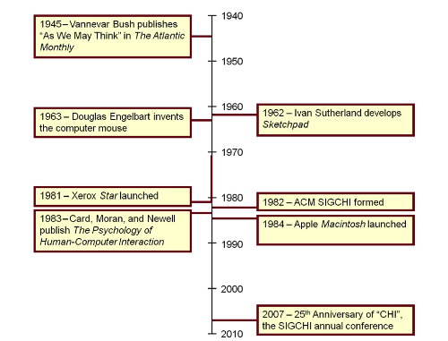
Bush-> Sketchpad-> Mouse-> XeroxStar-> ACM SIGCHI-> Card-> Macintosh
1.2: Bush was the U.S. government’s Director of the Office of Scientific Research and a scientific advisor to President Franklin D. Roosevelt. During World War II, he was charged with leading some 6,000 American scientists in the application of science to warfare. Bush wrote: the summation of human experience is being expanded at a prodigious rate, and the means we use for threading through the consequent maze to the momentarily important item is the same as was used in the days of square-rigged ships.
Aside from the reference to antiquated square-rigged ships, what Bush says we can fully relate to today, especially his mention of the expanding human experience in relation to HCI. For most people, nothing short of Olympian talent is needed to keep abreast of the latest advances in the information age. Bush’s consequent maze is today’s information overload or lost in hyperspace. Bush’s momentarily important item sounds a bit like a blog posting or a tweet.
Bush proposed navigating the knowledge maze with a device he called memex. Among the features of memex is associative indexing, whereby points of interest can be connected and joined so that selecting one item immediately and automatically selects another: hyperlinks and bookmarks. Although today it is easy to equate memex with hypertext and the World Wide Web, Bush’s inspiration for this idea came from the contemporary telephone exchange, which he described as a “spider web of metal, sealed in a thin glass container”.The maze of connections in a telephone exchange gave rise to Bush’s more general theme of a spider web of connections for the information in one’s mind, linking one’s experiences.

1.3: Sketchpad was the first direct manipulation interface, features included visibility of objects, incremental action, rapid feedback, reversibility, exploration, syntactic correctness of all actions, and replacing language with action. Compared to command-line: conversing with instead of writing to the computer. Compared with modern GUI: Conversing with instead of controlling the computer.
1.4: Doug Engelbart's NLS system (1963) as the first working hypertext system:
NLS, for oN-Line System, also the first system with mouse based input
advantages of the mouse over the light pen:
Fatigue often set in fast with the light pen, as the user held the device in the air.
the testing of the mouse as the first "modern" HCI user study (1967):
Multiple devices were tested, such as the light pen, mouse, joystick and knee-controlled lever. It contained what is expected today in a user study destined for presentation at a conference and publication in a conference proceedings. For example, the write-up contained a detailed description of the participants, the apparatus, and the procedure. The study could be reproduced if other researchers wished to verify or refute the findings. The evaluation included an independent variable, input method, with six levels. There were two dependent variables, task completion time and error rate. The order of administering the device conditions was different for each participant, a practice known today as counterbalancing. In short, the study contained and had as goal what a modern HCI study would have as well; to find out how to make humans and computers interact in the best way.
1.5: First appearance of the mouse as a product outside the lab by the Xerox Star in 1981:
The story of the Star began around 1970, when Xerox established its research center, PARC, in Palo Alto, California. The following year, Xerox signed an agreement with SRI licensing Xerox to use Engelbart’s invention, the mouse.
the underlying development of the hardware and software to support its graphical user:
The development of Alto, the Star’s predecessor, began in 1973. The Alto also included a GUI and mouse. It was used widely at Xerox and at a few external test sites. However, the Alto was never released commercially.
interface (GUI) with windows, icons, menus and a pointing device (WIMP):
developed over the course of 10 years from the ground up.
what-you-see-is-what-you-get (WYSISYG) style interaction:
Interact in the text directly, such as google docs works currently.
desktop metaphor:
Everything on your computer is a metaphor. Your ‘files’, ‘documents’, etc. When a metaphor is present, the user has a jump-start on knowing what to do. The user exploits existing knowledge from another domain.
Ethernet cable-based networking, event-driven programming etc:
Event-driven programming puts the user in charge. Programm so that you can go from Arial to Times New Roman to bold Times New Roman to Italics Arial. In any way the user would like. Much more complicated than sequential-programming.
Overall, the Xerox Star was the first try at a personal workstation, although a failed one, with lots of concepts from HCI kept in mind.

1.6: First ACM SIGCHI conference ("CHI") in 1983:
CHI is the event in HCI, and the yearly pilgrimage to attend is often the most important entry in the calendar for those who consider HCI their field. CHI papers have a high impact on the
field of HCI.
Publication of the book "The psychology of human-computer interaction" in 1983 by Card, Moran and Newell and its contributions to connecting the study of low-level human processes with interaction tasks, the idea of the "model human processor":
The book emerged from work done at Xerox PARC. For many students, Card, Moran, and Newell’s book was their first formalized exposure to human perceptual input (e.g., the time to visually perceive a stimulus), cognition (e.g., the time to decide on the appropriate reaction), and motor output (e.g., the time to react and move the hand or cursor to a target). What Card, Moran, and Newell did was connect low-level human processes with the seemingly
innocuous interactions humans have with computers (e.g., typing or using a mouse): MHP:
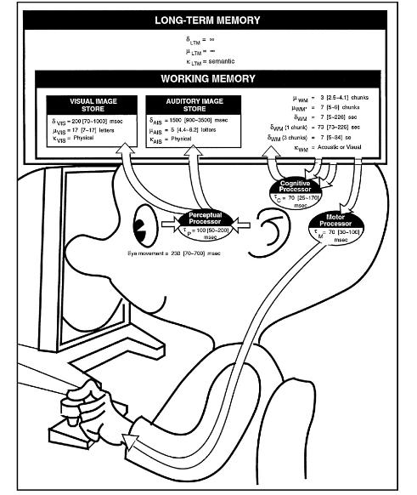

The book is fertile ground for discovering and spawning new and exciting interaction techniques. Newell also notes that an objective in the book was to generate “tools for
thought.”, such as the KLM model and the GOMS model. The book’s main contribution on modeling was to convincingly demonstrate why and how models are important and to teach us how to build them.
launch of the Apple Macintosh in 1984 (with one-button mouse):
The operating system and applications software heralded the new age of the GUI with
direct manipulation and point-select interaction. The Mac was not only cool, the interface was simple and intuitive. Anyone could use it. Part of the simplicity was its one-button mouse. With one button, there was no confusion on which button to press.

1.7:Release of MS Windows in 1985, Windows 3.1 in 1992, appearance of HCI as a common course in bachelor curricula, and as a method used by commercial companies:
With the formation of ACM SIGCHI in 1983 and the release and success of the Apple
Macintosh in 1984, human-computer interaction was off and running. GUIs entered the mainstream and, consequently, a much broader community of users and research-
ers were exposed to this new genre of interaction.
With advancing interest in human-computer interaction, all major universities introduced courses in HCI or user interface (UI) design, with graduate students often choosing a topic in HCI for their thesis research. HCI also emerged as a legitimate and popular focus in other areas such as psychology, cognitive science, industrial engineering, information systems, and sociology.

2.1: Newell's time scales in the biological, cognitive, rational and social bands
Describes human processes on a timescale:
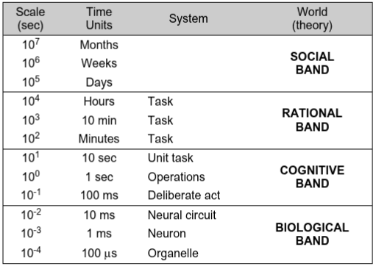
Newell ascribes a label for the human system at work (e.g., operations or task ). Within these labels we see a connection with HCI. The labels for the bands suggest a worldview or theory of human action. The most common dependent variable in experimental research in HCI is time— the time for a user to do a task. In this sense, Newell’s time-scale model is relevant to HCI. The model is also appropriate because it reflects the multidisciplinary nature of the field. HCI research is both high level and low level , and we see this in the model. If desired, we could select a paper at random from an HCI conference proceedings or journal, study it, then position the work somewhere in the scale.
For example, research on selection techniques, menu design, force or auditory feedback, text entry, gestural input, and so on, is within the cognitive band.
Up in the rational band, users are engaged in tasks that span minutes, tens of minutes, or hours. Research topics here include web navigation, user search strategies, user-centered design, collaborative computing, ubiquitous computing, social navigation, and situated awareness. Tasks related to these research areas occupy users for minutes or hours.
Tasks lasting days, weeks, or months are in the social band. HCI topics here might include workplace habits, groupware usage patterns, social networking, online dating, privacy, media spaces, user styles and preferences, design theory, and so on.
Top: qualitative, bottom: quantitative

2.2: Human Factors: sensor/responder vs display/control model fig 2.2
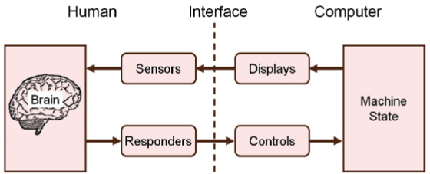
Simplifies the human to three components: sensors, responders, and brain.
2.3 Human sensors (vision, hearing, touch, smell, taste)
2.3.1: Vision
80% of information.
Frequency <-> color
Luminance: amount of light passing through an area - measured in candela per square meter.
Brightness: a subjective property of the eye that includes perception by the brain.
Fixation and saccades: Fixations can be long or short, but typically last at least 200 ms. Changing the point of fixation to a new location requires a saccade— a rapid repositioning of the eyes to a new position. Saccades are inherently quick, taking only 30– 120 ms.
HCI: scan paths, difference between gender(, age, etc.?)
2.3.2: Hearing
Loudness: decibel
Pitch: Hertz
Timbre: Klankkleur - richness or brightness. Related to harmonies, basically how you differentiate a trumpet playing a 400hz note from a flute playing a 400hz note.
Envelope: Envelope is the way a note and its harmonics build up and transition in time— from silent to audible to silent.
Sounds, complex sounds, can be described as being harmonious (pleasant) or discordant (unpleasant).
2.3.3: Touch
Tactile feedback, in HCI, refers to information provided through the somatosensory system from a body part, such as a finger, when it is in contact with (touching) a physical object.
All user interfaces that involve physical contact with the user’s hands (or other body parts) include tactile feedback.

Interaction with a desktop keyboard is also guided by tactile feedback. Tactile identifiers on key tops facilitate eyes-free touch typing. Augmenting the user experience through active tactile feedback is a common research topic. Added tactile feedback helps inform and guide the interaction and potentially reduces the demand on the visual channel.
2.3.4: Smell and Taste
Not particularly useful in HCI: “In the end, recall with smell tags was poorer than with word tags.”
2.3.5: Other senses
The word sense appears in many contexts apart from the five senses discussed above. We often hear of a sense of urgency, a sense of direction, musical sense, intuitive sense, moral sense, or even common sense. The value of these and related senses to HCI cannot be overstated. Although clearly operating at a higher level than the five primary senses, these additional senses encapsulate how humans feel about their interactions with computers. Satisfaction, confidence, frustration, and so on, are clearly steeped in how users feel about computing experiences.
2.4 Responders (limbs, handedness, voice, eyes)
2.4.1 Limbs/Handedness
Human control over machines is usually associated with the limbs, particularly the upper body limbs. The same is true in HCI. With fingers, hands, and arms we type on keyboards, maneuver mice and press buttons, hold mobile phones and press keys, touch and swipe the surfaces of touchscreen phones and tablets, and wave game controllers in front of displays. Of course, legs and feet can also act as responders and provide input to a computer. For users with limited or no use of their arms, movement of the head can control an on-screen cursor.
Movement of the limbs is tightly coupled to the somatosensory system, particularly proprioception (Proprioception is the coordination of limb movement and position through the perception of stimuli within muscles and tendons.), to achieve accuracy and finesse as body parts move relative to the body as a whole. Grasping a mouse without looking at it and typing without looking at the keyboard are examples.
HCI sometimes uses the handedness inventory:
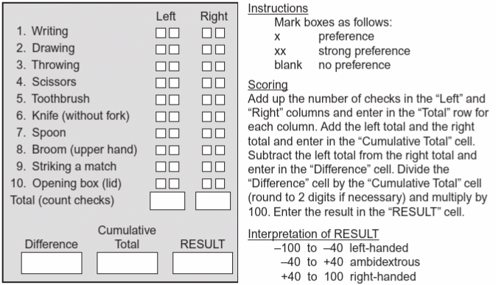
Handedness is often relevant in situations involving touch- or pressure-sensing displays. If interaction requires a stylus or finger on a display, then the user’s hand may occlude a portion of the display. Occlusion may lead to poorer performance or to a “hook posture” where users contort the arm position to facilitate interaction. This can be avoided by positioning UI elements in a different region on the display. Of course, this requires sensing or determining the handedness of the user, since the occlusion is different for a left handed user than for a right-handed user.
2.4.2 Voice
The most obvious form of vocalized sound— speech— is the primary channel for human communication. As an input modality, the speech must be recognized by algorithms implemented in software running on the host computer. With this modality, the computer interprets spoken words as though the same words were typed on the system’s keyboard.
You read faster sitting (18WPM) than walking(13WPM).
Computer input is also possible using non-speech vocalized sounds, a modality known as non-verbal voice interaction (NVVI). In this case, various acoustic parameters of the sound signal, such as pitch, volume, or timbre, are measured over time and the data stream is interpreted as an input channel. The technique is particularly useful to specify analog parameters. For example, a user could produce an utterance, such as “volume up, aaah.” In response, the system increases the volume of the television set for as long as the user sustains “aaah”
Vocal joystick —a system using NVVI to simulate a joystick and control an on-screen cursor (e.g., “eee” = move cursor left). Applications are useful primarily for creating accessible computing for users without a manual alternative.
2.4.3 Eyes
The eye is also capable of acting as a responder— controlling a computer through fixations and saccades. In this capacity, the eye is called upon to do double duty since it acts both as a sensor and as a responder.
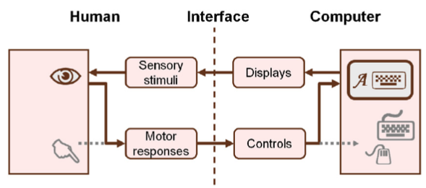
The normal path from the human to the computer is altered. Instead of the hand providing motor responses to control the computer through physical devices (set in grey), the eye provides motor responses that control the computer through soft controls —virtual or graphical controls that appear on the system’s display. For computer input control using the eyes, an eye tracking apparatus is required to sense and digitize the gaze location and the movement of the eyes. The eye tracker is usually configured to emulate a computer mouse. Much like point-select operations with a mouse, the eye can look-select , and thereby activate soft controls such as buttons, icons, links, or text (e.g., Zhang and MacKenzie, 2007). The most common method for selecting with the eye is by fixating, or dwelling, on a selectable target for a predetermined period of time, such as 750 ms.
Text entry is one application of eye tracking for input control. So-called eye typing uses an on-screen keyboard. The user looks at soft keys, fixating for a prescribed dwell time to make a selection.
2.5 The Brain
2.5.1 Perception
Perception, the first stage of processing in the brain, occurs when sensory signals are received as input from the environment. It is at the perceptual stage that associations and meanings take shape.
An auditory stimulus is perceived as harmonious or discordant. A smell is pleasurable or abhorrent. A visual scene is familiar or strange. Touch something and the surface is smooth or rough, hot or cold. With associations and meaning attached to sensory input, humans are vastly superior to the machines they interact with: We can go beyond the information given, examples are the Necker Cube and the Rubin vase, these show the ambiguity we as humans have in our perception.
(Since the late 19th century, perception has been studied in a specialized area of experimental psychology known as psychophysics . Psychophysics examines the relationship between human perception and physical phenomena. A common experimental goal is to measure the just noticeable difference (JND) in a stimulus. For example, basic research in psychophysics is used in algorithms for audio compression in MP3 audio encoding.)
Related to ambiguity is illusion, the deception of common sense. (Visual) Examples are Ponzo Lines and Muller-Lyer Arrows:
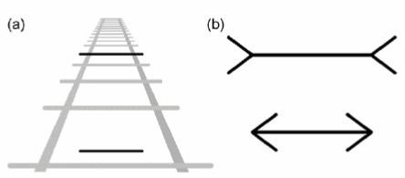
Auditory illusions. such as the Shepard musical scale that seems to fall continuously.
Tactile or haptic illusions also exist. A well-documented example is the “phantom limb.” Humans who have lost a limb through amputation often continue to sense that the limb is present and that it moves along with other body parts as it did before amputation.
Beyond perception, sensory stimuli are integrated into a myriad of other experiences to yield ideas, decisions, strategies, actions, and so on. The ability to excel at these higher-level capabilities is what propels humans to the top tier in classification schemes for living organisms. By and large it is the human ability to think and reason that affords this special position.
2.5.2 Cognition
The human process of conscious intellectual activity, such as thinking, reasoning, and deciding.
Sensory phenomena such as sound and light are easy to study because they exist in the physical world. Instruments abound for recording and measuring the presence and magnitude of sensory signals. Cognition occurs within the human brain, so studying cognition presents special challenges. For example, it is not possible to directly measure the time it takes for a human to make a decision.
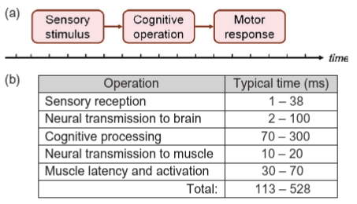
Note the wide variation in response time, indicating the difficulty in measuring cognitive response.
While using a mobile phone, one might decide to press the reject call key in response to an incoming call. While reading the morning news online, one might decide to click the close button on a popup ad. While editing a document, one might switch to e-mail in response to an audio alert of a new message. These examples involve a sensory stimulus, a cognitive operation, and a motor response, respectively.
2.5.3 Memory
Memory is the human ability to store, retain, and recall information. Interestingly enough, there are similarities between memory in the brain and memory in a computer. Computer memory often includes separate areas for data and code. In the brain, memory is similarly organized. A declarative/explicit area stores information about events in time and objects in the external world. This is similar to a data space. An procedural/implicit area in the brain’s memory stores information about how to use objects or how to do things. This is similar to a code space.
Within long-term memory is an active area for short-term memory or working memory . The contents of working memory are active and readily available for access. The amount of such memory is small, about seven units - the magic number 7 by Miller: Humans are typically able to distinguish about seven levels of a uni-dimensional stimulus.
Miller extended his work by revealing and analyzing a simple but powerful process within the brain: our ability to associate multiple items as one. So-called chunking is a process whereby humans group a series of low-level items into a single high-level item. Card et al. (1983, 36) give the example of BSCBMICRA. At nine units, the letter sequence is beyond the ability of most people to repeat back. But the sequence is similar to the following three groups of three-letter sequences: CBS IBM RCA. Shown like this, the sequence contains three chunks and is relatively easy to remember provided the person can perform the recoding rapidly enough. The process of chunking is mostly informal and unstructured. Humans intuitively build up chunked structures recursively and hierarchically, leading to complex organizations of memory in the brain.
2.6: Language
Daniels and Bright distinguish language and writing as follows: “Humankind is defined by language; but civilization is defined by writing.”
In HCI, our interest in language is primarily in systems of writing and in the technology that enables communication in a written form. Text is the written material on a page or display. How it gets there is a topic that intrigues and challenges HCI researchers, as well as the engineers and designers who create products that support text creation, or text entry. Although text entry is hugely important in HCI, our interest here is language itself in a written form.
Part-Of-Speech tagging can be important in predictive systems where knowing a word’s POS limits the possibilities for the next word.

3.1 Hard vs soft controls
Hard Controls are things like a mouse. A soft control is rendered on a display through software, its size, shape, or appearance can change dynamically to convey information to the user. Thus, soft controls often have properties of displays. Toolbar buttons and widgets are typical examples.
Combo Boxes Toggle Buttons
Most soft controls are also displayed. Each of these soft controls is manipulated by a hard control, by clicking.
The hard-control / soft-control distinction is similar to the idea of space multiplexing versus time multiplexing. With space multiplexing, there is a dedicated physical control for each parameter that is controlled. Each control has a separate physical location. With time multiplexing, there are fewer controls than parameters, and so a single device (e.g., a small region of a display) is reconfigured to control different parameters at different stages of an operation.
3.2 Control-display (CD) relations
When a user grasps a computer mouse and moves it to the right, the cursor on the system’s display moves to the right. This control-display relationship is not something users think much about. This is human-computer interaction as it should be— where the relationship between what a user does and what is experienced is natural, seamless, intuitive, and efficient. Control-display relationships are sometimes called mappings , since the relationships attribute how a controller property maps to a display property.
The mouse/cursor example describes a spatial relationship. There are also dynamic relationships, describing how a controller affects the speed of the response, and physical relationships, describing whether the response is to a movement or a force in the controller. We will examine each of these in this section, beginning with spatial relationships.
3.2.1 Spatial relations, transformed spatial mappings, camera movements: panning, zooming & positioning; rotations: pitch (x), roll (z), And yaw (y)
The mouse/cursor example describes a spatial relationship.
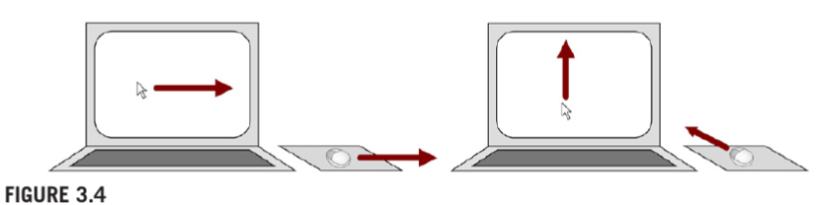
The mapping is congruent because there is an exact spatial correspondence between the controller input and the display output. Move the mouse right, and the cursor moves right. The situation in Figure 3.4b is different. Move the mouse “forward” and the cursor moves “up.”
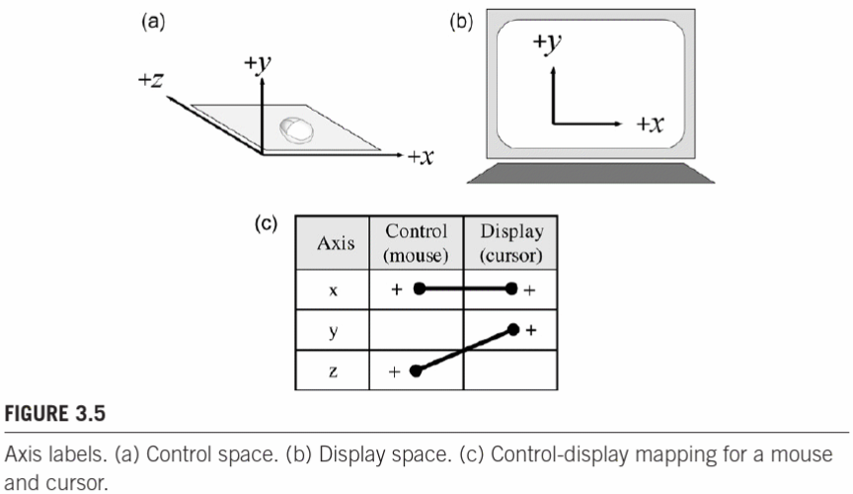
The y -axis cursor motion is an example of a transformed spatial mapping. In this case the transformation is 90°, if viewed along the y-z plane. We might expect an effect on user performance in the presence of a spatial transformation, and that is the case. While initial exposure to a mouse might pose a problem (and yield inaccurate pointing), with practice the relationship is learned and accuracy improves.
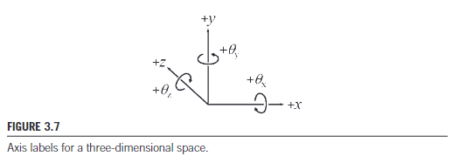
The next step in examining spatial relationships is to expand the 3D space to include rotation about each axis. This is shown in Figure 3.7 using theta (θ ) to designate angle or rotation. The arrows indicate positive rotation, corresponding to clockwise movement as viewed looking out from the origin along each axis. In all, there are six parameters, or degrees of freedom (DOF). Degrees of freedom means that each parameter may be manipulated independently of the others. So to fully place an object in 3D space, six parameters are required: three for the object’s position in space (x, y, z), and three for the object’s orientation in space (θx, θy, θz). In aeronautics, the rotation terms are known as pitch (θx), roll (θz), and yaw (θy).
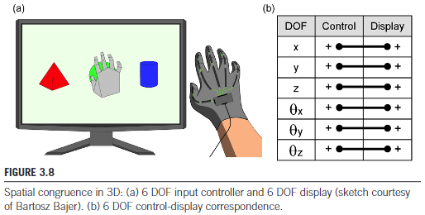
Consider Street View in Google Maps, which provides panoramic views of streets in major
cities around the world.The most common manipulations are panning, zooming, and positioning. Panning involves rotating the camera view left-right and up-down. Zooming involves changing the magnification of the view. Positioning is a change in the camera position. In the case of Google Street View, the camera position is constrained to points along the street from which the images were captured. So, while it is possible to zoom in to
the city hall, it is not possible to walk toward it.
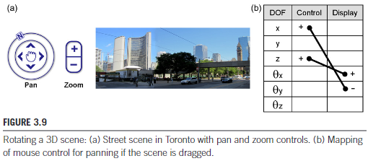
3.2.2 CD gain, transfer function, speed/accuracy trade offs for pointing devices
There is more to mouse-cursor movement than spatial mappings. Another property is CD gain, which represents the amount of movement in a display object, such as a cursor, for a given amount of movement in a control.8 For example, if a mouse is moved three cm and the cursor also moves three cm, then the CD gain is 1. If the cursor moves six cm, the CD gain is 6/3 = 2.
Often the relationship between controller motion and cursor motion is non-linear and uses a power function. In this case, the amount of cursor motion depends on the velocity of mouse motion as well as controller motion. If the mouse moves quickly, CD gain increases. If the mouse moves slowly, CD gain decreases. Lowering the CD gain for slow controller movements is useful to enhance the precision of target selection at the end of a point-select operation. The term transfer function is sometimes used since non-linear relationships are more elaborate.
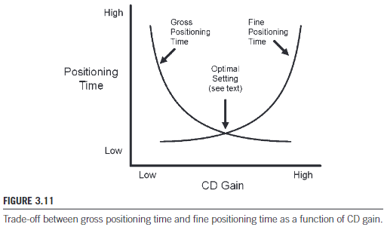
Varying CD gain evokes a trade-off between gross positioning time (getting to the vicinity of a target) and fine positioning time (final acquisition).
3.2.3 Latency, lag, sources of latency
The delay between an input action and the corresponding response on a display is called latency or lag. For example, in controlling a space vehicle on a distant moon or planet (as viewed on a display), transmission delays—latency—are on the order of several minutes or longer. (Latency is often present with Internet connections: click on a link and wait a few seconds or longer for a page to appear. The research issues here are more about user experience and frustration than about human performance. Frustration is reduced, for example, if the interface includes feedback informing the user that the network is processing the request).
Latency is attributable to properties of input devices, output devices, and software. Input devices are usually sampled at fixed rates in the range of 10 to 60 samples per second. At 60 Hz sampling, for example, an input movement may not be sensed for 1/60 s = 0.01667 s = 16.67ms. Latency will increase dramatically when output requires substantial computation for graphics rendering.
From the points above, we can infer that it is not possible to accurately measure latency from within the target system. Using software to log timestamps for input and output operations within a system misses the actions and responses at the human interface. To reflect the user’s experience as a whole, a proper latency measurement is done externally.
3.2.4 Property senses, order of control, isotonic vs isometric devices
When a human engages an input controller, the dialog involves actions such as touching, tapping, grasping, moving, pushing, flicking, and squeezing. The input controller senses the interaction and converts a property sensed into data that is transmitted to the host computer for processing. For pointing devices, the most common proper- ties sensed are position, displacement, and force. With a graphics tablet, touchpad, or touchscreen, the property sensed is the position of a stylus or a finger on a digitizing surface. Position is sensed as an absolute coordinate at the point of contact along the x-axis and z-axis. A mouse is different. It is not possible to know where a mouse is situated on a mousepad or desktop. With a mouse, the property sensed is the displacement—the amount of movement along the x-axis and z-axis. Each sample is reported relative to the last sample.

The most common orders of control are position-control (aka zero-order control) and velocity-control (aka first-order control) (Zhai, 1995, p. 4). With position-control, the sensed property of the input device controls the position of the object or view on a display. With velocity-control, the sense property controls the velocity of the object or view. A mouse is a position-control input device, since mouse displacement controls the position of the cursor.
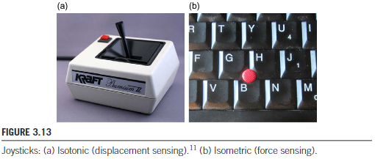
Order of control is often associated with joysticks. Joysticks are either iso-
tonic or isometric. With an isotonic joystick, the user manipulates the stick handle,
which, in turn, swivels about a pivot-point. The property sensed is the movement
of the stick. Isotonic joysticks are also called displacement joysticks. The output
signal represents the position of the stick as the amount of displacement (i.e., rota-
tion) from the neutral or home position, about the x- and z-axes. With an isometric joystick, the stick does not move. The property sensed is the force applied to the stick. The output signal represents the amount of force along the x-axis and z-axis. An example is the joystick between the G, H, and B keys on many notebook computer keyboards.
Isotonic senses displacements of stick, isometric senses force applied to stick.
3.3 Natural vs learned relationships, cultural standards or population stereotypes as learned relationships
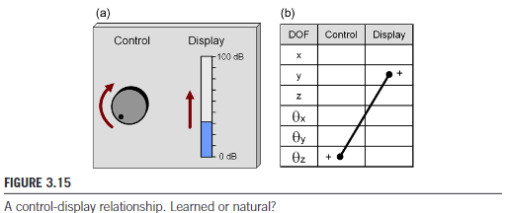
Is the relationship natural? Is it simple, intuitive, and easy? Both arrows in the figure point up, so perhaps the relationship is natural. However, if the curved arrow were positioned on the right of the control, rather than on the left, it would point down. So the relationship would
then appear backward. The real question, then, is not about the arrows, but whether there is a natural relationship between clockwise motion of a control and linear motion on a display. The answer is no. It is a learned relationship. It might seem simple, intuitive, and easy, but it is a learned relationship.
The best possible scenario is spatial congruence, which for a linear display implies using a sliding or linear control. This is shown in Figure 3.16. Upward movement in the control handle produces upward movement in the display reading.
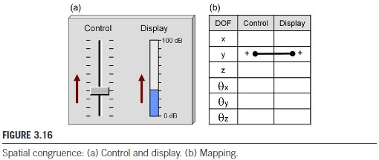
3.4 Mental models and metaphors, physical analogies, implementation models vs conceptual models
There is more to learning or adapting than simply experiencing. One of the most common ways to learn and adapt is through physical analogy or metaphor. Once we latch on to a physical understanding of an interaction based on experience, it all makes sense. We’ve experienced it, we know it, it seems natural. With a scroll pane, moving the slider up moves the view up. If the relationship were reversed, moving the slider up would move the content up. We could easily develop a physical sense of slider up → view up or slider up → content up. The up-up in each expression demonstrates the importance of finding a spatially congruent physical understanding. These two analogies require opposite control-display relationships, but either is fine and we could work with one just as easily as with the other, provided implementations were
consistent across applications and platforms.
3.5 Modes, pro and cons of using modes
A mode is “a functioning arrangement or condition.” The soft controls in Figure 3.3 demonstrate modes, since every new application brings a new functioning arrangement of controls and displays. Usually, though, modes are viewed in a more limited sense, such as lowercase mode versus uppercase mode. Either way, it is a simple fact that systems of all stripes have modes. For example, office phones have modes: light=on means message waiting. Electric staplers have modes: LED=on means add staples. A standard desktop keyboard has about 100 keys, yet can produce more than 800 key variations, using the modes afforded by modifier keys such as shift, ctrl, and alt.
If we combine the ideas above with the earlier discussion on soft controls, there
is the possibility of a mode model for keys. Physical keys on standard keyboards are
hard keys. They have a few modes. The Navi (Nokia) key and the image adjust buttons just
described are soft-hard keys, since they involve both a physical key and a definition of
the key created through software. They have lots of modes. The small regions on GUIs such as Word are the full embodiment of soft keys. Their size, shape, location,
and function are entirely malleable. Soft keys have an infinite number of modes.
From a design perspective, the main issues with modes are (a) changing modes, and (b) feedback, or making the mode apparent to the user.
Selecting a mode might make it impossible to select other modes without exiting the current mode: problem.
User not knowing what mode they’re in: problem.
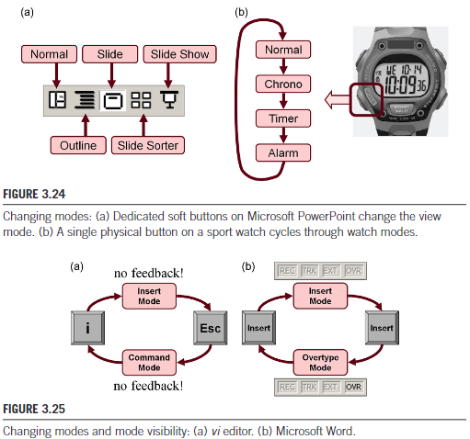
Gulf of evaluation—a disconnect between what the system provides and what the user intends and expects.
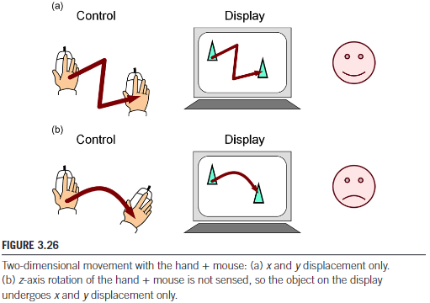
Note that the final position of the triangle is the same in (a) and (b). Yet the hand + mouse movements were different.
Reducing modes often leads to actually implementing other modes (mouse with y axis added). Modes for 3D models work very clunky for a 2D screen.
3.6 Degrees of freedom
There is more to degrees of freedom than simply counting them. It is important to consider the relationship between device properties, such as degrees of freedom, and task requirements. Jacob et al. (1994) speak of the integrality and separability of the degrees of freedom. With a regular mouse, controlling one degree of freedom in isolation of the other is difficult. Consider drawing a horizontal line with a mouse using the drawing mode of an application. The task is difficult because the x and y degrees of freedom are integrated.
The message in this section is that degrees of freedom (DOF) is a property that spans a rich complement of tasks and interaction techniques. User interactions are plentiful, and they are juxtaposed in complex ways, such as overlapping, sequential, and in parallel. The degrees of freedom in the interactions merit deeper consideration.
3.7 Mobile interaction, multi-touch, offset cursors/animations, take-off selection, spatially aware displays
With the arrival of the iPhone and follow-on products, such as touch-based tablet computers, the landscape of HCI experienced a dramatic shift. Pressing keys on small keyboards or gesturing with a stylus gave way to finger actions: swiping, flicking, pinching, tapping, and so on. Furthermore, devices in this genre include additional components to enhance the user experience. Cameras, light sensors, vibro-tactile actuators, accelerometers, gyroscopes, GPS receivers, and so on work together in broadening the experience for users. With the prefix “smart,” these devices are full-fledged media players, providing unprecedented connectivity to users through both Third Generation (3G) and Internet access.
Many of the interaction elements noted above for desktop environments don’t even exist in the mobile context. This follows from the distinction between indirect input and direct input. Cursor control using a mouse or touchpad is an example of indirect input because the system response is spatially displaced from the input device. Finger input on a touch-sensitive display uses direct input because the system response is located at the point of touch. Properties like control-display mappings and CD gain do not exist for direct input. Mouse-based systems, on the other hand, require an on-screen tracking symbol such as a cursor or pointer. This is a by-product of indirect input. Direct touch input is the full embodiment of WYSIWYG interaction – what you see is what you get.
However, direct touch input has an unfortunate side effect: precise pixel-level selection is difficult. On a desktop system, the tip of the on-screen pointer visually identifies the selection point. With touchscreens, users typically do not know, and cannot control, the precise location of the contact point. There are two reasons: (1) the finger occludes the location of contact, and (2) finger contact forms an area, not a point.
Improving the precision of pointing was a key challenge. How can occlusion and precision be accommodated for touch input? Are there alternate methods to consider and, if so, which ones perform better? These are the sorts of questions that underpin empirical research in HCI. One of the earliest selection enhancements for touchscreens was the offset cursor presented at the ACM SIGCHI conference in 1988. When the finger contacts the display surface, a crosshair cursor appears just above the fingertip. The user maneuvers his or her finger along the display surface, positions the cursor within a selectable target, then lifts the finger to select the target. Potter et al. called the method take-off selection. They described an experimental evaluation to compare take-off selection with two alternate methods, first-contact, where selection occurs immediately when the contact point enters a target, and land-on, where selection occurs only if the initial contact point is on a target. Of the three methods, they found take-off most accurate, but first-contact fastest. Apple keyboard uses a combination of an offset cursor with take-off selection. Yet another difference between touch input and mouse input is the ability of touch-sensing technologies to sense multiple contact points.
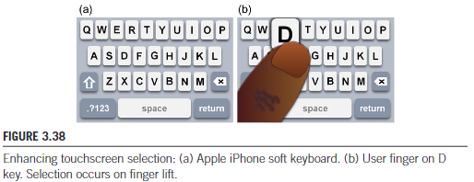
An accelerometer allows the angle or tilt of the device to be sensed. Tilt as an input primitive has entered the mainstream of interaction techniques in mobile computing. An interesting application of accelerometer input is a spatially aware display. In this case, a view on the display moves as the device moves, as sensed by the accelerometer.
If there is one observation that emerges from the annual ACM SIGCHI conference, it is that the pace of innovation in HCI is increasing. New technologies and new ideas for interactions are plentiful and they are emerging quickly. They are often presented, like tilt was initially, as possibilities. Prototypes, demos, videos, posters, work-in-progress contributions, and so on, get the ideas out there. But sooner or later, plausible ideas need testing with users. Testing that is empirical and experimental is recommended. The results will add to the knowledge base that engineers and designers draw upon in bringing to market new and cool products
3.8 Interaction errors
Empirical research in HCI is largely about finding the physical properties and combinations that improve and enhance human performance. We conclude this chapter on interaction elements with comments on that nagging aspect of human performance that frustrates users: interaction errors.
(1) Most users have, at some point, lost information while working on their computers. Instead of saving new work, it was mistakenly discarded, overwritten, or lost in some way.
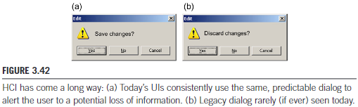
The point is that a user's expectation is broken. Broken expectations sooner or later cause errors.

(2) If prompted to enter a password, and caps_lock mode is in effect, logging on will fail and the password must be reentered. The user may not know that caps_lock is on.
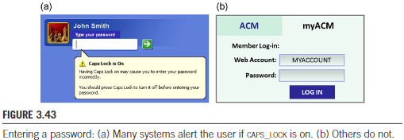
In editing a document, suppose the user wishes to move some text to another location in the document. The task is easy. With the pointer positioned at the beginning of the text, the user presses and holds the primary mouse button and begins dragging. But the text spans several lines and extends past the viewable region. As the dragging extent approaches the edge of the view-able region, the user is venturing into a difficult situation. The interaction is about to change dramatically. (See Figure 3.44.) Within the viewable region, the interaction is position-control—the displacement of the mouse pointer controls the position of the dragging extent. As soon as the mouse pointer moves outside the viewable region, scrolling begins and the interaction becomes velocity-control—the displacement of the mouse pointer now controls the velocity of the dragging extent. User beware! Once in velocity-control mode, it is anyone’s guess what will happen. This is a design flaw.
Whether the velocity-control is too sensitive or too sluggish really doesn’t matter. What matters is that the user experience is broken or awkward. Any pretense to the interaction being facile, seamless, or transparent is gone. The user will recover, and no information will be lost, but the interaction has degraded to error recovery. This is a design error or, at the very least, a design-induced error.
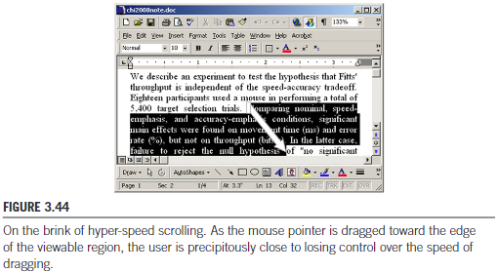
When an application or a dialog box is active, one of the UI components has focus and receives an event from the keyboard if a key is pressed. For buttons, focus is usually indicated with a dashed border (see “Yes” button in Figure 3.42). For input fields, it is usually indicated with a flashing insertion bar (“|”). “Focus advancement” refers to the progression of focus from one UI component to the next. There is wide-spread inconsistency in current applications in the way UI widgets acquire and lose focus and in the way focus advances from one component to the next. The user is in trouble most of the time. Here is a quick example. When a login dialog box pops up, can you immediately begin to enter your username and password? Sometimes yes, sometimes no. Many online activities, such as reserving an airline ticket or booking a vacation, require a user to enter data into a form. The input fields often require very specific information, such as a two-digit month, a seven-digit account number, and so on. When the information is entered, does focus advance automatically or is a user action required? Usually, we just don’t know. So we remain “on guard.”
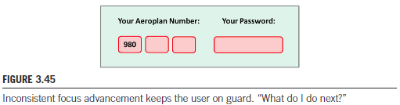
The user’s attention is on the keyboard while the physical presentation is on the system’s display. The disconnect is small, but nevertheless, a shift in the user’s attention is required.
The absence of expectations keeps the user on guard. The user is often never quite sure what to do or what to expect. The result is a slight increase in the attention demanded during interaction, which produces a slight decrease in transparency. Instead of engaging in the task, attention is diverted to the needs of the computer. The user is like a wood carver who sharpens tools rather than creates works of art.
Do programmers ever discuss the nuances of focus advancement in building a GUI? Perhaps. But was the discussion framed in terms of the impact on the attention or gaze shifts imposed on the user? Not likely. Each time a user shifts his or her attention (e.g., from the keyboard to the display and back), the cost is two gaze shifts. Each gaze shift, or saccade, takes from 70 to 700 ms. These little bits of interaction add up. They are the fine-grained details—the microstructures and micro-strategies used by, or imposed on, the user. “Micro-strategies focus on what designers would regard as the mundane aspects of interface design; the ways in which subtle features of interactive technology influence the ways in which users perform tasks” Another reason little errors tend to linger is that they are often deemed user errors, not design, programming, or system errors. These errors, like most, are more correctly called design-induced errors.They occur “when designers of products, systems, or services fail to account for the characteristics and capabilities of people and the vagaries of human behavior”
Figure 3.46 illustrates a tradeoff between the cost of errors and the frequency of errors. There is no solid ground here, so it’s just a sketch. The four errors described above are shown. The claim is that high-cost errors occur with low frequency. They receive a lot of attention and they get dealt with. As systems mature and the big errors get fixed, designers shift their efforts to fixing less costly errors, like the caps_lock design-induced error, or consistently implementing velocity-controlled scrolling. Over time, more and more systems include reasonable and appropriate implementations of these interactions. Divergence in the implementations diminishes and, taken as a whole, there is an industry-wide coalescing toward the same consistent implementation (e.g., a popup alert for caps_lock). The ground is set for user expectation to take hold. Of the errors noted in Figure 3.46, discard changes are ancient history (in computing terms), caps lock is still a problem but is improving, scrolling frenzy is much more controlled in new applications, and focus uncertainty is, well, a mess. The cost is minor, but the error happens frequently.
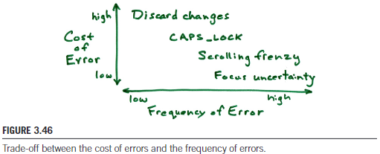
4.1: Difference between research, engineering and design
There are many ways to distinguish research from engineering and design. Researchers often work closely with engineers and designers, but the skills and contributions each brings are different. Engineers and designers are in the business of building things. They create products that strive to bring together the best in form (design emphasis) and function (engineering emphasis). One can imagine that there is certain tension, even a trade-off, between form and function. Finding the right balance is key. However, sometimes the balance tips one way or the other. When this occurs, the result is a product or a feature that achieves one (form or function) at the expense of the other. An example is shown in Figure 4.2a:
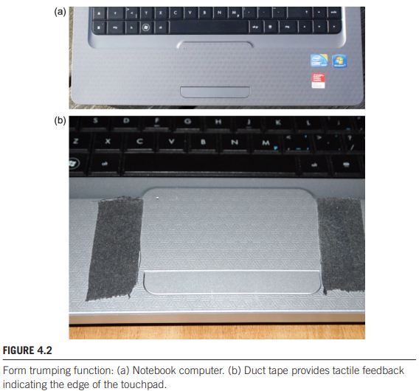
The look is elegant—smooth, shiny, metallic. But something is wrong. Because the mounting is seamless and smooth, tactile feedback at the sides of the touchpad is missing. While positioning a cursor, the user has no sense of when his or her finger reaches the edge of the touchpad, except by observing that the cursor ceases to move. This is an example of form trumping function.
Engineers and designers work in the world of products. The focus is on designing complete systems or products. Research is different. Research tends to be narrowly focused. Small ideas are conceived of, prototyped, tested, then advanced or discarded. New ideas build on previous ideas and, sooner or later, good ideas are refined into the building blocks—the materials and processes—that find their way into products. But research questions are generally small in scope. Research tends to be incremental, not monumental.
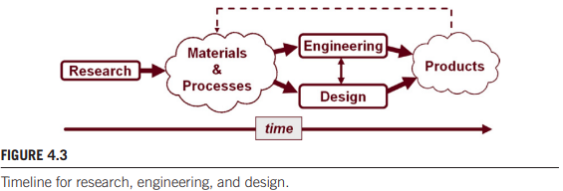
One facet of research that differentiates it from engineering and design is the timeline. Research precedes engineering and design.
While engineers and designers strive to build better systems or products, in the broadest sense, researchers provide the raw materials and processes engineers and designers work with: stronger steel for bridges, a better mouse for pointing, a better algorithm for a search engine, a more natural touch interface for mobile phones.
4.2: Empirical research: observations
According to one definition, empirical means originating in or based on observation or experience. Simple enough. Another definition holds that empirical means relying on experience or observation alone, often without due regard for system and theory (Heliocentric). By another definition, empirical means capable of being verified or disproved
by observation or experiment.
4.3: Research methods (only 2 are required)
There are three common approaches, or methods, for conducting research in HCI and other disciplines in the natural and social sciences: the observational method, the experimental method, and the correlational method. All three are empirical as they are based on observation or experience. But there are differences and these follow from the objectives of the research and from the expertise and style of the researcher.
4.3.1 Observational
The observational method encompasses a collection of common techniques used in HCI research. These include interviews, field investigations, contextual inquiries, case studies, field studies, focus groups, think aloud protocols, storytelling, walkthroughs, cultural probes, and so on. The approach tends to be qualitative rather than quantitative. As a result, observational methods achieve relevance while sacrificing precision.
Observational methods are generally concerned with discovering and explaining the reasons underlying human behavior. In HCI, this is the why or how of the interaction, as opposed to the what, where, or when.
Observational methods tend to examine and record the quality of interaction rather than
quantifiable human performance.
4.3.2 Experimental (scientific)
With the experimental method (also called the scientific method), knowledge is acquired through controlled experiments conducted in laboratory settings. Since the tasks are artificial and occur in a controlled laboratory setting, relevance is diminished. However, the control inherent in the methodology brings precision, since extraneous factors—the diversity and chaos of the real world—are reduced or eliminated.
A controlled experiment requires at least two variables: a manipulated variable and a response variable. In HCI, the manipulated variable is typically a property of an interface or interaction technique that is presented to participants in different configurations.
In HCI, we often hear of a system or design undergoing a “usability evaluation” or “user testing.” Although these terms often have different meanings in different contexts, such evaluations or tests generally do not follow the experimental method. The reason is simple: there is no manipulated variable. This is mentioned only to distinguish a usability evaluation from a user study. Undertaking a user study typically implies conducting a controlled experiment where different configurations of a system are tested and compared. A “usability evaluation,” on the other hand, usually involves assessing a single user interface for strengths and weaknesses.
4.4: Measurements scales: nominal, ordinal, interval and ratio scales
4.4.1 Nominal / Categorical
A measurement on the nominal scale involves arbitrarily assigning a code to an attribute or a category. The measurement is so arbitrary that the code needn’t be a number (although it could be). Examples are automobile license plate numbers, codes for postal zones, job classifications, military ranks, etc
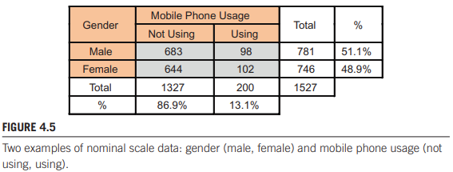
4.4.2 Ordinal
Ordinal scale measurements provide an order or ranking to an attribute. The attribute can be any characteristic or circumstance of interest. For example, users might be asked to try three global positioning systems (GPS) for a period of time and then rank the systems by preference: first choice, second choice, third choice.

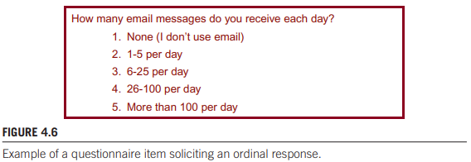
The main limitation of ordinal data is that the interval is not intrinsically equal between successive points on the scale. Ordinal data are slightly more sophisticated than nominal data since comparisons of greater than or less than are possible. However, it is not valid to compute the mean of ordinal data.
4.4.3 Interval
Moving up in sophistication, interval data have equal distances between adjacent values. However, there is no absolute zero. The classic example of interval data is temperature measured on the Fahrenheit or Celsius scale. Unlike ordinal data, it is meaningful to compute the mean of interval data, for example, the mean midday temperature during the month of July. Ratios of interval data are not meaningful, however. For example, one cannot say that 20°C is twice as warm as 10°C.
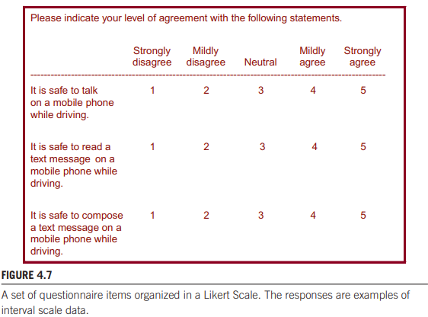
In HCI, interval data are commonly used in questionnaires where a response on a linear scale is solicited. An example is a Likert Scale (see Figure 4.7), where verbal responses are given a numeric code. Interval has equal gradations between responses, which validates calculating the mean of the responses across multiple respondents.
4.4.4 Ratio
Ratio data have an absolute zero and support a myriad of calculations to summarize, compare, and test the data. Ratio data can be added, subtracted, multiplied, divided; means, standard deviations, and variances can be computed. In HCI, the most common ratio-scale measurement is time—the time to complete a task. But generally, all physical measurements are also ratio-scale, such as the distance or velocity of a cursor as it moves across a display, the force applied by a finger on a touchscreen, and so on. Many social variables are also ratio-scale, such as a user’s age or years of computer experience. Another common ratio-scale measurement is count. Often in HCI research, we count the number of occurrences of certain human activities, such as clicks.
The expressive nature of a count is improved through normalization; that is, expressing the value as a count per something. So for example, knowing that a 10-word phrase was entered in 30 seconds is less revealing than knowing that the rate of entry was 10 /0.5 = 20 words per minute (wpm). The main benefit of normalizing counts is to improve comparisons. It is easy to compare 20 wpm for one method with 23 wpm for another method—the latter method is faster. It is much harder to compare 10 words entered in 30 seconds for one method with 14 words entered in 47 seconds for another method.
4.5: Research questions: relevant but untestable questions vs focused, narrow testable research questions
Relevant but untestable:
l Is it viable?
l Is it as good as or better than current practice?
l What are its strengths and weaknesses?
l Which of several alternatives is best?
l What are the human performance limits and capabilities?
l Does it work well for novices, for experts?
l How much practice is required to become proficient?
These questions are unquestionably relevant, since they capture a researcher’s thinking at the early stages of a research project

| Is the new technique any good?
l Is the new technique better than QSK?
l Is the new technique faster than QSK?
l Is the new technique faster than QSK after a bit of practice?
l Is the measured entry speed (in words per minute) higher for the new technique than for a QSK after one hour of use?
From top to bottom, the questions are progressively narrower and more focused. Expressions like “any good” or “better than,” although well intentioned, are problematic for research. Farther down the list, the questions address qualities that are more easily observed and measured. Furthermore, since they are expressed across alternative designs, comparisons are possible. The last question speaks very specifically to entry speed measured in words per minute, to a comparison between two methods, and to a criterion for practice. This is a testable research question.
4.6: Internal vs external validity
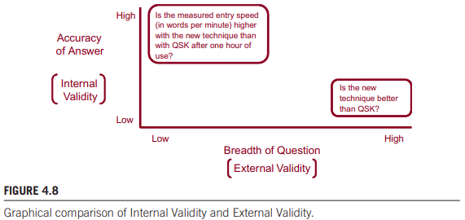
Attempts to answer “Is the new technique better than QSK?” directly are fraught with problems, because we lack a methodology to observe and measure “better than” (even though finding better interfaces is the final goal).
The “Is the measured entry speed (in words per minute) higher for the new technique than for a QSK after one hour of use?” question is testable, which means we can craft a methodology to answer it through observation and measurement. Unfortunately, the narrow scope of the question brings different problems. Focusing on entry speed is fine, but what about other aspects of the interaction? What about accuracy, effort, comfort, cognitive load, user satisfaction, practical use of the technique, and so on? The question excludes consideration of these, hence the low breadth rating.
Internal validity (definition) is the extent to which an effect observed is due to the test conditions. For the example above, an effect is simply the difference in entry speed between the new technique and QSK. If we conduct an experiment to measure and compare the entry speed for the two techniques, we want confidence that the difference observed was actually due to inherent differences between the techniques. Internal validity captures this confidence. Were some participants tested early in the day, others late in the day? Were there any distractions, interruptions, or other environmental changes during testing? Suffice it to say that any source of variation beyond that due to the inherent properties of the test
conditions tend to compromise internal validity. High internal validity means the effect observed really exists
External validity (definition) is the extent to which experimental results are generalizable to other people and other situations. Generalizable clearly speaks to breadth in Figure 4.8. To the extent the research pursues broadly framed questions, the results tend to be broadly applicable. But there is more. Research results that apply to “other people” imply that the participants involved were representative of a larger intended population. If the experiment used 18- to 25-year-old computer literate college students, the results might generalize to middle-aged computer literate professionals. But they might not generalize to middle-aged people without computer experience. In experimental research, random sampling is important for generalizability; that is, the participants selected for testing were drawn at random from the desired population. Generalizable to “other situations” means the experimental environment and procedures were representative of real world situations where the interface or technique will be used. If the research studied the usability of a GPS system for taxi drivers or delivery personnel and the experiment was conducted in a quiet, secluded
research lab, there may be a problem with external validity. Perhaps a different experimental environment should be considered. Research on text entry where participants enter predetermined text phrases with no punctuation symbols, no uppercase characters, and without any ability to correct mistakes, may have problems with external validity. Again, a different experimental procedure should be considered.
Before moving on, it is worth mentioning ecological validity, a term closely related to external validity. The main distinction is in how the terms are used. Ecological validity refers to the methodology (using materials, tasks, and situations typical of the real world), whereas external validity refers to the outcome (obtaining results that generalize to a broad range of people and situations).

4.7: Comparative evaluations: (established) baselines
From a research perspective, our third definition is more appealing, since it includes the ideas of experimentation, discovery, and developing theories of interaction. Certainly, more meaningful and insightful results are obtained if a comparative evaluation is performed. In other words, a new user interface or interaction technique is designed and implemented and then compared with one or more alternative designs to determine which is faster, more accurate, less confusing, more preferred by users, etc. The alternatives may be variations in the new design, an established design (a baseline condition), or some combination of the two.
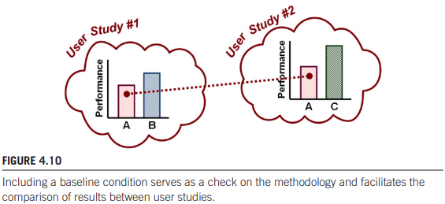
The idea of including an established design as a baseline condition is particularly appealing. There are two benefits. First, the baseline condition serves as a check on the methodology. Baseline conditions are well traveled in the research literature, so results in a new experiment are expected to align with previous results. Second, the baseline condition allows results to be compared with other studies. The general idea is shown in Figure 4.10. The results from two hypothetical user studies are shown. Both user studies are comparative evaluations and both include condition A as a baseline. Provided the methodology was more or less the same, the performance results in the two studies should be the same or similar for the baseline condition. This serves not only as a check on the methodology but also facilitates comparisons between the two user studies. A quick look at the charts suggests that condition C out-performs condition B. This is an interesting observation because condition C was evaluated in one study, condition B in another.
A comparative evaluation yields more valuable and insightful results than a single-interface evaluation.
4.8: Causal relations
Differences observed may be due to prior experience and usage habits, rather than to inherent differences. One final point deserves mention. Cause and effect conclusions are not possible in certain types of controlled experiments. If the variable manipulated is a naturally occurring attribute of participants, then cause and effect conclusions are unreliable. Examples of naturally occurring attributes include gender (female, male), personality (extrovert, introvert), handedness (left, right), first language (e.g., English, French, Spanish), political viewpoint (left, right), and so on. These attributes are legitimate independent variables, but they cannot be manipulated, which is to say, they cannot be assigned to participants. In such cases, a cause and effect conclusion is not valid because is not possible to avoid confounding variables (defined in Chapter 5). Being a male, being an extrovert, being left-handed, and so on always brings forth other attributes that systematically vary across levels of the independent variable. Cause and effect conclusions are unreliable in these cases because it is not possible to know whether the experimental effect was due to the independent variable or to the confounding variable.
5.1: Importance of research methods, advantage of standard methods
The term method or methodology refers to the way an experiment is designed and carried out. This involves deciding on the people (participants), the hardware and software (materials or apparatus), the tasks, the order of tasks, the procedure for briefing and preparing the participants, the variables, the data collected and analyzed, and so on. Having a sound methodology is critical. On this point, Allen Newell did not hesitate: “Science is method. Everything else is commentary.” Methodology is the bedrock of science. If the methodology is weak or flawed, there is no science forthcoming. What remains is little else than commentary. For the advantage of standard methods, see 4.7 (in short, being able to compare different research papers with each other with ease).
5.2: Ethics approval
One crucial step that precedes the design of every HCI experiment is ethics approval. Since HCI research involves humans, “researchers must respect the safety, welfare, and dignity of human participants in their research and treat them equally and fairly.” Typically, the review committee serves to ensure a number of ethical guidelines are acknowledged and adhered to. These include the right of the participant to be informed of the following:
l The nature of the research (hypotheses, goals and objectives, etc.)
l The research methodology (e.g., medical procedures, questionnaires, participant observation, etc.)
l Any risks or benefits
l The right not to participate, not to answer any questions, and/or to terminate participation at any time without prejudice (e.g., without academic penalty, withdrawal of remuneration, etc.)
l The right to anonymity and confidentiality
The basis for approving the research, where human participants are involved, is in achieving a balance between the risks to participants and the benefits to society.
5.3: Experiment design
Experiment design is the process of bringing together all the pieces necessary to test hypotheses on a user interface or interaction technique. It involves deciding on and defining which variables to use, what tasks and procedures to use, how many participants to use and how to solicit them, and so on.
Here is a question that will focus the mind more than any other in getting off and running with an HCI experiment: what are the experimental variables? The process forces us to transition from well-intentioned, broad yet untestable questions (e.g. Is my idea any good?) to narrower yet testable questions (e.g. Can a task be performed more quickly with my new interface than with an existing interface?).
5.4: Independent Variables
An independent variable is a circumstance or characteristic that is manipulated or systematically controlled to a change in a human response while the user is interacting with a computer. An independent variable is also called a factor. Experiments designed with independent variables are often called factorial experiments. The variable is manipulated across multiple (at least two) levels of the circumstance or characteristic. The variable is “independent” because it is independent of participant behavior, which means there is nothing a participant can do to influence an independent variable. The idea of “manipulating” simply refers to systematically giving one interface, then another, to participants as part of the experimental procedure. Note that human characteristics such as gender or first language are naturally occurring attributes. Although such attributes are legitimate independent variables, they cannot be “manipulated” in the same way as an attribute of an interface.
In your method, it is important to separately name both the independent variable (e.g., feedback modality) and the levels (audio, tactile).
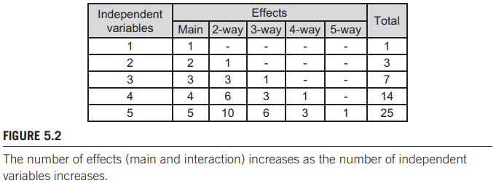
A design with a single independent variable includes a main effect, but no interaction effects. A design with two independent variables includes two main effects and one interaction effect, for a total of three effects. The interaction effect is a two-way interaction, since it is between two independent variables. Interaction effects that are three-way or higher are extremely difficult to interpret and are best avoided. A good design, then, is one that limits the number of independent variables to one or two, three at most.
5.5: Dependent Variables
A dependent variable is a measured human behavior. In HCI the most common dependent variables relate to speed and accuracy, with speed often reported in its reciprocal form, time—task completion time. Accuracy is often reported as the percentage of trials or other actions performed correctly or incorrectly. In the latter case, accuracy is called errors or error rate. The dependent in dependent variable refers to the variable being dependent on the human. The measurements depend on what the participant does. Others include preparation time, action time, throughput, gaze shifts, mouse-to-keyboard hand transitions, presses of backspace, target re-entries, retries, key actions, gaze shifts, etc.
As with independent variables, it is often helpful to name the variable separately from its units. For example, in a text entry experiment there is likely a dependent variable called text entry speed with units “words per minute.” Experiments on computer pointing devices often use a Fitts’ law paradigm for testing. There is typically a dependent variable named throughput with units “bits per second.” The most common dependent variable is task completion time with units “seconds” or “milliseconds.” If the measurement is a simple count of events, there is no unit per se.
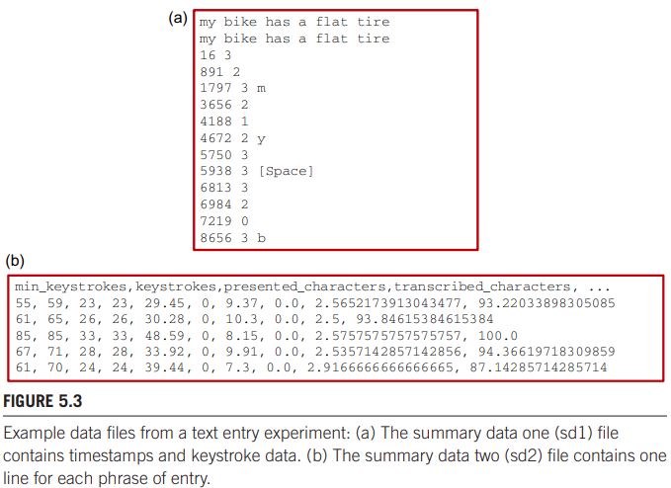
When contriving a dependent variable, it is important to consider how the measurements are gathered and the data collected, organized, and stored. The most efficient method is to design the experimental software to gather the measurements based on timestamps, key presses, or other interactions detectable through software events. The data should be organized and stored in a manner that facilitates followup analyses. Figure 5.3 shows an example for a text entry experiment. There are two data files. The first contains timestamps and key presses, while the second summarizes entry of a complete phrase, one line per phrase.
To facilitate follow-up analyses, the data should also include codes to identify the participants and test conditions. Typically, this information is contained in additional columns in the data or in the filenames. For example, the filename for the data in Figure 5.3a is TextInputHuffman-P01-D99-B06-S01.sd1 and identifies the experiment (TextInputHuffman), the participant (P01), the device (D99), the block (B06) and the session (S01). The suffix is “sd1” for “summary data one.” Note that the sd2 file in Figure 5.3b is comma-delimited to facilitate importing and contains a header line identifying the data in each column below
5.6: Control, random, and confounding variables
5.6.1 Control
There are many circumstances or factors that (a) might influence a dependent variable but (b) are not under investigation. These need to be accommodated in some manner. One way is to control them—to treat them as control variables. Examples include room lighting, room temperature, background noise, display size, mouse shape, mouse cursor speed, keyboard angle, chair height, and so on. Controlling them means that they are fixed at a nominal
setting during the experiment so they don’t interfere. But they might interfere if set at an extreme value. Having lots of control variables reduces the variability in the measured behaviors but yields results that are less generalizable.
5.6.2 Random
Instead of controlling all circumstances or factors, some might be allowed to vary randomly. Such circumstances are random variables. There is a cost since more variability is introduced in the measures, but there is a benefit since results are more generalizable.
Typically, random variables pertain to characteristics of the participants, including biometrics (e.g., height, weight, hand size, grip strength), social disposition (e.g., conscientious, relaxed, nervous), or even genetics (e.g., gender, IQ).
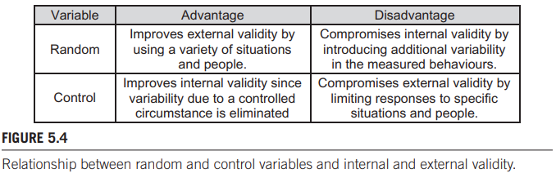
5.6.3 Confounding
Any circumstance or condition that changes systematically with an independent variable is a confounding variable. Researchers must attune to the possible presence of a confounding variable and eliminate it, adjust for it, or consider it in some way. Otherwise, the effects observed may be incorrectly interpreted.
As an example, consider an experiment seeking to determine if there is an effect of camera distance on human performance using an eye tracker for computer control. In the experiment, camera distance—the independent variable—has two levels, near and far. For the near condition, a small camera (A) is mounted on a bracket attached to the user’s eye glasses. For the far condition, an expensive eye tracking system is used with the camera (B) positioned above the system’s display. Here, camera is a confounding variable since it varies systematically across the levels of the independent variable: camera A for the near condition and camera B for the far condition. The confound is avoided by using the same camera (and same system) in both the near and far conditions. Another possibility is simply to rename the independent variable. The new name could be “setup,” with levels “near setup” and “far setup.” The new labels acknowledge that the independent variable encompasses multiple facets of the interface, in this case, camera distance, camera, and system. The distinction is important for no other reason than to ensure the conclusions speak accurately to the different setups, rather than to camera distance alone.
5.7: Task & procedure: representative tasks for external validity, discriminative for internal validity
There are two objectives in designing a good task: represent and discriminate. A good task is representative of the activities people do with the interface. A task that is similar to actual or expected usage will improve the external validity of the research–the ability to generalize results to other people and other situations.
A good task is also one that can discriminate the test conditions. A good task must attune to the points of differentiation in order to elicit behavioral responses that expose benefits or problems among the test conditions. This should surface as a difference in the measured responses across the test conditions. A difference might occur if the interfaces or interaction techniques are sufficiently distinct in the way the task is performed.
Making a task representative of actual usage will improve external validity, but there is a downside. The more representative the task, the more the task is likely to include behaviors not directly related to the interface or interaction method under test. Such behaviors are likely to compromise the ability of the task to discriminate among the test conditions. . It is simply a reflection of the complex way humans go about their business while using computers. When we enter text, we also think about what to enter. We might pause, think, enter something, think again, change our minds, delete something, enter some more, and so
on. This is actual usage. If the research goal is to evaluate a new text entry method, a task that mimics actual usage is fraught with problems. Actual usage includes secondary tasks—lots of them. If the task involves, for example, measuring text entry speed in words per minute, the measurement is seriously compromised if tasks unrelated to the entry method are present.
While using a task that is representative of actual usage may improve external validity, the downside is a decrease in internal validity. The additional sources of variation introduced by secondary tasks reduce the likelihood that the differences observed are actually due to, or
caused by the test conditions. The best task is one that is natural yet focuses on the core aspects of the interaction: the points of differentiation between the test conditions. Points of similarity, while true to actual usage, introduce variability. Consider two different text entry
techniques being compared in an experimental evaluation. If the techniques include the same method of capitalization, then capitalization does not serve to discriminate between the techniques and can be excluded from the experimental task. Including capitalization will improve external validity but will also compromise internal validity due to the added variability.
5.8: Study participants: representative for target population, sufficient number
Researchers often assume that their results apply to people who were not tested. Applying results to people other than those who were tested is possible; however, two conditions are required. First, the people actually tested must be members of the same population of people to whom results are assumed to hold. Second, a sufficient number of participants must be tested. Increasing the number of participants (large n) increases the likelihood of achieving statistically significant results. Use the same number of participants as in similar research. Use enough participants and statistically significant results will appear. But the difference may be small and of no practical value. Therein lies the problem of using a large number of participants: statistically significant results for a difference of no practical significance.
In HCI, we often hear of researchers doing usability evaluation or usability testing. These exercises often seek to assess a prototype system with users to determine problems with the interface. Such evaluations are typically not organized as factorial experiments. So the question of how many participants is not relevant in a statistical sense. In usability evaluations, it is known that a small number of participants is sufficient to expose a high percentage of the problems in an interface. There is evidence that about five participants (often usability experts) are sufficient to expose about 80 percent of the usability problems
5.9: Questionnaire design
Questionnaires are a part of most HCI experiments. They have two purposes. One is to gather information on demographics (age, gender, etc.) and experience with related technology. Another is to solicit participants’ opinions on the devices or interaction tasks with which they are tested.
Closed-end questions simplify follow-on analyses, since it is straightforward to tally counts of responses.
5.10: Within-subjects and between-subjects designs
The administering of test conditions (levels of a factor) is either within-subjects or between-subjects. If each participant is tested on each level, the assignment is within-subjects. Within-subjects is also called repeated measures, because the measurements on each test condition are repeated for each participant. If each participant is tested on only one level, the assignment is between-subjects. For a between-subjects design, a separate group of participants is used for each test condition.
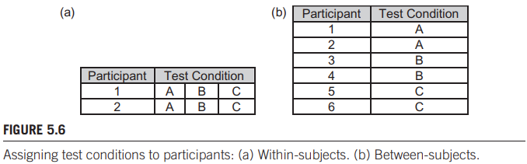
For a between-subjects design, each participant is tested on only one level of a factor; therefore, more participants are needed to obtain the same number of observations (Figure 5.6b). For a within-subjects design, each participant is tested on all levels of a factor. Fewer participants are needed; however, more testing is required for each participant (Figure 5.6a).
If the independent variable is not manipulative-able (gender, age, handedness), between-subjects is the only way to go. A participant cannot be male for half the testing, then female for the other half. Sometimes a factor must be within-subjects. The most obvious example is practice, since the acquisition of skill occurs within people, not between people. There is a significant advantage to using fewer participants, since recruiting, scheduling, briefing, demonstrating, practicing, and so on is easier if there are fewer participants. Another advantage of a within-subjects design is that the variance due to participants’ predispositions will be approximately the same across test conditions. Predisposition, here, refers to any aspect of a participant’s personality, mental condition, or physical condition that might influence performance. Yet another advantage of within-subjects designs is that it is not necessary to balance groups of participants—because there is only one group. Because of the three advantages just cited, experiments in HCI tend to favor within-subjects designs over between-subjects designs. However, there is an advantage to a between-subjects design. Between-subjects designs avoid interference between test conditions.
For an experiment with two factors it is possible to assign the levels of one factor within-subjects and the levels of the other factor between-subjects. This is a mixed design. Consider the example of an experiment seeking to compare learning of a text entry method between left-handed and right-handed users. The experiment has two factors: Block is within-subjects with perhaps 10 levels (block 1, block 2 … block 10) and handedness is between-subjects with two levels (left, right).
5.11: Order effects and latin squares
In most within-subjects designs, it is possible that participants’ performance will improve as they progress from one test condition to the next. Thus participants may perform better on the second condition simply because they benefited from practice on the first. Practice, then, is a confounding variable, because the amount of practice increases systematically from one condition to the next. This is referred to as a practice effect or a learning effect. Although less common in HCI experiments, it is also possible that performance will worsen on conditions that follow other conditions. This may follow from mental or physical fatigue—a fatigue effect. In a general sense, then, the phenomenon is an order effect or sequence effect. The most common method of compensating for an order effect is to divide participants into groups and
administer the conditions in a different order for each group. The compensatory ordering of test conditions to offset practice effects is called counterbalancing. In the simplest case of a factor with two levels, say, A and B, participants are divided into two groups. If there are 12 participants overall, then Group 1 has 6 participants and Group 2 has 6 participants. Group 1 is tested first on condition A, then on condition B. Group 2 is given the test conditions in the reverse order This is the simplest case of a Latin square. In general, a Latin square is an n × n table filled with n different symbols (e.g., A, B, C, and so on) positioned such that each
symbol occurs exactly once in each row and each column. Some examples of Latin
square tables are shown in Figure 5.7.
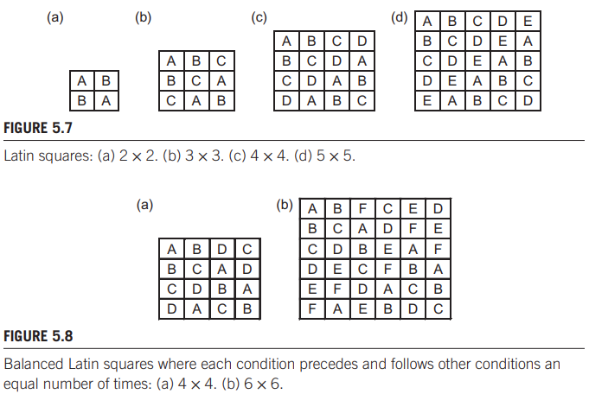
A deficiency in Latin squares of order 3 and higher is that conditions precede and follow other conditions an unequal number of times. In the 4 × 4 Latin square, for example, B follows A three times, but A follows B only once. Thus an A-B sequence effect, if present, is not fully compensated for. A solution to this is a balanced Latin square, which can be constructed for even-order tables. Figure 5.8 shows 4 × 4 and 6 × 6 balanced Latin squares. When designing a within-subjects counterbalanced experiment, the number of levels of the factor must divide equally into the number of participants. If a factor has three levels, then the experiment requires multiple-of-3 participants. You can check if counter balancing works by checking if group means are close.
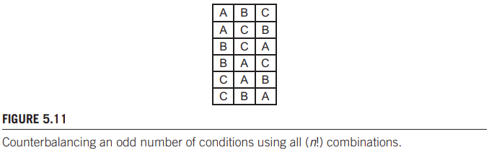
There is a potential problem for the 3 × 3 Latin square. Note in Figure 5.7b that B follows A
twice, but A follows B only once. So there is an imbalance. This cannot be avoided in Latin squares with an odd number of conditions. One solution in this case is to counterbalance by using all sequences. There are 3! = 6 combinations. Balancing is complete (e.g., B follows A three times, A follows B three times). For this arrangement an experiment will need a different number of participants, for the example above: 18 participants, assigning 3 participants to each order.
Yet another way to offset learning effects is to randomize the order of conditions. This is most appropriate where (a) the task is very brief, (b) there are many repetitions of the task, and (c) there are many test conditions. Examples shown in figure 5.12.
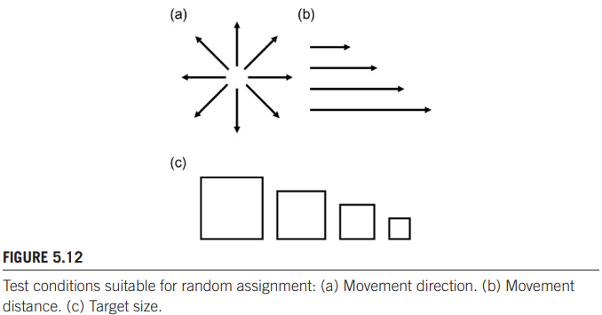
5.12: Group effects, asymmetric skill transfer
However, there are occasions where different effects appear for one order (e.g., A→B) compared to another (e.g., B→A). In such cases there may be a group effect—differences across groups in the mean scores on a dependent variable. When this occurs, it is a problem. In essence, counterbalancing did not work. A group effect is typically due to asymmetric skill transfer— differences in the amount of improvement, depending on the order of testing.
(Honestly, the next part is going to be almost the entire chapter. If this subject is hard for you, I recommend reading this straight from the book as it fully explains the example given.)

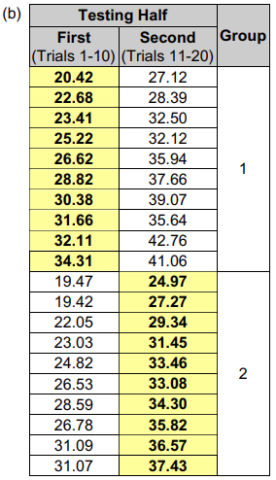
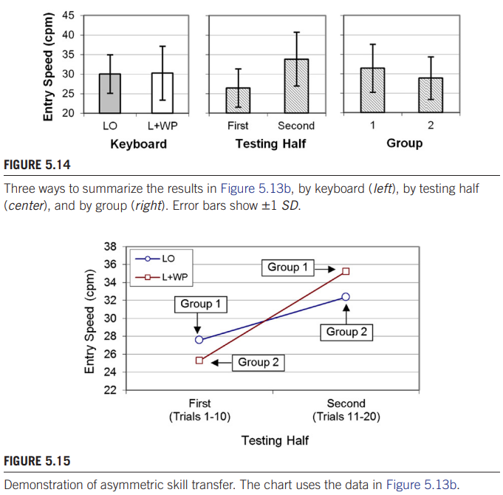
(Example) There are at least three ways to summarize the data in Figure 5.13b (the chart above). The overall result showing the difference between the LO and L + WP keyboards is shown in the left-side chart in Figure 5.14. Clearly, there was very little difference between the two keyboards: 30.0 cpm for the LO keyboard versus 30.3 cpm for the L + WP keyboard. The L + WP keyboard was just 1 percent faster. The error bars are large, mostly due to the improvement from trial to trial, as seen in Figure 5.13b. The center chart in Figure 5.14 shows another view of the results, comparing the first half and second half of testing. A learning effect is clearly seen. The overall entry speed was 26.4 cpm in the first half of testing (trials 1 to 10) and 33.8cpm, or 28 percent higher, in the second half of testing (trials 11 to 20). Learning is fully expected, so this result is not surprising.
Now consider the right-side chart in Figure 5.14. Counterbalancing only works if the order effects are the same or similar. This implies that the performance benefit of an LO→L + WP order is the same as the performance benefit of an L + WP→LO order. If so, the group means will be approximately equal. (This was demonstrated earlier in the counterbalancing example; see Figure 5.9). The right-side chart in Figure 5.14 reveals a different story. The mean for Group 1 was 31.4cpm. The mean for Group 2 was lower at 28.8cpm. For some reason, there was an 8 percent performance disadvantage for Group 2. This is an example of asymmetric skill transfer. Figure 5.15 illustrates. The figure reduces the data in Figure 5.13b to four points, one for each quadrant of 10 trials. Asymmetry is clearly seen in the cross-over of the lines connecting the LO points and L + WP points between the first half and second half of testing. If counterbalancing had worked, the lines in Figure 5.15 would be approximately parallel. They are not parallel because of the asymmetry in the LO →L + WP
order versus the L + WP→LO order. Asymmetric skill transfer is usually explainable by considering the test conditions or the experimental procedure. For this experiment, the effect occurs because of the inherent differences in entering text with the letters-only (LO) keyboard versus entering text with the letters plus word prediction (L+ WP) keyboard.
The simplest way to avoid asymmetric skill transfer is to use a between-subjects design. Clearly, if participants are exposed to only one test condition, they cannot experience skill transfer from another test condition. There are other possibilities, such as having participants practice on a condition prior to data collection. The practice trials seek to overcome the benefit of practice in the earlier condition, so that the measured performance accurately reflects the inherent properties of the test condition.
5.13: Longitudinal studies: when & why to use them
Sometimes the research has a particular interest in learning, or the acquisition of skill. In this case, the experimental procedure involves testing users over a prolonged period while their
improvement in performance is measured. Instead of eliminating learning, the research seeks to observe it and measure it. An experimental evaluation where participants practice over a prolonged period is called a longitudinal study.
In a longitudinal study, “amount of practice” is an independent variable. Participants perform the task over multiple units of testing while their improvement with practice is observed and measured. Each unit of testing is a level of the independent variable. Various names are used for the independent variable, but a typical example is Session with levels Session 1, Session 2, Session 3, and so on.
An example is an experiment comparing two text entry methods for mobile
phones: multi-tap and LetterWise. For English text entry, LetterWise requires an average of 44 percent fewer keystrokes than does multi-tap. However, a performance benefit might not appear immediately, since users must learn the technique. Furthermore, learning occurs with both methods, as participants become familiar with the experimental procedure and task. However, it was felt that the reduction in keystrokes with LetterWise would eventually produce higher text entry speeds. To test this, a longitudinal study was conducted.
The results are shown in Figure 5.16. Indeed, the conjectured improvement with practice was observed. Initial entry speeds were about 7.3wpm for both methods in Session 1.
With practice, both methods improved; however, the improvement was greater with LetterWise because of the ability to produce English text with fewer keystrokes on average. By Session 20, text entry speed with LetterWise was 21.0wpm, about 36 percent higher than the rate of 15.5wpm for multi-tap.
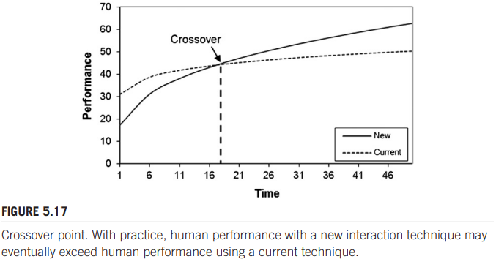
Performance trends in longitudinal studies, as shown in Figure 5.15, are often accompanied by an equation and best-fitting curve demonstrating the power law of learning.
In many situations, the goal of a longitudinal study is to compare the viability of a new technique against current practice.
From a practical standpoint, learning a new technique bears a cost, since performance is initially superior with the current technique. However, after the crossover point is reached, the new technique provides a benefit, since performance is superior compared to current practice. The cost-benefit trade-off is shown in Figure 5.18.
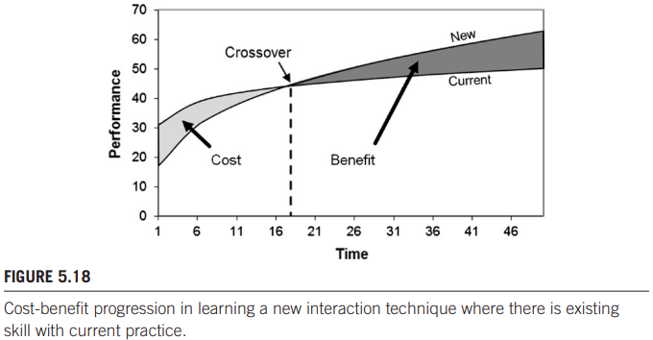
If learning the new technique is likely to take several hours or more, then the evaluation requires a longitudinal study, where users are tested over multiple sessions of input. Eventually, the crossover point may appear.
5.14: Pragmatics of running an experiment
It is always useful to have a pilot test with one or two participants. This will help smooth out the protocol for briefing and preparing the participants. It will serve as a check on the amount of time needed for each participant or you might find a final tweak to the protocol to be necessary.
An important aspect of the experiment is the instructions given to participants. For most interaction tasks, the participant is expected to proceed quickly and accurately. These terms—quickly and accurately—are subject to interpretation, as well as to the capabilities of participants. What is reasonably quick for one participant may be unattainable by another. Performing tasks reasonably quick and with high accuracy, but at a rate comfortable to the individual, is usually the goal. Whatever the case, the instructions must be carefully considered and must be given to all participants in the same manner. If a participant asks for clarification, caution must be exercised in elaborating on the instructions. Any additional explanation that might motivate a participant to act differently from other participants is to be avoided. The experimenter plays a special role as the public face of the experiment. It is important that the experimenter portrays himself or herself as neutral. Participants should not feel they are under pressure to produce a specific outcome. Also, participants should not sense a particular attitude in the experimenter. An overly attentive experimenter may make the participant nervous. Similarly, the experimenter should avoid conveying indifference or disregard. If the experimenter conveys a sense of not caring, the participant may very well act with little regard to his or her performance. A neutral manner is preferred.

Understand relation between measurement scales and applicable statistics, e.g. understand table of Figure 16.1 (e.g. given such a table explain why a mean makes sense for interval scales but not for ordinal scales)
Statistical procedures for hypothesis testing come in two flavors: parametric tests and non-parametric tests. Both are examined in this chapter. The distinguishing feature is that parametric tests operate on data from a probability distribution, such as the normal distribution or the t-distribution, whereas non-parametric tests are “distribution free,” which is to say, they make no assumption about the distribution of the underlying data.
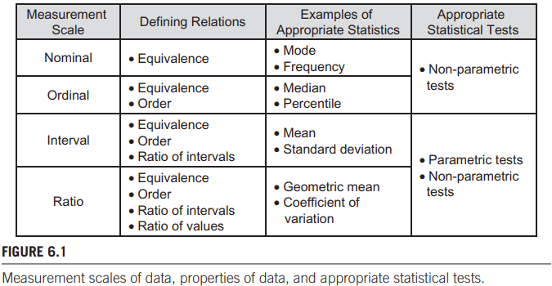
A useful way to distinguish parametric tests versus non-parametric tests is by the level or scale of measurement in the data being tested. Figure 6.1 illustrates. The figure shows the four scales of measurement discussed in Chapter 4 (see section 4.4.2). Parametric tests are applicable to ratio data and interval data, although they are most commonly used with ratio data. The analysis of variance (ANOVA), discussed in detail in this chapter, is the most widely used parametric procedure.
For experimental research in HCI, ratio data are typically human performance measurements such as the time, speed, or accuracy in doing tasks, or counts for events such as key presses, finger flicks, gaze shifts, or target re-entries. Nonparametric tests are applicable to any scale of data, although they are most commonly used for nominal or ordinal data. The non-parametric procedures examined in this chapter include the chi-square (χ2) test for nominal data and the MannWhitney U, Wilcoxon Signed Rank, Kruskal-Wallis, and Friedman tests for ordinal data. Typically, the data used in non-parametric tests are nominal categories, questionnaire responses, rating scores, or assessments on a scale. There is limited use of non-parametric tests for ratio data, a topic we will return to later in this chapter.
By the criterion of power, parametric tests are superior to non-parametric tests. This is a by-product of the strong assumptions and requirements of parametric tests. Provided the assumptions are reasonably well adhered to, parametric tests bring greater ability (power) to draw correct conclusions in the statistical tests undertaken.

6.1: Analysis of variance, ANOVA
Be able to explain and reason over variance testing on high level (e.g. you do not need to perform an ANOVA as in Question 3 of the W4/5 assignment, but given the solution to such assignment, you should be able to understand it and be able to answer questions about the analysis). understand use and misuse of p-values
An ANOVA, or F-test, is the main statistical procedure for hypothesis testing in factorial experiments.An ANOVA, or F-test, is the main statistical procedure for hypothesis testing in factorial experiments. The majority of HCI research papers that describe experiments include the results of an ANOVA, giving an F-statistic, the degrees of freedom for the F-statistic, and the associated p value (explained later). The ANOVA result is typically reported in parentheses as support for a statement indicating whether or not the outcome of the test was statistically significant.
An ANOVA determines if an independent variable—the test conditions—had a significant impact on a dependent variable—the measured responses. The “components attributable” are the test conditions (factors and levels) and the participants. If the variance across levels of a factor is large relative to all the remaining variance (other factors and the participants), it is often possible to conclude that the distinguishing properties of the factor—features in the test conditions—caused the observed differences in the measurements on the dependent variable. If so, the factor is said to have had a statistically significant effect on the dependent variable.
With an ANOVA, you don’t ‘calculate’ the answer to your research question, but the answer to the null-hypothesis. Figures below show the difference.
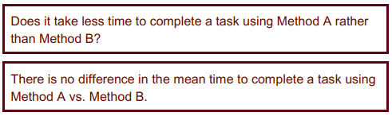
First: research question. Second: null-hypothesis
As you can see, to go from research question to null-hypothesis you change the sentence so that it implies there is no difference in the mean of your dependent variable between your groups.
The ANOVA tests the data to determine the likelihood of the null hypothesis being true (tenable) or false (rejected). In most cases, the researcher seeks to reject the null hypothesis. By convention, a statistically significant result means there is little likelihood the null hypothesis is true. The conclusion in such a case is that (a) there is a difference in the means, (b) the difference is statistically significant, and (c) the difference was caused by distinguishable properties in the test conditions.
(If you have trouble understanding, I recommend studying the examples in the book itself, this chapter has a ton of examples. Personally, I found the explanations around figure 6.2/6.3/6.4 to explain pretty clearly)
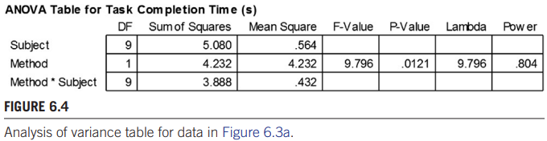
The most important statistic in the table is the “P-Value.” This is the probability of obtaining the observed data if the null hypothesis is true. A low probability indicates that the differences in the means are unlikely to have occurred in view of the null hypothesis. A high probability indicates that the differences in the means may simply be due to chance. With p = .0121, there is a fairly low probability—less than 2 percent—that the difference is simply a chance outcome. In all likelihood, there is some inherent and distinguishing property of one or the other method that caused the difference. Note the term “caused” in the preceding sentence. One reason experimental research is so valuable is that conclusions of a cause-and-effect nature are possible.
It is a convention in experimental research that significance, in a statistical sense, requires p less than .05, or a 1 in 20 probability.3 In other words, we consider the null hypothesis true unless there is a 1 in 20 chance or less that it is not. In addition to the probability, important statistics in the ANOVA are the F statistic (F-Value, the ratio of sample variances) and the degrees of freedom for the main effect (Method) and the residual effect (Method * Subject). The relevant statistics come together in a statement that declares the outcome of the research question.
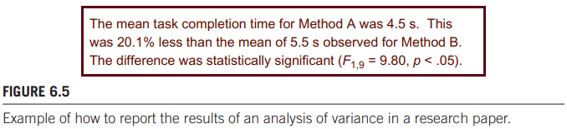
Note that the probability is not precisely cited. Instead, p is cited as less than a more conservative threshold from the set {.05, .01, .005, .001, .0005, .0001}. So p is cited as
p < .05 rather than p = .0121. The language in Figure 6.5 includes both the means for the test conditions and an articulation of the difference in the means. The difference in the means is the effect size. The effect size is usually conveyed in HCI research in a statement giving the means and the absolute difference (one second, in this case) or the relative difference. In the example, the effect size is given as a relative difference. Some notes for reporting the F statistics:
l Placed in parentheses
l Uppercase for F
l Lowercase for p
l Italics for F and p
l Space on both sides of the equal sign
l Space after the comma
l Space on both sides of the less than sign
l Degrees of freedom are subscript, plain, smaller font8
l Three or four significant figures for the F statistic
l No zero before the decimal point for the p statistic (because it is constrained
between 0 and 1)

Bear in mind that a non-significant ANOVA does not imply that the null hypothesis is true (i.e., no difference in the means). A non-significant ANOVA simply indicates that the evidence is insufficient to reject the null hypothesis: The null hypothesis remains tenable.
For non-significant results, the ANOVA result is reported in one of two ways. If F is less than 1, it is impossible for the effect to be significant, and in this case “ns,” for “not significant,” is substituted for p. If the F statistic is greater than 1 and p is greater than .05, the result does not meet the acceptable threshold for significance and p is reported as p > .05.

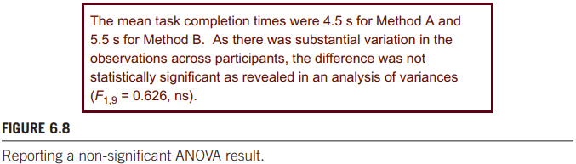
As you might have noticed, there are 2 numbers after the F. These are the degrees of freedom. If n is the number of test conditions and m is the number of participants, then the degrees of freedom are (n − 1) for the variance due to Method and (n − 1)(m − 1) for the variance due to Method × Subject. Put more simply: look at Figure 6.4. For the first number, take the second row of the DF column, and for the second number take the third row of the DF column.
However, when dealing with more than 2 test conditions, you still only get one F result and one p result, while there are multiple effects in play (A-B, A-C, A-D, B-C, etc.). The results of the test taken to see which of these effects is easy to read, as it uses a p value as well:
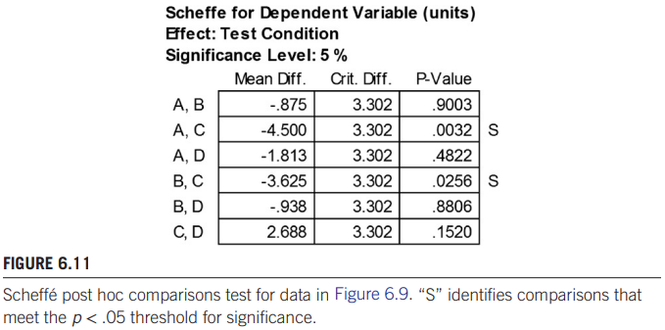
For the test, you don’t need to understand what this test does, but you should be able to distinguish the significant p values from the insignificant p values.
(Note that the significant values have great mean differences, this is a good way to check if you’re making the right call.)
Understand impact on statistical tests when choosing a within-subject or between-subject design
The examples above assume a within-subjects design: each participant was tested on all test conditions (levels of the factor). While within-subjects designs are the most common in HCI, between-subjects designs are also used. When performing an ANOVA on the data for either design, it is important to set up the analysis properly, as the variances are partitioned differently for within-subjects data versus between-subjects data.
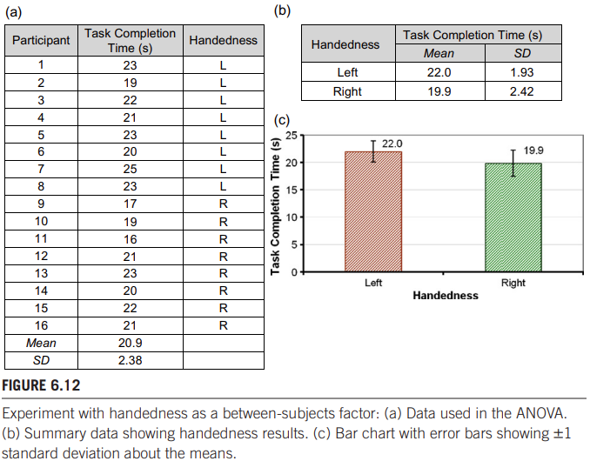
The between-subjects factor is identified as an added column of nominal data encoding the levels of the factor. “L” and “R '' identify the participants who were left handed versus right handed. Figure 6.12b summarizes the results by handedness, while Figure 6.12c presents the same information in a bar chart, as might appear in a research paper. The ANOVA is performed on the 16 × 2 matrix in the right two columns in Figure 6.12a. The result is shown in Figure 6.13. The degrees of freedom are (n − 1) for the variance due to Handedness and (m − n) for the variance due to the Residual. Since the P-value in Figure 6.13 is greater than .05, the difference between left handers and right handers was not statistically significant. Even though there was about a 10 percent difference between the groups—22.0s for left handers, 19.9 s for right handers—there was considerable variability in the observations. Based on the results of this experiment, we consider the null hypothesis tenable and conclude that there is no performance difference between left and right handed users in performing the add calendar entry task on the system under test.

6.1.5 Two-way analysis of variance
An experiment with two independent variables, or two factors, is called a “two-way design.” For such experiments, the analysis of variance tests for the main effects of each factor on the dependent variable, as well as an interaction effect. A significant interaction effect means that the factors in combination influence, or have an effect on, the dependent variable.
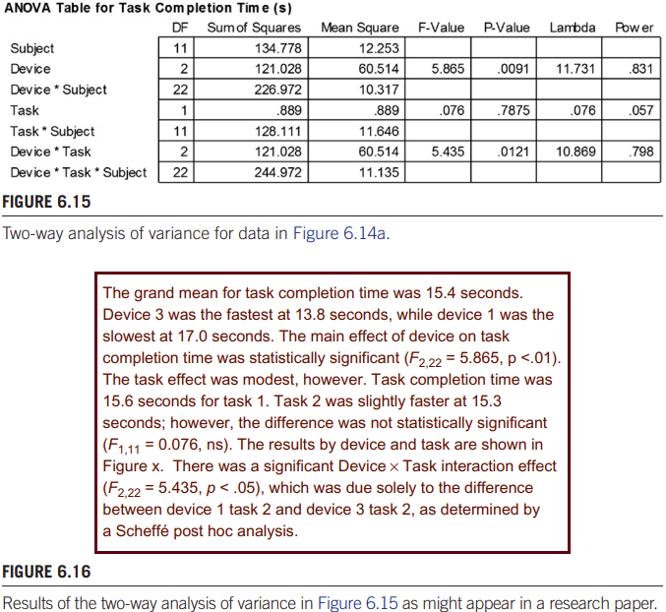
It is a challenge to create interest in presenting statistical results. A reader who confronts a tedious, sterile recitation of statistic after statistic will quickly lose interest. The goal in reporting results is to selectively pull interesting and revealing measures and statistics from the large array of data that emerges in experimental research. Note in Figure 6.16 expressions like “difference was modest,” “slightly faster,” and “due solely to.” These are minor embellishments intended to improve the readability of the results.
As a rule of thumb: Don’t feel compelled to explain the analysis of variance, or any other statistical method. Give the results in terms of the data, with supporting statistical tests conveyed plainly and without elaboration.

6.2: Chi-square test
Understand this is a non-parametric test often used on categorical/nominal data
Again, on the exam you will not be asked to perform a Chi-square test, but given an example result of such a test, you are expected to understand it and be able to answer questions about the analysis.
A common statistical procedure for investigating relationships is the chi-square test, also known as the Pearson chi-square test. The relationships are between categorical, or nominal-scale, variables representing attributes of people, interaction methods, systems, and so on. The data are commonly summarized in a contingency table—a cross tabulation organizing data in rows and columns with each cell containing counts or frequency data for the number of observations in the category. A chi-square test compares the observed values—the counts in the table—against expected values. The expected values are developed under the assumption that there is no difference among the categories in the table. The chi-square test is a non-parametric test since the categories are nominal-scale attributes and do not have a probability distribution associated with them.
The test statistic is written χ2, using the lowercase Greek letter chi. As with the analysis of variance, the underlying assumption is “no difference” with the test, seeking to reject the assumption. Unlike the analysis of variance, however, a chi-square test is simple. The calculations are easily done using a spreadsheet application.

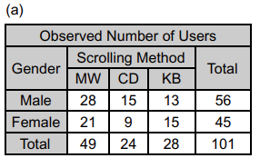
Figure 6.22
The chi-square test is a comparison between the observed values and the
expected values, with the expected values accounting for the different row and column totals. Figure 6.23a shows the expected values for the data in Figure 6.22a,
under the no-difference assumption. Each expected value is the row total multiplied by the column total, divided by the grand total. For example, the Male-MW
expected value is (56 × 49) / 101 = 27.2. From the observed and expected values,
a table of chi-squares is created, as shown in Figure 6.23b. Each chi-square is the
square of (the observed value minus the expected value), divided by the expected
value. For example, the Male-MW chi-square is (28.0 − 27.2)^2 / 27.2 = 0.025.

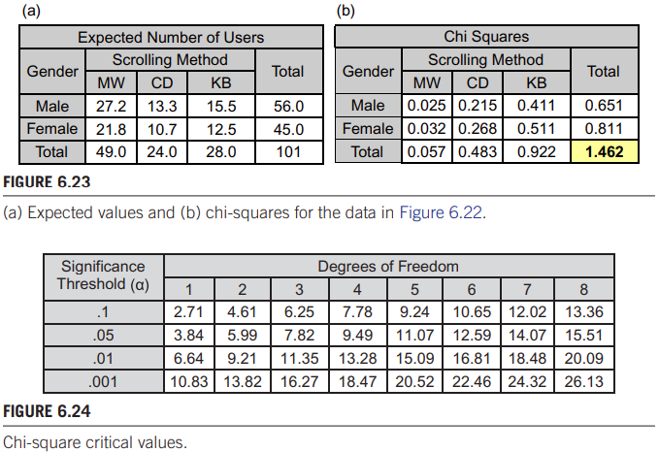
The final chi-square value is the sum of the individual chi-squares in the table. For the example data, the result is χ2 = 1.462, shown in the bottom-right cell in Figure 6.23b. Determining if there is a statistically significant difference among the cell entries involves comparing the final chi-square with values in a table of critical values. If the chi-square exceeds the critical value, the differences in the contingency table are statistically significant, implying there is a significant difference in the nominal-scale variables in the table. Two additional details are required: (a) the degrees of freedom, and (b) the required alpha level, or p-value, for significance. The degrees of freedom for the chi-square statistic is
(r − 1)(c − 1), where r is the number of rows and c is the number of columns. For the example, df = (2 − 1)(3 − 1) = 2. The alpha level is chosen prior to testing.
Since the computed value of χ2 = 1.462 is less than the critical value, the differences in the observed values are not statistically significant. Therefore, we conclude that there is no difference in the way males and females scroll using desktop computer systems.
6.3: Testing ordinal data (e.g. Likert-scales)
Understand and be able to reason over a Figure 6.29 (e.g. given an example as in 6.3.X, and given the table in Figure 6.29, be able to select the appropriate test)
Non-parametric tests make no assumptions about the probability distribution of the population from which the underlying data are obtained. For this reason, nonparametric tests are applicable to a wider range of data than parametric tests. However, there is a downside to non-parametric tests: loss of information. While parametric tests such as the analysis of variance operate on interval or ratio data, most non-parametric tests deal with ordinal data (ranks). Non-parametric tests ignore any property of the scale of data except ordinality. If the data tested are in fact interval or ratio, non-parametric tests waste this knowledge by collapsing differences into ranks. For example, a trio of values such as 49, 81, 82 (perhaps student marks on an exam) is transformed to 1, 2, 3. Clearly information is sacrificed, since the middle value is now equidistant from the first and third. Non-parametric tests benefit by not being bound by parametric assumptions, but sacrifice the power to use all available information to reject a false null hypothesis.

Rather than using direct measurement of human responses, the data are obtained subjectively, from participants, or using heuristics or other non-empirical or semi-empirical methods.
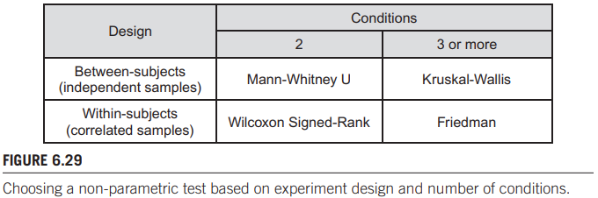
The four most common non-parametric procedures are the Mann-Whitney U test, the Wilcoxon Signed-Rank test, the Kruskal-Wallis test, and the Friedman test. Each is used in a particular context, depending on the number of test conditions and the experiment design. (Figure 6.29 illustrates.) Between-subjects and within-subjects designs generate data that are from independent samples and correlated samples, respectively, as shown in the figure. Between-subjects designs generate independent samples because different participants are tested with each condition. Within-subjects designs generate correlated samples because the same participants are tested with each condition. Bear in mind that the conditions are
levels of a single independent variable (factor) in the experiment.
Since the Kruskal-Wallis and Friedman tests operate on three or more conditions, a statistically significant outcome is usually followed with a post hoc pairwise comparisons test.
(For the exam I recommend reading the examples given in this chapter in the book and trying to connect the examples to one of the tests in Figure 6.29. It’s kind of overdone for me to just copy and paste the examples here, but it’s still a good exercise to see if you understand the difference between between- and within-subject designs and to see if you're able to accurately distinguish between conditions.)
6.4: Understand difference between parametric and non-parametric tests
(For a simple answer to this question, see the sentence after the paragraph (3), and the last sentence of this block, although I do recommend reading this entire piece)
When alternative tests are available to study data in an experiment, a rationale is needed to choose among the possibilities. For statistical tests, the guiding principle is that of power. Statistical power is about improving the odds of getting it right with the null hypothesis: rejecting the null hypothesis when it should be rejected and not rejecting it when there is no (or insufficient) basis to do so. However, there are other issues to consider. Siegel (1957) suggests that an appropriate test is one where the measurement requirements of the test are consistent with the measurements used in the research. Of the four scales of measurement—nominal, ordinal, interval, ratio (see section 4.1.4 in chapter 4)—the pairings are simple. If the research data are ordinal, then a statistical test that operates on ordinal data is a good choice. Similarly, if the experimental data are ratio, then a statistical test
that operates on ratio data is a good choice. In HCI, there is a common (and perhaps growing) practice that cuts across this simple principle.
Parametric tests, such as the analysis of variance, assume the data are sampled from a probability distribution, such as the normal distribution. Provided this assumption is met (and a few others are), parametric tests have more statistical power and are more accurate and more precise than non-parametric tests. However, if the assumptions are not met, then the researcher must decide on the appropriate course of action. There are three possibilities: (1) proceed with the parametric test, (2) transform or clean the data in some manner to correct the violations and then proceed with the parametric test, or (3) use a non-parametric test. All three options have advantages and disadvantages.
(1) Proceeding with a parametric test on data that potentially violate underlying assumptions is a common approach. This may occur because researchers don’t understand or don’t have access to statistical tools that test the assumptions. Also, some researchers feel parametric tests are reasonably robust to violations and, in any event, the underlying assumptions
are rarely met when analyzing real data.
(2)Transforming data using a log or power function is an effective way to correct the violations in assumptions. But as Siegel asks, “Will the process of ‘normalizing’ the distribution by altering the numerical values of the scores cause a distortion in the experimental effect under investigation?” (Siegel, 1957, p. 14). He notes that this is a question the investigator may not be able to answer.
(3) Conveniently, this approach sidesteps questions about the probability distribution of the underlying data. However, the decision to use a nonparametric test on data that are potentially parametric but violate assumptions is not to be entered lightly. Let’s consider this point further.
For ordinal data, such as rankings or qualitative assessments on a scale, nonparametric tests are the logical choice. For ratio data, such as measurements of human performance, parametric tests are preferred, in part due to their increased power (the ability to reject a false null hypothesis) but also by the simple standard that the test-to-data pairing is correct.

There are numerous tests for normality, skewness, etc., and small sets of empirically sampled data will frequently fail. If the data are measured on a dependent variable collected in an experiment, a researcher may conclude that the data are not parametric and then proceed with a non-parametric test. But this may be unnecessary or unwise. Recall from our earlier discussions that non-parametric tests collapse data into ranks. As Sheskin notes, “When a researcher elects to transform a set of interval/ratio data into ranks, information is sacrificed” (Sheskin, 2011, p. 531). So choosing a non-parametric test for ratio-scale measurements that deviate from normality is to replace one deficiency with another.
In the 1950s and early 1960s, applied statistics in the social sciences experienced a broad migration to non-parametric tests. However, abandoning parametric tests—mainly the parametric ANOVA—in favor of non-parametric tests was largely unnecessary, as noted by Glass et al. (1972). The shift occurred because researchers asked the wrong question. They asked “Are the assumptions of the parametric ANOVA met?” instead of “What are the consequences of the inevitable violations in the parametric ANOVA?”
In the end, there is evidence that the parametric ANOVA is reasonably robust to violations in the underlying assumptions. Even with small sample sizes (e.g., n = 3), the consequences of violations in the assumptions underpinning the ANOVA are usually minor.
So which test is the correct test? At this juncture, it would be remiss to recommend strict testing of ratio data using a parametric test (despite violations in assumptions) or a non-parametric test (despite loss of information). Arguably, the balance tips in favor of parametric tests due to the added precision and statistical power. However, the practice of Munteanu et al. (2006) and Perugini et al. (2007) is laudable: examine both avenues, consider the outcome for each, and attune for possible contradictions.
(So yeah, the book does not really give a complete answer, but I’ll try to summarize: using a non-parametric test for ratio data that violates the assumptions of a parametric test leads to loss of information; while using a parametric test for ratio data that violates the assumptions of a parametric test seems to not really have a big downside other than that you’re possibly using a test that's based on normality while your data does not have normality as a feature. I know, confusing as hell, but this is how the book states this dilemma.)
Chapter 7 "Modeling Interaction" - being able to apply Fitts' law and the KLM model as in the assignment. Please make sure you also have read and understand:
7.1: Role of descriptive models in HCI, understand the role of Figure 7.1 - 7.10 as examples of descriptive models in HCI
Models are reductions or simplifications of more complex phenomena. They are useful because they allow us to explore the phenomena, think about them, make changes, and so
on, without actually constructing the building or throwing the ball. A great many problems in HCI are explored in this manner. Models using “loose verbal analogy and metaphor” describe phenomena. Let’s called them descriptive models. Models using “closed-form mathematical equations” predict phenomena. Let’s call them predictive models. An architect’s model of a building is a descriptive model. A physicist’s equation for the trajectory of a tossed ball is a predictive model.
7.1.1 Delineating a problem space
Consider politics, a subject we all know a little about. Figure 7.1a gives the “big fuzzy cloud” model of politics. Of course, there is no model; it’s just the thing itself, without delineation. If we really want to study politics, it would be useful to break it down, delineate it, categorize it, structure it, or whatever—so we can get inside the problem, define and understand its constituent parts, and begin the process of charting out a corner of the problem space as a research area.
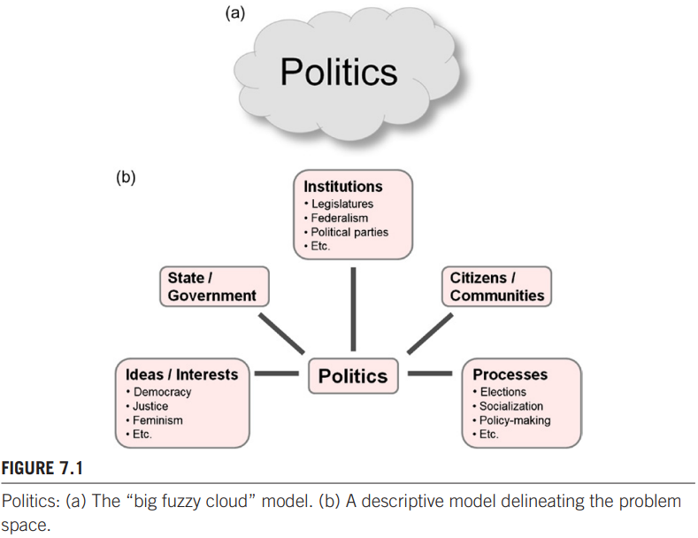
Figure 7.1b utilized delineation of the problem space for politics, which results in a descriptive model for politics. The descriptive model in Figure 7.1b adds tremendous insight into politics. With it, we are empowered not only to think differently about the problem, but to think critically about it. With every tweak, refinement, and improvement we get a better
model and, more importantly, we get a better understanding of the problem. That’s the power of descriptive models.
7.1.2 Quadrant model of groupware
An important area of research within HCI is computer supported collaborative work (CSCW). Computer applications to support collaboration are known as groupware. The starting point, as always, is to just think about groupware, to consider aspects of it that differ in some way. These differences can assist in dividing the problem space into simpler components or processes. One possibility for groupware is to consider collaboration in terms of space and time. Spatially, users might collaborate in the same physical place or in different physical places. Temporally, users might collaborate at the same time or at different times. The spatial and temporal aspects of the collaboration are illustrated in a descriptive model known as the quadrant model of groupware.
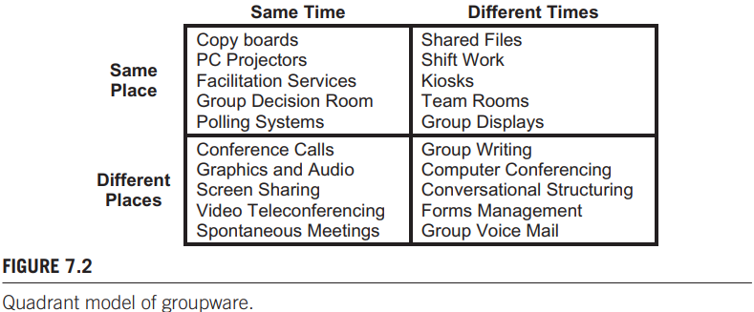
One use of a descriptive model is to identify common elements for interactions located in the same area of the problem space. Perhaps all such interactions should contain the same common elements, and if they don’t, this might motivate a design change. The goal here is not to engage in this exercise for groupware, but only to suggest that descriptive models provide a context for this sort of analysis. The quadrant model of groupware seems to offer this possibility.
7.1.3 Key-action model (KAM)
Computer keyboards today contain a vast array of buttons, or keys. Most desktop systems use a keyboard with a row of function keys across the top and a numeric keypad on the right. Have you ever thought about the operation and organization of keys on a keyboard?
Here’s a descriptive model for this purpose. We’ll call it the key-action model (KAM).
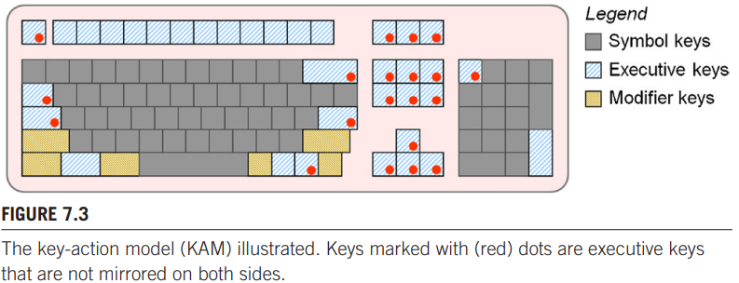
It’s a simple model. It has a name, it delineates a problem space, and it identifies three
categories of keys; for each category it provides a name, a definition, and examples. What do you think of KAM? Is it correct? Is it flawed? Do all keyboard keys fit the model? Can you think of additional categories or subcategories to improve the model or to make it more accurate or more comprehensive? Do some keys have features of more than one category? Is the model useful? The questions above—by their very nature—are evidence of the power of descriptive models such as the KAM. The model piques our interest and suggests aspects of keyboard operation that merit consideration, particularly if a new design is contemplated. The most important question is the last. There is no greater measure of the merit of a model than its ability to tease out critical arguments on the potential, the capabilities, and the limitations in an interaction domain.
First, consider the executive keys (e.g., enter) and modifier keys (e.g., shift). On the keyboard’s left we find seven such keys. On the right we find no less than 22. Because shift, ctrl, alt, and windows are mirrored, they do not pose a left- or right-hand bias and are eliminated from further discussion. Only three keys on the left are without a right-side replica, thus, the numbers are three on the left, 18 on the right. These are identified by dots in
Figure 7.3.
Before continuing, let’s remember our goal. I am not here is to deliver a tutorial
on keyboards, but to develop a descriptive model and demonstrate the ability of the
model to delineate a problem space and potentially expose problems and suggest
opportunities. The analysis in the preceding paragraph is a good example of this.
Using the key-action model, we have identified a very peculiar bias in desktop keyboards.
The key-action model delineates a design space for keyboards and allows for analyses to tease out design issues.
7.1.4 Model of bimanual control
Humans are not only two-handed, they use each of their hands differently. This human behavior has undergone considerable study in a specialized area of human motor control known as bimanual control or laterality. Studying the between-hand division of labor in everyday tasks reveals that most tasks are asymmetric: Our hands work together but have different roles and perform different tasks. Given this, and the knowledge that people are either right-handed or left-handed, examining the assignment of tasks to hands is a useful exercise. Guiard undertook such an exercise and proposed what he described as “a simple model, based on a non-quantitative physical approach, which aims at describing the logic of the division of labor that appears to govern the variety of human bimanual asymmetrical
actions” (1987). This is the essence of a descriptive model. The result is Guiard’s model of bimanual control:
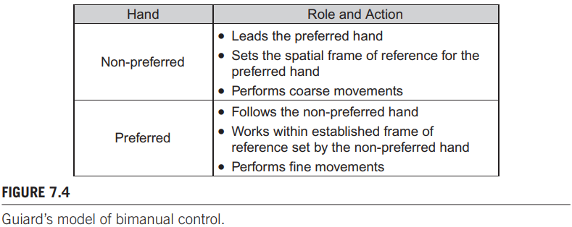
The roles and actions just described provide a provocative and fresh way of describing how humans approach common tasks. This is true both for every-day tasks and in the specialized context of human-computer interaction. Guiard’s research was published in a journal article in experimental psychology, not HCI. As originally published, no context for HCI was provided. However, the research got adapted in a different research to apply to HCI:
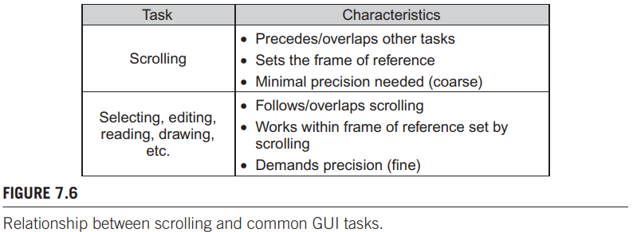
The important thing to take away here is that descriptive models can be adapted to fit their respective fields.
7.1.5 Three-state model for graphical input
Another descriptive model is Buxton’s three-state model of graphical input. The model is a simple characterization of the operation of computer pointing devices in terms of state transitions. It is described as “a vocabulary to recognize and explore the relationship between pointing devices and the interaction techniques they afford”. In this sense, it is a paradigm of descriptive modeling. The three states are identified in Figure 7.9, annotated for
mouse interaction.
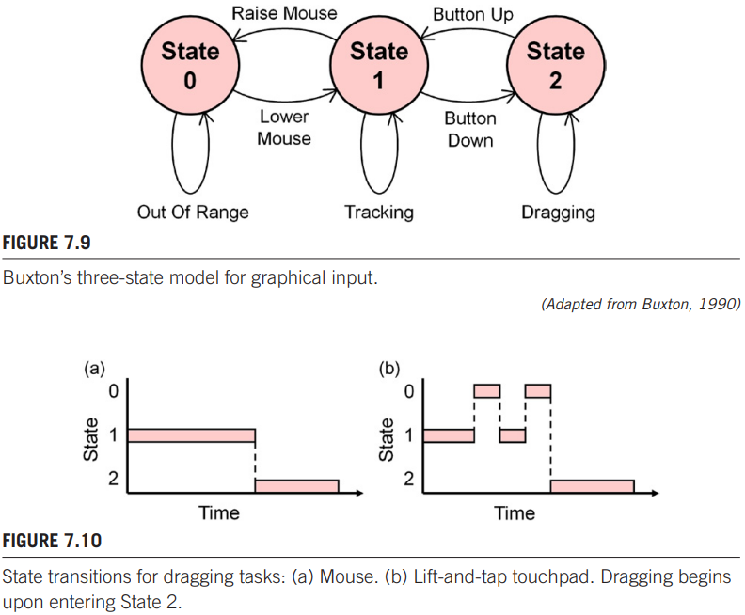
From left to right in Figure 7.9, the states are Out of Range (State 0) for clutching or repositioning a mouse on a mouse pad, Tracking (State 1) for moving a tracking symbol (e.g., a cursor) on a display, and Dragging (State 2) for moving an icon on the display or for grouping a set of objects or a range of text. The model seems simple and obvious, and we might question its ability to add insight to the existing body of pointing device research. Yet the model can be extended to capture additional aspects of pointing device interaction such as multi-button interaction, stylus or finger input, and direct versus indirect input. As further evidence of the utility of this model, the three-state model helped characterize an interaction technique that didn’t exist at the time of the model's creation. The insight led to a redesign of an interaction technique that later appeared in the Blackberry Storm and Apple MacBook, the trackpad now commonly used in notebooks.
Diagrams like this are evidence of the power of descriptive models such as Buxton’s three-state model. Two observations follow: (1) lift-and-tap necessitates extra state transitions in comparison to a mouse, and (2) the use of state 1-0-1 transitions for lift-and-tap is confounded with clutching (not shown) which uses the same state transitions. Among users’ frustrations in using touchpads is that these primitives are difficult, awkward, or error prone. For example, if a touch following a lift is spatially displaced from the point of lifting, the system sometimes enters the Tracking state (State 1) instead of the Dragging state (State 2). Armed with a deeper understanding of touchpad interaction, the state transitions on touchpads were redesigned. The additional pressure sensing capability of touchpads was used to implement state 1–2 transitions by “pressing harder.” A relay was added to provide both tactile and auditory feedback to inform the user of state transitions, much like the feedback in pressing a mouse button. Thus clicking, double clicking, and dragging were implemented on the touchpad, without a button, yet using the same state transitions as on a mouse. Despite being introduced in 1990, Buxton’s work continues to serve as a descriptive model for interactive systems
7.2: Role of predictive models in HCI, predictor variables, quantitative nature of predictive models, basics of linear regression, be able to interpret scatter plots as in Fig, 7.12 and 7.13
A predictive model is an equation. The equation predicts the outcome of a variable based on the value of one or more other variables (predictors). The outcome variable is a dependent variable, typically the time or speed in doing a task. It could also be accuracy, represented as spatial variability, error rate, or any other measure of human behavior. The only requirement is that the variable uses continuous, or ratio-scale, data. Most statistics sources call the predictor variable the independent variable. While correct, the terminology is problematic here. In experimental research, independent variable has a special meaning: it is a circumstance or characteristic that is manipulated. The vast majority of independent variables are nominal-scale attributes (e.g., device, feedback modality, display type, gender). Of course, independent variables in experimental research can also be ratio-scale attributes. Such variables can serve as predictors in prediction equations. A predictor variable can also be a ratio-scale attribute of users such as age, years of computer experience, number of emails received per day, hours per day playing video games, geographic distance from a friend, and so on. Predictive models are useful in HCI. Like descriptive models, they allow a problem space to be explored. However, with a predictive model we are dealing with numbers, not concepts.

7.2.1 Linear regression model
The basic prediction equation expresses a linear relationship between an independent variable (x, a predictor variable) and a dependent variable (y, a criterion variable or human response). An example would be y= mx + b, where m is the slope of the relationship and b is the y intercept.
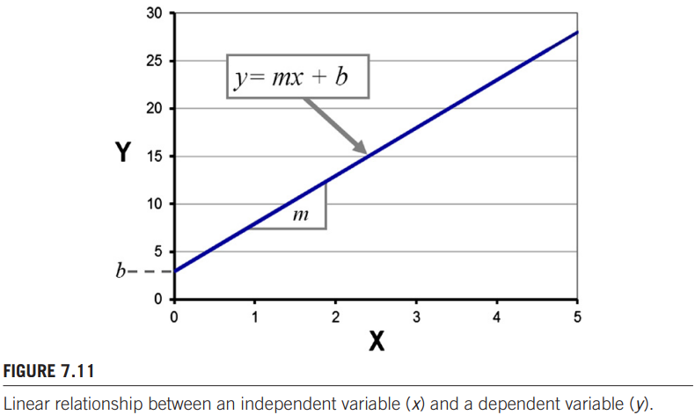
To build this equation, we first need a set of x-y sample points. Although any two ratio-scale variables will do, most commonly the x-y points combine the setting on an independent ratio-scale variable (x) with the measured value of a human response on a dependent variable (y). Since we are dealing with humans, variability is unavoidable, so the sample points are unlikely to lie on the line. They will scatter about. If the model is good, the points will be reasonably close to a straight line. How close is a key question. Finding the best-fitting straight line involves a process known in statistics as linear regression. The objective is to find coefficients m and b in Equation 1 for the line that minimizes the squared distances (least squares) of the points from the line. The result is the prediction equation—an equation that gives the best estimate of y in terms of x. Of course, the model is based on the sample points used in building the equation. If the data are good and the model is correct, a good prediction equation should emerge. There is also a built-in assumption that the relationship is linear, which is not necessarily the case.
One of the benefits of a predictive model is the potential to predict the outcome on a value of the predictor never actually visited.
Once again, I recommend reading the entire 7.2.1 chapter if this section seems unclear to you. The book goes in depth with an example that I can’t really summarize, unless I would copy paste the entire chapter.
7.2.2: Understand and be able to apply Fitts' law as in the assignment, being able to interpret data examples as given in Fig 7.16 and 7.17.
One of the most widely used models in HCI is Fitts’ law. If an interaction involves a rapid-aimed movement, such as moving a finger or cursor to a target and selecting the target, there’s a good chance someone has experimented with the interaction and used Fitts’ law to model it. Fitts’ law has three uses in HCI: (1) to learn if a device or interaction technique conforms to the model by building the prediction equation and examining the correlation for “goodness of fit,” (2) to use the prediction equation in analyzing design alternatives, or (3) to use Fitts’ index of performance (now throughput) as a dependent variable in a comparative evaluation.
If using Fitts’ law as a predictive model is the goal, then the movement time (MT) to complete a task is predicted using a simple linear equation:
MT= a + b x ID
The slope and intercept coefficients in the prediction equation are determined through empirical tests, typically using linear regression. The tests are undertaken in a controlled experiment using a group of participants and one or more input devices and task conditions.
(aaaand once again I’m going to refer you to the book. In my opinion this is the hardest part of the course and I can’t explain it any other way than the book does with the example it gives. I recommend studying 7.2.2.2 until you understand what the numbers in (11) and (12) mean and where they come from.)
7.2.3: Understand the Hick-Hyman law for choice reaction times
(Same goes for this part, unexplainable without copy-pasting the entire 7.2.3 chapter)
7.2.4: Understand and be able to apply the keystroke-level model (KLM) as in the assignment, predict task execution time for a given task sequence and given example data for K, P, H, D, M and R events
One of the earliest and certainly one of the most comprehensive predictive models in the HCI literature is the keystroke-level model (KLM). Unlike Fitts’ law and the Hick-Hyman law, the KLM was developed specifically for analyzing human performance in interactive computing systems. It was offered as a practical design tool, or as the authors called it, an engineering model. The model predicts expert error-free task completion times using the following elements:
l Task (or series of sub-tasks)
l Method used
l Command language of the system
l Motor skill parameters of the user
l Response time parameters of the system
The model is useful in situations where the sequence of interactions in performing a task is known. For example, if the task is “delete a file,” the KLM can predict the time to do the task provided the interactions (operators) can be explicitly specified. The KLM is not useful if the details of the interactions are not known. A KLM prediction requires a task to be broken down into a series of subtasks, or primitive operations. The total predicted time is the sum of the subtask times. The model works with four motor-control operators (K = keystroking, P = pointing, H = homing, D = drawing, B/BB = clicking/double clicking the mouse button), one mental operator (M), and one system response operator (R). Some operations are omitted or repeated, depending on the task. For example, if a keying subtask requires n keystrokes, tK becomes n × tK. Each tK operation is assigned a value according to the skill of the user, with values ranging from tK = 0.08s for highly skilled typists to tK = 1.20 s for a novice working with an unfamiliar keyboard. The operators and their values from the original KLM are given in Figure 7.20.
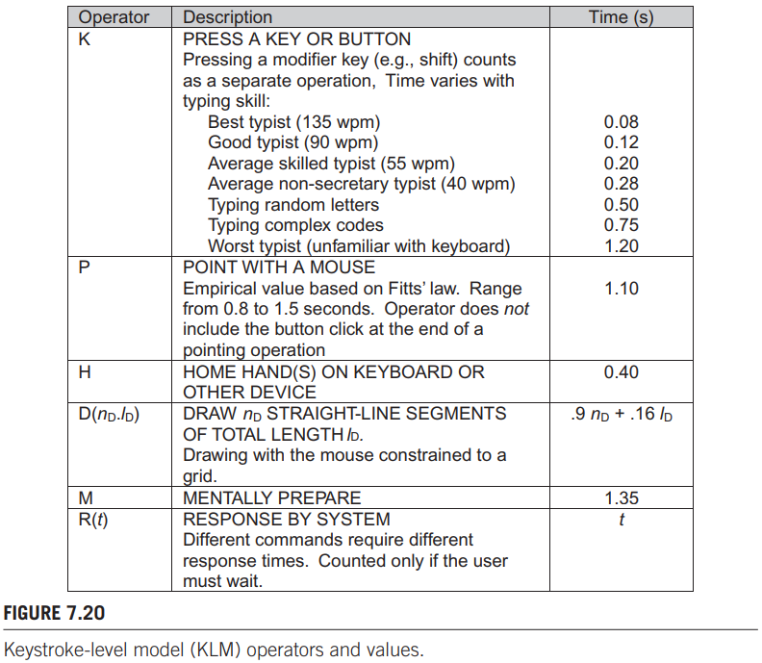
KLM is actually quite easy. Say, you have to calculate how long it takes for a user to use this application:
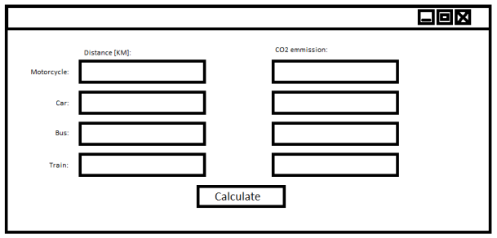
The application works to show you the CO2 emission when you fill in the distance you want to travel according to the transport method you chose. On the left, fill in the distance you travel in the right row for your transportation mode. On the right side the CO2 emission will be shown for the input fields in which a number was typed once “calculate” has been pressed.
Applying KLM to ‘predict task execution time for a given task sequence and given example data for K, P, H, D, M and R events’ goes as follows:
First, write down the different actions the user will take in using the application:
1. Click into input field;
2. Enter 321 (example number);
3. Click calculate.
Then, divide every action into the different operators used in KLM:
(K = key press P = pointing the mouse, H = move hand between mouse and keyboard, D = drawing, B/BB = clicking/double clicking the mouse button, M = mental time taken (thinking about what to do next for example), and system response time (R). The exact time values associated with each operator will be given on the exam, as they differ from person to person.) - (For this specific case, it was assumed the user already had their hand on the mouse)
1:
M [consider mode of transportation]
P [to input field with mode of transportation]
BB [click]
2:
H [to keyboard]
M [consider distance]
3x K [3-2-1]
3:
H [to mouse]
P [to “Calculate]
B [click]
R [show result]
Then, calculate the total time the interaction took by counting all operator occurrences and multiplying them by their respective time values, and then adding them all together:
T = 2xP + 3xB + 2xH + 2xM + 3xK +R
It can be useful to write down the time values, as there are quite a lot of numbers you need to work with. Again, the time values associated with the different operators will be given to you on the exam:
2xP = 2.2s P = 1.1s
3xB = 0.3s B = 0.1s
2xH = 0.8s H = 0.4s
2xM = 2.7s M = 1.35s
3xK = 0.84s K = 0.28s
R = 1.0s
Note the total time it took for the application to work.
Sum = 7.84 seconds (difference with previous is 2.4 seconds)
You have now used KLM to predict task execution time for a given task sequence.

(The rest of the chapter about KLM can be skipped, as the canvas page specifies only having to know how to apply KLM in the way described above.)

7.2.5: Basic notion of skill acquisition and associated predictive models
Not surprisingly, there is a relationship between skill and practice. Initial performance is poor, but with practice we acquire skill. With continued practice, we become proficient, perhaps experts. If the skilled behavior is adequately represented by a ratio-scale variable, then the transition from novice to expert is well suited to predictive modeling. In the model, the predicted or dependent variable is performance or skill, typically the time to do a specified task or the speed in doing the task. The independent variable is the amount of practice, typically in hours, days, years, trials, blocks, or sessions. The relationship between skill and practice is non-linear. In the beginning, a small amount of practice yields substantial improvement. After a lot of practice, the same “small amount” produces only a slight improvement. It seems the best mathematical expression of the relationship is a power function of the form:where x is the regressor or independent variable (amount of practice), y is the dependent variable (performance), and a and b are constants that determine the shape of the relationship. Represented in this form, the relationship between skill and practice is often called the power law of practice.
If the dependent variable is the time to do a task, T, then the power function above can be recast as, where Tn is the time to do the task on the nth trial, T1 is the time on the first trial. The trial number is n and a is a constant setting the shape of the curve. Trial is any practice indicator, such as task number, hours of practice, session number, etc.
Note that a is negative, because the acquisition of skill means task completion time decreases with practice.
Alternatively, the dependent variable can be speed (S), the reciprocal of time. In this case, the model predicts “tasks per unit time,” rather than “time per task.” An example for speed might be text entry speed in “words per minute.” Predicting speed, the power function above is recast aswhere Sn is the speed on the nth trial, S1 is the speed on the first trial, n is the trial number, and a is a constant setting the shape of the curve. In this form, a is positive since speed increases with practice. Furthermore, 0 < a < 1 to reflect the diminishing return with practice.
When applying these functions, be aware of the limits of the model. As shown in figure 7.37, when going far beyond the testing range the numbers become a bit unrealistic. 60 words per minute is not really a realistic measurement.
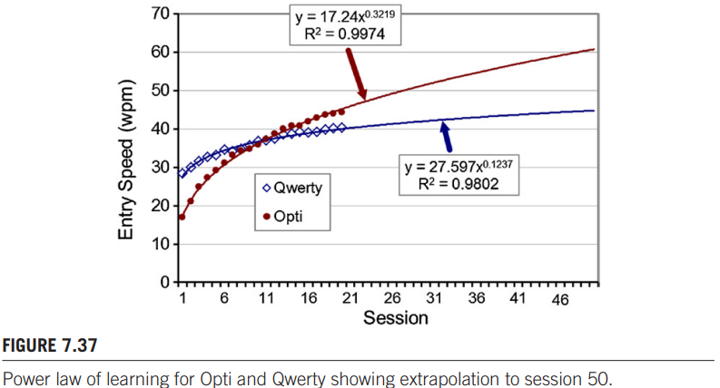
7.2.6: Basic notion of multiple regression, e.g. regression over more than one predictor variable
The equations above predict the outcome on a dependent variable from a single predictor variable (independent variable). It is also possible to build a prediction model where the outcome is predicted from multiple predictors. In statistics the technique is called multiple regression and takes the form
Example: A researcher is interested in the relationship between the time taken to learn a computer game and the age and computing habits of players. Can the time to learn the game be predicted from a player’s age and daily computer use? This question suggests a prediction equation with multiple predictors. The dependent variable is y, the time to reach a performance criterion in playing the game. The two independent variables (predictors) are x1, a player’s age, and x2, a player’s daily computer use in hours. Fourteen participants were recruited. The participants were given basic instructions on the operation of the game. Then they were observed playing and learning the game in 15–20 minute segments over a period of one week. They continued to play until they reached a criterion score. The data are shown in Figure 7.39.
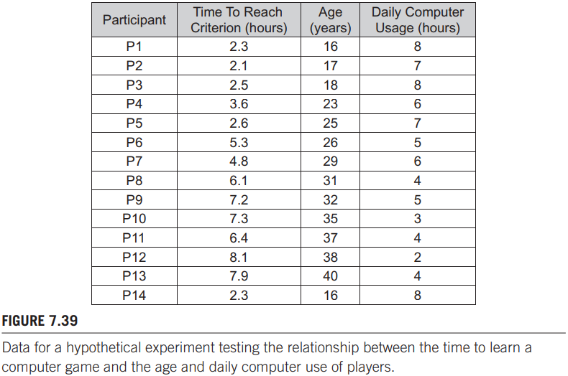
Two scatter plots derived from the data are shown in Figure 7.40. In both cases, a strong relationship is seen. Older participants generally took longer to reach the criterion in playing the game (Figure 7.40a). At r = .9448, the coefficient of correlation is high. The relationship is similarly strong between the time taken to reach the criterion score and players’ daily use of computers. In this case, however, the relationship is negative. Players who self-report spending a lot of time each day using computers generally took less time learning the game
(Figure 7.40b). The coefficient of correlation is r = −.9292, indicating a strong negative relationship.
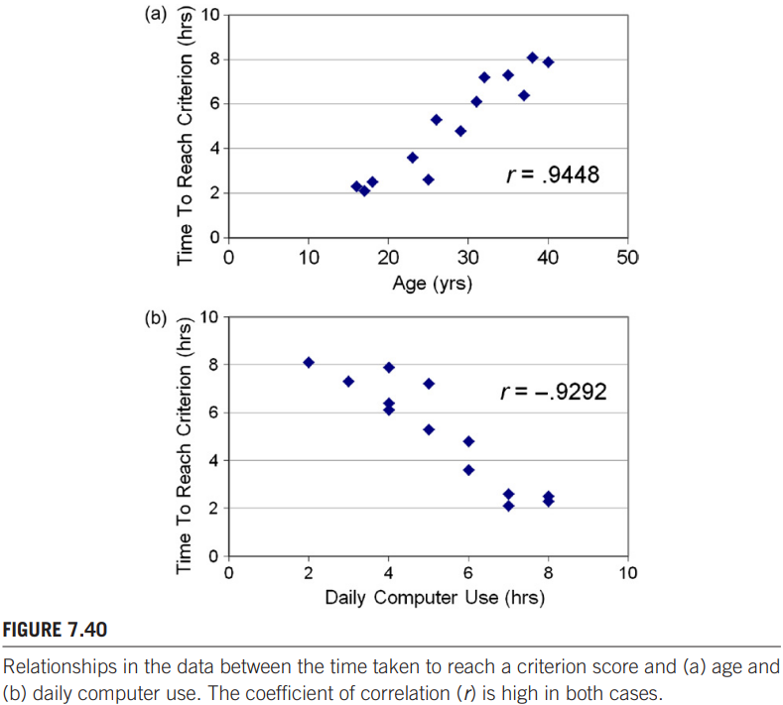
Regardless of the tool used, a multiple prediction equation for the data in Figure 7.39 yields
where y is the time taken to reach the criterion score, x1 is a player’s age, and x2 is a player’s daily computer usage in hours. The equation is accompanied with R2 = .9249, meaning the model explains about 92.5 percent of the variance in the data. All in all, it’s a very good model. Typically, other statistics are provided, such as the standard error of estimate for the prediction equation overall (SE = .6769, for the example above) and for each regression coefficient, and for the p-value for each coefficient.
HCI researchers with a social science perspective tend to use multiple regression with a slightly different motivation. Social scientists are more interested in observing and explaining human behavior rather than in measuring and predicting human performance. Typically the research seeks to determine the relative impact of several behavioral factors (independent variables) on a dependent variable. A common method is stepwise linear regression. All variables are tested individually to determine which has the greatest explanatory power (highest R2) on the variance in the dependent variable. A linear model is built using that variable. Then the remaining variables are tested one at a time against the model to determine which has the greatest explanatory power on the remaining variance. The process is repeated until all variables are added.
One property of multiple regression deserves mention. When an additional predictor is added to the model, the correlation (R) always increases. It cannot decrease. Thus, caution is warranted in declaring the new model a “better model” simply because of a higher correlation. The true test is whether the new predictor offers additional explanatory power relevant to the intended application of the model.

Chapter 8 "Writing and Publishing a Research Paper".
This chapter discusses how (HCI) research papers are written and how to report on your work. For this course, please make sure you have read and understand:
Most HCI research papers present a novel interface idea, then describe an evaluation of the idea in a user study. User studies are designed (or should be designed!) according to accepted standards for experiments with human participants, as laid out in Chapter 5.
8.1: Conference papers, journal papers
The main venues for publishing HCI research papers are conference proceedings or journals. Journals are considered the top tier for research publications. There are two primary reasons. First, journal submissions undergo a tightly controlled peer review to ensure the research is novel, correct, and carried out according to accepted standards in the field. The reviewers are experts in the subject matter and are enlisted by the journal’s editor or by a member of the editorial board. Second, journals are archived in major libraries around the world; thus, research published in a journal is readily available to other researchers.
HCI conferences bring together researchers and practitioners. The practitioners are the engineers and designers of products, and they are there to learn about the latest research in HCI. Life cycles and timelines for such products are short. The big players, like Apple, Microsoft, and Nokia, announce new products regularly and with great fanfare. So reaching and influencing the designers and engineers of products requires HCI research to have a short timeline. Unfortunately, the timeline from submission to publication in a journal is long—typically one to two years, sometimes more. For conferences the timeline is short—typically eight months, sometimes less. It is no surprise, then, that conferences and conference publications have emerged as an important vehicle for presenting and publishing research in HCI. For some HCI conferences, the peer review process is as rigorous as it is with many journals. So the prestige of publishing in some HCI conferences, such as the ACM’s annual SIGCHI conference, equals that of publishing in some journals.
Prior to publication, a research paper is a manuscript. In most cases, the venue for submitting is decided before writing begins. The decision will depend on many factors such as the subject matter, the timing and scope of the research, and the prestige of the conference or journal.
Journals generally have relaxed requirements for the format of submissions.
This is reasonable since a journal submission, if accepted, undergoes a round or
two of revision before publication. Revisions are introduced to improve the manuscript based on the referees’ suggestions. Acceptance is often conditional on final
approval by the journal editor or referees. Publication in a journal also includes professional copyediting by the journal staff. Hence, the formatting of the initial manuscript is not so important.
Conferences, on the other hand, have strict requirements on the format of submissions, including page length. There are a few reasons. For one, the timeline is short. The entire process is deadline-driven, with dates that are set for the initial submission, reviewer feedback, notification (accept or reject), and final submission. The initial submission must be formatted as per the conference requirements, since there is very little time to rework a rough manuscript into the final camera-ready copy that is published. Another reason for formatting the initial submission is that the responsibility lies with the author(s) to provide the final camera-ready copy that is published. Acceptance usually includes a request for “minor revisions,” again, based on referees’ suggestions. However, there is little or no vetting of the revisions or of the formatting within the manuscript, in part due to the short timelines. So formatting lies with the author and precedes the initial submission.
8.2: Parts of a research paper
While the typical HCI research includes a user study, this is not always the case. The annual ACM SIGCHI conference welcomes other types of submissions, such as “Theory,” “Argument,” or “Systems, Tools, Architectures and Infrastructure.” Although in the minority, such contributions are important to HCI. And it is likely they do not include a user study (although they could). It is worth reiterating the important role of non-experimental research in HCI. However, our discussion here focuses on a traditional HCI research paper with a user study.
8.2.1 Title
The title must identify the subject area of the paper while at the same time narrowing the scope of the work. An overly broad title fails to indicate if the paper is relevant to a sub-topic within a subject area. Furthermore, an overly broad title is misleading, as it implies that the work addresses a wider area of research than it actually does. Titles are often in two parts with a separator (typically a colon) between the main title and a secondary title. There are no rules here. Either part can serve to broaden or narrow the scope of the work. Often the goal is to catch the attention of the reader, perhaps with a provocative claim or phrase; for example, “Silk From a Cow’s Ear: Extracting Usable Structures From the Web”. In short, any title is fine provided it is concise, identifies the subject area, and narrows the scope of the work. The title is followed by the names of, affiliations with, and contact information for the authors. This information is provided and positioned according to the submission requirements of the conference or journal.
8.2.2 Abstract
The abstract is written last. There is typically a size limit imposed, such as 150 words, so the abstract must be concise. The abstract is a single paragraph and should not include any citations. After the title, the abstract is likely the first part of the research paper that is read. The title has caught someone’s interest; the abstract then delivers a succinct summary of the story within. After reading the abstract, the reader will decide if the rest of the paper is relevant and worth reading. The abstract should be the best-written section of the paper. The English and grammar should be perfect, the content succinct and clear. A poorly written abstract foretells of a tough slog ahead for anyone with the patience to continue reading.
The objective of an abstract is two-fold. The abstract should tell the reader what was done and what was found. Both themes are highly condensed since the abstract is constrained in size.
Unfortunately, treating the abstract as an introduction is a common flaw. This point deserves emphasis: The abstract is not an introduction to the subject matter of the paper. The reader has read the title and is now examining the abstract for further details. It is reasonable to assume, therefore, that the reader is familiar with the subject matter. Save the introductory material for the Introduction. Another common flaw in abstracts is the failure to give specific results. All too often, abstracts convey general conclusions and note that detailed results and discussions are found in the paper. Not good. Convey the most salient finding(s) in the abstract.
8.2.3 Keywords
Keywords are used for database indexing and searching. They allow others who are interested in the work to find it. Keywords are chosen by the author. They identify the subject matter and the scope of the work. Although choosing descriptors and terms is a challenge, there is an easy way. Just find a paper on the same or similar topic in the same proceedings or journal as the paper in preparation and mimic that paper’s descriptors and terms.
8.2.4 Introduction
The opening section of a research paper is typically called Introduction, although other labels, such as Background, are fine as well. The introduction gives the context for the research. Usually opening comments characterize the state of the art and indicate why the subject matter is interesting and relevant. A user interface problem or challenge is identified and the reader is alerted, early on, to the solution that is developed in the rest of the paper. It is common practice to give an overview of the contents of the entire paper, usually at a convenient place within the first page or so of the introduction.
It is also desirable to state the contribution of the work. This is tricky, since it entails laying down the bragging rights, so to speak, for a novel aspect of the work. Usually it is sufficient to note that the idea improves on existing practice, or something similar.
Usually a literature review is expected. This is typically organized in a separate section, with an appropriate heading (e.g., Related Work). The literature review discusses earlier published work related to the subject matter of the research. Points relevant to the current research are presented. A citation is included for each publication mentioned. Include figures, charts, or tables as appropriate. The main ideas developed in the paper should be laid out in detail. Use formulas, screen snaps, sketches, or any appropriate visual aid to help the reader understand the solution to a problem that the research presents. The introduction usually finishes with a statement indicating the need to test the idea in an empirical evaluation. This sets the stage for the method section.
8.2.5 Method
The method section of a research paper tells the reader how the experiment was designed and carried out. The method section should be written in an entirely straightforward fashion.
Any creative flair conveyed in the introduction should come to a full stop here. The reader wants to know what you did and how you did it. This information must be delivered in a style that is simple, clear, and predictable.
The method section delivers the crucial property of research that it must be reproducible. After reading the method section a reader might ask, “Could this research be reproduced?”
If the reader is reviewing the manuscript for a conference or journal and answer is
“no” or “I’m not sure,” there is little chance of acceptance.
Predictability is important. It allows a reader to scour papers and quickly find
key points and results. A reader will lose patience if it is a struggle to determine
the independent and dependent variables, the number of participants, the tasks performed by participants, and other important details of the experiment. On predictability, convention dictates that the method section is divided into the following subsections (and in the following order):
l Participants
l Apparatus
l Procedure
l Design
8.2.5.1 Participants
The participants section states the number of participants and how they were selected. Relevant demographic information is also given, such as age, gender,
and related experience. The details to provide depend on the task and apparatus used in the
experiment.
The information on participants identifies the population of people used and, therefore, the population to which the results apply. It is reasonable to limit the population pool to people with certain skills or attributes, if it makes sense for the research.
The participants section is usually short—just a couple of sentences. However, if a property of the user is an independent variable, then the participants section is often more detailed.
8.2.5.2 Apparatus
The Apparatus section describes the hardware and software. Other titles for this section include Materials, Interface, etc. Think of reproducibility when preparing this section. Give all the details necessary so that a skilled researcher could replicate the apparatus if he or she chooses. Some discretion is warranted. If, for example, the experimental task involved finger input on a touchscreen, then the make and model of the touchscreen should be given. Other details that might be relevant include the screen resolution, screen size, sampling rate, how the screen was held, or even the participants’ finger sizes. If the experiment used a custom interface, the development language (e.g., Java) and other relevant details should be given. It is particularly useful to provide screen snaps or photos of the interface.
8.2.5.3 Procedure
The procedure section tells exactly what happened with each participant. State the instructions given, and indicate if demonstration or practice was used, etc. If participants completed a questionnaire before or after testing (or both), indicate this in the procedure section. It is also common to indicate if participants were paid, volunteered without pay, or were required to participate, for example, as part of a university course. Typically, participants are tested over multiple conditions and perhaps multiple trials for each condition. Give the details. Usually there is a specific task that participants perform. Ensure the task is properly defined. Again, a screen snap of the interface may help. It is also useful to include a photograph of a participant performing the task.
8.2.5.4 Design
The design section summarizes the experiment in terms of the independent variables (factors and levels), the dependent variables (measures and units), or other relevant details. For short papers, these details are sometimes given in the procedure section. It is common to begin with a statement such as, “The experiment was a 3 × 2 within-subjects design.” If counterbalancing was used, the way the conditions were administered to participants should be stated. Be thorough and clear! It’s important that your research is reproducible.
A good way to conclude the design section is to indicate the total number of trials administered in the experiment. This can be revealed by a calculation that includes the number of participants and the variables and repetitions in the study.
8.2.6 Results and Discussion
Following the method section, the results of the experiment are given. It is common in HCI to combine the results with discussion. If there were outliers or problems in the data collection, state this up front and give details on any filtering of the data that took place before analysis. Before presenting the results it is common to describe the statistical approach and tests used in the data analysis.
Although there are no strict rules, it is common to use subsections that organize the results by dependent measures, beginning with the most important dependent variable.
For each dependent variable, begin with a broad observation, such as the overall mean, and then move to finer details such as the means for each test condition. The difference in the means between test conditions is the effect size. In HCI, effect size is typically given either as an absolute difference or as a relative difference, expressing the percent difference between one condition and another.
It is important to explain the results through discussion: What caused the differences in the measurements across experimental conditions? What detail in the interaction caused one method to be slower? Etc. Obviously the answers lie in the interactions used in the experiment and the observations made by the experimenter or obtained through a post-experiment questionnaire or interview.
There is very likely a difference in the observed dependent measures across experimental conditions. The difference may be real or it may be an artifact of the variability that occurs in experiments with human participants. Of course, finding a real difference is often the goal of the research: a novel interaction method improves on an existing interaction method. “Improves on” usually implies interaction that is faster, more accurate, more efficient, or better in some other quantifiable manner (e.g., fewer re-tries, less movement, higher quality results, etc.). Testing for a real difference typically involves doing an analysis of variance on the data, as described in Chapter 6. The results of this test are given in a succinct statement indicating the outcome.
In conveying ANOVA results, bear in mind that the statistical tests are not the results per se. The results lie in the observations and measurements. So avoid characterizing the results in terms of statistics. Of course, finding a statistically significant effect of an independent variable on a dependent variable is important. But the statistical test is simply the supporting
evidence. The result is the difference in outcome between the test conditions.
If there is no insight to be gleaned from a result, then don’t include it.
Another way to make results interesting for the reader is through visuals. Bar charts, line graphs, 3D plots, or the like appear in most research papers in HCI. The results and discussion section should compare the results with those in other research papers on a similar topic, citing prior work as appropriate.The results and discussion section also summarizes information obtained through questionnaires or interviews given at the end of testing. Participant feedback is often enlightening. Include it. Discuss it. What does participant feedback suggest in terms of improvements to the interaction?
8.2.7 Conclusion
The conclusion summarizes what you did, restates the important findings, and restates the contribution. It is common to identify topics for future work, although developing new ideas is to be avoided in the concluding section.
8.2.8 References
The last section of a research paper is the reference list. The list contains the full bibliographic details on papers cited earlier in the paper. Only papers cited in the paper are included in the reference list.
8.3: Preparing the manuscript
The process of creating a manuscript is more about transparency than flair: writing in a straightforward style and constructing figures, tables, and other visuals that are simple, clear, and consistent. Easier said than done. Resist any temptation to jazz up the presentation. A research paper is a product of scholarship, not a marketing brochure.
8.3.1 Formatting
Formatting is about the minutia: the punctuation, spelling, capitalization, italics, quotations, abbreviations, numbers, variables, and so on. These properties of a manuscript are important for clarity and flow. The goal is to get the formatting right; actually, perfect. In fact, get it so perfect that the reader won’t even notice.
A dictionary is a good source to determine if a word is capitalized (Internet), hyphenated (e-mail), not hyphenated (online), set as two words (screen snap), or set as a single word (database).
To facilitate formatting, conferences (APA, Harvard, etc.) provide template files, typically in both Microsoft Word and LaTeX formats. The template embeds many of the formatting requirements such as the margin sizes, fonts for headings and text, line spacing, paragraph spacing, and so on. Generally, the manuscript is prepared directly in a renamed copy of the template file. The template file also provides instructions and guidance on aspects of the paper under control of the author. These include writing style, the preparation of figures and other visual aids, formatting for citations and references, etc.
8.3.2 CItations and references
To facilitate formatting, conferences provide template files, typically in both Microsoft Word and LaTeX formats. The template embeds many of the formatting requirements such as the margin sizes, fonts for headings and text, line spacing, paragraph spacing, and so on. Generally, the manuscript is prepared directly in a renamed copy of the template file. The template file also provides instructions and guidance on aspects of the paper under control of the author. These include writing style, the preparation of figures and other visual aids, formatting for citations and references, etc.
8.3.2.1 Reference list
The following is a checklist of common formatting rules for reference lists in
conference publications:
l References are numbered.
l References are ordered alphabetically by first author’s surname.
l For each author, the surname comes first, followed a comma, then the initials for
the given names. Include a space between the initials if there is more than one
(e.g., “Smith, B. A.” not “Smith, B.A.”).
l For the title of the publication, only capitalize the first word, the first word in a
secondary title (e.g., after a colon), and proper nouns.
| Always include the year. Substitute “in press” for accepted but not-yet-published papers.
l Always include page numbers (except for complete books or web pages).
l The name of the publication is set in italics with all keywords capitalized (e.g.,
Proceedings of the ACM SIGCHI Conference on Human Factors in Computing
Systems—CHI 2011).
l For journal publications, include the volume number in italics.
l If space permits, use the full name for conferences and journals. If space is
tight, use abbreviated names for conferences and journals (e.g., Proc CHI ’99).
Do not mix full and abbreviated names; use one style or the other. If using
abbreviated names, be consistent.
l Give the location and name of the publisher for conference papers and books
(e.g., “New York: ACM”). Use the most economical yet understandable expression of the location (e.g., “New York,” not “New York: NY”; but use “Cambridge:
MA”) and publisher (e.g., “Springer” not “Springer Publishing Company”).
l Use align left (ragged right) for the reference list. (Note: The rest of the manuscript is justified.)
l Only include works that are cited in papers.
l Study and imitate!
l Be consistent.
8.3.2.2 Citations
Citations connect current research with prior research or other sources. The following are examples and tips for correctly citing prior work:

Do not treat citations as nouns;
(There is an exception to this rule. When it is inside parentheses, a citation may serve as a noun);
Quotations require a citation with a page number;
If citing a specific point from a book, include the page number (p. 41). If the point spans several pages, indicate the range (pp. 41-43);
If a paper is referred to by author(s), cite the first author followed by “et al.” (Latin for “and others”) if there are three or more authors;
Alternatively, include all the authors’ names for the first appearance of the citation and use “et al.” for subsequent appearances. Of course, all the authors’ names appear in the reference list.
8.3.3 Visual aids
Visual aids are powerful tools for conveying ideas and results. One of the most common results to present is the effect of an independent variable on a dependent variable. A bar chart is usually the most appropriate format, since most independent variables are nominal-scale attributes. Error bars are an important reminder to the reader of variability in human responses. However, error bars add little insight unless they are appropriately labeled.
If the variable shown along the x-axis is continuous, then a line chart is appropriate. The lines between intervals convey a sense of continuity as the experiment trials progressed.
Well before the Results and Discussion section, visuals are an important adjunct to text. Visuals can clarify concepts about the research or the technical details of an apparatus. In preparing a manuscript, try to find opportunities to assist the reader wherever possible. The methodology in particular can benefit from a judicious and targeted use of visuals. Remember that a powerful way to augment the procedure section of a research paper is through a photograph of a participant performing the experiment task. The photos help a reader understand the nuisances of the experiment task.
8.3.4 Writing for clarity
The goal in writing a research paper is communication. Effective communication demands clarity: “a clear mind attacking a clearly stated problem and producing clearly stated conclusions”. Clarity comes with economy—saying what needs to be said and little else.
l Write in a straightforward style.
l Avoid long or complex sentence structures.
So the goal in writing a research paper is to organize and deliver the story of the research in sentences that are simple and straightforward. This seems simple and straightforward. But it isn’t. Writing with clarity and economy is a challenge that is never fully achieved. Even the most seasoned researcher continuously struggles to express ideas in the clearest and most succinct way possible. (this has nothing to do with the summary, but look at the sentence that I filtered out here that actually followed the previous sentence: “The guard must never be down, lest the prose enlarge and swell.” Whoever wrote this book must've gone slightly crazy near the end of writing this book. This guy is writing about clarity in papers and drops these kinds of sentences. He goes on:) If clarity is the prize, clutter is the curse. A profusion of words that fills space but adds nothing is certain to suffocate any research paper. Without doubt, the reader who faces a stream of added useless words will quickly tire. The superfluous words demand the reader’s attention—so as not to miss a point—but in the end they encumber rather than enlighten.

Congratulations! U reached the end of this monstrosity of a summary. Good luck on the exams, I hope this summary helped all of you pass :))

