📖
Summary Syllabus Chapter 1-6

Chapter 1 - What is computational thinking
Computational thinking: a set of problem‐solving methods, but it is not only about solving problems but also about formulating them. By doing this, we can develop a stepby‐step solution to the problem. These steps are used to program a computer to solve a complex problem.

Chapter 2 - Solution Strategies

2.1 Easy vs. efficient solution strategy
2.2. How to approach a problem?
Five steps required to solve a problem:
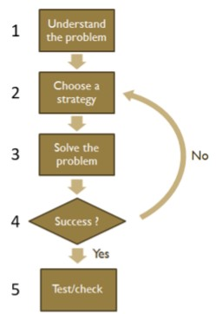
- Have a good understanding of the problem.
- Choose the right solution strategy to solve the problem.
- Solve the problem using the chosen strategy.
- Check whether the solution strategy worked to solve the problem.
If not, go back to the second step and choose a different solution strategy.
- Check our solution.
Could have made miscalculations or fallacies. Test the solution or check whether the solution found is reasonable or not.

Chapter 3 - Examples of solution strategies

3.1. The “Guess and Check” solution strategy
Just try something. Used for problems that are not too complex and that we have an overview of.
3.2. The “Go through all the possibilities” solution strategy
Used when the number of possibilities to solve a problem is limited.

3.3. The “Divide the problem into several subproblems” solution strategy
Divide the problem into sub‐problems, the problem becomes easier to solve. Several approaches to divide a problem into sub‐problems (can be combined):
Simplifying
Back reasoning
Exclusion
3.4. The “Use of formulas or equations” solution strategy
Using formulas and equations (duh).
3.5. The “Discover a structure or pattern” solution strategy
Look at other similar problems to discover a structure or pattern.

3.6. The “Make a model” solution strategy
When we model a problem, we omit many of the aspects that make the problem complex, we simplify the problem (e.g. making a diagram or drawing a picture).

3.7. The “Brute force” solution strategy
Relies on sheer computing power to try out all possibilities until a solution is found.
Does not use any algorithm or heuristics to speed up the calculation of the solution.
Often used if no algorithm is known to reach a solution faster or more efficiently.

3.8. The “Divide‐and‐conquer” solution strategy
Three major steps:
- Divide: Divide the given problem into sub‐problems of the same type.
- Conquer: Solve these sub‐problems recursively.
- Combine: Combine the solutions appropriately.
D&C technique is ideally suited for parallel computations (each sub‐problem can be solved simultaneously by its own processor).
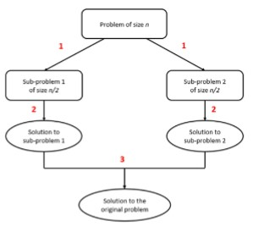

Chapter 4 - Algorithms

4.1. The importance of knowing something about algorithms
Reasons to know something about algorithms:
You should know a standard set of important computer science algorithms and be able to design new algorithms and analyze their efficiency.
The study of algorithms is recognized as the pillar of computer science.
If you're not a student in a computing‐related program:
Computer applications are integrated into many things today.
Computer programs have become indispensable in many aspects of our personal and professional lives.
We develop analytical skills, which are necessary to solve problems. Algorithms can be considered as special kinds of solutions to problems – not just answers but precisely defined procedures for getting answers.
Specific algorithm design techniques can be interpreted as problem-solving strategies.
Donald Knuth:
“A person well‐trained in computer science knows how to deal with algorithms: how to construct them, manipulate them, understand them, analyze them. This knowledge is preparation for much more than writing good computer programs; it is a general‐purpose mental tool that will be a definite aid to the understanding of other subjects, whether they be chemistry, linguistics, or music, etc. The reason for this may be understood in the following way: It has often been said that a person does not really understand something until after teaching it to someone else. Actually, a person does not really understand something until after teaching it to a computer, i.e., expressing it as an algorithm... An attempt to formalize things as algorithms leads to a much deeper understanding than if we simply try to comprehend things in the traditional way.”
4.2. What is an algorithm?
Algorithm: an effective method of solving a problem or performing a task that consists of a finite number of steps or instructions.
Algorithms need not be overly complicated.
An algorithm always works if we follow the steps. A solution strategy does not necessarily always work.
We can say that all algorithms are solution strategies, but not all solution strategies are algorithms.

4.3. Properties of algorithms
An algorithm must meet the following properties to be a fail‐proof way to solve the problem for which it was designed:
- Input: an algorithm takes input values from a specified set of elements, specifying the amount and type of input.
- Output: algorithm produces the output values for the specified set from the input values. These output values are the solution for the specific problem.
- Definiteness: steps of the algorithm must be precisely defined (no ambiguity).
- Correctness: algorithm must produce the correct output values for each set of input values.
- Finiteness: output values must be produced after a finite number of steps for any input values in the specified set.
- Effectiveness: must be possible to perform each step of the algorithm correctly and within a reasonable time.
- Generality: algorithm should work for all problems of the desired form, not just for a particular set of input values.

4.4. Pseudocode
Pseudocode: an English‐like syntax similar to a programming language. It is a detailed yet readable description of what a computer program or algorithm should do.
Example of pseudocode for counting people in a classroom:
1| Let NumberOfPerson = 0
2| for each person in the classroom
3| set NumberOfPerson = NumberOfPerson + 1
Advantages of writing pseudocode:
Catching errors (i.e., debugging) at the pseudocode stage is less costly than debugging them later in the development process.
Pseudocode can be inspected by a team of designers and programmers to ensure that actual programming is likely to match the design specifications.

Chapter 5 - Big O

5.1. Big O notation
Big 𝑂 notation: used to classify algorithms based on how they respond (e.g., in their processing time or workspace requirements) to changes in input size.
Characterizes functions based on their growth rates: different functions with the same growth rate can be represented with the same big 𝑂 notation.
Describes the asymptotic behavior of functions as 𝑥 grows to infinity.
Growth rate of a function is also called the order of the function (therefore the 𝑂).
A description of a function in terms of big 𝑂 notation usually only gives an upper bound on the growth rate of the function.
Is useful when analyzing algorithms for efficiency.
Suppose we have an algorithm that completes a problem of size 𝑛 in the time (or a number of steps) 𝑇(𝑛), where 𝑇(𝑛) is defined as T(n)= 5n² −2n+10 . Then the n² term will dominate when 𝑛 grows large so that we can ignore all the other terms. We write: T(n)= O(n²) (can also be written as T(n)∈ O(n²).
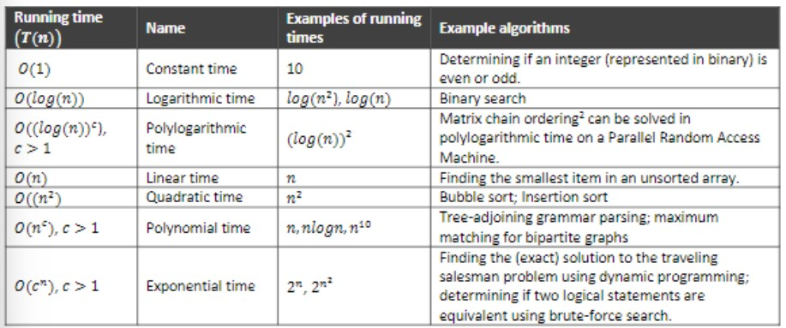
O(n^{c}) and O(c^{n}) are very different. The latter grows much, much faster, regardless of how big the constant 𝑐 is.
Superpolynomia: function that grows faster than any power of 𝑛.
Sub‐exponential: function that grows slower than an exponential function of the form c^{n} .
An algorithm can require time that is both superpolynomial and sub‐exponential.
Note that 𝑂(𝑙𝑜𝑔(𝑛)) is exactly the same as O((log(n))^{c} . The logarithms differ only by a constant factor that is ignored by the big 𝑂 notation.
Similarly, logs with different constant bases are equivalent.

5.2. Understanding Big 𝑶
Many resources are involved in efficiency, including:
CPU (time) usage
Memory usage
Disk usage
Network usage
The performance is about how much time, memory, disk, etc., is actually used when a program is running. This depends on the machine, compiler, etc. as well as the code.
Time complexity refers to the resource requirements of a program or algorithm scale.
This affects performance but not the other way around.
The time required by a function or procedure is proportional to the number of “basic operations” that it performs.
Examples of basic operations:
One arithmetic operation (e.g., +, *, /).
One assignment (e.g., 𝑥 = 5)
One test (e.g., 𝑥 == 5)
One read (of a primitive type: integer, float, character, Boolean)
One write (of a primitive type: integer, float, character, Boolean)
Some functions or procedures perform the same number of operations every time they are called. We say that these functions or procedures take constant time.
Other functions or procedures may perform a different number of operations depending on the value of a parameter.
Problem size or input size: the number of elements.
Most of the time, we are interested in the worst‐case time complexity, denoted as 𝑇(𝑛) (maximum number of operations).
For a linear‐time algorithm, if the problem size doubles, the number of operations also doubles.
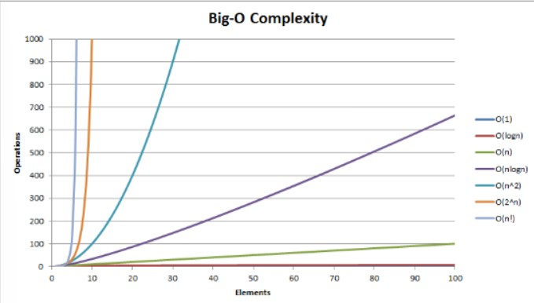

5.3. Determining complexities
In general, to determine the running time of a piece of code, we have to look at the statements, since the kind of statements used in the code determines the running time.

5.3.1. Sequence of statements
Suppose we have a sequence of statements such as the following:
statement 1 statement 2
…
statement 𝑘
The total time is found by adding the times for all the statements
𝑡𝑜𝑡𝑎𝑙 𝑡𝑖𝑚𝑒 = 𝑡𝑖𝑚𝑒(𝑠𝑡𝑎𝑡𝑒𝑚𝑒𝑛𝑡 1) + 𝑡𝑖𝑚𝑒(𝑠𝑡𝑎𝑡𝑒𝑚𝑒𝑛𝑡 2) + … + 𝑡𝑖𝑚𝑒(𝑠𝑡𝑎𝑡𝑒𝑚𝑒𝑛𝑡 𝑘).
If each statement is “simple” (only involves basic operations) then the time for each statement is constant and the total time is also constant, which means that 𝑇(𝑛) = 𝑂(1).

5.3.2. if‐else
if (condition) then block 1 (sequence of statements) else block 2 (sequence of statements) end if
Either block 1 will execute, or block 2 will execute → the worst‐case time complexity is the slower of the two possibilities.
If block 1 takes 𝑂(1) and block 2 takes 𝑂(𝑁), then the time complexity of the if‐else statement would be 𝑂(𝑁).

5.3.3. Loops
for 𝑖 in 1. . 𝑛 loop
sequence of statements end loop
If we assume that all the statements are 𝑂(1), then the total time for the for‐loop is 𝑛 x 𝑂(1), which is 𝑂(𝑛) overall.

5.3.4. Nested loops
for 𝑖 in 1. . 𝑛 loop for 𝑗 in 1. . 𝑚 loop
sequence of statements end loop end loop
The statements in the inner loop execute a total of 𝑛 x 𝑚 times. Thus, the time complexity is 𝑂(𝑛 x 𝑚).

5.3.5. Statements with function or procedure calls
When a statement includes a function or procedure call, the time complexity of the statement includes the time complexity of the function or procedure.
Suppose that we know that a function or procedure 𝑓 takes constant time and that a function or procedure 𝑔 takes time proportional to (linear in) the value of its parameter 𝑘.
Then, the statements below have the following time complexities:
𝑓(𝑘) has 𝑂(1) g(𝑘) has 𝑂(𝑘).
Then when a loop is involved, the same rule applies, e.g.,
for 𝑗 in 1. . 𝑛 loop
𝑔(𝑗)
end loop
The above example has a time complexity of O(n²) . The loop executes 𝑛 times and each function or procedure call 𝑔(𝑛) has a time complexity of 𝑂(𝑛).

Search algorithms

Introduction
Search algorithm: an algorithm for finding an item with specified properties among a collection of items. Unlike sorting algorithms, searching algorithms have no stability problems.

Linear search
Linear search (sequential search):
Belongs to the Brute force strategy and is only efficient for small lists (n ≤ 8).
Sequentially moves through a list and checks each element until the desired element (key) is found or the list is exhausted. When linear search finds the desired element, it returns the location of the element and stops searching further.
The list does not need to be sorted.
FOR each element in the list check if element is equal to the element being searched
IF element found stop with searching and return the element’s location
ELSE continue stop

Analysis
For the best case, the algorithm needs only one comparison to search the key element in a list with n elements (when the key element is in the first position of the list).
In the worst case, the algorithm needs n comparisons if there are n elements in the list (when the key element is in the last position or it is not present).
If the searched value occurs k times in the list, and all order of the list is equally likely, then the expected number of comparisons is
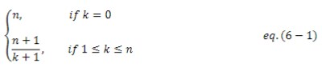
The worst‐case cost and the expected cost of the linear search are both 𝑂(𝑛).

Binary search
Binary search algorithm (half‐interval search algorithm)
Belongs to the Divide‐and‐Conquer solution strategy.
Is an efficient algorithm for searching the position of an element in a sorted list.
Average speed of binary search is faster than the linear search.
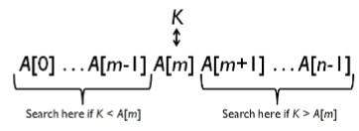
The binary search algorithm:
Starts by comparing a search key 𝐾 with the middle element 𝐴[𝑚] of the list.
If they match, the algorithm stops.
If the search key 𝐾 is greater than the middle element 𝐴[𝑚], then the first half of the list is eliminated and the algorithm continues with the same operation recursively for the second half of the list.
If the search key 𝐾 is less than the middle element, then the second half of the list is eliminated and the algorithm continues with the same operation recursively for the first half of the list.
The binary search algorithm reduces the number of elements needed to be checked by a factor of two each time and finds the searched value if it exists in the list, or if not, it determines “not present”, in logarithmic time.
The only time that binary search makes no sense is when the collection is frequently updated.

Analysis
The standard way to analyze the efficiency of binary search is to count the number of times the search key 𝐾 is compared with an element of the list. We will count the socalled three‐way comparisons:
Assumes that after one comparison of 𝐾 with 𝐴[𝑚], the algorithm can determine whether 𝐾 is less than, equal to, or greater than 𝐴[𝑚].
In the best case, we just need 1 comparison to find the search key 𝐾. In the best case, the search key 𝐾 is equal to the middle element 𝐴[𝑚].
In the worst case, we need⌈log₂( n+1)⌉ comparisons and in the average case we need about log2(𝑛) comparisons. Note that in the worst case we take the ceiling⁴ of log₂( n+1).
The runtime complexity of the binary search algorithm is 𝑂(1) in the best case. For both the worst case and the average case, the runtime complexity of binary search is
𝑂(log(𝑛)).

