Dynamic modeling
Summary
Lecture 1
What is a model?

1.Model - A representation of an object, system, or idea in some form other than that of the entity itself.
Dynamic model:
Describes a specific phenomenon, theory, or system (process) specifies changes over time, can simulate the process, can be used to study the process.
Study a process to increase understanding:study the behaviour of a process over time, performing “what if” simulations.Models are used as a basis for intelligent systems, to understand what is happening with humans (and what to do) models can make systems behave human like.Users of models are researchers, adaptive systems, human-like systems.

1.a) Elements of the Dynamic Model:
-Concepts represented as variables, temperature of an egg: TempEgg
-Timeline timepoint, stepsize, Δt (change in time) is time step between two states
-Rules that describe how concepts change per time step :
TempEgg(t+ Δt) = β * TempWater(t) + (1-β) * TempEgg(t)

1.b) Advantage of modeling:
-Easier to study than in reality, because that is expensive, hard to measure, not ethical, time consuming.

1.c) Use of models for scientific understanding:
- Scientific method: research questions lead to hypotheses, formulate specific and precise hypotheses: “if A occurs, then we observe B after some time”
-validate hypotheses on simulation traces (Run (several) simulations of the model and check the properties ⇒scenarios, choose conditions / input parameters intelligently be precise about what you can conclude. Hypothesis / properties can be formulated and validated against simulation( for evaluating expected patterns, for tudying the process).

1.d) Use of models for intelligent applications:
Ambient Intelligence:Intelligent systems support humans in their daily environment
Requirements:Systems have knowledge about human
functioning.This course: making dynamic models about human functioning and incorporate them in systems.

2.a) Designing models
1.Conceptualization(list of concepts and their relations)2. formalization(formal
model (executable)3.simulation(simulation traces)4.evaluation(situation in the real world)
Steps in brief:
1. Conceptualisation: identification of important concepts and relations
2. Formalisation: describe concepts and relations in an unambiguous way
3. Simulation: running experiments with models to generate simulations traces
4. Evaluation: verify whether the simulations are in line with expectations(properties)

Understanding growth - Generic process growth can be met in economy, biology etc.

a) biological growth:
Generic growth patterns
-Linear growth: division by fixed number of cells equal gain per time step
-Exponential growth: division by every cell every time step doubling
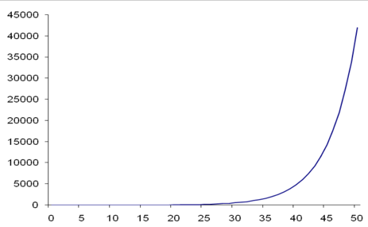
-Limited growth: growth decreases when some maximum is approached. Growth is linear or exponential at start, then decreasing gain per time step.
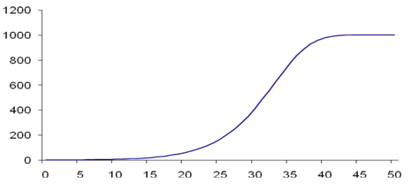

-Negative growth: loss is larger than the gain exists in several variants -linear, exponential, etc.
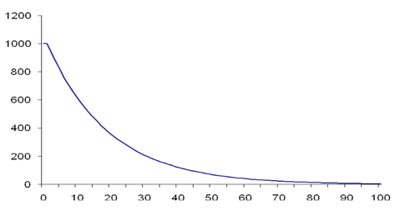
b) Amount and gain factor affect gain
Gain is calculated by multiplying the gain factor by the amount:
Gain(t) = GainFactor(t)*Amount(t)

c) Amount and loss factor affect loss
Loss is calculated by multiplying the loss factor by the amount:
Loss(t) = LossFactor(t)*Amount(t)

d)From gain and loss to amount
Gain adds to the amount and loss subtracts from the amount, both taken over the time interval that is passing.
Amount(t+Δt) = Amount(t) + (Gain(t) – Loss(t)) * Δt
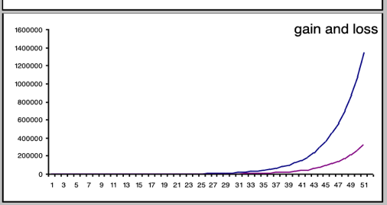

Lecture 2
- Creating models of physiological processes- Decision making: E_Coli

a)Food Consumption-Glucose or lactose.
Observe the behavior of food intake, patterns:
-Time delay of food intake
-If food is present, bacterium eats
-Preference for glucose over lactose

b) List of concepts and relations
External state:
-Glucose externally present (0/1)
-Lactose externally present (0/1)
● Internal states:
- CRPcAMP internally absent (Glucose indicator) (0/1)
-Some lactose internally present (Lactose indicator)
● Internal states for action initiation:
- Enzyme for glucose import present (0/1)
-Enzyme for lactose import present (0/1)
● Action performance:
- Glucose import takes place (0/1)
- Lactose import takes place (0/1)
● Internal states showing effect of actions:
- Substantial glucose internally present: => INTgluc (0/1)
-Substantial lactose internally present: => INTlac (0/1)
- Mass: => M (non-negative, real number)
Mathematical representation for the concepts:
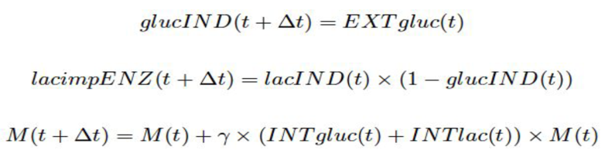

c) List of concepts and relations (Learning (neural mechanisms))
External stimuli:
○ tail shock => TailShock (0/1)
○ siphon touch => SiphonTouch (0/1)
● Neural concepts:
○ sensory neuron SN1 is activated => ASN1 (0/1)
○ sensory neuron SN2 is activated => ASN2 (0/1)
○ motor neuron MN is activated => AMN (0/1)
● Strength synapses:
○ strength of synapse S1 => S1 (integer)
○ strength of synapse S2 => S2 (integer)
● Result: contraction => Contraction (0/1
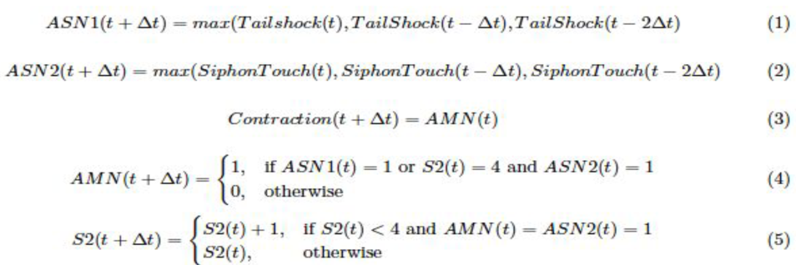

Lecture 3
Modelling Social Processes

Creating models of social processes- (Domain model)
1.Relation between individual behaviour and global patterns:
-Decisions of individual persons.e.g. choosing time to go home, affect global patterns
1.a) Relations in two directions:
upward interaction (forward)e.g. washing hands causes less virus spread
downward interaction (backward)e.g. high oil prices causes energy saving behaviours of individuals

2. Collective pattern and individual behaviour
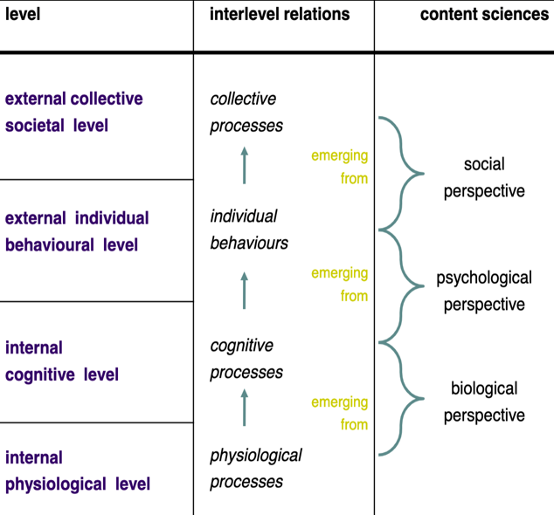
3.SELFORGANISATION IN HONEYBEE SOCIETIES
a) Honeybee Colony- A Society based on Decentralised Decision Making where individual decisions influence global processes. Taking up a role from the bee is triggered by environmental cues. Global aspects influencing individual behavior are Food availability,Larvae strength(pheromone rate),Cleanness(dead bodies),Safety (enemies).
b) Cognitive Level Decision Model
-Each individual maintains norms for each of the aspects. For each aspect, the individual determines in how far the current state is unsatisfactory, expressed in a degree of urgency for that aspect.
-For each aspect the relative urgency is determined: the degree of urgency divided by the norm for that aspect. The most urgent aspect is the one with highestrelative urgency; the role is taken that relates to this aspect.
-Norms are adapted: if an individual is in a role addressing a certain aspect, then the norm for that aspect is slowly decreased over time.

4.MODELLING EPIDEMICS FROM CONTACT BEHAVIOUR (virus spread)
-Understand the process of virus spread
-Predict future scenarios
-burden on hospitals
-Compare different intervention strategies

4.a) Modeling Epidemics-Two approaches:
-Modeling individuals(individual-based)
-Modeling groups (population-based (collective))

b) Individual Level:
- Each individual represented separately; more faithful, computationally complex, probabilistic element needed
Concepts individual approach:
-infection state of a person (susceptible, infective, recovered)
-location of a person
-contact frequency per day
-contact intensity
- recovery rate (chance per day for infective to recover)
Example of individual model formalization:
1.Susceptibles(t) = Σk if(InfectionStateAk(t) = 0, 1, 0)
2.Infectives(t) = Σk if(InfectionStateAk(t) = 1, 1, 0)
3.Recovered(t) = Σk if(InfectionStateAk(t) = 2, 1, 0)

c) Collective Level:
-Sub-groups represented by numbers, abstraction from reality, computationally efficient.
Concepts collective approach (Same, but no individual infection state)
Instead: different concepts for total number of people in a specific state
-(the group of) Susceptibles
-(the group of) Infected
-(the group of) Recovered

Example of collective model formalization:
1.Susceptibles(t+Δt) = Susceptibles(t) - Infections(t)*Δt
2. Infectives(t+Δt) = Infectives(t) + Infections(t) *Δt-RecoveryRate*Infectives(t)*Δt
3.Recovered(t+Δt) = Recovered(t) + RecoveryRate* Infectives(t) *Δt

Lecture 4
Behaviour modelling

a) What is behaviour and how can we model (intelligent) behaviour?
-Behaviour is the range of actions and mannerisms made by organisms, systems, or artificial entities in conjunction with their environment, which includes the other systems or organisms around as well as the physical environment. It is the response of the system or organism to various stimuli or inputs, whether internal or external,
conscious or subconscious, overt or covert, and voluntary or involuntary.”

b) Two viewpoints on modelling world knowledge
-External (observers) viewpoint knowledge, externally explain the subject’s behaviour without making any claim on the actual internal functioning of the subject.
external descriptions are the “characteristic patterns” that are used to provide evidence for the feasibility of internal descriptions.External viewpoint not always possible to model
-Internal (the subject’s own) viewpoint a subject has knowledge, encoded in one way or the other in it (cognition), and this knowledge is used by the subject to generate its behaviour. . Complex behaviour requires complex mental states!

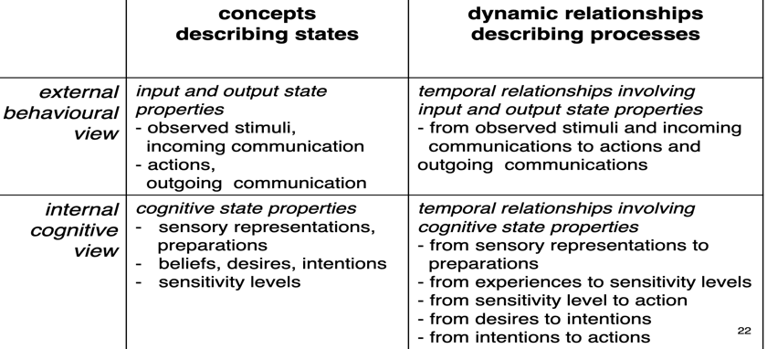

2.Modelling and simulation of behaviour requires observations and actions
Different behaviour types:
- Reactive behaviour (stimulus-response, delayed response)
-Motivation-based behaviour (behaviour depends on motivation or goal)
-Adaptive behaviour
-Mind-in-the-world behaviour

3.Conceptualization
- Make a list of what are considered: input concepts and output concepts
Specification of Input and Output:
Input: observation(of presence of food and screen)
Output: action(of going to p2)

Lecture 5
EMOTION CONTAGION

What is Emotion Contagion-Influencing others through conscious or unconscious induction of emotion states
-Contagion strength: expressiveness, channel strength & openness

Lecture 6
Developing a Domain model from scratch

List of concepts can be input state(observation), internal state, output state(actions)
Conceptualisation (Static)-concepts that play a role in a given description
-States of the world are described in terms of logical predicates = ontology with predicates and sorts
- Dynamics of the world are expressed as temporal if-then rules

Conceptualisation (Dynamic)- concepts influence each other

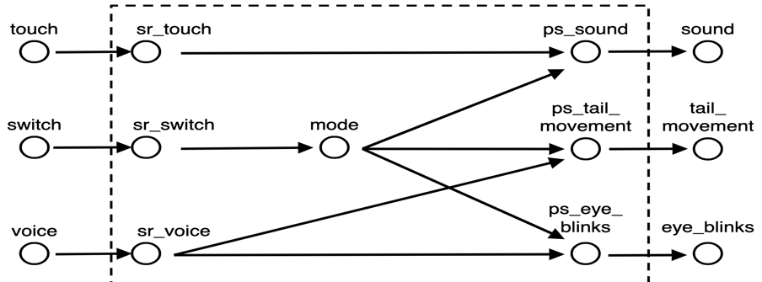

Modelling - considerations
1.Why do I build a model at all?
2.Simple is good (principle of parsimony)
3. Use concepts that can be made concrete
4.Level of granularity (physiological, cognitive, social, ...)
5. Distinguish input, internal, output, external
6. Formalisation: qualitative or quantitative?
7.Rules: type of influence (positive, negative, conjunction)?

Lecture 8
Integrating Models in Intelligent Systems.

Building ambient intelligent systems
-Ambient intelligent systems interact and cooperate with users, adapt to needs and preferences of users. To do so, knowledge about humans and how they function is needed. Integrating Models in Applications by incorporating a model within an application, a smart system can be built that has knowledgeabout human functioning, and is able to reasonabout this (possibly over time)

2.Two types of reasoning
-What is going on?
Making assessments of the current situation ‘This user has a sad face and has used negativewords over the last 2 hours, he is probably depressed’‘This driver is blinking with her eyes all the time, she is probably getting tired’
-What will happen if?
Predicting the effect of possible interventions‘If the user goes for a walk in the park, he might feel better’,‘If the driver takes a break of 30 minutes, she will recover’

3.Integrating Models within Intelligent Systems
Examples of intelligent systems:
-intelligent cars, smart homes, search bots / recommender systems on Internet, robots -called agents .An agent is a computer system that is situated in some environment, and that is capable of autonomous action in this environment in order to achieve its delegated goals.Both humans and computer systems can be considered as interaction agents computer systems can use simulations of human behaviour / thinking for own actions.Smart applications can be build by integrating models of human functioning within applications that can reason about humans by assessment of the situation and decision on support.

Agents are in Interaction with the External World by observation. They can be Passive (without taking initiative) or Active (actively initiated and controlled).
-Execution of Actions (to change the state of the environment)
- Communication with Other Agents
- Outgoing (sending)
-Incoming (receiving)

4.Agent-based modelling
Agent-oriented development is paradigm of looking at software development, not one large program,small pieces of software that have their own goals and communicate with others.Why using agent paradigm?Five ongoing trends within computing:
-Ubiquity:(processing power is everywhere),interconnection (computer systems are networked and distributed) intelligence (computers solve increasingly complex tasks) delegation :(we provide more and more control to computers) human-orientation(machines are increasingly being treated as humans)

Intelligent Agents types:
-Autonomous: Able to control its own processes independently
-Reactive: Able to receive information from environment and respond
-Pro-active- Able to take initiative to work systematically towards your goals
-Social-Able to communicate, coordinate, negotiate and cooperate

Examples of Natural Agents
- Humans, Travel agent, traffic agent, insurance agent, secret service agent, Primates, Cats, Bacteria, Plants
Examples of Artificial Agents
-Thermostat, Intelligent car, Smart home, Robot, Game character, Search engine
Internal Agent Concepts:
- Beliefs about the world, Desire goals the agent wants to achieve, Intentions -plans of action to achieve its goals

Examples of domain models of human functioning:
- physiological processes:(circulatory system, medicine uptake, exhaustion)
-cognitive/behavioural processes:(decision process, emotions, beliefs)
social processes:(spread of information between people, group behaviour)

Lecture 9
Integrating Domain Models within Agent Models

Integrating Models in Intelligent Applications:
By incorporating a model within an application, a smart system can be built that has knowledgeabout human functioning and is able to reason about this.Two types of reasoning:
-What is going on? → assessment of situation (analysis model)
- What will happen? → prediction of consequence (support model)
Reasoning about observations can be done in two ways:
-forward in time (from causes to effects) and backward in time (from effects to causes).

Integration: Four ways
-Domain model: represents human process
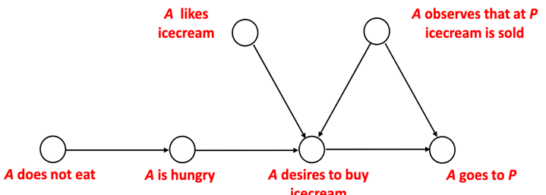

-Analysis model: derive conclusion about the situations.
It analyse and assess the process, uses domain model to interpret observations, matches believed human state to some desired state, generates assessments. Main purpose is find out whether some undesired state occurs.Requires Domain model and sensors.

3.Analysis model via forward reasoning
Concepts used for forward reasoning in an analysis model- ambient agent X observes Y, ambient agent X believes Y, ambient agent X desires Y, ambient agent X assess Y

Analysis model via forward reasoning:
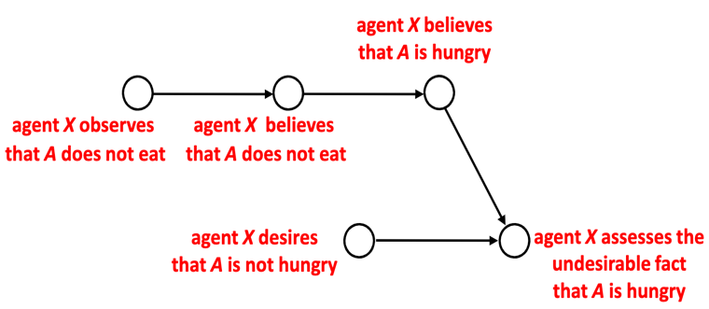

4.Analysis model via backward reasoning
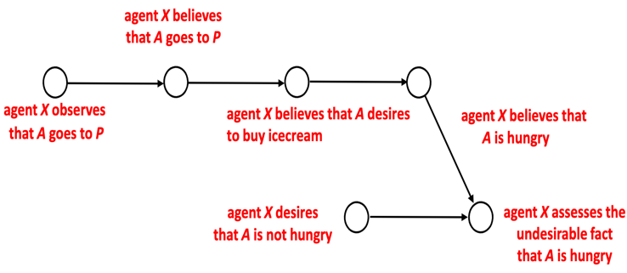
Part from lecture 10 5. Support model: determine what actions to take.
Generates support for the process, uses domain model to reason about effect of actions⇨ generates support actions. Main purpose is a support action that will have a positive effect (on the undesirable state)in time: after having done assessment with analysis model.It requires domain and analysis model and a set of possible support actions

Concepts: ambient agent X desires that A goes to Q, ambient agent X believes that there is a restaurant at Q, ambient agent X proposes that A goes to Q, assume

Extension of domain model with support actions
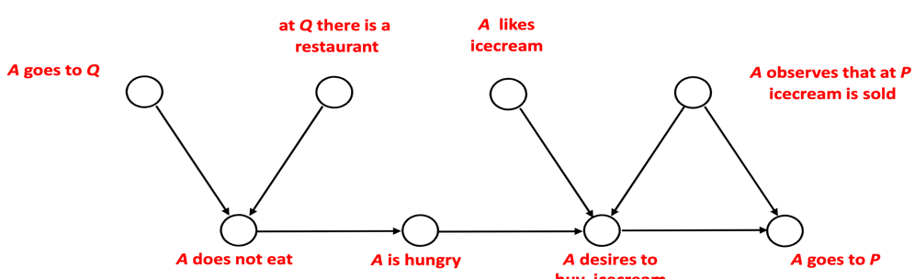

Reasoning in support model can be done in two ways: Forward or backward reasoning (or both)
a)-Backward reasoning (deduct which action influences the state we are
interested in) starting from desired state, towards actions
1. (Extend domain model by including support actions)
2. Decide which concept of domain model is (not) desired
3. Introduce a desire for this concept
4. (Propagate and remove negative effects)
Backward:
5. Derive more desires by following arrows backwards
6. If support action is reached, propose this action

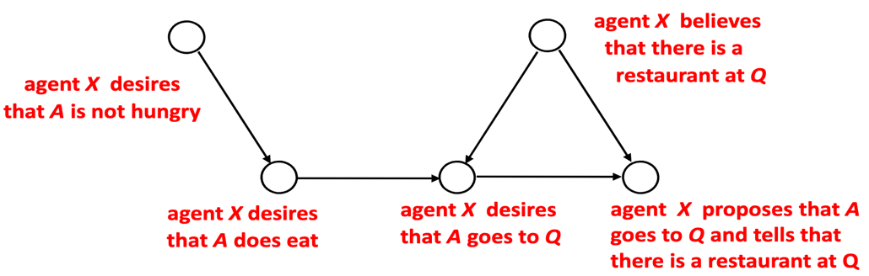

-Forward reasoning- simulate effect of each possible action, starting from action(s), towards desired state. Reasoning about (hypothetical) beliefs. Forward chaining can be used for tasks such as planning, design process monitoring.

1. (Extend domain model by including support actions)
2. Decide which concept of domain model is (not) desired
3. Introduce a desire for this concept
4. (Propagate and remove negative effects)
Forward:
5. Introduce an assumption for a selected support action
6. Derive beliefs by following arrows forwards
7. If desire is reached, propose the support action
(also include arrows from desire and assumption)

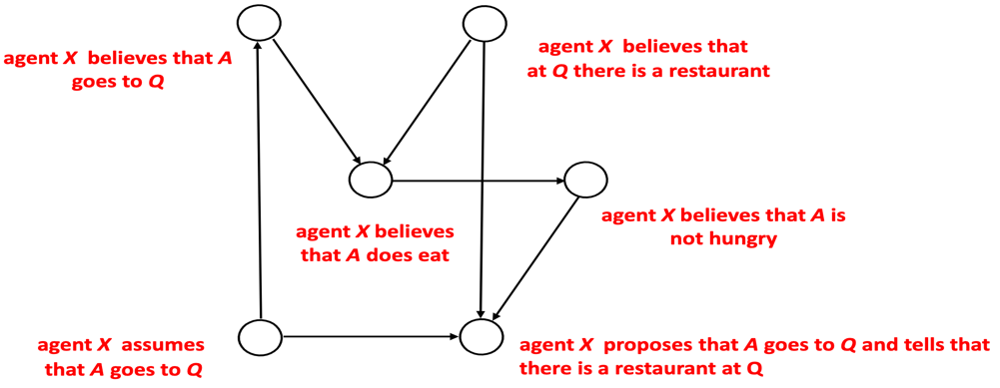
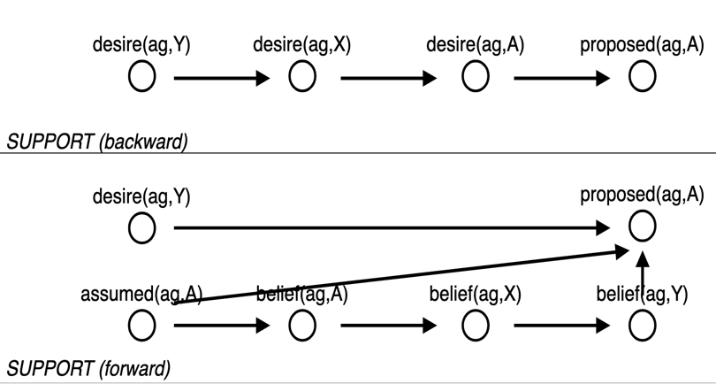

6. Beliefs can we generate in our analysis / support model when applying forward reasoning and when applying backward reasoning:
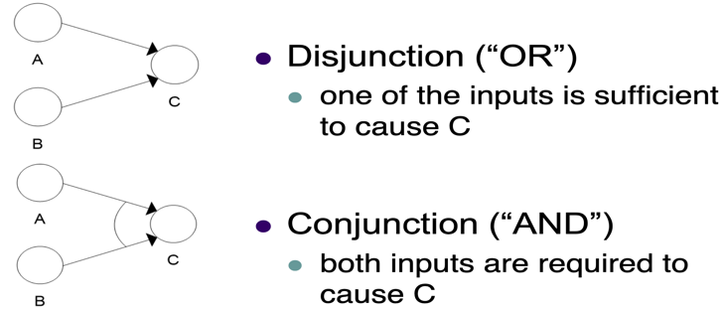

Forward reasoning: Disjunction -one to one
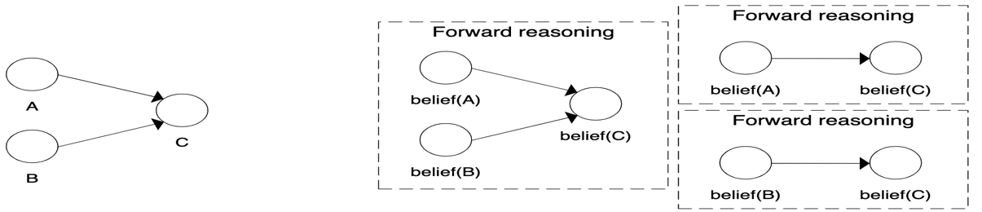
Backward Reasoning: Disjunction
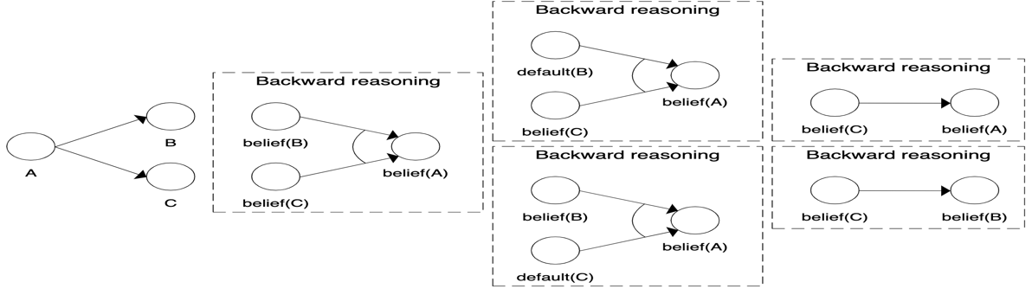
Conjunction: Many to one
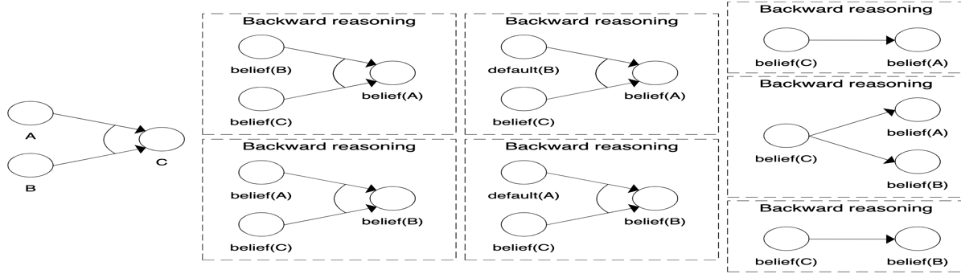

In reality, there is usually a discrepancy between the model’s prediction and reality this is where parameter adaptation models come in!

Lecture 11
Case study & ethical questions

1.Intelligent support systems have aim of “understanding” and “support” people. There are serious concerns around privacy, autonomy, freedom.

2.Societal or ethical concerns of intelligent support systems and how can we deal with these concerns?
-Transparency of aims of system
- Increase users’ awareness of: abilities of AI, (privacy) risks
-Adequate legislation: (explicit permission; ownership of data with users)
- Adequate security
-Explore various modes of system autonomy
-Extensive evaluation & testing
-Human in the loop: always build an on/off button

Lecture 12
Analysis and Support in Intelligent Cars

1.Model-based Intelligent Systems uses sensor information about human functioning, reason about the state of the human, (re)act by undertaking actions in a knowledgeable manner

2.Driver Support System -Improve safety by monitoring the driver by his/her steering behaviour, sweating (alcohol), gaze and eye movements. Based on this input, draw conclusions on driver’s state( when this behaviors are present, the driver is uncapable to drive). Driving behaviour can be impaired by alcohol intake, medication, fatigue, health problems, poor eyesight, specific emotional states, presence of other persons in the car and others

Doman Model
.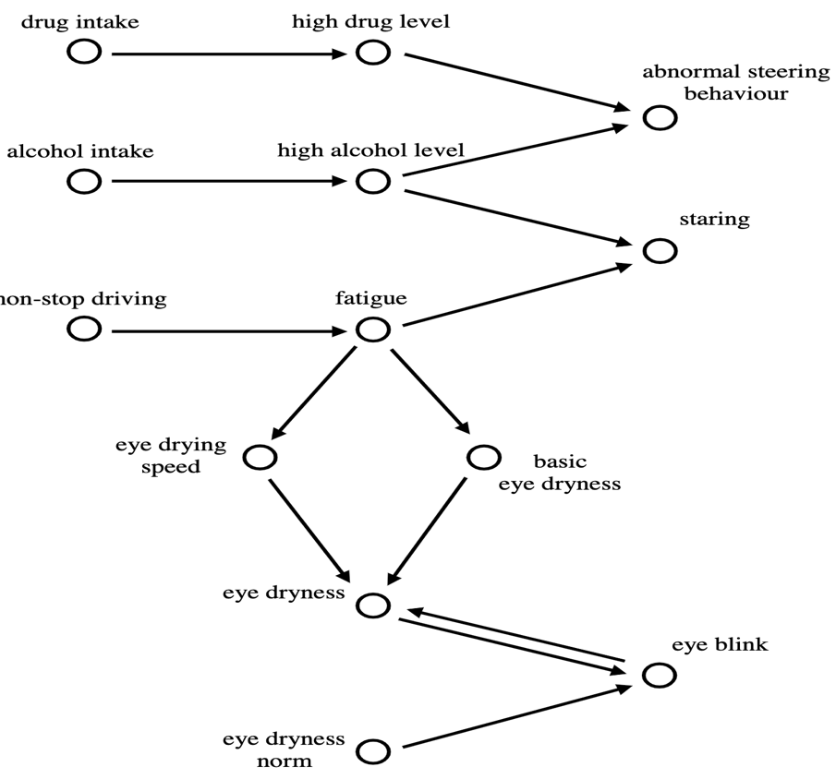

3.Model for analyses- intelligent agent should reason about the domain. Some concepts can be observed - (non-stop driving, eye blinking), some concepts have a believed status- (fatigue, eye_dryness), for some concepts the agent has a specific desire - (fatigue), some concepts are new (assessment on fatigue_discrepancy) (difference between desired and believed level of fatigue).

3.a Analyses model forward
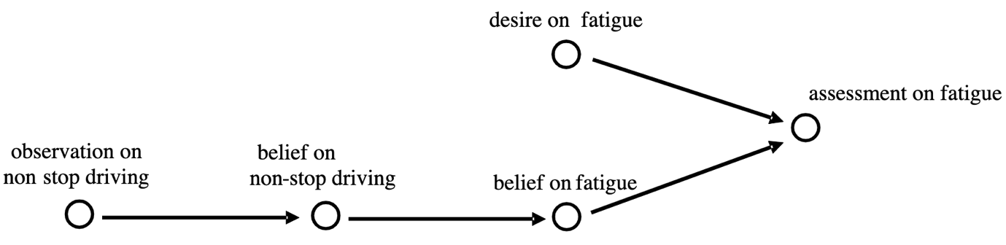
3.b) Analyses model-backward
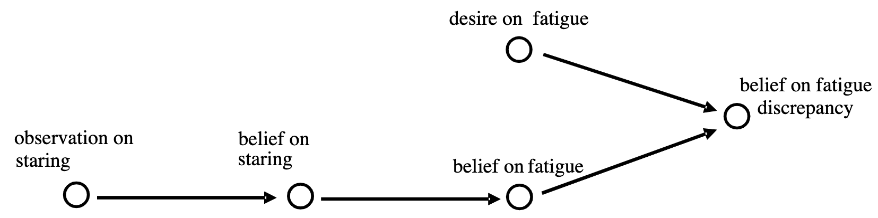
3.c Analyses model – extended (the model consists more than one observations, which leads to the same believe state) E.g. observation 1 and 2 are leading to the same believe state( eye blinking)
-Possible extensions: Taking more factors into account than alcohol, drugs, and fatigue (emotions, other passengers, music, mobile phones. Developing more complex models for analysis start from eye-blinking, a model to analyse steering patterns by taking speed and direction of steering movements into account.
Considering different and more complex types of support a mechanism to compare different options and select the one with the highest feasibility

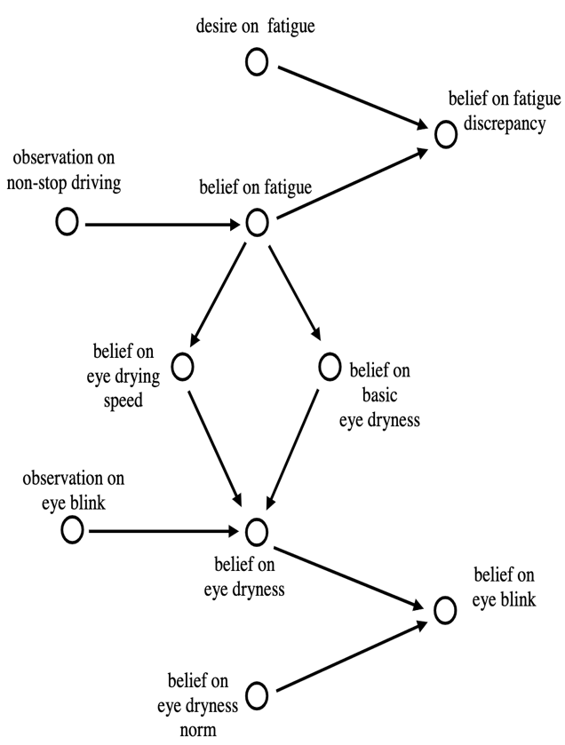

4.Support Model- (Model for supporting the driver)
Measures can be taken: -keep a safe distance with the car in front, slow down the car and safely pull it over wake up a sleepy driver, (e.g., by making a loud sound (tell him or her to take a break)
- include support action (take some rest)

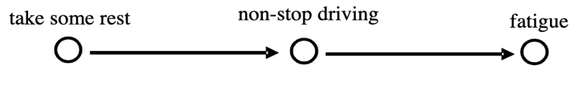
- Propagate and remove negative effect (not stop driving to not non-stop driving)

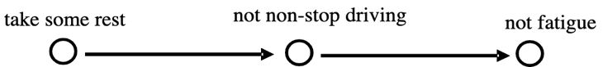

4.c) Support Model (backwards)

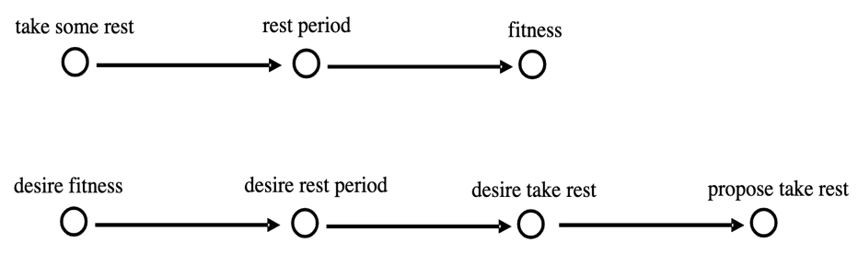
4.d) Support model forwards

